Supplementary Information for:
“Party or Policy? The Role of Policy Partisanship in Voter Decision-Making”

Clareta Treger, Thomas Galipeau, Thomas Bergeron, Sarah Lachance, Natasha Goel, Md Mujahedul Islam, Blake Lee-Whiting, Beatrice Magistro and Peter John Loewen

A Sample Demographics 2
B Question Wording 4
Voter’s PID 4
Voter’s policy positions 4
Policy Partisanship 5
Conjoint Experiment Attribute Levels 6
C Descriptives: Policy Partisanship and Policy Congruence 8
D Regression of Candidate Evaluation on Policy Congruence and Partisanship 9
Rating Outcome 9
Choice Outcome 11
Including Non-partisans and Partisans of Minor Parties 13
E Regression of Candidate Evaluation on Policy Congruence and Treatment Assignment 15
Rating Outcome 15
Including Non-partisans and Partisans of Minor Parties 17
Choice Outcome 20
Excluding NDP identifiers 23
F Pre-registered Analysis 24
F.1 Hypothesis H1 24
F.2 Hypothesis H2 26
G Ethics 28
References 28

Sample Demographics

Table A1: Sample demographics and comparison to population benchmarks

Variable | Sample Percentage |  | Population Benchmarks
Gender (%)
Men |  | 49.69 |  | 49.91
Women |  | 50.31 |  | 50.09
Education (%)
No post-secondary education |  | 65.25 |  | 56.42
Post-secondary education |  | 34.75 |  | 43.58
Province (%)
Alberta |  | 12.64 |  | 11.69
BC |  | 15.03 |  | 13.8
Manitoba |  | 3.71 |  | 3.63
Saskatchewan |  | 2.83 |  | 3.02
Ontario |  | 39.26 |  | 38.98
Quebec |  | 19.36 |  | 22.07
PEI |  | 0.71 |  | 0.43
Nova Scotia |  | 2.21 |  | 2.64
New Brunswick |  | 2.3 |  | 2.08
Newfoundland and Labrador |  | 1.86 |  | 1.34
Yukon |  | 0.09 |  | 0.11
Northwest Territories |  | 0 |  | 0.11
Nunavut |  | 0 |  | 0.1
Party Affiliation (%)
Liberal Party |  | 26.53 |  | 30.5
Conservative Party |  | 24.58 |  | 22.89
New Democratic Party |  | 14.24 |  | 14.85
Other/none |  | 34.66 |  | 31.76
Notes: Population benchmarks for the socio-demographic variables are based on 2023 Statistics Canada data (StatCan 2023). Population party affiliation is based on 2021 Canadian Election Study data (Stephenson et al. 2020). We used the following item for both: In politics, do you usually think of yourself as a(n): [party]. The category of “Other/none” for political affiliation includes: The Green Party (GPC); Bloc Qu´eb´ecois, (BQ), People’s Party (PPC), and Other party/no party/Don’t know.

Fig. A1: A plot of the positions of parties over time generated using the Manifesto Project data

Note: The graph plots the left-right positions of Canadian political parties on federal elections based on their platforms. The y-axis indicates the left-right position of a party according to the rile-index where higher positive values indicate a right-wing position and negative values a left-wing position, Source: (Lehmann et al. 2024) using Dashboard 1: Election Scatter Plot: https://visuals.manifesto-project.wzb.eu/mpdb-shiny/cmp_dashboard_selectable/

Question Wording

Voter’s PID
In politics, do you usually think of yourself as a(n):
[Randomize response order for options 1-6]
- Liberal
- Conservative
- NDP
- Bloc Québécois
- Green
- People’s Party of Canada
- Another party (specify):
- No party
- Don’t know

Voter’s policy positions
[randomize order of issues and responses]
- Which of the following policy positions on climate change is closest to your own?
- Reach net-zero greenhouse gas emissions by 2050
- Keep greenhouse gas emissions as they are
- Which of the following policy positions on income redistribution is closest to your own?
- Increase the minimum wage
- Cut taxes
- Which of the following policy positions on the cost of living is closest to your own?
- Give tax credits to low-income families
- Cut government spending
- Which of the following policy positions on the deficit is closest to your own?
- Increase deficit to spend more on social services
- Decrease deficit and cut back on social services
- Which of the following policy positions on the housing crisis is closest to your own?
- Subsidize the construction of a million more houses
- Cut mortgage insurance rates by 25 per cent
- Which of the following policy positions on healthcare is closest to your own?
- Expand the scope of the public healthcare system to include additional coverage
- Restrict the scope of the public healthcare system to give a greater share of the market to the private sector

Policy Partisanship
Question wording:
We are interested in knowing whether parties are associated with certain positions on six policy issues. For each policy position, please indicate whether you think it is a typical Conservative Party position, a typical Liberal Party position, a typical NDP position, or it is not a typical position of any party.
Table B1: Survey Question Used to Measure Policy Partisanship

Issue | Position | Conservative | Liberal | NDP | Not typical of any party | Don’t know
Climate change | Climate action as a high priority | ◯ | ◯ | ◯ | ◯ | ◯
Climate change | Climate action as a low priority | ◯ | ◯ | ◯ | ◯ | ◯
Income redistribution | Support for income redistribution | ◯ | ◯ | ◯ | ◯ | ◯
Income redistribution | Opposition to income redistribution | ◯ | ◯ | ◯ | ◯ | ◯
Cost of living | Support for government spending | ◯ | ◯ | ◯ | ◯ | ◯
Cost of living | Opposition to government spending | ◯ | ◯ | ◯ | ◯ | ◯
The deficit | Deficit is tolerable | ◯ | ◯ | ◯ | ◯ | ◯
The deficit | Deficit should be reduced as much as possible | ◯ | ◯ | ◯ | ◯ | ◯
The housing crisis | Lower mortgage rates | ◯ | ◯ | ◯ | ◯ | ◯
The housing crisis | Build more housing units | ◯ | ◯ | ◯ | ◯ | ◯
Healthcare | Expand the scope of public healthcare system | ◯ | ◯ | ◯ | ◯ | ◯
Healthcare | Narrow the scope of public healthcare system | ◯ | ◯ | ◯ | ◯ | ◯

Conjoint Experiment Attribute Levels

Table B2: Conjoint Attributes and Levels
Attribute | Levels
Party affiliation* | Liberal, Conservative
Gender | Man, Woman
Years of experience | 1, 4, 12
Position on climate change | Reach net-zero greenhouse gas emissions by 2050,  Keep greenhouse gas emissions as they are
Position on income  redistribution | Increase the minimum wage,  Cut taxes
Position on cost of living | Give tax credits to low-income families,  Cut government spending
Position on deficit | Increase deficit to spend more on social services,  Decrease deficit and cut back on social services
Position on housing | Subsidize the construction of a million more houses,  Cut mortgage insurance rates by 25 per cent
Position on healthcare | Expand the scope of the public healthcare system to  include additional coverage,  Restrict the scope of the public healthcare system to give a greater share of the market to the private sector
Note: *Treatment group only.
Table B3: Mapping of general policy positions to specific policy positions in the conjoint

Policy Area | General Policies for Policy Partisanship | Specific Policies for Conjoint
Climate Change | Climate action as a high priority | Reach net-zero greenhouse gas emissions by 2050
Climate Change | Climate action as a low priority | Keep greenhouse gas emissions as they are
Income Redistribution | Support for income redistribution | Increase the minimum wage
Income Redistribution | Opposition to income redistribution | Cut taxes
Cost of Living | Support for government spending | Give tax credits to low-income families
Cost of Living | Opposition to government spending | Cut government spending
The Deficit | Deficit is tolerable | Increase deficit to spend more on social services
The Deficit | Deficit should be reduced as much as possible | Decrease deficit and cut back on social services
Housing | Build more housing units | Subsidize the construction of a million more houses
Housing | Lower mortgage rates | Cut mortgage insurance rates by 25 per cent
Healthcare | Expand the scope of public healthcare system | Expand the scope of the public healthcare system to include additional coverage
Healthcare | Narrow the scope of public healthcare system | Restrict the scope of the public healthcare system to give a greater share of the market to the private sector

Descriptives: Policy Partisanship and Policy Congruence
Figure C1 shows the joint distribution of policy congruence and policy partisanship (non- partisan, in-group partisan, out-group partisan). It allows us to assess the prevalence of projection bias in our sample. For the sake of simplicity, imagine that all our respondents’ assignments of parties to policies (used to code policy partisanship) were biased by projection. If it were the case, we would expect that respondents would always assign their preferred party to policy positions that are congruent with their own, and that they would assign parties they dislike to incongruent policies.
This is not the case. The bottom bar in Figure C1 shows that 67% of the policy positions of candidates in the conjoint profiles that were congruent with the respondent’s policy preferences, were not assigned the respondent’s preferred party (and were assigned either to an out-party or considered non-partisan). Similarly, the top bar shows that 62% of incongruent policy positions were assigned to either the in-party or were considered non-partisan. This provides evidence that our data on individual-level policy partisanship is not determined by projection bias.
Fig. C1: Joint Distribution of Policy Congruence and Policy Partisanship
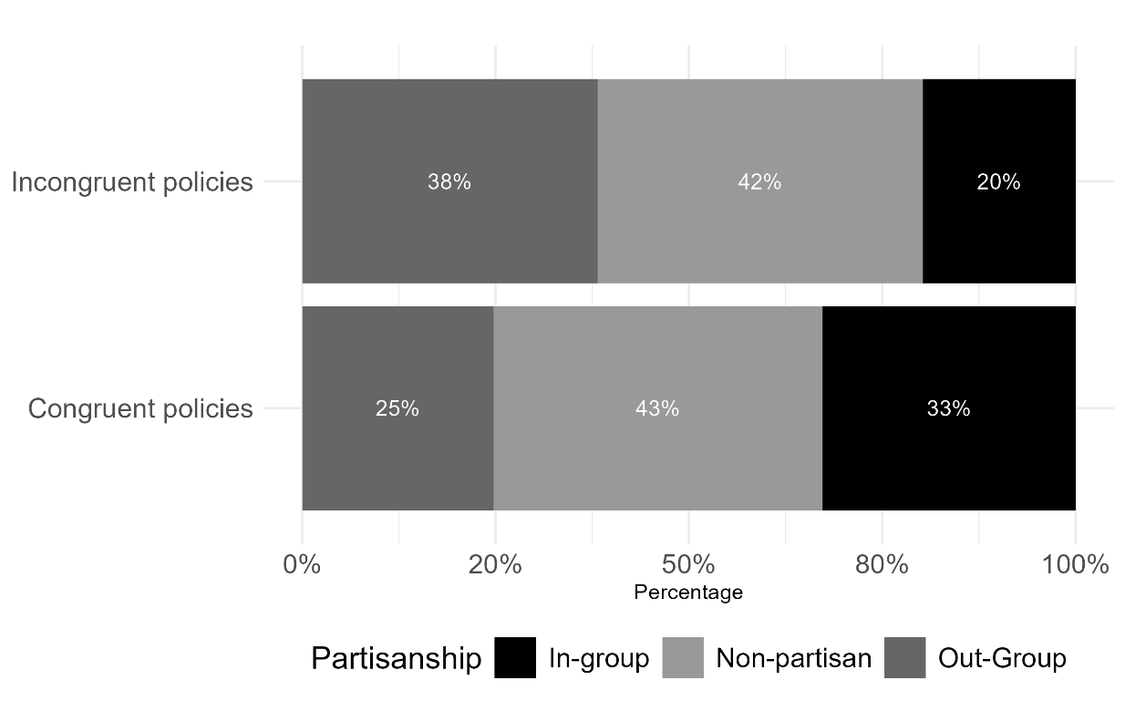

Note: The plot shows the proportion of each policy partisanship category within each policy congruence category. The sample of policy-party associations includes all the policy attribute levels that were displayed in the two profiles for each of the three conjoint tasks for all our respondents. N=26,604 (13,228 incongruent and 13,316 congruent).

Regression of Candidate Evaluation on Policy Congruence and Partisanship

Rating Outcome
Table D1: Regression of Candidate Evaluation on Policy Congruence and Policy Partisanship (Control Group). Dependent variable: Candidate Evaluation.

Variable | Estimate | Standard Error
Candidate Gender: Woman | 0.005 | 0.069
Candidate Experience: 4 years | 0.084 | 0.086
Candidate Experience: 12 years | 0.376*** | 0.088
Climate Change: Congruent and in-party | 0.079 | 0.159
Climate Change: Congruent and out-party | -0.108 | 0.173
Climate Change: Non-congruent and non-partisan | -0.598*** | 0.127
Climate Change: Non-congruent and in-party | -0.118 | 0.207
Climate Change: Non-congruent and out-p0arty | -0.514** | 0.158
Cost of living: Congruent and in-party | 0.174 | 0.167
Cost of living: Congruent and out-party | -0.070 | 0.184
Cost of living: Non-congruent and non-partisan | -0.342** | 0.112
Cost of living: Non-congruent and in-party | -0.269 | 0.223
Cost of living: Non-congruent and out-party | -0.299 | 0.173
Deficit: Congruent and in-party | -0.046 | 0.189
Deficit: Congruent and out-party | 0.284 | 0.186
Deficit: Non-congruent and non-partisan | -0.347** | 0.112
Deficit: Non-congruent and in-party | -0.179 | 0.187
Deficit: Non-congruent and out-party | -0.320 | 0.175
Healthcare: Congruent and in-party | -0.177 | 0.168
Healthcare: Congruent and out-party | -0.155 | 0.176
Healthcare: Non-congruent and non-partisan | -0.527*** | 0.112
Healthcare: Non-congruent and in-party | -0.292 | 0.222
Healthcare: Non-congruent and out-party | -0.673*** | 0.169
Housing: Congruent and in-party | 0.342* | 0.168
Housing: Congruent and out-party | -0.140 | 0.190
Housing: Non-congruent and non-partisan | -0.112 | 0.105
Housing: Non-congruent and in-party | 0.021 | 0.187
Housing: Non-congruent and out-party | -0.175 | 0.184
Income: Congruent and in-party | -0.099 | 0.189
Income: Congruent and out-party | 0.126 | 0.168
Income: Non-congruent and non-partisan | -0.107 | 0.112
Income: Non-congruent and in-party | -0.261 | 0.181
Income: Non-congruent and out-party | -0.190 | 0.169
Intercept | 4.858*** | 0.279
Adj. R2 | 0.10
N clusters | 378
Observations | 2249
∗p < 0.05; ∗∗p < 0.01; ∗∗∗p < 0.001
Notes: 1) The candidate rating outcome is measured on a 1-7 scale. 2) Included covariates: respondents’ gender, education, income, citizenship status, province and party identification. 3) The reference level for the policies is “congruent and non-partisan”, candidate gender, “man”, and for experience, “1 year”. 4) The estimates were used to produce Fig. 3 in the main analysis.

Choice Outcome
Table D2: Regression of Candidate Choice on Policy Congruence and Policy Partisanship. Dependent variable: Candidate Choice.

Variable | Estimate | Standard Error
Candidate Gender: Woman | 0.030 | 0.021
Candidate Experience: 4 years | 0.030 | 0.026
Candidate Experience: 12 years | 0.070** | 0.027
Climate Change: Congruent and in-party | -0.005 | 0.028
Climate Change: Congruent and out-party | -0.036 | 0.032
Climate Change: Non-congruent and non-partisan | -0.184*** | 0.032
Climate Change: Non-congruent and in-party | -0.065 | 0.042
Climate Change: Non-congruent and out-party | -0.181*** | 0.025
Cost of living: Congruent and in-party | 0.023 | 0.030
Cost of living: Congruent and out-party | -0.078* | 0.033
Cost of living: Non-congruent and non-partisan | -0.115*** | 0.032
Cost of living: Non-congruent and in-party | -0.057 | 0.048
Cost of living: Non-congruent and out-party | -0.087*** | 0.026
Deficit: Congruent and in-party | -0.049 | 0.032
Deficit: Congruent and out-party | -0.044 | 0.030
Deficit: Non-congruent and non-partisan | -0.146*** | 0.032
Deficit: Non-congruent and in-party | -0.175*** | 0.033
Deficit: Non-congruent and out-party | -0.150*** | 0.029
Healthcare: Congruent and in-party | -0.032 | 0.030
Healthcare: Congruent and out-party | 0.002 | 0.034
Healthcare: Non-congruent and non-partisan | -0.175*** | 0.029
Healthcare: Non-congruent and in-party | -0.062 | 0.039
Healthcare: Non-congruent and out-party | -0.186*** | 0.025
Housing: Congruent and in-party | 0.015 | 0.026
Housing: Congruent and out-party | -0.049 | 0.032
Housing: Non-congruent and non-partisan | -0.139*** | 0.030
Housing: Non-congruent and in-party | -0.140*** | 0.029
Housing: Non-congruent and out-party | -0.085** | 0.029
Income: Congruent and in-party | -0.067* | 0.030
Income: Congruent and out-party | 0.055* | 0.028
Income: Non-congruent and non-partisan | -0.117*** | 0.030
Income: Non-congruent and in-party | -0.207*** | 0.034
Income: Non-congruent and out-party | -0.062* | 0.024
Intercept | 0.853*** | 0.047
R2 Adj. | 0.10
N clusters | 366
Observations | 2070
∗p < 0.05; ∗∗p < 0.01; ∗∗∗p < 0.001
Notes: 1) Included covariates: respondents’ gender, education, income, citizenship status, province and party identification. 2) The reference level for the policies is “congruent and non-partisan”, candidate gender, “man”, and for experience, “1 year”.

Fig. D1: Average Marginal Effect of Policy Congruence on Candidate Choice by Implicit Party Cue (Control Group)

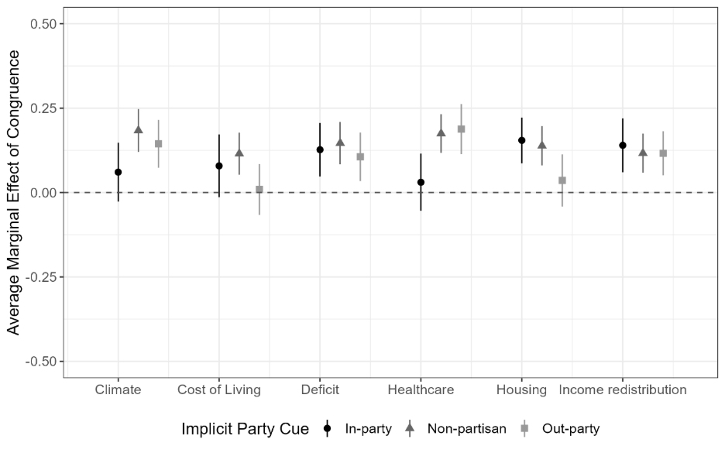

Including Non-partisans and Partisans of Minor Parties

Table D3: Regression of Candidate Evaluation on Policy Congruence and Policy Partisanship, Including Non-partisans and Partisans of Minor Parties (Control Group). Dependent variable: Candidate Evaluation.

Variable | Estimate | Standard Error
Candidate Gender: Woman | 0.013 | 0.059
Candidate Experience: 4 years | 0.054 | 0.070
Candidate Experience: 12 years | 0.279*** | 0.073
Climate Change: Congruent and partisan-matching | -0.151 | 0.141
Climate Change: Congruent and partisan-non-matching | -0.154 | 0.143
Climate Change: Non-congruent and non-partisan | -0.452*** | 0.101
Climate Change: Non-congruent and partisan-matching | -0.407* | 0.191
Climate Change: Non-congruent and partisan-non-matching | -0.570*** | 0.129
Cost of living: Congruent and partisan-matching | 0.086 | 0.159
Cost of living: Congruent and partisan-non-matching | -0.136 | 0.156
Cost of living: Non-congruent and non-partisan | -0.228* | 0.092
Cost of living: Non-congruent and partisan-matching | -0.384* | 0.195
Cost of living: Non-congruent and partisan-non-matching | -0.303* | 0.152
Deficit: Congruent and partisan-matching | 0.044 | 0.167
Deficit: Congruent and partisan-non-matching | 0.252 | 0.161
Deficit: Non-congruent and non-partisan | -0.292*** | 0.085
Deficit: Non-congruent and partisan-matching | -0.193 | 0.167
Deficit: Non-congruent and partisan-non-matching | -0.186 | 0.154
Healthcare: Congruent and partisan-matching | 0.061 | 0.151
Healthcare: Congruent and partisan-non-matching | 0.017 | 0.151
Healthcare: Non-congruent and non-partisan | -0.380*** | 0.086
Healthcare: Non-congruent and partisan-matching | -0.168 | 0.199
Healthcare: Non-congruent and partisan-non-matching | -0.479** | 0.148
Housing: Congruent and partisan-matching | 0.418** | 0.151
Housing: Congruent and partisan-non-matching | 0.097 | 0.151
Housing: Non-congruent and non-partisan | 0.010 | 0.084
Housing: Non-congruent and partisan-matching | 0.050 | 0.167
Housing: Non-congruent and partisan-non-matching | -0.028 | 0.149
Income: Congruent and partisan-matching | -0.091 | 0.167
Income: Congruent and partisan-non-matching | 0.287* | 0.142
Income: Non-congruent and non-partisan | -0.091 | 0.094
Income: Non-congruent and partisan-matching | -0.148 | 0.169
Income: Non-congruent and partisan-non-matching | -0.118 | 0.147
Intercept | 4.483*** | 0.234
R2 Adj. | 0.07
N clusters | 570
Observations | 3393
∗p < 0.05; ∗∗p < 0.01; ∗∗∗p < 0.001
Note: 1) The candidate rating outcome is measured on a 1-7 scale. 2) Included covariates: respondents’ gender, education, income, citizenship status, province and party identification. 3) The reference level for the policies is “congruent and non-partisan”, candidate gender, “man”, and for experience, “1 year”.

Figure D2: Average Marginal Effect of Policy Congruence on Candidate Evaluation by Implicit Party Cue (Control Group), including Non-partisans and Partisans of Minor Parties

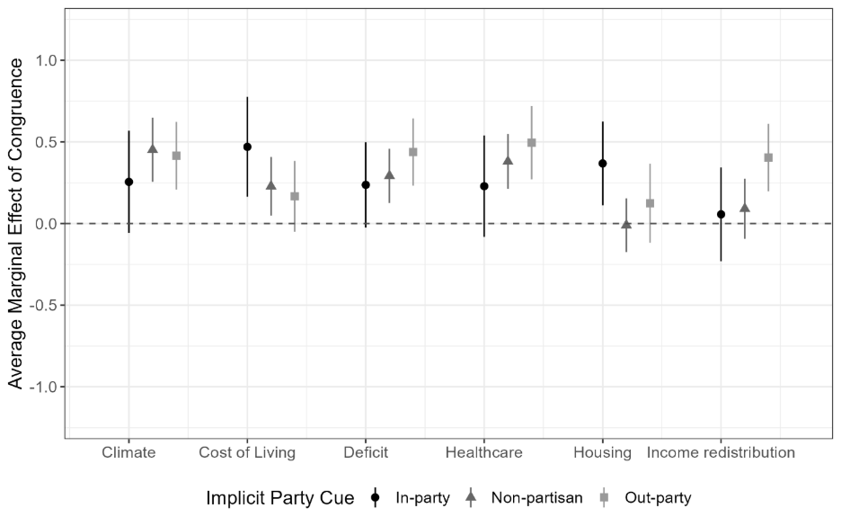

Regression of Candidate Evaluation on Policy Congruence and Treatment Assignment

Rating Outcome
Table E1 shows the regression estimates used in Figure 4 of the main analysis. Due to limited space, the estimates for respondent-level covariates included in the model are not shown in the table.

Table E1: Regression of Candidate Evaluation on Policy Congruence and Other attributes. Dependent variable: Candidate evaluation.
 | Treatment Group |  | Control Group
Variable | Estimate | Standard Error | Estimate | Standard Error
Explicit Party Cue: In-party | 0.753*** | 0.106
Candidate Gender: Woman | 0.139* | 0.070 | 0.016 | 0.069
Candidate Experience: 4 years | -0.077 | 0.086 | 0.074 | 0.086
Candidate Experience: 12 years | -0.063 | 0.090 | 0.365*** | 0.089
Climate Change: Congruent | 0.379*** | 0.078 | 0.486*** | 0.074
Income Redistribution: Congruent | 0.137 | 0.074 | 0.200** | 0.074
Cost of Living: Congruent | 0.219** | 0.071 | 0.340*** | 0.072
Deficit: Congruent | 0.357*** | 0.078 | 0.361*** | 0.070
Housing: Congruent | 0.080 | 0.074 | 0.178* | 0.072
Healthcare: Congruent | 0.363*** | 0.078 | 0.437*** | 0.078
Intercept | 2.860*** | 0.253 | 3.000*** | 0.284
Adj. R2 | 0.08 |  | 0.08
Observations | 2095 |  | 2249
N Clusters | 352 |  | 378

∗p < 0.05; ∗∗p < 0.01; ∗∗∗p < 0.001
Notes: 1) The candidate rating outcome is measured on a 1-7 scale. 2) Included covariates: respondents’ gender, education, income, citizenship status, province and party identification. 3) The reference level for explicit party cue is “out-party”, for the policies is incongruent”, for gender, “man”, and for experience, “1 year”.

Table E2 shows the regression estimates used to test H2, namely the interaction between policy congruence and treatment assignment to conjoint tasks that included or excluded explicit party cues (i.e. the party affiliation of the candidates). Due to limited space, the estimates for respondent-level covariates included in the model are not shown in the table.

Table E2: Regression of Candidate Evaluation on the Interaction of Policy Congruence and Treatment Assignment. Dependent variable: Candidate evaluation.
Variable | Estimate | Standard Error
Party Cue Present (Treatment) | 0.200 | 0.164
Candidate Gender: Woman | 0.087 | 0.050
Candidate Experience: 4 years | 0.019 | 0.061
Candidate Experience: 12 years | 0.176** | 0.065
Climate Change: Congruent | 0.491*** | 0.074
Cost of Living: Congruent | 0.340*** | 0.072
Deficit: Congruent | 0.361*** | 0.070
Healthcare: Congruent | 0.436*** | 0.077
Housing: Congruent | 0.179* | 0.072
Income Redistribution: Congruent | 0.200** | 0.074
Interactions
Climate Change: Congruent x Treatment | -0.118 | 0.108
Cost of Living: Congruent x Treatment | -0.113 | 0.102
Deficit: Congruent x Treatment | 0.001 | 0.105
Healthcare: Congruent x Treatment | -0.093 | 0.111
Housing: Congruent x Treatment | -0.116 | 0.105
Income Redistribution: Congruent x Treatment | -0.045 | 0.104
Intercept | 2.982*** | 0.206
Adj. R2 | 0.06
Observations | 4344
N Clusters | 730
∗p < 0.05; ∗∗p < 0.01; ∗∗∗p < 0.001
Notes: 1) The candidate rating outcome is measured on a 1-7 scale. 2) Included covariates: respondents’ gender, education, income, citizenship status, province and party identification. 3) The reference level for the policies is “incongruent”, for gender, “man”, and for experience, “1 year”.

Including Non-partisans and Partisans of Minor Parties

Table E3: Regression of Candidate Evaluation on Policy Congruence and Other Attributes Including Non-partisans and Partisans of Minor Parties. Dependent variable: Candidate evaluation

 | Treatment Group |  | Control Group
Variable | Estimate | Standard Error | Estimate | Standard Error
Party: Liberal | -0.101 | 0.075
Candidate Gender: Woman | 0.069 | 0.062 | 0.014 | 0.059
Candidate Experience: 4 years | -0.005 | 0.073 | 0.050 | 0.070
Candidate Experience: 12 years | 0.015 | 0.073 | 0.275*** | 0.074
Climate Change: Congruent | 0.337*** | 0.063 | 0.408*** | 0.061
Income Redistribution: Congruent | 0.154** | 0.060 | 0.187** | 0.061
Cost of Living: Congruent | 0.205*** | 0.059 | 0.257*** | 0.061
Deficit: Congruent | 0.309*** | 0.063 | 0.317*** | 0.057
Housing: Congruent | 0.098 | 0.063 | 0.134* | 0.060
Healthcare: Congruent | 0.345*** | 0.064 | 0.401*** | 0.063
Intercept | 3.213*** | 0.228 | 3.001*** | 0.222
R2 Adj. | 0.05 |  | 0.06
Observations | 3139 |  | 3393
Clusters | 529 |  | 570
∗p < 0.05; ∗∗p < 0.01; ∗∗∗p < 0.001
Notes: 1) The candidate rating outcome is measured on a 1-7 scale. 2) Included covariates: respondents’ gender, education, income, citizenship status, province and party identification. 3) The reference level for the policies is “incongruent”, for party “Conservative”, for gender, “man”, and for experience, “1 year”.

Figure E1: Average Marginal Effect of Policy Congruence and Other Conjoint Attributes on Candidate Evalaution by Experimental Condition Including Non-partisans and Partisans of Minor Parties

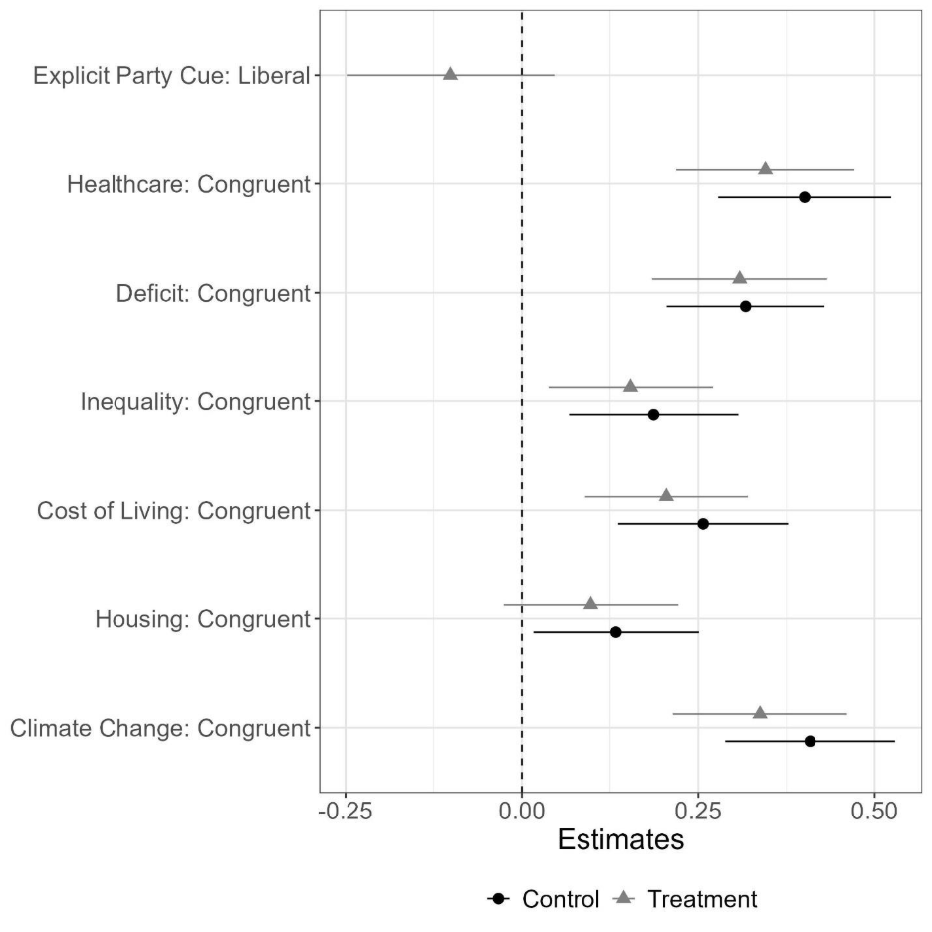

Table E4: Regression of Candidate Evaluation on the Interaction of Policy Congruence and Treatment Assignment Including Non-partisans and Partisans of Minor Parties. Dependent variable: Candidate evaluation.

Variable | Estimate | Standard Error
Party Cue: Present (Treatment) | 0.109 | 0.132
Candidate Gender: Woman | 0.043 | 0.043
Candidate Experience: 4 years | 0.022 | 0.050
Candidate Experience: 12 years | 0.151** | 0.052
Climate Change: Congruent | 0.411*** | 0.061
Cost of Living: Congruent | 0.257*** | 0.061
Deficit: Congruent | 0.318*** | 0.057
Healthcare: Congruent | 0.401*** | 0.062
Housing: Congruent | 0.133* | 0.060
Income Redistribution: Congruent | 0.184** | 0.061
Interactions
Climate Change: Congruent × Treatment | -0.079 | 0.088
Treatment × Cost of Living: Congruent | -0.054 | 0.085
Treatment × Deficit: Congruent | -0.007 | 0.085
Treatment × Healthcare: Congruent | -0.056 | 0.090
Treatment × Housing: Congruent | -0.042 | 0.087
Treatment × Income redistribution Congruent | -0.031 | 0.085
Intercept | 3.052*** | 0.167
R2 Adj. | 0.06
Observations | 6532
N Clusters | 1099
∗p < 0.05; ∗∗p < 0.01; ∗∗∗p < 0.001
Notes: 1) The candidate rating outcome is measured on a 1-7 scale. 2) Included covariates: respondents’ gender, education, income, citizenship status, province and party identification. 3) The reference level for treatment is “Party cue absent (control)”, for the policies, “incongruent and non-partisan”, for candidate gender, “man”, and for experience, “1 year”.

Choice Outcome
Table E5: Regression of Candidate Choice on Policy Congruence and Policy Partisanship. Dependent variable: Candidate choice.
 | Treatment Group |  | Control Group
Variable | Estimate | Standard Error | Estimate | Standard Error
Explicit Party Cue: In-party | 0.19*** | 0.028
Candidate Gender: Woman | 0.038 | 0.022 | 0.031 | 0.021
Candidate Experience: 4 years | -0.069** | 0.026 | 0.027 | 0.025
Candidate Experience: 12 years | 0.044 | 0.026 | 0.072** | 0.027
Climate Change: Congruent | 0.114*** | 0.022 | 0.154*** | 0.021
Income Redistribution: Congruent | 0.107*** | 0.023 | 0.111*** | 0.021
Cost of Living: Congruent | 0.062** | 0.023 | 0.082*** | 0.022
Deficit: Congruent | 0.138*** | 0.022 | 0.126*** | 0.022
Housing: Congruent | 0.044 | 0.023 | 0.121*** | 0.020
Healthcare: Congruent | 0.158*** | 0.023 | 0.149*** | 0.021
Intercept | 0.069 | 0.039 | 0.039 | 0.035
R2 Adj. | 0.10 |  | 0.09
Observations | 1904 |  | 2070
∗p < 0.05; ∗∗p < 0.01; ∗∗∗p < 0.001
Notes: 1) Included covariates: respondents’ gender, education, income, citizenship status, province and party identification. 2) The reference level for the policies is “incongruent”, for gender, “man”, and for experience, “1 year”.

Fig. E2: Average Marginal Effect of Policy Congruence and Other Conjoint Attributes on Candidate Choice by Experimental Condition. Dependent variable: Candidate Choice.

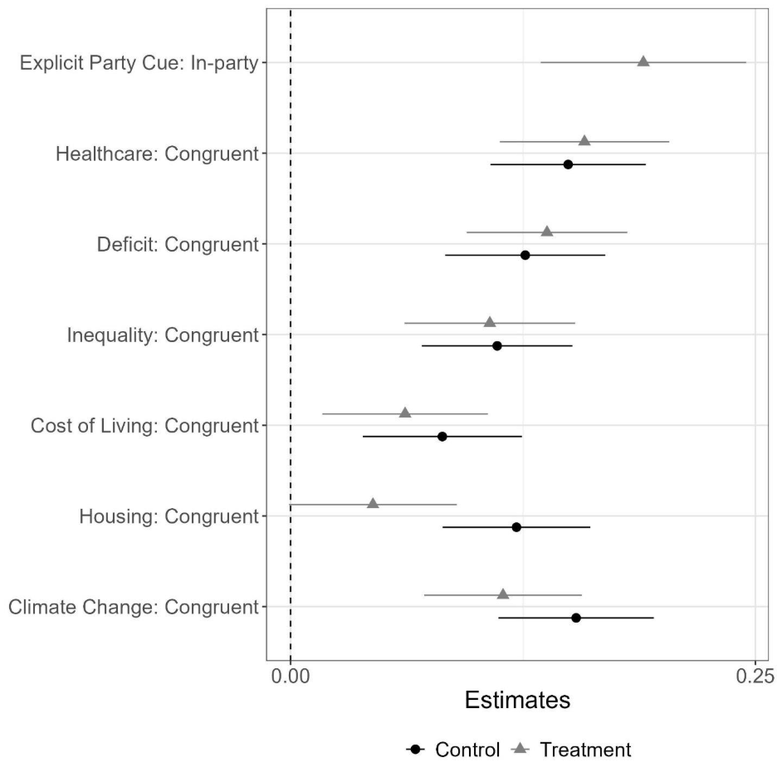

Table E6: Regression of Candidate Choice on the Interaction of Policy Congruence and Treatment Assignment. Dependent variable: Candidate choice.

Variable | Estimate | Standard Error
Party Cue Present (Treatment) | 0.062 | 0.035
Candidate Gender: Woman | 0.035* | 0.015
Candidate Experience: 4 years | -0.015 | 0.018
Candidate Experience: 12 years | 0.064*** | 0.019
Climate Change: Congruent | 0.153*** | 0.021
Cost of Living: Congruent | 0.081*** | 0.022
Deficit: Congruent | 0.127*** | 0.022
Healthcare: Congruent | 0.148*** | 0.021
Housing: Congruent | 0.121*** | 0.020
Income Redistribution: Congruent | 0.109*** | 0.021
Interactions
Treatment × Climate Change: Congruent | -0.040 | 0.031
Treatment × Cost of Living: Congruent | -0.018 | 0.032
Treatment × Deficit: Congruent | 0.006 | 0.031
Treatment × Healthcare: Congruent | 0.006 | 0.032
Treatment × Housing: Congruent | -0.080** | 0.031
Treatment × Income Redistribution: Congruent | 0.001 | 0.031
Intercept | 0.069* | 0.029
R2 Adj. | 0.08
Observations | 3974
N Clusters | 702
∗p < 0.05; ∗∗p < 0.01; ∗∗∗p < 0.001
Notes: 1) Included covariates: respondents’ gender, education, income, citizenship status, province and party identification. 2) The reference level for the policies is “incongruent”, for gender, “man”, and for experience, “1 year”.

Excluding NDP identifiers

Table E7: Regression of Candidate Evaluation on the Interaction of Policy Congruence and Treatment Assignment excluding NDP Identifiers. Dependent variable: Candidate evaluation.

Variable | Estimate | Standard Error
Party Cue Present (Treatment) | 0.246 | (0.183)
Candidate Gender: Woman | 0.036 | (0.056)
Candidate Experience: 4 years | -0.001 | (0.070)
Candidate Experience: 12 years | 0.172* | (0.073)
Climate Change: Congruent | 0.505*** | (0.084)
Cost of Living: Congruent | 0.327*** | (0.081)
Deficit: Congruent | 0.331*** | (0.078)
Healthcare: Congruent | 0.384*** | (0.082)
Housing: Congruent | 0.176* | (0.080)
Income Redistribution: Congruent | 0.228** | (0.085)
Interactions
Climate Change: Congruent x Treatment | -0.161 | (0.121)
Cost of Living: Congruent x Treatment | -0.088 | (0.115)
Deficit: Congruent x Treatment | -0.005 | (0.121)
Healthcare: Congruent x Treatment | -0.107 | (0.123)
Housing: Congruent x Treatment | -0.154 | (0.118)
Income Redistribution: Congruent x Treatment | 0.001 | (0.120)
Intercept | 3.078*** | (0.227)
Adj. R2 | 0.59
Observations | 3391
N Clusters | 570
∗p < 0.05; ∗∗p < 0.01; ∗∗∗p < 0.001
Notes: 1) The candidate rating outcome is measured on a 1-7 scale. 2) Included covariates: respondents’ gender, education, income, citizenship status, province and party identification. 3) The reference level the policies, “incongruent and non-partisan”, for candidate gender, “man”, and for experience, “1 year”.

Pre-registered Analysis
An earlier version of the project was pre-registered with Open Source Foundation and can be found here: https://osf.io/n4h58. We report the pre-registered analysis in this section instead of the main text because the pre-registered hypotheses were not formulated in a way that could generate valuable insights on the research questions.

F.1 Hypothesis H1
In this section, we test the pre-registered hypotheses H1a & H1b (below) by analyzing the effect of policy partisanship (binary variable; partisan or non-partisan) on candidate ratings within each experimental condition using linear regression.

H1a (pre-registered): Partisan policy positions have a stronger effect on candidate choice than non-partisan policy positions.
H1b (pre-registered): Partisan policy positions have a weaker effect on candidate choice than non-partisan policy positions.

The results in Table F1 and Table F2 do not support the pre-registered hypotheses H1a nor H1b, as they show that policy partisanship has no effect on candidate evaluation overall. Yet, as we do not account for policy congruence, these null effects may be the result of partisan policies associated with competing parties canceling each other out.

Table F1: Regression of Candidate Evaluation on Policy Partisanship (Binary) and Other Attributes (Control Group). Dependent variable: Candidate evaluation.

Variable | Estimate | Standard Error
Candidate Gender: Woman | 0.00 | 0.07
Candidate Experience: 4 years | 0.04 | 0.09
Candidate Experience: 12 years | 0.33*** | 0.09
Climate Change: Partisan | 0.06 | 0.13
Cost of Living: Partisan | 0.06 | 0.12
Deficit: Partisan | 0.1 | 0.13
Healthcare: Partisan | -0.46*** | 0.13
Housing: Partisan | 0.34** | 0.13
Income Redistribution: Partisan | -0.01 | 0.12
Intercept | 4.12*** | 0.27
Adj. R2 | 0.04
Observations | 2249
N Clusters | 378
∗p < 0.05; ∗∗p < 0.01; ∗∗∗p < 0.001
Notes: 1) The candidate rating outcome is measured on a 1-7 scale. 2) Included covariates: respondents’ gender, education, income, citizenship status, province and party identification. 3) The reference level for the policies is “non-partisan”, for candidate gender, “man”, and for experience, “1 year”.

Table F2: Regression of Candidate Evaluation on Policy Partisanship (Binary) and Other Attributes (Treatment Group). Dependent variable: Candidate evaluation.

Variable | Estimate | Standard Error
Candidate Party: Liberal | -0.11 | 0.10
Candidate Gender: Woman | 0.12 | 0.07
Candidate Experience: 4 years | -0.05 | 0.09
Candidate Experience: 12 years | -0.04 | 0.09
Climate Change: Partisan | -0.12 | 0.14
Cost of Living: Partisan | 0.15 | 0.11
Deficit: Partisan | 0.09 | 0.12
Healthcare: Partisan | -0.46*** | 0.13
Housing: Partisan | 0.04 | 0.13
Income Redistribution: Partisan | -0.14 | 0.12
Intercept | 4.33*** | 0.28
Adj. R2 | 0.03
Observations | 2095
N Clusters | 352
∗p < 0.05; ∗∗p < 0.01; ∗∗∗p < 0.001
Notes: 1) The candidate rating outcome is measured on a 1-7 scale. 2) Included covariates: respondents’ gender, education, income, citizenship status, province and party identification. 3) The reference level for the candidate’s party is “Liberal Party”, for policies is “non-partisan”, for gender, “man”, and for experience, “1 year”.

F.2 Hypothesis H2
In this section we test the pre-registered hypothesis H2 (below) by analyzing the effect of policy partisanship (binary variable; partisan or non-partisan) on candidate ratings across experimental conditions using interactions in a linear regression model.

H2 (pre-registered): The presence of explicit party cues weakens the effect of partisan and non-partisan policies on candidate choice.

The results in Table F3 do not support the pre-registered hypothesis H2, as it shows that the interaction effects for all issues are not statistically significant at standard levels, meaning that explicit party cues (the treatment) do not moderate the effects of policy partisanship on candidate evaluation. However, this analysis suffers from the same limitations as above: by not accounting for policy congruence we do not know whether competing policy partisanship is driving the effects to zero. Additionally, in this analysis we have not recoded the candidate’s party attribute to match (or not) that of the respondent. This explains its non-significant effect.

Table F3: Regression of Candidate Evaluation on the Interaction of Policy Partisanship (Binary) and Treatment Assignment. Dependent variable: Candidate evaluation.
Variable | Estimate | Standard Error
Party cue present (Treatment) | 0.38 | 0.27
Candidate Gender: Woman | 0.07 | 0.05
Candidate Experience: 4 years | -0.01 | 0.06
Candidate Experience: 12 years | 0.15* | 0.07
Climate Change: Partisan | 0.09 | 0.12
Cost of Living: Partisan | 0.05 | 0.12
Deficit: Partisan | 0.11 | 0.13
Healthcare: Partisan | -0.44** | 0.13
Housing: Partisan | 0.34** | 0.12
Income Redistribution: Partisan | -0.04 | 0.12
Interactions
Climate Change: Partisan x Treatment | -0.19 | 0.19
Cost of Living: Partisan x Treatment | 0.1 | 0.17
Deficit: Partisan x Treatment | -0.02 | 0.18
Healthcare: Partisan x Treatment | 0.00 | 0.19
Housing: Partisan x Treatment | -0.33 | 0.18
Income Redistribution: Partisan x Treatment | -0.07 | 0.17
Intercept | 3.98*** | 0.24
Adj. R2 | 0.03
Observations | 4344
N Clusters | 730
∗p < 0.05; ∗∗p < 0.01; ∗∗∗p < 0.001
ssNotes: 1) The candidate rating outcome is measured on a 1-7 scale. 2) Included covariates: respondents’ gender, education, income, citizenship status, province and party identification. 3) The reference level for Treatment is “party cues absent”, for policies is “non-partisan”, for gender is “man”, and for experience, “1 year”.

Ethics
Our study obtained ethics approval from the Institutional Review Board (IRB) at The University of Toronto, with the assigned protocol number 44379. Our survey design adheres strictly to the principles of research transparency and ethical standards as endorsed by the American Political Science Association (APSA) Council in April 2020, under the title “Principles and Guidance for Human Subjects Research.”
Participants were recruited via Abacus. Compensation was administered by the sample provider, and consisted of either direct financial compensation or survey points that can be redeemed by the respondents with the survey provider. Participants had to express their informed consent to participate in the study, ensuring they were aware they could discontinue participation at any time without consequences. To preserve confidentiality, no personal identifiers were collected. Participants were notified that their anonymized data might be used for replication in subsequent scholarly work, reinforcing the commitment to transparency and the advancement of knowledge.

References
Lehmann, Pola, Franzmann, Simon, Al-Gaddooa, Denise, Burst, Tobias, Ivanusch, Christoph, Regel, Sven, Riethmüller, Felicia, Volkens, Andrea, Weßels, Bernhard & Zehnter, Lisa (2024): The Manifesto Data Collection. Manifesto Project (MRG/CMP/MARPOR). Version 2024a. Berlin: Wissenschaftszentrum Berlin für Sozialforschung (WZB) / Göttingen: Institut für Demokratieforschung (IfDem). https://doi.org/10.25522/manifesto.mpds.2024a[Dashboard 1: Election Scatter Plot: https://visuals.manifesto-project.wzb.eu/mpdb-shiny/cmp_dashboard_selectable/]
StatCan (2023). Population Estimates Quarterly.
Stephenson, Laura B, Harell, Allison, Rubenson, Daniel & Loewen, Peter J. (2020). “2019 Canadian Election Study—Online Survey”. Harvard Dataverse 1.

The Hebrew University of Jerusalem. Corresponding author, email: clareta.treger@mail.huji.ac.il

