Appendix A. Survey Items
Study 1 Survey
Attention Screener 1
Puppy is to dog as kitten is to _____? (answer coded as: cat)
Attention Screener 2
Help us keep track of who is paying attention, please select - "Somewhat disagree" in the options below. Strongly agree, Agree, Somewhat agree, Neither agree nor disagree, Somewhat disagree, Disagree, Strongly disagree
ANES Party Identification
Generally speaking, do you usually think of yourself as a Democrat, a Republican, an Independent, or what? Democrat, Republican, Independent, Other Party, please specify:
Do you think of yourself as closer to the Democratic Party or the Republican Party? Closer to the Democratic Party, Closer to the Republican Party, Closer to Neither Party
Would you call yourself a strong [Democrat/Republican] or a not very strong [Democrat/Republican]? Strong [Democrat/Republican], Not very strong [Democrat/Republican]
Attention Check 1
We would like to get a sense of your general preferences.
Most modern theories of decision making recognize that decisions do not take place in a vacuum. Individual preferences and knowledge, along with situational variables can greatly impact the decision process. To demonstrate that you've read this much, just go ahead and select both red and green among the alternatives below, no matter what your favorite color is. Yes, ignore the question below and select both of those options.
What is your favorite color?
White, Black, Red, Pink, Green, Blue
Partisan Identity Strength
How important is being a [Democrat/Republican] to you? Extremely important, Very important, Not very important, Not at all important
How well does the term [Democrat/Republican] describe you? Extremely well, Very well, Not very well, Not at all
When talking about [Democrat/Republican], how often do you use "we" instead of "they"? All the time, Most of the time, Some of the time, Rarely, Never
To what extent do you think of yourself as being a [Democrat/Republican]? A great deal, Somewhat, Very little, Not at all
Attention Check 2
People are very busy these days and many do not have time to follow what goes on in the government. We are testing whether people read questions. To show that you've read this much, answer both "extremely interested" and "very interested": Not at all interested, Slightly interested, Somewhat interested, Very interested, Extremely interested
Symbolic Ideology
When it comes to politics do you usually think of yourself as extremely liberal, liberal, slightly liberal, moderate or middle of the road, slightly conservative, extremely conservative?
Attention Check 3
Thinking about your news habits, how often do you...
Read newspapers in print: Often, Sometimes, Hardly ever, Never
Listen to news on the radio: Often, Sometimes, Hardly ever, Never
Watch local television news: Often, Sometimes, Hardly ever, Never
Watch national evening network television news (such as ABC World News, CBS Evening News, or NBC Nightly News)?: Often, Sometimes, Hardly ever, Never
For this one please select "hardly ever" to show that you're paying attention.: Often, Sometimes, Hardly ever, Never
Watch news on CNN: Often, Sometimes, Hardly ever, Never
Watch news on The Fox News Channel: Often, Sometimes, Hardly ever, Never
Watch news on MSNBC: Often, Sometimes, Hardly ever, Never
Read news on social media (such as Facebook or Twitter)?: Often, Sometimes, Hardly ever, Never
Need for Uniqueness
I prefer being _____ different from other people. no, slightly, moderately, very, extremely
Being distinctive is ______ important to me. not at all, slightly, moderately, very, extremely
I ______ intentionally do things to make myself different from those around me. never, seldom, sometimes, often, always
I have a _____ need for uniqueness. weak, slight, moderate, strong, very strong
Partisan Violence Scale
How much do you feel it is justified for [Democrats/Republicans] to use violence in advancing their political goals these days? Not at all, A little, A moderate amount, A lot, A great deal
What if [Republicans/Democrats] win the 2024 presidential election? How much do you feel violence would be justified then? Not at all, A little, A moderate amount, A lot, A great deal
Offensive Violence
If [Democrats/Republicans] engage in violence to achieve their political goals, how justified or unjustified do you think it is for [Republicans/Democrats] to use violence in response? Strongly Justified, Somewhat Justified, Neither justified or unjustified, Somewhat Unjustified, Strongly Unjustified
Willingness to Engage in Violence
Think about the next presidential election in 2024. If a [Democrat/Republican] is declared the winner of a contested election, how likely would you be to engage in each of the following activities?
Post on social media about your views on the topics. Not at all likely, Not too likely, Somewhat likely, Very likely
Join an in-person protest. Not at all likely, Not too likely, Somewhat likely, Very likely
Violate laws but without violence (e.g., defacing public property, trespassing). Not at all likely, Not too likely, Somewhat likely, Very likely
Use violence. Not at all likely, Not too likely, Somewhat likely, Very likely
Fight for Party Scale
How much do you agree or disagree with the following statements?
I would fight someone physically threatening another [Democrat/Republican]. Completely Disagree, Disagree, Somewhat Disagree, Neither Disagree or Agree, Somewhat Agree, Agree, Completely Agree
I would fight someone insulting or making fun of [Democrats/Republicans] as a whole. Completely Disagree, Disagree, Somewhat Disagree, Neither Disagree or Agree, Somewhat Agree, Agree, Completely Agree
I would help others get revenge on someone who insulted [Democrats/Republicans]. Completely Disagree, Disagree, Somewhat Disagree, Neither Disagree or Agree, Somewhat Agree, Agree, Completely Agree
Hurting other people is acceptable if it means protecting [Democrats/Republicans]. Completely Disagree, Disagree, Somewhat Disagree, Neither Disagree or Agree, Somewhat Agree, Agree, Completely Agree
I’d do anything to protect [Democrats/Republicans]. Completely Disagree, Disagree, Somewhat Disagree, Neither Disagree or Agree, Somewhat Agree, Agree, Completely Agree
Trait Aggression Scale
Please indicate the extent to which the following statements are true or false.
Given enough provocation I may hit a person. Completely false, Mostly false, Slightly false, Slightly true, Mostly true, Completely true
My friends say I am somewhat argumentative. Completely false, Mostly false, Slightly false, Slightly true, Mostly true, Completely true
I have trouble controlling my temper. Completely false, Mostly false, Slightly false, Slightly true, Mostly true, Completely true
At times, I feel I have gotten a raw deal out of life. Completely false, Mostly false, Slightly false, Slightly true, Mostly true, Completely true
Need to Belong Scale
Full item wording is omitted for copyright reasons, see Leary et al., 2013.
Study 2 Survey Additional Items
Support for General Political Violence
How much do you agree or disagree with the following statements?
It is acceptable to use violence in advancing political goals these days. Strongly agree, Somewhat agree, Neither agree nor disagree, Somewhat disagree, Strongly disagree
Violence is sometimes an acceptable way for Americans to express their disagreement with the government. Strongly agree, Somewhat agree, Neither agree nor disagree, Somewhat disagree, Strongly disagree
Violence is justified if the members of the other side act violently first. Strongly agree, Somewhat agree, Neither agree nor disagree, Somewhat disagree, Strongly disagree
Basic Demographic Controls (Supplied by Lucid Theorem)
Gender
What is your gender? Male, Female
Education (coded as (1) Some high school or less to (8) Doctorate degree)
What is the highest level of education you have completed? Some high school or less, High school graduate, Other post high school vocational training, Completed some college, but no degree, Associate's degree, Bachelor's degree, Master's or professional degree, Doctorate degree, None of the above (coded as NA)
Race (coded as White = 1, else = 0)
What is your race? White, Black, or African American, American Indian or Alaska Native, Asian *** Asian Indian, Asian *** Chinese, Asian *** Filipino, Asian *** Japanese, Asian *** Korean, Asian *** Vietnamese, Asian *** Other, Pacific Islander *** Native Hawaiian, Pacific Islander *** Guamanian, Pacific Islander *** Samoan, Pacific Islander *** Other Pacific Islander, Some other race, Prefer not to answer
Hispanic (coded as Hispanic = 1, else = 0)
Are you Hispanic, Latino, or Spanish Origin? No, not of Hispanic, Latino, or Spanish origin, Yes, Mexican, Mexican American, Chicano, Yes, Cuban, Yes, another Hispanic, Latino, or Spanish origin *** Argentina, Yes, another Hispanic, Latino, or Spanish origin *** Colombia, Yes, another Hispanic, Latino, or Spanish origin *** Ecuador, Yes, another Hispanic, Latino, or Spanish origin *** El Salvadore, Yes, another Hispanic, Latino, or Spanish origin *** Guatemala, Yes, another Hispanic, Latino, or Spanish origin *** Nicaragua, Yes, another Hispanic, Latino, or Spanish origin *** Panama, Yes, another Hispanic, Latino, or Spanish origin *** Peru, Yes, another Hispanic, Latino, or Spanish origin *** Spain, Yes, another Hispanic, Latino, or Spanish origin *** Venezuela, Yes, another Hispanic, Latino, or Spanish origin *** Other Country, Prefer not to answer, Yes, Puerto Rican
Income (coded as (1) Less than $14,999 to (24) $250,000 and above)
What is your current Annual household income before taxes? Less than $14,999, $15,000 to $19,999, $20,000 to $24,999, $25,000 to $29,999, $30,000 to $34,999, $35,000 to $39,999, $40,000 to $44,999, $45,000 to $49,999, $50,000 to $54,999, $55,000 to $59,999, $60,000 to $64,999, $65,000 to $69,999, $70,000 to $74,999, $75,000 to $79,999, $80,000 to $84,999, $85,000 to $89,999, $90,000 to $94,999, $95,000 to $99,999, $100,000 to $124,999, $125,000 to $149,999, $150,000 to $174,999, $175,000 to $199,999, $200,000 to $249,999, $250,000 and above, Prefer not to answer (coded as NA)
Appendix B. Descriptive Statistics for Survey Items & Representativeness
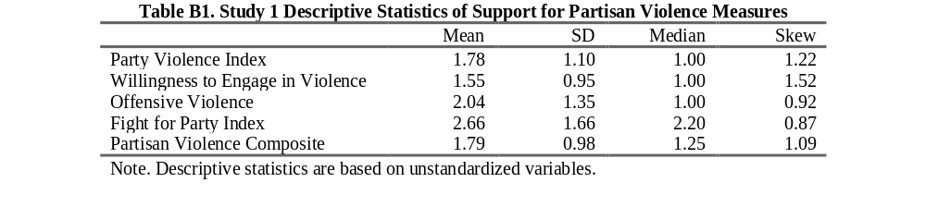
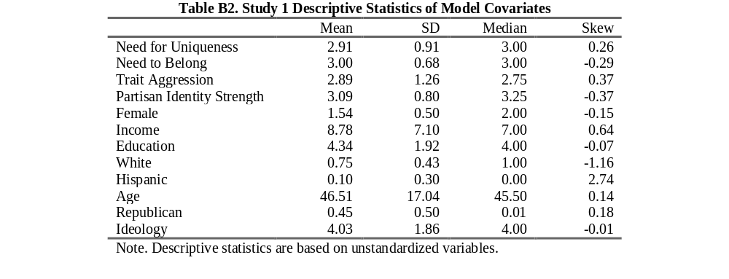
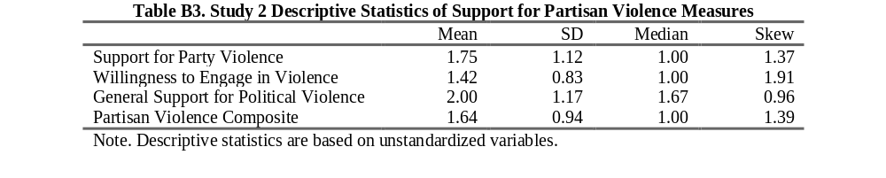
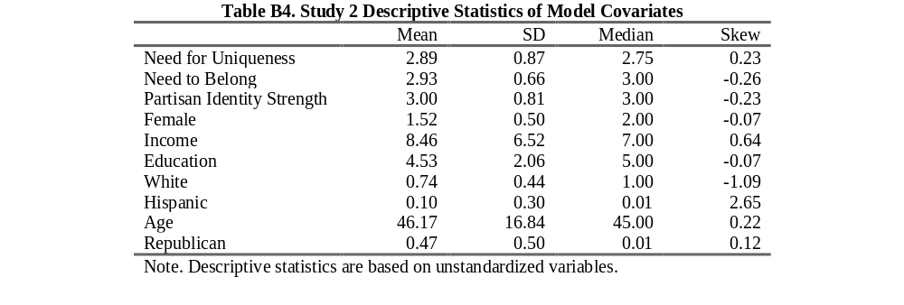

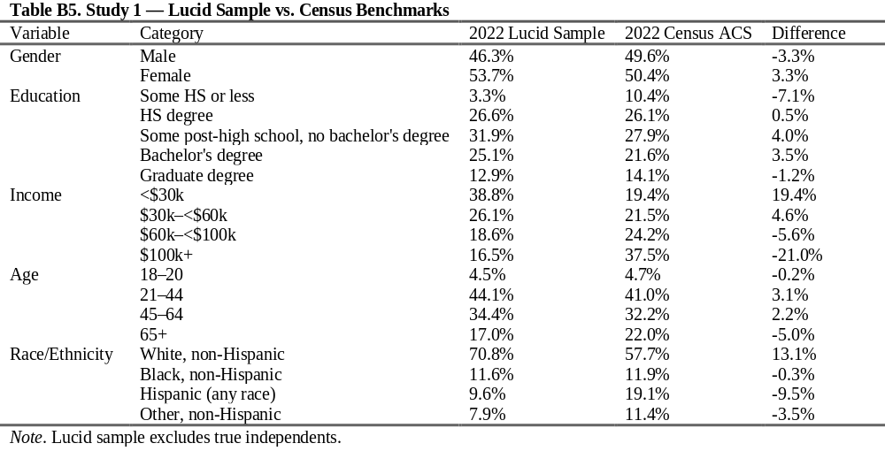
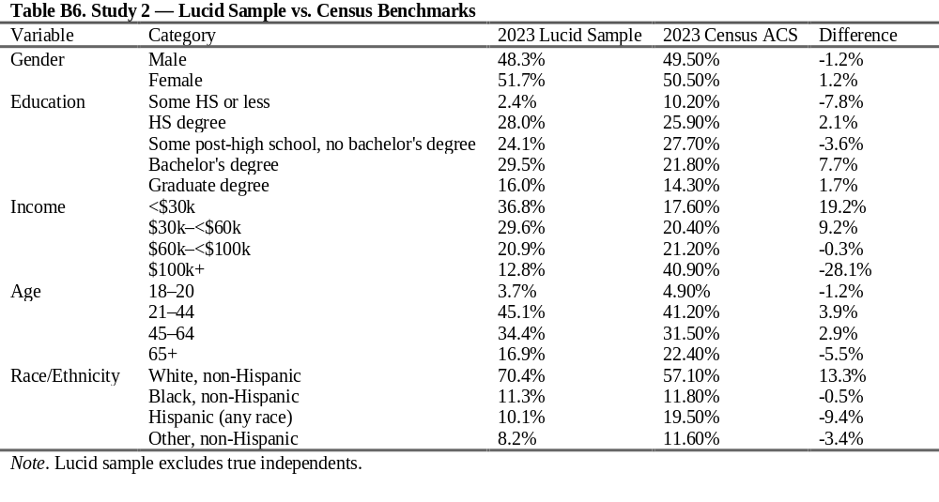

Appendix C. OLS Models with Individual Partisan Violence Measures
To test for differences between the support for partisan violence measures, I ran several regression analyses from both samples, regressing support for partisan violence on the interaction of need for uniqueness and the need to belong, as well as the interaction of need for uniqueness and partisan identity strength. As Tables C1 and C2 uniformly show, the interaction effect with need to belong remains statistically significant (ps < .001) no matter how support for political violence is operationalized. Figures C1 and C2 display the shape of the interaction. For the interaction of need for uniqueness and partisan identity strength, the results are more mixed, but overall, the interaction is significant at least at the (p < .05) level for all instances except for the measure of offensive partisan violence in study 1 (shown in Tables C3 and C4 and displayed in Figures C3 and C4). The pattern observed and theorized in the main analysis remains, where those with a high need for uniqueness and a high need to belong or a high partisan identity strength are supportive of political violence.
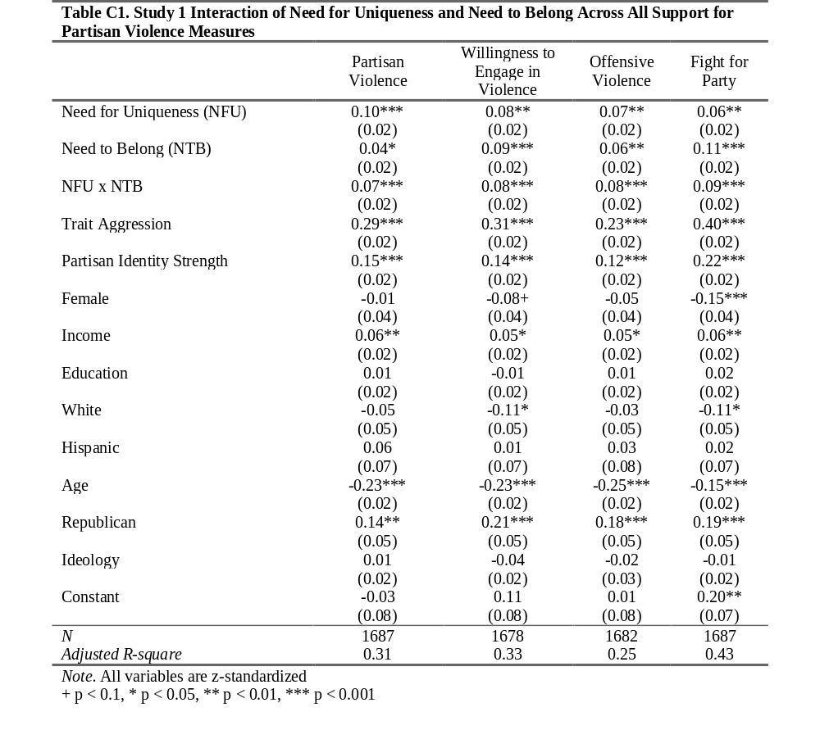
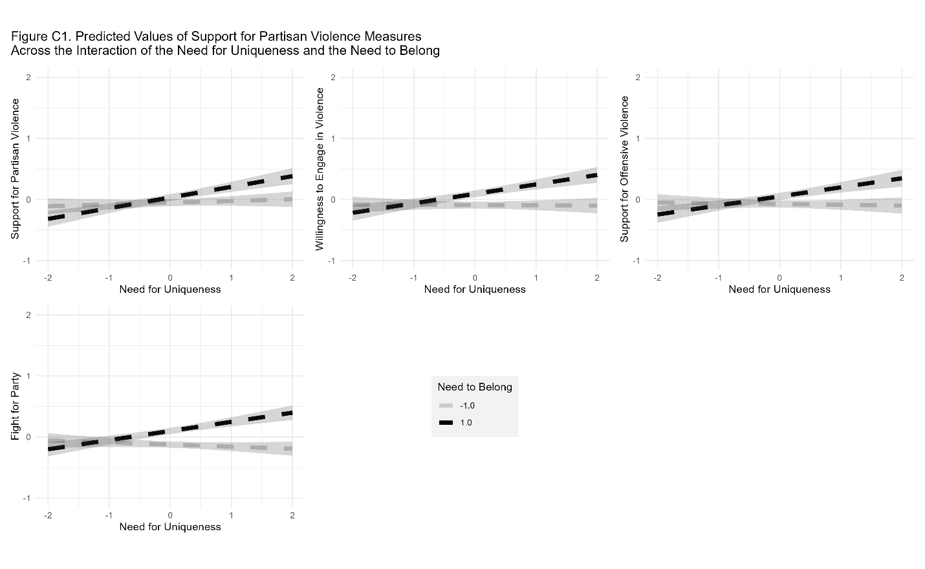

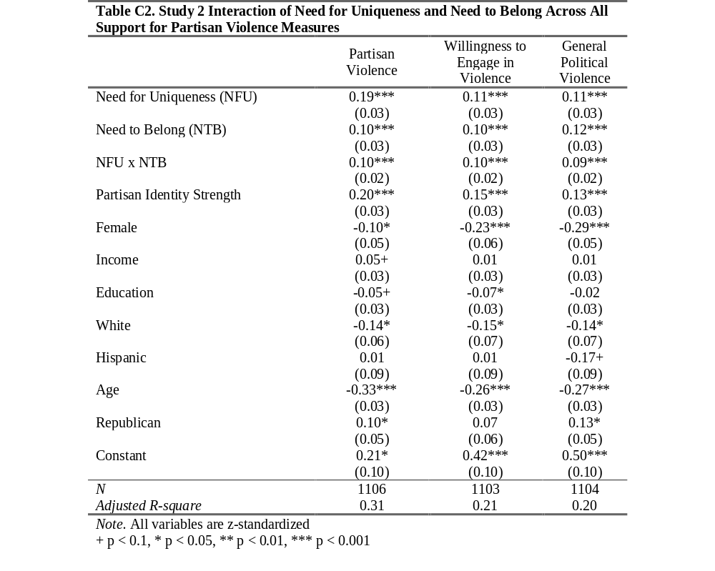
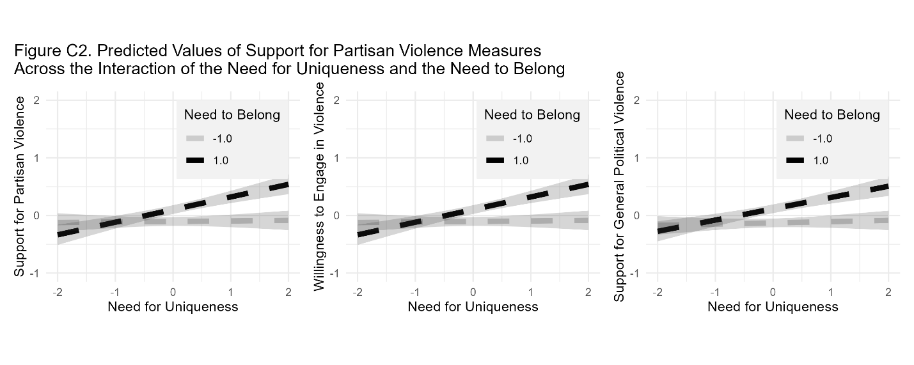

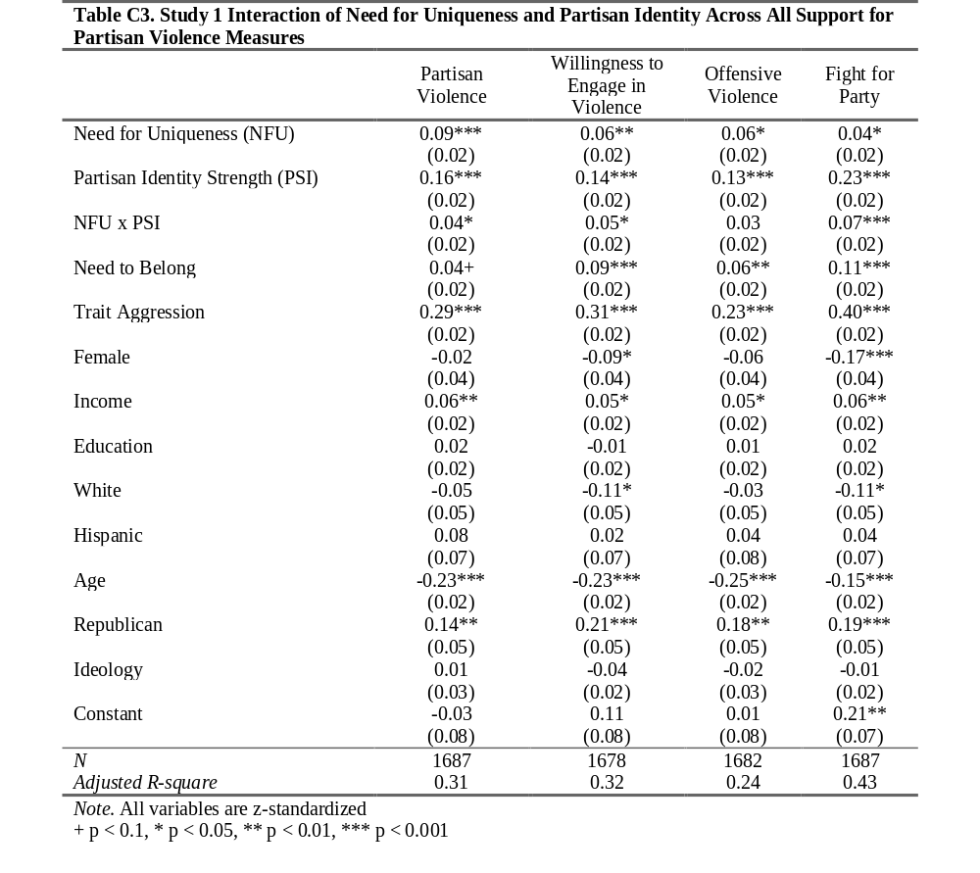
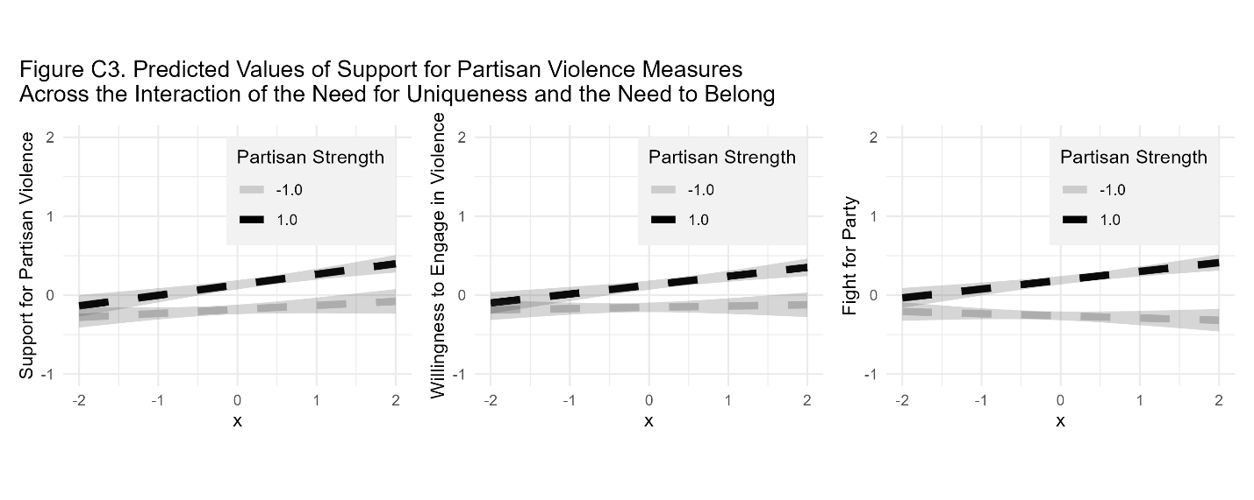

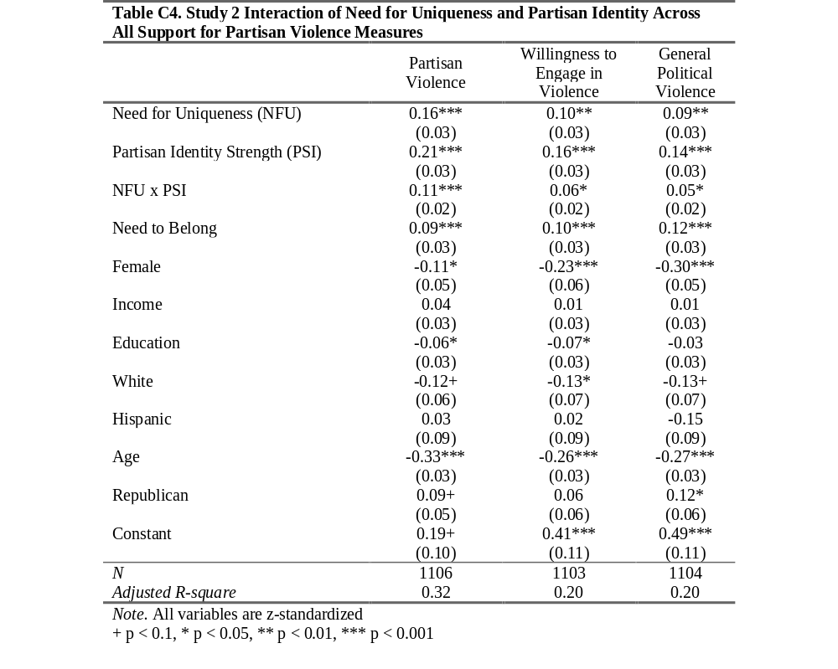
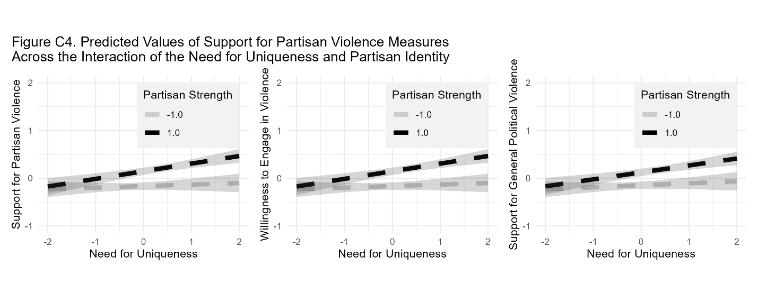

Appendix D. Survey Attention Checks
To test for potential of survey disengagement affecting the interaction of need for uniqueness and need to belong observed in the main study, I re-ran the interaction of the need for uniqueness and need to belong and the interaction of need for uniqueness and partisan identity strength predicting the composite support for partisan violence measure first with all respondents included. Next, I then included those who got at least two or more attention checks correct, and lastly I analyzed the models amongst those who passed all attention checks or spent more than or equal to 5 minutes on the survey for study 1. For study 2, the full sample was analyzed, then only including those who passed all attention checks, and lastly including those who passed all attention checks and spent more than or equal to 5 minutes on the survey.
Thus, I go from the least restrictive model (full sample) to the most restrictive (passing every attention check and spending more than or equal to 5 minutes). This was done so to account for the possibility that survey inattention may affect the theorized relationships observed in the main analysis, in relation to support for political violence (Westwood et al., 2022).
Tables D1 and D3 show the regression results for the first study, and Tables D2 and D4 show the OLS results for the second study. As both Table D1 and Table D2 show, the interaction of need for uniqueness and the need to belong remains statistically significant (ps < .001) across all levels of attention and across all restricted models. Additionally, Tables D3 and D4 shows the interaction of need for uniqueness and partisan identity strength also does not differ across levels of attention, with all models being significant (ps < .05).

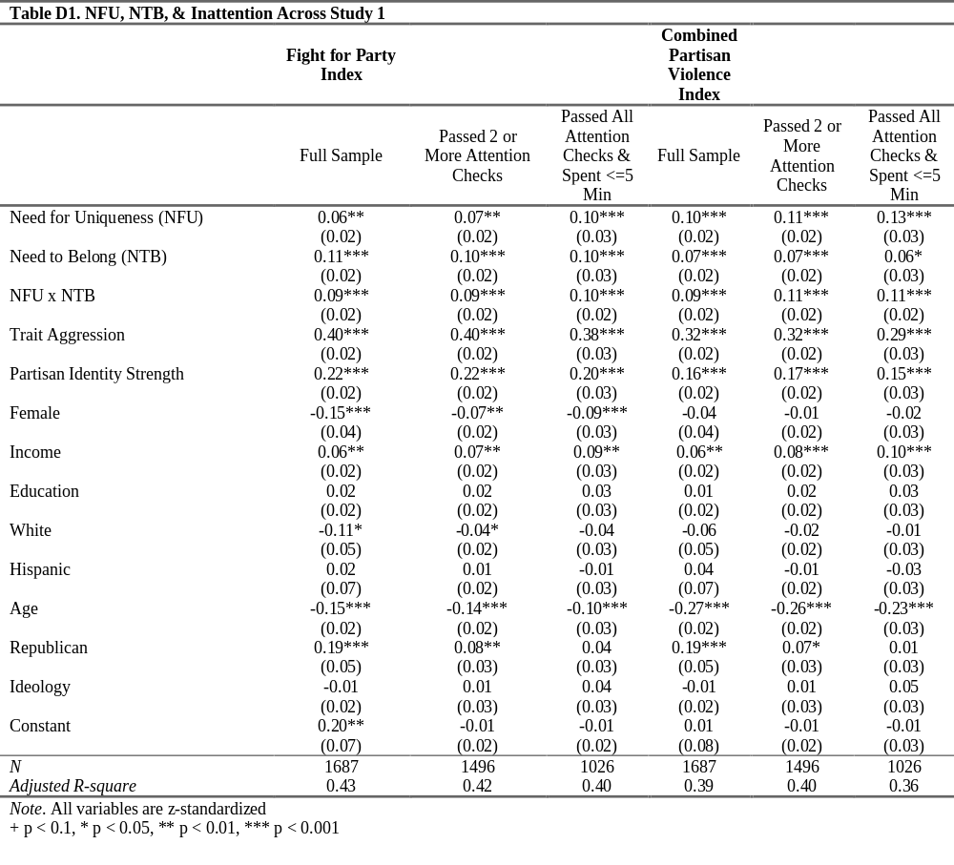

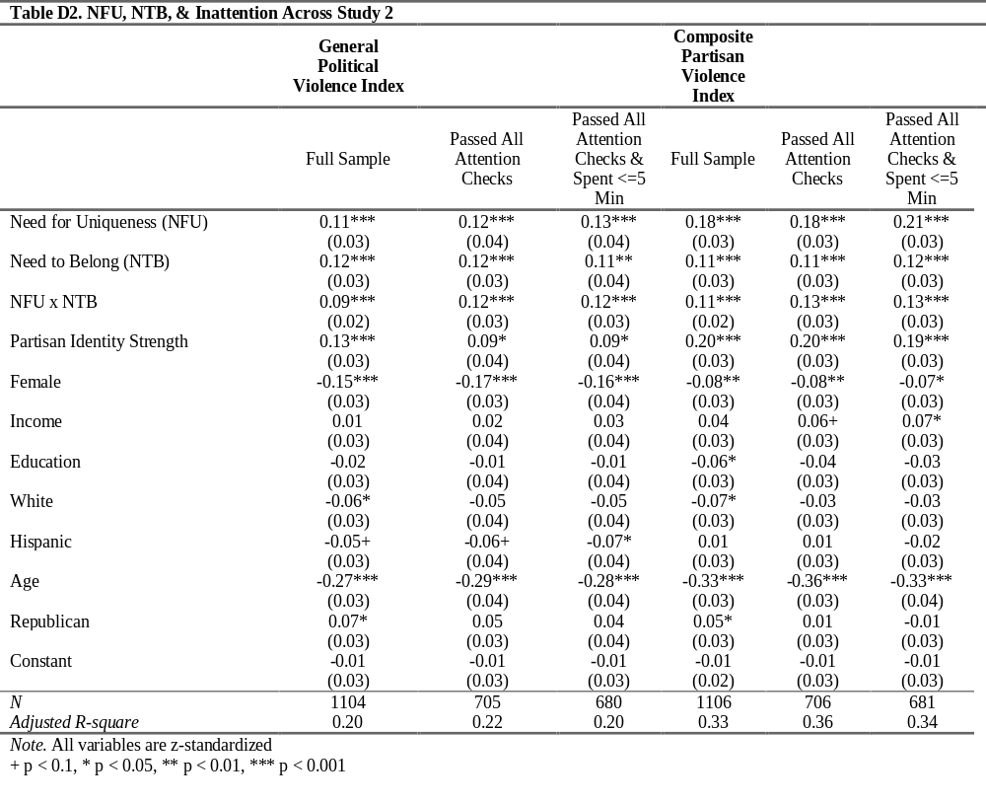
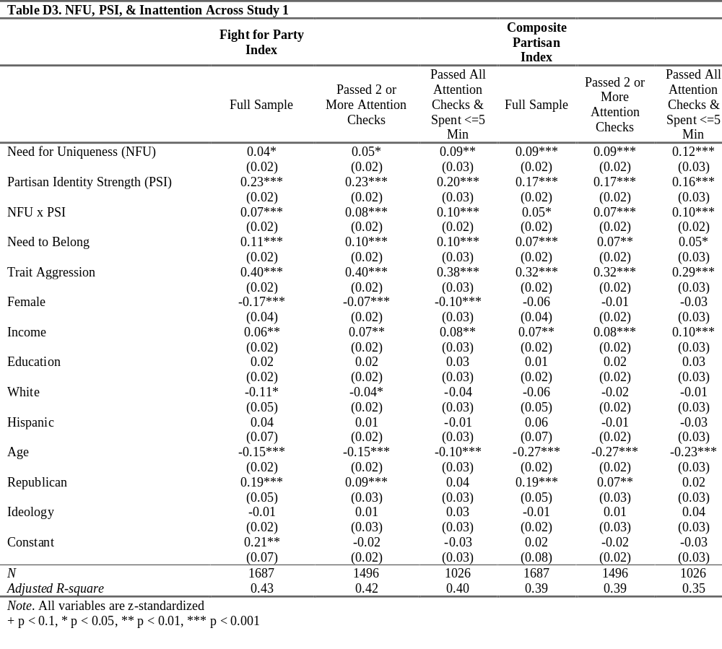
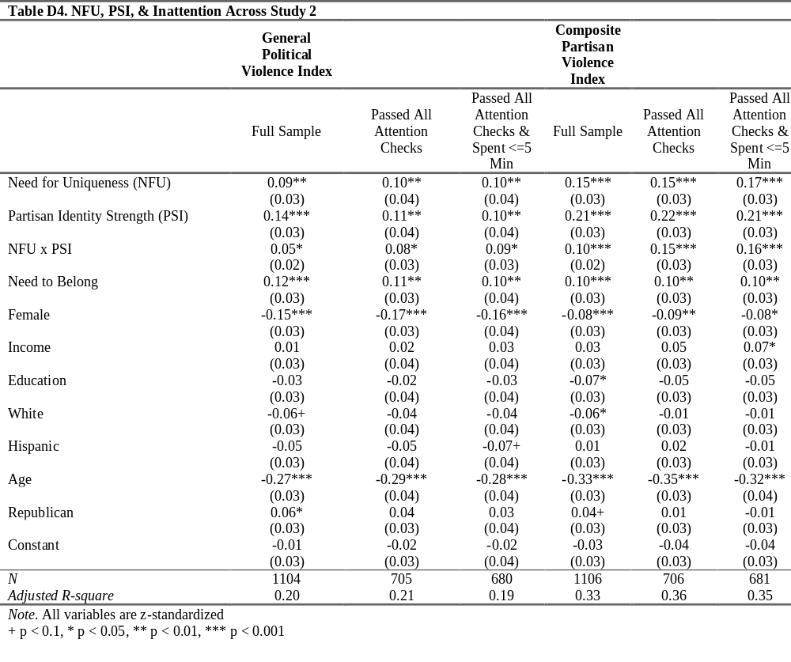

Appendix E. Factor Analyses for Composite Support for Political Violence
First, the relationship between all of the violence variables in study 1 is shown by the correlation matrix below (Figure E1), which finds that the items all positively correlated at the p < .001 level, ranging from r = 0.39 to r = 0.83. Next, a parallel analysis was run to ascertain the optimal number of factors to extract. As Figure E2, the results suggest that 2 factors should be extracted. A principal axis factor analysis (FA) with oblimin rotation was then performed to analyze the separate violence scales utilized in study 1. As Table E1 shows, loadings differed for the fight for party items versus the rest of the items, and all loadings > 0.45.
For the violence measures in study 2, the correlations are shown in Figure E2 (all ps < .001), ranging from r = 0.38 to r = 0.78. A parallel analysis was run to explore the optimal number of factors, ultimately suggesting 2 factors (Figure E4). The principal axis factor analysis (FA) with oblimin rotation for study 2 corroborates a 2 factor solution, the (non-partisan) general political violence items loading on a different factor than the rest of the (partisan) violence items, with all loadings > 0.50.
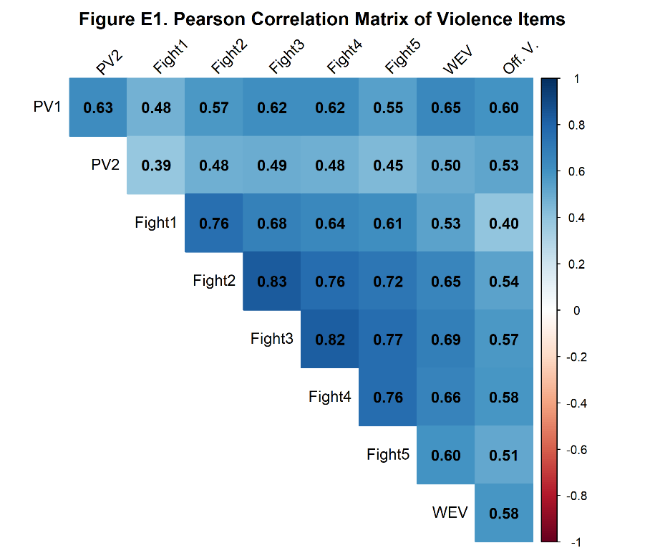
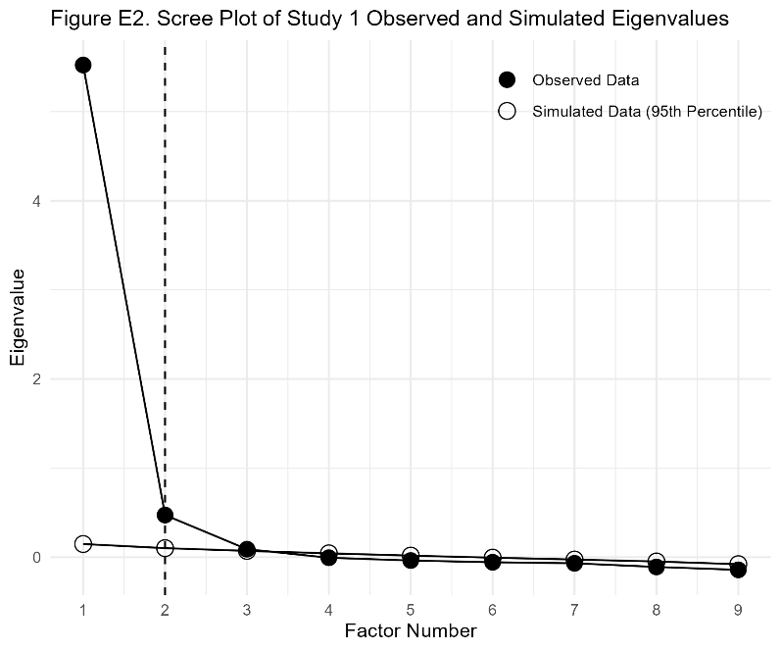
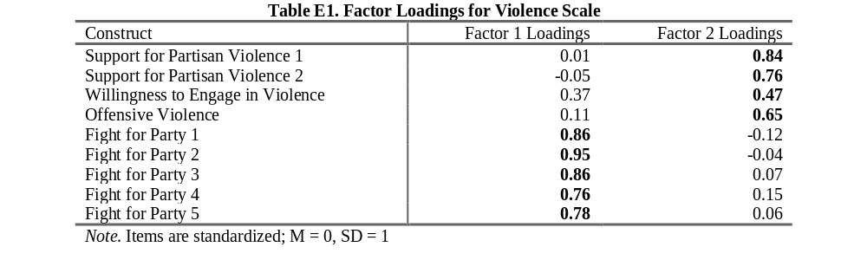
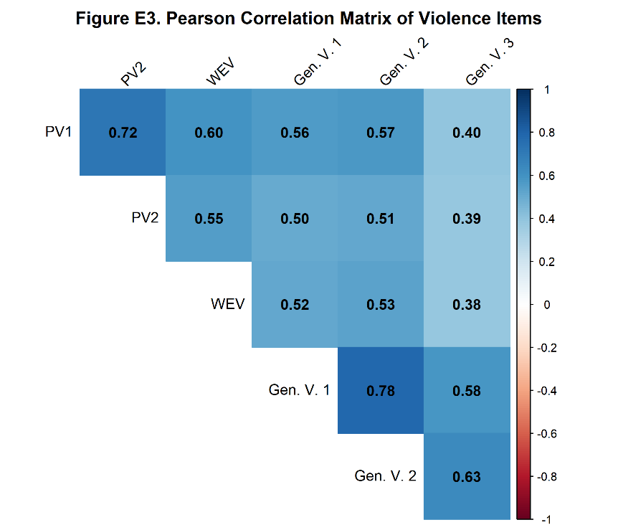
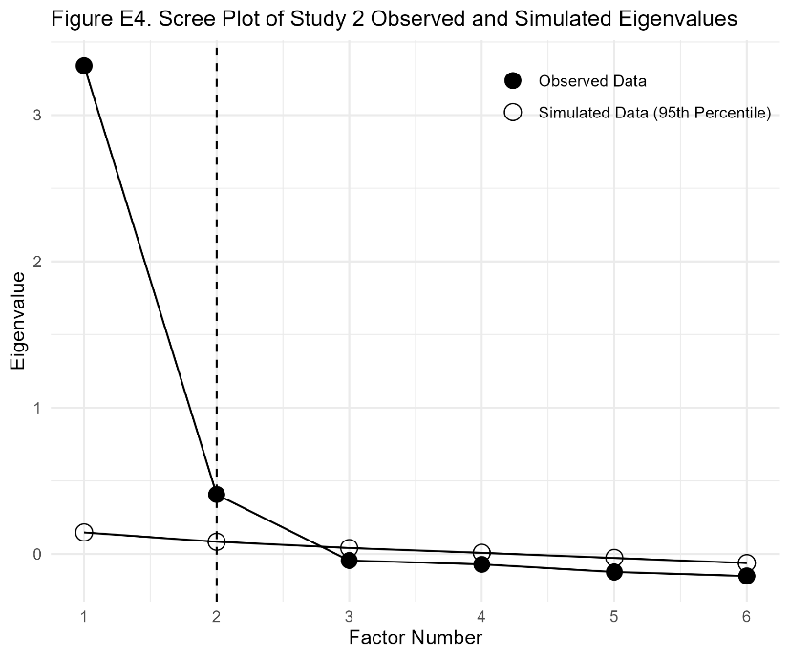

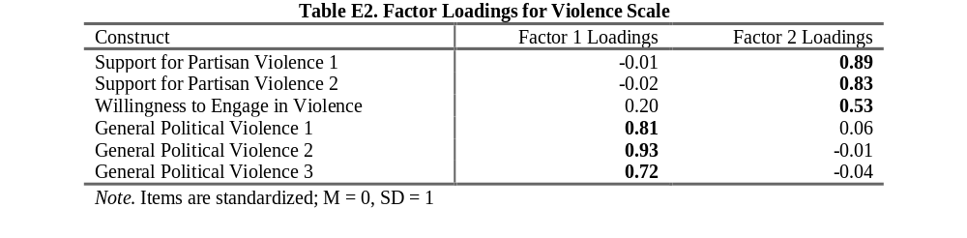

Appendix F. Test for Local Support and Predictor Variation at ±1 SD
To examine local support for the standardized scales (see Hainmueller et al., 2019), variation was examined at the -1 SD and +1 SD of the moderator (see Figures F1-F4). For every study and for each moderator, the predictor (need for uniqueness) was plotted against the moderators (need to belong and partisan identity strength) with reference lines at +1 SD and -1 SD (see Figures F1-F4 below). The number of observations around +1 SD and -1 SD was computed within +0.25 and -0.25 windows around the SD (-1.25 to -0.75 and 0.75 to 1.25) and variation within those bands was computed via a within band SD and the number of distinct values.
With need to belong as the moderator, for study 1, there were 152 respondents near -1 SD (8.49% of respondents; within band SD of 1.04; 89 unique values) and 233 respondents near +1 SD (13.0% of respondents; within band SD of 1.15; 108 unique values). For need to belong in study 2, there were 122 respondents near -1 SD (10.7% of respondents; within band SD of 1.06; 75 unique values) and 123 respondents near +1 SD (10.7% of respondents; within band SD of 1.04; 73 unique values). With partisan identity strength set as the moderator, and for study 1, there were 209 respondents near -1 SD (10.08%; within band SD of 0.87; 97 unique values) and 226 respondents near +1 SD (11.7%; within band SD of 0.98; 116 unique values). Lastly, for partisan identity strength in study 2, there were 129 respondents near -1 SD (11.1%; within band SD of 0.89; 80 unique values) and 95 respondents near +1 SD (8.2%; within band SD of 0.92; 74 unique values).
Because there are sufficient observations near the moderator’s −1 SD and +1 SD and the predictor exhibits clear within-band variation (±0.25 SD windows), the data provide adequate local support to estimate and interpret the OLS interaction at −1 SD and +1 SD of the moderator.
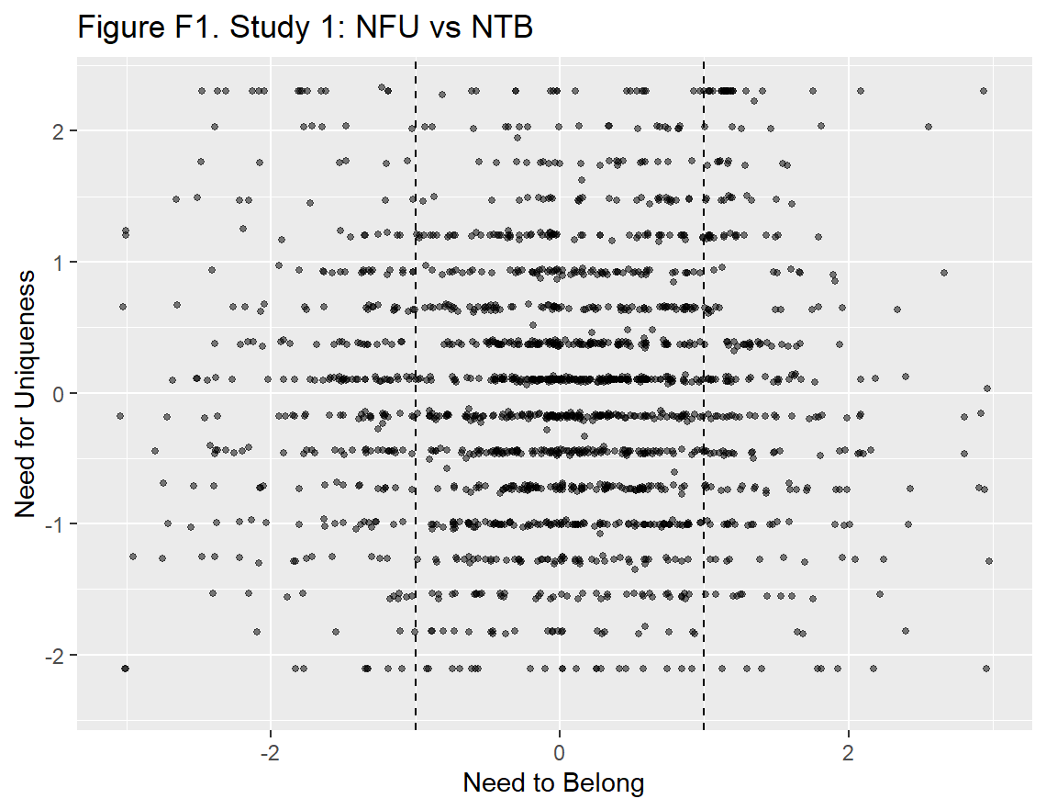
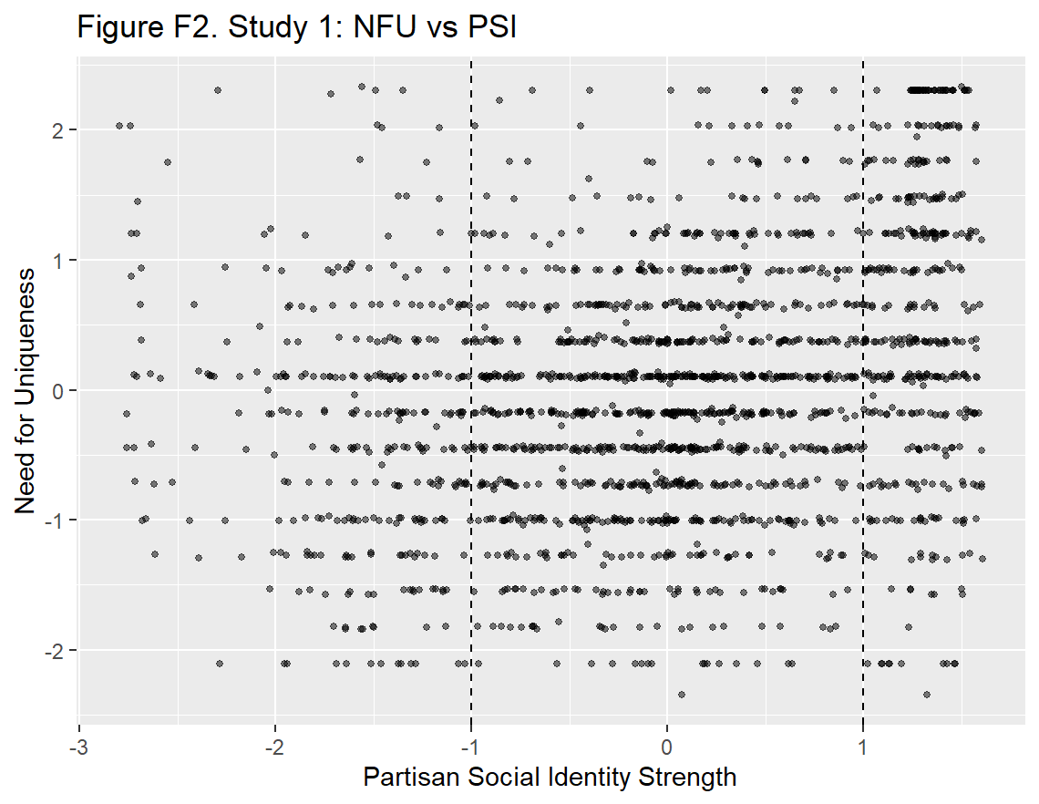
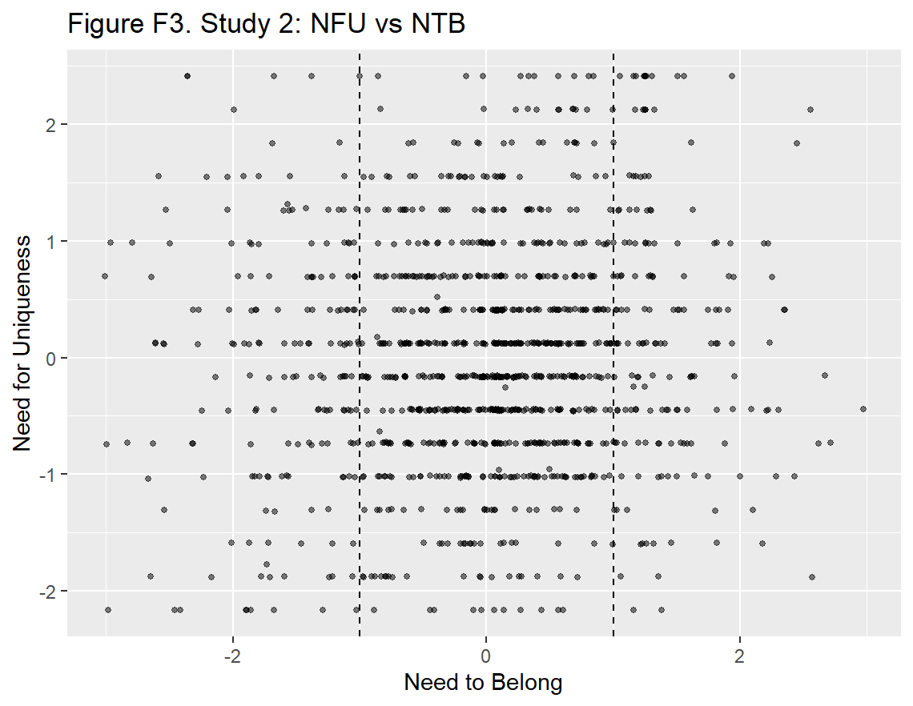
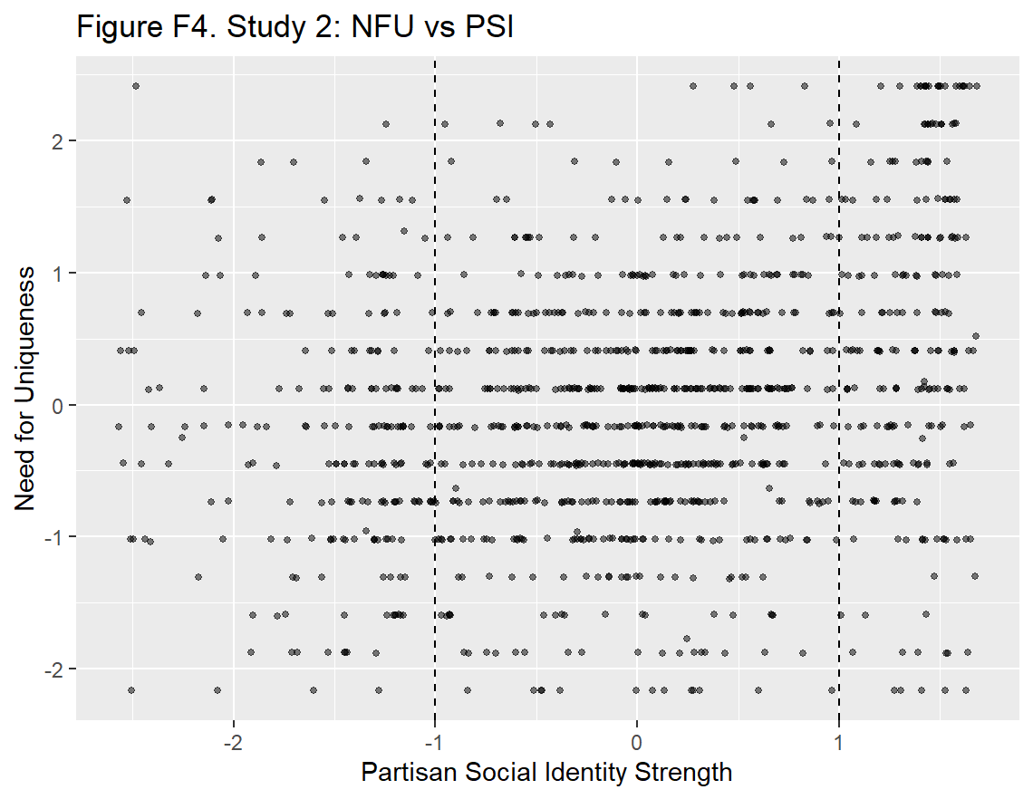

Appendix G. Joint Counts for High Need for Uniqueness and Need to Belong
Tables G1 through G4 show the joint counts for the number of respondents who scored high on both the need for uniqueness and the need to belong using quartiles and the number of respondents at +1 SD and above for both and at -1 SD and below for both. In each table the observed count, expected count (the independence baseline), observed/expected, and 95% CIs for the observed percentages are all reported. An observed/expected > 1 indicates that the co-occurrence of both needs is more frequent than expected under independence, which is suggestive of there being a sufficient number of observations at the extreme of both the predictor and moderator for the analyses in the main paper.
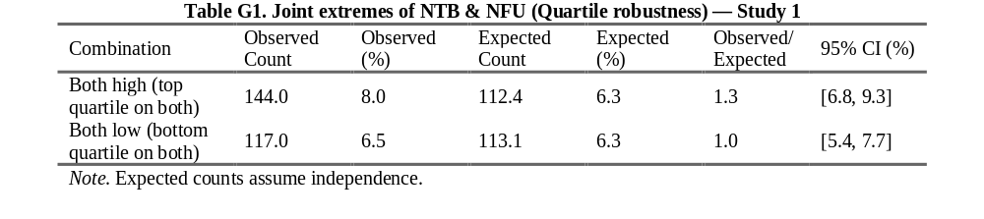
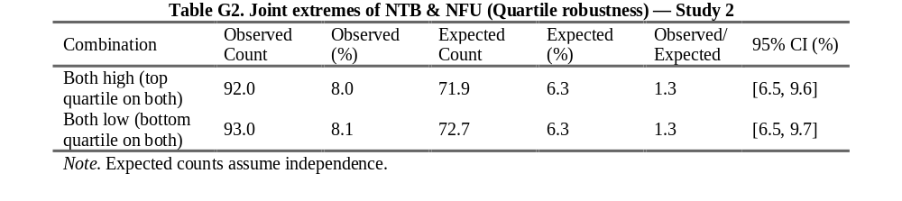
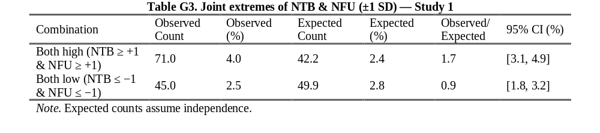
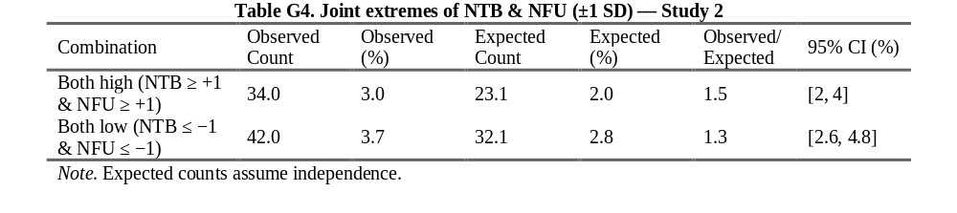

Appendix H. Test for a Non-linear Interaction
To test if the interactions reported are non-linear, OLS analyses were conducted with a quadratic term, shown in Tables H1 and H2. As the tables show, there is no significant quadratic term for any of the models, with the exception of the interaction of need for uniqueness and partisan identity strength predicting the combined partisan violence in study 2 only (p < .05).

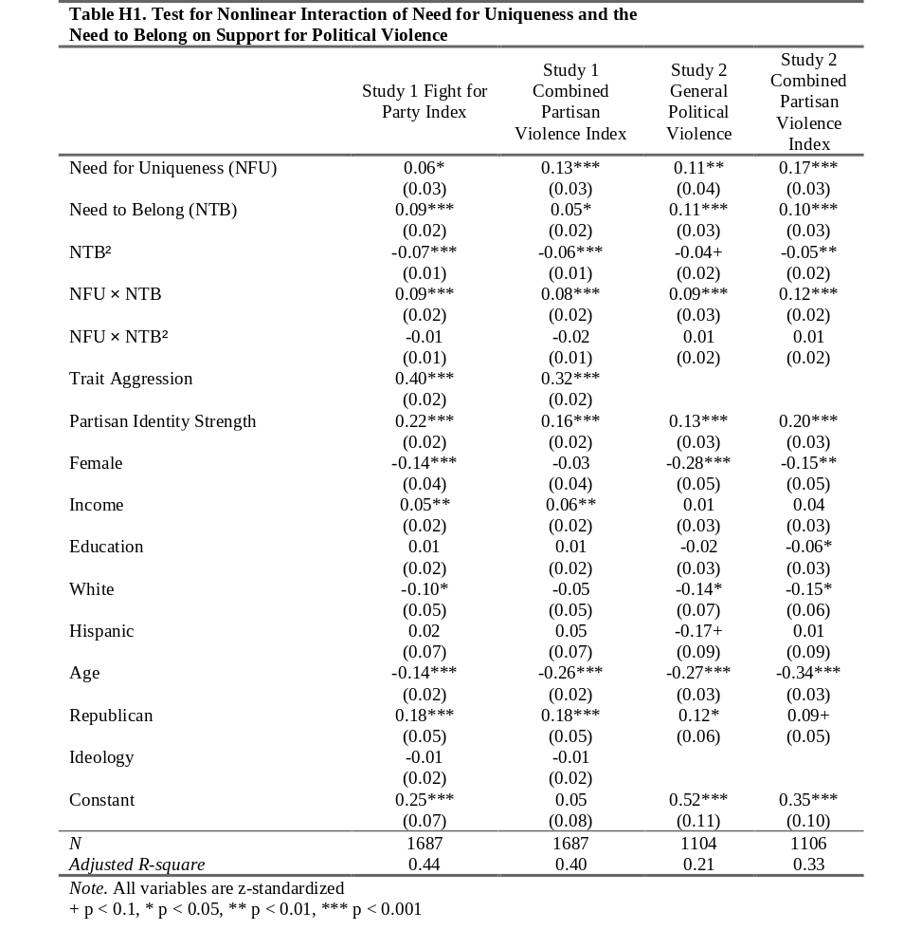

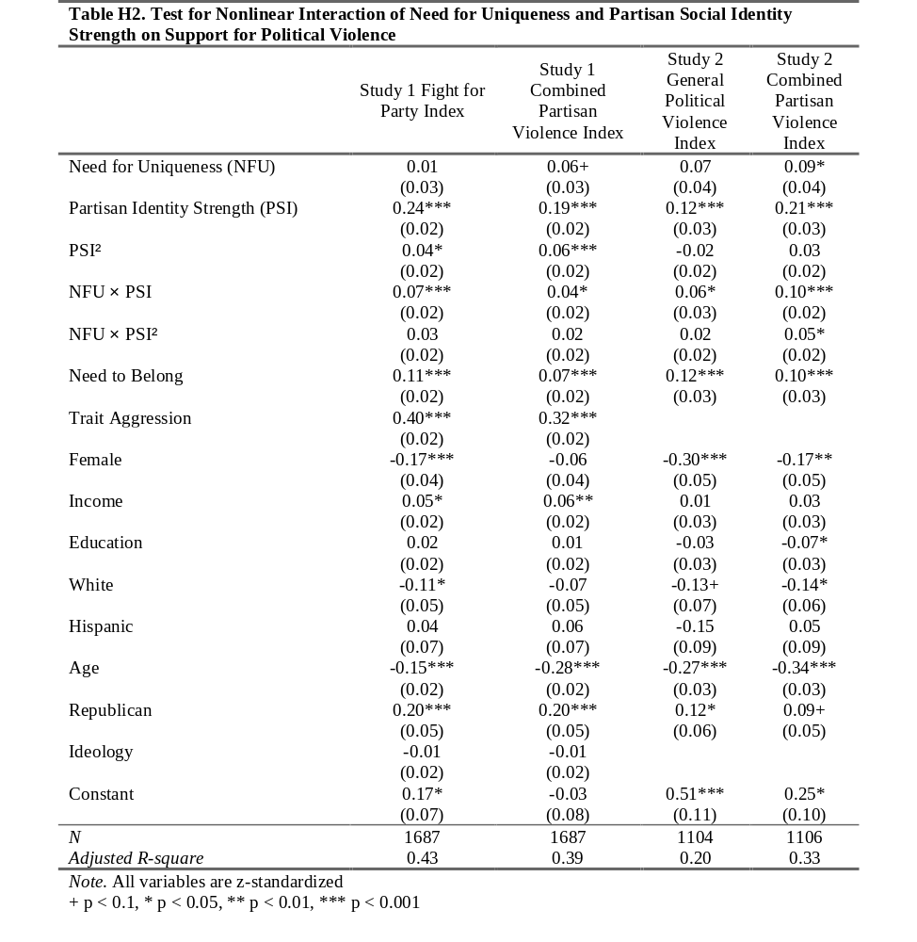

Appendix I. Both Interactions Regressed on Support for Political Violence
To examine the distinctiveness between need to belong and partisan identity strength, both variables were interacted with need for uniqueness in Table I1 below. As the table shows, the interaction of need for uniqueness and need to belong is significant across all models (ps < .01), however, the interaction of partisan identity strength is only significant for the fight for party index in the first study (p < .01) and the combined partisan index in the second study (p < .001). This suggests that both the need to belong and partisan identity strength are related but still distinct, and the need to belong is the better fit for the hypotheses tested in the main paper.
