Online Appendix
Political Behavior

Perspective-Taking and Partisan Depolarization in the U.S. and Turkey

Online Appendix A
Survey details: Study1, The U.S. Case
Sample Construction:
The survey was fielded on 11 March 2023. Respondents who completed the survey received $0.60. The survey took 5.29 (SD=8.03) minutes to complete on average.
461 started, but 423 cases completed 100% of the survey. Among those who finished the survey, Independents (n=87, 20.57%) were asked if they lean towards the Republican or Democratic Party. Pure Independents, i.e., those who did not lean towards any of the parties (n=29, 6.86%), were dropped. Those who identified with another party (n=8, 1.89%) were also dropped. This resulted in a sample size of 386.
Eligible participants continued the survey, while non-eligibles were bonused with $0.10 and thanked for their participation. Eligibility criteria are determined based on the quota for each party and whether the respondent leans towards one of the parties. Pure independents and out-of-quota respondents were not eligible to continue with the survey.
Measures:
Demographic Measures: Participants answered several demographic questions, including their gender, education level, income level, religious identification, birth year, and the state that they currently live in.
Gender: Participants indicated their gender by selecting four alternatives (Male, Female, Non-binary / third gender, Prefer not to say). The variable was recoded so that “0” referred to male, and “1" referred to female.
Education level: Respondents were asked about the highest education level they had completed. The choices ranged from “No grades” (1) to “Doctorate” (14). The education variable was recorded to have 5 categories: 1"some school," 2 "high school," 3 "some college, no degree," 4"Bachelor's degree," 5 "Graduate degree."
Income level: Respondents indicated the total income of their family in 2022 from “less than $10.000” (1) to “more than $150.000” (12).
Religious identification: Respondents rated how often they attend religious services on a 6-point Likert-type scale from “more than once a week” (1) to “never” (6). Then, this item was recoded so that higher scores indicated a higher level of religious attendance.
Age: Participants’ age was calculated based on their answers to the question asking their birth year.
Party Identification: Participants indicated whether they consider themselves Democrat, Republican, Independent or some other party. If independent, they have answered an additional question asking if they feel closer to the Democratic Party, the Republican Party, or neither of them. The survey ended for the pure independents.
Party Identification Strength: Participants who indicated that they consider themselves either Republican or Democrat also rated the strength of their identification (e.g., Would you call yourself a strong Democrat or not very strong?).
Party Identification Strength Summary: The party identification strength summary measure was calculated based on the answers given to the party identification question(s) and party identification strength, following the ANES coding manual. Since we dropped pure Independents, the scale did not include that category. Accordingly, the scale ranged from 0 (strong Democrat) to 5 (strong Republican).
Affective Support of Casey: Affect towards Casey was measured by questions tapping into feelings of care (“How much do you CARE about Casey?”), feeling sorry (“While reading the passage, how SORRY did you feel for Casey?”), and sympathy (“While reading the passage, how much SYMPATHY did you feel for Casey?”). Sympathy and care were rated on a 5-point Likert-type scale’ sorry was rated on a 4-point response scale. In addition, respondents feelings toward Casey were measured on a thermometer scale that ranges from 0 (coldest) to 10 (warmest).
Cognitive and Behavioral Support for Casey: Cognitive aspects of empathy for Casey were measures by a question on understanding (“How well do you understand why Casey identifies with the Republican Party?”) and argument strength (“In your view, how weak or strong is Casey's reason for supporting the Democratic Party?”). Respondents were also asked about their interest in future contact with Casey (“How interested are you in meeting and talking with Casey if the opportunity arose?”). Future contact interest was rated on a 5-point Likert-type scale, whereas argument strength and understanding were rated at a 4-point Likert-type scale.
Attitudes Towards Out-party Supporters:
Respondents rated outpartisans (i.e., Democrats, Republicans) on a feeling thermometer scale which served as the main measure of outpartisan warmth. In addition, respondents rated their feelings of sympathy, care, understanding, and future contact interest with outpartisans, modifying the measures used to assess attitudes towards Casey. The wording for interest in future contact with an outpartisan differed from the question asked about Casey (“If you were at a social event and discovered that you were talking to a Democrat, how likely are you to end the conversation and move on?”). Responses were rated on a 4-point Likert type scale from 1 (not at all likely) to 4 (extremely likely).

Table A1. Frequency Statistics for Categorical Variables
Variable Name | Category | n | %
Gender | Female | 209 | 54.6
 | Male | 174 | 45.4
Education* | Some School | 7 | 1.8
 | High School | 33 | 8.6
 | Some College, no degree | 88 | 22.8
 | Bachelor’s degree | 170 | 44.0
 | Graduate degree | 88 | 2.8
Party | Democrats | 200 | 51.8
 | Republicans | 186 | 48.2
Party ID Strength*ª | Leaners | 58 | 15
 | Not so strong | 146 | 37.8
 | Strong Identifier | 182 | 47.2
Income Levels* | <$29.999 | 63 | 16.3
 | $30,000-$59.999 | 130 | 33.7
 | $60,000-$89.999 | 86 | 22.3
 | >$90,000 | 107 | 27.7
Religious Service Attendance* | Rarely | 261 | 67.6
 | Sometimes | 53 | 13.7
 | Frequently | 72 | 18.7
Condition | Treatment | 293 | 75.9
 | Control | 93 | 24.1

*Variables were coded as numeric and scaled to 0-1 before the regression analyses
ªPID Strength=Party Identification Strength
Table A2. Descriptive Statistics for Continuous Variables
 | N | Min | Max | Mean | SD
Age | 386 | 0.00 | 1.00 | 0.34 | 0.21
Education | 386 | 0.00 | 1.00 | 0.66 | 0.15
Religious Service Attendance | 386 | 0.00 | 1.00 | 0.27 | 0.32
PID Strengthª | 386 | 0.00 | 1.00 | 0.66 | 0.36
Income | 386 | 0.00 | 1.00 | 0.53 | 0.29
Feeling sorry for the target | 386 | 0.00 | 1.00 | 0.54 | 0.33
Feeling sympathy for the target | 386 | 0.00 | 1.00 | 0.41 | 0.31
Warmth felt for the target | 386 | 0.00 | 1.00 | 0.53 | 0.26
Care for target | 386 | 0.00 | 1.00 | 0.40 | 0.29
Opinion strength of the target | 386 | 0.00 | 1.00 | 0.40 | 0.32
Contact interest with the target | 386 | 0.00 | 1.00 | 0.30 | 0.31
Understanding the target | 386 | 0.00 | 1.00 | 0.65 | 0.30
Warmth Felt for In-party | 386 | 0.00 | 1.00 | 0.67 | 0.22
Warmth: Out-party Supporters | 386 | 0.00 | 1.00 | 0.35 | 0.27
Care: Out-party Supporters | 386 | 0.00 | 1.00 | 0.31 | 0.26
Understanding: Out-party Supporters | 386 | 0.00 | 1.00 | 0.56 | 0.29
Contact interest: Out-party Supporters | 386 | 0.00 | 1.00 | 0.72 | 0.32
AP^{b}: in-party affect - out-party affect | 386 | 0.00 | 1.00 | 0.66 | 0.16
Valid N (listwise) | 386
ªPID Strength=Party Identification Strength, ^{b}AP= Affective Polarization

Online Appendix B
Experimental Perspective Getting Vignettes: Study1, The United States
Casey is a Democrat
Version 1: Domestic Violence
To answer the question, “Why am I a Democrat?” I go back to terrible times when I experienced constant domestic violence.
In 1992, my husband injured me with a knife during an argument. For 13 years, my son and I were abused by him. We finally escaped, but he tracked us down. Back then, there was limited help available. Local shelters were full. I did not even know the name of what was happening to me then. Domestic violence. Now, working to end domestic violence is my life's work. When I started to look for information about domestic violence, I was shocked to find out how many people, including children, experience physical or sexual abuse. And I committed myself to the movement to end this violence.
In my small hometown, I did not feel like I could speak out about my experience with sexual assault. But when I went back to university as an older student, I met an incredible group of people working to end the culture of sexual assault. I went from survivor to advocate.
The Democratic Party works to eliminate domestic violence by initiating legislation such as the Violence Against Women Act. We need Congress to reauthorize and enhance that law. That’s why I support the Democratic Party.
Version 2: Health Care
To answer the question, “Why am I a Democrat?” I go back to terrible times when I was diagnosed with cancer.
I came from rural Missouri. My family and I put off going to the doctor because we did not have health insurance. I finally went to the doctor, who looked at my throat and said, you have cancer. Stage four. The worst kind of cancer you can have. My wife applied for Obamacare, and my coverage began on April 1, 2012. I started chemotherapy and radiation that same day, and it saved my life. And I know that I was not the only one who could not have afforded the expense of medical treatment for a serious illness without Obamacare. We definitely need an inclusive healthcare system so that people can afford the cost of medical treatment.
The Democratic Party has been fighting to fix our broken health-care system for years by trying to lower the cost of healthcare and cut down on the rate of uninsured Americans. That’s why I support the Democratic Party.
Version 3: Climate Change
To answer the question, “Why am I a Democrat?” I go back to the time when the disastrous Camp Fire broke out in Northern California and worsened my asthma.
I was 13 years old when the Camp Fire, the most destructive fire in history, occurred. My asthma flared up badly. I could hardly breathe. After that bad experience, I decided to work against climate change. I have been organizing young people to take action on climate change since 2018. Climate change is affecting us now and robbing my generation of the future. For people my age, every aspect of our lives, from where we go to school, the kind of careers we pursue to whether we can raise a family, depends on us taking climate change seriously right now.
The Democratic Party will not solve this crisis in four years. No one can, but the party will put us back on track so my generation has a fighting chance. I do not want to let our future go up in flames. That’s why I support the Democratic Party.
Version 4: Control:
The answer to “Why are you a Democrat?” is easy: because I care about every man, woman, and child. I want them to have affordable health care and housing. I want the poor and suffering seeking a better life for their families to be treated humanely. I want everyone to be free from gun violence and discrimination. I want our children and grandchildren to be able to enjoy real democracy and have a fighting chance as the earth gets hotter and hotter.
Casey is a Republican
Version 1: Undocumented Immigrant
To answer the question, “why I am a Republican,” I go back to the time when my son was attacked by an unlawful immigrant ten years ago.
I used to live in California with my son, Dominic. In June 2012, we watched a baseball game on TV at home, and he left to meet with his close friends. After two and half hours or so, I got a call from a hospital. Dominic had a traffic accident, so he was in the emergency room. When I get there, I learned that he was terribly injured, and his leg was broken when his motorcycle was hit by an undocumented immigrant. He had to stay in the hospital for weeks. During that time, I was so stressed and hoping my son had no permanent damage and got well. This was horrible.
I talked to the police, and I learned that the undocumented immigrant who hit the motorcycle reportedly had a history of DUI arrests. And I know that this is not the only destructive incidence caused by illegal immigrants in this country. I believe that we need an administration that cares more about legal citizens than about illegals, putting all our children’s lives at risk.
Republican party works for border security and deportations of immigrants who are in the country illegally. That’s why I support the Republican Party.
Version 2: Religious Faith
To answer the question, “why are you a Republican?,” I go back to the times when I regained my life thanks to my religious faith.I grew up in the Evangelical Church, but in middle school lost my faith in God. From eighth grade through my first two years of high school, I was an atheist. During my period of atheism, I hit rock bottom. I was contemplating suicide. It was bad. I almost got expelled because I bullied kids. I caused them physical harm. I hated everybody. I hated the world. What got me out of that dark place was my mom convincing me to go to a church retreat with my sisters. My mom had to force me to go but once I got there I spoke to God, and I asked for help. After some time, I felt peaceful being there. I trusted in God again and my life got better. A big part of my political identity comes from my religious identity what I consider a “morality standpoint”. There are a lot of troubled young people out there and they need to believe in something bigger than themselves.
I believe the Republican Party respects Christians and understands the comfort that religion provides to young people who have lost their way. That’s why I am a Republican.
Version 3: Gun Policy
To answer the question, “why I am a Republican,” I go back to the time when I was attacked by a group of strangers in the street.
I live in Texas. Ten years ago, after hanging out with some friends at the beach, I walked to my car at 2 a.m. at night. There was no one in the street when I finally found my car. Suddenly, a group of men appeared and approached me. They threatened me. There were no police officers around to protect me. I was scared and attempted to get into my car and flee, but the group prevented me from doing so. The last thing I remember is that one of the men brought out a big knife pulling towards me. When I woke up, I was in a hospital with my brother. I was hospitalized for weeks and finally returned back to my normal life. However, the trauma of this horrible event is still with me.
On that night, if I had a gun for self-defense, I would never have experienced such a terrible incident. And I know that I was the lucky one. Every day in this country, many people lose their lives because of violent attacks from strangers. Republican party works best for protecting people’s right to self-defense. Therefore, I support the Republican party.
Version 4: Control
The answer to “Why are you a Republican?” is easy: because I care about every man, woman, and child. I believe everyone has a right to live given by God. I want to maximize the role of people and minimize the role of government. I want lower taxes, less bureaucracy, stronger national security, greater enforcement of criminal law, vigilance against terrorism, and free market competition in health care and other compassionate programs.

Online Appendix C
Results details: Study 1, The Case of U.S

Out-party Ratings by Vignette
Mean differences in out-group attitudes for each of the three treatment vignettes and the control condition in Figure C1 and C2. There were no significant differences in the effect of the policy focus in the out-partisan vignettes. Therefore, they are combined into one treatment condition in the analyses.
As seen in C1 figure, Republican feelings of warmth towards Democrats increased after the PG intervention and this was true for all three treatment vignettes. As seen in C2, the treatment had little or no effect on feelings of sympathy or concern for Democrats regardless of vignette. The treatment also had no effect on cognitive aspects of empathy such as understanding outpartisans or desiring greater contact with them regardless of the specific vignette. or desiring greater contact with them regardless of the specific vignette.
Fig. C1 Mean Out-Partisan Ratings by Story: Republicans’ Ratings of Democrats
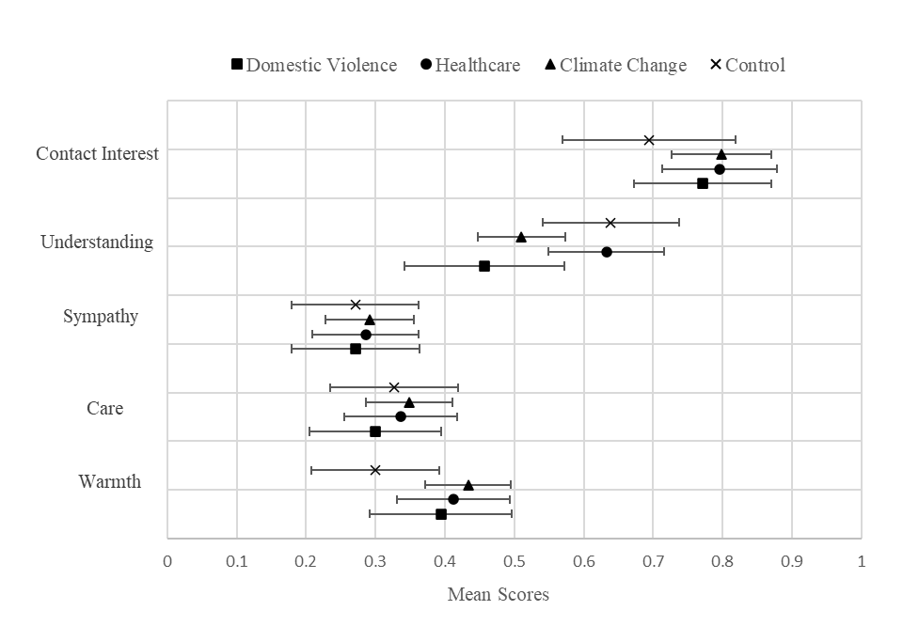
Entries in the graph are mean scores and 95% Confidence Intervals.

Fig. C2 Mean Out-Partisan Ratings by Story: Democrats’ Ratings of Republicans
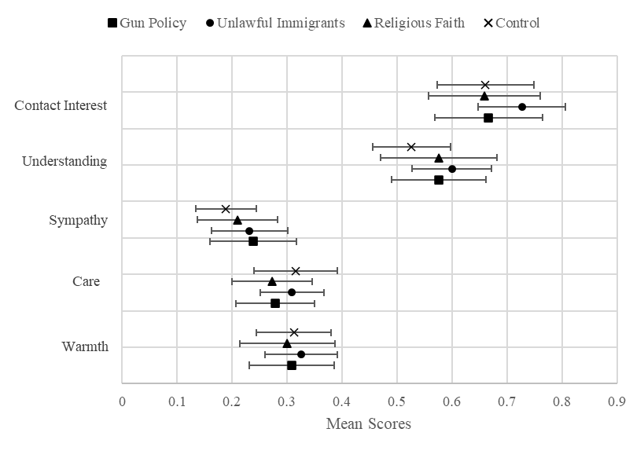
Entries in the graph are mean scores and 95% Confidence Intervals.
.
Table C1. Regression Analyses Predicting Out-party Attitudes by Treatment and Controls
 | Outparty Individual Warmth |  |  |  |  | Outpartisan Group Warmth
 | (1) | (2) | (3) | (4) | (5) | (6) | (7) | (8) | (9) | (10)
Constant | 0.41*** | 0.38*** | 0.40*** | 0.25** | 0.28*** | 0.31*** | 0.28*** | 0.31*** | 0.25** | 0.29***
 | (0.03) | (0.03) | (0.03) | (0.07) | (0.07) | (0.03) | (0.03) | (0.03) | (0.07) | (0.07)
Treatmentª | 0.16*** | 0.15*** | 0.12** | 0.16*** | 0.12** | 0.06* | 0.05 | 0.00 | 0.07** | 0.01
 | (0.03) | (0.03) | (0.04) | (0.03) | (0.04) | (0.03) | (0.03) | (0.04) | (0.03) | (0.04)
Party dummy^{b} |  | 0.08** | 0.03 | 0.06** | -0.01 |  | 0.08** | -0.01 | 0.06** | -0.04
 |  | (0.03) | (0.06) | (0.03) | (0.06) |  | (0.03) | (0.06) | (0.03) | (0.06)
Party*Treatment |  |  | 0.07 |  | 0.08 |  |  | 0.12* |  | 0.13**
 |  |  | (0.07) |  | (0.07) |  |  | (0.06) |  | (0.07)
PID Strength^{c} |  |  |  | -0.01 | -0.01 |  |  |  | -0.04 | -0.04
 |  |  |  | (0.04) | (0.04) |  |  |  | (0.04) | (0.04)
Gender^{d} |  |  |  | 0.03 | 0.03 |  |  |  | 0.05* | 0.04
 |  |  |  | (0.03) | (0.03) |  |  |  | (0.03) | (0.03)
Education |  |  |  | 0.07 | 0.07 |  |  |  | 0.05 | 0.05
 |  |  |  | (0.09) | (0.09) |  |  |  | (0.09) | (0.09)
Religiosity |  |  |  | 0.16*** | 0.16*** |  |  |  | 0.24*** | 0.24***
 |  |  |  | (0.04) | (0.04) |  |  |  | (0.05) | (0.05)
Income |  |  |  | 0.02 | 0.02 |  |  |  | -0.06 | -0.06
 |  |  |  | (0.05) | (0.05) |  |  |  | (0.05) | (0.05)
Age |  |  |  | 0.09 | 0.09 |  |  |  | -0.10 | -0.10
 |  |  |  | (0.06) | (0.06) |  |  |  | (0.06) | (0.06)
R² | 0.07 | 0.09 | 0.09 | 0.13 | 0.13 | 0.01 | 0.03 | 0.04 | 0.13 | 0.12
N | 386 | 386 | 386 | 383 | 383 | 386 | 386 | 386 | 383 | 383
Table shows unstandardized regression coefficients with robust standard errors in parentheses. All measures were standardized to range from 0-1. p<.10* p<.05** p<.001*** ªTreatment (Perspective Getting =1), ^{b}Party dummy (Republican=1), ^{c}Party Identification Strength (PID Strength), ^{d}Gender (Female=1).

Fig. C3 Rating Outparty Individual (All Measures)
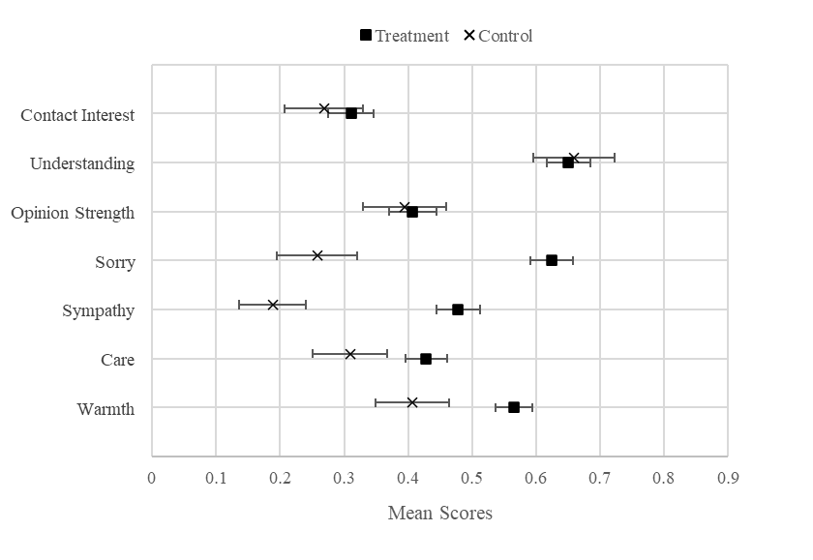
Entries in the graph are mean scores and 95% Confidence Intervals.
Fig. C4 Rating Outparty (All Measures)
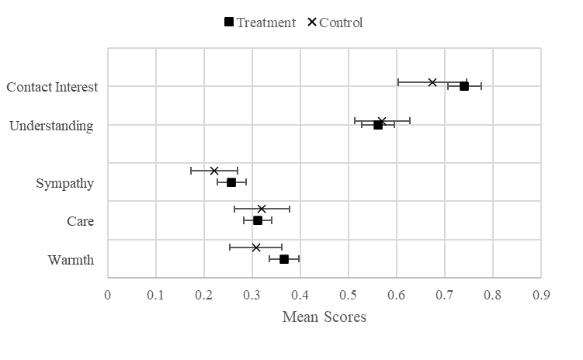
Entries in the graph are mean scores and 95% Confidence Intervals.

Fig. C5 Out-party Warmth Ratings by Party Identification
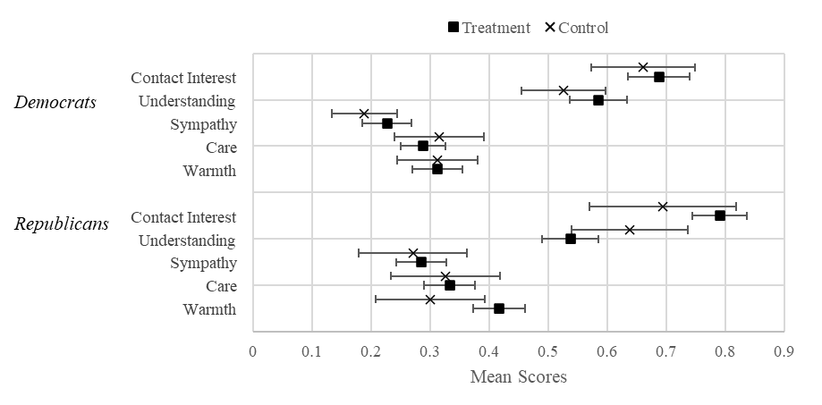
Entries in the graph are mean scores and 95% Confidence Intervals for out-party ratings separately shown by Democrat and Republican respondents.

Online Appendix D
Survey details, Study 2: The Turkish Case
Sample Construction
Data was collected between the 1st of January 2024 and the 11th of April 2024. The study was introduced as related to social and political attitudes in Turkey and respondents were not given any incentive to participate in the survey. The survey took 20.64 minutes to complete on average (SD=58.26).
Table D1 shows the percentage of the participants recruited from each social media platform using Facebook Ads, TikTok Ads, and purposive sampling.
The main source for the data collection was Facebook Ads. First, we created a Facebook page to publish the campaign with the name “Türkiye’de Sosyal ve Siyasi Tutumlar Araştırması” (Research on Social and Political Attitudes in Turkey). In ads, we used pictures or short videos based on these pictures, asking for opinions on short videos to attract potential participants. The ads included the Qualtrics link through the survey and were distributed to the campaign on Facebook and Instagram through Feeds, Stories, Marketplace, and Reels between the 1st of January and the 27th of February. The campaign cost 7504.98 Turkish Lira in total.
On the 22nd of January, TikTok Ads (22nd of January- 3rd of March 2024, 1500 Turkish Lira) and Snowball/Purposive sampling was used to increase the sample size. Due to the low level of interest in the survey link, we removed our ad from TikTok after about a month. We collaborated with members of the AKP and MHP headquarters in Istanbul, who helped distribute the survey link to relevant WhatsApp groups consisting of those working in the headquarters, and we also shared the link within networks of known People’s Alliance supporters.
Among 944 participants who completed 100% of the survey, 218 (23.09%) participants who did not have a party identification or lean towards any party were excluded. An additional 12 (1.27%) participants who provided non-classifiable open-ended answers were dropped. Among the remaining 714 participants, those without a least-liked party preference (n=19, 2.66%) or who selected a least-liked party beyond the five biggest parties (n=80, 11.20%) were removed. Finally, 10 (1.4%) participants whose least-liked and most-liked party preferences were the same were deleted. This resulted in 605 cases.
No substantial difference was found between those excluded and the retained effective sample regarding their party attachment. The popular parties and their respective percentages were roughly the same across the two groups. For the effective sample, the ranking of the parties was like the following: CHP (39.8%), TIP (15.7%), AKP (14.6%), DEM Party (7.4%), ZP (6.3 %), IYI Party (2.6 %), YRP (1.7%), MHP (5.3%). For the excluded, the ranking was found as follows: CHP (27.3%), TIP (23.2 %), AKP (10.1%), DEM Party (11.1 %), IYI Party (4%), YRP (4%), MHP (2%) and ZP (2%).
Recruitment Platform
We compared demographic characteristics of the sample recruited through Facebook and WhatsApp. The education levels and gender distributions are similar in that most of the sample have an undergraduate degree (Facebook=49.6%, WhatsApp=50.3%) and nearly half are female (Facebook=46%, WhatsApp=44%). As expected, the WhatsApp sample is dominated by People’s Alliance (46.2%) and is more religious (M=0.62; SD=0.40) than the Facebook sample (M=0.34; SD=0.39) which is mostly composed of the Nation Alliance supporters (53.3%). The Facebook sample is older (M=60; SD=12.21) than the WhatsApp sample (M=41.14; SD=11.87), but age does not predict out-party attitudes as shown in the regression tables (Table F1 – Table F3.)
We also checked the robustness of the results across social media platforms, comparing respondents obtained from Facebook and WhatsApp (only 3 were obtained on TikTok). The treatment significantly increased positive ratings of the outpartisan target among Facebook respondents (M_{t}=0.44, SD_{t}=0.27 vs. M_{c}=0.34, SD_{c}=.26; t(405) = -3.69, p <.001) and WhatsApp (M_{t}=0.48, SD_{t}=0.28 vs. M_{c}=0.30, SD_{c}=0.27; t(193) = -4.61, p <.001). The effect of the treatment on outpartisan ratings are consistent regardless of recruitment platform.
The treatment also significantly increased positive ratings of the outparty for respondents obtained from Facebook (M_{t}=0.24, SD_{t}=0.24 vs. M_{c}=0.20, SD_{c}=0.21; t(405) = -2.03, p <.05). Treatment effects were slightly smaller and non-significant but in the positive direction for the much smaller sample obtained from WhatsApp (M_{t}=0.21, SD_{t}=0.21 vs. M_{c}=0.19, SD_{c}=0.22; t(193) = -0.61).
The treatment boosted positive ratings of outaliance significantly among respondents recruited from WhatsApp (M_{t}=0.37, SD_{t}=0.22 vs. M_{c}=0.30, SD_{c}=0.23; t(193) = -2.17, p <.05) but not among those recruited on Facebook (M_{t}=0.35, SD_{t}=0.20 vs. M_{c}=0.33, SD_{c}=0.19; t(405) = -0.79).
Table D1 Data Sources and Recruitment Platforms
Source | Platform | n | %
Facebook & Instagram | Facebook Ads | 407 | 67.3
TikTok | TikTok Ads | 3 | 0.50
Purposive | WhatsApp | 195 | 32.2

Measures
Measures:
We adapted the US vignettes to the Turkish context. Similar questions are used to measure attitudes towards the individual outpartisan and outpartisans as a group. We assesed feeling sorry towards target outparty indıvidual (“Hikayeyi okurken Ahmet/Fatma için ne kadar üzgün hissettiniz?) and opinion strength of target outparty indıvidual (e.g., “Size göre, Ahmet’in CHP’li olmakta ne kadar zayıf ya da güçlü bir sebebi var?. All other dimensions targeted both outparty individual and outpartisan group. This include caring (e.g., “CHP’lileri ne kadar önemsiyorsunuz?”), warmth (e.g., “Lütfen, CHP’lilere karşı ne derece sıcaklık hissettiğinizi aşağıdaki duygu termometresini kullanarak belirtiniz.”), contact interest (e.g., “Eğer bir imkan olsaydı, Ahmet ile görüşüp konuşmayı ne kadar isterdiniz?”, “Bir sosyal etkinlik sırasında CHP'li biriyle sohbet ettiğinizi farketseniz, ne olasılıkla bu sohbeti sonlandırırdınız?”), and understanding (e.g., “Bazı insanların neden CHP'li olduğunu ne kadar iyi anlıyorsunuz?”). Additionally, we asked if respondents thought the outpartisan target’s statement was realistic (e.g., “Ahmet'in anlattıklarını ne kadar gerçekçi buldunuz?”). Responses to all items were measured on 4-point Likert-type scales, where 1 represents not adopting the corresponding attribute at all, while 4 shows adopting the attitude most strongly.We measured warmth towards the outpartisan, in-party, and the five most popular parties using a Turkish adaptation of the feeling thermometer scale (Haddock et al., 1993). Parties included the Justice and Development Party (AKP), the National Movement Party (MHP), the Republican People’s Party (CHP), the Good Party (IYIP), and the Peoples' Equality and Democracy Party (DEM Party).
Accordingly, on a feeling thermometer scale that ranges from 0 (coldest) to 100 (warmest), respondents rated the level of warmth they felt towards the target individual/partisan group (“Please indicate to what extent you feel warmth towards [OUT-PARTISAN] on a feeling thermometer scale below. In this thermometer, 0 indicates the COLDEST, and 100 indicates the WARMEST feelings. 50 indicates NEUTRAL feelings. Please indicate your feelings using this rating scale.”).
Social Distance: Participants rated how they would feel about one of their family members marrying someone who supports the least-liked party by answering the following question “How would you feel if someone in your family, e.g., siblings, children, married someone supporting [LEAST-LIKED PARTY NAME]?” (e.g. “Çekirdek ailenizden (ör., kardeşler, çocuklar) biri CHP'li biriyle evleneceğini söylese nasıl hissederdiniz?”) at a four-point scale from 1 (very unhappy) to 4 (does not matter to me).
Warmth Towards the “Out-Alliance” Supporters: A composite score was calculated by averaging participants’ feeling thermometer ratings for the main political parties (AKP, CHP, MHP, İYİ Party, and DEM Party) excluding the participant’s in-party, any parties allied with the in-party, and the least-liked party. This composite score thus captures warmth toward parties that fall outside the respondent’s in-party alliance (i.e., out-alliance parties).
Although Turkish electoral alliances include additional parties (see Table 1), we restricted out-alliance warmth measure to be constructed based on the ratings for 5 main parties listed above (see Table D2 and FN 15). For example, for an AKP supporter, the out-alliance score consists of ratings for the Nation Alliance parties (CHP and IYI Party; parties in the opposing Nation Alliance) and DEM Party, excluding their least-liked party. For a DEM Party supporter, all of whom chose one of the two parties in the People’s Alliance, the out-alliance score includes ratings for the other party in the People’s Alliance (AKP or MHP), excluding their least-liked party. Similarly, for a CHP supporter, the out-alliance score comprises ratings for the People’s Alliance (AKP and MHP) and DEM Party.
In-party – Out-party Feelings: The warmth score given to the least-liked party supporters was subtracted from the score given to the in-party supporters to obtain in-party-out-party feelings.
Out-Alliance Polarization: The warmth score given to the out-alliance parties (all parties outside the in-party alliance) was subtracted from the score given to the in-party supporters to obtain out-alliance polarization (see Huddy et al., 2018).
Empathic Concern and Dispositional Perspective-taking: To measure empathic concern and dispositional PT, Engeler and Yargıç’s (2007) Turkish adaptation of the Interpersonal Reactivity Index (IRI) developed (Davis, 1983) was used. Respondents rated to what extent each item describes them at a 5-point Likert-type scale from 1 (does not describe me well) to 5 (describes me very well). 7 item empathic concern dimension measures individuals’ tendency to feel concern or compassion towards others (e.g., “I often have tender, concerned feelings for people less fortunate than me.”). 7-item PT assesses the ability to take the perspective of others with items like “I sometimes try to understand my friends better by imagining how things look from their perspective.” Higher scores indicated higher functionality in respective subscales. Factor analyses were conducted separately for both subscales. Excluding the two items showing a low level of communalities (below .10), the five-item PT subscale has an acceptable reliability score (α=.68). Moreover, all EC items were loaded on a single factor, yielding a reasonable reliability level (α=.59).
Party Identification: Participants indicated the party they felt was the closest among the eleven parties including AKP, CHP, YSP, MHP, IYI Party, YRP (New Welfare Party), TIP (Workers’ Party of Turkey) ZP (Victory Party) with a vote share higher than 1% in the last general elections on the 14th of May, 2023. Besides, we added DEVA (Democracy and Progress Party), GP (Future Party), and SP (Felicity Party) under the main opposition alliance. Participants were also allowed to write to any other party they preferred. Respondents who chose “none of them” answered an additional question asking if they feel closer to any parties from the same list of parties. The survey ended for the pure independents. Open-ended responses were coded and led to the addition of several parties. These include the Grand Unity Party (BBP), Democrat Party (DP), Labor Party (EMEP), the People’s Liberation Party (HKP) (n=1, 0.17%), the Communist Party of Turkey (TKP), the Left Party (SOL), Free Cause Party (HÜDA-PAR), Motherland Party (Memleket), the Nation Party (VP) (n=1, 0.17%), Independent Turkey Party (BTP) and Liberal Democrat Party (LDP).
Alliances: Respondents were grouped under five alliance categories based on their responses to the party identification question. Accordingly, categories included the People’s Alliance led by the incumbent AKP (Justice and Development Party), the Nation Alliance led by the main opposition center-left CHP (Republican People’s Party), a far-left group, pro-Kurdish DEM Party, and other non-allied parties. People’s Alliance is the incumbent alliance, which is constituted of pro-Islamist and nationalist right-wing parties. Far-left parties included parties with far-left orientation and pro-Communist values. DEM Party is a left-wing pro-ethnic party that centers its politics around pro-Kurdish policies. On the other hand, there is no ideological overlap among the Nation Alliance in that the alliance includes parties from center-left orientation to ultra-conservative parties. Nevertheless, in the current study, the center-left CHP supporters dominate the category (n=233, 87.3%). The remaining parties were categorized as the other parties. The distribution of the alliances by in-party was provided at Table 1.
There are two additional alliances that we did not categorize here. The first one is “Labor and Freedom Alliance” led by the DEM Party and the Workers’ Party of Turkey (TIP), along with a few far-left parties. There were intra-alliance conflicts that posed a challenge for the DEM Party (Esen et al., 2023). Further, TIP preferred to compete with its own party symbol and candidates. Therefore, the parties failed to be considered within an alliance (https://www.bbc.com/turkce/articles/cp3j7keykdyo). The second one is the ATA Alliance led by the Victory Party (ZP), which was not included as the sample size is insufficient for further analyses (n=38).

Party Identification Strength: The same question as the U.S. study was used but dummy-coded. To illustrate, participants who indicated themselves as supporting a party and called themselves strong partisans were coded as 1. In contrast, weak partisans and independents who consider themselves closer to a party when asked a second time were coded as 0.
Least-liked Party: Participants were asked to select the party they disliked most from the same list used in the previous questions.
Political Interest: To assess political interest, respondents were asked to what extent they are interested in politics. The answer choices ranged from 1 (very interested) to 4 (not at all interested). The item was reverse-coded so that higher scores represented a higher level of political interest.
Gender: Participants selected one of the four alternatives to indicate their gender (“male,” “female,” “other,” or “Prefer not to answer”). Gender was dummy coded, with females coded as 1 and males coded as zero, since there were no cases selecting the other options.
Descriptives
Table D2 show that almost half of the sample is female. Participants’ ages ranged from 19 to 87 (M=53.82, SD=15.05). Most are university graduates (%73.8, n= 431) and are high-income. Regarding the alliance group that participants most liked party included, most of the participants supported Nation Alliance. It is followed by the incumbent alliance and far-left group. The remaining supports the DEM party and the other parties. Most respondents indicated that they believe in a religion, and among them, the frequency of praying is moderate to high (M=0.43, SD=0.45). Participants are found to be highly interested in politics (M=0.78, SD= 0.23). Almost half of the participants were in the treatment group (%49.1, n=287).

Table D2. Frequency Statistics for Categorical Variables
Variable Name | Category | n | %
Gender | Female | 272 | 45
 | Male | 326 | 53.9
Educationª | Primary School | 28 | 4.6
 | High School | 132 | 21.8
 | Undergraduate Degree | 301 | 49.8
 | Graduate Degree | 144 | 23.8
Belief in a Religion | Beliefs in a religion | 423 | 69.9
 | Does not believe in a religion | 162 | 26.8
Income | <25.000TL^{b} | 202 | 33.4
 | 25.000TL-40.000TL | 151 | 25
 | >40.000TL | 236 | 39
Party ID Strength | Strong Identifier | 384 | 63.5
 | Weak Identifier | 218 | 36
Condition | Treatment | 298 | 49.3
 | Control | 307 | 50.7
Alliance | People’s Alliance | 131 | 21.7
 | Nation Alliance | 276 | 45.6
 | DEM Party | 45 | 7.4
 | Far-left | 105 | 17.4
 | Others | 48 | 7.9
Least-liked Party | AKP^{c}  CHP^{d}  MHP^{e}  IYI P^{f}  DEM Party^{g} | 354  41  59  1  150 | 58.5  6.8  9.8  0.2  24.8
Note. ªIncome and education levels were considered as scale variables and rescaled to 0-1 before the analyses. ^{b}TL=Turkish Lira, ^{c}AKP=Justice and Development Party, ^{d}CHP=Republican People’s Party, ^{e}MHP =Nationalist Action Party, ^{f}IYIP =Good Party, ^{g}DEM Party=Peoples' Equality and Democracy Party

Table D3. Alliance Distribution of Sample by Least-Liked Party Choice
 | Least-Liked Party Preference (%)
Alliance Supported | AKP | CHP | MHP | IYI Party | DEM Party |  | Total
People’s Alliance | 5.3 | 29.1 | 1.5 | 0.8 | 63.4 |  | 100
Nation Alliance | 81.5 | 1.09 | 6.2 | 0.0 | 11.2 |  | 100
DEM Party | 33.3 | 0.0 | 66.7 | 0.0 | 0.0 |  | 100
Far-left | 89.5 | 0.0 | 9.5 | 0.0 | 0.0 |  | 100
Others | 27.1 | 0.0 | 0.00 | 0.0 | 72.9 |  | 100
Table shows the row percentages for each least-liked party preference.

Table D4. Descriptive Statistics of the Study Variables
 | N | Min. | Max. | Mean | SD
Age | 601 | 0 | 1 | 0.51 | 0.22
Education Level | 605 | 0 | 1 | 0.63 | 0.22
Income | 589 | 0 | 1 | 0.80 | 0.23
Religiosity Level: Frequency of Praying | 570 | 0 | 1 | 0.43 | 0.41
Political interest | 605 | 0 | 1 | 0.78 | 0.23
Feeling sorry for the target | 605 | 0 | 1 | 0.41 | 0.33
Warmth felt for the target | 605 | 0 | 1 | 0.39 | 0.28
Care for target | 605 | 0 | 1 | 0.50 | 0.36
Opinion strength of the target | 605 | 0 | 1 | 0.30 | 0.32
Understanding the target | 605 | 0 | 1 | 0.43 | 0.36
Contact interest with the target | 605 | 0 | 1 | 0.52 | 0.40
Perceived level of realism in the story | 605 | 0 | 1 | 0.29 | 0.30
Warmth Felt for In-party | 605 | 0 | 1 | 0.79 | 0.20
Warmth: Least-liked Party Supporters | 605 | 0 | 1 | 0.21 | 0.22
Care: Least-liked Party Supporters | 605 | 0 | 1 | 0.32 | 0.34
Understanding: Least-liked Party Supporters | 605 | 0 | 1 | 0.45 | 0.38
Contact interest: Least-liked Party Supporters | 605 | 0 | 1 | 0.54 | 0.34
Social Distance (R): Least-liked Party Supporters | 605 | 0 | 1 | 0.28 | 0.28
Warmth: Out-alliance Party Supporters | 605 | 0 | 1 | 0.34 | 0.20
In-party – Out-party Feelings (AP1)^{ab} | 605 | 0 | 1 | 0.71 | 0.20
Out-Alliance Polarization (AP2)^{c} | 605 | 0 | 1 | 0.62 | 0.19
Dispositional PT^{d} | 605 | 0 | 1 | 0.62 | 0.17
Dispositional ECe | 605 | 0 | 1 | 0.59 | 0.20
ªAP= Affective Polarization, ^{b}AP1 is calculated by subtracting in-party warmth from least-liked party warmth. ^{c}AP2 is calculated by subtracting in-party warmth from out-alliance warmth score. ^{d}PT= Dispositional Perspective-taking, ^{e}Dispositional EC=Dispositional Empathic Concern.

Online Appendix E
Experimental Vignettes & Pictures: Study 2, The Case of Turkey
For male respondents, the target was named Ahmet, a typical Turkish male name, and for women the target was named Fatma, a typical female Turkish name.
Ahmet/Fatma Supports AKP
Experimental Condition
Hello. I am Fatma/Ahmet. The answer to the question "Why am I a supporter of the AK Party (Justice and Development Party)?" for me lies in the difficulties my mother faced because of her headscarf.
My mother is a lawyer who wears a headscarf. However, at the end of the 1990s, she had a very hard time finding a job. She eventually found a position at a law firm, but her salary was quite low. Knowing that her colleagues were earning much higher wages, she brought up the issue with her boss one day. Her boss told her, "But you wear a headscarf; you wouldn't be able to find a job anywhere else anyway. If you don't accept it, you can leave." So, my mother quit her job. This situation upset me a lot. There are many women in Turkey who face problems in their professional lives because of their headscarves. I want women who wear headscarves to be able to work comfortably under the conditions they deserve.
I have followed the AK Party's steps against the headscarf ban with joy. I also appreciate their efforts to provide constitutional protection for headscarf rights. For all these reasons, I support the AK Party.
Control Condition
Hello. I am Fatma/Ahmet. The answer to the question "Why am I a supporter of the AK Party (Justice and Development Party)?" for me is rooted in the issue of the headscarf.
I want women who wear headscarves to be able to work comfortably under the conditions they deserve.
I have followed the AK Party's steps against the headscarf ban with joy. I also appreciate their efforts to provide constitutional protection for headscarf rights. For all these reasons, I support the AK Party.
Ahmet/Fatma Supports MHP
Experimental Condition
Hello. I am Fatma/Ahmet. The answer to the question "Why am I a supporter of the MHP (Nationalist Action Party)?" for me stems from my brother being injured in a terrorist attack.
In 2007, my brother was serving as a gendarmerie soldier in Tunceli Pülümür. Three months before completing his duty, on June 4, I saw a news report about a clash on TV. There had been an attack on the Kocatepe Gendarmerie Station where my brother was stationed. For a while, we couldn't get any news about him. This terrified me. Finally, the next morning, we learned that he was alive. However, he had been wounded in the leg. Even though he underwent long-term physical therapy, he never walked the same way again. There are many young people in Turkey who, like my brother, have been harmed by terrorism. I want young people to live in peace and security.
I believe that the MHP takes a firm stance on public safety. I also appreciate their efforts regarding social assistance, solidarity funds, and employment initiatives for citizens affected by terrorism. For all these reasons, I support the MHP.
Control Condition
Hello. I am Fatma/Ahmet. The answer to the question "Why am I a supporter of the MHP (Nationalist Action Party)?" for me is rooted in the issue of terrorism. I want young people to live in peace and security.
I believe that the MHP takes a firm stance on public safety. I also appreciate their efforts regarding social assistance, solidarity funds, and employment initiatives for citizens affected by terrorism. For all these reasons, I support the MHP.
Ahmet/Fatma Supports CHP/IYI Party
Experimental Condition
Hello. I am Fatma/Ahmet. The answer to the question "Why am I a supporter of the CHP (Republican People’s Party)/IYI Party?" for me stems from my mother experiencing violence from my father.
My father was an alcoholic. He used to often beat my mother. He would get especially angry when he wasn’t drinking. One evening, during dinner, he started yelling at my mother for not cooking the meat from the fridge. He was throwing whatever he could grab. I ran to my room in fear. As soon as my father left the house, we called the police. They placed us in a shelter. However, while we were there, my father kept threatening my mother to return home. We lived in fear for a long time.
There are many women in Turkey who, like my mother, are victims of domestic violence. I want women to live in peace and security.
I believe that the CHP/IYI Party is committed to fighting domestic violence through the Istanbul Convention. I appreciate their efforts to provide psychological and legal support for victims and ensure that perpetrators are held accountable. For all these reasons, I support the CHP/IYI Party.
Control Condition
Hello. I am Fatma/Ahmet. The answer to the question "Why am I a supporter of the CHP (Republican People’s Party)?" for me is rooted in the issue of domestic violence.I want women to live in peace and security.
I believe that the CHP is committed to fighting domestic violence through the Istanbul Convention. I appreciate their efforts to provide psychological and legal support for victims and to ensure that perpetrators are held accountable. For all these reasons, I support the CHP.
Ahmet/Fatma Supports HDP
Experimental Condition
Hello. I am Fatma/Ahmet. The answer to the question "Why am I a supporter of DEM Party/HDP (Peoples’ Equality and Democracy Party)?" for me stems from the difficulties I faced when I couldn’t speak my native language when I started primary school.
I am the youngest of four children from a Kurdish family in Diyarbakır. When I started primary school, I could hardly speak any Turkish. By the second semester, everyone except me had learned to read. One day, the teacher asked me to read a sentence from the book. When I couldn’t, she hit my palm hard with a stick. I went home crying. I only managed to learn to read and write by the fourth grade. The feeling of failure I experienced in primary school followed me throughout my entire education.
There are many children in Turkey who face similar challenges because they cannot use their native language. I want everyone to have access to education in their mother tongue.
I believe that DEM Party/HDP will fight for education in native languages. I appreciate their efforts to ensure constitutional guarantees for mother-tongue education and to promote the free expression of all identities. For all these reasons, I support DEM Party/HDP.
Control condition
Hello. I am Fatma/Ahmet. The answer to the question "Why am I a supporter of DEM Party/HDP (Peoples’ Equality and Democracy Party)?" for me is rooted in the issue of mother-tongue education.
I want everyone to have access to education in their native language.
I believe that DEM Party/HDP will fight for mother-tongue education. I appreciate their efforts to ensure constitutional guarantees for education in native languages and to promote the free expression of all identities. For all these reasons, I support DEM Party/HDP.

ORIGINAL VERSIONS (TURKISH)
Ahmet/Fatma Supports AKP
Experimental Condition
Merhaba. Ben Fatma/Ahmet. “Neden AK Parti (Adalet ve Kalkınma Partisi) taraftarıyım?” sorusunun cevabı benim için annemin başörtüs nedeniyle yaşadığı zorluklara dayanıyor.
Annem başörtülü bir avukattır. Fakat, 90’lı yılların sonunda iş bulmakta çok zorlanmıştı. Sonunda bir büroda iş buldu ama maaşı oldukça düşüktü. Arkadaşlarının çok daha yüksek maaş aldığını bildiği için bir gün konuyu patronuna açmış. Patronu ona “ama başörtülüsün, zaten başka bir yerde iş bulamazsın. Kabul etmiyorsan çık” demiş. Annem de çalışmayı bıraktı. Bu durum beni çok üzdü. Türkiye’de annem gibi başörtüsü yüzünden iş hayatında sorun yaşayan pek çok kadın var. Ben başörtülü kadınların hakettikleri koşullarda rahatça çalışabilmelerini istiyorum.
AK Parti'nin başörtüsü yasağına karşı attığı adımları sevinçle takip ediyorum. Başörtüsüne anayasal güvence verilmesine yönelik atılımlarını da takdir ediyorum. Tüm bu sebeplerden ötürü AK Parti’yi destekliyorum.
Control Condition
Merhaba. Ben Fatma/Ahmet. “Neden AK Parti (Adalet ve Kalkınma Partisi) taraftarıyım?” sorusunun cevabı benim için başörtüsü konusuna dayanıyor. Ben başörtülü kadınların hakettikleri koşullarda rahatça çalışabilmelerini istiyorum.
AK Parti'nin başörtüsü yasağına karşı attığı adımları sevinçle takip ediyorum. Başörtüsüne anayasal güvence verilmesine yönelik atılımlarını da takdir ediyorum. Tüm bu sebeplerden ötürü AK Parti’yi destekliyorum.
Ahmet/Fatma Supports MHP
Experimental Condition
Merhaba. Ben Fatma/Ahmet. “Neden MHP (Milliyetçi Hareket Partisi) taraftarıyım?” sorusunun cevabı benim için abimin terör saldırısında sakatlanmasına dayanıyor.
Abim 2007 yılında Tunceli Pülümür'de askerlik görevini jandarma olarak yapıyordu. Görevinin bitmesine üç ay kala, 4 Haziran’da, televizyonda bir çatışma haberi gördüm. Abimin bulunduğu Kocatepe Jandarma Karakolu'na saldırı olmuş. Bir süre ondan haber alamadık. Bu beni çok korkuttu. Nihayet, ertesi sabah yaşadığını öğrendik. Fakat, bacağından yaralanmıştı. Uzun süre fizik tedavi görse de bir daha eskisi gibi yürüyemedi. Türkiye’de abim gibi terörden zarar gören pek çok genç var. Ben gençlerin huzur ve güvenle yaşamalarını istiyorum.
MHP'nin toplum güvenliği için kararlı bir duruş sergilediğine inanıyorum. Ayrıca terör mağduru vatandaşlara yönelik, “sosyal yardımlaşma ve dayanışma” teşvik fonu ve istihdam gibi konulardaki çabalarını takdir ediyorum. Tüm bu sebeplerden ötürü MHP’yi destekliyorum.
Control Condition
Merhaba. Ben Fatma/Ahmet. “Neden MHP (Milliyetçi Hareket Partisi) taraftarıyım?” sorusunun cevabı benim için terör konusuna dayanıyor. Ben gençlerin huzur ve güvenle yaşamalarını istiyorum.
MHP'nin toplum güvenliği için kararlı bir duruş sergilediğine inanıyorum. Ayrıca terör mağduru vatandaşlara yönelik, “sosyal yardımlaşma ve dayanışma” teşvik fonu ve istihdam gibi konulardaki çabalarını takdir ediyorum. Tüm bu sebeplerden ötürü MHP’yi destekliyorum.
Ahmet/Fatma Supports CHP/IYI Party
Experimental Condition
Merhaba. Ben Fatma/Ahmet. Benim için “Neden CHP (Cumhuriyet Halk Partisi)/IYI Parti taraftarıyım?” sorusunun cevabı annemin babam tarafından şiddet görmesine dayanıyor.
Babam alkolikti. Annemi sık sık döverdi. Özellikle içmediği zamanlarda çok sinirli olurdu. Bir gün akşam yemekte anneme dolaptaki eti neden pişirmedi diye bağırmaya başladı. Eline geçenleri fırlatıyordu. Ben korkudan odama koştum. Babam evden çıkar çıkmaz polisi aradık. Bizi bir sığınma evine yerleştirdiler. Fakat, biz oradayken babam annemi eve dönmesi için sürekli tehdit etmeye başladı. Uzun süre korkuyla yaşadık. Türkiye’de annem gibi şiddet mağduru pek çok kadın var. Ben kadınların huzur ve güvenle yaşamasını istiyorum.
CHP’nin/ IYI Parti’nin İstanbul Sözleşmesi ile ev içi şiddete karşı köklü bir mücadele vereceğine inanıyorum. Mağdurların ruhsal ve hukuki olarak desteklenmesi, ve faillerin cezalandırılmaları konusundaki çabalarını takdir ediyorum. Tüm bu nedenlerle CHP’yi/IYI Parti’yi destekliyorum.
Control Condition
Merhaba. Ben Fatma/Ahmet. Benim için “Neden CHP (Cumhuriyet Halk Partisi) taraftarıyım?” sorusunun cevabı benim için ev içi şiddet konusuna dayanıyor. Ben kadınların huzur ve güvenle yaşamasını istiyorum.
CHP'nin İstanbul Sözleşmesi ile ev içi şiddete karşı köklü bir mücadele vereceğine inanıyorum. Mağdurların ruhsal ve hukuki olarak desteklenmesi, ve faillerin cezalandırılmaları konusundaki çabalarını takdir ediyorum. Tüm bu nedenlerle CHP’yi destekliyorum.
Ahmet/Fatma Supports HDP
Experimental Condition
Merhaba. Ben Fatma/Ahmet. Neden “DEM Parti/HDP (Halkların Eşitlik ve Demokrasi Partisi) taraftarıyım?” sorusunun cevabı benim için ilkokula başladığımda anadilimi konuşamadığım için yaşadığım zorluklara dayanıyor.
Diyarbakır’da 4 çocuklu Kürt kökenli bir ailenin en küçük çocuğuyum. İlkokula başladığımda neredeyse hiç Türkçe bilmiyordum. İkinci dönem ben hariç herkes okumayı sökmüştü. Bir gün öğretmen kitaptan bir cümle okumamı söyledi. Okuyamayınca elindeki sopayla avucuma sertçe vurdu. Eve ağlayarak döndüm. Okuma yazmayı ancak 4. sınıfa geldiğimde sökebilmiştim. İlkokulda yaşadığım bu başarısızlık duygusu tüm eğitim hayatımda sürdü. Türkiye’de benim gibi anadilini kullanamadığı için sorun yaşayan pek çok çocuk var. Ben herkesin ana dili ile eğitim alabilmesini istiyorum.
DEM Parti/HDP’nin anadilde eğitim için mücadele vereceğine inanıyorum. Anadilde eğitimin anayasal düzeyde sağlanması, ve tüm kimliklerin özgürce yaşanabilmesi için gösterdiği çabayı takdir ediyorum. Tüm bu sebeplerden dolayı DEM Parti/HDP’yi destekliyorum.
Control condition
Merhaba. Ben Fatma/Ahmet. Neden “DEM Parti/HDP (Halkların Eşitlik ve Demokrasi Partisi) taraftarıyım?” sorusunun cevabı benim için anadilde eğitim konusuna dayanıyor. Ben herkesin ana dili ile eğitim alabilmesini istiyorum.
DEM Parti/HDP’nin anadilde eğitim için mücadele vereceğine inanıyorum. Anadilde eğitimin anayasal düzeyde sağlanması, ve tüm kimliklerin özgürce yaşanabilmesi için gösterdiği çabayı takdir ediyorum. Tüm bu sebeplerden dolayı DEM Parti/HDP’yi destekliyorum.

Fig. E1 Fictional Target Out-Partisan Pictures
Ahmet | Fatma (AKP) | Fatma (Others)
 | 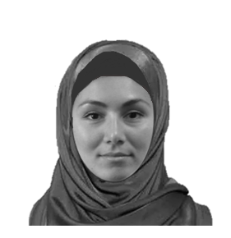 | 
Note. The pictures were selected from American Multiracial Face Database (Chen et al., 2020) based on two criteria. First, faces like those of an average Turkish woman or man were selected. Second, faces with neutral expression poses instead of smiling faces were selected.

Online Appendix F
Results details: Study 2, The Case of Turkey

Fig. F1 Rating Out-party Individual (All Measures)
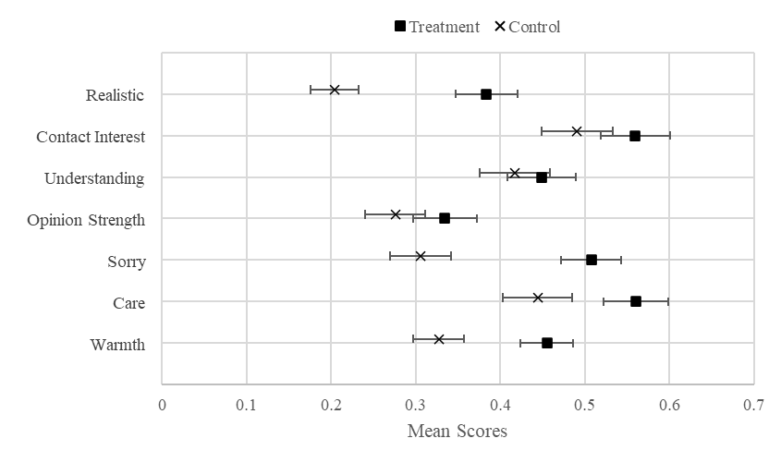
Entries in the graph are mean scores and 95% Confidence Intervals.

Table F1. Regression Analyses Predicting Warmth towards Outparty Individual (Multiple Imputation Post Estimation Analyses)
 | Outparty Individual
 | 1 | 2 | 3 | 4 | 5
Constant | 0.33*** | 0.28*** | 0.02 | 0.26*** | -0.02
 | (0.02) | (0.03) | (0.08) | (0.03) | (0.08)
Treatmentª | 0.13*** | 0.13*** | 0.13*** | 0.18*** | 0.17**
 | (0.02) | (0.02) | (0.02) | (0.05) | (0.05)
Nation Alliance |  | 0.04 | -0.00 | 0.07* | 0.02
 |  | (0.03) | (0.03) | (0.04) | (0.04)
Far-Left Group |  | 0.07* | 0.02 | 0.14** | 0.08*
 |  | (0.04) | (0.04) | (0.05) | (0.05)
DEM Party^{b} |  | 0.13** | 0.06 | 0.12* | 0.04
 |  | (0.04) | (0.04) | (0.06) | (0.07)
Others |  | 0.03 | 0.01 | 0.05 | 0.04
 |  | (0.05) | (0.05) | (0.06) | (0.06)
Nation *Treatment |  |  |  | -0.05 | -0.03
 |  |  |  | (0.06) | (0.06)
Far-Left*Treatment |  |  |  | -0.15** | -0.14**
 |  |  |  | (0.07) | (0.07)
DEM * Treatment |  |  |  | 0.01 | 0.03
 |  |  |  | (0.09) | (0.09)
Others * Treatment |  |  |  | -0.03 | -0.05
 |  |  |  | (0.10) | (0.10)
PID Strength^{c} |  |  | 0.00 |  | 0.01
 |  |  | (0.02) |  | (0.02)
Political interest |  |  | -0.01 |  | -0.00
 |  |  | (0.05) |  | (0.05)
Gender^{d} |  |  | 0.13*** |  | 0.13***
 |  |  | (0.02) |  | (0.02)
Education |  |  | 0.19*** |  | 0.19***
 |  |  | (0.05) |  | (0.06)
Income |  |  | -0.04 |  | -0.04
 |  |  | (0.05) |  | (0.05)
Age |  |  | 0.05 |  | 0.04
 |  |  | (0.05) |  | (0.05)
Dispositional PT^{e} |  |  | 0.12* |  | 0.13*
 |  |  | (0.07) |  | (0.07)
Dispositional EC^{f} |  |  | 0.11* |  | 0.11*
 |  |  | (0.05) |  | (0.05)
N | 605 | 605 | 605 | 605 | 605

Note. Regression analyses were conducted after the multiple imputation to fill out missing in PID Strength (n=3), gender (n=7), income (n=16), and age (n=4). We used a chained type of multiple imputation analysis to get information from all variables of interest in filling in the missing data. Treatment, PID Strength, Gender and Alliance Category were coded as categorical. Alliance categories are based on partisanship. Table shows unstandardized regression coefficients with robust standard errors are in parentheses. All continuous measures were standardized to range from 0-1. p<.10* p<.05** p<.001*** ªTreatment (Experimental condition=1); ^{b}DEM Party (Peoples' Equality and Democracy Party) ^{c}Party Identification Strength (PID Strength, Strong Party Identifiers=1), ^{d}Gender (Female=1), ^{e}PT=dispositional Perspective Taking, ^{f}EC= Empathic Concern.
Fig. F2 Rating Out-party (All measures)
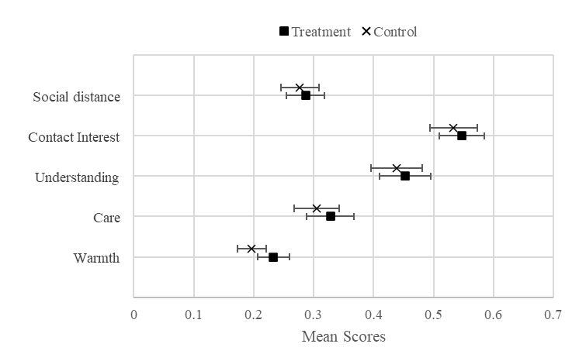
Entries in the graph are mean scores and 95% Confidence Intervals.

 | Least-liked Party Supporters
 | 1 | 2 | 3 | 4 | 5
Constant | 0.20*** | 0.16*** | 0.05 | 0.14*** | 0.04
 | (0.01) | (0.02) | (0.07) | (0.02) | (0.07)
Treatmentª | 0.04** | 0.03* | 0.04** | 0.06* | 0.06*
 | (0.02) | (0.02) | (0.02) | (0.03) | (0.04)
Nation Alliance |  | 0.06** | 0.04 | 0.06* | 0.04
 |  | (0.02) | (0.03) | (0.03) | (0.03)
Far-Left Group |  | 0.05* | 0.03 | 0.09** | 0.06
 |  | (0.03) | (0.03) | (0.04) | (0.04)
DEM Party^{b} |  | 0.06 | 0.03 | 0.12** | 0.09*
 |  | (0.04) | (0.04) | (0.05) | (0.05)
Others |  | 0.03 | 0.03 | 0.06 | 0.05
 |  | (0.04) | (0.04) | (0.05) | (0.05)
Nation *Treatment |  |  |  | -0.01 | -0.00
 |  |  |  | (0.05) | (0.05)
Far-Left*Treatment |  |  |  | -0.07 | -0.07
 |  |  |  | (0.06) | (0.06)
DEM * Treatment |  |  |  | -0.13* | -0.12
 |  |  |  | (0.08) | (0.08)
Others * Treatment |  |  |  | -0.06 | -0.06
 |  |  |  | (0.08) | (0.08)
PID Strength^{c} |  |  | -0.00 |  | -0.00
 |  |  | (0.02) |  | (0.02)
Political interest |  |  | 0.04 |  | 0.04
 |  |  | (0.04) |  | (0.04)
Gender^{d} |  |  | 0.03 |  | 0.03
 |  |  | (0.02) |  | (0.02)
Education |  |  | 0.09** |  | 0.09**
 |  |  | (0.05) |  | (0.05)
Income |  |  | -0.04 |  | -0.05
 |  |  | (0.04) |  | (0.04)
Age |  |  | 0.04 |  | 0.03
 |  |  | (0.05) |  | (0.05)
PT^{e} |  |  | -0.02 |  | -0.02
 |  |  | (0.06) |  | (0.06)
EC^{f} |  |  | 0.08 |  | 0.07*
 |  |  | (0.04) |  | (0.04)
N | 605 | 605 | 605 |  | 605
Table F2. Regression Analyses Predicting Warmth towards Least-liked Party Supporters (Multiple Imputation Post Estimation Analyses)

Note.Table shows unstandardized regression coefficients with robust standard errors are in parentheses. All continuous measures were standardized to range from 0-1. p<.10* p<.05** p<.001*** ªTreatment (Experimental condition=1); ^{b}DEM Party (Peoples' Equality and Democracy Party) ^{c}Party Identification Strength (PID Strength, Strong Party Identifiers=1), ^{d}Gender (Female=1), ^{e}PT=dispositional Perspective Taking, ^{f}EC= Empathic Concern
Table F3. Regression Analyses Predicting Warmth towards Out-alliance Supporters (Multiple Imputation Post Estimation Analyses)
 | Out-alliance Party Supporters
 | 1 | 2 | 3 | 4 | 5
Constant | 0.32*** | 0.30*** | 0.16** | 0.29*** | 0.15**
 | (0.01) | (0.02) | (0.06) | (0.03) | (0.06)
Treatmentª | 0.03** | 0.04** | 0.04** | 0.07* | 0.06
 | (0.02) | (0.02) | (0.02) | (0.04) | (0.04)
Nation Alliance |  | -0.02 | -0.02 | -0.00 | -0.01
 |  | (0.02) | (0.02) | (0.03) | (0.03)
Far-Left Group |  | 0.08*** | 0.08** | 0.11** | 0.10**
 |  | (0.02) | (0.03) | (0.03) | (0.03)
DEM Party^{b} |  | -0.01 | -0.02 | 0.06 | 0.03
 |  | (0.04) | (0.04) | (0.05) | (0.05)
Others |  | 0.11** | 0.10** | 0.13** | 0.12**
 |  | (0.03) | (0.03) | (0.05) | (0.05)
Nation *Treatment |  |  |  | -0.03 | -0.01
 |  |  |  | (0.05) | (0.05)
Far-Left*Treatment |  |  |  | -0.07 | -0.06
 |  |  |  | (0.05) | (0.05)
DEM * Treatment |  |  |  | -0.14* | -0.11
 |  |  |  | (0.07) | (0.07)
Others * Treatment |  |  |  | -0.05 | -0.03
 |  |  |  | (0.07) | (0.07)
PID Strength^{c} |  |  | -0.01 |  | -0.01
 |  |  | (0.02) |  | (0.02)
Political interest |  |  | 0.04 |  | 0.04
 |  |  | (0.04) |  | (0.04)
Gender^{d} |  |  | 0.03 |  | 0.02
 |  |  | (0.02) |  | (0.02)
Education |  |  | 0.07 |  | 0.07
 |  |  | (0.04) |  | (0.04)
Income |  |  | 0.10** |  | 0.09**
 |  |  | (0.04) |  | (0.04)
Age |  |  | -0.03 |  | -0.03
 |  |  | (0.04) |  | (0.04)
PT^{e} |  |  | 0.03 |  | 0.03
 |  |  | (0.05) |  | (0.05)
EC^{f} |  |  | -0.02 |  | -0.02
 |  |  | (0.04) |  | (0.04)
N | 605 | 605 | 605 | 605 | 605

Note. Table shows unstandardized regression coefficients with robust standard errors are in parentheses. All continuous measures were standardized to range from 0-1. p<.10* p<.05** p<.001*** ªTreatment (Experimental condition=1); ^{b}DEM Party (Peoples' Equality and Democracy Party) ^{c}Party Identification Strength (PID Strength, Strong Party Identifiers=1), ^{d}Gender (Female=1), ^{e}PT=dispositional Perspective Taking, ^{f}EC= Empathic Concern

Treatment Effect by Alliance Group
Ratings of the target outpartisan increased among supporters of the People’s Alliance (M_{t}=0.44, SD_{t}=0.28 vs. M_{c}=0.26, SD_{c}=0.28), Nation Alliance (M_{t}=0.45, SD_{t}=0.27 vs. M_{c}=0.33, SD_{c}=0.26), DEM Party supporters (M_{t}=0.57, SD_{t}=0.23 vs. M_{c}=0.38, SD_{c}=0.26) and Other (M_{t} = 0.45, SD_{t}=0.34 vs. M_{c} = 0.31, SD_{c}=0.27). By contrast, the treatment was less effective among far-left supporters (M_{t}=0.43, SD_{t}=0.26 vs. M_{c}=0.40, SD_{c}=0.26), who make up a smaller portion of the sample (16%) and an even smaller share of the Turkish population (2%). This finding was confirmed in regression analyses (see column 4 in Table F1).
The treatment effect on the least-liked party was larger among supporters of the parties in the two main alliances, who make up two-thirds (67%) of the sample and an even larger percent (85%) of the population (see Table 1). This can be seen in mean warmth scores among supporters of the People’s Alliance (M_{t}=0.21, SD_{t}=0.21 vs. M_{c}=0.14, SD_{c}=0.20), and Nation Alliance (M_{t}=0.26, SD_{t}=0.24 vs. M_{c}=0.20, SD_{c}=0.21) The effect is less evident among supporters of the far-left (M_{t}=0.23, SD_{t}=0.22 vs. M_{c}=0.23, SD_{c}=0.20), and the Other (M_{t}=0.20, SD_{t}=0.25 vs. M_{c}=0.20, SD_{c}=0.24) but both samples are small and there is not significant interaction for Far-left and the Other in the regression analyses (see column 4 in Table F2). Unexpectedly, warm feelings for the least-liked party decreased among supporters of the DEM Party (M_{t}=0.20, SD_{t}=0.24 vs. M_{c}=0.26, SD_{c}=0.21) who constitutes a small share of the population (9%) and the sample (7%); the negative interaction between the alliance and treatment reached modest significance in regression analyses (column 4, Table F2).
The effect on out-alliance group was effective among supporters of parties in the two main alliances. People’s Alliance (M_{t}=0.36, SD_{t}=0.23 vs. M_{c}=0.29, SD_{c}=0.23), and Nation Alliance (M_{t}=0.33, SD_{t}=0.21 vs. M_{c}=0.28, SD_{c}=0.20) supporters rated parties in the outalliance more warmly in the treatment than control condition. The treatment was less effective among far-left supporters (Mt=0.41, SDt=0.14 vs. Mc=0.40, SDc=0.14), and supporters in the Others group (Mt=0.44, SDt=0.17 vs. Mc=0.42, SDc=0.20) but the alliance and treatment interaction is insignificant in regression analyses (column 4, Table F3). However, warmth ratings decreased among DEM Party supporters (Mt=0.28, SDt=0.21 vs. Mc=0.35, SDc=0.18) which constitutes small share of the population, as shown in the negative interaction between party and treatment in regression analyses.

Fig. F3 Mean Difference by Alliance Group
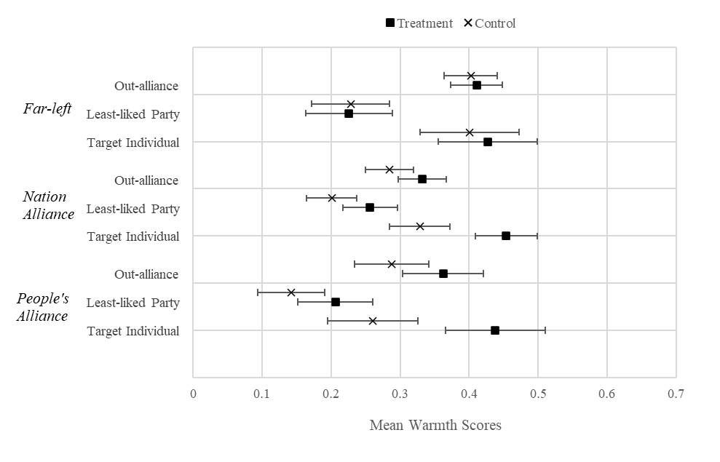
Entries in the graph are mean scores and 95% Confidence Intervals for out-party ratings separately shown by Far-left, Nation Alliance, and People’s Alliance supporters.

https://electionstudies.org/wp-content/uploads/2018/03/20091208PartyID.pdf
Only “Feeling sorry about the Target” reversely coded as the highest score was showing not feeling sorry for the target at all in the original version.
The “in-party” was the answer given to the “Party Identification” question.
Removed items are as follows: “I sometimes find it difficult to see things from the “other person’s” point of view.” If I am sure I am right about something, I do not waste much time listening to other people’s arguments.”
A few respondents who selected “other” (n=2) and or “Do not want to say” (n=5) were categorized as "Female" in the experimental conditions.
A few (n=19, 3.14%) of respondents refused to indicate a preference for religion.

