Appendix A: Notes on Sampling Procedures and Survey Quality Control

Sampling Procedures

To obtain a nationally representative sample, we used a multi-stage cluster sampling design where the strata are residency locations and households. The first level of stratification is residency locations. The survey covers fourteen oblasts (states) in the country and three cities (Almaty, Astana, and Shymkent). Each oblast is split into urban and rural areas based on the definition provided by the National Statistical Committee of Kazakhstan, and thus there were 31 strata in total for the entire country. We allocated 150 Primary Stage Units (PSUs) of twenty households to each of these strata so that the proportion of respondents from each stratum in the sample is proportional to the population proportion of each stratum. Within each PSU, twenty households were sampled by enumerators. The details on these issues are shown in Table A.

The starting point of sampling is the geographic center of the PSU in urban areas while in rural areas sampling began randomly with either an administrative building, a post office, a school, a bus station in the center of a village, or the first or the last house from the entrance of a village. Starting from the given address/point, each interviewer followed the random route method, sample every third household on their right, and turned right at the end of each block. If a starting address or a selected building on the route was an apartment, the interviewer walked from the top floor selecting every sixth apartment unit on her right. For each selected household, the interviewer attempted up to three contacts at different times of the day, days of the week, and the weekend within the survey period to conduct a successful interview. In areas where the interviewer could not return on a different day, they made attempts with at least a two-hour gap between each attempt before substituting the household. Geolocation data for all visits were recorded in contact sheets completed by interviewers to increase the quality of the survey sampling and interviewing.

After identifying a household, only one respondent within the household was interviewed. The “last birthday method” was used to select a respondent if more than one adult person resided in a sampled household. If there was no adult member or the selected household member refused to answer the survey, the interviewer continued to the next eligible household.

Survey Quality Control

Interviews were conducted by using tablets based face-to-face interviews in respondents’ homes. Tablets were set to automatically record the start time, stop time, and geographic location of the interview.

The fieldwork supervisors selected and trained interviewers and monitored the quality of their work. The interviewer’s supervision was necessary to make sure that the interviewers followed all necessary fieldwork procedures. If any problems occurred during the supervision process, regional supervisors were tasked with discussing these problems with the interviewers and, if, necessary, conducted additional training, such as the description of the study, the survey instruments, the sampling procedures and a role play where a research coordinator used the questionnaire to rehearse interviews by interviewing each other. About 50 experienced interviewers were selected to collect data. Each interviewer was assigned to conduct no more than 10% of all interviews.

Field work quality control was carried out in the following five steps. First, the research team remotely monitored the interviewers' routes by using a GPS technology (including location, time, duration of the survey, dynamics of the interview). Second, the research team listened to audio recordings of at least 25% of interviews from the final sample to check their accuracy and the correctness of filling out the questionnaire. Third, the research team listened to 100% of audio recordings of certain sections of the questionnaire in order to assess the completeness of the survey. Fourth, the polling company made sure to see if interviews were successfully done for 10% of interviews conducted by each interviewer by phone. At the same time, regional supervisors in the field controlled an additional 15% by phone and they personally visited another 10% of respondents for follow-up. Firth, before conducting the main survey, the research team conducted a pre-test with 200 respondents drawn from random sampling of the national population. In addition to double-check the validity of question wording, we ensured reactions from respondents on possibly sensitive questions on their attitude toward immigrants with varying religious attitudes. As a consequence, we did not experience any issues in the field in both the pre-test and main survey.

Table A: The Number and Allocations of the Primary Sampling Units
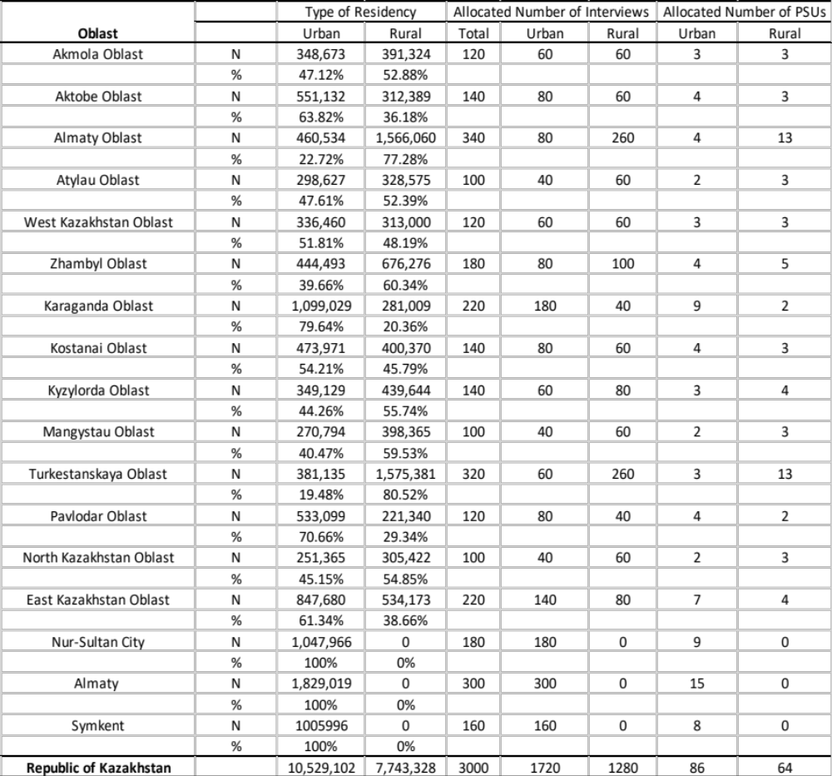

Note: The table shows types of residencies for all the samples, the number of 3,000, taken for our survey. Our actual analysis (Appendix B and onwards) eliminates respondents who did not answer to be Muslim or match to the national census information, eventually yielding 2,097 respondents.

Appendix B: The Complete Results of the Main Analyses

B-1. Profile-Level Marginal Means

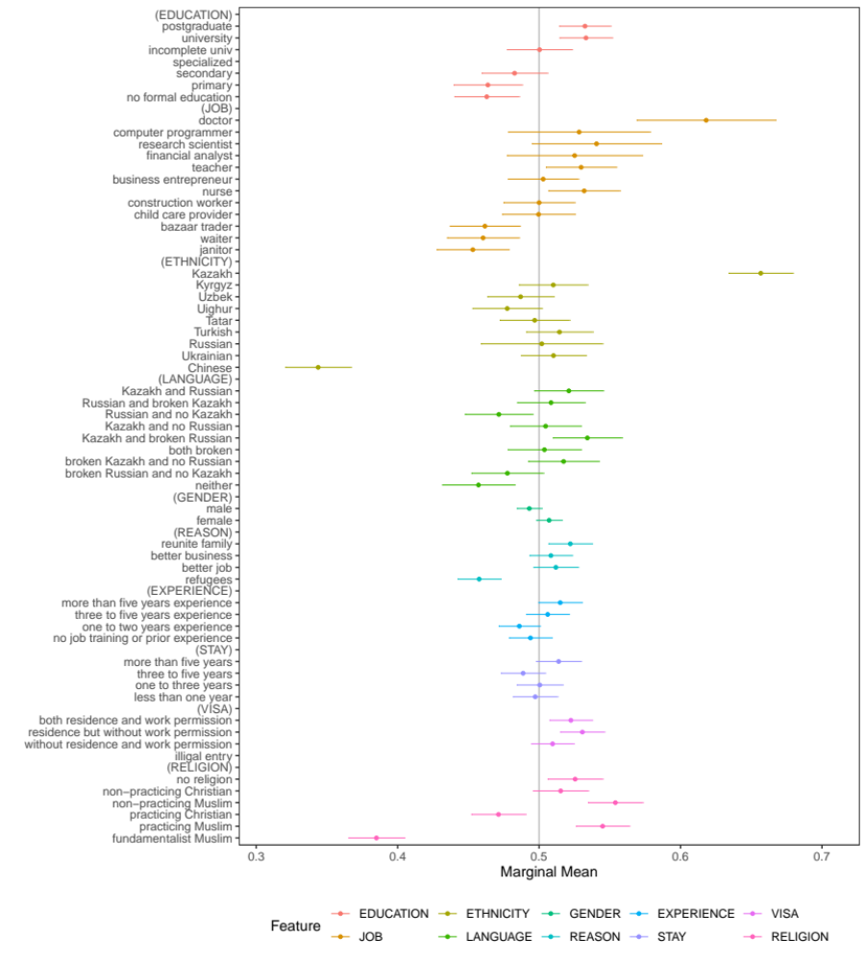

B-2: Profile-Level Average Marginal Component Effects (AMCEs)

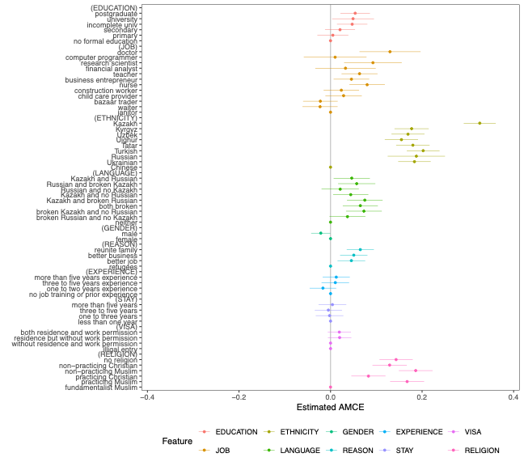

B-3: Heterogeneous Treatment Effects

a. Weak Religiosity
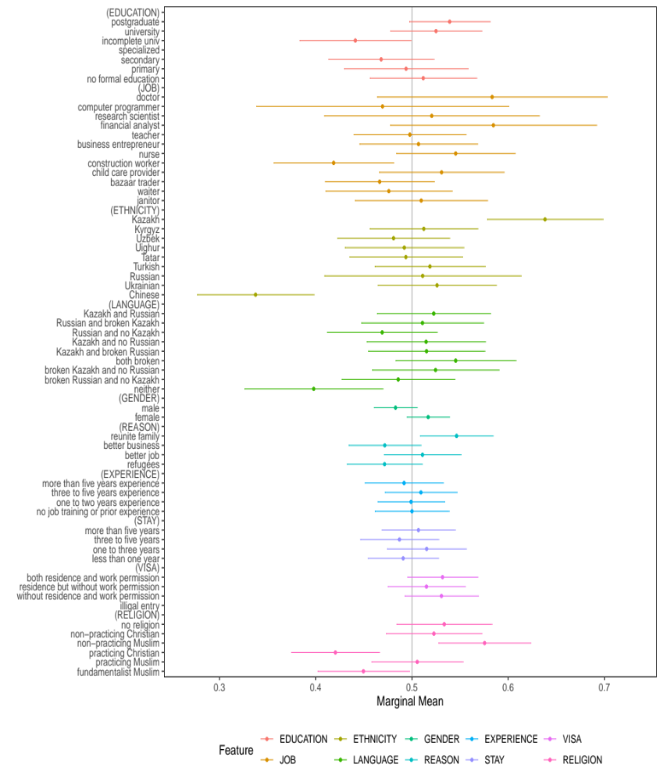

b. Strong Religiosity

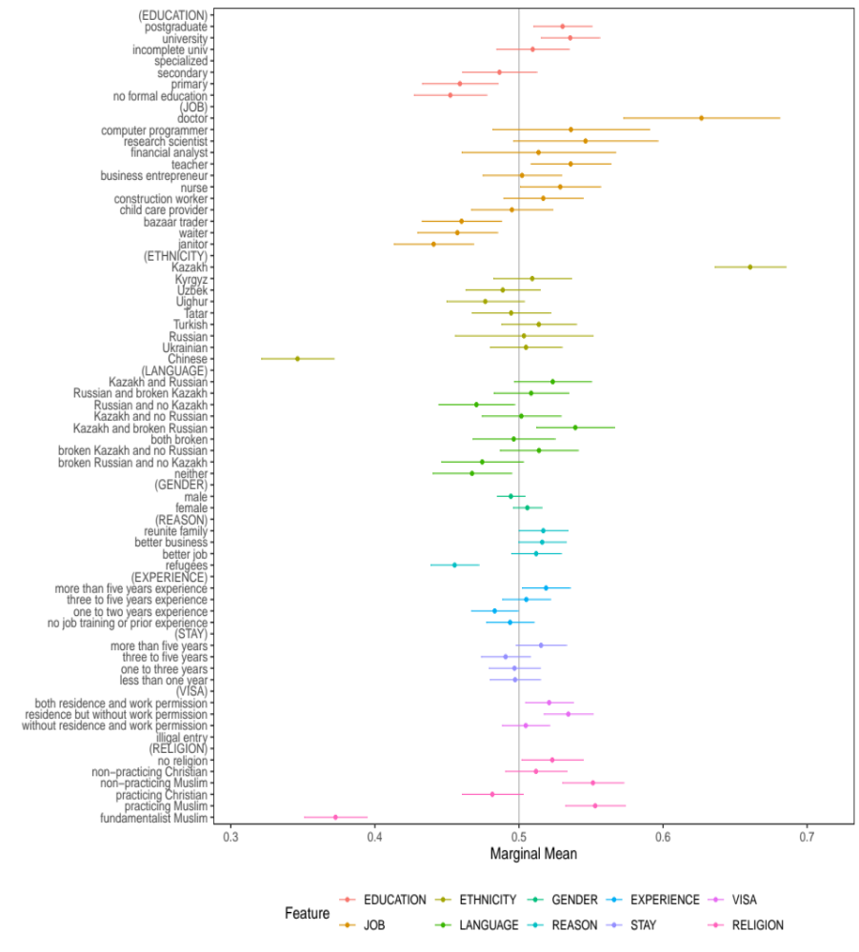

Appendix C: Rating Measure of Immigrant Acceptance
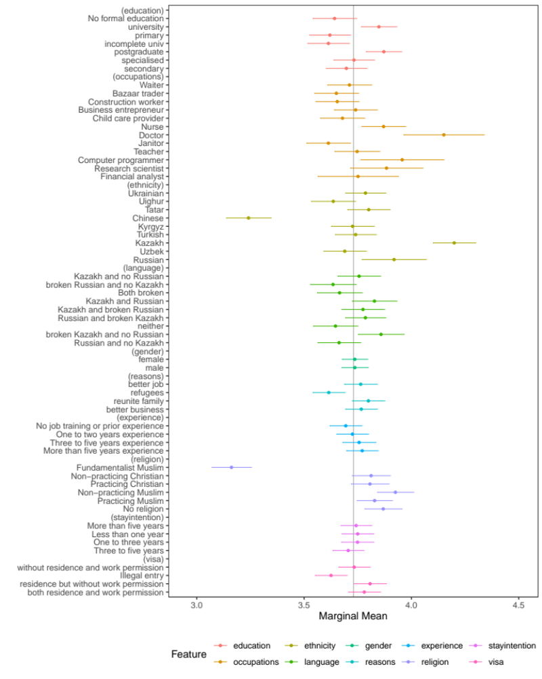
Note: The dots are point estimates and the bars are the 95% confidence intervals. The mean of the rating outcome variable is 3.73 and the marginal means plots investigate whether marginal changes from the mean are statistically significant.

a. Weak Religiosity b. Strong Religiosity
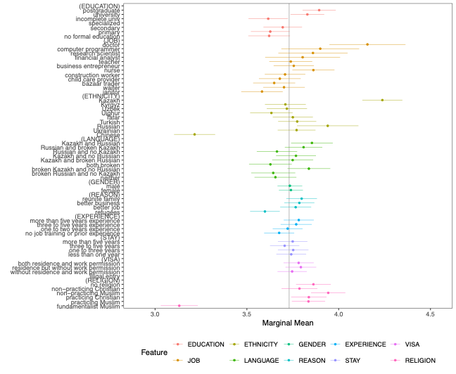
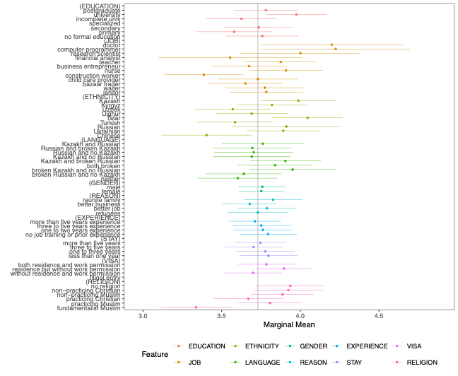

Note: The dots are point estimates and the bars are the 95% confidence intervals. The mean of the rating outcome variable is 3.73 and the marginal means plots investigate whether marginal changes from the mean are statistically significant.

Appendix D: Inspections and Analysis of Carryover Effects
1. Distinguish immigrants shown in the left panel from those in the right panel
a. All Muslim Respondents b. Weak Religiosity c. Strong Religiosity
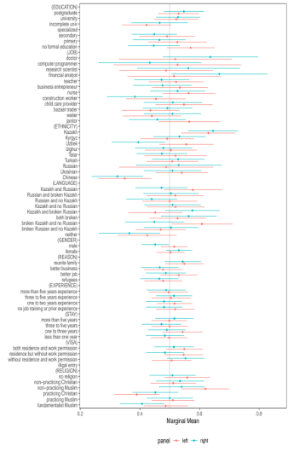
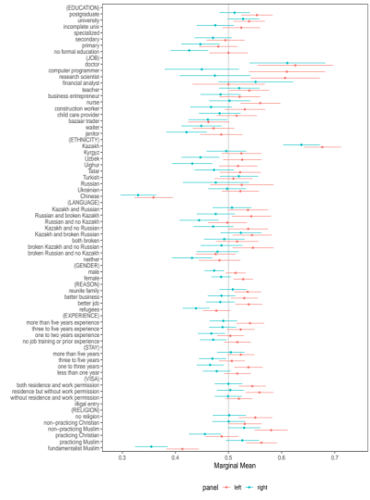
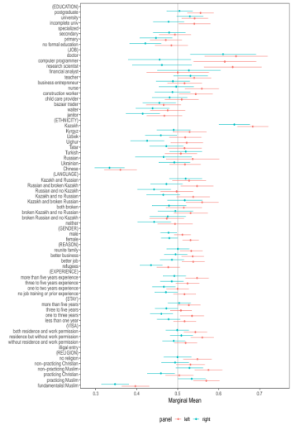

2. Controlling for immigrants’ locations on the Conjoint Table
a. All Muslim Respondents b. Weak Religiosity c. Strong Religiosity
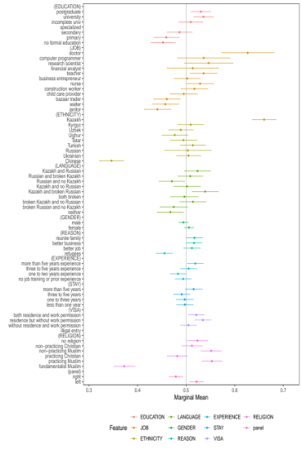
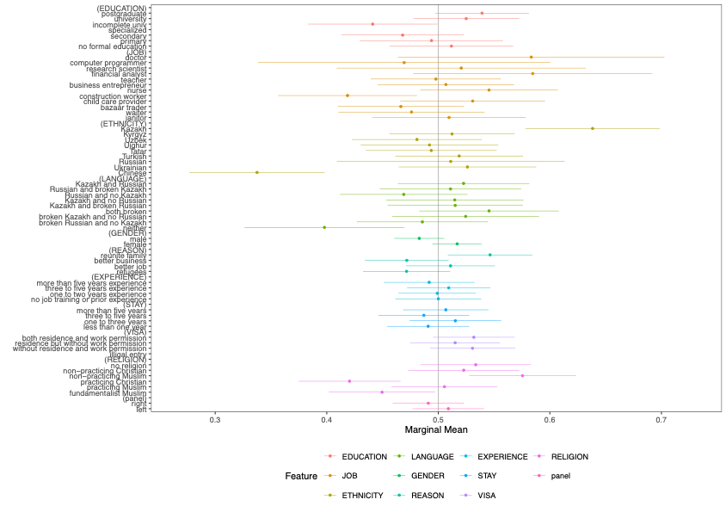
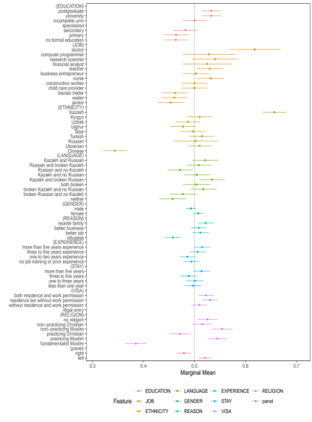

3. Jackknife Analysis (Exclude conjoint trial one by one)
I. All Muslim Respondents
a. Remove the first trial b. Remove the second trial c. Remove the third trial
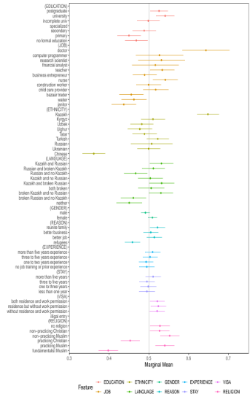
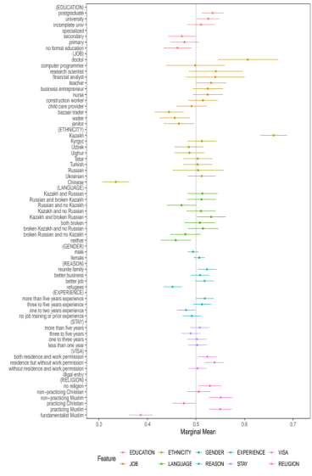
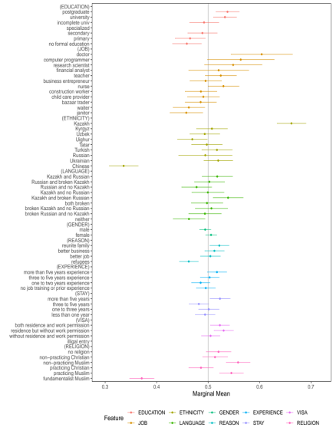

II. Weak Religiosity
a. Remove the first trial b. Remove the second trial c. Remove the third trial
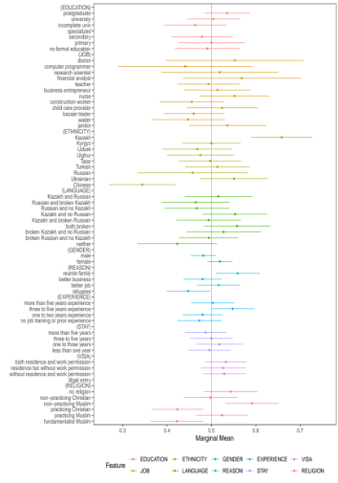
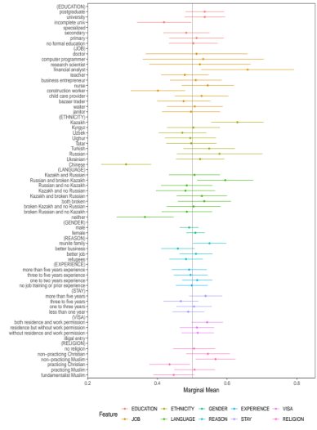
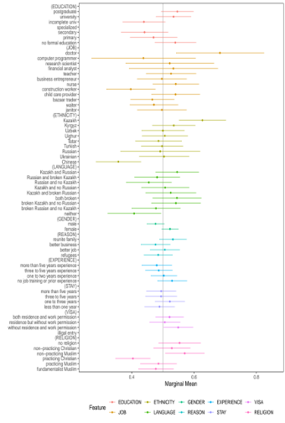

III. Strong Religiosity
a. Remove the first trial b. Remove the second trial c. Remove the third trial
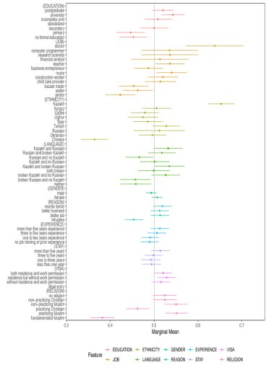
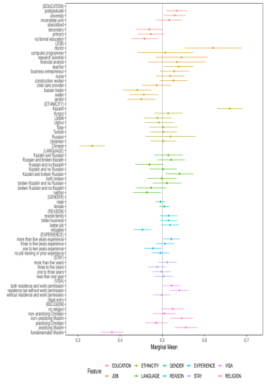
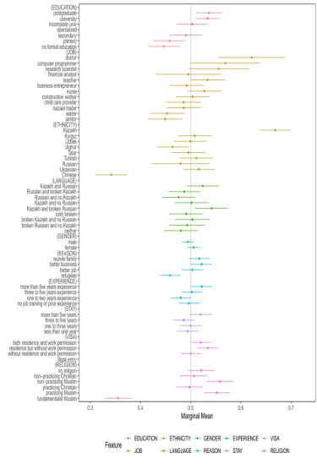

Appendix E: Balance Tests

1. General Sample
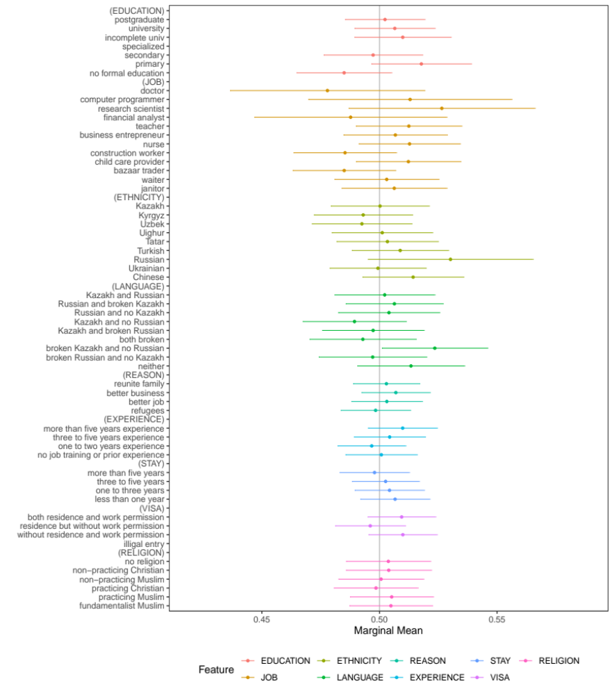

2. Sample with Weak Religiosity

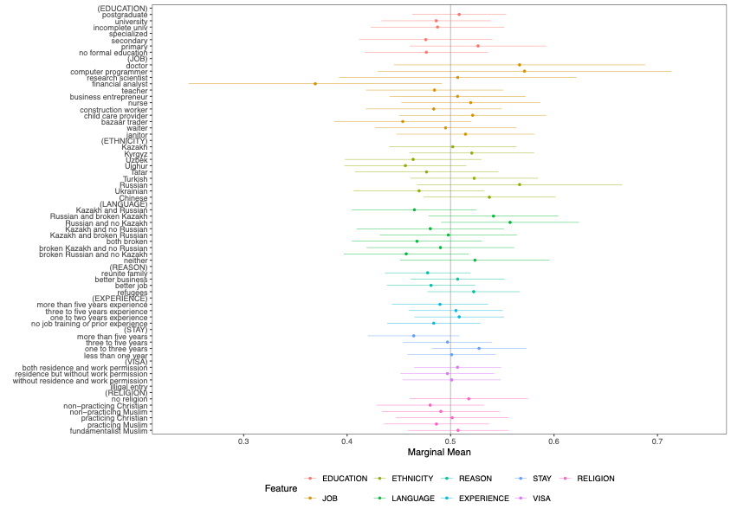

3. Sample with Strong Religiosity

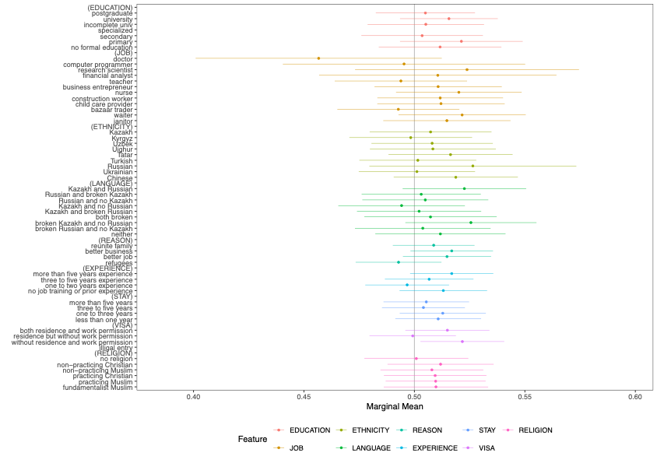

Appendix F: Frequencies of Attributes and Levels

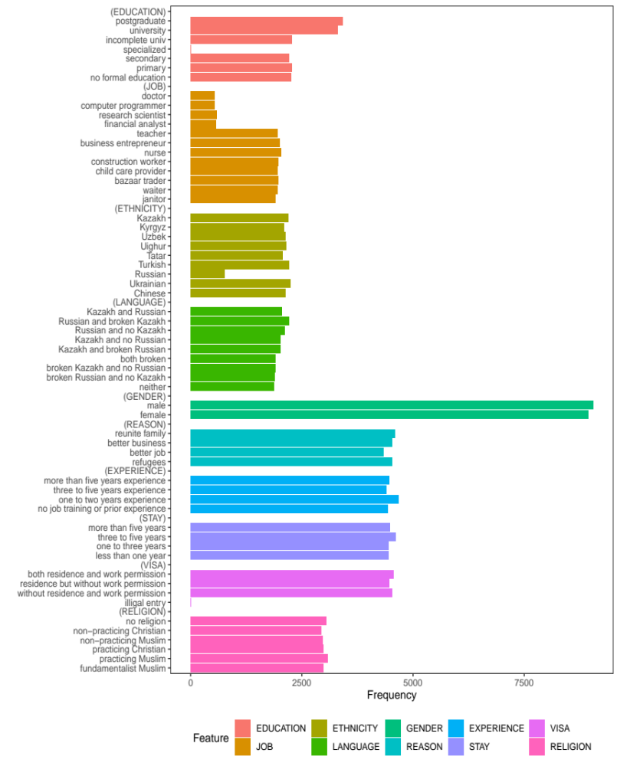

Appendix G: Five Point Scale of Religiosity
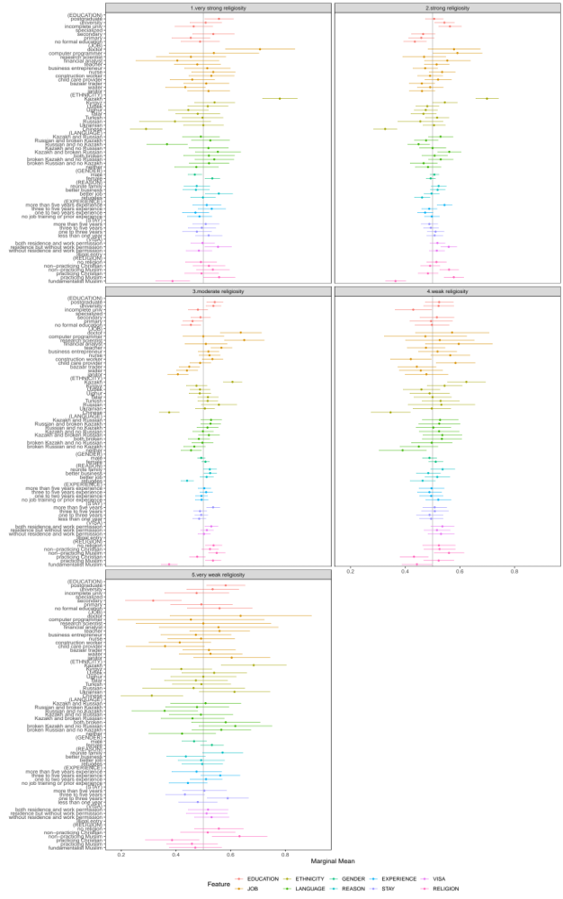

Appendix H: Adjusting Respondents’ Religiosity

a. Weak Religiosity b. Strong Religiosity

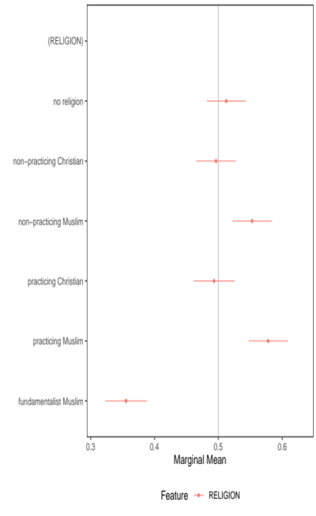
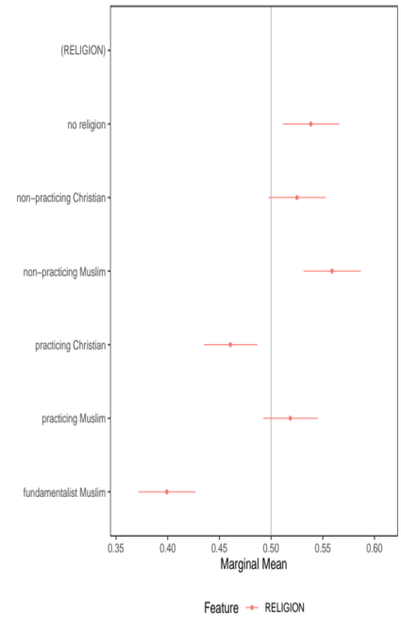

Note: To calculate residuals of respondents’ religiosity, we estimate an Ordinary Least Squares estimator by regressing respondents’ religiosity on various attributes such as gender, education levels, income, occupations, ethnicity (whether a respondent is Kazakh or not), religion (whether a respondent is Muslim or not), and regional locations with respondent-clustered standard errors (The regression table is reported in the next page). The OLS model explains 11 percent variations in respondents’ religiosity and the calculated residuals of religiosity are highly correlated with the original religiosity variable (r. = 0.94).

Appendix I: Regression Table for Calculating Residuals

 | Model 1
 | Religiosity
Gender | 0.0793***
 | (0.0158)
Education level | -0.0103
 | (0.0065)
Income | 0.0281**
 | (0.0087)
Employed (Part-time) | 0.0233
 | (0.0039)
Self-employed | 0.0768*
 | (0.0307)
Entrepreneur | 0.0799
 | (0.0477)
Running a household | 0.1674***
 | (0.0307)
Retired | 0.1305***
 | (0.0243)
Unemployed | 0.0199
 | (0.0260)
Temporarily jobless | 0.0724*
 | (0.0345)
Permanently jobless due to disability | 0.5790***
 | (0.0836)
Student | -0.2030***
 | (0.0320)
Unpaid intern/volunteer | -0.3221
 | (0.1773)
Kazakh | -0.1673***
 | (0.0297)
Islam | 0.6429***
 | (0.0297)
Constant | 2.8309***
 | (0.0529)
Oblast Fixed Effects | Yes
Observations | 16,476
R-squared | 0.112
Notes: Robust standard errors in parentheses; *** p<0.01, ** p<0.05, * p<0.1

Appendix J: Mechanism Analysis – Security Concern

To provide evidence for the security threat mechanism, we explored heterogeneous treatment effects based on respondents’ levels of security concern. If our proposed theoretical mechanism is correct, we would expect respondents who express higher concern about security in general—and terrorism in particular—to be more likely to dislike fundamentalist Muslim immigrants. In addition to the conjoint experiment, our survey also included the following question:

- Question: Which of the following statements is closest to your view? Choose Statement 1 or Statement 2:

Statement 1: Government should prioritize ensuring security and fighting
terrorism, even if it undermines democracy and human rights.

Statement 2: Government should prioritize strengthening democracy and
protecting human rights, even if this undermines security and the
fight against terrorism.
- Answer Choices:
1: Agree very strongly with Statement 1
2: Agree with Statement 1
3: Agree with Statement 2
4: Agree very strongly with Statement 2
5: Agree with neither

Based on this question, we created a dummy variable coded as 1 if respondents selected either option 1 or 2, and 0 otherwise. We use this variable as a moderator to examine: (1) whether respondents with higher security concerns tend to express more negative attitudes toward fundamentalist Muslim immigrants than those with lower security concerns, and (2) whether highly religious respondents with high security concerns also display stronger negative attitudes toward fundamentalist Muslim immigrants than those with lower security concerns.
The results are presented below. Figure (a) shows the results for the first analysis. The upper row represents the high-security-concern scenario, while the lower row represents the low-security-concern scenario. As the figure indicates, respondents with high security concerns exhibit stronger negative reactions toward fundamentalist Muslim immigrants, particularly when these immigrants are compared with practicing Christians or non-religious immigrants.
Figure (b) shows the results among highly religious respondents and reveals an even clearer pattern. Highly religious respondents who prioritize security consistently display stronger aversion toward fundamentalist Muslim immigrants across multiple comparisons, particularly when these immigrants are compared with practicing Christians and non-religious immigrants. By contrast, when highly religious respondents report lower levels of security concern, the magnitude of this aversion becomes substantially weaker for several comparisons (non-practicing Muslim, practicing Muslim, and non-practicing Christian) and becomes statistically insignificant in others (practicing Christian and no religion).
Taken together, these results suggest that security perceptions constitute an important mechanism underlying negative attitudes toward fundamentalist Muslim immigrants. We discuss this mechanism analysis in greater detail in the main text (pp. 28–29).

(a) High security concern vs low security concern among general respondents
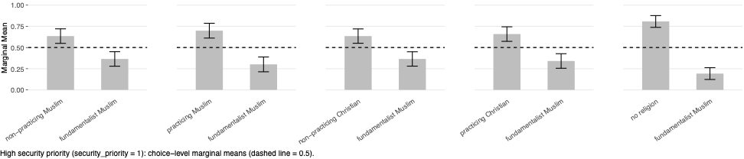

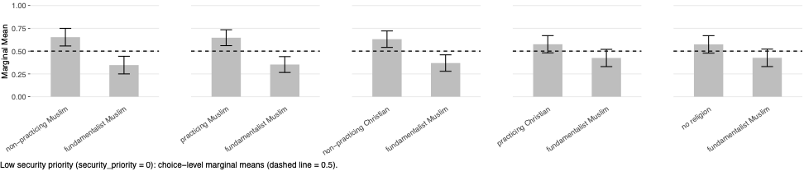

(b) High security concern vs low security concern among high-religiosity respondents

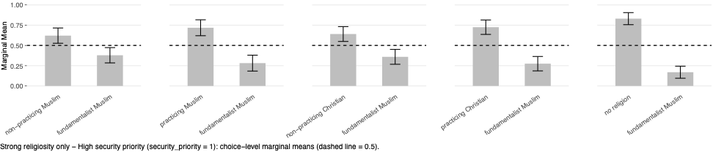
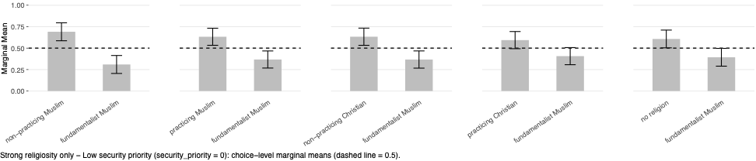

Appendix K: Heterogeneous Treatment Effects

a. Age: Young vs Old Respondents

1. General sample

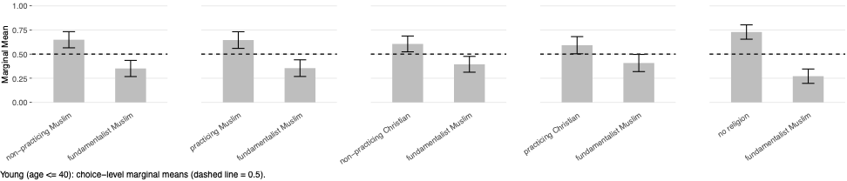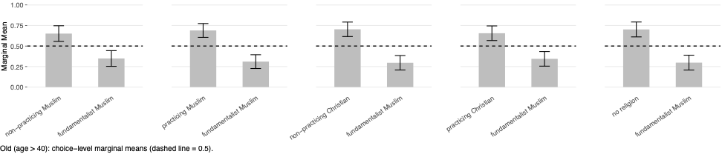

2. Strong religiosity sample

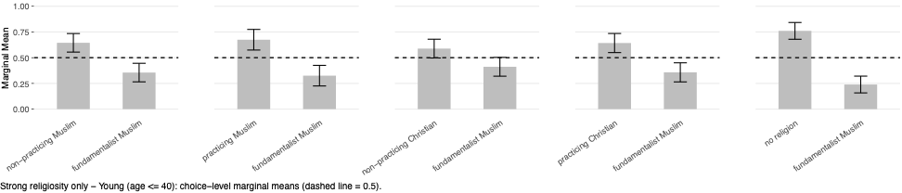
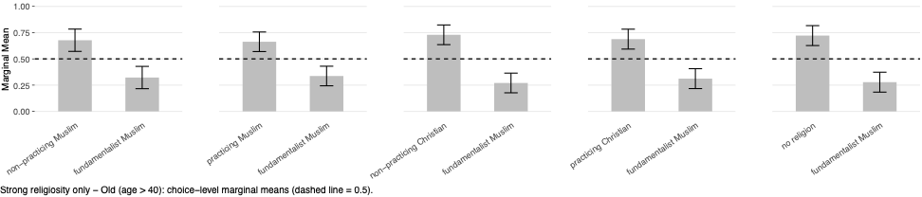

b. Education Levels: Low vs High Education

1. General sample
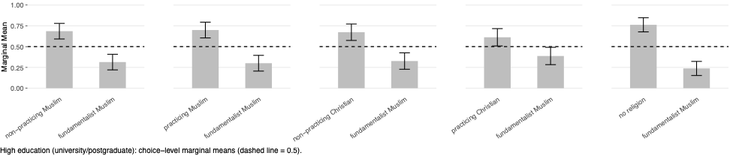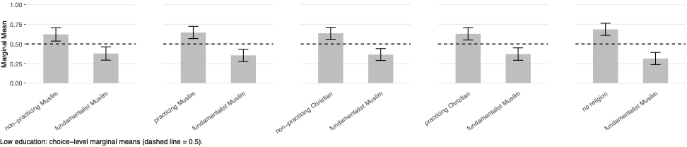
2. Strong religiosity sample
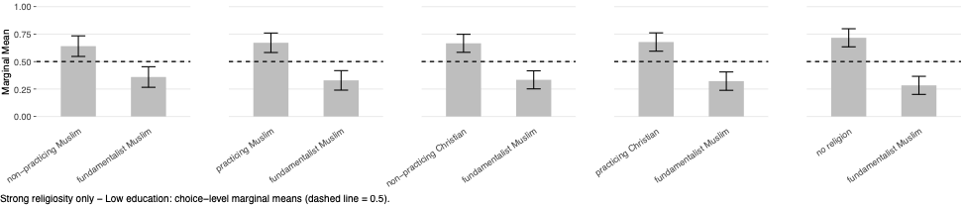
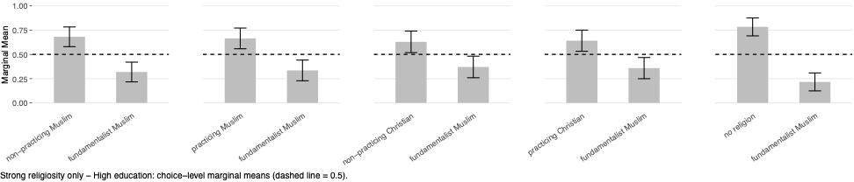

c: Residence Location: Rural vs Urban

1. General sample
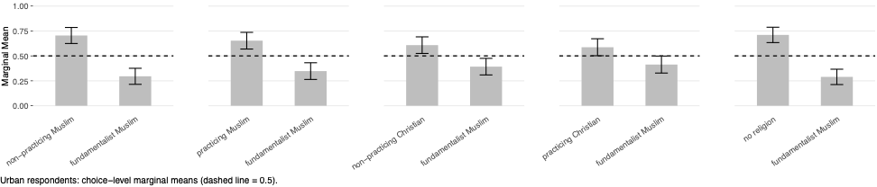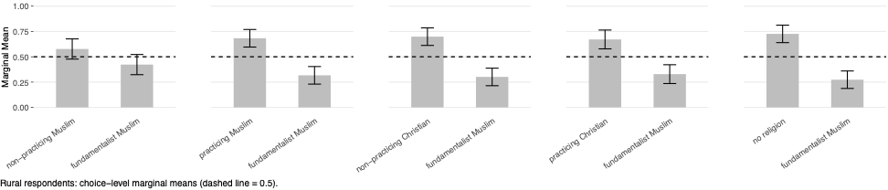

2. Strong religiosity sample

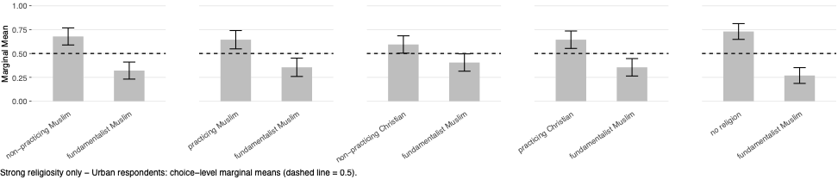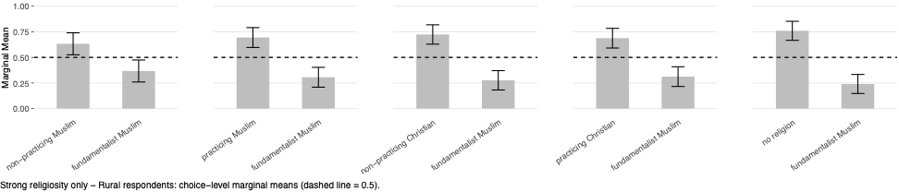

d: Employment: State vs Private Enterprises

1. General sample
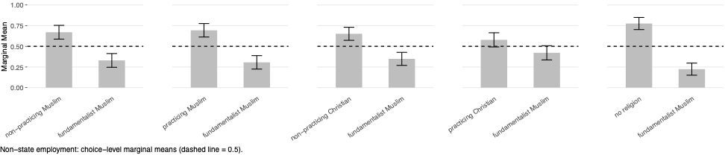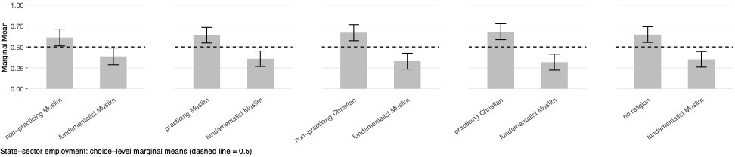

2. Strong religiosity sample
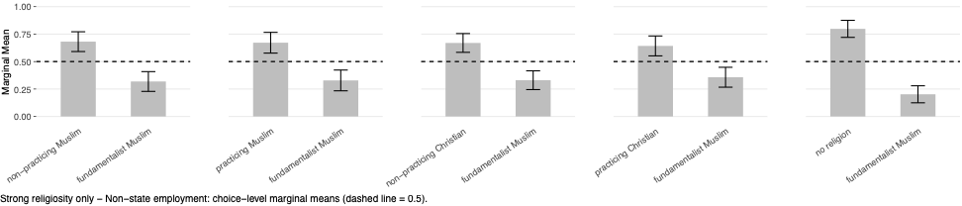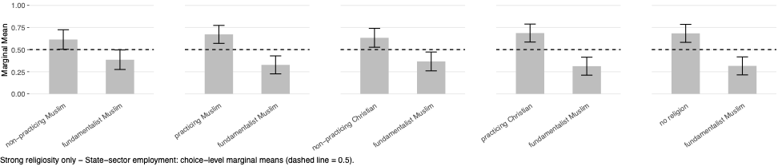

e. Ethnic Fractionalization in PSUs

1. General sample
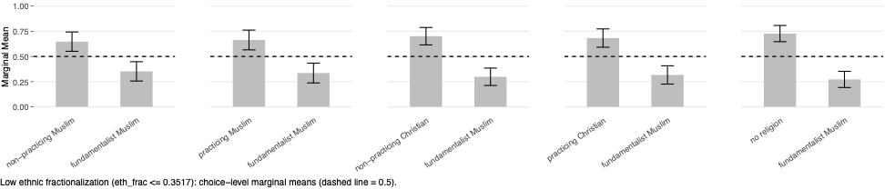

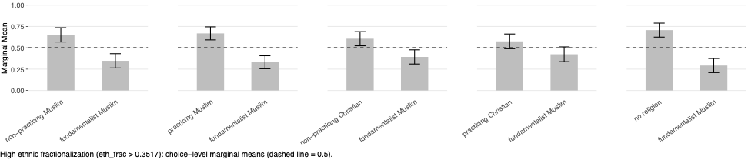

2. Strong religiosity sample
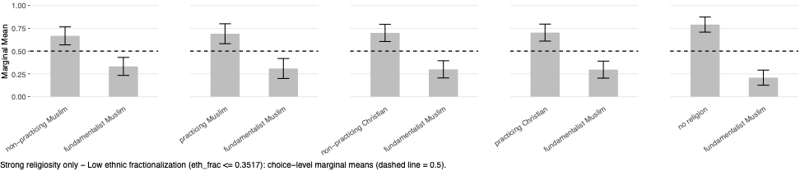
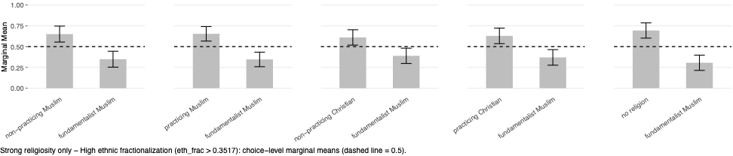

Appendix L: Impacts of Russian Proportions and Russian Language Fluency on Weak-Religiosity Respondents

1. Low vs High Russian Proportions
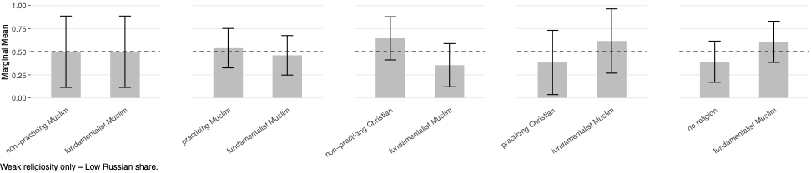
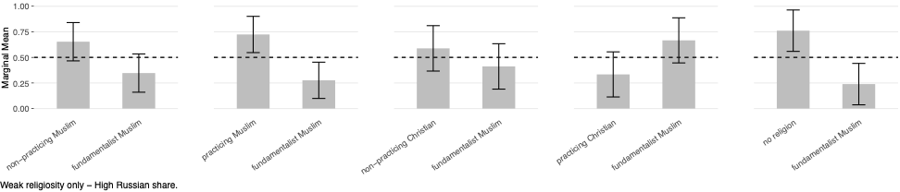

2. Not-Fluent vs Fluent Russian- Speaking Migrants

