Cool Citizens? How Affectively Unpolarized Citizens View and Participate in Democracy
Supplementary Information (SI)

SI1: Ethical Considerations 1
SI2: Sample Statistics 2
SI3: Exact Question Wording of Items 4
SI4: Fit Statistics Cluster Analyses 7
SI5: Demographic Composition of Clusters 11
SI6: Regression Tables 14
SI7: Unpolarized Americans Are Not Just Independents 16
SI8: Unpolarized Skeptics Are Not Just Libertarians 17
SI9: Unpolarized Skeptics Do Not Just Lack Political Knowledge 18
SI10: General Group Views and Straightlining 19
SI11: Thermometers Toward Parties vs. Voters in YouGov 2024 22
References 25

SI1: Ethical Considerations
We ensured that this paper complied with the American Political Science Association’s Principles and Guidance for Human Subjects Research.
The first two data sets are provided by the American National Election Studies (ANES). The ANES reports on their sampling, recruitment, and interviews in the codebooks of each survey (see here). While the ANES ensure the ethical treatment of their respondents, our analyses did not violate this ethical treatment and ensured the anonymity of all respondents.
The third dataset was original data collected by YouGov. Data collection, data processing, and analyses complied with the above-mentioned principles and one of the authors’ responsible Institutional Review Boards (IRB). YouGov ensured the informed consent and debriefing of all respondents, informing them about the research study, its tasks, voluntariness, anonymity, options to terminate the study, and that the anonymized data was intended for publication in scientific journals. Respondents received financial compensation in accordance with YouGov agreements. The expected duration for the full survey was 10-15 minutes. The data were fully anonymized, and due to the large sample size, the risk of respondent identification is minute. All data are stored on institutional servers of the authors’ institutions.
While the contents of all three surveys––political attitudes, political feelings, inter-partisan animosity, and political participation––are sensitive topics, they are commonly assessed in social science research. We did not anticipate any physiological harm resulting from our studies. Likewise, we did not anticipate that our studies would create any psychological burden on respondents beyond what they could experience in everyday life.

SI2: Sample Statistics
Table SI2.1. Sample Statistics ANES 2016.
Variable | Statistic | n | %
Age | M = 49.58 (SD = 17.53)
Gender
Female |  | 2,176 | 52.12
Male |  | 1,948 | 46.66
Race
White |  | 2,981 | 71.40
Black |  | 392 | 9.39
Asian |  | 143 | 3.43
Native American |  | 26 | 0.62
Hispanic |  | 432 | 10.35
Other (incl. multiple races) |  | 169 | 4.06
Education
Less than high school |  | 266 | 6.37
High school |  | 1,660 | 39.76
Associate’s degree |  | 593 | 14.20
Bachelor’s degree |  | 944 | 22.61
Master’s degree |  | 579 | 13.87
Professional or doctorate degree |  | 92 | 2.20
Occupation
Currently working |  | 2,499 | 59.86
Temporarily laid off |  | 47 | 1.13
Unemployed |  | 214 | 5.13
Retired |  | 903 | 21.63
Permanently disabled |  | 174 | 4.17
Homemaker |  | 215 | 5.15
Student |  | 110 | 2.63
Individual income | Median = $55,000-59,999
Religiosity
Religious |  | 2,725 | 65.27
Not religious |  | 1,432 | 34.30
Partisanship
Strong Democrat |  | 875 | 20.96
Not very strong Democrat |  | 549 | 13.15
Independent-Democrat |  | 479 | 11.47
Independent |  | 551 | 13.20
Independent-Republican |  | 492 | 11.78
Not very strong Republican |  | 496 | 11.88
Strong Republican |  | 719 | 17.22
Note. N = 4,175

Table SI2.2. Sample Statistics ANES 2020.
Variable | Statistic | n | %
Age | M = 51.48 (SD = 17.17)
Gender
Female |  | 4,354 | 53.65
Male |  | 3,705 | 45.65
Race
White |  | 5,868 | 72.30
Black |  | 708 | 8.72
Asian |  | 277 | 3.41
Native American |  | 165 | 2.03
Hispanic |  | 745 | 9.18
Other (incl. multiple races) |  | 265 | 3.27
Education
Less than high school |  | 363 | 4.47
High school |  | 1,298 | 15.99
College |  | 1,654 | 20.38
Associate’s degree |  | 1,087 | 13.39
Bachelor’s degree |  | 2,023 | 24.93
Master’s degree |  | 1,170 | 14.42
Professional or doctorate degree |  | 403 | 4.97
Occupation
Currently working |  | 5,058 | 62.32
Temporarily laid off |  | 228 | 2.81
Unemployed |  | 146 | 1.80
Retired |  | 1,796 | 22.13
Permanently disabled |  | 312 | 3.84
Homemaker |  | 428 | 5.27
Student |  | 102 | 1.26
Family income | Median = $65,000-69,999
Religion importance
Not important at all |  | 1,696 | 20.90
A little important |  | 1,050 | 12.94
Moderately important |  | 1,567 | 19.31
Very important |  | 1,552 | 19.12
Extremely important |  | 2,229 | 27.46
Partisanship
Strong Democrat |  | 1,933 | 23.82
Not very strong Democrat |  | 885 | 10.90
Independent-Democrat |  | 962 | 11.85
Independent |  | 925 | 11.40
Independent-Republican |  | 866 | 10.67
Not very strong Republican |  | 823 | 10.14
Strong Republican |  | 1,705 | 21.01
Note. N = 8,116

Table SI2.3. Sample Statistics YouGov 2024.
Variable | Statistic | n | %
Age | M = 50.95 (SD = 17.64)
Gender
Female |  | 939 | 51.45
Male |  | 863 | 47.29
Non-binary |  | 16 | 0.88
Other |  | 7 | 0.38
Race
White |  | 1,244 | 68.16
Black |  | 212 | 11.62
Hispanic |  | 175 | 9.59
Asian |  | 57 | 3.12
Native American |  | 26 | 1.42
Two or more races |  | 70 | 3.84
Other |  | 35 | 1.92
Middle Eastern |  | 6 | 0.33
Education
Less than high school |  | 58 | 3.18
High school graduate |  | 588 | 32.22
Some college |  | 347 | 19.01
2-year |  | 182 | 9.97
4-year |  | 400 | 21.92
Post-grad |  | 250 | 13.70
Occupation
Full-time |  | 647 | 35.45
Part-time |  | 221 | 12.11
Temporarily laid off |  | 16 | 0.88
Unemployed |  | 130 | 7.12
Retired |  | 460 | 25.21
Permanently disabled |  | 129 | 7.07
Homemaker |  | 115 | 6.30
Student |  | 67 | 3.67
Other |  | 40 | 2.19
Family income | Median = $60,000,69,999
Religion importance
Not at all important |  | 357 | 19.56
Not too important |  | 280 | 15.34
Somewhat important |  | 506 | 27.73
Very important |  | 682 | 37.37
Partisanship
Strong Democrat |  | 411 | 22.52
Not very strong Democrat |  | 208 | 11.40
Lean Democrat |  | 141 | 7.73
Independent |  | 310 | 16.99
Lean Republican |  | 163 | 8.93
Not very strong Republican |  | 197 | 10.79
Strong Republican |  | 361 | 19.78
Note. N = 1,825

SI3: Exact Question Wording of Items
Table SI3.1. Exact Item Wording 2016.
Name (item code) | Wording | Response options
Independent variables
Feeling Thermometer Republican Party (V161095) | How would you rate: the Republican party | 0 (very cold or unfavorable feeling) – 100 (very warm or favorable feeling)
Feeling Thermometer Democratic Party (V161096) | How would you rate: the Democratic party | 0 (very cold or unfavorable feeling) – 100 (very warm or favorable feeling)
Dependent variables
Political trust (V162261) | Most politicians are trustworthy. | 1 (Disagree strongly) – 5 (Agree strongly)
Violence justification (V161344) | How much do you feel it is justified for people to use violence to pursue their political goals in this country? | 1 (Not at all) – 5 (A great deal)
Political participation: protest (V162018a) | During the past 12 months, have you joined in a protest march, rally, or demonstration, or have you not done this in the past 12 months? | 1 (Have done this in past 12 months) vs. 0 (Have not done this in past 12 months)
Political participation: sign petition (V162018b) | During the past 12 months, have you signed a petition on the Internet or on paper about a political or social issue, or have you not done this in the past 12 months? | 1 (Have done this in past 12 months) vs. 0 (Have not done this in past 12 months)
Political participation: donate (V162018d) | Not counting a religious organization, during the past 12 months, have you given money to any other organization concerned with a political or social issue, or have you not done this in the past 12 months? | 1 (Have done this in past 12 months) vs. 0 (Have not done this in past 12 months)
Political participation: post online (V162018e) | (derived variable): sent a message on Facebook/Twitter about political issues | 1 (Have done this in past 12 months) vs. 0 (Have not done this in past 12 months)
Political participation: contact politician (V162018f) | During the past 12 months, have you contacted or tried to contact a member of the U.S. Senate or U.S. House of Representatives, or have you not done this in the past 12 months? | 1 (Have done this in past 12 months) vs. 0 (Have not done this in past 12 months)
Likelihood to vote (V161133) | How likely is it that you will vote in the general election this November? | 1 (Not at all likely) – 5 (Extremely likely)
Control variables
Age (V161267) | (derived variable) | (Based on year of birth)
Gender (V161342) | What is your gender? | 1 (Male), 2 (Female)
Race (V161310x) | I am going to read you a list of five race categories. Please choose one or more races that you consider yourself to be: - white, - black or African- American, - American Indian or Alaska Native, - Asian, or - Native Hawaiian or other Pacific Islander? | 1 (White), 2 (Black), 3 (Asian), 4 (Native American), 5 (Hispanic), 6 (Other (incl. multiple races))
Education (V161270) | What is the highest level of school you have completed or the highest degree you have received? | 1 (Less than high school), 2 (High school), 3 (College), 4 (Bachelor’s degree), 5 (Master’s degree), 6 (Professional or doctorate degree)
Occupation (V161277) | Please look at page [PRELOAD: page] of the booklet. We’d like to know if you are working now, temporarily laid off, or are you unemployed, retired, permanently disabled, a homemaker, a student, or what? | 1 (Currently working), 2 (Temporarily laid off), 3 (Unemployed), 4 (Retired), 5 (Permanently disabled), 6 (Homemaker), 7 (Student)
Individual income (V161361x) | (derived variable) | 30 income categories
Religiosity (V161241) | Now on another topic.... Do you consider religion to be an important part of your life, or not? | 1 (Important), 0 (Not important)
Partisanship (V161158x) | (derived variable) | 1 (Strong Democrat), 2 (Not very strong Democrat), 3 (Independent-Democrat), 4 (Independent), 5 (Independent-Republican), 6 (Not very strong Republican), 7 (Strong Republican)

Table SI3.2. Exact Item Wording 2020.
Name (item code) | Wording | Response options
Independent variables
Feeling Thermometer Republican Party (V201156) | How would you rate: the Republican party | 0 (very cold or unfavorable feeling) – 100 (very warm or favorable feeling)
Feeling Thermometer Democratic Party (V201157) | How would you rate: the Democratic party | 0 (very cold or unfavorable feeling) – 100 (very warm or favorable feeling)
Dependent variables
Political trust (V202411) | Most politicians are trustworthy. | 1 (Disagree strongly) – 5 (Agree strongly)
Norm 1: Free media (V201366) | For the next few items, we would like to know how important you think each one is to the United States maintaining a strong democracy. First, how important is it that news organizations are free to criticize political leaders? | 1 (Not important at all) – 5 (Extremely important)
Norm 2: Separation of power V201367) | How important is it that the executive, legislative, and judicial branches of government keep one another from having too much power? | 1 (Not important at all) – 5 (Extremely important)
Norm 3: Punishment of misconduct (V201368) | How important is it that elected officials face serious consequences if they engage in misconduct? | 1 (Not important at all) – 5 (Extremely important)
Norm 4: Agreement on facts (V201369) | How important is it that people agree on basic facts even if they disagree politically? | 1 (Not important at all) – 5 (Extremely important)
Norm 5: President – legislative (V201372x) | Would it be helpful, harmful, or neither helpful nor harmful if U.S. presidents could work on the country’s problems without paying attention to what Congress and the courts say? | 1 (Extremely helpful) – 7 (Extremely harmful)
Norm 6: Free journalistic access (V201375x) | Do you favor, oppose, or neither favor nor oppose elected officials restricting journalists’ access to information about government decision-making? | 1 (Favor a great deal) – 7 (Oppose a great deal)
Norm 7: Government should not undermine media (V201376) | How concerned are you that some people in the government today might want to undermine the news media’s ability to serve as a check on governmental power? | 1 (Not at all concerned) – 5 (Extremely concerned)
Norm 8: Against foreign interference (V201377) | In general, how appropriate or inappropriate is it for the president of the United States to ask leaders of foreign countries to investigate political rivals? | 1 (Very appropriate) – 5 (Very inappropriate)
Violence justification (V201602) | On another topic: How much do you feel it is justified for people to use violence to pursue their political goals in this country? | 1 (Not at all) – 5 (A great deal)
Political participation: protest (V202025) | During the past 12 months, have you joined in a protest march, rally, or demonstration, or have you not done this in the past 12 months? | 1 (Have done this in past 12 months) vs. 0 (Have not done this in past 12 months)
Political participation: sign petition (V202026) | During the past 12 months, have you signed a petition on the Internet or on paper about a political or social issue, or have you not done this in the past 12 months? | 1 (Have done this in past 12 months) vs. 0 (Have not done this in past 12 months)
Political participation: donate (V202028) | Not counting a religious organization, during the past 12 months, have you given money to any other organization concerned with a political or social issue, or have you not done this in the past 12 months? | 1 (Have done this in past 12 months) vs. 0 (Have not done this in past 12 months)
Political participation: post online (V202029) | During the past 12 months, have you posted a message or comment online about a political issue or campaign, or have you not done this in the past 12 months? | 1 (Have done this in past 12 months) vs. 0 (Have not done this in past 12 months)
Political participation: contact politician (V202030) | During the past 12 months, have you contacted or tried to contact a member of the U.S. Senate or U.S. House of Representatives, or have you not done this in the past 12 months? | 1 (Have done this in past 12 months) vs. 0 (Have not done this in past 12 months)
Likelihood to vote (V201100) | How likely is it that you will vote in the general election this November? | 1 (Not at all likely) – 5 (Extremely likely)
Control variables
Age (V201507x) | (derived variable) | (Based on year of birth)
Gender (V201600) | What is your gender? | 1 (Male), 2 (Female)
Race (V201549x) | I am going to read you a list of five race categories. Please choose one or more races that you consider yourself to be: - white, - black or African- American, - American Indian or Alaska Native, - Asian, or - Native Hawaiian or other Pacific Islander? | 1 (White), 2 (Black), 3 (Asian), 4 (Native American), 5 (Hispanic), 6 (Other (incl. multiple races))
Education (V201510) | What is the highest level of school you have completed or the highest degree you have received? | 1 (Less than high school), 2 (High school), 3 (College), 4 (Associate’s degree), 5 (Bachelor’s degree), 6 (Master’s degree), 7 (Professional or doctorate degree)
Occupation (V201534x) | Please look at page [PRELOAD: page] of the booklet. We’d like to know if you are working now, temporarily laid off, or are you unemployed, retired, permanently disabled, a homemaker, a student, or what? | 1 (Currently working), 2 (Temporarily laid off), 3 (Unemployed), 4 (Retired), 5 (Permanently disabled), 6 (Homemaker), 7 (Student)
Family income (V201617x) | (derived variable) | 22 income categories
Religiosity (V201433) | Now on another topic: How important is religion in your life? | 1 (Not important at all) – 5 (Extremely important)
Partisanship (V201231x) | (derived variable) | 1 (Strong Democrat), 2 (Not very strong Democrat), 3 (Independent-Democrat), 4 (Independent), 5 (Independent-Republican), 6 (Not very strong Republican), 7 (Strong Republican)

Table SI3.3. Exact Item Wording 2024.
Name (item code) | Wording | Response options
Independent variables
Feeling Thermometer Republican Party (FT_Rep_Party) | Please indicate your feelings toward the following people and groups below. Ratings between 50 degrees and 100 degrees mean that you feel favorable and warm toward the person or group. Ratings between 0 degrees and 50 degrees mean that you don’t feel favorable and warm toward the person or group. You would rate them at the 50 degree mark if you don’t feel particularly warm or cold toward them. If there is a person or group you don’t recognize, you don’t need to rate them.  The Republican Party | 0 (very cold or unfavorable feeling) – 100 (very warm or favorable feeling)
Feeling Thermometer Democratic Party (FT_Dem_Party) | Please indicate your feelings toward the following people and groups below. Ratings between 50 degrees and 100 degrees mean that you feel favorable and warm toward the person or group. Ratings between 0 degrees and 50 degrees mean that you don’t feel favorable and warm toward the person or group. You would rate them at the 50 degree mark if you don’t feel particularly warm or cold toward them. If there is a person or group you don’t recognize, you don’t need to rate them.  The Democratic Party | 0 (very cold or unfavorable feeling) – 100 (very warm or favorable feeling)
Dependent variables
Procedural trust  (Procedural_trust) | When it comes to the 2024 presidential elections, how much confidence do you have that...  - all votes will be counted accurately?  - everyone who is eligible will be able to vote if they want?  - only eligible voters will cast votes?  - voters will be able to cast their votes freely without intimidation or threat of violence?  - the current state legislatures will accept and certify the winning candidates, regardless of party? | 1 (No confidence at all) – 4 (Very much confidence)
Supporting equality  (Norm_1) | In general, do you support or oppose new laws to ensure each American citizen is treated equally by federal, state, and local governments? | 1 (Strongly oppose) – 5 (Strongly support)
Supporting inclusive voting  (Norm_2) | Do you support or oppose making it as easy to legally vote as possible (for example: automatic registration, more voting sites, early voting, absentee voting, federal election holiday, local elections held on the same day)? | 1 (Strongly oppose) – 5 (Strongly support)
Threat justification  (Threat_Just_1, Threat_Just_2) | - When, if ever, is it OK for [Own party] to send threatening and intimidating messages to [Opposing party] leaders?  - When, if ever, is it OK for an ordinary [Own party] in the public to harass ordinary [Opposing party] voters on the Internet, in a way that makes the targets feel frightened? | 1 (Never) – 4 (Always)
Violence for goals  (Violence_goals) | How much do you feel it is justified for [Own party] to use violence in advancing their political goals these days? | 1 (Not at all) – 5 (A great deal)
Violence retribution  (Violence_retribution) | What if [Opposing party] engage in violence first? How much do you feel violence by [Own party] would be justified then? | 1 (Not at all) – 5 (A great deal)
Moral disengagement  (MD_1, MD_2, MD_3) | - Agree or disagree? [Own party] are not just better for politics—they are morally right.  - MD_2: Agree or disagree? [Opposing party] are not just worse for politics—they are downright evil.  - MD_3: Agree or disagree? Many [Opposing party] lack the traits to be considered fully human—they behave like animals. | 1 (Strongly disagree) – 5 (Strongly agree)
Respect (Respect) | How willing are you to respect the viewpoint from a voter of the [Opposing party]. | 1 (Not at all) – 5 (A great deal)
Willingness to interact (Interact) | How willing are you to have a general discussion with a voter of the [Opposing party]. | 1 (Not at all) – 5 (A great deal)
Extensions
Feeling Thermometer Republican Voters (FT_Rep_Voters) | Please indicate your feelings toward the following people and groups below. Ratings between 50 degrees and 100 degrees mean that you feel favorable and warm toward the person or group. Ratings between 0 degrees and 50 degrees mean that you don’t feel favorable and warm toward the person or group. You would rate them at the 50 degree mark if you don’t feel particularly warm or cold toward them. If there is a person or group you don’t recognize, you don’t need to rate them.  Republican voters | 0 (very cold or unfavorable feeling) – 100 (very warm or favorable feeling)
Feeling Thermometer Democratic Voters (FT_Dem_Voters) | Please indicate your feelings toward the following people and groups below. Ratings between 50 degrees and 100 degrees mean that you feel favorable and warm toward the person or group. Ratings between 0 degrees and 50 degrees mean that you don’t feel favorable and warm toward the person or group. You would rate them at the 50 degree mark if you don’t feel particularly warm or cold toward them. If there is a person or group you don’t recognize, you don’t need to rate them.  Democratic voters | 0 (very cold or unfavorable feeling) – 100 (very warm or favorable feeling)
Control variables
Age (Age) | (derived variable) | (Based on year of birth)
Gender (Gender) | What is your gender? | 1 (Male), 2 (Female), 3 (Non-binary), 4 (other)
Race (Race) | What racial or ethnic group describes you best? | 1 (White), 2 (Black), 3 (Hispanic), 4 (Asian), 5 (Native American), 6 (Two or more races), 7 (Other), 8 (Middle Eastern)
Education (Education) | What is the highest level of school you have completed or the highest degree you have received? | 1 (Less than high school), 2 (High school), 3 (Some college), 4 (2-year), 5 (4-year), 6 (Post-grad)
Occupation (Occupation) | What is your current occupation status? | 1 (Full-time), 2 (Part-time), 3 (Temporarily laid off), 4 (Unemployed), 5 (Retired), 6 (Permanently disabled), 7 (Homemaker), 8 (Student), 9 (Other)
Family income (Family_income) | (derived variable) | 16 income categories
Religiosity (Religiosity) | How important is religion in your life? | 1 (Not at all important) – 4 (Very important)
Partisanship (Partisanship) | (derived variable) | 1 (Strong Democrat), 2 (Not very strong Democrat), 3 (Lean Democrat), 4 (Independent), 5 (Lean Republican), 6 (Not very strong Republican), 7 (Strong Republican)

SI4: Fit Statistics Cluster Analyses
As we explain in the analysis section of this manuscript, cluster analyses allow us to group observations based on two or more variables. The grouping is done by a simple machine learning algorithm, which reiteratively assigns observations to a cluster, computes their mean, assesses the variation between and within clusters, and then reassigns the observation to a potentially better-fitting cluster. An observation fits a cluster well when its values resemble those of the cluster mean and are not better represented by the mean of another cluster.
The challenge in any cluster analysis is to identify the best number of clusters. This is of vital importance, given that substantive conclusions would fundamentally differ based on whether analyses suggest three, four, five, or ten clusters. In this paper, we follow common practice to determine the best number of clusters (Everitt et al. 2011). Specifically, our criteria are that an additional cluster is necessary if it substantially a.) minimizes within-cluster variation, b.) maximizes between-cluster distance, c.) allows for parsimony, and d.) is theoretically interpretable. Arguably, these criteria are subjective to some extent. Therefore, we complement them with a series of fit statistics provided by the R-package nbclust (Charrad et al. 2014) that indicate which number of clusters is best, most often based on reduced within-cluster variation and parsimony.
In the example of 2016, Table SI4.1 shows the number of observations for each number of clusters, along with the share of between-cluster variance (to be maximized) and within-cluster variance (to be minimized). It shows that adding a third cluster reduces 14.6% of the within-cluster variance. Adding a fourth cluster to a three-cluster solution reduces another 12.3%. However, adding a fifth one only reduces 4.5% of within-cluster variance. This suggests that a fourth cluster still distills information, while the benefit of a fifth cluster for explaining variation is limited. Visual heuristics support this impression: the elbow plot indicates that adding a fifth cluster no longer substantially reduces within-cluster variation (Figure SI4.1, left panel), such that the “elbow” occurs after four clusters. The silhouette plot (Figure SI4.1, right panel) determines how well each observation lies within a cluster. Silhouette scores indicate how well the observations in a given cluster fit the cluster, and high average silhouette scores suggest that many of a cluster’s observations fit it well. In this case, the average silhouette score is highest in the four-cluster solution, suggesting that this is the best-fitting solution.
Moreover, the fit statistics in Table SI4.2 indicate that different indices recommend different solutions. According to the majority rule (Charrad et al. 2014), however, four clusters are the best solution (i.e., 10 indices suggest four clusters are best, 5 indices recommend two clusters, etc.). We conduct these tests for each survey independently and, together with parsimony and theoretical considerations, proceed with four clusters as the best solution in the 2016, 2020, and 2024 data.

Table SI4.1. Cluster Overview.
Clusters | Cluster Size |  |  |  |  |  |  |  | Between/Total Sum of Squares | Reduced Within Sum of Squares
2 | 1805 |  | 2370 |  |  |  |  |  | 49.5% | /
3 | 1397 |  | 1471 | 1307 |  |  |  |  | 64.1% | 14.6%
4 | 1005 | 1419 | 501 | 1250 |  |  |  |  | 76.4% | 12.3%
5 | 1131 | 797 | 851 | 468 | 928 |  |  |  | 80.9% | 4.5%
6 | 873 | 1089 | 768 | 400 | 405 | 640 |  |  | 83.7% | 2.8%
7 | 438 | 725 | 675 | 559 | 573 | 394 | 811 |  | 86.0% | 2.3%
8 | 339 | 375 | 507 | 290 | 542 | 559 | 576 | 987 | 87.9% | 1.9%
ANES 2016

Table SI4.2. Fit Statistics.
Fit statistic | Value | Best-fitting solution
KL | 19.67 | 4
CH | 4473.13 | 4
Hartigan | 1128.2 | 4
CCC | 92.76 | 4
Scott | 3142.59 | 3
Marriot | 1.9996E+12 | 4
TrCovW | 1.3944E+12 | 3
TraceW | 517772.09 | 4
Friedman | 11.26 | 8
Rubin | -2.57 | 5
Cindex | 0.22 | 7
DB | 0.83 | 4
Silhouette | 0.43 | 4
Duda | 0.82 | 2
PseudoT2 | 630.25 | 2
Beale | 0.22 | 2
Ratkowsky | 0.49 | 2
Ball | 916319.28 | 3
PtBiserial | 0.6 | 4
Frey | NA | 1
McClain | 0.53 | 2
Dunn | 0.01 | 8
Hubert | 0 | 0
SDindex | 0.07 | 4
Dindex | 0 | 0
SDbw | 0.32 | 8
Note. See Charrad and colleagues (2014) for more information on the single fit statistics.

FIGURE SI4.1. Visual Heuristics.

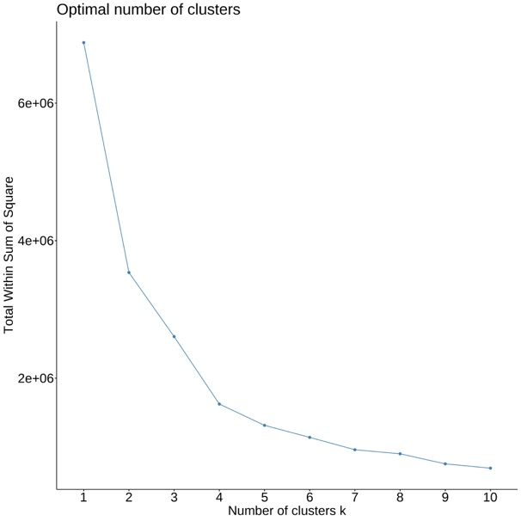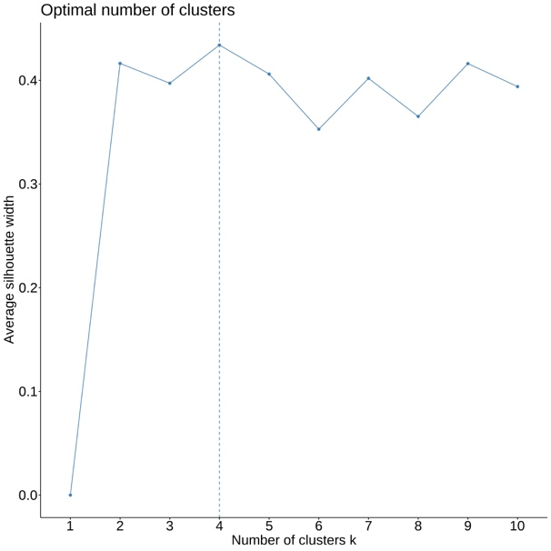
Note. Elbow plot (left) and silhouette plot (right).

ANES 2020

Table SI4.3. Cluster Overview.
Clusters | Cluster Size |  |  |  |  |  |  |  | Between/Total Sum of Squares | Reduced Within Sum of Squares
2 | 3288 |  | 4828 |  |  |  |  |  | 62.3% | /
3 | 2622 |  | 2621 | 2873 |  |  |  |  | 75.0% | 12.7%
4 | 682 | 2641 | 2689 | 2104 |  |  |  |  | 82.6% | 7.6%
5 | 2323 | 2292 | 1322 | 645 | 1534 |  |  |  | 85.7% | 3.1%
6 | 1131 | 1531 | 580 | 1267 | 1284 | 2323 |  |  | 87.8% | 2.1%
7 | 2290 | 1253 | 1036 | 535 | 1193 | 637 | 1172 |  | 89.6% | 1.8%
8 | 1319 | 1561 | 824 | 382 | 470 | 1257 | 1269 | 1034 | 91.5% | 1.9%

Table SI4.4. Fit Statistics.
Fit statistic | Value | Best-fitting solution
KL | 7.53 | 2
CH | 12785.94 | 4
Hartigan | 2907.86 | 4
CCC | 172.6 | 3
Scott | 7960.64 | 3
Marriot | 1.2834E+13 | 4
TrCovW | 1.2251E+13 | 3
TraceW | 1093440.84 | 3
Friedman | 15.42 | 7
Rubin | -3.76 | 4
Cindex | 0.19 | 3
DB | 0.79 | 4
Silhouette | 0.51 | 2
Duda | 0.75 | 2
PseudoT2 | 1721.85 | 2
Beale | 0.33 | 2
Ratkowsky | 0.55 | 2
Ball | 1905623.39 | 3
PtBiserial | 0.66 | 2
Frey | NA | 1
McClain | 0.45 | 2
Dunn | 0.03 | 8
Hubert | 0 | 0
SDindex | 0.06 | 4
Dindex | 0 | 0
SDbw | 0.26 | 8
Note. See Charrad and colleagues (2014) for more information on the single fit statistics.
FIGURE SI4.2. Visual Heuristics.

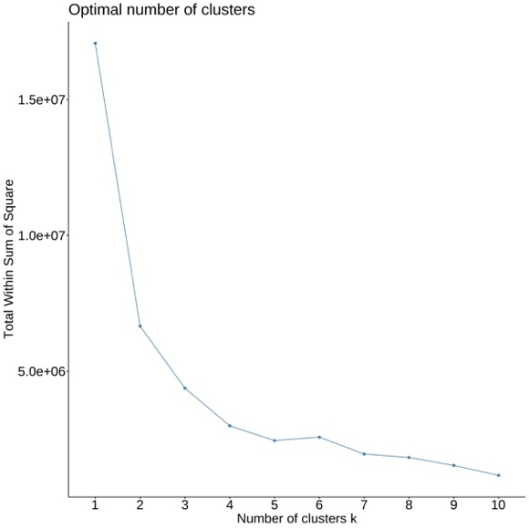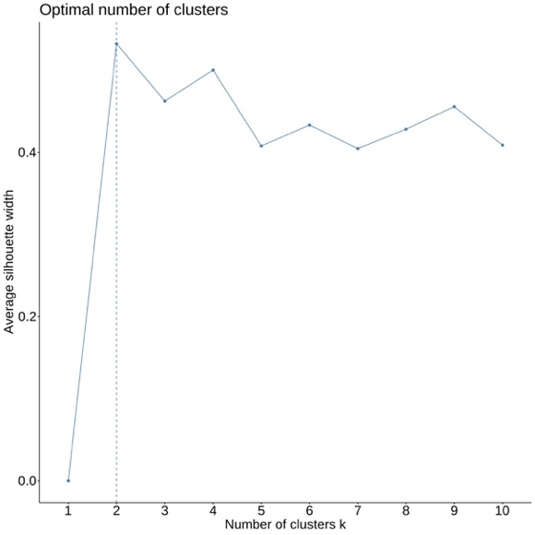
Note. Elbow plot (left) and silhouette plot (right).
YouGov 2024

Table SI4.5. Cluster Overview.
Clusters | Cluster Size |  |  |  |  |  |  |  | Between/Total Sum of Squares | Reduced Within Sum of Squares
2 | 806 |  | 1019 |  |  |  |  |  | 48.9% | /
3 | 687 |  | 812 | 326 |  |  |  |  | 66.4% | 17.5%
4 | 557 | 479 | 518 | 271 |  |  |  |  | 80.5% | 14.1%
5 | 203 | 254 | 503 | 529 | 336 |  |  |  | 84.1% | 3.6%
6 | 287 | 197 | 237 | 244 | 517 | 332 |  |  | 86.6% | 2.5%
7 | 286 | 302 | 186 | 345 | 278 | 225 | 203 |  | 88.9% | 2.3%
8 | 270 | 279 | 130 | 277 | 178 | 179 | 224 | 288 | 90.6% | 1.7%

Table SI4.6. Fit Statistics.
Fit statistic | Value | Best-fitting solution
KL | 4.67 | 4
CH | 2510.27 | 4
Hartigan | 1313.62 | 4
CCC | 64.34 | 4
Scott | 2162.28 | 4
Marriot | 2.5232E+12 | 4
TrCovW | 5.7694E+11 | 3
TraceW | 593491.89 | 4
Friedman | 12.44 | 4
Rubin | -4.48 | 4
Cindex | 0.26 | 6
DB | 0.77 | 4
Silhouette | 0.5 | 4
Duda | 1.07 | 2
PseudoT2 | -89.28 | 2
Beale | -0.07 | 2
Ratkowsky | 0.48 | 2
Ball | 557750.75 | 3
PtBiserial | 0.66 | 4
Frey | NA | 1
McClain | 0.54 | 2
Dunn | 0.02 | 4
Hubert | 0 | 0
SDindex | 0.05 | 4
Dindex | 0 | 0
SDbw | 0.25 | 8
Note. See Charrad and colleagues (2014) for more information on the single fit statistics.
FIGURE SI4.3. Visual Heuristics.

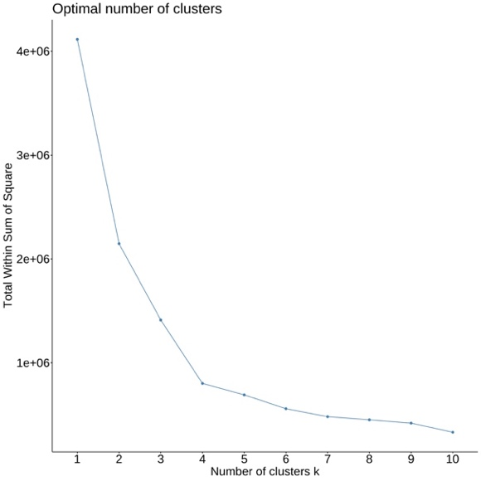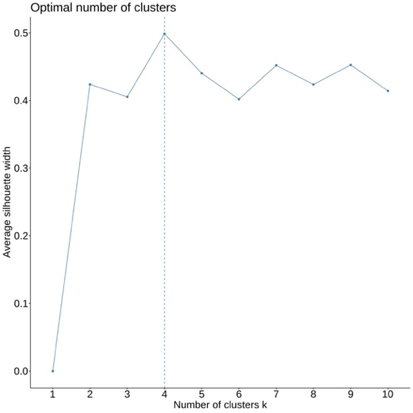
Note. Elbow plot (left) and silhouette plot (right).

SI5: Demographic Composition of Clusters

Table SI5.1. Demographic Composition of the Clusters, 2016
Variable | Aggregate | Unpolarized Supporters | Unpolarized Skeptics | Polarized Republicans | Polarized Democrats
Age | 49.6 (17.5) | 47.26 (17.59) | 47.9 (16.92) | 53.68 (17.09)* | 49.57 (17.49)*
Female | 52.8% | 54.7% | 41.8%* | 48.1%* | 58.7%*
Male | 47.2% | 45.3% | 58.2%* | 51.9%* | 41.3%*
White | 72% | 67.2% | 78.4%* | 89.9%* | 60.4%*
Black | 9.5% | 8.4% | 5.9% | 0.6%* | 19.3%*
Asian | 3.5% | 4.8% | 3.6% | 1.8%* | 3.1%*
Native American | 0.6% | 1% | 0.4% | 0.2%* | 0.6%
Hispanic | 10.4% | 14% | 8.3%* | 4.2%* | 12.2%
Other race (incl. multiple) | 4.1% | 4.7% | 3.4% | 3.3% | 4.3%
Less than high school | 6.4% | 9.1% | 3.8%* | 4.7%* | 5.8%*
High school | 40.2% | 44.3% | 39.2% | 41.3% | 34.9%*
Associate’s degree | 14.3% | 15.2% | 12.1% | 17.1% | 12%*
Bachelor’s degree | 22.8% | 20.3% | 26.3%* | 24.4%* | 23.1%
Master’s degree | 14% | 9.1% | 16%* | 11.4% | 20.9%*
Professional/doctorate | 2.2% | 2% | 2.6% | 1.1% | 3.2%*
Currently working | 60% | 62.2% | 63.5% | 55.6%* | 59.8%
Temporarily laid off | 1.1% | 1.4% | 1.4% | 1.3% | 0.6%*
Unemployed | 5.1% | 6.3% | 5.2% | 2.8%* | 5.7%
Retired | 21.7% | 17.4% | 17.7% | 28.1%* | 23%*
Permanently disabled | 4.2% | 4.4% | 4.6% | 3.1% | 4.6%
Homemaker | 5.2% | 5.3% | 4.4% | 7.5%* | 3.5%*
Student | 2.6% | 3% | 3.2% | 1.6%* | 2.9%
Individual income | 15.4 (8.1) | 14.24 (8.08) | 16.54 (8.18)* | 16.45 (7.56)* | 15.56 (8.21)*
Religious | 65.6% | 68.4% | 56.8%* | 80.6%* | 53.7%*
Not religious | 34.4% | 31.6% | 43.2%* | 19.4%* | 46.3%*
Partisanship | 3.9 (2.2) | 3.85 (1.73) | 4.36 (1.53)* | 6.26 (1.06)* | 1.76 (1.09)*
Ideology | 5.7 (2.5) | 5.63 (1.8) | 5.62 (2.31) | 7.62 (1.71)* | 4.39 (2.69)*
Political interest | 2.9 (0.8) | 2.61 (0.84) | 2.92 (0.91)* | 3.0 (0.75)* | 3.03 (0.84)*
Media interest | 2.8 (0.8) | 2.56 (0.81) | 2.81 (0.86)* | 2.9 (0.77)* | 2.96 (0.79)*
Note. The table shows means and standard deviations (in parentheses) for numeric variables and percentages for categorical variables. * denotes p < .05 compared to Unpolarized Supporters. Significantly higher values are shaded blue, significantly lower values are shaded red. Income is measured in 28 categories, partisanship 1 (strong Democrat) – 7 (strong Republican), ideology 0 (left) – 10 (right), political interest 1 (not at all) – 4 (very), media interest 1 (not at all) – 4 (very closely).

Table SI5.2. Demographic Composition Clusters, 2020
Variable | Aggregate | Unpolarized Supporters | Unpolarized Skeptics | Polarized Republicans | Polarized Democrats
Age | 51.5 (17.2) | 48.33 (17.26) | 43.7 (16.16)* | 55.01 (16.32)* | 52.45 (17.11)*
Female | 54% | 59.1% | 39.3%* | 49.2%* | 58.6%
Male | 46% | 40.9% | 60.7%* | 50.8%* | 41.4%
White | 73.1% | 63% | 74.6%* | 87.7%* | 66.2%*
Black | 8.8% | 11.5% | 5.4%* | 1.1%* | 15.2%*
Asian | 9.3% | 13.4% | 9.7%* | 5.3%* | 9.8%*
Native American | 3.5% | 5.6% | 3.3%* | 1.8%* | 3.5%*
Hispanic | 2.1% | 2.8% | 3.3% | 1.6%* | 1.7%*
Other race (incl. multiple) | 3.3% | 3.7% | 3.9% | 2.4%* | 3.7%
Less than high school | 4.5% | 6.6% | 3.6%* | 4.1%* | 3.6%*
High school | 16.2% | 19.8% | 12.4%* | 18.6% | 12.1%*
College | 20.7% | 21.6% | 19% | 23.3% | 17.8%*
Associate’s degree | 13.6% | 13.5% | 11.5% | 16.3%* | 11.5%*
Bachelor’s degree | 25.3% | 23% | 30.2%* | 23.6% | 27.5%*
Master’s degree | 14.6% | 12.3% | 16.8%* | 10.6% | 19.8%*
Professional/doctorate | 5% | 3% | 6.5%* | 3.5% | 7.7%*
Currently working | 62.7% | 65.5% | 73.1%* | 59.2%* | 61.2%*
Temporarily laid off | 2.8% | 2.7% | 4.1% | 2.1% | 3.4%
Unemployed | 1.8% | 2.1% | 2.6% | 1.1%* | 2.1%
Retired | 22.3% | 17% | 11.2%* | 27.2%* | 24.3%*
Permanently disabled | 3.9% | 4.5% | 3.5% | 3.5% | 3.9%
Homemaker | 5.3% | 6.3% | 3.7%* | 6.4% | 3.8%*
Student | 1.3% | 2% | 1.8% | 0.5%* | 1.3%*
Family income | 11.8 (6.7) | 10.54 (6.8) | 11.8 (6.96)* | 12.27 (6.42)* | 12.31 (6.82)*
Importance of religion | 3.2 (1.5) | 3.18 (1.42) | 2.63 (1.56)* | 3.78 (1.3)* | 2.77 (1.5)*
Partisanship | 3.9 (2.3) | 3.61 (1.75) | 3.94 (1.42)* | 6.27 (1.04)* | 1.75 (1.09)*
Ideology | 4.1 (1.7) | 3.92 (1.11) | 3.75 (1.56)* | 5.66 (1.04)* | 2.74 (1.16)*
Political interest | 2.9 (0.8) | 2.6 (0.85) | 2.79 (0.93)* | 2.96 (0.8)* | 3.13 (0.8)*
Media interest | 2.8 (0.8) | 2.53 (0.8) | 2.69 (0.87)* | 2.81 (0.8)* | 3.09 (0.78)*
Note. The table shows means and standard deviations (in parentheses) for numeric variables and percentages for categorical variables. * denotes p < .05 compared to Unpolarized Supporters. Significantly higher values are shaded blue, significantly lower values are shaded red. Income is measured in 22 categories, importance of religion 1 (not at all) – 5 (extremely), partisanship 1 (strong Democrat) – 7 (strong Republican), ideology 1 (extremely liberal) – 7 (extremely conservative), political interest 1 (not at all) – 4 (very), media interest 1 (not at all) – 4 (very closely).

Table SI5.3. Demographic Composition Clusters, 2024
Variable | Aggregate | Unpolarized Supporters | Unpolarized Skeptics | Polarized Republicans | Polarized Democrats
Age | 50.9 (17.6) | 44.17 (17.43) | 47.14 (16.17)* | 56.14 (16.12)* | 53.8 (17.65)*
Female | 51.5% | 53.7% | 47.2% | 48.3% | 54.6%
Male | 47.3% | 45.7% | 48.7% | 51.4% | 44.2%
Non-binary | 0.9% | 0.4% | 3.3%* | 0.0% | 0.9%
Other gender | 0.4% | 0.2% | 0.7% | 0.4% | 0.4%
White | 68.2% | 61.2% | 66.1% | 83.8%* | 60.7%
Black | 11.6% | 18% | 9.2%* | 2.7%* | 15.6%
Hispanic | 9.6% | 10.2% | 10.7% | 6.2%* | 11.7%
Asian | 3.1% | 4.4% | 1.5%* | 1.9%* | 3.9%
Native American | 1.4% | 1.9% | 2.2% | 1.2% | 0.9%
Two or more races | 3.8% | 2.9% | 7.7%* | 1.5% | 4.8%
Other race | 1.9% | 1% | 2.2% | 2.5% | 2%
Middle Eastern | 0.3% | 0.4% | 0.4% | 0.2% | 0.4%
Less than high school | 3.2% | 5.2% | 1.8%* | 3.3% | 2%*
High school graduate | 32.2% | 39.5% | 29.9%* | 34.6% | 25%*
Some college | 19% | 14.6% | 23.2%* | 20.8%* | 19%
2-year | 10% | 9.6% | 9.6% | 11% | 9.5%
4-year | 21.9% | 20.3% | 23.6% | 20.3% | 24.1%
Post-grad | 13.7% | 10.9% | 11.8% | 10% | 20.5%*
Full-time | 35.5% | 35.5% | 38.4% | 35.3% | 34.1%
Part-time | 12.1% | 17.5% | 7.4%* | 10.2%* | 11.5%*
Temporarily laid-off | 0.9% | 0.6% | 0.7% | 0.8% | 1.3%
Unemployed | 7.1% | 8.6% | 12.5% | 4.6%* | 5.6%
Retired | 25.2% | 15.9% | 17.3% | 31.5%* | 31.2%*
Permanently disabled | 7.1% | 6.9% | 8.1% | 7.3% | 6.5%
Homemaker | 6.3% | 6.9% | 8.5% | 6.4% | 4.7%
Student | 3.7% | 6.5% | 4.4% | 0.8%* | 3.6%*
Other occupation | 2.2% | 1.7% | 2.6% | 3.1% | 1.6%
Family income | 6.6 (3.6) | 6.23 (3.66) | 6.74 (3.63) | 6.78 (3.39)* | 6.72 (3.54)*
Importance of religion | 2.8 (1.1) | 3.01 (1) | 2.53 (1.18)* | 3.21 (1)* | 2.46 (1.18)*
Partisanship | 3.9 (2.2) | 3.93 (1.99) | 4.18 (1.51) | 6.12 (1.17)* | 1.75 (1.08)*
Ideology | 3.1 (1.2) | 3.11 (0.92) | 3.11 (1.15) | 4.07 (0.82)* | 2.19 (0.83)*
Political interest | 3.1 (1) | 2.68 (0.96) | 2.99 (1.08)* | 3.27 (0.94)* | 3.39 (0.87)*
Note. The table shows means and standard deviations (in parentheses) for numeric variables and percentages for categorical variables. * denotes p < .05 compared to Unpolarized Supporters. Significantly higher values are shaded blue, significantly lower values are shaded red. Income is measured in 16 categories, importance of religion 1 (not at all) – 4 (very), partisanship 1 (strong Democrat) – 7 (strong Republican), ideology 1 (very liberal) – 5 (very conservative), political interest 1 (hardly at all) – 4 (most of the time).

SI6: Regression Tables

Table SI6.1. Full Regression Results Trust, Norms, Inter-Partisan Attitudes, and Voting (All Surveys)
 | 2016 Trust | 2020 Trust | 2024 Trust | 2020 Norms | 2024 Norms | 2016 Violence justification | 2020 Violence justification | 2024 Threat justification | 2024 Violence for goals | 2024 Violence retribution | 2024 Moral disengagement | 2024 Willingness to respect | 2024 Willingness to interact | 2020 Vote intention | 2024 Vote intention
Unpolarized Skeptics | -0.10 (0.02)*** | -0.10 (0.01)*** | -0.10 (0.02)*** | 0.03 (0.00)*** | -0.02 (0.02) | -0.01 (0.01) | 0.00 (0.01) | -0.06 (0.02)*** | -0.08 (0.02)*** | 0.00 (0.03) | -0.04 (0.02) | -0.08 (0.03)** | -0.00 (0.03) | 0.04 (0.02) | 0.04 (0.01)***
Polarized Republicans | -0.04 (0.01)** | -0.06 (0.01)*** | -0.13 (0.02)*** | -0.03 (0.00)*** | -0.05 (0.02)** | -0.02 (0.01)* | -0.02 (0.01)** | -0.05 (0.01)** | -0.08 (0.02)*** | 0.07 (0.03)* | 0.14 (0.02)*** | -0.09 (0.02)*** | -0.02 (0.02) | 0.16 (0.02)*** | 0.14 (0.01)***
Polarized Democrats | -0.00 (0.01) | -0.01 (0.01) | 0.02 (0.02) | 0.05 (0.00)*** | 0.13 (0.02)*** | -0.02 (0.01)** | -0.00 (0.01) | -0.06 (0.01)*** | -0.07 (0.02)*** | 0.03 (0.03) | 0.13 (0.02)*** | -0.13 (0.03)*** | -0.05 (0.03) | 0.19 (0.02)*** | 0.13 (0.01)***
Age | 0.00 (0.00)** | 0.00 (0.00)*** | 0.00 (0.00) | 0.00 (0.00)*** | 0.00 (0.00) | -0.00 (0.00)*** | -0.00 (0.00)*** | -0.00 (0.00)*** | -0.00 (0.00)*** | -0.00 (0.00)*** | -0.00 (0.00) | 0.00 (0.00) | 0.00 (0.00)** | 0.00 (0.00)*** | 0.00 (0.00)***
Male | 0.01 (0.01) | 0.01 (0.01)* | 0.03 (0.01)** | 0.01 (0.00)*** | -0.02 (0.01) | 0.01 (0.01)* | 0.00 (0.00) | 0.04 (0.01)*** | 0.05 (0.01)*** | 0.09 (0.02)*** | -0.00 (0.01) | 0.02 (0.02) | 0.07 (0.02)*** | 0.01 (0.01) | -0.02 (0.01)**
Non-binary |  |  | -0.00 (0.06) |  | 0.17 (0.05)** |  |  | -0.03 (0.05) | -0.01 (0.06) | 0.08 (0.09) | 0.01 (0.06) | -0.07 (0.08) | 0.04 (0.08)
Other gender |  |  | -0.03 (0.10) |  | 0.06 (0.10) |  |  | 0.03 (0.08) | 0.03 (0.10) | 0.08 (0.15) | -0.00 (0.11) | -0.03 (0.14) | -0.04 (0.14)
Black American | 0.01 (0.02) | -0.01 (0.01) | 0.02 (0.02) | -0.02 (0.00)*** | 0.00 (0.02) | 0.07 (0.01)*** | 0.05 (0.01)*** | 0.03 (0.02)* | 0.05 (0.02)** | 0.08 (0.03)** | 0.01 (0.02) | 0.04 (0.03) | -0.03 (0.03) | 0.06 (0.02)* | 0.00 (0.01)
Asian American | 0.02 (0.03) | 0.03 (0.01)** | 0.02 (0.03) | -0.01 (0.00)** | -0.00 (0.03) | 0.08 (0.02)*** | 0.03 (0.01)*** | 0.01 (0.03) | 0.04 (0.03) | 0.02 (0.05) | 0.04 (0.04) | 0.01 (0.05) | -0.07 (0.05) | -0.14 (0.03)*** | -0.04 (0.01)***
Native American | -0.04 (0.06) | 0.02 (0.02) | 0.06 (0.05) | -0.01 (0.00)** | 0.04 (0.05) | -0.04 (0.04) | 0.07 (0.01)*** | -0.02 (0.04) | -0.01 (0.05) | 0.05 (0.08) | 0.09 (0.06) | -0.03 (0.07) | -0.03 (0.07) | -0.03 (0.10) | -0.09 (0.02)***
Hispanic American | 0.02 (0.02) | -0.03 (0.02) | 0.05 (0.02)** | -0.02 (0.01)** | -0.02 (0.02) | 0.06 (0.01)*** | 0.02 (0.02) | 0.00 (0.02) | 0.02 (0.02) | 0.02 (0.03) | 0.02 (0.02) | 0.02 (0.03) | -0.08 (0.03)** | -0.08 (0.02)*** | -0.02 (0.02)
Other (incl. multiple) | -0.04 (0.02) | -0.02 (0.02) | 0.02 (0.03) | -0.01 (0.00)** | 0.04 (0.03) | -0.00 (0.02) | 0.04 (0.01)*** | -0.01 (0.03) | -0.01 (0.03) | 0.07 (0.05) | -0.06 (0.03) | 0.02 (0.04) | -0.01 (0.04) | 0.01 (0.04) | -0.04 (0.02)*
Other (YouGov) |  |  | -0.04 (0.05) |  | -0.01 (0.04) |  |  | -0.02 (0.04) | 0.01 (0.04) | 0.11 (0.07) | 0.02 (0.05) | -0.08 (0.07) | -0.10 (0.07)
Middle Eastern |  |  | 0.08 (0.09) |  | -0.04 (0.09) |  |  | -0.00 (0.08) | 0.04 (0.09) | 0.17 (0.14) | -0.11 (0.10) | 0.01 (0.13) | -0.09 (0.13)
High school | -0.01 (0.02) | -0.01 (0.02) | 0.06 (0.03) | 0.01 (0.00)** | 0.00 (0.03) | -0.06 (0.01)*** | -0.05 (0.01)*** | -0.03 (0.03) | -0.02 (0.03) | -0.02 (0.05) | -0.01 (0.04) | -0.02 (0.05) | -0.01 (0.05) | 0.06 (0.03)* | 0.10 (0.02)***
College |  | -0.01 (0.02) |  | 0.04 (0.00)*** |  |  | -0.08 (0.01)*** |  |  |  |  |  |  |  | 0.17 (0.02)***
Associate’s degree | -0.04 (0.02) | -0.00 (0.02) |  | 0.03 (0.00)*** |  | -0.07 (0.01)*** | -0.08 (0.01)*** |  |  |  |  |  |  | 0.13 (0.03)*** | 0.18 (0.02)***
Bachelor’s degree | -0.01 (0.02) | 0.01 (0.02) |  | 0.05 (0.00)*** |  | -0.07 (0.01)*** | -0.09 (0.01)*** |  |  |  |  |  |  | 0.17 (0.03)*** | 0.21 (0.02)***
Master’s degree | -0.00 (0.02) | -0.00 (0.02) |  | 0.06 (0.00)*** |  | -0.06 (0.02)*** | -0.08 (0.01)*** |  |  |  |  |  |  | 0.16 (0.03)*** | 0.21 (0.02)***
Professional/doctorate | 0.03 (0.04) | -0.00 (0.02) |  | 0.06 (0.01)*** |  | -0.08 (0.02)** | -0.07 (0.01)*** |  |  |  |  |  |  | 0.14 (0.05)* | 0.21 (0.02)***
High school graduate |  |  | 0.04 (0.03) |  | 0.02 (0.03) |  |  | -0.03 (0.03) | -0.03 (0.03) | -0.04 (0.06) | -0.03 (0.04) | 0.01 (0.05) | 0.06 (0.05)
Some college |  |  | 0.11 (0.04)** |  | 0.04 (0.03) |  |  | -0.01 (0.03) | -0.02 (0.04) | 0.01 (0.06) | -0.02 (0.04) | -0.01 (0.05) | 0.01 (0.05)
2-year |  |  | 0.08 (0.03)* |  | 0.03 (0.03) |  |  | -0.01 (0.03) | -0.00 (0.03) | 0.00 (0.06) | -0.04 (0.04) | 0.02 (0.05) | 0.04 (0.05)
4-year |  |  | 0.09 (0.04)* |  | 0.03 (0.03) |  |  | -0.01 (0.03) | -0.02 (0.04) | -0.07 (0.06) | -0.10 (0.04)* | 0.03 (0.05) | 0.05 (0.05)
Post-grad | -0.06 (0.05) | -0.02 (0.02) | -0.01 (0.06) | 0.01 (0.00) | 0.10 (0.06) | 0.02 (0.03) | -0.01 (0.01) | -0.00 (0.05) | 0.01 (0.06) | 0.03 (0.10) | -0.03 (0.07) | 0.07 (0.08) | 0.05 (0.08) | -0.08 (0.06) | 0.04 (0.02)*
Temporarily laid off | -0.01 (0.02) | 0.05 (0.02)* | -0.02 (0.02) | 0.00 (0.01) | -0.02 (0.02) | 0.02 (0.01) | 0.01 (0.02) | -0.01 (0.02) | -0.02 (0.02) | 0.02 (0.04) | -0.01 (0.03) | 0.00 (0.03) | -0.03 (0.03) | -0.02 (0.03) | -0.03 (0.02)
Unemployed | 0.01 (0.01) | 0.01 (0.01) | 0.03 (0.02) | 0.00 (0.00) | -0.02 (0.02) | -0.01 (0.01) | 0.01 (0.01) | 0.03 (0.02)* | 0.03 (0.02) | -0.01 (0.03) | 0.02 (0.02) | -0.00 (0.03) | 0.00 (0.03) | -0.05 (0.02)* | 0.01 (0.01)
Retired | -0.06 (0.02)** | -0.02 (0.02) | 0.03 (0.02) | -0.01 (0.00)* | 0.02 (0.02) | -0.02 (0.02) | -0.02 (0.01) | -0.01 (0.02) | -0.04 (0.02) | -0.02 (0.04) | -0.00 (0.03) | 0.04 (0.03) | 0.03 (0.03) | -0.08 (0.03)* | -0.01 (0.02)
Permanently disabled | 0.01 (0.02) | -0.01 (0.01) | -0.03 (0.03) | 0.01 (0.00)* | -0.00 (0.02) | -0.02 (0.01) | 0.01 (0.01) | -0.00 (0.02) | -0.00 (0.02) | -0.08 (0.04)* | -0.03 (0.03) | 0.00 (0.04) | -0.00 (0.04) | -0.04 (0.03) | 0.01 (0.01)
Homemaker | 0.02 (0.03) | 0.01 (0.03) | -0.03 (0.03) | 0.00 (0.01) | -0.05 (0.03) | 0.00 (0.02) | 0.04 (0.02) | 0.01 (0.03) | 0.03 (0.03) | 0.04 (0.05) | 0.00 (0.04) | -0.06 (0.05) | -0.02 (0.05) | 0.04 (0.04) | 0.02 (0.03)
Student |  |  | 0.02 (0.02) |  | -0.04 (0.02)* |  |  | 0.01 (0.02) | 0.00 (0.02) | 0.02 (0.03) | -0.01 (0.02) | 0.02 (0.03) | 0.05 (0.03)*
Part-time |  |  | 0.02 (0.04) |  | -0.04 (0.04) |  |  | -0.04 (0.03) | -0.04 (0.04) | 0.05 (0.07) | 0.04 (0.05) | 0.05 (0.06) | 0.07 (0.06)
Other occupation | -0.00 (0.00) |  |  |  |  | -0.00 (0.00)*** |  |  |  |  |  |  |  | 0.00 (0.00)***
Individual income |  | 0.00 (0.00) | 0.00 (0.00)** | 0.00 (0.00)*** | -0.00 (0.00) |  | -0.00 (0.00)*** | -0.00 (0.00) | 0.00 (0.00) | -0.00 (0.00) | -0.00 (0.00) | 0.01 (0.00)** | 0.01 (0.00)** |  | 0.01 (0.00)***
Family income | 0.04 (0.01)*** |  |  |  |  | 0.01 (0.01)* |  |  |  |  |  |  |  | 0.05 (0.01)**
Religious |  | 0.01 (0.00)*** | -0.00 (0.01) | -0.00 (0.00)*** | -0.02 (0.01)*** |  | -0.00 (0.00) | 0.01 (0.00) | 0.01 (0.01)* | -0.00 (0.01) | 0.01 (0.01) | 0.02 (0.01)** | 0.01 (0.01) |  | 0.01 (0.00)***
Religion importance | 0.00 (0.00) | -0.01 (0.00)*** | -0.01 (0.00)*** | -0.01 (0.00)*** | -0.02 (0.00)*** | 0.00 (0.00) | -0.00 (0.00) | 0.00 (0.00) | 0.00 (0.00) | 0.00 (0.01) | -0.01 (0.00) | -0.00 (0.01) | -0.00 (0.01) | 0.00 (0.00) | -0.01 (0.00)***
Partisanship | 0.04 | 0.06 | 0.18 | 0.38 | 0.29 | 0.08 | 0.09 | 0.12 | 0.16 | 0.07 | 0.10 | 0.05 | 0.06 | 0.22 | 0.21
R² | 0.03 | 0.05 | 0.16 | 0.38 | 0.28 | 0.07 | 0.09 | 0.10 | 0.15 | 0.05 | 0.09 | 0.03 | 0.04 | 0.21 | 0.21
R²_{Adjusted} | 3,307 | 6,498 | 1,630 | 7,200 | 1,630 | 3,845 | 7,236 | 1,618 | 1,594 | 1,533 | 1,623 | 1,630 | 1,630 | 1,858 | 6,883
Note. * p < .05, ** < .01, *** < .001. Standard errors in parentheses. Reference category: Unpolarized Supporters, female (gender), white (race), less than high school (education), full-time/working now (employment), not religious (religious).

Table SI6.2. Results Non-Electoral Political Participation (All Surveys)
 | 2016 |  |  |  |  | 2020
 | Protest | Petition | Donate | Post online | Contact politician | Protest | Petition | Donate | Post online | Contact politician
Unpolarized Skeptics | 3.44 [1.71; 6.94]*** | 1.84 [1.39; 2.43]*** | 1.42 [1.05; 1.92]* | 1.86 [1.43; 2.40]*** | 1.95 [1.33; 2.83]*** | 1.84 [1.32; 2.54]*** | 1.82 [1.45; 2.27]*** | 2.20 [1.70; 2.83]*** | 1.64 [1.33; 2.02]*** | 2.36 [1.76; 3.16]***
Polarized Republicans | 0.86 [0.26; 2.47] | 1.26 [0.95; 1.69] | 1.01 [0.75; 1.37] | 2.13 [1.66; 2.74]*** | 1.40 [0.95; 2.07] | 1.43 [1.01; 2.04]* | 2.10 [1.71; 2.59]*** | 01.42 1.12; 1.81]** | 2.61 [2.17; 3.14]*** | 2.17 [1.65; 2.86]***
Polarized Democrats | 2.77 [1.53; 5.23]** | 2.19 [1.72; 2.79]*** | 1.64 [1.25; 2.14]*** | 2.09 [1.67; 2.63]*** | 1.97 [1.40; 2.80]*** | 2.08 [1.60; 2.71]*** | 2.17 [1.83; 2.58]*** | 2.21 1.81; 2.70]*** | 2.27 [1.93; 2.66]*** | 3.05 [2.41; 3.87]***
Age | 0.97 [0.95; 0.98]*** | 0.99 [0.99; 1.00]* | 1.01 [1.01; 1.0]2*** | 0.97 [0.97; 0.98]*** | 1.02 [1.01; 1.03]*** | 0.97 [0.97; 0.98]*** | 0.98 [0.98; 0.99]*** | 1.01 [1.00; 1.01]** | 0.99 [0.98; 0.99]*** | 1.01 [1.00; 1.01]**
Male | 0.97 [0.63; 1.47] | 0.72 [0.61; 0.86]*** | 1.02 [0.85; 1.23] | 0.75 [0.64; 0.88]*** | 1.27 [1.00; 1.60]* | 0.98 [0.82; 1.17] | 0.73 [0.65; 0.82]*** | 0.77 [0.68; 0.88]*** | 0.77 [0.69; 0.85]*** | 0.97 [0.84; 1.12]
Black American | 1.23 [0.67; 2.19] | 0.70 [0.51; 0.95]* | 0.58 [0.39; 0.83]** | 0.58 [0.44; 0.78]*** | 0.60 [0.37; 0.95]* | 0.89 [0.64; 1.22] | 0.72 [0.58; 0.89]** | 0.50 [0.38; 0.65]*** | 0.59 [0.48; 0.72]*** | 0.50 [0.37; 0.68]***
Asian American | 0.49 [0.08; 1.65] | 0.91 [0.56; 1.45] | 0.59 [0.33; 0.98] | 0.56 [0.34; 0.90]* | 0.77 [0.38; 1.43] | 0.89 [0.66; 1.20] | 0.87 [0.70; 1.06] | 0.57 [0.44; 0.74]*** | 0.84 [0.70; 1.02] | 0.65 [0.48; 0.86]**
Native American | 6.54 [0.95; 27.31]* | 0.54 [0.08; 1.99] | 0.44 [0.02; 2.23] | 1.22 [0.43; 3.23] | 2.00 [0.31; 7.47] | 0.68 [0.41; 1.06] | 0.90 [0.66; 1.22] | 0.55 [0.38; 0.78]** | 0.69 [0.51; 0.93]* | 0.41 [0.25; 0.63]***
Hispanic American | 1.12 [0.56; 2.10] | 1.04 [0.77; 1.38] | 0.73 [0.51; 1.02] | 0.79 [0.61; 1.03] | 0.50 [0.29; 0.81]** | 1.10 [0.56; 1.96] | 1.09 [0.72; 1.61] | 0.53 [0.30; 0.90]* | 0.95 [0.65; 1.38] | 1.12 [0.68; 1.78]
Other (incl. multiple) | 1.02 [0.30; 2.61] | 1.14 [0.74; 1.73] | 0.89 [ 0.54; 1.42] | 0.97 [0.65; 1.43] | 1.52 [0.89; 2.50] | 1.07 [0.69; 1.60] | 1.44 [1.08; 1.92]* | 0.82 [0.57; 1.16] | 1.04 [0.78; 1.37] | 1.08 [0.75; 1.53]
High school | 2.00 [0.68; 8.51] | 2.34 [1.44; 4.04]** | 1.74 [1.00; 3.31] | 1.14 [0.80; 1.63] | 2.19 [1.02; 5.74] | 1.06 [0.59; 2.04] | 1.22 [0.83; 1.82] | 2.02 [1.04; 4.40] | 0.98 [0.72; 1.33] | 0.98 [0.59; 1.71]
College |  |  |  |  |  | 1.49 [0.85; 2.79] | 2.14 [1.49; 3.15]*** | 4.10 [2.18; 8.78]*** | 1.64 [1.22; 2.21]** | 1.73 [1.07; 2.95]*
Associate’s degree | 2.72 [0.83; 12.26] | 3.53 [2.10; 6.25]*** | 2.52 [1.40; 4.91]** | 1.30 [0.89; 1.93] | 4.35 [1.97; 11.56]*** | 1.22 [0.67; 2.34] | 2.26 [1.55; 3.35]*** | 4.45 [2.34; 9.59]*** | 1.46 [1.08; 2.00]* | 1.64 [1.00; 2.83]
Bachelor’s degree | 2.92 [0.94; 12.91 | 3.87 [2.33; 6.79]*** | 3.48 [1.97; 6.66]*** | 1.34 [0.92; 1.96] | 4.16 [1.91; 10.96]** | 1.94 [1.12; 3.64]* | 2.57 [1.79; 3.78]*** | 7.84 [4.19; 16.72]*** | 1.46 [1.09; 1.98]* | 12.71 [1.69; 4.59]***
Master’s degree | 4.89 [1.53; 22.02]* | 4.76 [2.80; 8.49]*** | 5.40 [3.01; 10.46]*** | 1.48 [0.99; 2.23] | 4.77 [2.14; 12.71]*** | 2.78 [1.57; 5.26]*** | 3.01 [2.06; 4.48]*** | 9.90 [5.25; 21.23]*** | 1.57 [1.15; 2.16]** | 3.41 [2.10; 5.83]***
Professional/doctorate | 0.00 [0.00; 0.00] | 2.99 [1.43; 6.31]** | 4.14 [1.96; 9.12]*** | 1.07 [0.56; 1.99] | 2.36 [0.79; 7.50] | 2.39 [1.26; 4.76]** | 2.77 [1.82; 4.30]*** | 12.06 [6.22; 26.36]*** | 1.56 [1.09; 2.24]* | 3.29 [1.94; 5.82]***
Temporarily laid off | 3.21 [0.49; 12.17] | 1.18 [0.46; 2.71] | 0.98 [0.32; 2.49] | 0.63 [0.24; 1.45] | 0.61 [0.10; 2.12] | 1.49 [0.96; 2.25] | 1.56 [1.14; 2.12]** | 1.19 [0.81; 1.72] | 1.65 [1.22; 2.22]** | 1.80 [1.24; 2.56]**
Unemployed | 0.95 [0.35; 2.14] | 1.26 [0.86; 1.82] | 0.93 [0.57; 1.45] | 0.97 [0.68; 1.36] | 0.84 [0.44; 1.49] | 1.25 [0.66; 2.18] | 0.91 [0.57; 1.40] | 0.82 [0.44; 1.45] | 0.89 [0.59; 1.34] | 1.35 [0.77; 2.26]
Retired | 1.52 [0.67; 3.35] | 1.19 [0.89; 1.57] | 0.91 [0.68; 1.22] | 0.94 [0.72; 1.23] | 0.80 [0.56; 1.14] | 0.97 [0.70; 1.34] | 1.18 [0.98; 1.41] | 1.17 [0.96; 1.43] | 0.97 [0.82; 1.15] | 0.94 [0.76; 1.16]
Permanently disabled | 0.70 [0.16; 2.08] | 1.60 [1.03; 2.43]* | 0.77 [0.41; 1.34] | 1.51 [1.02; 2.21]* | 0.87 [0.42; 1.65] | 0.60 [0.30; 1.09] | 1.10 [0.80; 1.50] | 0.66 [0.41; 1.02] | 1.21 [0.92; 1.59] | 1.00 [0.66; 1.48]
Homemaker | 1.14 [0.38; 2.75] | 0.88 [0.59; 1.30] | 0.74 [0.45; 1.17] | 1.05 [0.75; 1.46] | 0.91 [0.48; 1.58] | 1.03 [0.66; 1.55] | 0.99 [0.76; 1.29] | 1.11 [0.81; 1.50] | 0.97 [0.76; 1.23] | 0.78 [0.54; 1.12]
Student | 1.41 [0.54; 3.24] | 1.28 [0.78; 2.07] | 1.18 [0.60; 2.15] | 0.72 [0.46; 1.13] | 1.85 [0.88; 3.59] | 1.30 [0.69; 2.32] | 1.08 [0.65; 1.74] | 1.21 [0.61; 2.24] | 0.70 [0.43; 1.13] | 1.68 [0.85; 3.09]
Individual income | 0.98 [0.96; 1.01] | 1.01 [1.00; 1.02] | 1.03 [1.02; 1.05]*** | 0.99 [0.98; 1.01] | 1.02 [1.00; 1.04]*
Family income |  |  |  |  |  | 0.99 [0.98; 1.00] | 1.00 [0.99; 1.01] | 1.03 [1.02; 1.04]*** | 1.00 [0.99; 1.01] | 1.01 [1.00; 1.02]
Religious | 1.03 [0.66; 1.59] | 0.73 [0.61; 0.87]*** | 1.01 [0.83; 1.24] | 0.75 [0.63; 0.88]*** | 0.90 [0.70; 1.14]
Religion importance |  |  |  |  |  | 0.90 [0.85; 0.96]** | 0.97 [0.94; 1.02] | 0.99 [0.94; 1.04] | 0.96 [0.92; 1.00]* | 0.98 [0.94; 1.04]
Partisanship | 0.80 [0.67; 0.94]** | 0.93 [0.88; 1.00]* | 0.95 [0.89; 1.02] | 0.97 [0.92; 1.03] | 0.94 [0.86; 1.02] | 0.86 [0.80; 0.93]*** | 0.90 [0.86; 0.94]*** | 0.89 [0.85; 0.94]*** | 0.92 [0.89; 0.96]*** | 0.94 [0.88; 0.99]*
BIC | 1,022.85 | 3,661.38 | 3,252.47 | 4,193.84 | 2,374.58 | 4,027.66 | 7,676.51 | 6,259.87 | 8,636.20 | 5,687.69
N | 3,314 | 3,313 | 3,312 | 3,313 | 3,311 | 6,551 | 6,552 | 6,550 | 6,552 | 6,551
Note. * p < .05, ** < .01, *** < .001. Odds ratios and 95% confidence intervals. Reference category: Unpolarized Supporters, female (gender), white (race), less than high school (education), full-time/working now (employment), not religious (religious).

SI7: Unpolarized Americans Are Not Just Independents
One explanation for the existence of affectively unpolarized clusters (i.e., Unpolarized Supporters and Unpolarized Skeptics) may be that respondents in these groups are just ideologically centric or lack partisanship. However, Table SI7.1 shows that their reported warmth toward Republicans and Democrats reflects more than that. We plot the distribution of clusters across ideology and partisanship for all three surveys, respectively.
The table shows the expected patterns, such that Polarized Republicans are more conservative and more identified with Republicans, and Polarized Democrats are more liberal and more identified with Democrats. More importantly, however, Unpolarized Supporters and Unpolarized Skeptics are distributed across the ideological spectrum and partisanship. Both groups tend to be ideologically centric and less strongly identified with the parties, but they are substantially represented on any value of the ideological and partisanship spectrum.

Table SI7.1. Ideology and Partisanship Across Clusters (All Surveys)
 | 2016 |  |  |  | 2020 |  |  |  | 2024
 | Polarized Republicans | Polarized Democrats | Unpolarized Skeptics | Unpolarized Supporters | Polarized Republicans | Polarized Democrats | Unpolarized Skeptics | Unpolarized Supporters | Polarized Republicans | Polarized Democrats | Unpolarized Skeptics | Unpolarized Supporters
Ideology: 0 | 2.3% (2) | 69.8% (60) | 16.3%  (14) | 11.6%  (10)
Ideology: 1 | 0.0% (0) | 79.4% (85) | 9.3%  (10) | 11.2%  (12) | 3.3%  (12) | 71.4% (262) | 18.8%  (69) | 6.5%  (24) | 1.1%  (2) | 70.1% (122) | 16.7%  (29) | 12.1%  (21)
Ideology: 2 | 2.6% (5) | 76.0% (146) | 10.9%  (21) | 10.4%  (20) | 1.7%  (20) | 79.5% (954) | 5.6%  (67) | 13.2%  (159) | 3.4%  (11) | 65.6% (212) | 9.6%  (31) | 21.4%  (69)
Ideology: 3 | 0.5% (1) | 70.6% (151) | 8.4%  (18) | 20.6%  (44) | 4.0%  (36) | 54.4% (494) | 8.7%  (79) | 32.9%  (299) | 17.3% (107) | 30.0% (186) | 16.3%  (101) | 36.5%  (226)
Ideology: 4 | 4.2% (10) | 47.1% (112) | 10.1%  (24) | 38.7%  (92) | 16.1%  (285) | 30.8% (547) | 10.8%  (192) | 42.3%  (750) | 56.4% (207) | 4.1%  (15) | 14.4%  (53) | 25.1%  (92)
Ideology: 5 | 10.3% (100) | 23.5% (229) | 13.7%  (133) | 52.6%  (512) | 45.1%  (366) | 8.7%  (71) | 12.4%  (101) | 33.7%  (274) | 71.8% (171) | 0.8%  (2) | 13.4%  (32) | 13.9%  (33)
Ideology: 6 | 23.6% (87) | 18.4% (68) | 16.0%  (59) | 42.0%  (155) | 84.7% (1,251) | 2.8%  (42) | 4.1%  (61) | 8.3%  (123)
Ideology: 7 | 41.2% (139) | 10.7% (36) | 12.5%  (42) | 35.6%  (120) | 90.7%  (382) | 2.1%  (9) | 3.8%  (16) | 3.3%  (14)
Ideology: 8 | 50.4% (211) | 15.3% (64) | 12.2%  (51) | 22.2%  (93)
Ideology: 9 | 63.6% (143) | 16.0% (36) | 8.0%  (18) | 12.4%  (28)
Ideology: 10 | 45.7% (126) | 26.4% (73) | 8.7%  (24) | 19.2%  (53)
Ideology: Total | 24.0% (824) | 30.8% (1,060) | 12.0% (414) | 33.1% (1,139) | 33.8% (2,352) | 34.2% (2,379) | 8.4%  (585) | 23.6% (1,643) | 28.9% (498) | 31.2% (537) | 14.3%  (246) | 25.6%  (441)
Partisanship: 1 | 0.3% (3) | 81.5% (713) | 2.3%  (20) | 15.9%  (139) | 0.4%  (7) | 82.4% (1,592) | 1.7%  (33) | 15.6%  (301) | 0.2%  (1) | 78.8% (324) | 4.6%  (19) | 16.3%  (67)
Partisanship: 2 | 2.2% (12) | 45.9% (252) | 8.2%  (45) | 43.7%  (240) | 3.1%  (27) | 48.9% (433) | 7.7%  (68) | 40.3%  (357) | 4.3%  (9) | 50.5% (105) | 7.2%  (15) | 38.0%  (79)
Partisanship: 3 | 0.6% (3) | 43.6% (209) | 13.8%  (66) | 42.0%  (201) | 0.3%  (3) | 51.8% (498) | 15.6%  (150) | 32.3%  (311) | 1.4%  (2) | 60.3% (85) | 19.1%  (27) | 19.1%  (27)
Partisanship: 4 | 7.3% (40) | 8.2%  (45) | 24.7% (136) | 59.9%  (330) | 9.8%  (91) | 11.5% (106) | 22.8%  (211) | 55.9%  (517) | 13.2%  (41) | 10.3% (32) | 36.8%  (114) | 39.7%  (123)
Partisanship: 5 | 33.5% (165) | 1.6%  (8) | 24.2% (119) | 40.7%  (200) | 58.2%  (504) | 1.8%  (16) | 14.0%  (121) | 26.0%  (225) | 52.8%  (86) | 1.8%  (3) | 26.4%  (43) | 19.0%  (31)
Partisanship: 6 | 40.7% (202) | 4.2%  (21) | 13.9%  (69) | 41.1%  (204) | 54.2%  (446) | 3.6%  (30) | 7.9%  (65) | 34.3%  (282) | 50.8% (100) | 2.0%  (4) | 11.7%  (23) | 35.5%  (70)
Partisanship: 7 | 80.7% (580) | 0.3%  (2) | 6.4%  (46) | 12.7%  (91) | 91.6% (1,561) | 0.5%  (8) | 1.8%  (31) | 6.2%  (105) | 75.9% (274) | 0.6%  (2) | 6.6%  (24) | 16.9%  (61)
Partisanship: Total | 24.2% (1,005) | 30.0% (1,250) | 12.0% (501) | 33.8% (1,405) | 32.6% (2,639) | 33.1% (2,683) | 8.4%  (679) | 25.9% (2,098) | 28.6% (513) | 31.0% (555) | 14.8%  (265) | 25.6%  (458)

SI8: Unpolarized Skeptics Are Not Just Libertarians
An alternative to our affect-focused understanding may be ideological explanations. Rather than due to different affect, Unpolarized Skeptics may evolve as a group primarily because they are ideologically libertarian, such that they favor minimal state interventions and the private lives of citizens (Brennan 2012).
We can test this possibility with a feeling thermometer toward the libertarian presidential candidate in 2016. Table SI8.1 shows that Unpolarized Skeptics are not more likely to sympathize with libertarians. Instead, Unpolarized Supporters feel more warmly toward them than any other cluster. That is, there is a small but consistent effect that those feeling lukewarm toward both parties also tend to feel most warmly toward libertarians.
Another way to probe this explanation is by exploring the self-ascribed ideology. In the YouGov 2024 data, we asked whether respondents would consider themselves conservative, liberal, independent, libertarian, populist, or other. Fifty-six respondents (3.07%) described themselves as libertarian. Of this group, 39.3% are Polarized Republicans, 35.7% are Unpolarized Skeptics, 17.9% are Unpolarized Supporters, and 7.1% are Polarized Democrats. While this suggests that some Unpolarized Skeptics endorse libertarian ideology, it also shows that this cluster is not just an artifact of this ideology.

Table SI8.1. Results Warmth Libertarians (2016)
 | Warmth Libertarians
Unpolarized Skeptics | -0.08 (0.01)***
Polarized Republicans | -0.08 (0.01)***
Polarized Democrats | -0.10 (0.01)***
Age | -0.00 (0.00)***
Male | -0.00 (0.01)
Black American | -0.03 (0.02)*
Asian American | -0.01 (0.02)
Native American | 0.02 (0.06)
Hispanic American | -0.00 (0.01)
Other American (incl. multiple races) | -0.04 (0.02)
High school | 0.01 (0.02)
Associate’s degree | 0.02 (0.02)
Bachelor’s degree | 0.03 (0.02)
Master’s degree | 0.02 (0.02)
Professional or doctorate degree | 0.00 (0.03)
Temporarily laid off | 0.04 (0.04)
Unemployed | 0.01 (0.02)
Retired | -0.01 (0.01)
Permanently disabled | -0.02 (0.02)
Homemaker | -0.01 (0.02)
Student | -0.02 (0.02)
Individual income | 0.00 (0.00)
Religious | -0.00 (0.01)
Partisanship | -0.01 (0.00)*
R² | 0.06
R²_{Adjusted} | 0.05
N | 2,957
Note. * p < .05, ** < .01, *** < .001. Standard errors in parentheses. Reference category: Unpolarized Supporters, female (gender), white (race), less than high school (education), full-time/working now (employment), not religious (religious).

SI9: Unpolarized Skeptics Do Not Just Lack Political Knowledge
Given findings that more affectively polarized individuals tend to have more political knowledge (Krupnikov and Ryan 2022), it is possible that particularly Unpolarized Skeptics are just citizens with limited political knowledge. To evaluate this possibility, we create sum scores of three political knowledge items from both ANES surveys (on what does the US government spend the least, which party holds the House majority, which party holds the Senate majority). Table SI9.1 shows that Unpolarized Skeptics are more knowledgeable than Unpolarized Supporters and Polarized Republicans in 2016 and more knowledgeable than Unpolarized Supporters in 2020. Thus, a lack of knowledge does not explain the existence of this group.

Table SI9.1. Results Political Knowledge (2016 + 2020)
 | Knowledge 2016 | Knowledge 2020
Unpolarized Supporters | -0.20 (0.05)*** | -0.22 (0.04)***
Polarized Republicans | -0.13 (0.05)* | -0.04 (0.04)
Polarized Democrats | 0.04 (0.05) | 0.00 (0.04)
Age | 0.01 (0.00)*** | 0.01 (0.00)***
Male | 0.21 (0.03)*** | 0.29 (0.02)***
Black American | -0.02 (0.05) | -0.17 (0.04)***
Asian American | -0.10 (0.08) | -0.05 (0.04)
Native American | 0.00 (0.20) | 0.11 (0.05)*
Hispanic American | -0.01 (0.05) | -0.02 (0.07)
Other American (incl. multiple races) | 0.15 (0.07)* | -0.03 (0.06)
High school | 0.17 (0.06)** | 0.16 (0.05)**
College |  | 0.25 (0.05)***
Associate’s degree | 0.26 (0.07)*** | 0.22 (0.06)***
Bachelor’s degree | 0.42 (0.07)*** | 0.47 (0.05)***
Master’s degree | 0.61 (0.07)*** | 0.60 (0.06)***
Professional or doctorate degree | 0.60 (0.11)*** | 0.68 (0.07)***
Temporarily laid off | -0.14 (0.13) | -0.02 (0.06)
Unemployed | 0.06 (0.06) | 0.06 (0.08)
Retired | -0.02 (0.05) | 0.17 (0.03)***
Permanently disabled | -0.02 (0.07) | 0.02 (0.05)
Homemaker | 0.14 (0.07)* | 0.02 (0.05)
Student | 0.11 (0.09) | 0.25 (0.09)**
Individual income | 0.01 (0.00)***
Family income |  | 0.01 (0.00)***
Religious | -0.08 (0.03)**
Religion importance |  | -0.02 (0.01)**
Partisanship | 0.00 (0.01) | -0.02 (0.01)**
R² | 0.13 | 0.16
R²_{Adjusted} | 0.13 | 0.16
N | 3,725 | 7,113
Note. * p < .05, ** < .01, *** < .001. Standard errors in parentheses. Reference category: Unpolarized Skeptics, female (gender), white (race), less than high school (education), full-time/working now (employment), not religious (religious).

SI10: General Group Views and Straightlining
Another theoretical explanation for the unpolarized clusters may be that they differ in their general evaluation of other people: If Unpolarized Supporters or Unpolarized Skeptics would merely reflect a generally positive or negative view of other people and groups, their thermometer ratings should be consistently more positive and negative even across less political targets, respectively. Figure SI10.1 shows the four clusters’ views on different targets. We find that Unpolarized Supporters are not unanimously more positive toward all targets and that Unpolarized Skeptics are not unanimously more negative toward all targets.
FIGURE SI10.1. Feeling Thermometers Toward Various Groups

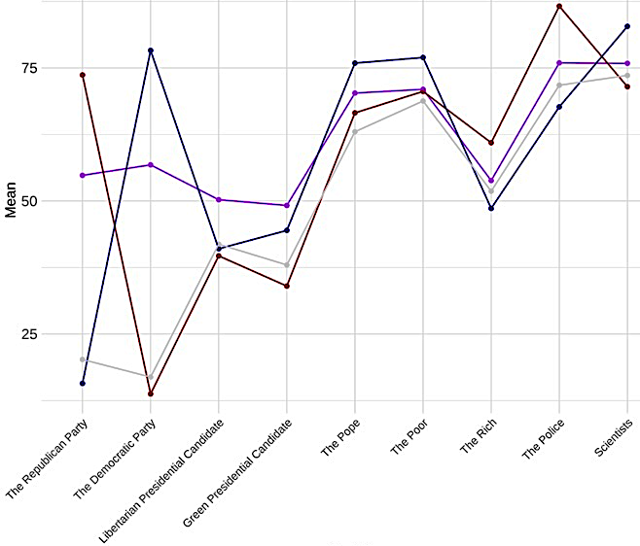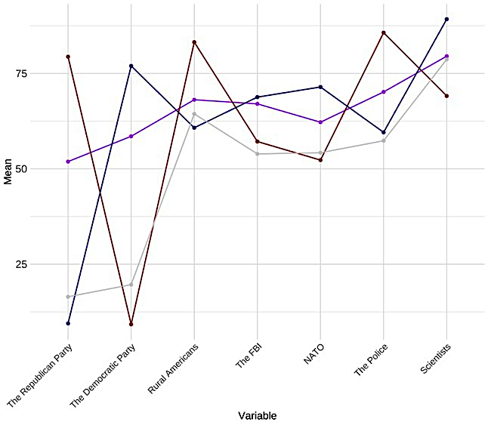
Note. Left plot shows groups in 2016, right plot shows groups in 2020. Dark red = Polarized Republicans; dark blue = Polarized Democrats; purple = Unpolarized Supporters; light gray = Unpolarized Skeptics.

A related but more methodological explanation is that especially the cluster of Unpolarized Supporters primarily reflect straightlining. Five reasons and analyses make us confident that Unpolarized Supporters are not just straightlining or providing “don’t know” answers. First, the ANES surveys include the options to answer “don’t know,” “don’t recognize,” “refused,” or similar in the feeling thermometers. We exclude these respondents from the data before running the cluster analysis. Second, Figure SI10.2 shows that there is variation in how respondents feel about different political targets. If they had sped through the survey, the patterns would look more similar. Moreover, they fulfill criterion validity, such that feelings toward a libertarian or Green candidate are more lukewarm than toward Republican or Democrat candidates. Third, the correlations between single thermometers (Figure SI10.3) corroborate this impression, such that the thermometers are correlated with what they are theorized to correlate with. For example, the thermometers for one party’s candidate are highly correlated with the party but strongly negatively associated with feelings toward the other party and their candidate. People liking the Democrats are also more sympathetic toward a Green candidate and Bill Clinton, but sympathizers of Republicans not so much. Likewise, the thermometer for a libertarian candidate is relatively weakly correlated with the other thermometers.
Fourth, when computing an irv-score (i.e., intra-individual response variability, Dunn et al. 2018) across the thermometers, only n = 34 respondents in 2016 and n = 136 respondents in 2020 have an irv of 0, which would indicate an identical score across all thermometers (i.e., straightlining or some other form of lacking attention). When excluding respondents with an irv-score of two standard deviations below the mean, the results remain substantially the same both for the cluster solutions and for the regression results.
Fifth, in the 2024 data we collected with YouGov, we can test whether the survey duration varies between the clusters. If, for example, respondents in the two unpolarized clusters would have significantly shorter survey durations, this could indicate that their cluster membership was due to speeding. However, a bivariate OLS regression of survey duration (in minutes and seconds) on clusters shows no significant differences between clusters (all p ≥ .580).
Together, we are confident that straightlining does not create the unpolarized clusters or explains the regression results.
FIGURE SI10.2. Distributions of Different Feeling Thermometers.

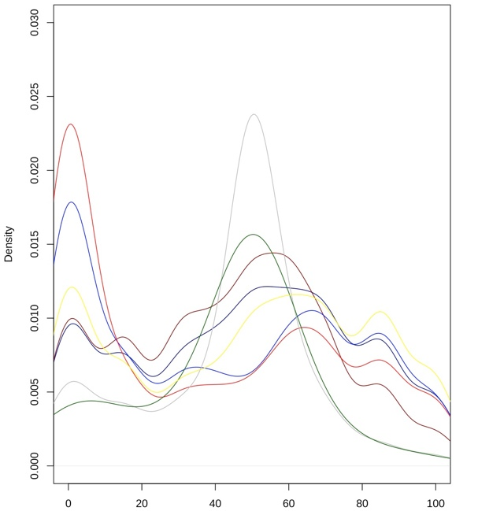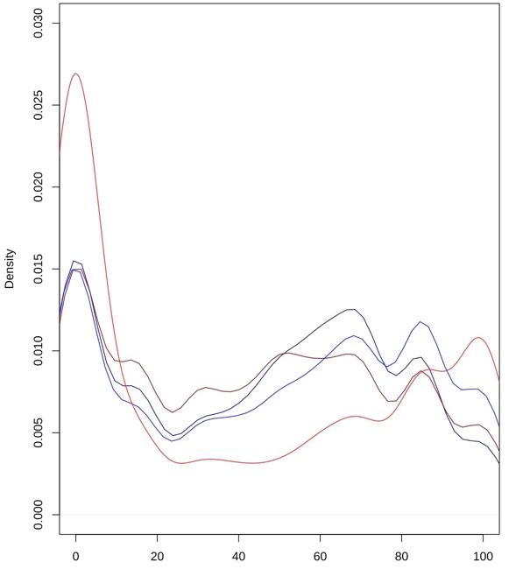
Note. ANES 2016 (left) and ANES 2020 (right). Dark red = Republican candidate; dark blue = Democrat candidate; red = Republican party; blue = Democrat party; gray = Libertarian candidate; dark green = Green candidate; yellow = Bill Clinton.

FIGURE SI10.3. Correlations Between Different Feeling Thermometers.

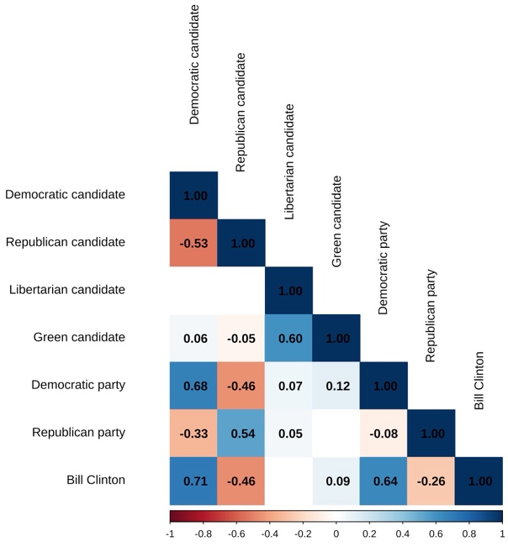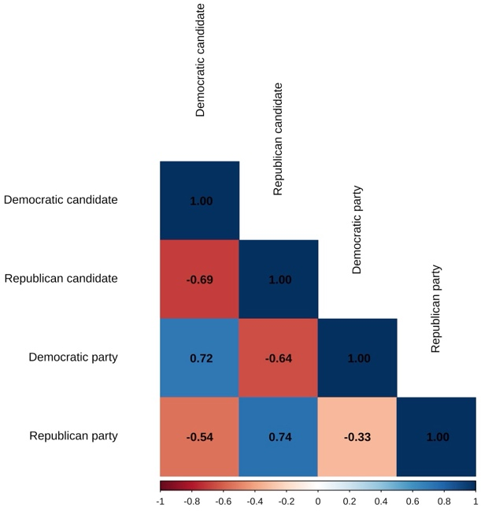
Note. ANES 2016 (left) and ANES 2020 (right). Colored cells p < .001.

To give a better overview of responses in each cluster, Table SI10.1 reports the absolute counts and percentages of respondents who rate the two parties (or, in 2024, the two parties’ voters) with the exact same score, or within differences of 5, 10, 20, and 30 points, respectively. The table shows that about one-third of respondents in both unpolarized clusters rate the two parties with the exact same rating. These shares rise cumulatively with each threshold, amounting to about 90% of respondents in these clusters who score the parties (or, in 2024, the two parties’ voters) within a 30-point difference. The table also shows the polarization among the two polarized groups, such that there no respondents in these clusters who score the two parties within differences of 0, 5, 10, and 20 points. This is not surprising but validates the clustering approach.

Table SI10.1. Overview of Response Behaviors by Clusters
Cluster | Exact same (0) | Within 5 | Within 10 | Within 20 | Within 30
2016
Unpolarized Supporters | 447 (31.5%) | 520 (36.6%) | 722 (50.9%) | 1,110 (78.2%) | 1,332 (93.9%)
Unpolarized Skeptics | 166 (33.1%) | 193 (38.5%) | 256 (51.1%) | 356 (71.1%) | 450 (89.8%)
Polarized Republicans | 0 (0%) | 0 (0%) | 0 (0%) | 0 (0%) | 81 (8.1%)
Polarized Democrats | 0 (0%) | 0 (0%) | 0 (0%) | 0 (0%) | 86 (6.9%)
2020
Unpolarized Supporters | 666 (31.7%) | 685 (32.6%) | 992 (47.1%) | 1,445 (68.7%) | 1,881 (89.4%)
Unpolarized Skeptics | 234 (34.3%) | 261 (38.3%) | 349 (51.2%) | 447 (65.5%) | 587 (86.1%)
Polarized Republicans | 0 (0%) | 0 (0%) | 0 (0%) | 0 (0%) | 89 (3.4%)
Polarized Democrats | 0 (0%) | 0 (0%) | 0 (0%) | 0 (0%) | 5 (0.2%)
2024 (Party)
Unpolarized Supporters | 69 (14.4%) | 167 (34.9%) | 225 (47%) | 310 (64.7%) | 409 (85.4%)
Unpolarized Skeptics | 54 (19.9%) | 124 (45.8%) | 142 (52.4%) | 196 (72.3%) | 248 (91.5%)
Polarized Republicans | 0 (0%) | 0 (0%) | 0 (0%) | 0 (0%) | 18 (3.5%)
Polarized Democrats | 0 (0%) | 0 (0%) | 0 (0%) | 0 (0%) | 17 (3.1%)
2024 (Voters)
Unpolarized Supporters | 95 (16.7%) | 216 (38%) | 267 (47%) | 374 (65.8%) | 495 (87.1%)
Unpolarized Skeptics | 53 (20.4%) | 103 (39.6%) | 126 (48.5%) | 160 (61.5%) | 212 (81.5%)
Polarized Republicans | 0 (0%) | 0 (0%) | 0 (0%) | 0 (0%) | 3 (0.7%)
Polarized Democrats | 0 (0%) | 0 (0%) | 0 (0%) | 0 (0%) | 6 (1.1%)
Note. For each respondent, we compute the absolute difference between the two feeling thermometer scores. Difference thresholds are inclusive (e.g., 60 and 65 constitute a 5-point difference and are counted as “Within 5”). Columns are cumulative: respondents with identical scores (“Exact same”) are also included in “Within 5” and all larger thresholds.

SI11: Thermometers Toward Parties vs. Voters in YouGov 2024
Cluster Fit
Table SI11.1. Cluster Overview
Clusters | Cluster Size |  |  |  |  |  |  |  | Between/Total Sum of Squares | Reduced Within Sum of Squares
2 | 1093 |  | 711 |  |  |  |  |  | 48.4% | /
3 | 640 |  | 603 | 561 |  |  |  |  | 64.4% | 17.5%
4 | 453 | 260 | 568 | 523 |  |  |  |  | 78.6% | 14.1%
5 | 208 | 257 | 449 | 402 | 488 |  |  |  | 83.0% | 3.6%
6 | 303 | 331 | 231 | 478 | 261 | 200 |  |  | 85.7% | 2.5%
7 | 239 | 290 | 190 | 229 | 268 | 244 | 344 |  | 87.8% | 2.3%
8 | 256 | 226 | 248 | 236 | 272 | 172 | 229 | 165 | 89.8% | 1.7%

Table SI11.2. Fit Statistics.
Fit statistic | Value | Best-fitting solution
KL | 4.89 | 6
CH | 2208.34 | 4
Hartigan | 1047.05 | 4
CCC | 64 | 4
Scott | 1925.48 | 4
Marriot | 1.9546E+12 | 4
TrCovW | 5.6993E+11 | 4
TraceW | 491286.64 | 4
Friedman | 13.84 | 8
Rubin | -4.12 | 4
Cindex | 0.28 | 7
DB | 0.81 | 4
Silhouette | 0.47 | 4
Duda | 1.65 | 2
PseudoT2 | -620.07 | 2
Beale | -0.39 | 2
Ratkowsky | 0.48 | 2
Ball | 530542.44 | 3
PtBiserial | 0.63 | 4
Frey | NA | 1
McClain | 0.54 | 2
Dunn | 0.02 | 8
Hubert | 0 | 0
SDindex | 0.05 | 3
Dindex | 0 | 0
SDbw | 0.38 | 8
Note. See Charrad and colleagues (2014) for more information on the single fit statistics.

FIGURE SI11.1. Visual Heuristics.

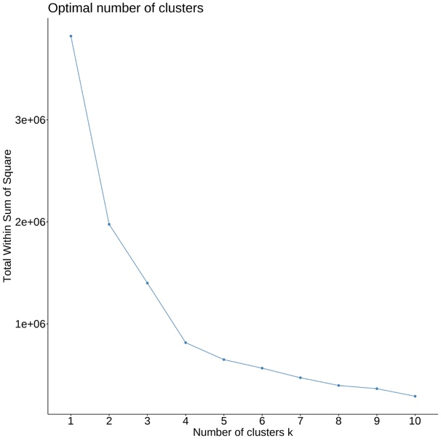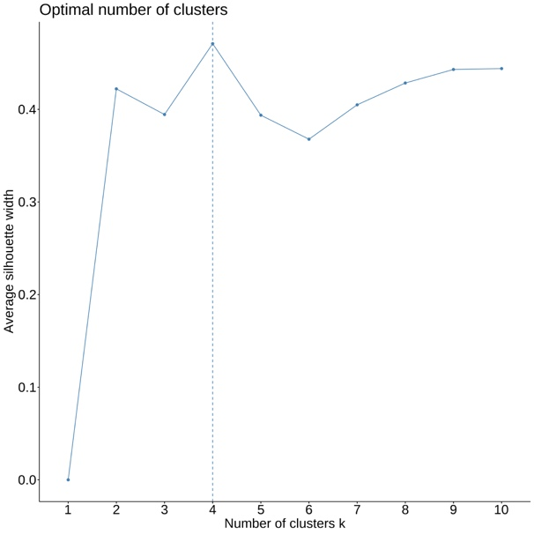
Note. Elbow plot (left) and silhouette plot (right).

Cluster Solution
Table SI11.3. Cluster Means Comparing Feelings Toward Parties and Voters
YouGov 2024 (Party)
Democrats  Thermometer | Republicans Thermometer | Affective Polarization Score | Cluster Name | Cluster Size  (%)
10.71 | 78.04 | 67.33 | Polarized Republicans | 518 (28.38)
79.57 | 9.79 | 69.78 | Polarized Democrats | 557 (30.52)
61.95 | 62.16 | 0.21 | Unpolarized Supporters | 479 (26.25)
13.34 | 15.45 | 2.11 | Unpolarized Skeptics | 271 (14.85)
YouGov 2024 (Voters)
Democrats  Thermometer | Republicans Thermometer | Affective Polarization Score | Cluster Name | Cluster Size  (%)
15.29 | 84.62 | 69.33 | Polarized Republicans | 453 (22.65)
82.71 | 12.98 | 69.73 | Polarized Democrats | 523 (26.15)
62.75 | 61.98 | 0.77 | Unpolarized Supporters | 568 (28.40)
16.53 | 23.48 | 6.95 | Unpolarized Skeptics | 260 (13.00)

Table SI11.4. Results Parties vs. Voters (2024)
 | Procedural trust (P) | Procedural trust (V) | Norms Index (P) | Norms Index (V) | Threat justification (P) | Threat justification (V) | Violence for goals (P) | Violence for goals (V) | Violence retribution (P) | Violence retribution (V) | Moral disengagement (P) | Moral disengagement (V) | Willingness to Respect (P) | Willingness to Respect (V) | Willingness to interact (P) | Willingness to interact (V)
Unpolarized Skeptics | -0.10 (0.02)*** | -0.14 (0.02)*** | -0.02 (0.02) | -0.06 (0.02)*** | -0.06 (0.02)*** | -0.05 (0.01)*** | -0.08 (0.02)*** | -0.04 (0.02)* | 0.00 (0.03) | -0.01 (0.03) | -0.04 (0.02) | 0.02 (0.02) | -0.08 (0.03)** | -0.13 (0.02)*** | -0.00 (0.03) | -0.09 (0.02)***
Polarized Republicans | -0.13 (0.02)*** | -0.13 (0.02)*** | -0.05 (0.02)** | -0.06 (0.02)*** | -0.05 (0.01)** | -0.00 (0.01) | -0.08 (0.02)*** | -0.00 (0.02) | 0.07 (0.03)* | 0.15 (0.03)*** | 0.14 (0.02)*** | 0.22 (0.02)*** | -0.09 (0.02)*** | -0.16 (0.02)*** | -0.02 (0.02) | -0.09 (0.02)***
Polarized Democrats | 0.02 (0.02) | 0.00 (0.02) | 0.13 (0.02)*** | 0.13 (0.02)*** | -0.06 (0.01)*** | -0.06 (0.01)*** | -0.07 (0.02)*** | -0.06 (0.02)*** | 0.03 (0.03) | 0.01 (0.03) | 0.13 (0.02)*** | 0.16 (0.02)*** | -0.13 (0.03)*** | -0.15 (0.02)*** | -0.05 (0.03) | -0.08 (0.02)***
Age | 0.00 (0.00) | 0.00 (0.00) | 0.00 (0.00) | 0.00 (0.00) | -0.00 (0.00)*** | -0.00 (0.00)*** | -0.00 (0.00)*** | -0.00 (0.00)*** | -0.00 (0.00)*** | -0.00 (0.00)*** | -0.00 (0.00) | -0.00 (0.00) | 0.00 (0.00) | 0.00 (0.00)** | 0.00 (0.00)** | 0.00 (0.00)***
Male | 0.03 (0.01)** | 0.04 (0.01)*** | -0.02 (0.01) | -0.02 (0.01) | 0.04 (0.01)*** | 0.04 (0.01)*** | 0.05 (0.01)*** | 0.05 (0.01)*** | 0.09 (0.02)*** | 0.10 (0.02)*** | -0.00 (0.01) | -0.01 (0.01) | 0.02 (0.02) | 0.02 (0.02) | 0.07 (0.02)*** | 0.08 (0.02)***
Non-binary | -0.00 (0.06) | -0.04 (0.06) | 0.17 (0.05)** | 0.12 (0.06)* | -0.03 (0.05) | -0.03 (0.05) | -0.01 (0.06) | -0.02 (0.06) | 0.08 (0.09) | 0.10 (0.09) | 0.01 (0.06) | -0.04 (0.07) | -0.07 (0.08) | -0.06 (0.08) | 0.04 (0.08) | 0.06 (0.08)
Other gender | -0.03 (0.10) | -0.02 (0.09) | 0.06 (0.10) | -0.05 (0.08) | 0.03 (0.08) | 0.18 (0.07)* | 0.03 (0.10) | 0.08 (0.08) | 0.08 (0.15) | 0.13 (0.13) | -0.00 (0.11) | -0.04 (0.09) | -0.03 (0.14) | -0.05 (0.12) | -0.04 (0.14) | -0.05 (0.12)
Black American | 0.02 (0.02) | 0.03 (0.02) | 0.00 (0.02) | 0.01 (0.02) | 0.03 (0.02)* | 0.03 (0.02) | 0.05 (0.02)** | 0.05 (0.02)** | 0.08 (0.03)** | 0.07 (0.03)* | 0.01 (0.02) | 0.01 (0.02) | 0.04 (0.03) | 0.05 (0.03) | -0.03 (0.03) | -0.04 (0.03)
Hispanic American | 0.05 (0.02)** | 0.06 (0.02)*** | -0.02 (0.02) | 0.00 (0.02) | 0.00 (0.02) | 0.01 (0.02) | 0.02 (0.02) | 0.02 (0.02) | 0.02 (0.03) | 0.02 (0.03) | 0.02 (0.02) | 0.02 (0.02) | 0.02 (0.03) | 0.02 (0.03) | -0.08 (0.03)** | -0.08 (0.03)**
Asian American | 0.02 (0.03) | 0.02 (0.03) | -0.00 (0.03) | 0.00 (0.03) | 0.01 (0.03) | 0.02 (0.03) | 0.04 (0.03) | 0.05 (0.03) | 0.02 (0.05) | 0.06 (0.05) | 0.04 (0.04) | 0.04 (0.03) | 0.01 (0.05) | 0.02 (0.04) | -0.07 (0.05) | -0.07 (0.04)
Native American | 0.06 (0.05) | 0.06 (0.05) | 0.04 (0.05) | 0.04 (0.05) | -0.02 (0.04) | -0.02 (0.04) | -0.01 (0.05) | -0.01 (0.05) | 0.05 (0.08) | 0.05 (0.08) | 0.09 (0.06) | 0.07 (0.05) | -0.03 (0.07) | -0.02 (0.07) | -0.03 (0.07) | -0.04 (0.07)
Other (incl. multiple) | 0.02 (0.03) | -0.00 (0.03) | 0.04 (0.03) | 0.02 (0.03) | -0.01 (0.03) | -0.00 (0.02) | -0.01 (0.03) | -0.01 (0.03) | 0.07 (0.05) | 0.06 (0.04) | -0.06 (0.03) | -0.06 (0.03) | 0.02 (0.04) | 0.01 (0.04) | -0.01 (0.04) | -0.00 (0.04)
Other (YouGov) | -0.04 (0.05) | -0.06 (0.04) | -0.01 (0.04) | -0.05 (0.04) | -0.02 (0.04) | 0.00 (0.03) | 0.01 (0.04) | 0.01 (0.04) | 0.11 (0.07) | 0.13 (0.06)* | 0.02 (0.05) | -0.03 (0.04) | -0.08 (0.07) | -0.05 (0.06) | -0.10 (0.07) | -0.10 (0.06)
Middle Eastern | 0.08 (0.09) | 0.06 (0.09) | -0.04 (0.09) | -0.07 (0.09) | -0.00 (0.08) | 0.01 (0.08) | 0.04 (0.09) | 0.03 (0.09) | 0.17 (0.14) | 0.16 (0.14) | -0.11 (0.10) | -0.13 (0.10) | 0.01 (0.13) | 0.01 (0.13) | -0.09 (0.13) | -0.11 (0.13)
High school graduate | 0.06 (0.03) | 0.08 (0.03)* | 0.00 (0.03) | 0.02 (0.03) | -0.03 (0.03) | -0.03 (0.03) | -0.02 (0.03) | -0.02 (0.03) | -0.02 (0.05) | -0.05 (0.05) | -0.01 (0.04) | -0.06 (0.03) | -0.02 (0.05) | -0.00 (0.04) | -0.01 (0.05) | -0.00 (0.04)
Some college | 0.04 (0.03) | 0.05 (0.03) | 0.02 (0.03) | 0.03 (0.03) | -0.03 (0.03) | -0.03 (0.03) | -0.03 (0.03) | -0.04 (0.03) | -0.04 (0.06) | -0.06 (0.05) | -0.03 (0.04) | -0.07 (0.04)* | 0.01 (0.05) | 0.03 (0.04) | 0.06 (0.05) | 0.08 (0.05)
2-year | 0.11 (0.04)** | 0.12 (0.03)*** | 0.04 (0.03) | 0.06 (0.03) | -0.01 (0.03) | -0.01 (0.03) | -0.02 (0.04) | -0.01 (0.03) | 0.01 (0.06) | -0.01 (0.05) | -0.02 (0.04) | -0.06 (0.04) | -0.01 (0.05) | 0.00 (0.05) | 0.01 (0.05) | 0.02 (0.05)
4-year | 0.08 (0.03)* | 0.09 (0.03)** | 0.03 (0.03) | 0.04 (0.03) | -0.01 (0.03) | -0.01 (0.03) | -0.00 (0.03) | 0.01 (0.03) | 0.00 (0.06) | -0.02 (0.05) | -0.04 (0.04) | -0.09 (0.04)* | 0.02 (0.05) | 0.04 (0.04) | 0.04 (0.05) | 0.06 (0.05)
Post-grad | 0.09 (0.04)* | 0.12 (0.03)*** | 0.03 (0.03) | 0.05 (0.03) | -0.01 (0.03) | -0.00 (0.03) | -0.02 (0.04) | -0.01 (0.03) | -0.07 (0.06) | -0.09 (0.05) | -0.10 (0.04)* | -0.15 (0.04)*** | 0.03 (0.05) | 0.06 (0.05) | 0.05 (0.05) | 0.08 (0.05)
Part-time | 0.02 (0.02) | 0.01 (0.02) | -0.04 (0.02)* | -0.04 (0.02)* | 0.01 (0.02) | 0.01 (0.01) | 0.00 (0.02) | 0.00 (0.02) | 0.02 (0.03) | 0.02 (0.03) | -0.01 (0.02) | -0.00 (0.02) | 0.02 (0.03) | 0.00 (0.02) | 0.05 (0.03)* | 0.02 (0.03)
Temporarily laid off | -0.01 (0.06) | -0.04 (0.06) | 0.10 (0.06) | 0.09 (0.06) | -0.00 (0.05) | -0.06 (0.05) | 0.01 (0.06) | -0.06 (0.06) | 0.03 (0.10) | -0.04 (0.09) | -0.03 (0.07) | -0.02 (0.06) | 0.07 (0.08) | 0.07 (0.08) | 0.05 (0.08) | 0.06 (0.08)
Unemployed | -0.02 (0.02) | -0.05 (0.02)* | -0.02 (0.02) | -0.01 (0.02) | -0.01 (0.02) | -0.02 (0.02) | -0.02 (0.02) | -0.03 (0.02) | 0.02 (0.04) | 0.02 (0.04) | -0.01 (0.03) | -0.01 (0.02) | 0.00 (0.03) | -0.01 (0.03) | -0.03 (0.03) | -0.02 (0.03)
Retired | 0.03 (0.02) | 0.02 (0.02) | -0.02 (0.02) | -0.02 (0.02) | 0.03 (0.02)* | 0.03 (0.01)* | 0.03 (0.02) | 0.02 (0.02) | -0.01 (0.03) | -0.02 (0.03) | 0.02 (0.02) | 0.03 (0.02) | -0.00 (0.03) | -0.03 (0.02) | 0.00 (0.03) | -0.02 (0.02)
Permanently disabled | 0.03 (0.02) | 0.01 (0.02) | 0.02 (0.02) | 0.02 (0.02) | -0.01 (0.02) | -0.01 (0.02) | -0.04 (0.02) | -0.05 (0.02)* | -0.02 (0.04) | -0.02 (0.04) | -0.00 (0.03) | 0.04 (0.03) | 0.04 (0.03) | -0.01 (0.03) | 0.03 (0.03) | -0.03 (0.03)
Homemaker | -0.03 (0.03) | -0.02 (0.02) | -0.00 (0.02) | -0.00 (0.02) | -0.00 (0.02) | -0.00 (0.02) | -0.00 (0.02) | -0.01 (0.02) | -0.08 (0.04)* | -0.09 (0.04)* | -0.03 (0.03) | -0.05 (0.03)* | 0.00 (0.04) | -0.00 (0.03) | -0.00 (0.04) | -0.02 (0.03)
Student | -0.03 (0.03) | -0.02 (0.03) | -0.05 (0.03) | -0.05 (0.03) | 0.01 (0.03) | -0.00 (0.03) | 0.03 (0.03) | 0.01 (0.03) | 0.04 (0.05) | 0.02 (0.05) | 0.00 (0.04) | -0.01 (0.03) | -0.06 (0.05) | -0.04 (0.04) | -0.02 (0.05) | -0.02 (0.04)
Other occupation | 0.02 (0.04) | -0.01 (0.04) | -0.04 (0.04) | -0.06 (0.04) | -0.04 (0.03) | -0.02 (0.03) | -0.04 (0.04) | -0.03 (0.04) | 0.05 (0.07) | 0.01 (0.06) | 0.04 (0.05) | -0.01 (0.04) | 0.05 (0.06) | 0.04 (0.05) | 0.07 (0.06) | 0.03 (0.05)
Family income | 0.00 (0.00)** | -0.00 (0.00) | -0.00 (0.00) | -0.00 (0.00) | -0.00 (0.00) | -0.00 (0.00) | 0.00 (0.00) | -0.00 (0.00)* | -0.00 (0.00) | -0.00 (0.00) | -0.00 (0.00) | -0.00 (0.00) | 0.01 (0.00)** | -0.00 (0.00) | 0.01 (0.00)** | -0.00 (0.00)
Religion importance | -0.00 (0.01) | -0.01 (0.01) | -0.02 (0.01)*** | -0.02 (0.00)*** | 0.01 (0.00) | 0.01 (0.00) | 0.01 (0.01)* | 0.01 (0.00)** | -0.00 (0.01) | -0.00 (0.01) | 0.01 (0.01) | 0.01 (0.01)* | 0.02 (0.01)** | 0.02 (0.01)** | 0.01 (0.01) | 0.01 (0.01)*
Partisanship | -0.01 (0.00)*** | -0.02 (0.00)*** | -0.02 (0.00)*** | -0.02 (0.00)*** | 0.00 (0.00) | -0.00 (0.00) | 0.00 (0.00) | -0.00 (0.00) | 0.00 (0.01) | -0.01 (0.01) | -0.01 (0.00) | -0.01 (0.00)** | -0.00 (0.01) | 0.01 (0.01) | -0.00 (0.01) | 0.00 (0.01)
R² | 0.18 | 0.20 | 0.29 | 0.29 | 0.12 | 0.12 | 0.16 | 0.15 | 0.07 | 0.09 | 0.10 | 0.15 | 0.05 | 0.07 | 0.06 | 0.07
R²_{Adjusted} | 0.16 | 0.18 | 0.28 | 0.27 | 0.10 | 0.10 | 0.15 | 0.13 | 0.05 | 0.08 | 0.09 | 0.13 | 0.03 | 0.06 | 0.04 | 0.05
N | 1,630 | 1,770 | 1,630 | 1,770 | 1,618 | 1,755 | 1,594 | 1,730 | 1,533 | 1,657 | 1,623 | 1,764 | 1,630 | 1,770 | 1,630 | 1,770
Note. * p < .05, ** < .01, *** < .001. Standard errors in parentheses. Reference category: Unpolarized Supporters, female (gender), white (race), less than high school (education), full-time/working now (employment). P = Party, V = Voters.

References
Brennan, Jason. 2012. Libertarianism: What everyone needs to know. Oxford, UK: Oxford University Press.
Charrad, Malika, Nadia Ghazzali, Véronique Boiteau, and Azam Niknafs. 2014. “NbClust: an R package for determining the relevant number of clusters in a data set.” Journal of Statistical Software 61: 1–36.
Druckman, James N., and Matthew S. Levendusky. 2019. “What do we measure when we measure affective polarization?.” Public Opinion Quarterly 83 (1): 114–122.
Dunn, Alexandra M., Eric D. Heggestad, Linda R. Shanock, and Nels Theilgard. 2018. “Intra-individual response variability as an indicator of insufficient effort responding: Comparison to other indicators and relationships with individual differences.” Journal of Business and Psychology 33: 105–121.
Everitt, Brian S., Sabine Landau, Morven Leese, and Daniel Stahl. 2011. Cluster analysis: Wiley series in probability and statistics. Hoboken, NJ: John Wiley & Sons.
Krupnikov, Yanna, and John Barry Ryan. 2022. The Other Divide: Polarization and Disengagement in American Politics. Cambridge, UK: Cambridge University Press.

Due to data availability, ideology is measured from 0 to 10 in 2016, 1 to 7 in 2020, and 1 to 5 in 2024.
Note that this thermometer asked about warmth toward the presidential candidate, not a party. This may be an important difference compared to the feeling thermometers used as independent variables above, which asked about warmth toward the Republican and Democratic party, respectively (Druckman and Levendusky 2019). However, this was the best proxy for libertarianism available. The 2020 ANES survey did not include any useful proxies on this issue.

