The Limits of Incumbent Blame Games in Times of Crisis:
Experimental Evidence from Electoral Autocracy

Supplementary Material

Contents

Appendix A: Research ethics and transparency 2
Focus groups 2
Survey experiment 2
Appendix B: Descriptive statistics of the main variables (subsample) 4
Appendix C: Mean incumbent support across experimental groups (subsample) 5
Appendix D: Randomization check (balance test) 6
Appendix E: Post-estimation analyses of the voting model 7
Appendix F: Factor analysis of religiosity (subsample) 10
Appendix G: Heterogeneous treatment effects of the religious blame frame on support for incumbent parties, by respondents’ religiosity 11

Appendix A: Research ethics and transparency

- This study was reviewed and approved by our university’s Ethics Committee on Research Involving Human Subjects (Protocol No: 2021.08.09.01).
- The current study complies with the ethical and transparency obligations of APSA (American Political Science Association) Council’s Principles and Guidance for Human Subjects Research. Please find below further details.

Focus groups
- The focus groups are based on informed and voluntary consent of the participants. We obtained participants’ consent through a printed form that included detailed information about the source of financial support, research team, title, content, purpose, potential benefits, and the method and data sources of the study. The form also provided information about potential risks to participants and precautions taken to avoid any potential harm. Finally, the form also included a statement that the participants had the right and freedom to withdraw from the study whenever they wanted. At the beginning of each focus group, the research team distributed the consent form, signed by the principal investigator beforehand. The participants were given enough time to read the form and ask their questions about any aspect of the consent form and the research project. Once they voluntarily agreed to take part in the study, then they were asked to sign the consent form. Participants were also allowed and encouraged to take a signed copy or to take a picture of all the pages of the signed form.
- Regarding the confidentiality of the identities of research participants, the main goal of this study is to investigate general public attitudes and thoughts on a particular issue (i.e., the impact of various crisis frames on individuals’ attitudes and behaviors). In other words, this research project does not collect or analyze information intended to reveal the identities of individual respondents. Thus, during the focus groups, we randomly assigned fake names to each participant and made only audio recordings of group debates and conversations (i.e., no video recording). As we transcribed audio recordings, we used those fake names. The focus group protocol also did not include any item asking for information about the identities of participants. (Focus group protocol is available upon request).
- With respect to compensation, the duration of focus groups ranged from one hour and eight minutes to one hour and forty minutes (82 minutes on average). To compensate for their time and efforts, we paid each participant of the focus group 150 TL (around $9). Given the fact that daily minimum wage in the country was 167 TL at the time of focus group research (i.e., April-July 2022), this was a fair compensation for their participation.

Survey experiment
- The survey experiment included face-to-face household interviews with a nationwide sample of 3,562 participants. Similar to focus group studies, the survey experiment is also based on voluntary and informed consent. At the beginning of the survey, each participant was informed about the funder and the researchers, and the content, purpose, and method of the study. They were also assured about the confidentiality of their responses and informed that they had the right and freedom to withdraw from the survey whenever they wanted. The interviewers started the survey only after they obtained the consent and approval of potential participants.
- Based on the feedback from the pilot study, we concluded that on average the survey would take around 15 minutes. Hence, we did not compensate survey participants for this amount of time.
- In terms of the confidentiality (or anonymity) of survey participants’ identity, the survey questionnaire did not include any identifying information such as name, surname or personal address. In other words, the data sheets are totally anonymous. Hence, by looking at a particular questionnaire, one cannot retrospectively determine to whom that particular questionnaire belongs.
- The data were transferred to the computer by the research company based in Istanbul. The printed and completed questionnaires were kept in the company’s archives for two years and were then completely destroyed.
- In constructing the experimental vignettes, we utilized the actual crisis frames popular in Turkish socio-political life (see Figure 2 for an example). In other words, our experimental design did not involve any kind of deception (such as identity, activity, motivation or misinformation).

Appendix B: Descriptive statistics of the main variables (subsample)
Variables | N | Min | Max | Mean | Std. dev
Crisis | 1769 | 1 | 4 | 2.47 | 1.12
Frame | 1769 | 1 | 4 | 2.49 | 1.12
Support for incumbents | 1769 | 0 | 1 | 0.30 | 0.46

Appendix C: Mean incumbent support across experimental groups (subsample)
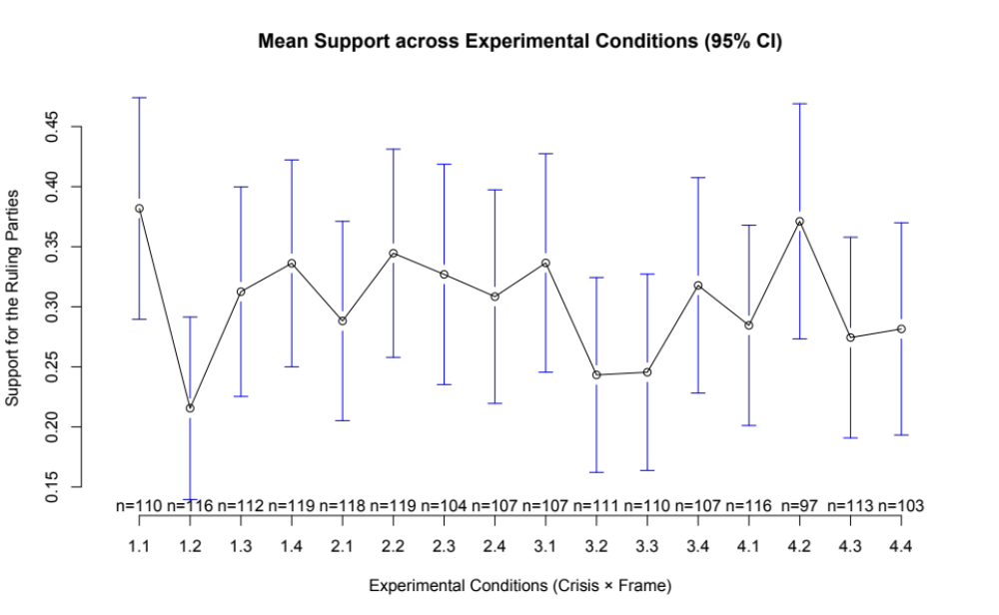
Figure C1: Mean electoral support for the parties of the ruling People’s Alliance across experimental groups

Appendix D: Randomization check (balance test)

Table D1: Multinomial logistic regression analysis of assignment to experimental conditions (full sample)
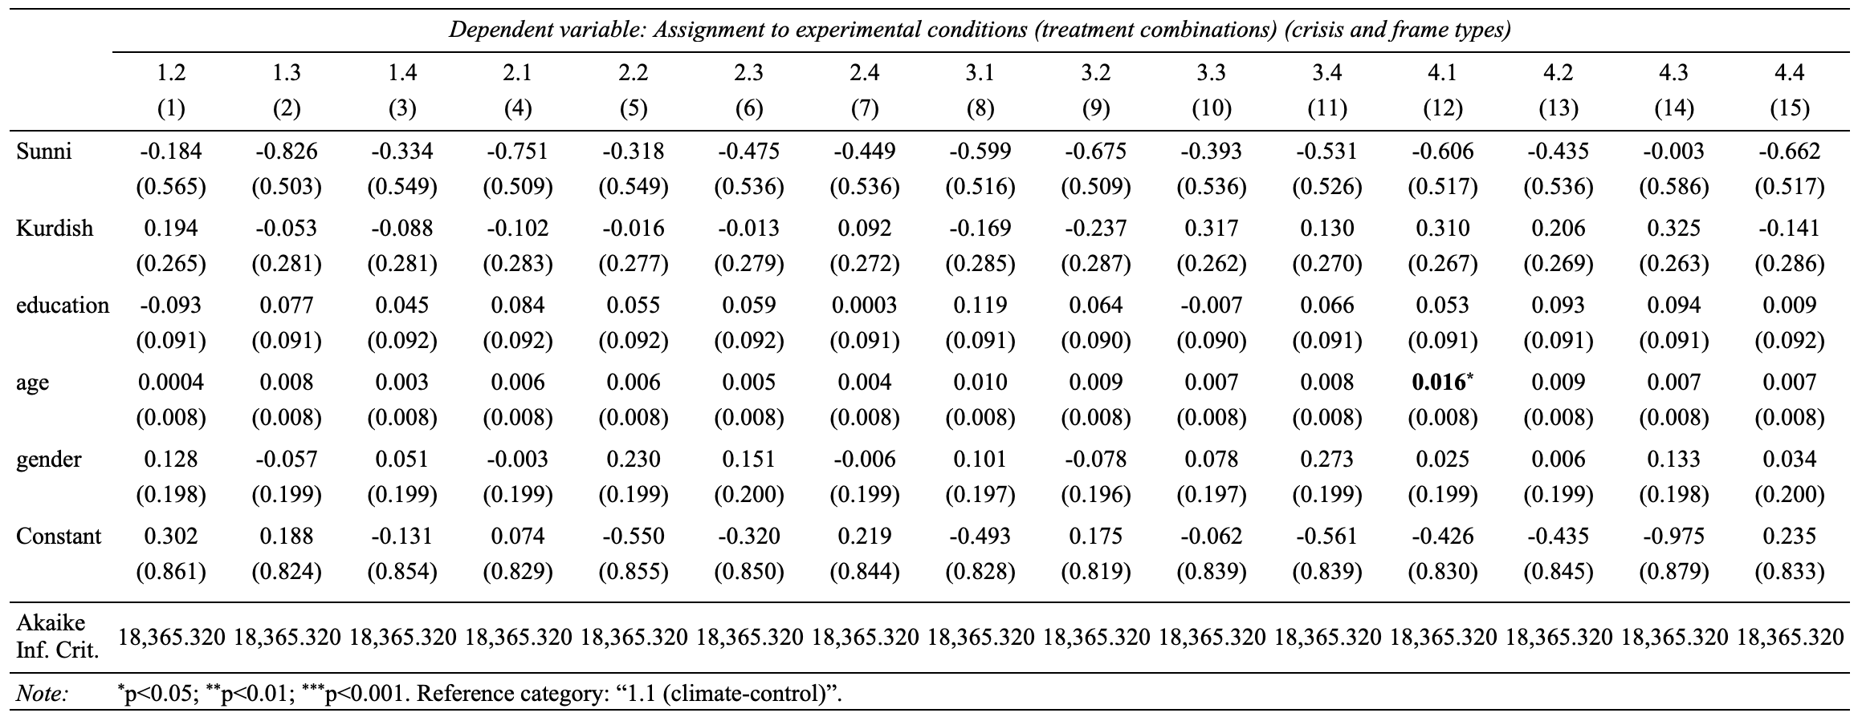

Table D2: Descriptive statistics of the variables included into the multinomial model
Variables | N | Min | Max | Mean | Std. dev
Sunni | 3303 | 0 | 1 | 0.95 | 0.21
Kurdish¹ | 3561 | 0 | 1 | 0.15 | 0.36
education | 3560 | 1 (illiterate) | 7 (graduate) | 4.41 | 1.23
age | 3546 | 18 | 86 | 39.61 | 14.65
gender | 3562 | 1 (female) | 2 (male) | 1.50 | 0.50

Appendix E: Post-estimation analyses of the voting model

Table E1: Estimated marginal probabilities of support for incumbent parties across crisis type and framing conditions (Model 1b)
 | Frames
Crisis type | Control | Religious | Conspiratorial | Scientific
Climate | .382 | .216 | .312 | .336
Earthquake | .288 | .345 | .327 | .308
Economic crisis | .336 | .243 | .245 | .318
Pandemic | .284 | .371 | .274 | .282

Table E2: Crisis-specific effects of frame conditions on support for incumbent parties relative to the control (blame-neutral) condition
Crisis type | Religious frame (2) vs. control (1) | Conspiratorial frame (3) vs. control (1) | Scientific frame (4) vs. control (1)
Climate (1) | -0.166**  (0.060) | -0.069  (0.064) | -0.046  (0.063)
Earthquake (2) | 0.056  (0.060) | 0.039  (0.062) | 0.020  (0.061)
Economic crisis (3) | -0.093  (0.061) | -0.091  (0.061) | -0.019  (0.064)
Pandemic (4) | 0.087  (0.065) | -0.010  (0.059) | -0.003  (0.061)
Notes:
*p<0.05, ** p<0.01, *** p<0.001
Entries report differences in predicted probabilities, also interpretable as average marginal effects for categorical frame conditions, estimated from Model 1b. Each estimate compares the predicted probability of supporting incumbent parties under the relevant frame condition with the predicted probability under the no-frame control condition within the same crisis type. Positive values indicate higher predicted support for incumbents relative to the control condition; negative values indicate lower predicted support. Standard errors are reported in parentheses.

Table E3: Pairwise frame comparisons within crisis types (support for incumbent parties)
frame contrasts | crisis | odds.ratio | SE | df | null | z.ratio | p.value
frame1 / frame2 | 1 | 2.248 | 0.673 | Inf | 1 | 2.708 | 0.034*
frame1 / frame3 | 1 | 1.359 | 0.385 | Inf | 1 | 1.084 | 0.700
frame1 / frame4 | 1 | 1.220 | 0.337 | Inf | 1 | 0.720 | 0.889
frame2 / frame3 | 1 | 0.604 | 0.184 | Inf | 1 | -1.655 | 0.348
frame2 / frame4 | 1 | 0.543 | 0.162 | Inf | 1 | -2.054 | 0.169
frame3 / frame4 | 1 | 0.898 | 0.253 | Inf | 1 | -0.383 | 0.981
frame1 / frame2 | 2 | 0.770 | 0.216 | Inf | 1 | -0.933 | 0.787
frame1 / frame3 | 2 | 0.833 | 0.243 | Inf | 1 | -0.625 | 0.924
frame1 / frame4 | 2 | 0.908 | 0.265 | Inf | 1 | -0.332 | 0.987
frame2 / frame3 | 2 | 1.082 | 0.308 | Inf | 1 | 0.278 | 0.993
frame2 / frame4 | 2 | 1.179 | 0.336 | Inf | 1 | 0.578 | 0.939
frame3 / frame4 | 2 | 1.089 | 0.322 | Inf | 1 | 0.289 | 0.992
frame1 / frame2 | 3 | 1.577 | 0.475 | Inf | 1 | 1.513 | 0.430
frame1 / frame3 | 3 | 1.559 | 0.470 | Inf | 1 | 1.472 | 0.455
frame1 / frame4 | 3 | 1.089 | 0.317 | Inf | 1 | 0.291 | 0.991
frame2 / frame3 | 3 | 0.988 | 0.309 | Inf | 1 | -0.038 | 1.000
frame2 / frame4 | 3 | 0.690 | 0.209 | Inf | 1 | -1.222 | 0.613
frame3 / frame4 | 3 | 0.698 | 0.212 | Inf | 1 | -1.182 | 0.638
frame1 / frame2 | 4 | 0.674 | 0.198 | Inf | 1 | -1.343 | 0.536
frame1 / frame3 | 4 | 1.052 | 0.310 | Inf | 1 | 0.171 | 0.998
frame1 / frame4 | 4 | 1.015 | 0.305 | Inf | 1 | 0.048 | 1.000
frame2 / frame3 | 4 | 1.561 | 0.465 | Inf | 1 | 1.496 | 0.440
frame2 / frame4 | 4 | 1.506 | 0.457 | Inf | 1 | 1.349 | 0.532
frame3 / frame4 | 4 | 0.965 | 0.293 | Inf | 1 | -0.118 | 0.999
Notes:
*p<0.05, ** p<0.01, *** p<0.001
Odds ratio entries report pairwise comparisons derived from the logistic regression model (Model 1b). P-values are adjusted using Tukey's method to account for multiple comparisons.
Crisis codes: crisis1 = climate; crisis2 = earthquake; crisis3 = economic; crisis4 = pandemic.
Frame codes: frame1= control; frame2= religious; frame3= conspiratorial; frame4= scientific
The df = Inf entries indicate that tests are based on large-sample z-statistics.

Table E4: Pairwise crisis comparisons within frames (support for incumbent parties)
crisis contrasts | frame | odds.ratio | SE | df | null | z.ratio | p.value
crisis1 / crisis2 | 1 | 1.526 | 0.431 | Inf | 1 | 1.496 | 0.440
crisis1 / crisis3 | 1 | 1.218 | 0.345 | Inf | 1 | 0.696 | 0.899
crisis1 / crisis4 | 1 | 1.553 | 0.442 | Inf | 1 | 1.549 | 0.408
crisis2 / crisis3 | 1 | 0.798 | 0.230 | Inf | 1 | -0.781 | 0.863
crisis2 / crisis4 | 1 | 1.018 | 0.294 | Inf | 1 | 0.062 | 1.000
crisis3 / crisis4 | 1 | 1.275 | 0.370 | Inf | 1 | 0.838 | 0.836
crisis1 / crisis2 | 2 | 0.523 | 0.155 | Inf | 1 | -2.185 | 0.127
crisis1 / crisis3 | 2 | 0.855 | 0.270 | Inf | 1 | -0.497 | 0.960
crisis1 / crisis4 | 2 | 0.466 | 0.144 | Inf | 1 | -2.479 | 0.063
crisis2 / crisis3 | 2 | 1.635 | 0.480 | Inf | 1 | 1.676 | 0.337
crisis2 / crisis4 | 2 | 0.891 | 0.254 | Inf | 1 | -0.406 | 0.977
crisis3 / crisis4 | 2 | 0.545 | 0.166 | Inf | 1 | -1.991 | 0.191
crisis1 / crisis2 | 3 | 0.936 | 0.273 | Inf | 1 | -0.227 | 0.996
crisis1 / crisis3 | 3 | 1.397 | 0.421 | Inf | 1 | 1.111 | 0.683
crisis1 / crisis4 | 3 | 1.202 | 0.353 | Inf | 1 | 0.628 | 0.923
crisis2 / crisis3 | 3 | 1.493 | 0.455 | Inf | 1 | 1.316 | 0.553
crisis2 / crisis4 | 3 | 1.285 | 0.381 | Inf | 1 | 0.844 | 0.833
crisis3 / crisis4 | 3 | 0.860 | 0.263 | Inf | 1 | -0.491 | 0.961
crisis1 / crisis2 | 4 | 1.135 | 0.324 | Inf | 1 | 0.445 | 0.971
crisis1 / crisis3 | 4 | 1.087 | 0.309 | Inf | 1 | 0.294 | 0.991
crisis1 / crisis4 | 4 | 1.292 | 0.378 | Inf | 1 | 0.875 | 0.818
crisis2 / crisis3 | 4 | 0.957 | 0.282 | Inf | 1 | -0.147 | 0.999
crisis2 / crisis4 | 4 | 1.138 | 0.345 | Inf | 1 | 0.426 | 0.974
crisis3 / crisis4 | 4 | 1.188 | 0.359 | Inf | 1 | 0.572 | 0.940
Notes:
*p<0.05, ** p<0.01, *** p<0.001
Odds ratio entries report pairwise comparisons derived from the logistic regression model (Model 1b). P-values are adjusted using Tukey's method to account for multiple comparisons.
Crisis codes: crisis1 = climate; crisis2 = earthquake; crisis3 = economic; crisis4 = pandemic.
Frame codes: frame1= control; frame2= religious; frame3= conspiratorial; frame4= scientific.
The df = Inf entries indicate that tests are based on large-sample z-statistics.

Appendix F: Factor analysis of religiosity (subsample)

Variables | Factor loadings
Variables | Factor 1: Practice | Factor 2: Attitude
Observance of daily prayers (namaz) | 0.81
Fasting during the month of Ramadan | 0.78
Avoiding financial interest due to the belief that charging or paying interest is religiously prohibited (haram) | 0.79
Avoiding alcohol consumption due to belief that it is haram | 0.90
Support for allowing the wearing of headscarf in primary schools |  | 0.42
Belief that religion should take precedence over science |  | 0.53
Support for designating Friday as an official public holiday |  | 0.73
Support for single-gender (gender-segregated) schooling |  | 0.91
SS loadings | 3.12 | 1.99
Proportion var. | 0.39 | 0.25
Proportion explained | 0.61 | 0.39
Reliability analysis (tetrachoric ordinal alpha) | 0.89 | 0.83
Notes:
- The suitability of the data for factor analysis was assessed using the Kaiser–Meyer–Olkin (KMO) measure of sampling adequacy and Bartlett’s test of sphericity. The KMO value indicated that the data were suitable for factor analysis (KMO = 0.82), and Bartlett’s test was statistically significant, p < .001, supporting the factorability of the correlation matrix.
- Because the survey items were dichotomous, we employed tetrachoric correlations in the factor analysis.

Appendix G: Heterogeneous treatment effects of the religious blame frame on support for incumbent parties, by respondents’ religiosity

Table G1: Religious blame frame by practical religiosity (earthquake)
 | DV: Support for incumbent parties
Religious frame | -0.104
 | (1.071)
Religiosity (practice) | 0.752***
 | (0.161)
Religious frame x Religiosity (practice) | 0.113
 | (0.295)
Constant | -3.323***
 | (0.592)
Observations | 431
Log Likelihood | -246.675
Akaike Inf. Crit. | 501.349
Notes: *p<0.05, ** p<0.01, *** p<0.001. Standard errors are in parentheses.

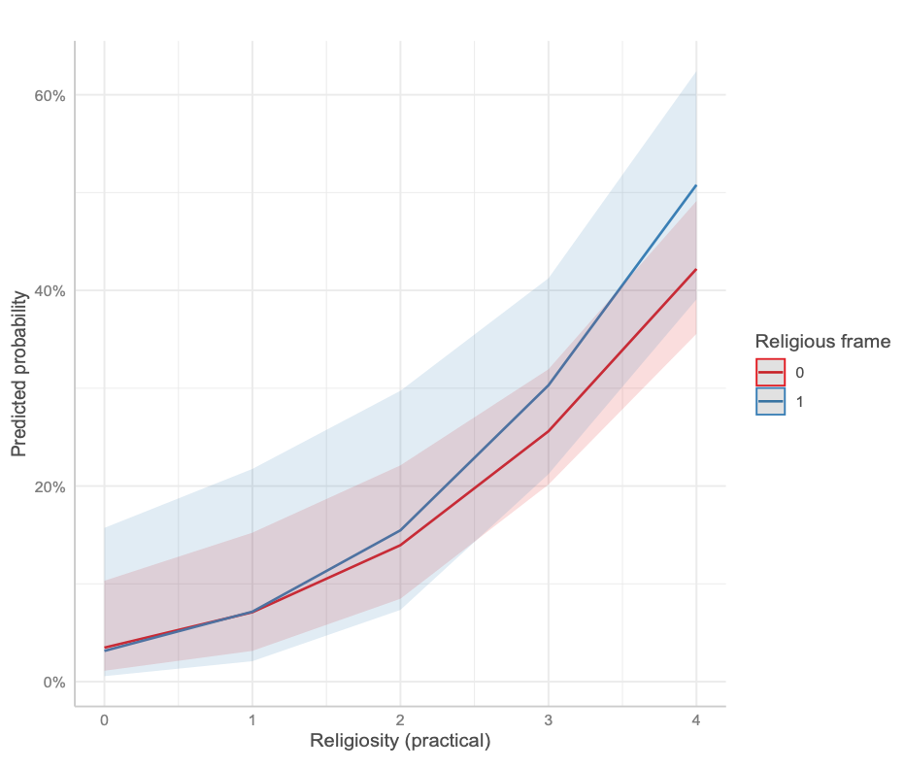
Figure G1: Predicted probability of support for incumbent parties by religious frame and practical religiosity (earthquake)

Table G2: Religious blame frame by attitudinal religiosity (earthquake)
 | DV: Support for incumbent parties
Religious frame | -0.374
 | (0.517)
Religiosity (attitude) | 0.405***
 | (0.102)
Religious frame x Religiosity (attitude) | 0.357
 | (0.217)
Constant | -1.667***
 | (0.254)
Observations | 365
Log Likelihood | -206.633
Akaike Inf. Crit. | 421.266
Notes: *p<0.05, ** p<0.01, *** p<0.001. Standard errors are in parentheses.

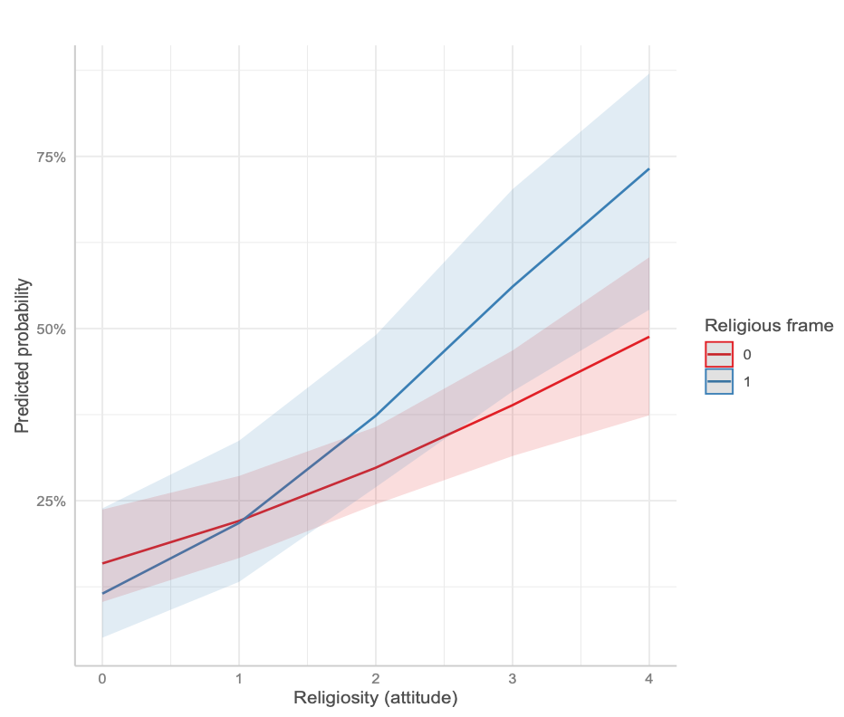
Figure G2: Predicted probability of support for incumbent parties by religious frame and attitudinal religiosity (earthquake)

Table G3: Religious blame frame by practical religiosity (pandemic)
 | DV: Support for incumbent parties
Religious frame | -1.174
 | (1.506)
Religiosity (practice) | 0.666***
 | (0.172)
Religious frame x Religiosity (practice) | 0.428
 | (0.399)
Constant | -3.213***
 | (0.639)
Observations | 416
Log Likelihood | -237.251
Akaike Inf. Crit. | 482.502
Notes: *p<0.05, ** p<0.01, *** p<0.001. Standard errors are in parentheses.

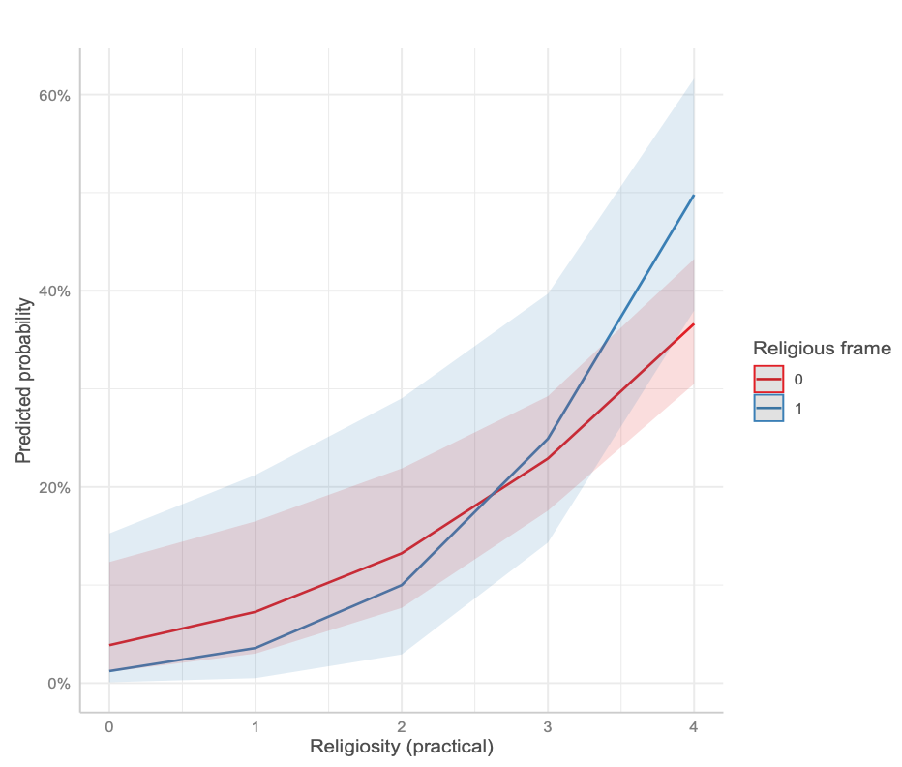
Figure G3: Predicted probability of support for incumbent parties by religious frame and practical religiosity (pandemic)

Table G4: Religious blame frame by attitudinal religiosity (pandemic)
 | DV: Support for incumbent parties
Religious frame | 0.251
 | (0.563)
Religiosity (attitude) | 0.484***
 | (0.105)
Religious frame x Religiosity (attitude) | 0.109
 | (0.219)
Constant | -1.990***
 | (0.287)
Observations | 354
Log Likelihood | -199.429
Akaike Inf. Crit. | 406.857
Notes: *p<0.05, ** p<0.01, *** p<0.001. Standard errors are in parentheses.

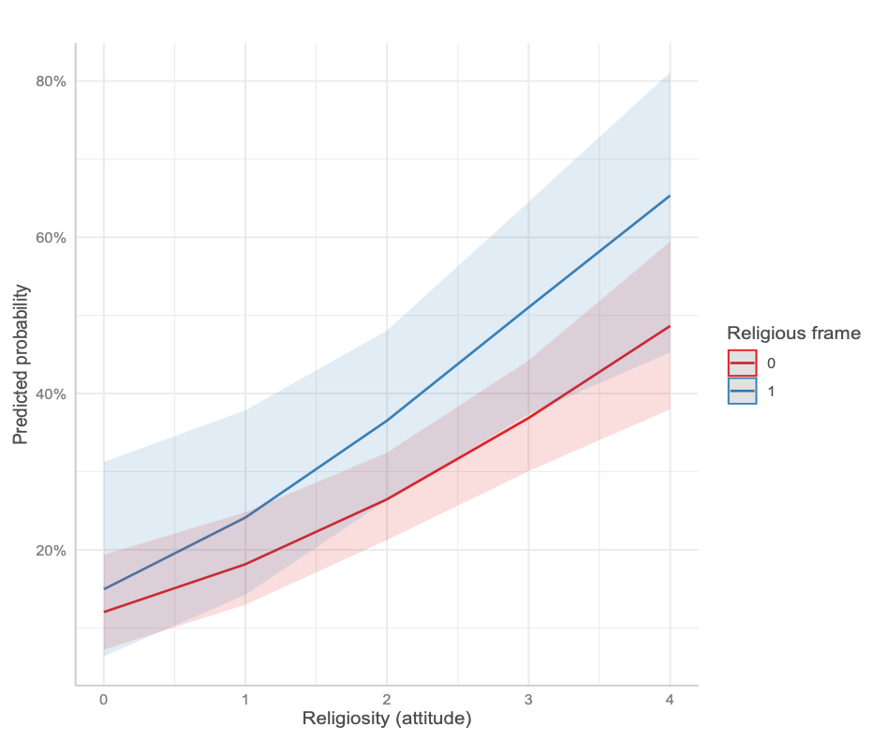
Figure G4: Predicted probability of support for incumbent parties by religious frame and attitudinal religiosity (pandemic)

To identify participants’ sectarian and ethnic backgrounds, we rely on their self-identification. Accordingly, we use responses to survey questions that ask respondents to indicate the religious denomination with which they identify and to describe how they primarily perceive or define their ethnic origin or identity, acknowledging that citizens of Türkiye may differ in both religious affiliation and ethnic background.

