Appendix
Figure A1: Leave vote (2016) at Local Authority District level
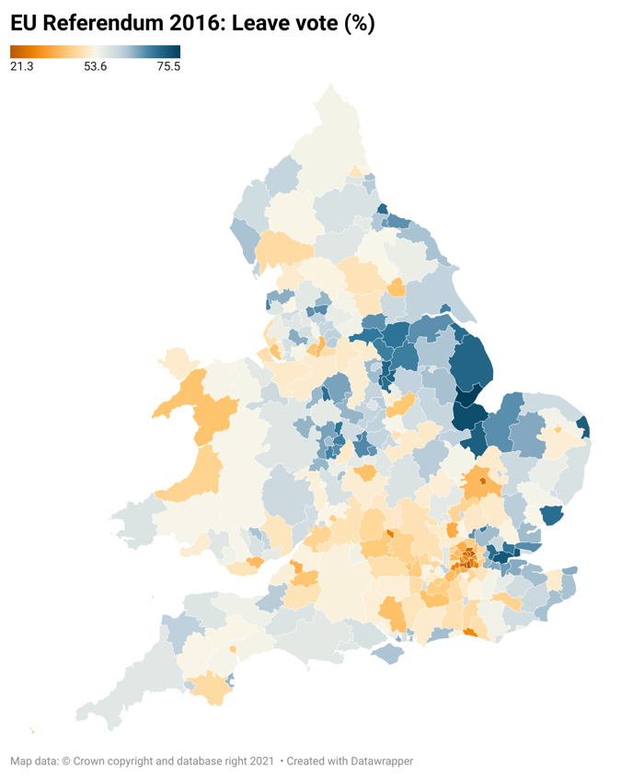
Source: Electoral Commission. Data aggregated to 2021 Local Authority boundaries

Harmonising to SOC00 Occupations
We harmonise to SOC00 occupations by identifying individuals present in Understanding Society survey waves where occupations were coded to more than one SOC classification scheme, for example SOC90 and SOC00. For all employed respondents with dual-coded SOC90 and SOC00 data, we first identify the proportions in which each SOC90 code splits into SOC00 codes. We use these splits to recode Census 1991 SOC90 occupations to SOC00 occupations, assuming that Understanding Society data are representative of broader reallocations.
We then do the same but in reverse in order to harmonise 2011 SOC10 and 2021 SOC20 to SOC00 occupations. We convert SOC20 to SOC10 and then SOC10 to SOC00 on the basis of dual-coded Understanding Society data. In this way, we are able to compare the share of employment in 81 SOC00 occupations in 1991 and 2016. We compute 2016 as the midpoint between 2011 and 2021 values.
Table A1: SOC00 rankings, based on mean hourly pay (2015 prices)
SOC00 | SOC00 Name | LFS 93-97 Mean | LFS 93-97 Rank | LFS 93-97 Tercile | APS 15-17 Mean | APS 15-17 Rank | APS 15-17 Tercile
622 | Hairdressers and related occupations | 5.20 | 1 | 1 | 7.56 | 2 | 1
923 | Elementary cleaning occupations | 6.29 | 2 | 1 | 7.62 | 3 | 1
925 | Elementary sales occupations | 6.32 | 3 | 1 | 7.76 | 4 | 1
922 | Elementary personal services occupations | 6.33 | 4 | 1 | 6.83 | 1 | 1
711 | Sales assistants and retail cashiers | 6.60 | 5 | 1 | 7.85 | 5 | 1
911 | Elementary agricultural occupations | 6.89 | 6 | 1 | 8.29 | 6 | 1
541 | Textiles and garments trades | 6.89 | 7 | 1 | 9.26 | 17 | 1
623 | Housekeeping occupations | 6.90 | 8 | 1 | 8.71 | 10 | 1
543 | Food preparation trades | 7.09 | 9 | 1 | 8.59 | 9 | 1
612 | Childcare and related personal services | 7.48 | 10 | 1 | 8.38 | 7 | 1
629 | Personal services occupations nec | 7.57 | 11 | 1 | 8.87 | 11 | 1
611 | Healthcare and related personal services | 7.75 | 12 | 1 | 8.92 | 13 | 1
813 | Assemblers and routine operatives | 7.88 | 13 | 1 | 10.66 | 29 | 2
414 | Administrative occupations: communications | 7.97 | 14 | 1 | 9.67 | 18 | 1
913 | Elementary process plant occupations | 8.28 | 15 | 1 | 8.39 | 8 | 1
914 | Elementary goods storage occupations | 8.46 | 16 | 1 | 8.91 | 12 | 1
511 | Agricultural trades | 8.47 | 17 | 1 | 9.06 | 16 | 1
549 | Skilled trades nec | 8.63 | 18 | 1 | 9.76 | 19 | 1
613 | Animal care services | 8.73 | 19 | 1 | 8.96 | 14 | 1
532 | Building trades | 8.76 | 20 | 1 | 9.82 | 21 | 1
921 | Elementary administration occupations | 8.78 | 21 | 1 | 9.78 | 20 | 1
912 | Elementary construction occupations | 8.79 | 22 | 1 | 10.11 | 25 | 1
523 | Vehicle trades | 8.97 | 23 | 1 | 12.11 | 38 | 2
721 | Customer service occupations | 9.10 | 24 | 1 | 9.94 | 22 | 1
821 | Transport drivers and operatives | 9.16 | 25 | 1 | 10.22 | 26 | 1
415 | Administrative occupations: general | 9.19 | 26 | 2 | 10.51 | 28 | 2
421 | Secretarial and related occupations | 9.34 | 27 | 2 | 10.80 | 30 | 2
811 | Process operatives | 9.51 | 28 | 2 | 10.10 | 24 | 1
413 | Administrative occupations: records | 9.52 | 29 | 2 | 11.07 | 32 | 2
531 | Construction trades | 9.94 | 30 | 2 | 11.77 | 35 | 2
412 | Administrative occupations: finance | 10.11 | 31 | 2 | 12.29 | 40 | 2
822 | Mobile machine drivers and operatives | 10.18 | 32 | 2 | 10.09 | 23 | 1
621 | Leisure and travel service occupations | 10.21 | 33 | 2 | 10.42 | 27 | 2
712 | Sales related occupations | 10.24 | 34 | 2 | 10.99 | 31 | 2
814 | Construction operatives | 10.25 | 35 | 2 | 12.71 | 42 | 2
122 | Managers and proprietors in hospitality and leisure services | 10.49 | 36 | 2 | 11.89 | 37 | 2
924 | Elementary security occupations | 10.67 | 37 | 2 | 8.99 | 15 | 1
812 | Plant and machine operatives | 10.72 | 38 | 2 | 11.24 | 33 | 2
542 | Printing trades | 10.75 | 39 | 2 | 11.54 | 34 | 2
323 | Social welfare associate professionals | 11.06 | 40 | 2 | 13.28 | 44 | 2
411 | Administrative occupations: government and related organisations | 11.20 | 41 | 2 | 12.16 | 39 | 2
521 | Metal forming, welding and related trades | 11.27 | 42 | 2 | 11.79 | 36 | 2
116 | Managers in distribution, storage and retailing | 11.57 | 43 | 2 | 14.87 | 49 | 3
121 | Managers in farming, horticulture, forestry and services | 11.68 | 44 | 2 | 18.06 | 63 | 3
311 | Science and engineering technicians | 12.22 | 45 | 2 | 14.18 | 47 | 3
522 | Metal machining, fitting and instrument making trades | 12.27 | 46 | 3 | 12.75 | 43 | 2
331 | Protective service occupations | 12.63 | 47 | 3 | 15.25 | 50 | 3
524 | Electrical trades | 12.66 | 48 | 3 | 14.17 | 46 | 2
321 | Health associate professionals | 12.68 | 49 | 3 | 15.44 | 51 | 3
322 | Therapists | 12.81 | 50 | 3 | 15.95 | 56 | 3
312 | Draughtspersons and building inspectors | 13.02 | 51 | 3 | 15.75 | 54 | 3
244 | Public service professionals | 13.38 | 52 | 3 | 15.93 | 55 | 3
123 | Managers and proprietors in other service industries | 13.41 | 53 | 3 | 18.31 | 65 | 3
245 | Librarians and related professionals | 13.59 | 54 | 3 | 13.76 | 45 | 2
313 | IT service delivery occupations | 13.98 | 55 | 3 | 15.66 | 53 | 3
355 | Conservation associate professionals | 14.06 | 56 | 3 | 16.03 | 57 | 3
341 | Artistic and literary occupations | 14.26 | 57 | 3 | 16.28 | 58 | 3
342 | Design associate professionals | 14.29 | 58 | 3 | 16.29 | 59 | 3
352 | Legal associate professionals | 14.52 | 59 | 3 | 15.55 | 52 | 3
343 | Media associate professionals | 14.60 | 60 | 3 | 17.49 | 61 | 3
232 | Research professionals | 15.17 | 61 | 3 | 20.47 | 73 | 3
115 | Financial institution and office managers | 15.48 | 62 | 3 | 18.27 | 64 | 3
243 | Architects, town planners, surveyors | 15.70 | 63 | 3 | 20.17 | 72 | 3
114 | Quality and customer care managers | 16.20 | 64 | 3 | 18.67 | 68 | 3
344 | Sports and fitness occupations | 16.21 | 65 | 3 | 12.31 | 41 | 2
211 | Science professionals | 16.27 | 66 | 3 | 18.47 | 67 | 3
354 | Sales and related associate professionals | 16.31 | 67 | 3 | 17.29 | 60 | 3
356 | Public service and other associate professionals | 16.47 | 68 | 3 | 14.83 | 48 | 3
353 | Business and finance associate professionals | 16.83 | 69 | 3 | 19.62 | 70 | 3
212 | Engineering professionals | 16.85 | 70 | 3 | 19.55 | 69 | 3
112 | Production managers | 16.93 | 71 | 3 | 21.37 | 74 | 3
213 | Information and communication technology professionals | 16.97 | 72 | 3 | 21.98 | 75 | 3
231 | Teaching professionals | 18.26 | 73 | 3 | 18.42 | 66 | 3
118 | Health and social services managers | 18.52 | 74 | 3 | 17.86 | 62 | 3
242 | Business and statistical professionals | 18.54 | 75 | 3 | 22.84 | 78 | 3
351 | Transport associate professionals | 18.67 | 76 | 3 | 22.47 | 77 | 3
113 | Functional managers | 18.70 | 77 | 3 | 22.40 | 76 | 3
111 | Corporate managers and senior officials | 19.61 | 78 | 3 | 29.23 | 81 | 3
117 | Protective service officers | 20.15 | 79 | 3 | 19.98 | 71 | 3
221 | Health professionals | 20.42 | 80 | 3 | 23.85 | 79 | 3
241 | Legal professionals | 21.07 | 81 | 3 | 25.26 | 80 | 3
Sources: Census 1991, 2011 and 2021; Quarterly Labour Force Survey 1993 – 1997 and Annual Population Survey 2015 – 2017.

Descriptive Statistics
Figure A2: LAD percentage point growth in employment in highly paid (Tercile 3) occupations 1991 – 2016
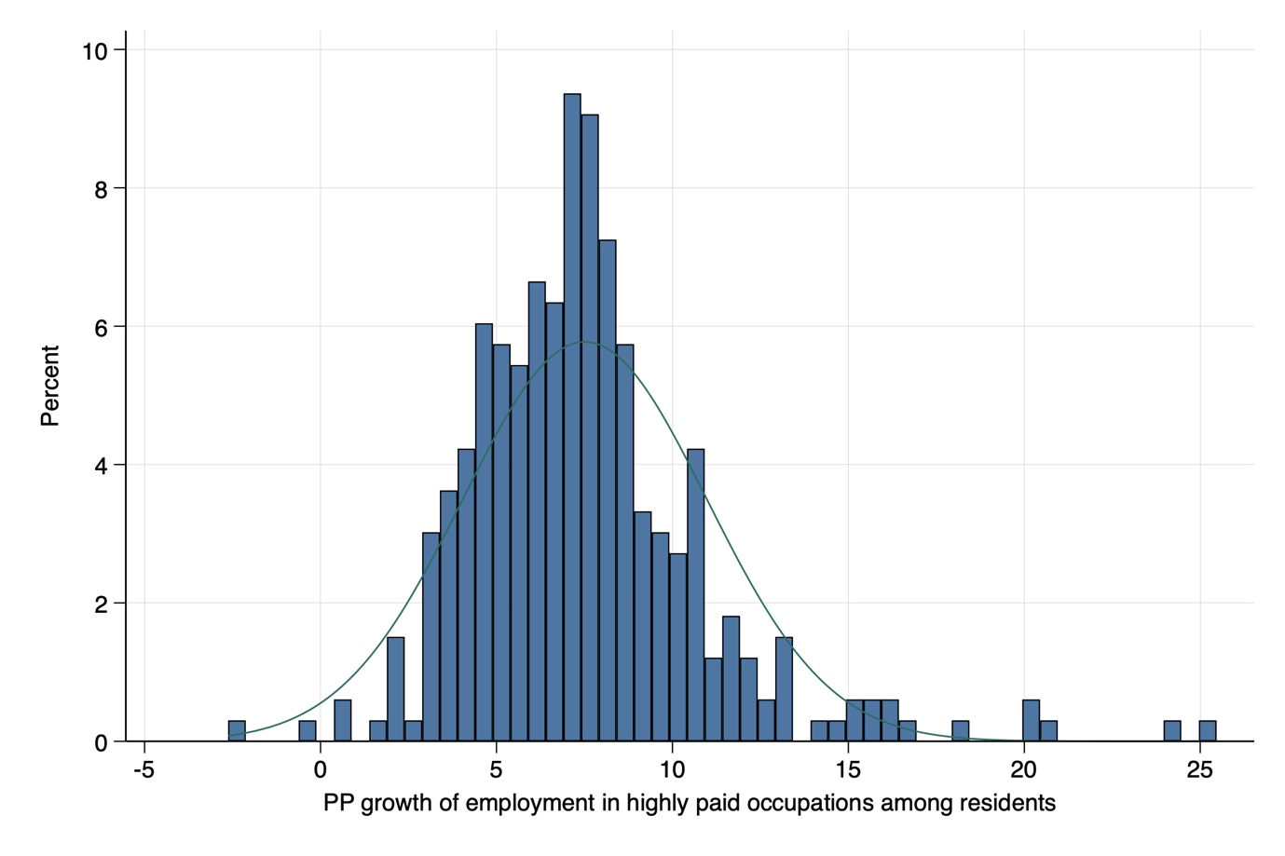
Figure A3: LAD initial versus growth in employment in highly paid (Tercile 3) occupations 1991 – 2021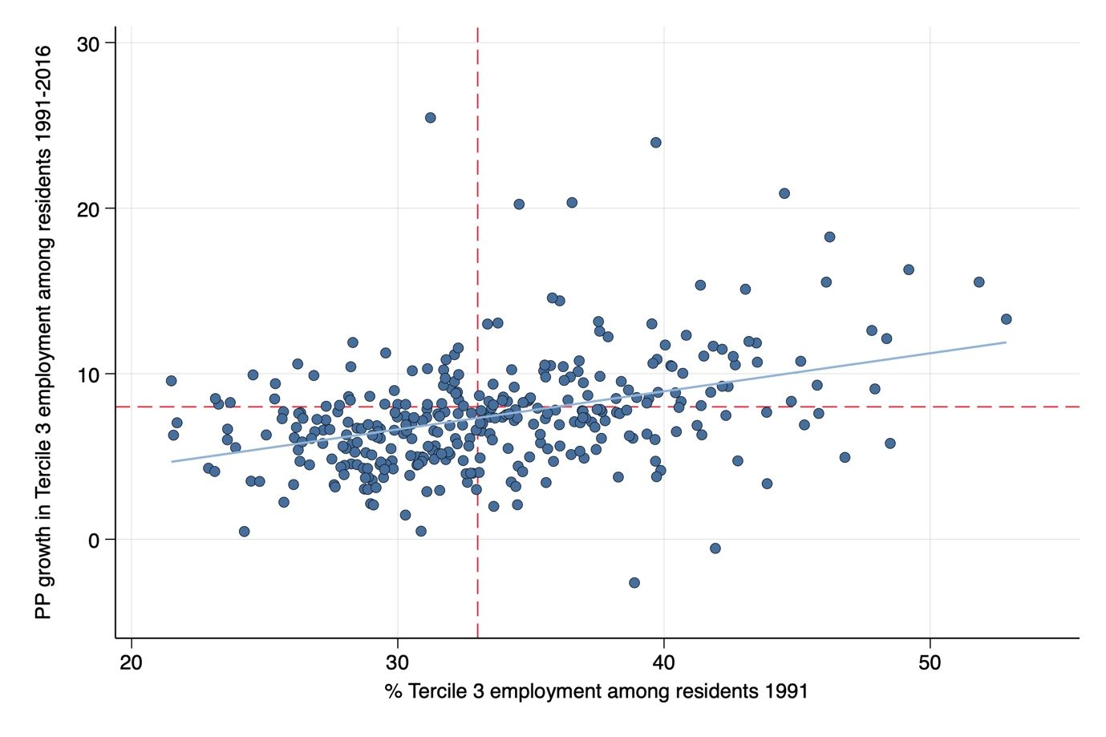Notes: Red dotted lines denote England and Wales average
Figure A4: Urban v rural LAD percentage point growth in employment in highly paid (Tercile 3) occupations 1991 – 2016
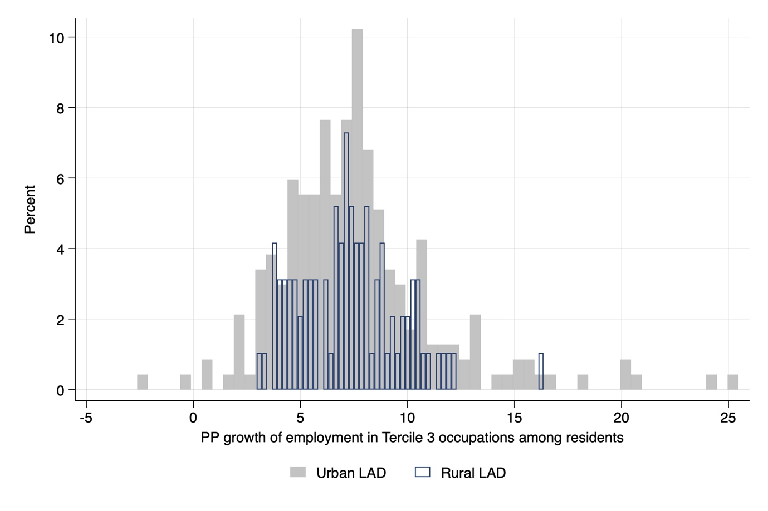Notes: LAD categorisation is based on the 2021 ONS Rural-Urban classification. This distinguishes between rural majority, intermediate rural, intermediate urban and urban LADs: here, we collapse to a binary urban-rural classification.

Table A2: Descriptive statistics for LAD-level variables
Indicator | Timeframe | Min | Max | Mean | SD | Source
% Leave vote | 2016 | 21.38 | 75.56 | 54.42 | 9.82 | Electoral Commission (2019)
PP growth in Tercile 3 employment among residents | 1991 - 2016 | -2.63 | 25.46 | 7.46 | 3.40 | Census 1991, 2011 & 2021
Tercile 3 employment (%) | 1991 | 21.49 | 52.86 | 33.56 | 5.78 | Census 1991, 2011 & 2021
% employment growth | 1991 - 2016 | -4.31 | 162.99 | 21.67 | 15.55 | Census 1991, 2011 & 2021
Employment (000s) | 1991 | 14.96 | 362.23 | 65.09 | 40.90 | Census 1991, 2011 & 2021
PP change in employment rate | 1991 - 2016 | -7.03 | 16.31 | 4.00 | 3.21 | Census 1991, 2011 & 2021
Employment rate (%) | 1991 | 50.02 | 77.23 | 68.34 | 5.23 | Census 1991, 2011 & 2021
PP change in unemployment rate | 1991 - 2016 | -16.78 | 0.26 | -3.55 | 2.42 | Census 1991, 2011 & 2021
Unemployment rate (%) | 1991 | 4.48 | 25.52 | 9.72 | 3.84 | Census 1991, 2011 & 2021
PP change in economic inactivity rate | 1991 - 2016 | -7.58 | 9.81 | -1.43 | 2.77 | Census 1991, 2011 & 2021
Economic inactivity rate (%) | 1991 | 17.77 | 35.68 | 24.39 | 3.15 | Census 1991, 2011 & 2021
PP change manufacturing employment | 1991 - 2016 | -11.19 | 41.54 | 15.13 | 9.07 | Census 1991, 2011 & 2021
% manufacturing employment | 1991 | 320.00 | 648.00 | 447.42 | 54.97 | Census 1991, 2011 & 2021
% increase in GDP per capita | 1998 - 2016 | -15.98 | 64.36 | 20.68 | 12.28 | ONS: Regional gross domestic product: local authorities
GDP per capita (£000s) | 1998 | 10.73 | 205.23 | 23.44 | 13.52 | ONS: Regional gross domestic product: local authorities
% increase in median house price | 1995 - 2016 | 76.84 | 478.65 | 177.38 | 68.41 | Land Registry
Log median house price | 1995 | 10.67 | 12.45 | 11.30 | 0.27 | Land Registry
% population growth | 1991 - 2016 | -6.69 | 75.23 | 16.17 | 10.77 | Census 1991, 2011 & 2021
Population (000s) | 1991 | 31.49 | 960.97 | 151.62 | 100.98 | Census 1991, 2011 & 2021
PP increase in BAME population | 1991 - 2016 | 0.97 | 42.11 | 7.85 | 7.55 | Census 1991, 2011 & 2021
% BAME population | 1991 | 0.25 | 44.81 | 4.39 | 7.08 | Census 1991, 2011 & 2021
Notes: N=329; City of London and Isles of Scilly excluded due to missing GDP data. Wages, GDP per capita and house prices in/deflated to 2015 prices

Table A3: Descriptive statistics for Understanding Society Wave 8 variables
Variable | Min | Max | Mean | SD
Dependent variable
Leave support 2016  0 = Remain  1 = Leave |  |  | 0.57  0.43
LAD-variables
PP growth in Tercile 3 employment among residents 1991 - 2016 | -2.63 | 25.46 | 7.58 | 3.54
Tercile 3 employment (%) 1991 | 21.49 | 52.86 | 33.07 | 5.35
% employment growth 1991 - 2016 | -4.31 | 162.99 | 23.84 | 19.39
Employment 1991 (000s) | 14.96 | 362.23 | 92.26 | 63.33
% increase in GDP per capita 1998 - 2016 | -15.98 | 64.36 | 20.73 | 11.50
GDP per capita (£000s) 1998 | 10.73 | 205.23 | 23.28 | 12.76
% increase in median house price 1995 - 2016 | 76.84 | 478.65 | 177.89 | 75.68
Log median house price 1995 | 10.67 | 12.45 | 11.27 | 0.25
PP increase in BAME population 1991 - 2016 | 0.97 | 42.11 | 10.10 | 8.92
% BAME population (000s) | 0.25 | 44.81 | 6.62 | 9.20
Individual-level variables
Sex  0 = female  1 = male |  |  | 0.55  0.45
Age | 16 | 101 | 48.65 | 18.46
Ethnicity: white  0 = ethnic minority  1 = white |  |  | 0.19  0.81
Highest qualification  1 = GCSE & below  2 = A-Level  3 = degree |  |  | 0.38  0.22  0.40
Labour force status  1 = employed  2 = unemployed  3 = student  4 = inactive |  |  | 0.57  0.04  0.06  0.33
Household income decile | 1 | 10 | 6.17 | 2.77
Interviewed before referendum  0 = no  1 = yes |  |  | 0.77  0.23
Notes: N = 28,133 in 329 Local Authority Districts

Sensitivity Analysis

Quintile 5 employment
Table A4: Linear regression of Quintile 5 growth on LAD-level Leave vote (2016)

 | I | II
PP change in Quintile 5 employment | -1.93*** | -1.37***
 | (-2.21 - -1.66) | (-1.70 - -1.04)
% Quintile 5 employment 1991 | -0.78*** | -0.96***
 | (-0.92 - -0.65) | (-1.18 - -0.74)
% employment growth |  | -0.08**
 |  | (-0.14 - -0.03)
Employment 1991 |  | -0.01
 |  | (-0.03 - 0.00)
% GDP per capita growth |  | -0.10***
 |  | (-0.15 - -0.05)
GDP per capita 1998 |  | 0.07**
 |  | (0.02 - 0.13)
% change median house price |  | -0.01
 |  | (-0.03 - 0.01)
Log median house price 1995 |  | 3.40
 |  | (-1.65 - 8.45)
PP change non-white population |  | 0.17**
 |  | (0.04 - 0.30)
% non-white population 1991 |  | -0.40***
 |  | (-0.55 - -0.24)
Constant | 84.09 | 50.21
R2 | 0.60 | 0.72
N | 329 | 329
Notes: Confidence intervals in parenthesis; *** p<0.001, ** p<0.01, * p<0.05

Table A5: Multilevel linear models of Leave support (2016), reported vote and contemporary Leave support, proxying high paid employment growth via Quintile 5 growth
 | I) LEAVE  SUPPORT 2016 | II) LEAVE  SUPPORT 2016 | III) VOTED LEAVE 2016 | IV) VOTED  LEAVE 2016 | V) LEAVE SUPPORT 2019 - 2021 | VI) LEAVE SUPPORT 2019 - 2021
Fixed Effects
LAD-level
PP change Quintile 5 employment | -0.013*** | -0.011*** | -0.016*** | -0.012*** | -0.015*** | -0.011**
 | (-0.017 - -0.009) | (-0.017 - -0.005) | (-0.021 - -0.011) | (-0.020 - -0.005) | (-0.019 - -0.011) | (-0.018 - -0.004)
% Quintile 5 employment 1991 | -0.002 | -0.004 | -0.004** | -0.006* | -0.002* | -0.003
 | (-0.004 - 0.000) | (-0.008 - 0.000) | (-0.007 - -0.001) | (-0.011 - -0.001) | (-0.005 - -0.000) | (-0.007 - 0.001)
% employment growth |  | -0.001 |  | -0.001 |  | -0.000
 |  | (-0.002 - 0.000) |  | (-0.002 - 0.000) |  | (-0.001 - 0.001)
Employment 1991 |  | -0.000 |  | -0.000 |  | 0.000
 |  | (-0.000 - 0.000) |  | (-0.000 - 0.000) |  | (-0.000 - 0.000)
% GDP per capita growth |  | -0.000 |  | -0.001* |  | -0.001
 |  | (-0.001 - 0.001) |  | (-0.002 - -0.000) |  | (-0.002 - 0.000)
GDP per capita 1998 |  | 0.000 |  | 0.001 |  | -0.000
 |  | (-0.000 - 0.001) |  | (-0.000 - 0.001) |  | (-0.001 - 0.001)
% change median house price |  | 0.000 |  | 0.000 |  | -0.000
 |  | (-0.000 - 0.000) |  | (-0.000 - 0.000) |  | (-0.000 - 0.000)
Log median house price 1995 |  | 0.024 |  | 0.021 |  | 0.039
 |  | (-0.074 - 0.122) |  | (-0.085 - 0.128) |  | (-0.058 - 0.136)
PP change non-white population |  | 0.001 |  | 0.000 |  | -0.001
 |  | (-0.001 - 0.003) |  | (-0.002 - 0.003) |  | (-0.003 - 0.002)
% non-white population 1991 |  | -0.001 |  | -0.001 |  | 0.000
 |  | (-0.003 - 0.002) |  | (-0.003 - 0.002) |  | (-0.003 - 0.003)
Individual-level
Male | 0.049*** | 0.049*** | 0.046*** | 0.046*** | 0.068*** | 0.068***
 | (0.038 - 0.060) | (0.038 - 0.060) | (0.033 - 0.059) | (0.033 - 0.059) | (0.054 - 0.081) | (0.054 - 0.081)
Age | 0.002*** | 0.002*** | 0.002*** | 0.002*** | 0.004*** | 0.004***
 | (0.002 - 0.003) | (0.002 - 0.003) | (0.001 - 0.003) | (0.001 - 0.003) | (0.003 - 0.005) | (0.003 - 0.005)
White | 0.118*** | 0.118*** | 0.141*** | 0.139*** | 0.148*** | 0.144***
 | (0.090 - 0.147) | (0.088 - 0.148) | (0.108 - 0.173) | (0.105 - 0.172) | (0.116 - 0.179) | (0.111 - 0.177)
Qualification (ref: GCSE & below)
A-Level | -0.064*** | -0.064*** | -0.090*** | -0.090*** | -0.051*** | -0.052***
 | (-0.081 - -0.046) | (-0.082 - -0.046) | (-0.114 - -0.065) | (-0.115 - -0.065) | (-0.074 - -0.029) | (-0.074 - -0.029)
Degree | -0.217*** | -0.217*** | -0.268*** | -0.268*** | -0.211*** | -0.211***
 | (-0.236 - -0.198) | (-0.236 - -0.198) | (-0.292 - -0.244) | (-0.292 - -0.244) | (-0.230 - -0.191) | (-0.230 - -0.192)
Employment status (ref: employed)
Unemployed | 0.041 | 0.041 | 0.014 | 0.015 | -0.029 | -0.030
 | (-0.000 - 0.081) | (-0.000 - 0.081) | (-0.043 - 0.071) | (-0.043 - 0.072) | (-0.069 - 0.010) | (-0.069 - 0.010)
Student | -0.175*** | -0.175*** | -0.128*** | -0.128*** | -0.127*** | -0.128***
 | (-0.209 - -0.142) | (-0.209 - -0.142) | (-0.203 - -0.053) | (-0.203 - -0.053) | (-0.166 - -0.089) | (-0.167 - -0.089)
Inactive | 0.007 | 0.007 | 0.000 | 0.000 | -0.014 | -0.014
 | (-0.014 - 0.028) | (-0.014 - 0.028) | (-0.026 - 0.026) | (-0.026 - 0.026) | (-0.035 - 0.007) | (-0.035 - 0.006)
Gross household income decile | -0.013*** | -0.013*** | -0.015*** | -0.015*** | -0.008*** | -0.008***
 | (-0.016 - -0.010) | (-0.017 - -0.010) | (-0.019 - -0.011) | (-0.019 - -0.011) | (-0.012 - -0.005) | (-0.012 - -0.005)
Interview before referendum dummy | YES | YES | NO | NO | NO | NO
Survey year dummy | NO | NO | YES | YES | YES | YES
Constant | 0.563 | 0.332 | 0.643 | 0.449 | 0.411 | 0.024
Random Effects
LAD (constant) | 0.006 | 0.006 | 0.008 | 0.007 | 0.006 | 0.006
Residual | 0.217 | 0.217 | 0.206 | 0.206 | 0.212 | 0.212
Observations | 28,183 | 28,183 | 18,556 | 18,556 | 25,056 | 25,056
Number of groups | 329 | 329 | 324 | 329 | 324 | 324
Notes: Confidence intervals in parenthesis; *** p<0.001, ** p<0.01, * p<0.05

Table A6: Multilevel linear models testing the unconditional effects hypothesis proxying high paid employment growth via Quintile 5 growth (sub-sample of employed respondents)
 | I) LEAVE  SUPPORT 2016 | II) VOTED LEAVE | III) LEAVE SUPPORT 2019-2020
PP change Quintile 5 employment  * individual employment quintile | 0.000 | 0.002 | 0.000
 | (-0.002 - 0.003) | (-0.001 - 0.004) | (-0.002 - 0.002)
LAD-level
PP change Quintile 5 employment | -0.014** | -0.021** | -0.010
 | (-0.024 - -0.003) | (-0.034 - -0.008) | (-0.022 - 0.002)
% Quintile 5 employment 1991 | -0.006* | -0.008** | -0.004
 | (-0.011 - -0.000) | (-0.014 - -0.002) | (-0.009 - 0.002)
Additional LAD controls | YES | YES | YES
Individual-level
Individual employment quintile | -0.030*** | -0.054*** | -0.027**
 | (-0.048 - -0.013) | (-0.072 - -0.036) | (-0.044 - -0.010)
Additional individual controls: | YES | YES | YES
Interview before referendum dummy | YES | NO | NO
Survey year dummy | NO | YES | YES
Constant | 0.263 | -0.560 | -0.273
Random Effects
Individual employment quintile | 0.001 | 0.001 | 0.001
LAD (constant) | 0.009 | 0.011 | 0.009
Residual | 0.210 | 0.196 | 0.208
Observations | 16,375 | 10,319 | 13,288
Number of groups | 329 | 324 | 324
Notes: Confidence intervals in parenthesis; *** p<0.001, ** p<0.01, * p<0.05

Mechanisms
Figure A5: Individual-level analysis of the association between Tercile 3 employment growth and progressive views
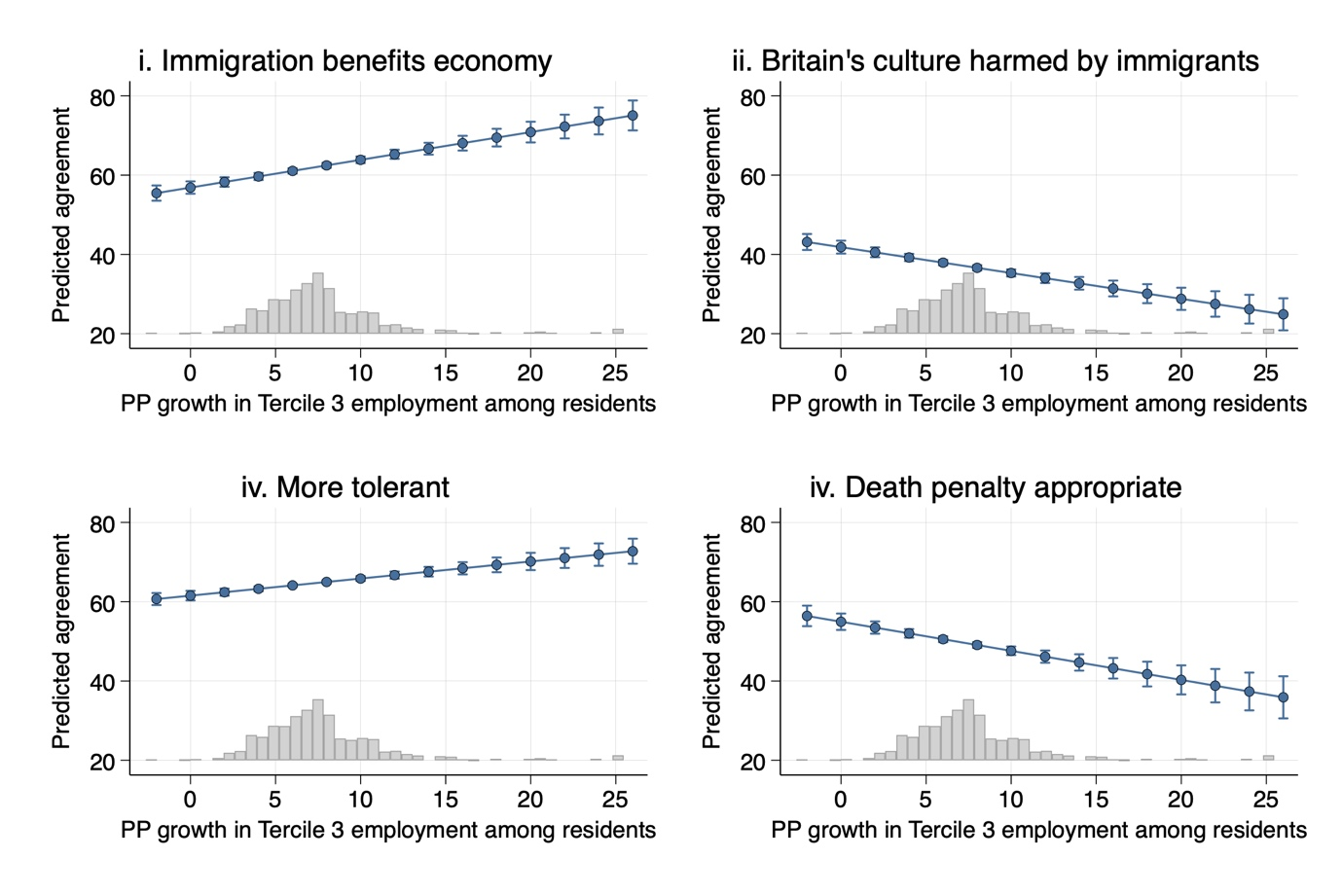
Notes: Predictive margins of multilevel linear regressions; N=21,334 in 322 Local Authority Districts

