Supplementary materials: Temperature and school absences: evidence from England
Tables
Table A1. Temperature and all types of school absences
 | (1) | (2) | (3) | (4) | (5)
 | All absences | Illness | Medical Appointment | Authorised Holiday | Unathorised Holiday
<0°C | -0.002 | 0.002 | 0.000 | -0.002 | 0.000
 | (0.003) | (0.002) | (0.000) | (0.001) | (0.001)
0 to 3°C | -0.001 | 0.000 | -0.000 | -0.001 | 0.000
 | (0.002) | (0.001) | (0.000) | (0.001) | (0.000)
3 to 6°C | -0.002 | 0.002* | -0.000 | -0.002* | 0.000
 | (0.001) | (0.001) | (0.000) | (0.001) | (0.000)
9 to 12°C | 0.002* | 0.001 | -0.000 | 0.001* | 0.001*
 | (0.001) | (0.001) | (0.000) | (0.000) | (0.000)
12 to 15°C | 0.002 | 0.000 | -0.000 | 0.002* | 0.001
 | (0.001) | (0.001) | (0.000) | (0.000) | (0.000)
15 to 18°C | 0.007* | 0.001 | -0.000 | 0.004* | -0.000
 | (0.002) | (0.001) | (0.000) | (0.001) | (0.000)
>18°C | 0.011* | 0.006* | -0.000 | 0.005* | -0.000
 | (0.002) | (0.001) | (0.000) | (0.001) | (0.001)
% of Native British | -0.002 | 0.003* | 0.001* | -0.001* | 0.001*
 | (0.001) | (0.001) | (0.000) | (0.000) | (0.000)
% boys | 0.003* | 0.000 | -0.000 | -0.000 | 0.000
 | (0.001) | (0.001) | (0.000) | (0.000) | (0.000)
% free school meal | 0.014* | 0.008* | 0.001* | -0.001* | -0.001*
 | (0.002) | (0.001) | (0.000) | (0.000) | (0.000)
% fuel poverty | -0.003 | -0.001 | -0.000 | -0.002 | 0.002*
 | (0.004) | (0.002) | (0.000) | (0.001) | (0.001)
PM10 (µg/m3) | -0.007 | 0.016 | -0.001 | 0.008* | 0.002
 | (0.011) | (0.011) | (0.001) | (0.003) | (0.003)
NO2 (µg/m3) | 0.007 | 0.001 | 0.001 | 0.002 | -0.002
 | (0.004) | (0.003) | (0.000) | (0.001) | (0.001)
PM2.5 (µg/m3) | -0.026 | -0.022 | 0.001 | -0.018* | -0.002
 | (0.014) | (0.014) | (0.002) | (0.005) | (0.004)
Rain N° days 75th to 90th | 0.001 | 0.000 | -0.000 | 0.001* | 0.000
 | (0.001) | (0.000) | (0.000) | (0.000) | (0.000)
Rain N° days 90th to 95th | 0.001 | 0.000 | -0.000 | 0.000 | 0.000
 | (0.001) | (0.001) | (0.000) | (0.000) | (0.000)
Rain N° days 95th to 99th | 0.002 | 0.001 | -0.000 | 0.002* | -0.000
 | (0.001) | (0.001) | (0.000) | (0.000) | (0.000)
Rain N° days >99th | 0.009* | -0.001 | -0.000 | 0.008* | -0.002*
 | (0.003) | (0.002) | (0.000) | (0.001) | (0.001)
Total schools | 22,909 | 22,909 | 22,909 | 22,909 | 22,909
Total school-years | 140,396 | 140,396 | 140,396 | 140,396 | 140,396
Note: the table shows the coefficients for the analysis based on equation (1) with outcomes: All absences, Illness Medical Appointment, Authorised Holiday and Unathorised Holiday. Constant present but not reported. Standard errors in parentheses. *p-value: ≤ 0.05.

Table A2. Temperature, interaction with fuel poverty and all types of school absences
 | (1) | (2) | (3) | (4) | (5)
 | All absences | Illness | Medical Appointment | Authorised Holiday | Unathorised Holiday
<0°C | -0.017 | -0.016* | -0.001 | 0.005 | -0.004
 | (0.013) | (0.006) | (0.001) | (0.004) | (0.003)
<0°C # Fuel poverty | 0.001 | 0.002* | 0.000 | -0.001 | 0.000
 | (0.001) | (0.001) | (0.000) | (0.000) | (0.000)
0 to 3°C | -0.007 | 0.005 | 0.000 | 0.001 | -0.001
 | (0.005) | (0.003) | (0.000) | (0.001) | (0.001)
0 to 3°C # Fuel poverty | 0.001 | -0.000 | -0.000 | -0.000 | 0.000
 | (0.000) | (0.000) | (0.000) | (0.000) | (0.000)
3 to 6°C | -0.001 | -0.002 | 0.000 | -0.001 | 0.001
 | (0.003) | (0.002) | (0.000) | (0.001) | (0.001)
3 to 6°C # Fuel poverty | -0.000 | 0.000 | -0.000 | -0.000 | -0.000
 | (0.000) | (0.000) | (0.000) | (0.000) | (0.000)
9 to 12°C | -0.008 | -0.003 | -0.000 | 0.002 | -0.000
 | (0.005) | (0.003) | (0.000) | (0.001) | (0.001)
9 to 12°C # Fuel poverty | 0.001* | 0.000 | 0.000 | -0.000 | 0.000
 | (0.000) | (0.000) | (0.000) | (0.000) | (0.000)
12 to 15°C | -0.004 | 0.006 | -0.000 | 0.003* | -0.001
 | (0.005) | (0.003) | (0.000) | (0.001) | (0.001)
12 to 15°C # Fuel poverty | 0.001 | -0.001 | -0.000 | -0.000 | 0.000
 | (0.000) | (0.000) | (0.000) | (0.000) | (0.000)
15 to 18°C | -0.006 | 0.002 | -0.001 | 0.006* | -0.002
 | (0.007) | (0.004) | (0.001) | (0.002) | (0.001)
15 to 18°C # Fuel poverty | 0.001* | -0.000 | 0.000 | -0.000 | 0.000
 | (0.001) | (0.000) | (0.000) | (0.000) | (0.000)
>18°C | 0.009 | 0.008 | 0.001 | 0.006* | -0.003
 | (0.007) | (0.004) | (0.000) | (0.002) | (0.002)
>18°C # Fuel poverty | 0.000 | -0.000 | -0.000 | -0.000 | 0.000
 | (0.001) | (0.000) | (0.000) | (0.000) | (0.000)
 | (0.205) | (0.133) | (0.021) | (0.055) | (0.045)
Total schools | 22,909 | 22,909 | 22,909 | 22,909 | 22,909
Total school-years | 140,396 | 140,396 | 140,396 | 140,396 | 140,396
Note: the table shows the coefficients for the analysis based on equation (2) with outcomes: All absences, Illness Medical Appointment, Authorised Holiday and Unathorised Holiday. Constant present but not reported. Standard errors in parentheses. *p-value: ≤ 0.05. We report only the coefficients for the temperature variables and the interaction with % fuel poverty. The other coefficients are included but not reported.

Table A3. Temperature, interaction with local climate and all types of school absences
 | (1) | (2) | (3) | (4) | (5)
 | All absences | Illness | Medical Appointment | Authorised Holiday | Unathorised Holiday
<0°C | 0.016 | 0.025 | 0.002 | 0.012 | -0.015*
 | (0.021) | (0.015) | (0.003) | (0.009) | (0.005)
<0°C # 50th percentile temperature | -0.003 | -0.003 | -0.000 | -0.002 | 0.001*
 | (0.002) | (0.001) | (0.000) | (0.001) | (0.000)
0 to 3°C | 0.033* | 0.018* | 0.000 | 0.002 | 0.008*
 | (0.012) | (0.009) | (0.002) | (0.004) | (0.003)
0 to 3°C # 50th percentile temperature | -0.004* | -0.002* | -0.000 | -0.000 | -0.001*
 | (0.001) | (0.001) | (0.000) | (0.000) | (0.000)
3 to 6°C | 0.010 | 0.029* | -0.000 | -0.013* | 0.001
 | (0.011) | (0.007) | (0.001) | (0.004) | (0.003)
3 to 6°C # 50th percentile temperature | -0.001 | -0.003* | 0.000 | 0.001* | -0.000
 | (0.001) | (0.001) | (0.000) | (0.000) | (0.000)
9 to 12°C | -0.025 | 0.003 | 0.001 | -0.012* | -0.002
 | (0.015) | (0.011) | (0.001) | (0.004) | (0.003)
9 to 12°C # 50th percentile temperature | 0.002 | -0.000 | -0.000 | 0.001* | 0.000
 | (0.001) | (0.001) | (0.000) | (0.000) | (0.000)
12 to 15°C | -0.029* | 0.001 | 0.000 | -0.015* | 0.007*
 | (0.013) | (0.008) | (0.001) | (0.004) | (0.003)
12 to 15°C # 50th percentile temperature | 0.003* | -0.000 | -0.000 | 0.002* | -0.001*
 | (0.001) | (0.001) | (0.000) | (0.000) | (0.000)
15 to 18°C | -0.023 | 0.005 | -0.000 | -0.022* | 0.001
 | (0.016) | (0.010) | (0.001) | (0.005) | (0.003)
15 to 18°C # 50th percentile temperature | 0.002 | -0.001 | -0.000 | 0.002* | -0.000
 | (0.002) | (0.001) | (0.000) | (0.000) | (0.000)
>18°C | -0.031 | 0.004 | -0.000 | -0.033* | 0.014*
 | (0.023) | (0.015) | (0.002) | (0.005) | (0.005)
>18°C # 50th percentile temperature | 0.003 | -0.000 | -0.000 | 0.004* | -0.001*
 | (0.002) | (0.001) | (0.000) | (0.001) | (0.000)
Total schools | 22,909 | 22,909 | 22,909 | 22,909 | 22,909
Total school-years | 140,396 | 140,396 | 140,396 | 140,396 | 140,396
Note: the table shows the coefficients for the analysis based on equation (2) with outcomes: All absences, Illness Medical Appointment, Authorised Holiday and Unathorised Holiday. Constant present but not reported. Standard errors in parentheses. *p-value: ≤ 0.05. We report only the coefficients for the temperature variables and the interaction with the 50th percentile temperature. The other coefficients are included but not reported.

Figures

Figure A1. Average number of hot and cold days during the school-years
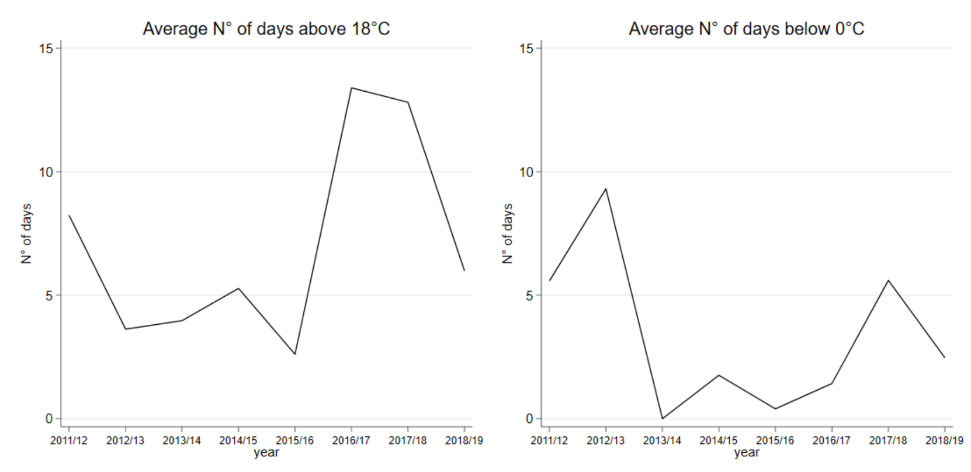
Note: the figure presents the average number of hot (>18°C) and cold (<0°C) from the school-year 2011/12 to 2018/19 weighted by the number of pupils in each school.

Figure A2. 99th and 1st percentiles of the school temperature
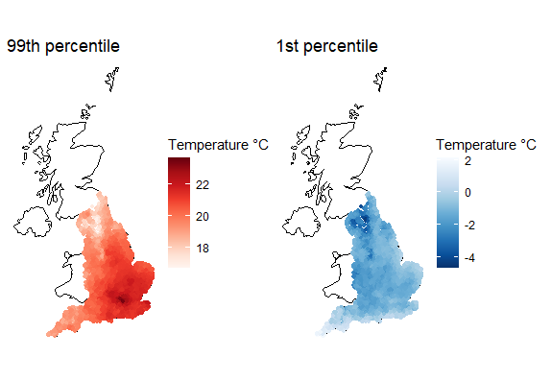
Note: the maps depict the variation in the 99th and 1st percentile of average temperature distribution from 2011 to 2019 calculated at the school location.

Figure A3. Temperature percentiles and effect on school absences
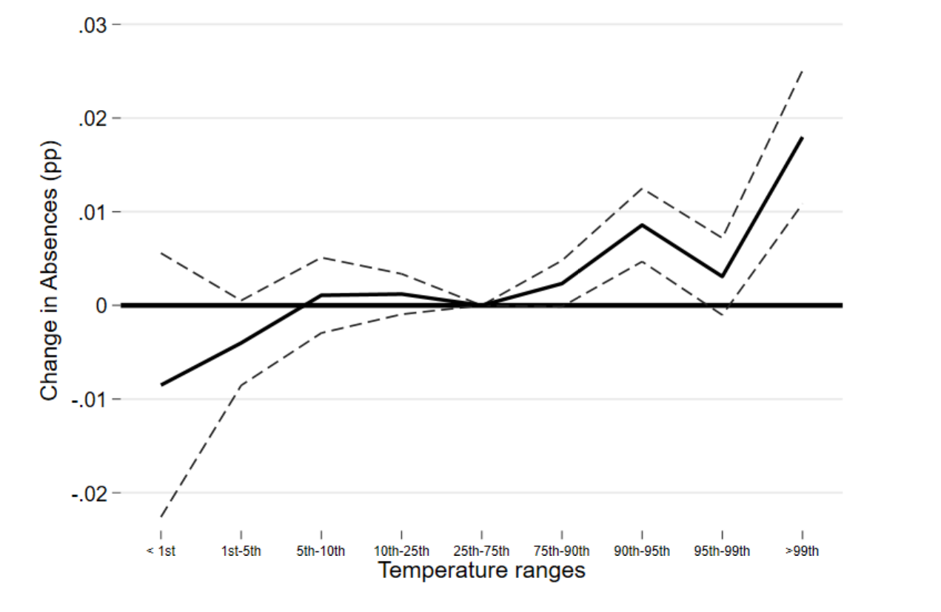
Note: the figure shows the results of exposure to the temperature ranges based on percentiles on overall absences and equation (1). Standard errors clustered at the county level. 95% confidence intervals.

Figure A4. Placebo test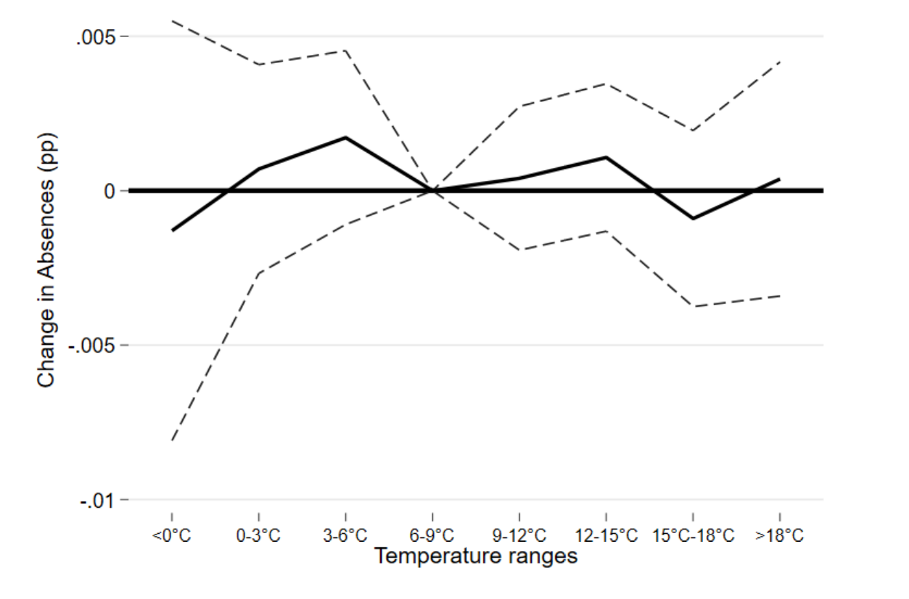
Note: the figure shows the results of running equation (1) with exposure to temperature bins measured one year after the school-year. Standard errors clustered at the county level. 95% confidence intervals.

Figure A5. Temperature and school absence without frequency weights for the number of students

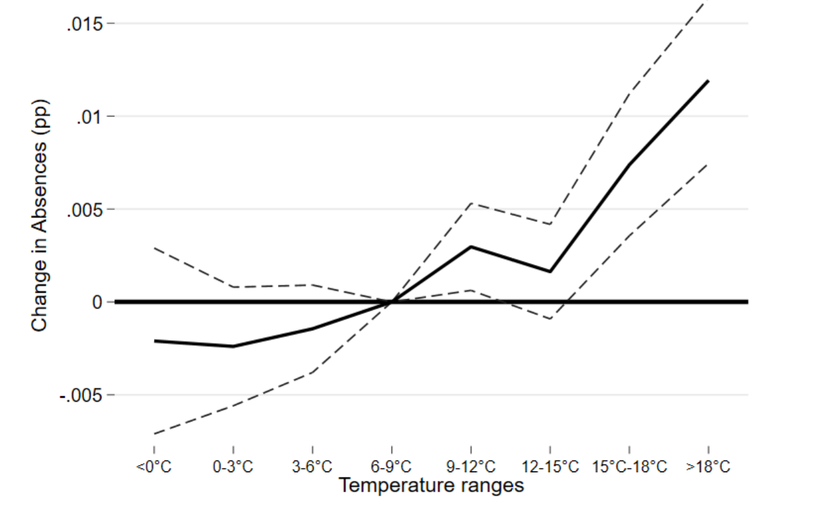
Note: the figure shows the results of exposure to the temperature ranges on school absences as in equation (1) but without frequency weights. Standard errors clustered at the county level. 95% confidence intervals.

Figure A6. Temperature and school absences with standard errors at the school level
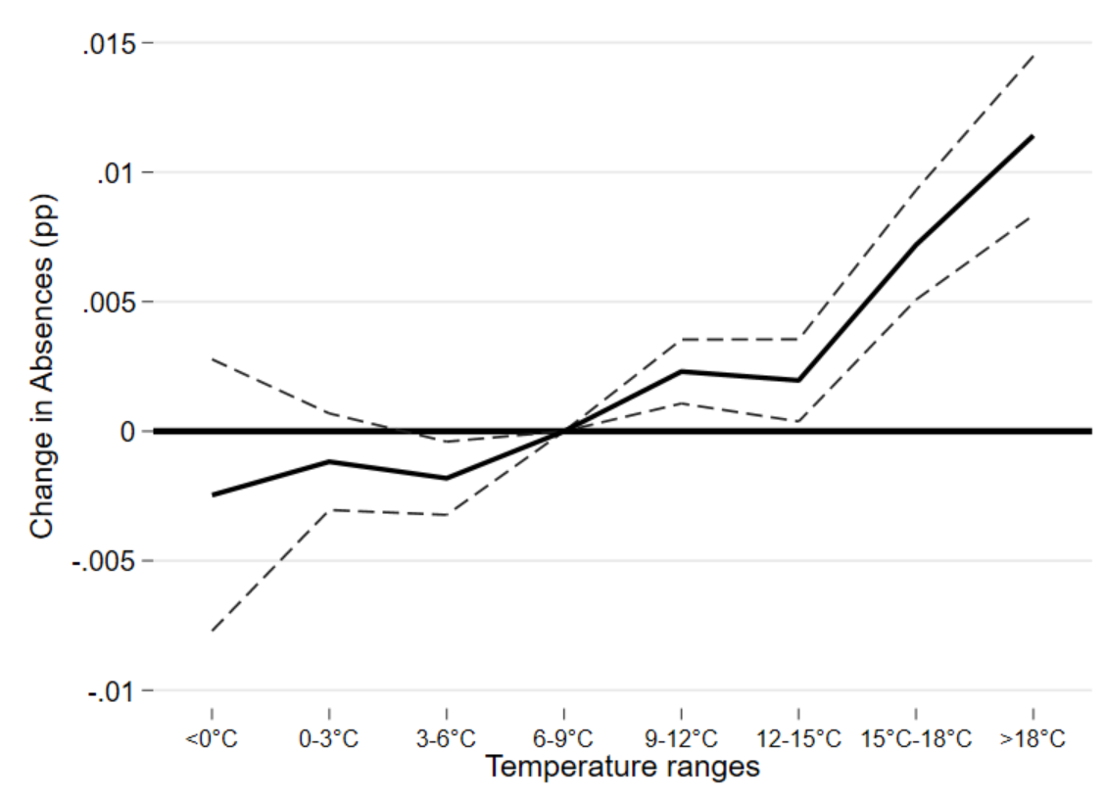
Note: the figure shows the results of exposure to the temperature ranges on school absences based on equation (1) but with standard errors clustered at the school level. 95% confidence intervals.

