Supplementary Material for: “Estimating Excess Migration Associated with Tropical Storms in the United States 1990-2010”
Table of Contents
Supplementary Methodology 1
Detailed Description of the Excess Migration Models 1
Bootstrap Procedure to Account for the Uncertainty in the Excess Estimates in the Stage 2 Analysis 2
Supplementary Tables and Figures 5
Supplementary Figure M1: Comparing Expected and Observed Migration Rates for Example Counties. 5
Supplementary Figure 1: Different Criteria for Identifying Storm-Affected Counties 6
Supplementary Table 2a: Summary Results for County-Years with a Four-Year Window 7
Supplementary Table 2b: Summary Results for County-Years with a Five-Year Window 7
Supplementary Table 2c: Summary Results for County-Years Removing County-Years Affected by Hurricanes Katrina and Rita. 7
Supplementary Table 2d: Summary Results for County-Years 1990-2004. 7
Supplementary Table 3a: Estimates of Excess In-Migration, Out-Migration, and Net Migration Rates per 100,000 Residents by Year Using a Four-Year Window. 8
Supplementary Table 3b: Estimates of Excess In-Migration, Out-Migration, and Net Migration Rates per 100,000 Residents by Year Using a Five-Year Window. 9
Supplementary Table 3c: Estimates of Excess In-Migration, Out-Migration, and Net Migration Rates per 100,000 Residents by Year Removing County-Years Affected by Hurricanes Katrina and Rita. 10
Supplementary Figure 2: Relative Excess Migration by County and Five-Year Period 11
Supplementary Figure 3: Relative Excess Migration by County and Five-Year Period, Median Values and Probability that the Observed Excess is Different from Zero 12
Supplementary Figure 4: Number of Excess Migrants (in thousands) by State, Year, and Risk Level 13
Supplementary Figure 5: Relative Excess In-Migration and Out-Migration by State, Year, and Risk Level 14
Supplementary Table 4a: Regression Table Corresponding to the Multivariate Model Presented in Figure 5 of the Main Text. 15
Supplementary Table 4b: Regression Table Corresponding to the Univariate Models Presented in Figure 5 of the Main Text. 16
Supplementary Figure 6: Factors Associated with Excess Migration, Comparing Confidence Intervals Treating the Dependent Variable as Random (Presented in the Main Text), and Traditional Confidence Intervals Treating the Dependent Variables as Fixed 17
Supplementary Table 5: Regression Table Corresponding to the Multivariate Model Presented in Figure 5 of the Main Text (unadjusted confidence intervals). 18
Supplementary Figure 7: Factors Associated with Excess Migration (2004-2010) 19
Supplementary Table 6a: Regression Table Corresponding to the Multivariate Model Presented in Supplementary Figure 7. 20
Supplementary Table 6b: Regression Table Corresponding to the Univariate Models Presented in Supplementary Figure 7. 21
Supplementary Figure 8: Factors Associated with Excess Migration (2004-2010), Comparing Confidence Intervals Treating the Dependent Variable as Random (Presented in the Main Text), and Traditional Confidence Intervals Treating the Dependent Variables as Fixed 22
Supplementary Table 7: Regression Table Corresponding to the Multivariate Model Presented in Supplementary Figure 8. 23
Supplementary Figure 9a: Factors Associated with Excess Migration, Fixed-Effects Models 24
Supplementary Figure 9b: Factors Associated with Excess Migration, Fixed-Effects Models (2004-2010) 25
Supplementary Figure 10: Damage, FEMA Assistance, and NFIP Insurance Payments. 26

Supplementary Methodology

Detailed Description of the Excess Migration Models

Let $y_{tsr}$ be the flow of migrants between spatial unit $s$ and other counties with risk level $r$ at time $t$. Let $P_{ts}$ be the population of spatial unit $s$ at time $t$. I assume a Poisson distribution for the number of migrants $y_{tsr}$ and model the rate of migration $γ_{tsr}$ using the following specification:

$$y_{tsr}∼Poisson(γ_{tsr}⋅P_{ts})$$
$$\log\left(γ_{tsr}\right)∼ Normal(β^{0}+β_{s}^{county}{+ β}_{t,s}^{time:county},σ)$$

Where $β^{0}$ is the global intercept, $β_{s}^{county}$ is the county-specific intercept for county $s$, $β_{ts}^{time:county}$ is the county-specific time effect for county $s$ and time $t$, and $σ$ is the standard deviation of $log(γ_{tsr})$. All county-specific time effects are modeled as random walks of first order (RW1):

$$β_{t,s}^{time:county}∼Normal(β_{t-1,s}^{time:county}, σ^{time})$$
Notice that the variance of the RW1 processes is shared among counties but the time-effects are different for each county in the sample. The choice of an RW1 model for the time effects relaxes functional assumptions on the effect of time and effectively performs linear interpolation between points when data is missing. Similar models have recently been used to model mortality rates and estimate excess mortality during the COVID-19 pandemic (Davies et al., 2021; Konstantinoudis et al., 2022). I experimented with alternative specifications substituting an autoregressive process of order 1 (AR1) to the RW1 processes as in (Paglino et al., 2023) and obtained similar results. Similarly, adding parametric time trends to the model did not substantially change the estimates.

I model county-level intercepts using the modified Besag, York and Mollie spatial model proposed by (Riebler et al., 2016) (BYM2 model). This model is the sum of a spatially unstructured random effect, $v_{s}∼Normal(0,τ_{v}^{-1})$ and spatially structured effects $u_{s}$. $β_{s}^{county}$ is defined as:

$$β_{s}^{county}= \frac{1}{\sqrt{τ_{b}}} \left(\sqrt{1-ϕ} v_{s}^{⋆}+\sqrt{ϕ} u_{s}^{⋆}\right)$$

where $u_{s}^{⋆}$ and $v_{s}^{⋆}$ are standardized versions of $u_{s}$ and $v_{s}$ to have variance equal to 1. The term $0≤ϕ≤1$ is a mixing parameter which measures the proportion of the marginal variance explained by the spatially structured effect. The rationale for using this model is that nearby counties will likely share some common characteristics and be affected by similar processes, creating the need to account for the resulting spatial autocorrelation.

I use default minimally informative prior distributions for the global intercept $β^{0}$. For the hyperparameters of the BYM2 model, $ϕ$ and $τ_{b}$, I adopt priors that tend to regularize inference while not providing too strong information, the so-called penalized complexity (PC) priors introduced in Simpson et al. (2017). For the standard deviation $σ_{b}=\sqrt{τ_{b}^{-1}}$ I select a prior so that $\operatorname{Pr}\left(σ_{b}>1\right)=0.01$. For $ϕ$ I set $\operatorname{Pr}\left(ϕ<0.5\right)=0.5$ reflecting our lack of knowledge about which spatial component, the unstructured or structured, should dominate the spatial term $β_{s}^{county}$. The choice of priors for $σ_{b}$ and $ϕ$ follows established practices (Davies et al., 2021; Konstantinoudis et al., 2022; Paglino et al., 2023). For the precision of the RW1 process, I adopt the recommended regularizing PC prior that expresses the belief that $\operatorname{Pr}\left(σ^{time}>1\right)=0.01$. I fit the models using the Integrated Nested Laplace Approximation (INLA) method, through the R-INLA software package (Rue et al., 2009). Examples of the model fit Supplementary Figure M1.

Bootstrap Procedure to Account for the Uncertainty in the Excess Estimates in the Stage 2 Analysis

To ensure uncertainty in the estimation of the excess migration rates $m_{tsr}^{e}$ is expressed in the stage 2 (determinants) analysis, I drew 200 samples from the posterior distribution of each $m_{tsr}^{e}$and ran a stage 2 analysis fixing $m_{tsr}^{e}$to each of these values in turn. For each of these 200 analyses, I sampled 200 values from the posterior distribution of each $δ_{j,q}$ coefficient and computed confidence intervals as the 2.5th and 97.5th percentiles of the resulting distributions. In this way, I fully expressed the uncertainty resulting from the two stages of the analysis. The choice of the numbers of samples followed analyses using a range of different posterior distribution sample sizes. I tested different sample sizes and chose the smallest one that ensured the stability of the estimates while minimizing unnecessary computational burden.

R-INLA Syntax for the Excess Migration Models
hyper.bym <- list(theta1 = list('PCprior', c(1, 0.01)),
theta2 = list('PCprior', c(0.5, 0.5)))
hyper.rw1 <- list(theta = list(prior="pc.prec", param=c(1, 0.01)))

formula <- "individualsCensored ~ 1 + offset(log(pop)) +
f(FIPSID, model='bym2', hyper = hyper.bym,
graph = inla.graph, scale.model = T) +
f(yearID,model='rw1',replicate=FIPSID2,
hyper=hyper.rw1,scale.model=T)"

model <- inla(as.formula(formula),
data = data,
family = 'poisson',
num.threads = round(parallel::detectCores()*0.7),
control.family = control.family)

Separate models are fit for each risk-level and for outflows and inflows. I thus fit a total of 10 models, 5 for outflows and 5 for inflows. Supplementary Figure M1 compares predicted and observed migration rates for a sample of counties. The counties were chosen to illustrate how the model performs under different scenarios.

References

Davies, B., Parkes, B. L., Bennett, J., Fecht, D., Blangiardo, M., Ezzati, M., & Elliott, P. (2021). Community factors and excess mortality in first wave of the COVID-19 pandemic in England. Nature Communications, 12(1), Article 1. https://doi.org/10.1038/s41467-021-23935-x
Konstantinoudis, G., Cameletti, M., Gómez-Rubio, V., Gómez, I. L., Pirani, M., Baio, G., Larrauri, A., Riou, J., Egger, M., Vineis, P., & Blangiardo, M. (2022). Regional excess mortality during the 2020 COVID-19 pandemic in five European countries. Nature Communications, 13(1), Article 1. https://doi.org/10.1038/s41467-022-28157-3
Paglino, E., Lundberg, D. J., Zhou, Z., Wasserman, J. A., Raquib, R., Luck, A. N., Hempstead, K., Bor, J., Preston, S. H., Elo, I. T., & Stokes, A. C. (2023). Monthly excess mortality across counties in the United States during the COVID-19 pandemic, March 2020 to February 2022. Science Advances, 9(25), eadf9742. https://doi.org/10.1126/sciadv.adf9742
Riebler, A., Sørbye, S. H., Simpson, D., & Rue, H. (2016). An intuitive Bayesian spatial model for disease mapping that accounts for scaling. Statistical Methods in Medical Research, 25(4), 1145–1165. https://doi.org/10.1177/0962280216660421
Rue, H., Martino, S., & Chopin, N. (2009). Approximate Bayesian inference for latent Gaussian models by using integrated nested Laplace approximations. Journal of the Royal Statistical Society: Series B (Statistical Methodology), 71(2), 319–392. https://doi.org/10.1111/j.1467-9868.2008.00700.x

Supplementary Tables and Figures

Supplementary Figure M1: Comparing Expected and Observed Migration Rates for Example Counties.
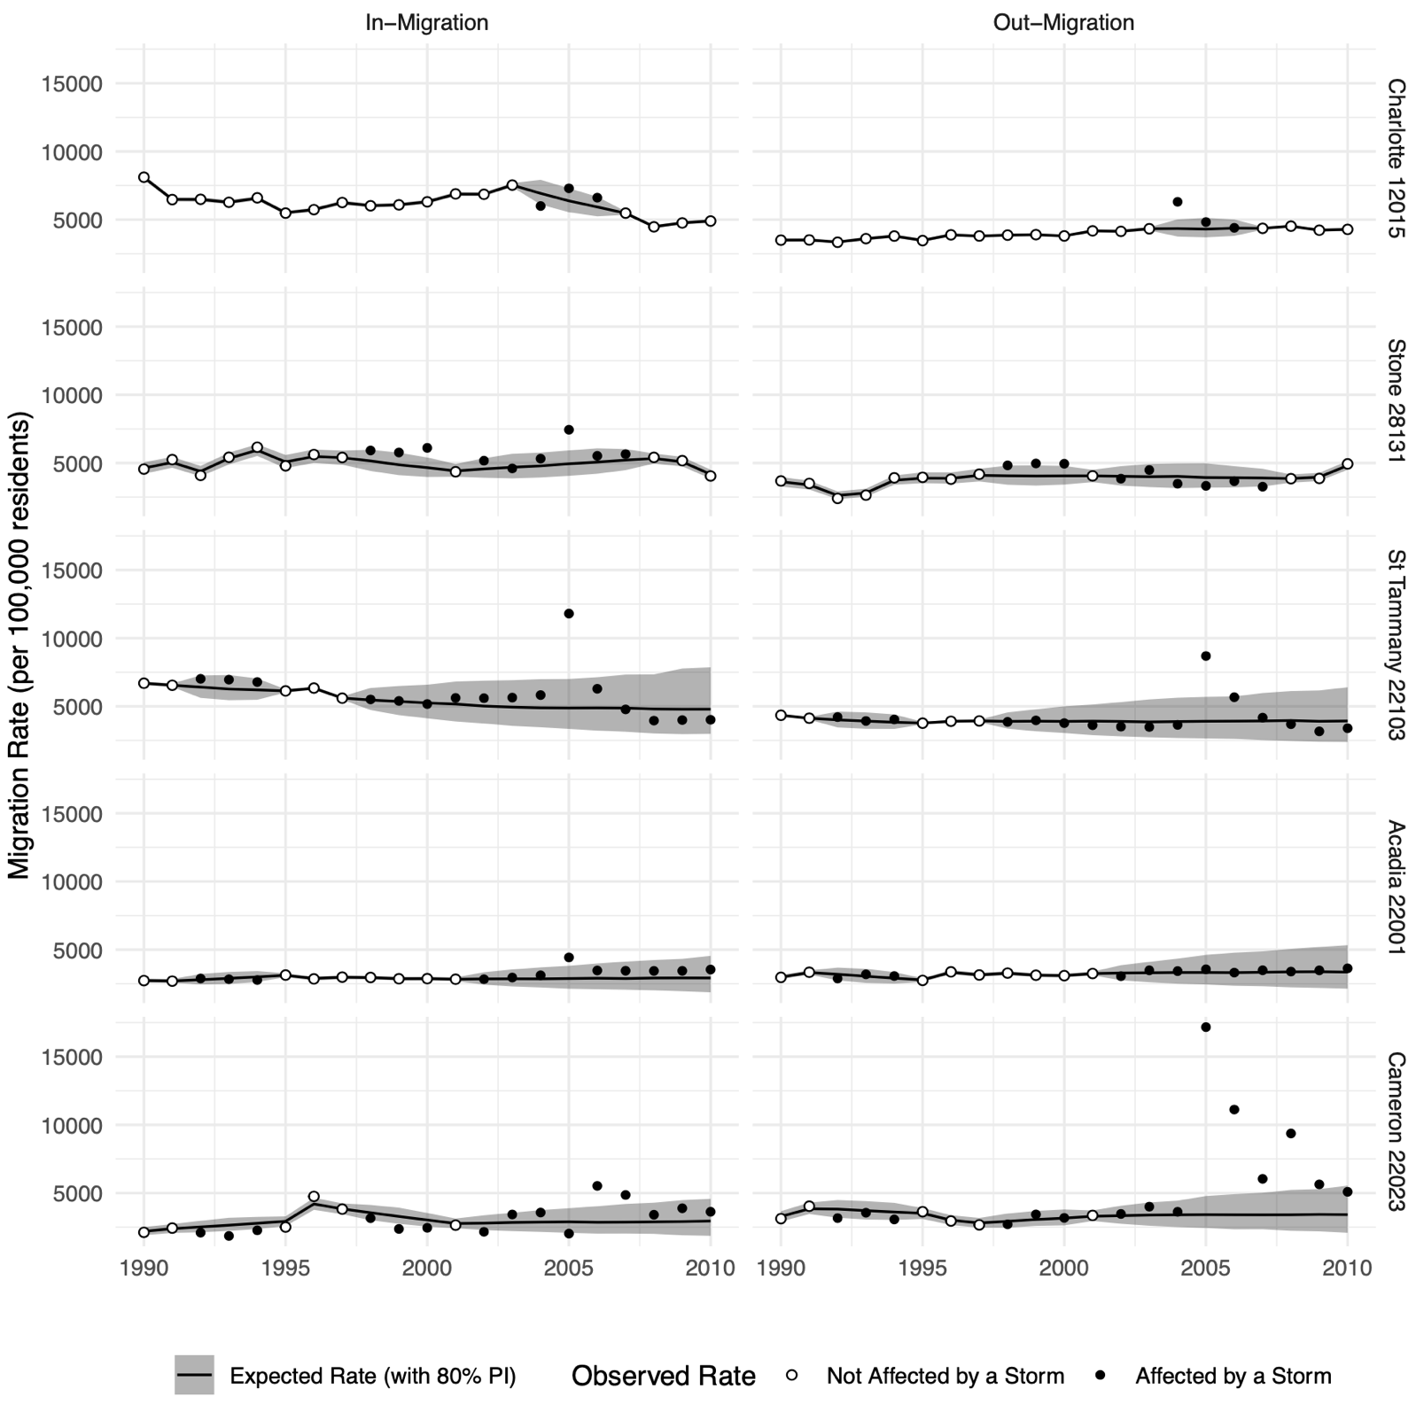
Notes: I selected the counties to show how the model works in different scenarios, with stable rates, unstable rates, no tropical storms (so no missing data), a single tropical storm, and multiple storms.

Supplementary Figure 1: Different Criteria for Identifying Storm-Affected Counties
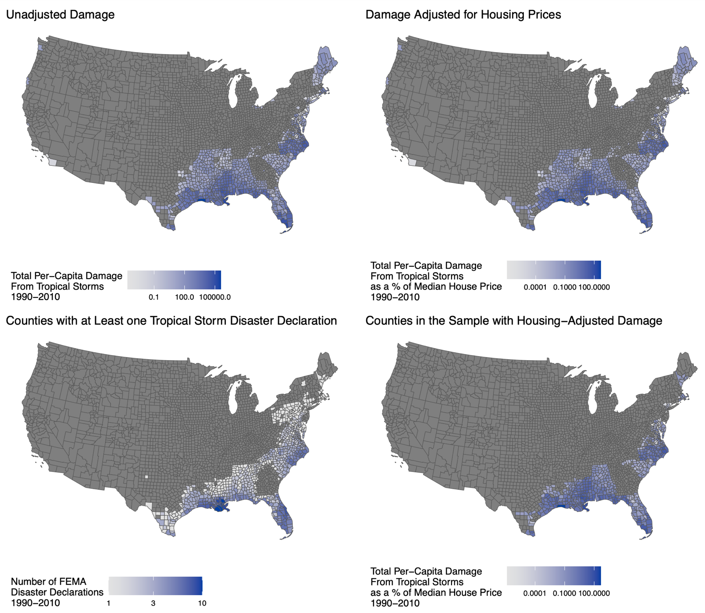

Supplementary Table 2a: Summary Results for County-Years with a Four-Year Window
 | Percentage of County-Years with Posterior Probability of Non-Zero Excess > 80%
 | Negative Excess | Positive Excess | Percentage of County-Years with Posterior Probability of Non-Zero Excess <=80%
Net-Migration | 2.43 | 4.02 | 93.55
In-Migration | 2.89 | 5.48 | 91.63
Out-Migration | 1.87 | 2.84 | 95.29
Notes: Rows should sum to 100% but may not do so exactly due to rounding.

Supplementary Table 2b: Summary Results for County-Years with a Five-Year Window
 | Percentage of County-Years with Posterior Probability of Non-Zero Excess > 80%
 | Negative Excess | Positive Excess | Percentage of County-Years with Posterior Probability of Non-Zero Excess <=80%
Net-Migration | 2.44 | 3.55 | 94.01
In-Migration | 2.82 | 5.43 | 91.75
Out-Migration | 1.84 | 2.33 | 95.83
Notes: Rows should sum to 100% but may not do so exactly due to rounding.

Supplementary Table 2c: Summary Results for County-Years Removing County-Years Affected by Hurricanes Katrina and Rita.
 | Percentage of County-Years with Posterior Probability of Non-Zero Excess > 80%
 | Negative Excess | Positive Excess | Percentage of County-Years with Posterior Probability of Non-Zero Excess <=80%
Net-Migration | 3.42 | 4.19 | 92.39
In-Migration | 4.26 | 4.55 | 91.19
Out-Migration | 2.44 | 3.02 | 94.54
Notes: Rows should sum to 100% but may not do so exactly due to rounding.

Supplementary Table 2d: Summary Results for County-Years 1990-2004.
 | Percentage of County-Years with Posterior Probability of Non-Zero Excess > 80%
 | Negative Excess | Positive Excess | Percentage of County-Years with Posterior Probability of Non-Zero Excess <=80%
Net-Migration | 3.76 | 3.42 | 92.82
In-Migration | 4.82 | 3.42 | 91.76
Out-Migration | 2.65 | 2.75 | 94.61
Notes: Rows should sum to 100% but may not do so exactly due to rounding.

Supplementary Table 3a: Estimates of Excess In-Migration, Out-Migration, and Net Migration Rates per 100,000 Residents by Year Using a Four-Year Window.
 | Excess In-Migration |  |  | Excess Out-Migration |  |  | Excess Migration (Net)
Year | Median | 10th Percentile | 90th Percentile | Median | 10th Percentile | 90th Percentile | Median | 10th Percentile | 90th Percentile
1990 | -26.92 | -54.19 | -3.51 | -35.73 | -62.27 | -13.59 | 4.43 | -13.16 | 22.54
1991 | -26.01 | -47.62 | -3.86 | -28.44 | -54.06 | -7.37 | 1.80 | -15.18 | 18.03
1992 | 11.95 | -21.16 | 48.56 | 31.17 | -4.74 | 66.24 | -9.38 | -33.19 | 16.04
1993 | 7.25 | -33.07 | 44.31 | -7.01 | -48.67 | 28.58 | 7.02 | -19.65 | 35.74
1994 | 3.72 | -35.75 | 43.06 | 2.85 | -36.82 | 40.00 | 1.77 | -27.60 | 27.54
1995 | -50.17 | -86.97 | -18.05 | -28.36 | -62.24 | 3.12 | -10.84 | -35.65 | 12.23
1996 | -7.79 | -39.39 | 19.91 | 6.71 | -20.60 | 33.05 | -7.84 | -27.57 | 11.45
1997 | -37.22 | -74.17 | -3.21 | -2.38 | -36.21 | 30.98 | -18.15 | -40.05 | 6.97
1998 | -43.08 | -85.66 | -0.66 | 8.62 | -38.64 | 47.88 | -26.28 | -56.26 | 6.48
1999 | -76.62 | -151.71 | -8.35 | -42.81 | -125.94 | 35.80 | -17.62 | -74.08 | 36.13
2000 | -147.84 | -238.34 | -63.72 | -81.56 | -180.18 | 14.56 | -34.61 | -99.84 | 31.28
2001 | -88.14 | -200.22 | 4.25 | -99.77 | -221.14 | 14.06 | 5.70 | -71.97 | 86.76
2002 | -160.70 | -274.78 | -52.68 | -124.40 | -270.77 | -15.28 | -16.03 | -101.48 | 72.60
2003 | -77.53 | -210.30 | 27.29 | -81.72 | -236.01 | 45.37 | -0.94 | -88.20 | 97.91
2004 | 52.55 | -100.61 | 186.08 | -26.87 | -214.92 | 120.74 | 41.25 | -63.41 | 163.18
2005 | 444.27 | 264.65 | 576.60 | 578.76 | 363.65 | 726.81 | -67.46 | -186.18 | 55.95
2006 | 120.97 | -72.16 | 265.05 | 157.51 | -77.98 | 300.27 | -14.05 | -140.15 | 118.52
2007 | 25.95 | -174.58 | 164.69 | 37.76 | -201.56 | 188.46 | -4.50 | -126.00 | 130.17
2008 | -115.37 | -350.45 | 16.86 | -116.34 | -381.49 | 42.20 | -5.32 | -129.89 | 147.50
2009 | -146.29 | -419.05 | -1.46 | -179.16 | -486.25 | -17.47 | 14.23 | -139.77 | 184.14
2010 | -206.92 | -487.90 | -36.92 | -204.33 | -528.24 | -28.40 | 1.73 | -174.30 | 179.19

Supplementary Table 3b: Estimates of Excess In-Migration, Out-Migration, and Net Migration Rates per 100,000 Residents by Year Using a Five-Year Window.
 | Excess In-Migration |  |  | Excess Out-Migration |  |  | Excess Migration (Net)
Year | Median | 10th Percentile | 90th Percentile | Median | 10th Percentile | 90th Percentile | Median | 10th Percentile | 90th Percentile
1990 | -28.46 | -51.09 | -5.02 | -47.83 | -81.46 | -19.96 | 9.79 | -8.87 | 31.21
1991 | -26.81 | -47.94 | -6.46 | -40.56 | -70.93 | -12.13 | 6.90 | -10.00 | 25.31
1992 | 13.76 | -20.67 | 46.73 | 18.13 | -20.85 | 56.18 | -2.40 | -27.01 | 23.67
1993 | 9.19 | -34.82 | 42.46 | -20.41 | -64.63 | 20.57 | 14.29 | -17.90 | 41.94
1994 | 4.11 | -36.96 | 38.81 | -2.72 | -50.68 | 40.64 | 2.68 | -26.48 | 31.45
1995 | -49.90 | -86.29 | -19.96 | -38.64 | -85.30 | 4.16 | -4.98 | -36.60 | 21.59
1996 | -11.70 | -39.58 | 16.81 | 5.92 | -39.57 | 48.29 | -8.13 | -34.65 | 16.13
1997 | -39.83 | -75.41 | -6.38 | 0.06 | -37.13 | 33.82 | -19.99 | -43.53 | 3.70
1998 | -45.27 | -88.41 | 1.37 | 10.67 | -34.64 | 53.51 | -27.36 | -58.99 | 4.90
1999 | -81.20 | -153.66 | -4.35 | -32.39 | -118.33 | 47.02 | -22.44 | -78.90 | 32.82
2000 | -151.02 | -242.86 | -60.00 | -76.96 | -186.85 | 25.78 | -34.11 | -104.47 | 33.03
2001 | -93.70 | -203.35 | 4.33 | -101.02 | -240.64 | 24.13 | 3.39 | -75.45 | 87.10
2002 | -163.38 | -282.55 | -53.30 | -137.91 | -296.78 | -7.81 | -11.87 | -101.37 | 83.73
2003 | -80.61 | -213.57 | 24.87 | -94.18 | -284.32 | 53.16 | 5.41 | -92.68 | 110.43
2004 | 56.38 | -97.73 | 185.37 | 10.32 | -197.64 | 171.11 | 18.54 | -88.71 | 150.09
2005 | 436.66 | 267.65 | 583.81 | 627.90 | 406.75 | 791.39 | -96.64 | -212.68 | 37.15
2006 | 119.70 | -67.41 | 260.17 | 213.12 | -12.04 | 382.02 | -47.95 | -171.24 | 89.67
2007 | 26.48 | -168.44 | 161.23 | 98.82 | -140.40 | 264.80 | -37.07 | -166.85 | 94.50
2008 | -110.93 | -344.13 | 25.51 | -126.05 | -373.60 | 20.82 | 8.06 | -128.87 | 144.72
2009 | -146.99 | -402.31 | 2.91 | -229.26 | -499.75 | -79.33 | 44.20 | -115.91 | 186.67
2010 | -207.72 | -490.54 | -38.71 | -192.87 | -492.04 | -32.60 | -0.44 | -171.20 | 160.01

Supplementary Table 3c: Estimates of Excess In-Migration, Out-Migration, and Net Migration Rates per 100,000 Residents by Year Removing County-Years Affected by Hurricanes Katrina and Rita.
 | Excess In-Migration |  |  | Excess Out-Migration |  |  | Excess Migration (Net)
Year | Median | 10th Percentile | 90th Percentile | Median | 10th Percentile | 90th Percentile | Median | 10th Percentile | 90th Percentile
1990 | -23.38 | -43.37 | -5.68 | -28.05 | -48.42 | -9.09 | 2.31 | -11.27 | 16.56
1991 | -23.31 | -40.95 | -5.18 | -22.25 | -42.70 | -4.07 | -0.24 | -12.73 | 12.71
1992 | 17.55 | -14.64 | 46.89 | 40.65 | 9.40 | 70.73 | -11.78 | -34.24 | 10.04
1993 | 14.99 | -23.67 | 50.07 | -6.10 | -40.15 | 28.33 | 10.10 | -15.64 | 35.44
1994 | 15.85 | -14.85 | 43.80 | 8.86 | -19.25 | 36.12 | 2.90 | -16.82 | 22.67
1995 | -27.65 | -42.39 | -13.71 | -14.78 | -28.43 | -2.08 | -6.16 | -16.54 | 4.09
1996 | -3.02 | -30.69 | 21.08 | 4.92 | -19.30 | 28.63 | -4.34 | -21.91 | 12.27
1997 | -25.57 | -55.19 | 2.71 | -5.06 | -35.24 | 22.14 | -9.92 | -29.83 | 9.65
1998 | -22.80 | -58.96 | 12.07 | 5.97 | -31.94 | 40.43 | -13.38 | -39.66 | 10.12
1999 | -47.44 | -114.93 | 14.57 | -31.06 | -106.72 | 28.09 | -6.24 | -55.52 | 42.37
2000 | -95.86 | -164.74 | -23.57 | -54.89 | -137.71 | 15.54 | -18.52 | -71.78 | 31.83
2001 | -3.10 | -85.60 | 71.57 | -50.32 | -137.56 | 33.15 | 23.14 | -32.81 | 82.20
2002 | -29.05 | -98.78 | 23.64 | -41.97 | -113.01 | 14.45 | 5.83 | -41.14 | 50.57
2003 | -23.70 | -100.47 | 50.28 | -39.03 | -129.51 | 36.67 | 9.70 | -47.23 | 66.41
2004 | 109.23 | 16.72 | 194.48 | 6.72 | -92.29 | 88.47 | 50.99 | -16.68 | 118.03
2005 | 284.89 | 191.74 | 373.79 | 209.73 | 110.25 | 304.43 | 37.40 | -31.08 | 104.44
2006 | 31.63 | -34.87 | 91.03 | 88.29 | 23.22 | 156.33 | -29.11 | -74.31 | 17.69
2007 | 0.63 | -36.95 | 35.84 | 52.40 | 13.27 | 89.01 | -25.26 | -50.92 | 0.98
2008 | -13.21 | -21.99 | -4.16 | -14.00 | -22.89 | -5.21 | 0.38 | -5.87 | 6.74
2009 | -98.15 | -283.98 | 24.19 | -129.95 | -303.48 | -9.31 | 15.31 | -100.85 | 126.23
2010 | -145.60 | -356.71 | -12.08 | -149.06 | -340.96 | -25.65 | -1.17 | -130.91 | 119.35

Supplementary Figure 2: Relative Excess Migration by County and Five-Year Period
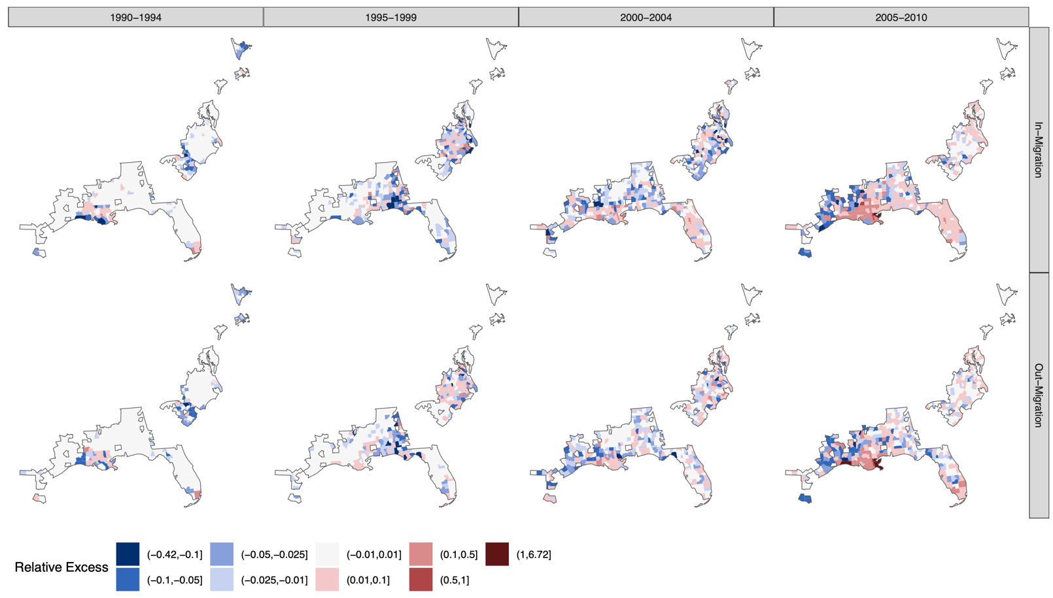

Supplementary Figure 3: Relative Excess Migration by County and Five-Year Period, Median Values and Probability that the Observed Excess is Different from Zero
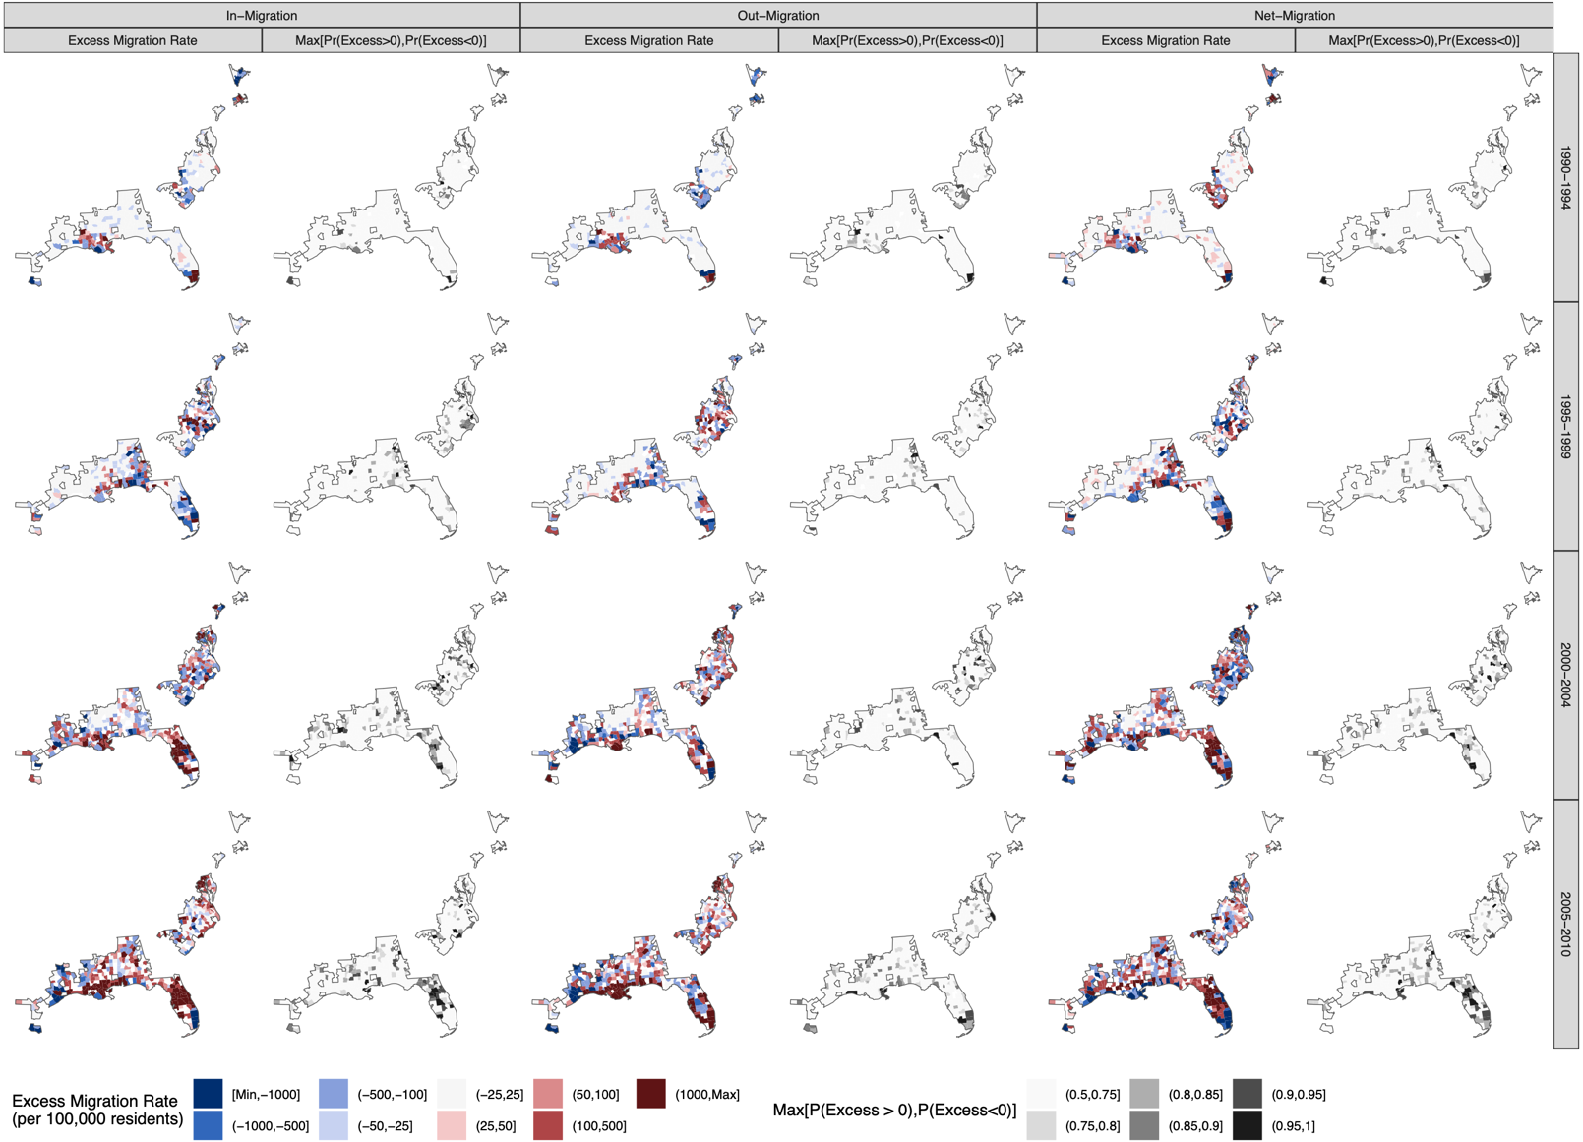

Supplementary Figure 4: Number of Excess Migrants (in thousands) by State, Year, and Risk Level
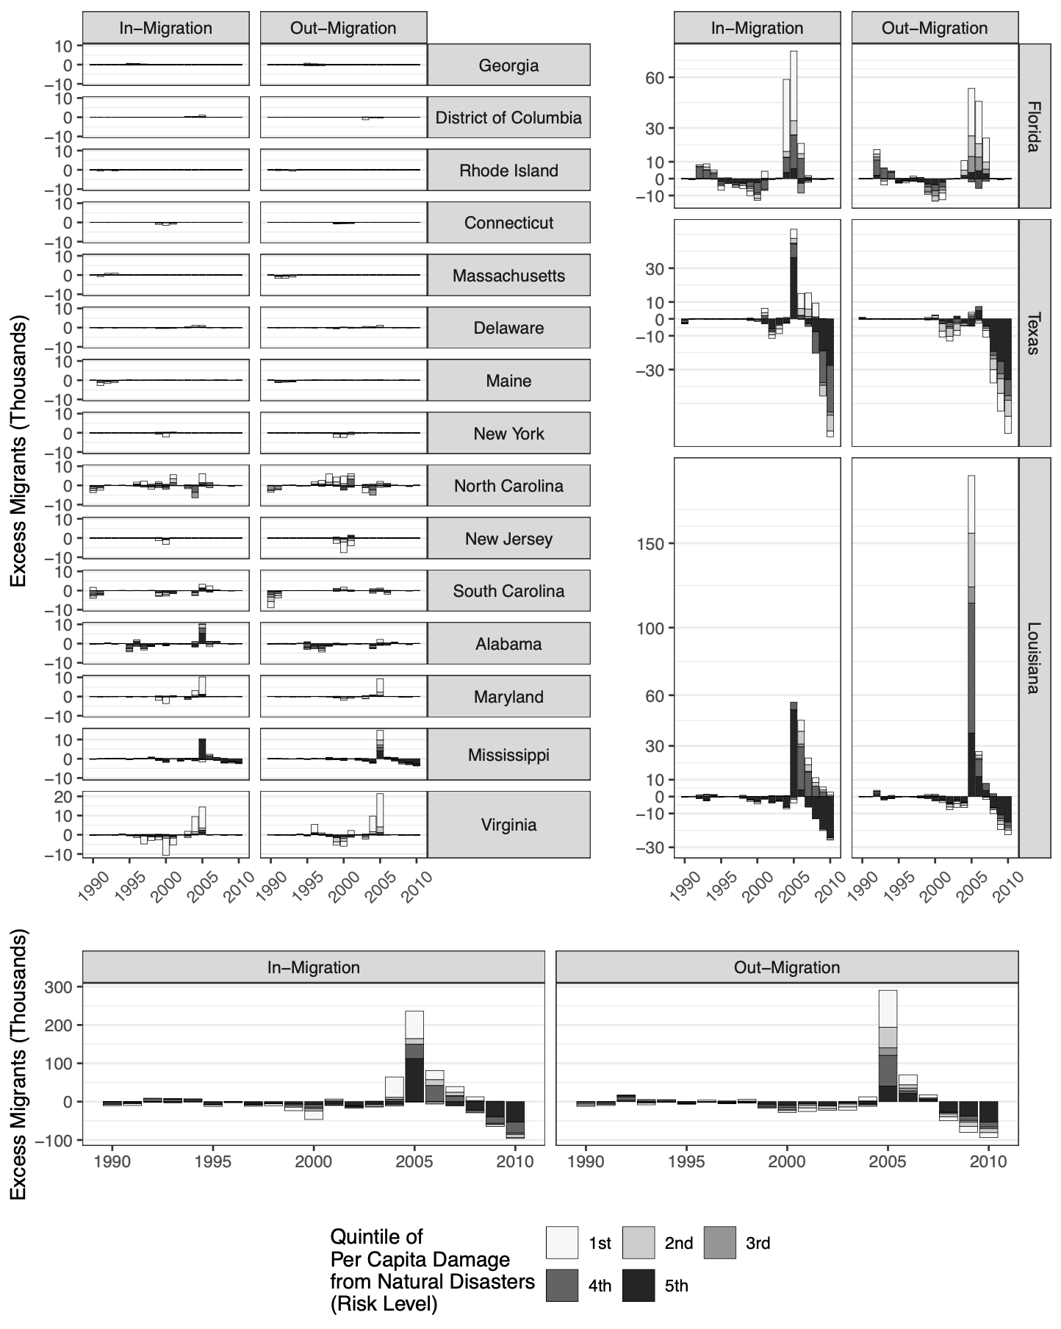
Notes: Excess migration by year decomposed by risk level of the origin (for in-migration) or the destination (out-migration). Excess in-migration is presented in the left panel and excess out-migration in the right panel.

Supplementary Figure 5: Relative Excess In-Migration and Out-Migration by State, Year, and Risk Level
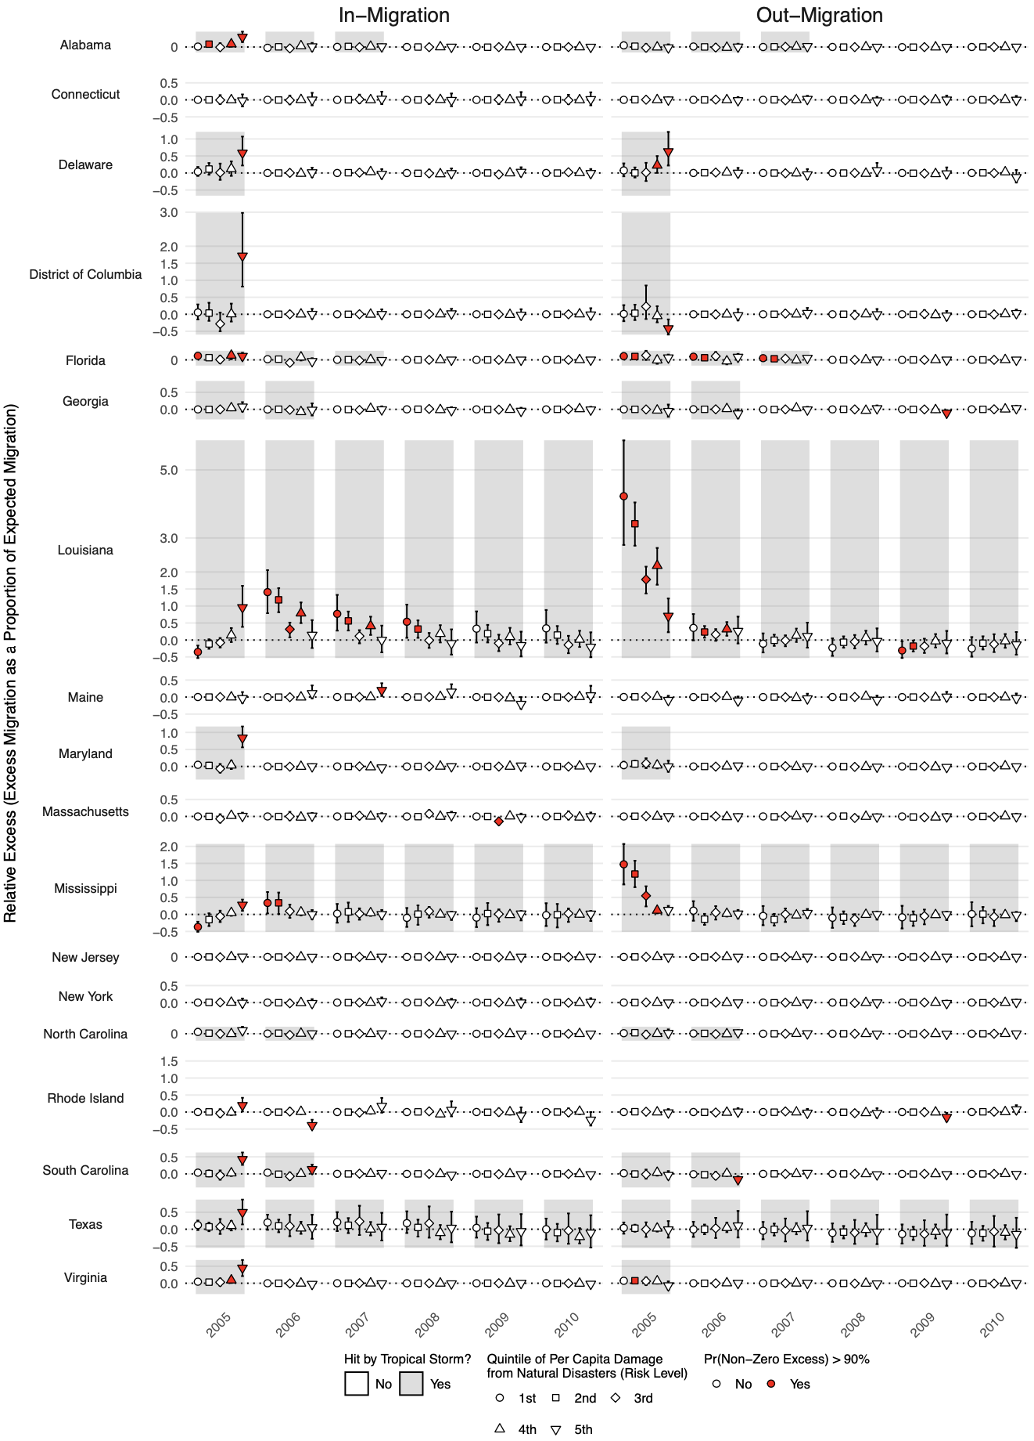
Notes: This figure only includes estimates for the period 2005-2010. Each dot represents relative excess (in-migration on the top and out-migration on the bottom), with shapes identifying the level of risk of the origin (in-migration) and the destination (out-migration). Dots colored in red identify observations for which the probability of either positive or negative excess exceeds 90%. The vertical lines indicate 80% posterior intervals around the point estimate.

Supplementary Table 4a: Regression Table Corresponding to the Multivariate Model Presented in Figure 5 of the Main Text.
 | In-Migration |  |  | Out-Migration |  |  | Net-Migration
 | Mean | Upper Bound | Lower Bound | Mean | Upper Bound | Lower Bound | Mean | Upper Bound | Lower Bound
NFIP Percentiles
25-48th | 0.270 | 3.029 | -2.475 | 0.240 | 3.063 | -2.642 | 0.031 | 4.034 | -3.729
50-74th | 0.693 | 3.487 | -2.124 | -0.316 | 2.424 | -3.258 | 1.011 | 5.045 | -2.917
75-89th | 0.954 | 4.177 | -2.805 | -0.096 | 3.149 | -3.476 | 1.034 | 5.559 | -4.064
90-94th | -0.437 | 4.451 | -7.096 | 4.880 | 9.548 | -0.731 | -5.328 | 2.290 | -13.493
>95th | 3.202 | 7.787 | -2.991 | 1.155 | 5.684 | -3.710 | 2.053 | 8.504 | -5.033
SVI Percentiles
20-39th | 2.758 | 7.279 | -2.127 | 1.049 | 4.880 | -3.223 | 1.692 | 7.684 | -4.754
40-59th | 0.550 | 5.456 | -4.236 | -0.173 | 3.750 | -4.081 | 0.697 | 6.912 | -5.657
60-79th | 0.742 | 5.252 | -4.681 | 0.358 | 4.324 | -3.922 | 0.380 | 6.474 | -6.132
>80th | 2.032 | 7.182 | -2.732 | 1.320 | 5.822 | -3.014 | 0.717 | 7.568 | -5.860
Damage Percentiles
50-74th | -1.732 | 1.466 | -5.659 | -1.538 | 1.659 | -4.952 | -0.201 | 4.382 | -4.974
75-89th | -0.073 | 2.314 | -2.569 | -1.134 | 1.311 | -3.660 | 1.062 | 4.474 | -2.318
90-94th | -0.165 | 3.517 | -4.015 | 0.111 | 3.447 | -3.481 | -0.268 | 4.904 | -5.252
>95th | 2.611 | 5.677 | -0.669 | 5.083 | 8.178 | 1.765 | -2.462 | 2.029 | -6.794
Large Central Metro
 | 6.875 | 12.977 | 0.094 | 8.262 | 15.509 | 0.238 | -1.408 | 8.693 | -10.935
Large Fringe Metro
 | 2.626 | 7.142 | -3.191 | 3.485 | 7.708 | -1.310 | -0.881 | 5.854 | -7.758
Medium or Small Metro
 | 0.437 | 4.031 | -2.979 | 0.974 | 4.304 | -2.266 | -0.545 | 4.554 | -5.345
Pct Old Percentiles
20-39th | 1.804 | 6.845 | -2.899 | 0.769 | 5.050 | -3.291 | 1.037 | 7.741 | -5.604
40-59th | 0.914 | 5.621 | -3.442 | 0.322 | 4.872 | -4.042 | 0.583 | 6.867 | -5.567
60-79th | 0.366 | 5.533 | -4.476 | -0.659 | 3.856 | -5.012 | 1.011 | 7.451 | -5.766
>80th | 1.205 | 6.127 | -2.883 | 0.366 | 4.759 | -3.797 | 0.830 | 7.265 | -5.005
Pct White Percentiles
20-39th | 0.147 | 4.151 | -3.545 | -0.713 | 3.036 | -4.399 | 0.864 | 6.218 | -4.339
40-59th | -0.820 | 4.052 | -5.537 | -0.940 | 3.730 | -5.334 | 0.137 | 7.020 | -6.318
60-79th | -0.497 | 4.256 | -4.646 | -1.643 | 2.802 | -5.840 | 1.168 | 7.305 | -4.918
>80th | 0.184 | 4.567 | -4.219 | 0.356 | 4.873 | -3.820 | -0.156 | 5.744 | -6.351
Notes: the “Mean” column reports the point estimate of each coefficient, the “Upper Bound” and “Lower Bound” columns report the upper and lower bound of the corresponding 95% confidence interval adjusting for uncertainty in the dependent variable via the bootstrap procedure described in the Supplementary Methodology. For regression statistics, sample size N, R-squared, and number of parameters, refer to Supplementary Table 5.

Supplementary Table 4b: Regression Table Corresponding to the Univariate Models Presented in Figure 5 of the Main Text.
 | In-Migration |  |  | Out-Migration |  |  | Net-Migration
 | Mean | Upper Bound | Lower Bound | Mean | Upper Bound | Lower Bound | Mean | Upper Bound | Lower Bound
NFIP Percentiles
25-49th | 0.400 | 2.945 | -2.192 | 0.392 | 3.062 | -2.318 | 0.005 | 3.691 | -3.628
50-74th | 0.806 | 3.315 | -1.801 | -0.075 | 2.542 | -2.825 | 0.883 | 4.586 | -2.792
75-89th | 1.257 | 4.402 | -2.347 | 0.306 | 3.395 | -2.948 | 0.948 | 5.317 | -4.034
90-94th | 0.232 | 5.260 | -7.263 | 5.726 | 10.392 | -0.064 | -5.523 | 2.008 | -14.081
>95th | 3.699 | 8.286 | -2.553 | 2.092 | 6.501 | -2.609 | 1.595 | 8.158 | -5.367
SVI Percentiles
20-39th | 2.231 | 6.739 | -2.250 | 0.751 | 4.418 | -3.133 | 1.475 | 7.054 | -4.145
40-59th | -0.286 | 4.201 | -4.448 | -1.136 | 2.394 | -4.633 | 0.842 | 6.322 | -4.703
60-79th | -0.011 | 4.346 | -4.239 | -0.474 | 3.080 | -4.253 | 0.457 | 6.047 | -5.266
>80th | 1.037 | 5.476 | -2.817 | 0.411 | 4.149 | -3.232 | 0.616 | 6.054 | -4.836
Damage Percentiles
50-74th | -1.640 | 1.369 | -5.155 | -1.352 | 1.742 | -4.616 | -0.278 | 4.054 | -4.842
75-89th | 0.240 | 2.716 | -2.469 | -0.524 | 1.969 | -3.139 | 0.782 | 4.326 | -2.722
90-94th | 0.010 | 3.398 | -3.825 | 0.291 | 3.607 | -3.237 | -0.255 | 4.661 | -5.280
>95th | 2.890 | 5.871 | -0.357 | 5.252 | 8.371 | 1.928 | -2.341 | 2.085 | -6.588
Large Central Metro
 | 5.673 | 11.231 | -0.684 | 7.321 | 14.222 | -0.009 | -1.661 | 7.652 | -10.684
Large Fringe Metro
 | 1.745 | 5.696 | -3.530 | 2.610 | 6.023 | -1.707 | -0.890 | 5.229 | -7.051
Medium or Small Metro
 | 0.477 | 3.566 | -3.276 | 0.874 | 3.731 | -2.010 | -0.396 | 3.805 | -5.158
Pct Old Percentiles
20-39th | 1.264 | 6.452 | -3.374 | 0.167 | 4.410 | -3.811 | 1.124 | 7.929 | -5.586
40-59th | 0.418 | 5.140 | -3.795 | -0.262 | 4.025 | -4.361 | 0.680 | 6.702 | -5.507
60-79th | -0.072 | 4.981 | -4.714 | -1.232 | 2.914 | -5.328 | 1.181 | 7.595 | -5.381
>80th | 0.323 | 5.082 | -3.567 | -1.048 | 3.165 | -4.839 | 1.386 | 7.726 | -4.215
Pct White Percentiles
20-39th | -0.445 | 3.265 | -3.995 | -1.123 | 2.371 | -4.728 | 0.672 | 5.816 | -4.285
40-59th | -0.888 | 3.079 | -5.381 | -0.964 | 3.107 | -5.135 | 0.075 | 6.070 | -5.867
60-79th | -0.322 | 3.564 | -4.106 | -1.687 | 1.882 | -5.323 | 1.366 | 6.599 | -3.800
>80th | 0.310 | 4.449 | -4.396 | 0.491 | 4.440 | -3.302 | -0.184 | 5.470 | -5.962
Notes: the “Mean” column reports the point estimate of each coefficient, the “Upper Bound” and “Lower Bound” columns report the upper and lower bound of the corresponding 95% confidence interval adjusting for uncertainty in the dependent variable via the bootstrap procedure described in the Supplementary Methodology. For regression statistics, sample size N, R-squared, and number of parameters, refer to Supplementary Table 5.

Supplementary Figure 6: Factors Associated with Excess Migration, Comparing Confidence Intervals Treating the Dependent Variable as Random (Presented in the Main Text), and Traditional Confidence Intervals Treating the Dependent Variables as Fixed
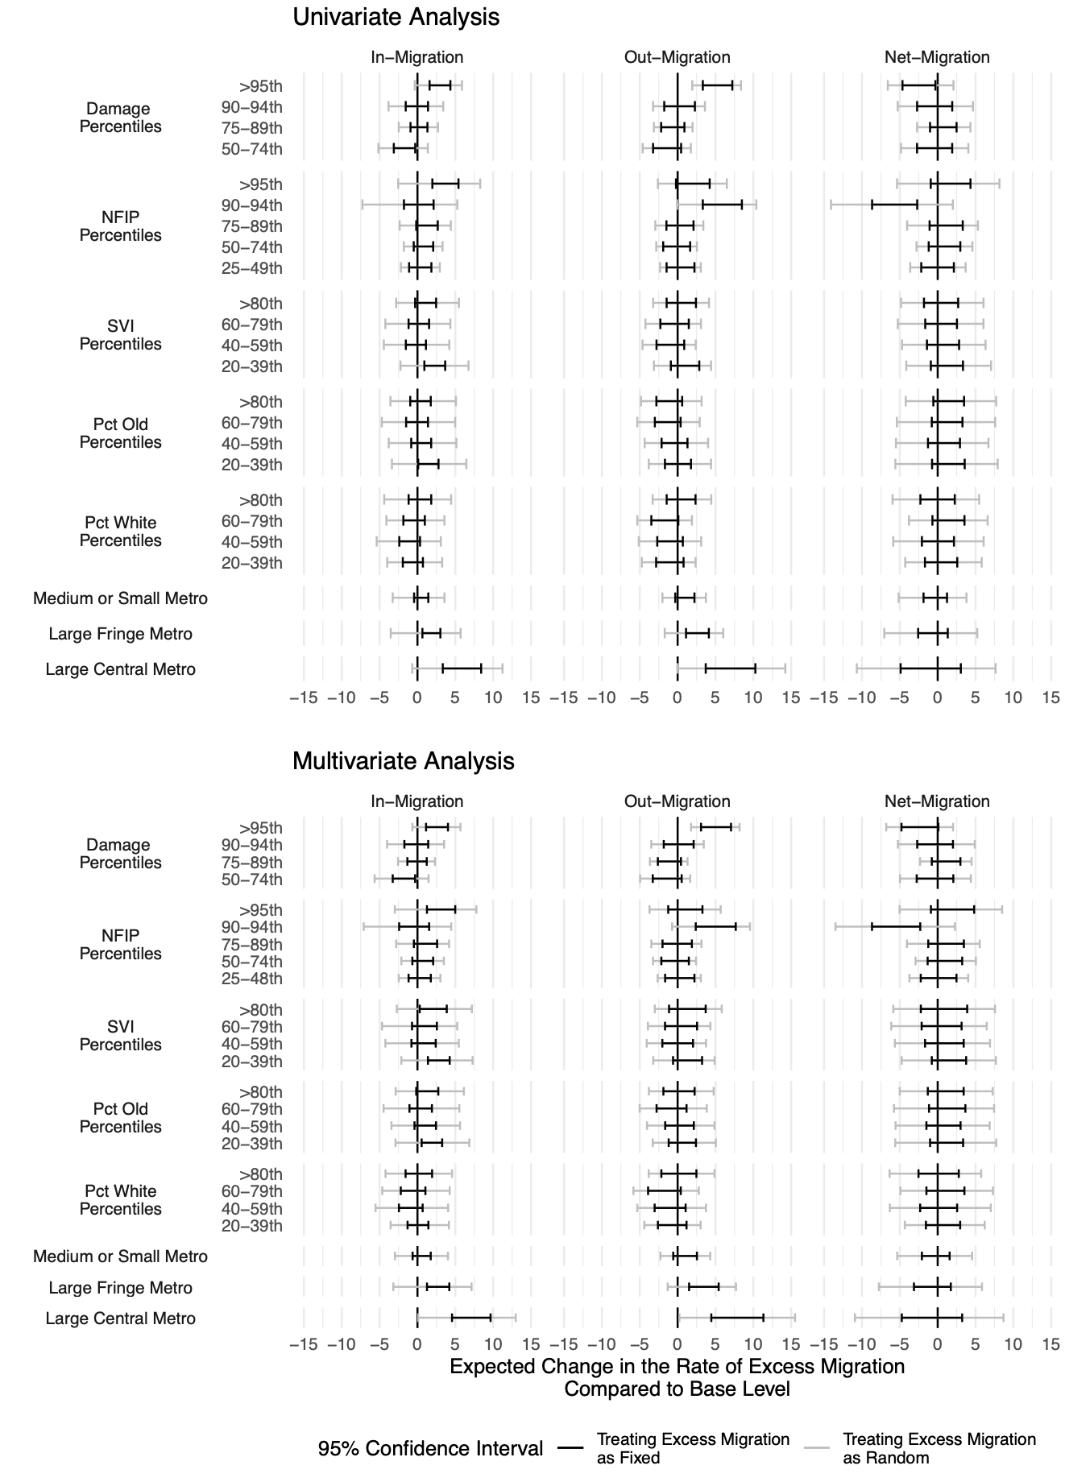
Notes: Point estimates are represented with diamonds, 95% confidence interval are presented with error bars. Damage from tropical storms and NFIP payments are time-variant. The percentage of the population 65 or older and identifying as White are time-invariant and measured in 1990, the SVI is also time-invariant and measured in 2000.

Supplementary Table 5: Regression Table Corresponding to the Multivariate Model Presented in Figure 5 of the Main Text (unadjusted confidence intervals).
 | Out-Migrations |  | In-Migration |  | Net-Migration
Damage 50th to 74th | -148.00 | (102.61) | -178.60 * | (77.50) | -30.60 | (123.36)
Damage 75th to 89th | -117.43 | (79.85) | -8.78 | (60.31) | 108.65 | (96.00)
Damage 90th to 94th | 9.39 | (99.98) | -18.98 | (75.52) | -28.37 | (120.20)
Damage 95th and Above | 511.43 *** | (98.94) | 262.81 *** | (74.73) | -248.62 * | (118.94)
NFIP 25th to 49th | 23.50 | (98.97) | 27.11 | (74.75) | 3.61 | (118.97)
NFIP 50th to 74th | -30.21 | (93.07) | 70.24 | (70.30) | 100.45 | (111.89)
NFIP 75th to 89th | -5.41 | (100.94) | 101.94 | (76.24) | 107.34 | (121.35)
NFIP 90th to 94th | 502.22 *** | (134.70) | -47.90 | (101.74) | -550.12 *** | (161.93)
NFIP 95th and Above | 109.78 | (123.61) | 314.61 *** | (93.36) | 204.83 | (148.61)
% 65+ 20th to 39th | 62.07 | (89.89) | 194.59 ** | (67.89) | 132.52 | (108.06)
% 65+ 40th to 59th | 21.04 | (96.39) | 100.71 | (72.80) | 79.68 | (115.88)
% 65+ 60th to 79th | -82.32 | (101.60) | 43.94 | (76.74) | 126.25 | (122.14)
% 65+ 80th and Above | 27.09 | (101.15) | 126.87 | (76.39) | 99.78 | (121.60)
% White 20th to 39th | -66.36 | (95.09) | 1.89 | (71.82) | 68.25 | (114.31)
% White 40th to 59th | -101.11 | (104.38) | -91.43 | (78.83) | 9.68 | (125.48)
% White 60th to 79th | -173.21 | (109.43) | -54.35 | (82.65) | 118.85 | (131.56)
% White 80th and Above | 19.25 | (116.15) | 22.65 | (87.73) | 3.40 | (139.64)
Medium or Small Metro | 91.90 | (79.34) | 55.49 | (59.92) | -36.41 | (95.38)
Large Fringe Metro | 343.08 *** | (101.22) | 279.40 *** | (76.45) | -63.68 | (121.68)
Large Central Metro | 782.54 *** | (173.03) | 708.27 *** | (130.69) | -74.27 | (208.01)
SVI (2000) 20th to 39th | 133.98 | (97.39) | 281.48 *** | (73.56) | 147.50 | (117.08)
SVI (2000) 40th to 59th | -6.91 | (104.58) | 71.38 | (78.99) | 78.29 | (125.72)
SVI (2000) 60th to 79th | 42.60 | (111.45) | 94.14 | (84.18) | 51.54 | (133.98)
SVI (2000) 80th and Above | 135.95 | (125.44) | 215.34 * | (94.74) | 79.39 | (150.80)
N | 3177 |  | 3177 |  | 3177
Residual DF | 3132.00 |  | 3132.00 |  | 3132.00
R2 | 0.06 |  | 0.08 |  | 0.02
*** p < 0.001; ** p < 0.01; * p < 0.05.
Notes: Point estimates, standard errors, and p-values reported in this table refer to the model not adjusting for the fact that the dependent variable is itself estimated. They match those presented in Supplementary Figure 5 (black error bars).

Supplementary Figure 7: Factors Associated with Excess Migration (2004-2010)
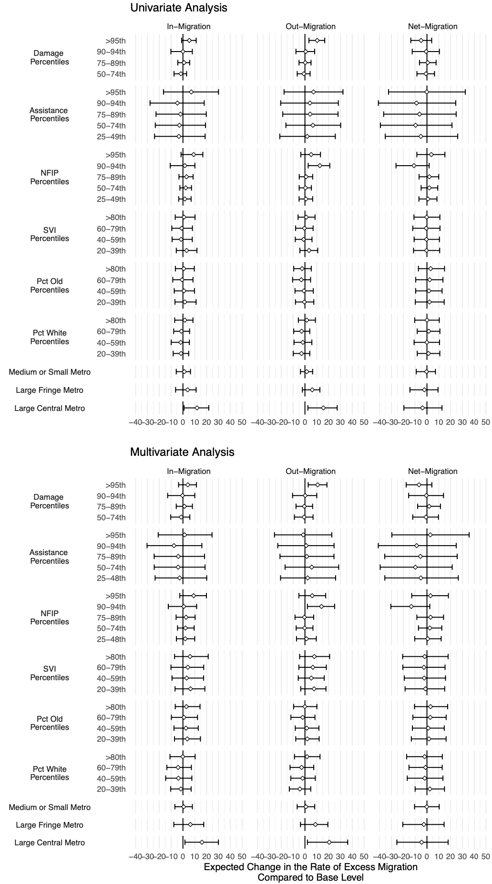
Notes: Point estimates are represented with diamonds, 95% confidence intervals, presented with error bars, account for the fact that the dependent variable (excess migration rates) are also estimated. Damage from tropical storms and NFIP payments are time-variant. The percentage of the population 65 or older and identifying as White are time-invariant and measured in 1990, the SVI is also time-invariant and measured in 2000.

Supplementary Table 6a: Regression Table Corresponding to the Multivariate Model Presented in Supplementary Figure 7.
 | In-Migration |  |  | Out-Migration |  |  | Net-Migration
 | Mean | Upper Bound | Lower Bound | Mean | Upper Bound | Lower Bound | Mean | Upper Bound | Lower Bound
NFIP Percentiles
25-48th | 1.939 | 9.959 | -5.500 | 1.267 | 9.582 | -7.140 | 0.677 | 12.012 | -10.347
50-74th | 2.138 | 9.463 | -4.570 | -0.295 | 6.761 | -7.421 | 2.455 | 12.540 | -7.186
75-89th | 2.604 | 10.305 | -5.798 | -0.467 | 7.383 | -8.383 | 3.041 | 14.016 | -8.538
90-94th | 0.731 | 11.590 | -12.379 | 13.965 | 25.090 | 2.104 | -13.224 | 2.423 | -30.489
>95th | 9.051 | 19.849 | -2.650 | 6.138 | 17.523 | -5.111 | 2.959 | 18.112 | -12.882
SVI Percentiles
20-39th | 6.401 | 18.521 | -6.663 | 7.705 | 17.769 | -3.560 | -1.304 | 14.999 | -18.475
40-59th | 3.114 | 17.450 | -9.225 | 5.378 | 16.273 | -5.660 | -2.294 | 15.708 | -19.135
60-79th | 4.183 | 17.545 | -10.131 | 6.683 | 18.049 | -5.121 | -2.542 | 15.288 | -20.358
>80th | 6.046 | 21.358 | -7.085 | 7.887 | 20.854 | -4.467 | -1.852 | 17.872 | -20.545
Assistance Percentiles
25-48th | -2.795 | 20.095 | -23.522 | 2.317 | 25.931 | -20.630 | -5.126 | 26.480 | -35.604
50-74th | -4.032 | 18.699 | -24.224 | 5.698 | 28.517 | -16.799 | -9.758 | 21.349 | -39.490
75-89th | -3.927 | 18.222 | -24.303 | 1.544 | 24.513 | -21.098 | -5.519 | 25.548 | -35.665
90-94th | -7.585 | 15.996 | -30.334 | 1.053 | 24.598 | -22.960 | -8.710 | 24.743 | -41.142
>95th | 1.399 | 24.585 | -20.899 | -1.449 | 22.684 | -25.759 | 2.823 | 35.646 | -29.655
Damage Percentiles
50-74th | -1.487 | 5.819 | -10.320 | -0.718 | 6.867 | -8.877 | -0.797 | 9.718 | -12.022
75-89th | 1.278 | 7.988 | -5.658 | -0.529 | 6.479 | -7.559 | 1.836 | 11.413 | -7.858
90-94th | -0.362 | 9.998 | -12.935 | 0.191 | 9.986 | -10.485 | -0.534 | 13.962 | -15.470
>95th | 4.102 | 11.402 | -3.689 | 10.752 | 18.594 | 2.725 | -6.678 | 4.135 | -17.558
Large Central Metro
 | 16.048 | 29.972 | 1.688 | 20.563 | 36.143 | 2.094 | -4.473 | 17.889 | -25.434
Large Fringe Metro
 | 6.252 | 17.567 | -7.715 | 8.854 | 19.346 | -3.760 | -2.601 | 14.480 | -20.453
Medium or Small Metro
 | 0.642 | 7.968 | -6.806 | 0.803 | 8.246 | -6.580 | -0.163 | 10.381 | -10.480
Pct Old Percentiles
20-39th | 3.646 | 14.787 | -7.109 | 1.948 | 12.020 | -7.774 | 1.694 | 16.182 | -13.207
40-59th | 2.510 | 12.950 | -7.542 | 1.471 | 11.803 | -8.176 | 1.066 | 14.614 | -12.290
60-79th | 0.831 | 12.302 | -9.770 | -1.960 | 8.466 | -11.858 | 2.777 | 16.222 | -11.874
>80th | 2.894 | 14.443 | -6.525 | -0.079 | 10.110 | -9.565 | 2.997 | 17.509 | -10.519
Pct White Percentiles
20-39th | -1.789 | 6.934 | -10.376 | -4.264 | 4.900 | -13.205 | 2.466 | 14.796 | -9.993
40-59th | -3.837 | 7.537 | -14.609 | -1.984 | 8.739 | -11.946 | -1.869 | 13.510 | -16.642
60-79th | -4.072 | 7.109 | -13.609 | -2.825 | 7.432 | -12.593 | -1.266 | 12.884 | -15.167
>80th | -0.186 | 10.313 | -10.958 | 1.753 | 12.745 | -8.809 | -1.964 | 12.999 | -17.155
Notes: the “Mean” column reports the point estimate of each coefficient, the “Upper Bound” and “Lower Bound” columns report the upper and lower bound of the corresponding 95% confidence interval adjusting for uncertainty in the dependent variable via the bootstrap procedure described in the Supplementary Methodology. For regression statistics, sample size N, R-squared, and number of parameters, refer to Supplementary Table 5.

Supplementary Table 6b: Regression Table Corresponding to the Univariate Models Presented in Supplementary Figure 7.
 | In-Migration |  |  | Out-Migration |  |  | Net-Migration
 | Mean | Upper Bound | Lower Bound | Mean | Upper Bound | Lower Bound | Mean | Upper Bound | Lower Bound
NFIP Percentiles
25-49th | 1.649 | 6.902 | -3.578 | 0.806 | 6.518 | -4.945 | 0.838 | 8.463 | -6.786
50-74th | 2.404 | 7.240 | -2.592 | 0.352 | 5.450 | -4.888 | 2.002 | 9.095 | -4.949
75-89th | 3.037 | 8.593 | -3.369 | 0.974 | 6.532 | -4.818 | 2.034 | 9.930 | -6.657
90-94th | 1.619 | 10.124 | -10.736 | 12.586 | 20.993 | 2.727 | -10.971 | 1.871 | -26.156
>95th | 9.038 | 16.816 | -1.620 | 5.228 | 13.121 | -3.521 | 3.714 | 15.160 | -8.520
SVI Percentiles
20-39th | 3.097 | 11.837 | -5.623 | 3.463 | 10.796 | -4.256 | -0.335 | 10.763 | -11.351
40-59th | -1.555 | 7.910 | -9.123 | -1.146 | 5.973 | -8.156 | -0.409 | 10.576 | -10.849
60-79th | -1.092 | 8.011 | -9.395 | -0.466 | 6.885 | -7.864 | -0.622 | 11.012 | -11.988
>80th | 0.877 | 10.214 | -6.514 | 1.112 | 8.528 | -5.824 | -0.229 | 10.935 | -10.990
Assistance Percentiles
25-49th | -3.410 | 18.740 | -23.969 | 1.858 | 25.660 | -21.256 | -5.176 | 25.982 | -35.244
50-74th | -2.977 | 19.038 | -23.356 | 6.715 | 30.207 | -16.092 | -9.617 | 21.156 | -39.292
75-89th | -2.049 | 19.720 | -22.742 | 4.344 | 27.970 | -18.743 | -6.299 | 24.696 | -36.581
90-94th | -4.697 | 17.985 | -27.803 | 4.211 | 28.220 | -20.536 | -8.814 | 24.304 | -41.034
>95th | 7.052 | 30.046 | -16.437 | 7.239 | 32.133 | -17.651 | -0.132 | 32.433 | -32.472
Damage Percentiles
50-74th | -1.765 | 3.086 | -7.537 | -0.902 | 4.350 | -6.533 | -0.860 | 6.407 | -8.458
75-89th | 0.955 | 5.714 | -4.312 | 0.280 | 5.164 | -4.994 | 0.645 | 7.731 | -6.320
90-94th | -0.018 | 7.918 | -10.173 | 0.607 | 8.185 | -7.609 | -0.626 | 10.510 | -12.446
>95th | 5.414 | 11.219 | -1.135 | 10.340 | 16.699 | 3.391 | -4.960 | 3.967 | -13.648
Large Central Metro
 | 11.853 | 21.864 | 0.940 | 15.578 | 27.252 | 2.477 | -3.747 | 12.700 | -19.478
Large Fringe Metro
 | 3.982 | 11.141 | -6.229 | 6.157 | 12.636 | -2.208 | -2.171 | 9.349 | -14.363
Medium or Small Metro
 | 1.145 | 6.371 | -5.669 | 1.508 | 6.508 | -3.787 | -0.372 | 7.170 | -9.035
Pct Old Percentiles
20-39th | 1.619 | 11.127 | -6.734 | -0.531 | 7.488 | -8.000 | 2.156 | 14.552 | -9.815
40-59th | 0.852 | 9.743 | -7.347 | -0.843 | 7.030 | -8.418 | 1.695 | 12.777 | -9.535
60-79th | -0.725 | 8.472 | -8.595 | -3.091 | 4.747 | -10.446 | 2.364 | 13.513 | -9.481
>80th | 0.699 | 9.593 | -6.382 | -2.396 | 5.337 | -9.473 | 3.064 | 14.862 | -7.223
Pct White Percentiles
20-39th | -1.639 | 4.886 | -8.261 | -2.890 | 4.059 | -9.901 | 1.273 | 10.892 | -8.208
40-59th | -1.904 | 5.436 | -9.916 | -1.787 | 5.842 | -9.246 | -0.065 | 10.629 | -10.871
60-79th | -1.330 | 5.614 | -7.817 | -2.831 | 4.037 | -9.505 | 1.510 | 10.930 | -8.225
>80th | 1.593 | 8.449 | -6.954 | 1.548 | 8.800 | -5.568 | 0.062 | 10.433 | -10.348
Notes: the “Mean” column reports the point estimate of each coefficient, the “Upper Bound” and “Lower Bound” columns report the upper and lower bound of the corresponding 95% confidence interval adjusting for uncertainty in the dependent variable via the bootstrap procedure described in the Supplementary Methodology. For regression statistics, sample size N, R-squared, and number of parameters, refer to Supplementary Table 5.

Supplementary Figure 8: Factors Associated with Excess Migration (2004-2010), Comparing Confidence Intervals Treating the Dependent Variable as Random (Presented in the Main Text), and Traditional Confidence Intervals Treating the Dependent Variables as Fixed
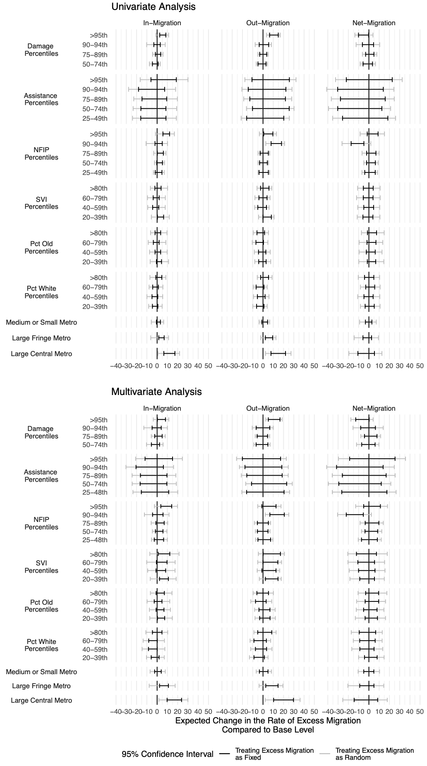
Notes: Point estimates are represented with diamonds, 95% confidence interval are presented with error bars. Damage from tropical storms and NFIP payments are time-variant. The percentage of the population 65 or older and identifying as White are time-invariant and measured in 1990, the SVI is also time-invariant and measured in 2000.

Supplementary Table 7: Regression Table Corresponding to the Multivariate Model Presented in Supplementary Figure 8.
 | Out-Migrations |  | In-Migration |  | Net-Migration
Damage 50th to 74th | -59.88 | (289.33) | -153.10 | (206.08) | -93.22 | (344.26)
Damage 75th to 89th | -71.98 | (259.44) | 124.88 | (184.79) | 196.86 | (308.69)
Damage 90th to 94th | 38.51 | (320.07) | -51.87 | (227.98) | -90.37 | (380.84)
Damage 95th and Above | 1081.21 *** | (289.34) | 419.89 * | (206.09) | -661.32 | (344.28)
NFIP 25th to 49th | 113.14 | (326.61) | 193.42 | (232.64) | 80.29 | (388.63)
NFIP 50th to 74th | -20.15 | (268.33) | 209.52 | (191.13) | 229.68 | (319.28)
NFIP 75th to 89th | -36.14 | (285.27) | 276.54 | (203.19) | 312.68 | (339.43)
NFIP 90th to 94th | 1421.07 *** | (369.96) | 67.60 | (263.52) | -1353.47 ** | (440.20)
NFIP 95th and Above | 601.04 | (368.40) | 905.20 *** | (262.41) | 304.16 | (438.35)
FEMA Assistance 25th to 49th | 208.83 | (922.25) | -261.64 | (656.91) | -470.47 | (1097.36)
FEMA Assistance 50th to 74th | 544.00 | (898.77) | -389.03 | (640.18) | -933.03 | (1069.41)
FEMA Assistance 75th to 89th | 129.53 | (903.25) | -389.55 | (643.37) | -519.08 | (1074.74)
FEMA Assistance 90th to 94th | 88.69 | (926.71) | -750.27 | (660.08) | -838.95 | (1102.66)
FEMA Assistance 95th and Above | -154.98 | (940.25) | 125.76 | (669.72) | 280.74 | (1118.77)
% 65+ 20th to 39th | 159.46 | (252.59) | 387.36 * | (179.91) | 227.90 | (300.54)
% 65+ 40th to 59th | 127.66 | (270.00) | 261.52 | (192.32) | 133.86 | (321.26)
% 65+ 60th to 79th | -221.47 | (281.14) | 96.00 | (200.25) | 317.46 | (334.52)
% 65+ 80th and Above | -20.06 | (283.95) | 291.88 | (202.25) | 311.95 | (337.86)
% White 20th to 39th | -403.87 | (269.54) | -204.21 | (191.99) | 199.66 | (320.71)
% White 40th to 59th | -209.98 | (291.76) | -407.45 | (207.82) | -197.47 | (347.16)
% White 60th to 79th | -280.96 | (307.69) | -409.45 | (219.17) | -128.49 | (366.11)
% White 80th and Above | 148.96 | (336.23) | -8.66 | (239.49) | -157.62 | (400.06)
Medium or Small Metro | 77.45 | (216.80) | 84.84 | (154.42) | 7.39 | (257.96)
Large Fringe Metro | 861.56 ** | (298.70) | 684.31 ** | (212.76) | -177.25 | (355.41)
Large Central Metro | 1967.48 *** | (489.59) | 1646.04 *** | (348.73) | -321.44 | (582.55)
SVI (2000) 20th to 39th | 835.90 ** | (310.99) | 667.74 ** | (221.51) | -168.16 | (370.03)
SVI (2000) 40th to 59th | 555.88 | (336.50) | 357.42 | (239.69) | -198.47 | (400.39)
SVI (2000) 60th to 79th | 690.00 | (361.82) | 468.75 | (257.72) | -221.25 | (430.52)
SVI (2000) 80th and Above | 821.38 * | (398.88) | 643.54 * | (284.12) | -177.84 | (474.62)
N | 1107 |  | 1107 |  | 1107
Residual DF | 1071.00 |  | 1071.00 |  | 1071.00
R2 | 0.11 |  | 0.14 |  | 0.04
*** p < 0.001; ** p < 0.01; * p < 0.05.
Notes: Point estimates, standard errors, and p-values reported in this table refer to the model not adjusting for the fact that the dependent variable is itself estimated. As such, the match the results presented in Supplementary Figure 7 (black error bars).

Supplementary Figure 9a: Factors Associated with Excess Migration, Fixed-Effects Models
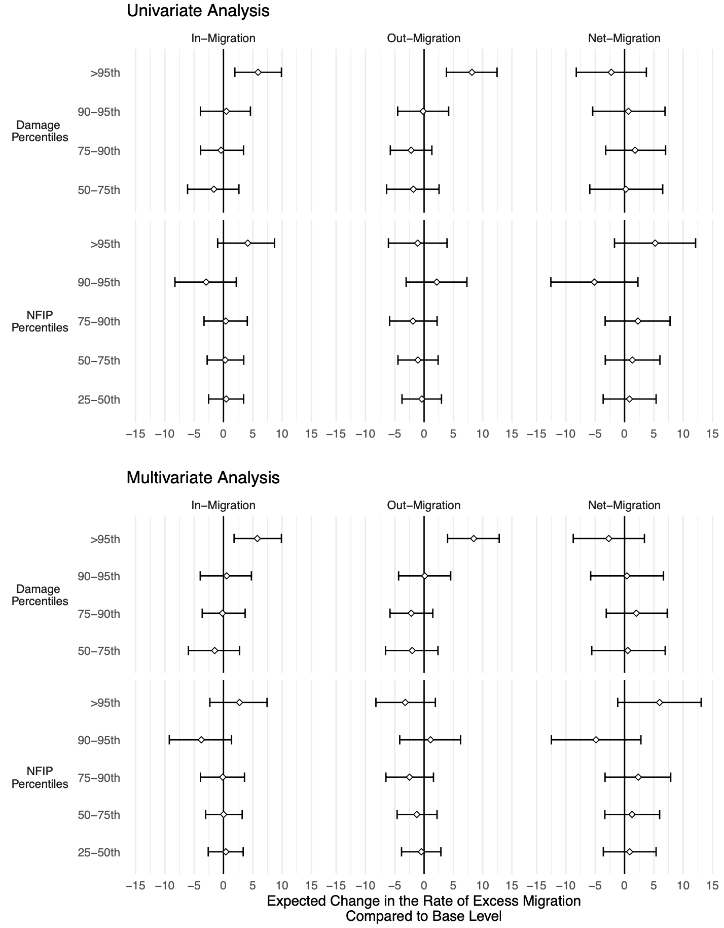
Notes: Point estimates are represented with diamonds, 95% confidence intervals, presented with error bars, account for the fact that the dependent variable (excess migration rates) are also estimated. Only time-varying variables are included because time-invariant ones are collinear with the county fixed effects.

Supplementary Figure 9b: Factors Associated with Excess Migration, Fixed-Effects Models (2004-2010)
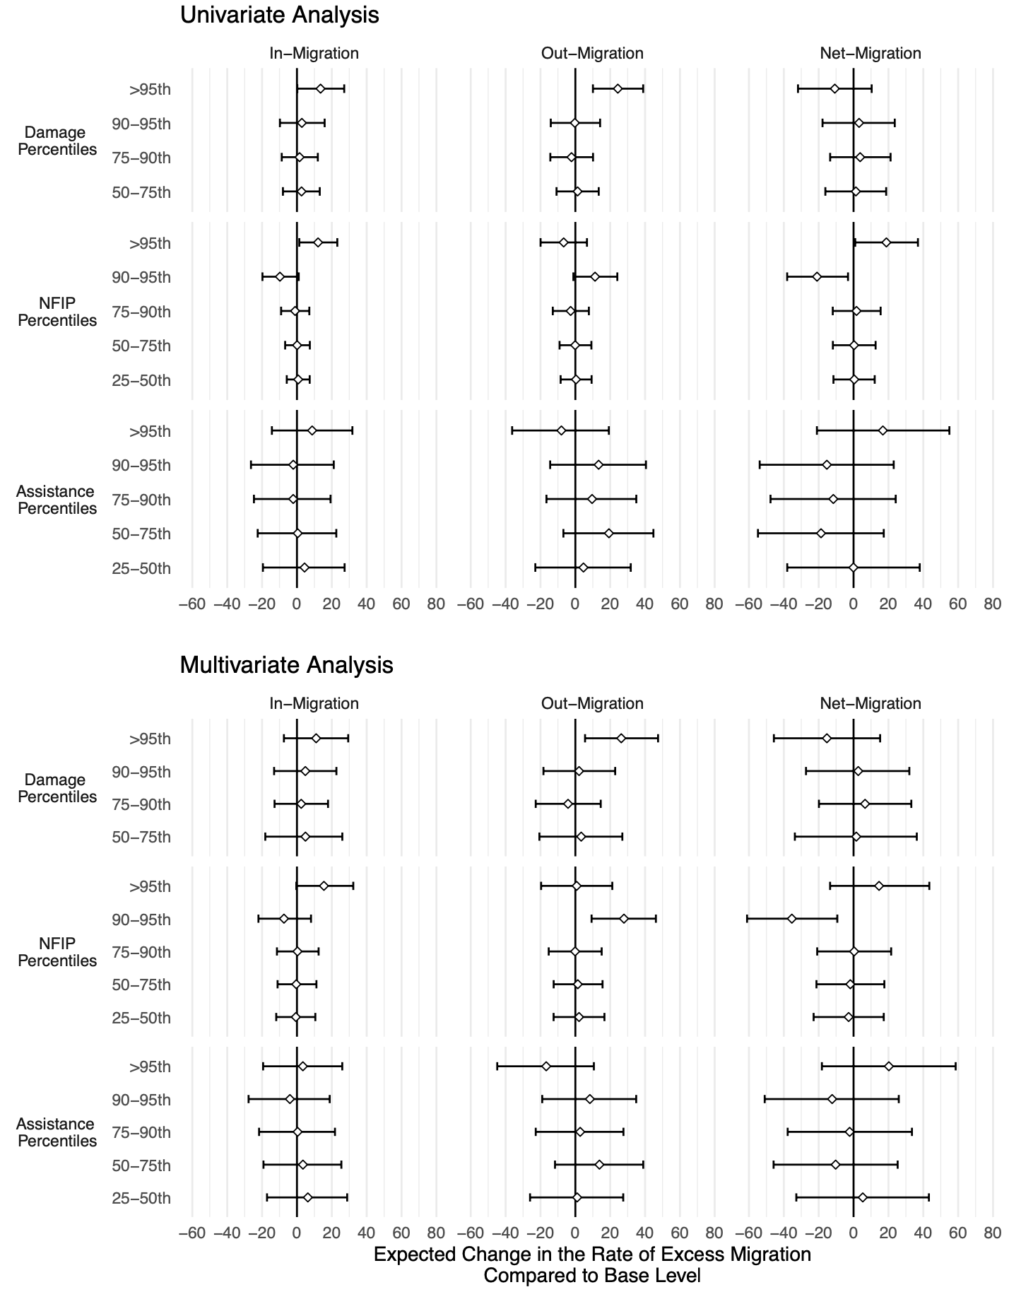
Notes: Point estimates are represented with diamonds, 95% confidence intervals, presented with error bars, account for the fact that the dependent variable (excess migration rates) are also estimated. Damage from tropical storms and NFIP payments are time-variant. The percentage of the population 65 or older and identifying as White are time-invariant and measured in 1990, the SVI is also time-invariant and measured in 2000.

Supplementary Figure 10: Damage, FEMA Assistance, and NFIP Insurance Payments.
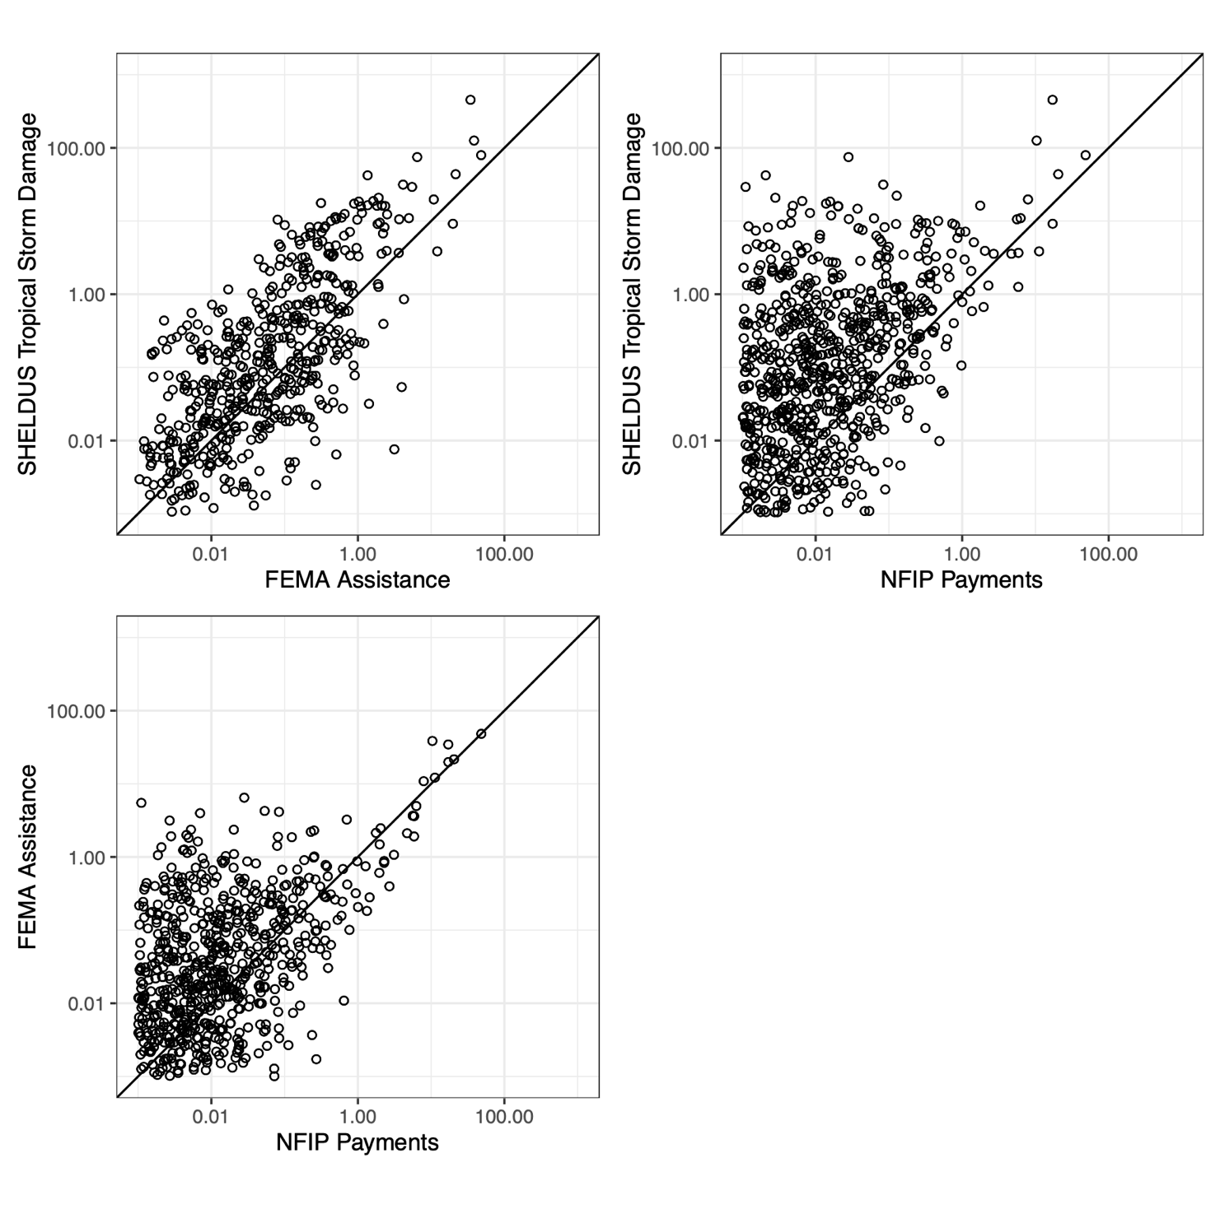
Notes: All variables are expressed in per capita terms and as a percentage of the county-specific median housing price in 1990. Monetary values are adjusted for inflation and converted into 2020 dollar values.

