Supplementary Material
Attitudes towards childbearing, population, and the environment: Prevalence, correlates, and connections with fertility outcomes in Sweden

Material, Study 1
NB: originally in Swedish, but also with an English-language option.

Various worries
Thinking about the future, how much does the following worry you?
- Climate change
- Overpopulation
- Prospects of coming generations
- Terrorism
- Economic crises
- Increased number of refugees
- High unemployment
- Organised crime
- Military conflicts
- Global epidemics
- Weakened democracy
- Increased social inequality
- Political extremism

Scale: 1=Very worrying, 2=Somewhat worrying, 3=Not particularly worrying, 4=Not at all worrying

Relative life quality between generations
- When your children will be your age, do you think their life will be better or worse?
- Compared with your parents when they were your age, do you consider your life to be better or worse? Try to respond even if you do not have any children

Scale: 1=Much better, 2=Better, 3=Neither better nor worse, 4=Worse, 5=Much worse

Childbearing intentions
- Do you intend to have a/another child during the next three years?
- Supposing you do not have a/another child during the next three years, do you intend to have any (more) children at all?

Scale: 1=Definitely not, 2=Probably not, 3=Probably yes, 4=Definitely yes

Measure: Future fertility intentions is either an intention the next 3 years or in the future.
- How many more children do you intend to have (not counting any ongoing pregnancy)?

Scale: Numeric response

Ideal number of children
- Generally speaking, what do you think is the ideal number of children for a family?

Scale: Numeric response, or checkbox ‘No opinion’=1.
Measure: Our continuous measure of ideal number of children, refers to only those that had not indicated no opinion.

Material, Study 2
NB: Originally in Swedish. The questions were randomized within each scale.

Childbearing decisions in relation to the environment
To what degree do you think the following should influence a person's decision to have a child?
- The possibility that the child will live in a world with serious environmental problems.
- The possibility that an increasing population will worsen environmental problems.

Scale: 1=Strongly Disagree; […] 5=Strongly Agree, 6=Don’t know

Opinion about population growth
- We are approaching the limit of the number of people the earth can support.

Scale: 1=Strongly Disagree; […] 5=Strongly Agree; 6=Don’t know

Societal measures to limit population
- To reduce the impact on the climate, Sweden should introduce measures that promote people having fewer children.
- To reduce the impact on the climate, developing countries should introduce measures that promote people having fewer children.

Scale: 1=Strongly Disagree; […] 5=Strongly Agree. 6=Don’t know

Personal environmental actions, including childbearing decisions
Indicate the degree to which you have engaged in the following behaviors that have been described as measures to reduce climate impact.
- Avoid flying
- Avoid driving/travelling by a car
- Avoid eating meat
- Avoid dairy products
- Recycle (e.g., metal, plastic)
- Avoid food waste
- Buy green energy
- Reduce use of electricity
- Purchase carbon offsets
- Vote a party/politician that focus on the climate issue
- Participate in demonstrations (e.g., Fridays for future)
- Discuss climate change with friends and family
- Have fewer (or no) children

Scale: 1=Not at all; […] 5=To high degree; 6= Not applicable

Climate Worry
- How worried are you about climate change?

Scale: 1=Not at all worried; […] 5=Very worried

Climate change denial
- It is true that global warming is happening. (R)
- It is unclear if the earth's climate is changing.
- Global warming that is caused by humans is happening. (R)
- The variation in the Earth's temperature is natural, and is not due to human activities .
- Climate change will not have a notable impact on humans’ living conditions in any significant way.
- Climate change will cause widespread losses and damages for people. (R)

Scale: 1=Strongly Disagree; […] 5=Strongly Agree; 6=Don’t know

Political trust
To what degree do you personally trust the following institutions and societal actors?
- The national parliament
- Universities

Scale: 1=Not at all; […] 5=To high degree

Social Dominance Orientation
- In setting priorities, we must consider all societal groups.
- We should not push for equality of societal groups.
- The equality of societal groups should be our goal.
- Superior societal groups should dominate inferior groups.

Scale: 1=Strongly Disagree; […] 5=Strongly Agree; 6=Don’t know

Right-Wing Authoritarianism
- To stop the radical and immoral currents in society today there is a need for a strong leader.
- Our society would be best off if we showed tolerance and understanding for nontraditional values and views. (R)
- The best way to live is in accordance with the old-fashioned values.

Scale: 1=Strongly Disagree; […] 5=Strongly Agree; 6=Don’t know

Table S1.

Correlations and p-values between the different variables. Study 1 (Swedish GGS Survey).

 | 1 | 2 | 3 | 4 | 5 | 6 | 7 | 8 | 9 | 10 | 11
1. Ideal family size | 1
(p)
2. Worry,  climate change | -0.02 | 1
(p) | 0.06
3. Worry, overpopulation | -0.03 | 0.35 | 1
(p) | 0.01 | 0.00
4. Worry,  future generations | 0.02 | 0.34 | 0.30 | 1
(p) | 0.08 | 0.00 | 0.00
5. Male  (=1) | -0.01 | -0.15 | 0.07 | -0.09 | 1
(p) | 0.36 | 0.00 | 0.00 | 0.00
6. Education  (ISCED, 8 levels) | -0.01 | 0.13 | -0.02 | 0.02 | -0.08 | 1
(p) | 0.59 | 0.00 | 0.04 | 0.06 | 0.00
7. Log income (ln SEK) | -0.06 | 0.02 | 0.00 | 0.00 | 0.04 | 0.17 | 1
(p) | 0.00 | 0.05 | 0.81 | 0.71 | 0.00 | 0.00
8. Swedish Born  (=1) | -0.05 | 0.02 | 0.01 | 0.04 | -0.01 | -0.07 | 0.10 | 1
(p) | 0.00 | 0.14 | 0.28 | 0.00 | 0.26 | 0.00 | 0.00
9. Age | 0.02 | -0.06 | 0.02 | 0.03 | 0.01 | 0.13 | 0.19 | -0.01 | 1
(p) | 0.07 | 0.00 | 0.03 | 0.00 | 0.26 | 0.00 | 0.00 | 0.19
10. General worries (index) | 0.04 | 0.33 | 0.44 | 0.45 | -0.10 | -0.03 | -0.04 | -0.10 | 0.09 | 1
(p) | 0.00 | 0.00 | 0.00 | 0.00 | 0.00 | 0.00 | 0.00 | 0.00 | 0.00
11. Number of children | 0.08 | -0.04 | -0.06 | 0.06 | -0.07 | 0.09 | 0.19 | 0.02 | 0.54 | 0.02 | 1
(p) | 0.00 | 0.00 | 0.00 | 0.00 | 0.00 | 0.00 | 0.00 | 0.11 | 0.00 | 0.08

Table S2.
Correlations and p-Values (r/p) Between Eco-Reproductive Concerns and Behaviors, and the Number of Children. Study 2.
 | 1 | 2 | 3 | 4 | 5 | 6
1. Childbearing Consideration: Future of the Child
2. Childbearing Consideration: Population Growth | .46/<.001
3. Climate Action: Fewer Children | .18/<.001 | .20/<.001
4. Population Limits Approaching | .25/<.001 | .56/<.001 | .12/.011
5. Population Limitation, Sweden | .20/<.001 | .38/<.001 | .40/<.001 | .38/<.001
6. Population Limitation, Developing Countries | .16/<.001 | .43/<.001 | .20/<.001 | .45/<.001 | .63/<.001
7. Number of Children | -.09/.029 | -.08/.052 | -.49/<.001 | .00/928 | -.14/<.001 | -.06/.116

Table S3.
Correlations and p-Values (r/p) Between the Psychological and Demographic Variables (i.e. Predictor Variables). Study 2.
 | 1 | 2 | 3 | 4 | 5 | 6 | 7 | 8 | 9
1. Climate Worry
2. Climate Denial | -.61/<.001
3. Climate Action | .55/<.001 | -.46/<.001
4. SDOª | -.33/<.001 | .50/<.001 | -.36/<.001
5. RWA^{b} | -.20/<.001 | .44/<.001 | -.27/<.001 | .41/<.001
6. Political Trust | .10/.009 | -.13/<.001 | .11/.005 | -.07/.069 | -.17/<.001
7. Age | .01/.799 | -.01/.716 | .02/.573 | -.10/.013 | .06/.150 | .02/.681
8. Gender^{c} | -.19/<.001 | .07/.063 | -.19/<.001 | .16/<.001 | .04/.356 | -.05/.217 | .11/.005
9. Married/Partner | -.07/.058 | .09/.020 | -.06/.141 | .04/.363 | .04/.296 | .06/.111 | .04/.356 | .06/.143
10. Education | .11/.004 | -.15/<.001 | .14/<.001 | -.05/.184 | -.17/<.001 | .13/<.001 | .05/.211 | -.03/.370 | .05/.224
Note. Correlations with ‘Gender’ and ‘Married/Partner’: Spearmans Rho, other correlations: Pearson; ªSocial Dominance Orientation; ^{b}Right-Wing Authoritarianism; ^{c}0 = Woman; 1 = Man;

Table S4.
Correlations and p-Values (r/p) Between Eco-Reproductive Concerns and Behaviors and the Demographic and Psychological Variables. Study 2.
 | Childbearing Consideration:  Future of the Child | Childbearing Consideration: Population Growth | Climate Action: Fewer Children | Population Limits Approaching | Population Limitation, Sweden | Population Limitation, Developing Countries | Number of Children
Climate Worry | .44/<.001 | .12/.002 | .15/<.001 | .19/<.001 | .16/<.001 | .03/.445 | -.08/.033
Climate Denial | -.42/<.001 | -.12/.002 | -.11/.015 | -.19/<.001 | -.01/.904 | .06/.171 | .13/<.001
Climate Action | .29/<.001 | .02/.693 | .29/<.001 | .06/.141 | .16/<.001 | -.06/.120 | -.05/.227
SDOª | -.17/<.001 | .06/.128 | -.02/.724 | -.00/.915 | .13/.002 | .22/<.001 | .01/.712
RWA^{b} | -.05/.177 | .09/.018 | -.05/.306 | .09/.024 | .17/<.001 | .24/<.001 | .13/<.001
Political Trust | -.01/.731 | -.17/<.001 | -.08/.094 | -.09/.023 | -.09/.023 | -.13/.002 | .00/.998
Age | .01/.888 | .04/.312 | -.15/.001 | .10/.016 | -.01/.861 | .12/.003 | .43/<.001
Gender^{c} | -.12/.003 | .12/.003 | -.05/.290 | -.00/.939 | .03/.425 | .10/.010 | -.05/.213
Married/Partner | -.12/.003 | -.09/.020 | -.27/<.001 | -.06/.137 | -.05/.241 | -.07/.083 | .24/<.001
Education | .01/.778 | -.00/.960 | -.02/.677 | .01/.834 | -.05/.245 | -.02/.599 | .03/.465
Note. Correlations with ‘Gender’ and ‘Married/Partner’: Spearmans Rho, other correlations: Pearson; ªSocial Dominance Orientation; ^{b}Right-Wing Authoritarianism; ^{c}0 = Woman; 1 = Man.

Table S5.
Regression Analyses Predicting Eco-Reproductive Concerns and Behaviors, Reporting p-Values and b-Values (Including 95% CI). Study 2.
 | Childbearing Consideration:  Future of the Child |  | Childbearing Consideration: Population Growth |  | Climate Action:  Fewer Children |  | Population Limits Approaching |  | Population Limitation, Sweden |  | Population Limitation, Developing Countries |  |  | Number of Children
 | b(95% CI) | p | b(95% CI) | p | b(95% CI) | p | b(95% CI) | p | b(95% CI) | p | b(95% CI) | p | b(95% CI) |  | p
Climate Worry | .264 (.166, .362) | <.001 | .108 (.004, .212) | .042 | -.002 (-.171, .167) | .984 | .140 (.036, .243) | .008 | .187 (.065, .309) | .003 | .140 (.013, .266) | .031 | -.050 (-.160, .061) |  | .378
Climate Denial | -.430 (-.566,-.294) | <.001 | -.240 (-.384,-.095) | .001 | .020 (-.207, .247) | .863 | -.297 (-.441,-.153) | <.001 | .030 (-.138, .197) | .728 | -.132 (-.309, .044) | .141 | .160 (.008, .312) |  | .040
Climate Action | .090 (-.046, .227) | .195 | -.028 (-.174, .118) | .707 | .698 (.464, .931) | <.001 | -.050 (-.196, .096) | .501 | .372 (.202, .543) | <.001 | -.022 (-.201, .158) | .814 | .002 (-.152, .155) |  | .983
SDOª | .068 (-.059, .195) | .290 | .183 (.047, .318) | .009 | .193 (-.026, .411) | .083 | .122 (-.014, .257) | .078 | .273 (.116, .430) | <.001 | .389 (.223, .555) | <.001 | -.041 (-.183, .101) |  | .573
RWA^{b} | .161 (.043, .280) | .008 | .144 (.016, .271) | .027 | -.026 (-.234, .182) | .808 | .254 (.125, .383) | <.001 | .277 (.128, .425) | <.001 | .347 (.191, .502) | <.001 | .107 (-.027, .241) |  | .118
Political trust | -.056 (-.140, .028) | .188 | -.185 (-.275,-.095) | <.001 | -.139 (-.284, .006) | .061 | -.089 (-.179, .000) | .049 | -.089 (-.194, .017) | .099 | -.113 (-.224,-.003) | .044 | .003 (-.092, .098) |  | .945
Age | .001 (-.004, .005) | .763 | .002 (-.003, .006) | .438 | -.008 (-.016,-.001) | .035 | .005 (.000, .009) | .047 | .000 (-.005, .005) | .985 | .009 (.003, .014) | .002 | .027 (.022, .031) |  | <.001
Gender^{c} | -.070 (-.230, .090) | .392 | .278 (.106, .450) | .002 | .040 (-.239, .318) | .779 | .038 (-.134, .209) | .666 | .187 (-.015, .389) | .069 | .206 (-.006, .418) | .056 | -.336 (-.517,-.155) |  | <.001
Married/Partner | -.083 (-.248, .082) | .325 | -.134 (-.311, .043) | .138 | -.924 (-1.212,-.636) | <.001 | -.052 (-.228, .124) | .560 | -.140 (-.346, .067) | .184 | -.186 (-.401, .030) | .091 | .577 (.392, .762) |  | <.001
Note. ªSocial Dominance Orientation; ^{b}Right-Wing Authoritarianism; ^{c}1 = Woman; 2 = Man.

Figure S1.
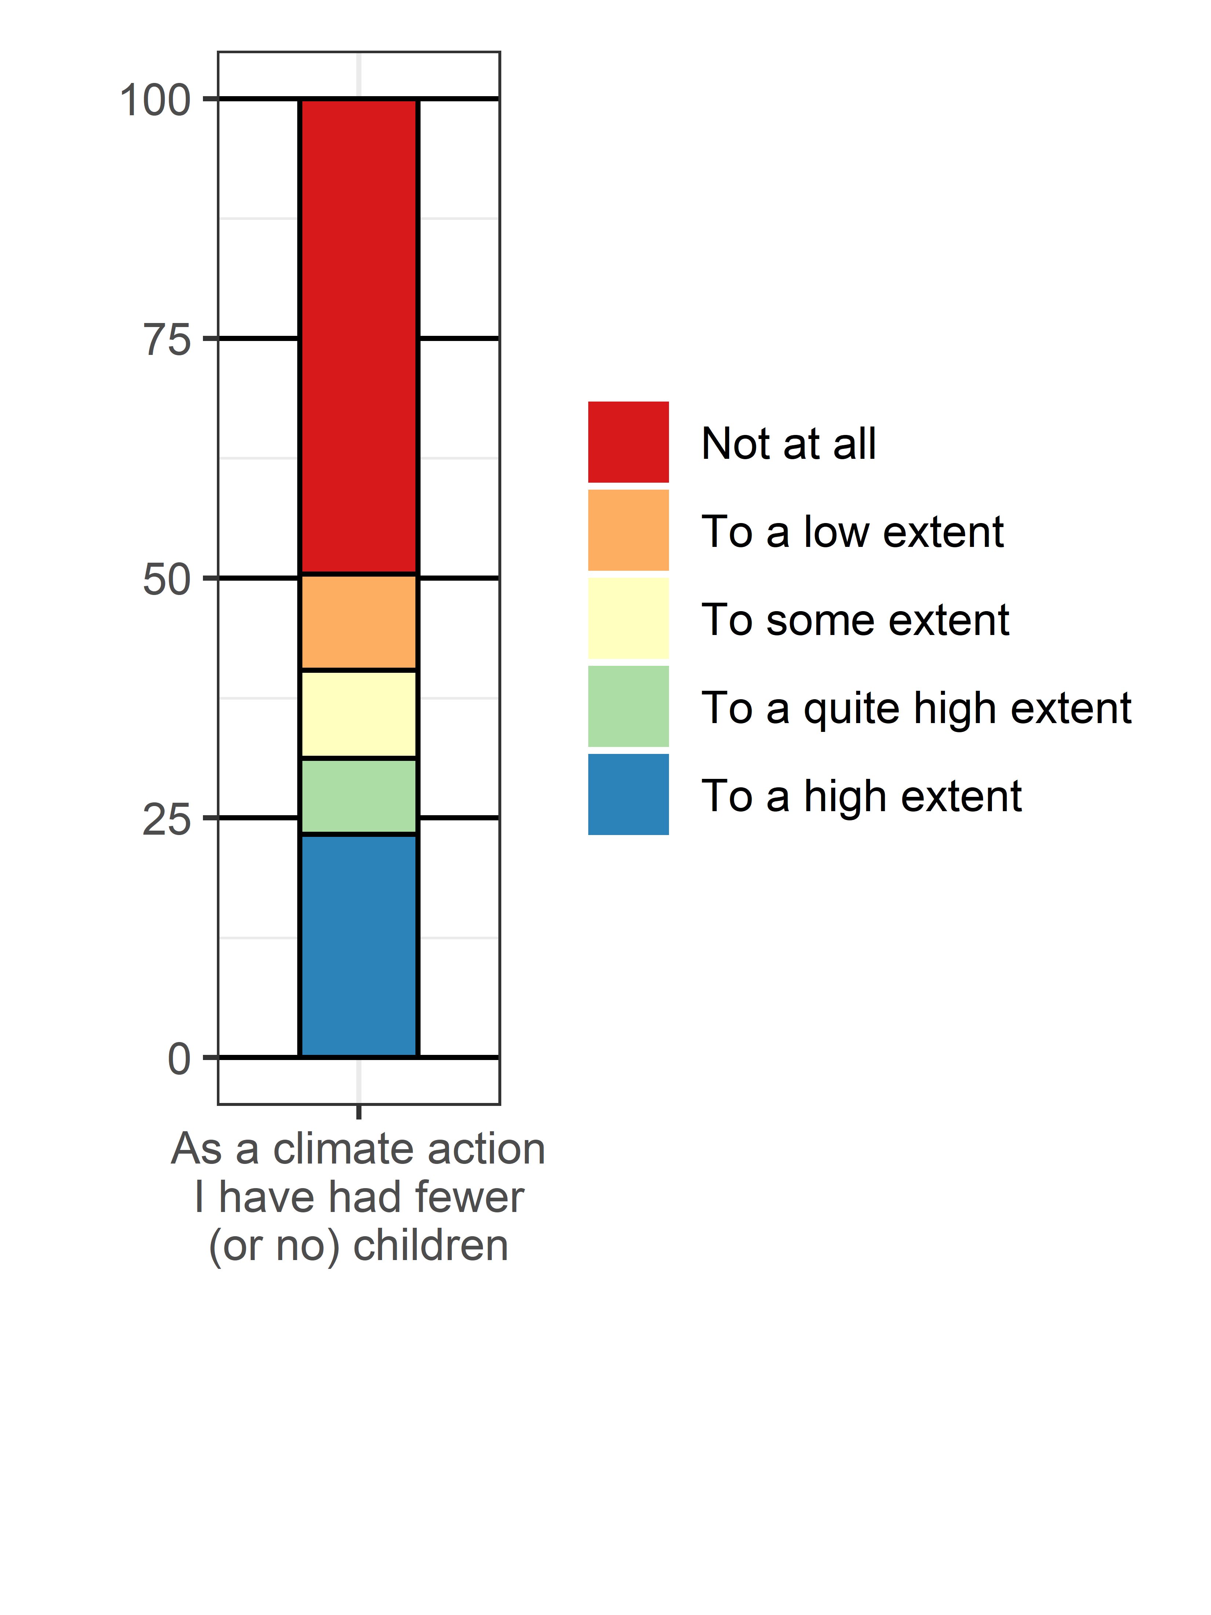
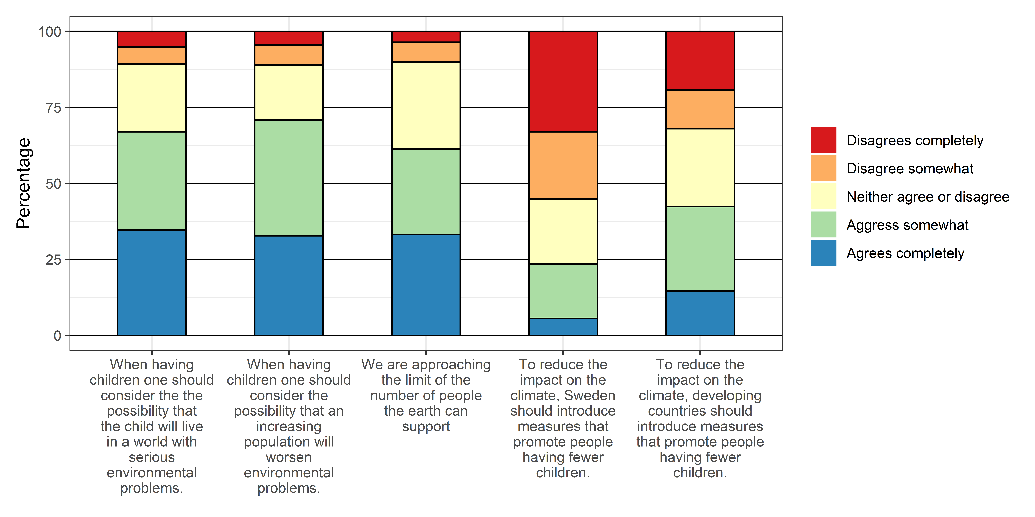
The prevalence of attitudes and behaviors in relation to population, environment, and childbearing in study 2 in the Age-Group 45 or below.

Table S6.
Regression Analyses Examining the Standardized Effects (Beta Values) of Psychological and Demographic Variables on Eco-Reproductive Concerns and Behaviors in the Age-Group 45 or below.
 | Childbearing Consideration:  Future of the Child | Childbearing Consideration: Population Growth | Climate Action: Fewer Children | Population Limits Approaching | Population Limitation, Sweden | Population Limitation, Developing Countries | Number of Children
Climate Worry | .29 | .14 | .00 | .17 | .24 | .17 | -.05
Climate Denial | -.36 | -.14 | .03 | -.20 | .11 | -.06 | .13
Climate Action | .10 | -.00 | .28 | .02 | .17 | .04 | -.04
SDOª | .00 | .01 | .10 | .04 | .12 | .16 | -.05
RWA^{b} | .15 | .11 | -.04 | .13 | .09 | .19 | .11
Political trust | -.06 | -.17 | -.14 | -.07 | -.07 | -.09 | .10
Age | .02 | -.02 | -.17 | .02 | -.11 | -.03 | .46
Gender^{c} | -.10 | .06 | -.08 | -.07 | .02 | .10 | -.11
Married/Partner | -.07 | -.05 | -.33 | .03 | -.04 | -.03 | .22
Adjusted R² | .34 | .05 | .24 | .07 | .09 | .07 | .36
N | 260 | 259 | 210 | 245 | 253 | 253 | 267
Note. Statistically significant (p < .05) effects are bolded; For b-values (including 95% confidence intervals) and exact p-values, see Table S4 in the Supplementary information; ªSocial Dominance Orientation; ^{b}Right-Wing Authoritarianism; ^{c}1 = Woman; 2 = Man.

