Supplementary Material 1:

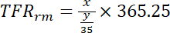 can be reordered to 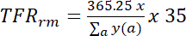 ; i.e. a global fertility rate which is multiplied by 35 to obtain an index in the unit of the total number of children per woman (during her whole life), which we produce as an estimate of the total fertility rate. This is equivalent to dividing the number of births by the arithmetic mean of women’s population by age.

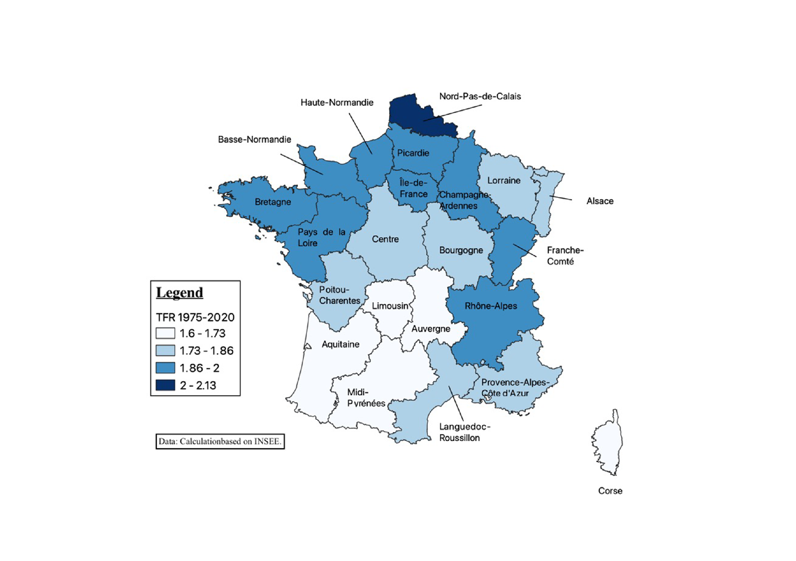Figure S1. Regional Fertility Rates in France 1975-2020

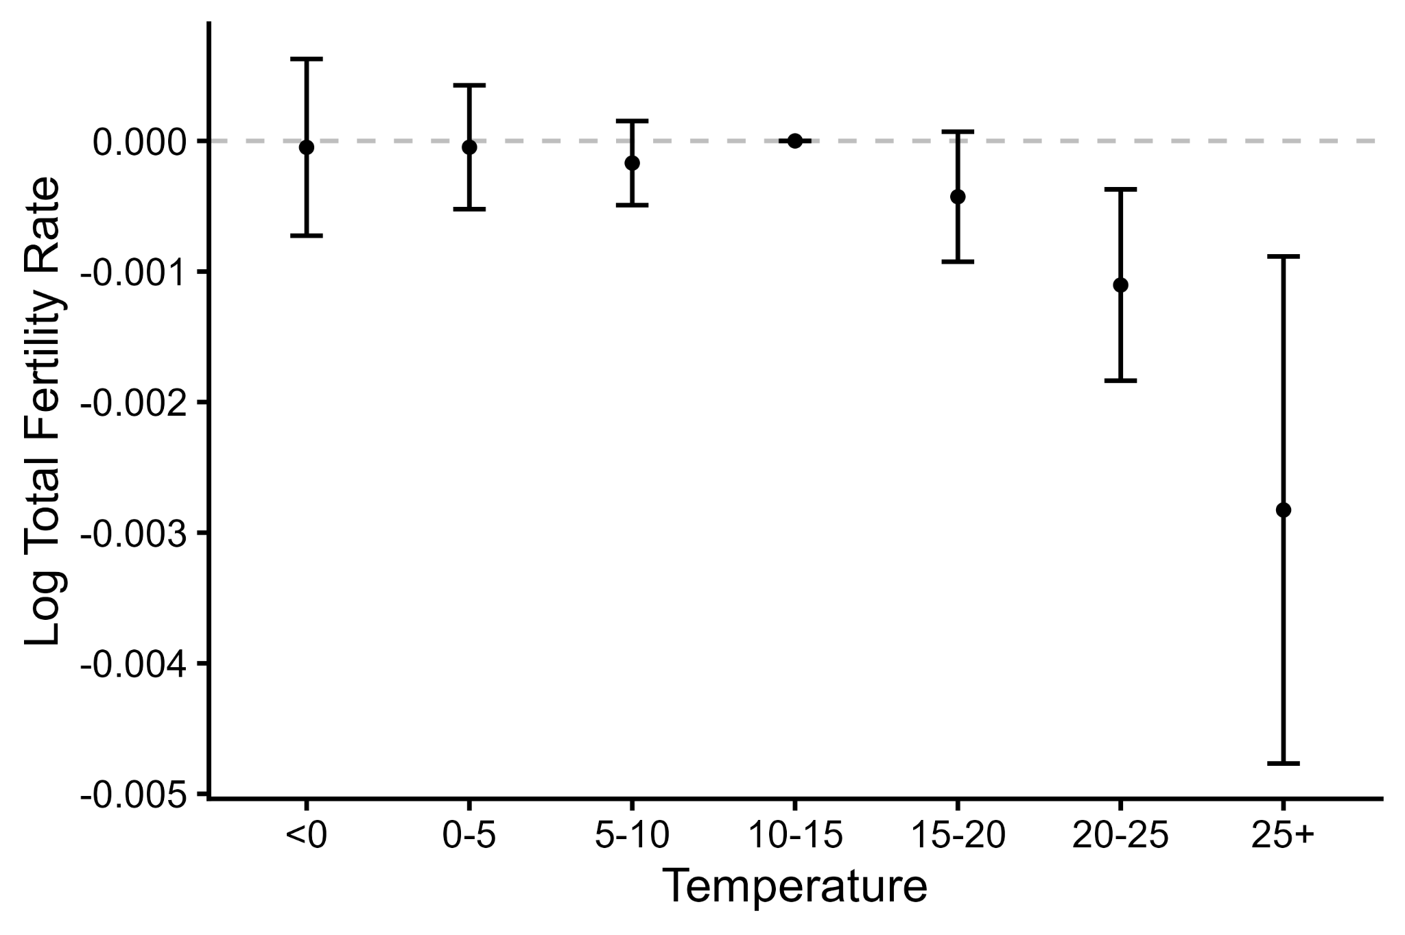
Figure S2. Estimated Effect of All Daily Temperature Bins Compared to a Day of 10- 15°C on 10-month lagged log TFR. Note: data derived from INSEE and Copernicus Climate Data Store (Cornes et al. 2018). Includes 22 French Regions in years 1975-2020

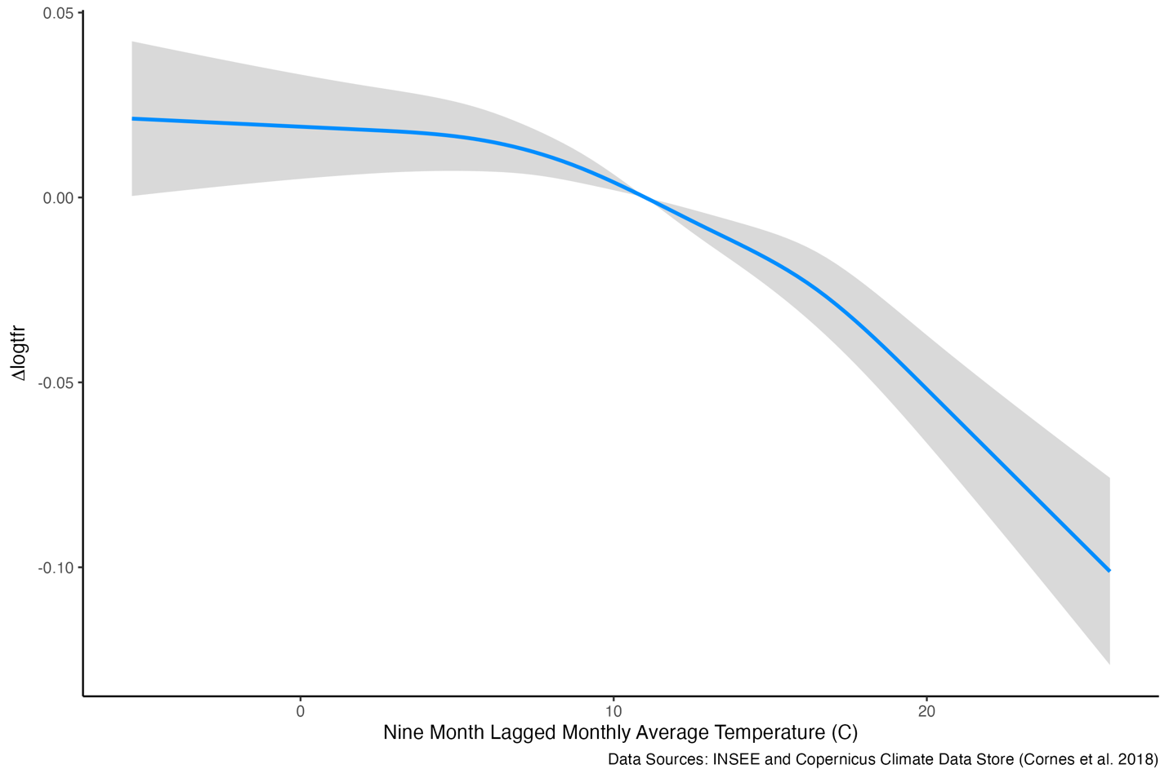
Figure S3. Estimated Effect of Monthly Temperature on nine-month lagged TFR. Note: Figure S3 displays the estimated effect of the monthly average of daily temperature for a given region-month on log TFR nine months later. The estimate is plotted in blue, and the shaded areas represent the 95 percent confidence interval. We use a restricted cubic spline with six degrees of freedom, which carries the advantage over natural splines as its behavior is bounded at the extremes of the function. We include fixed effects for region by month, region by year and month by year. We control for precipitation and humidity by including the daily average for a given region-month in the model.

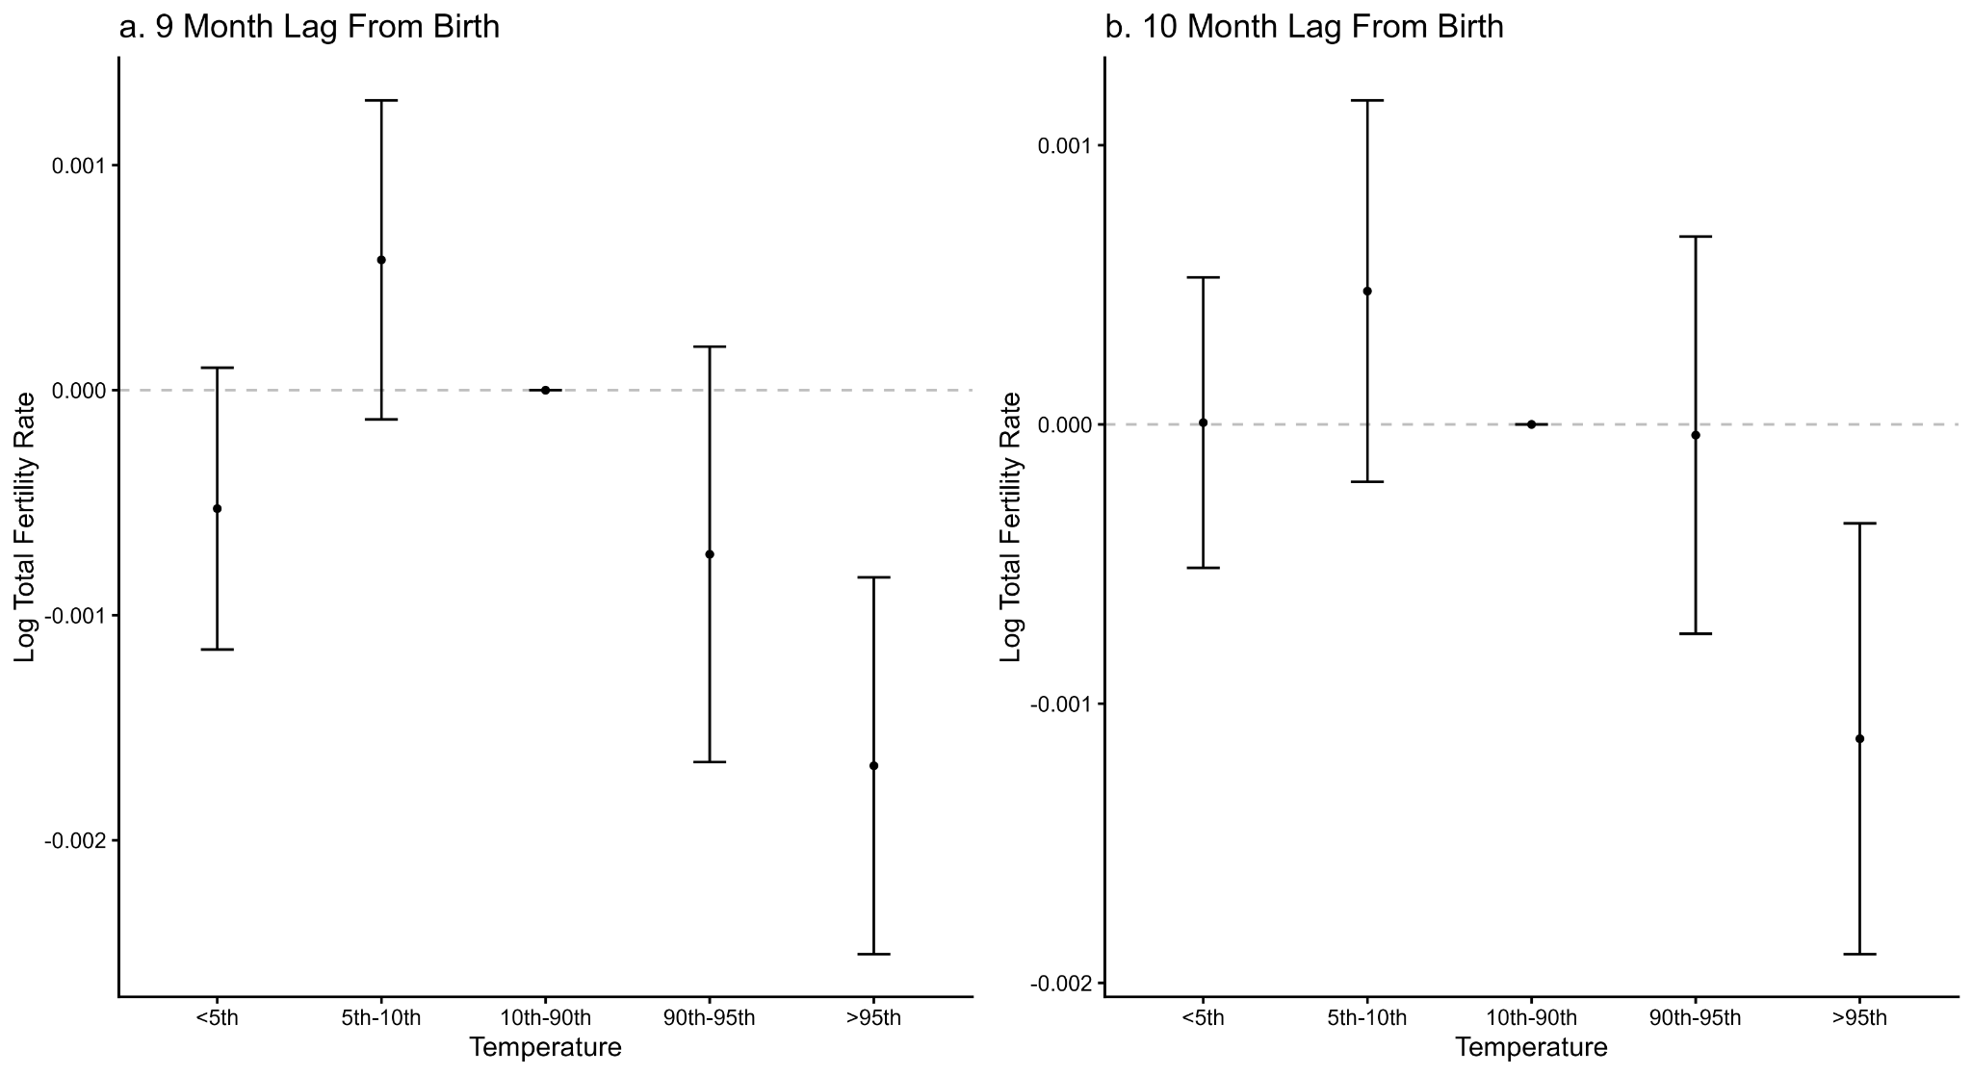
Figure S4. Estimated Effect of All Daily Temperature Bins Compared to a Day of 10- 15°C on 9- and 10-month lagged log TFR. Temperature percentiles are region specific daily mean percentiles from 1975-2020. Note: data derived from INSEE and Copernicus Climate Data Store (Cornes et al. 2018). Includes 22 French Regions in years 1975-2020

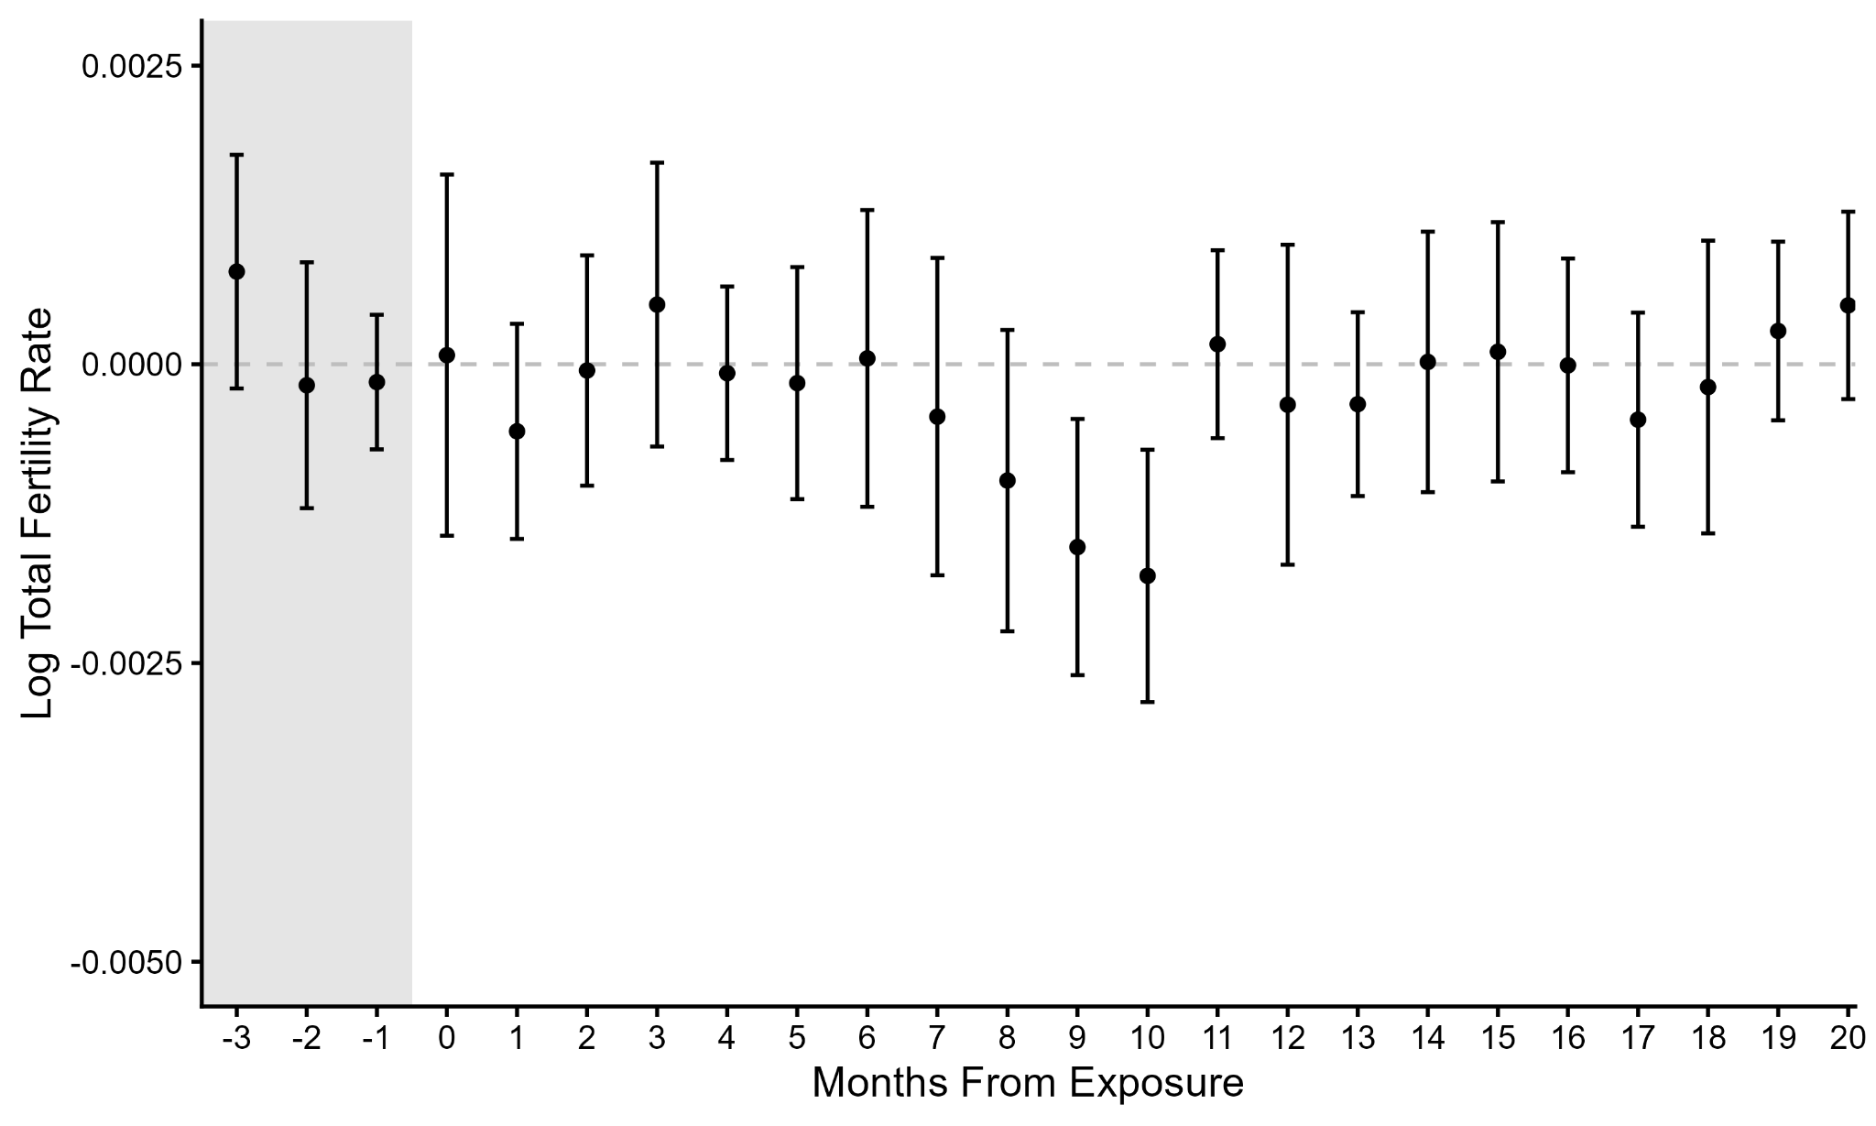
Figure S5. Estimated Effects of One Day with a Maximum Temperature ≥30°C Compared to a Day of Maximum Temperature Between 15- 20°C on log TFR Across Lags -3 to 20. Note: data derived from INSEE and Copernicus Climate Data Store (Cornes et al. 2018). Includes 22 French Regions in years 1975-2020.

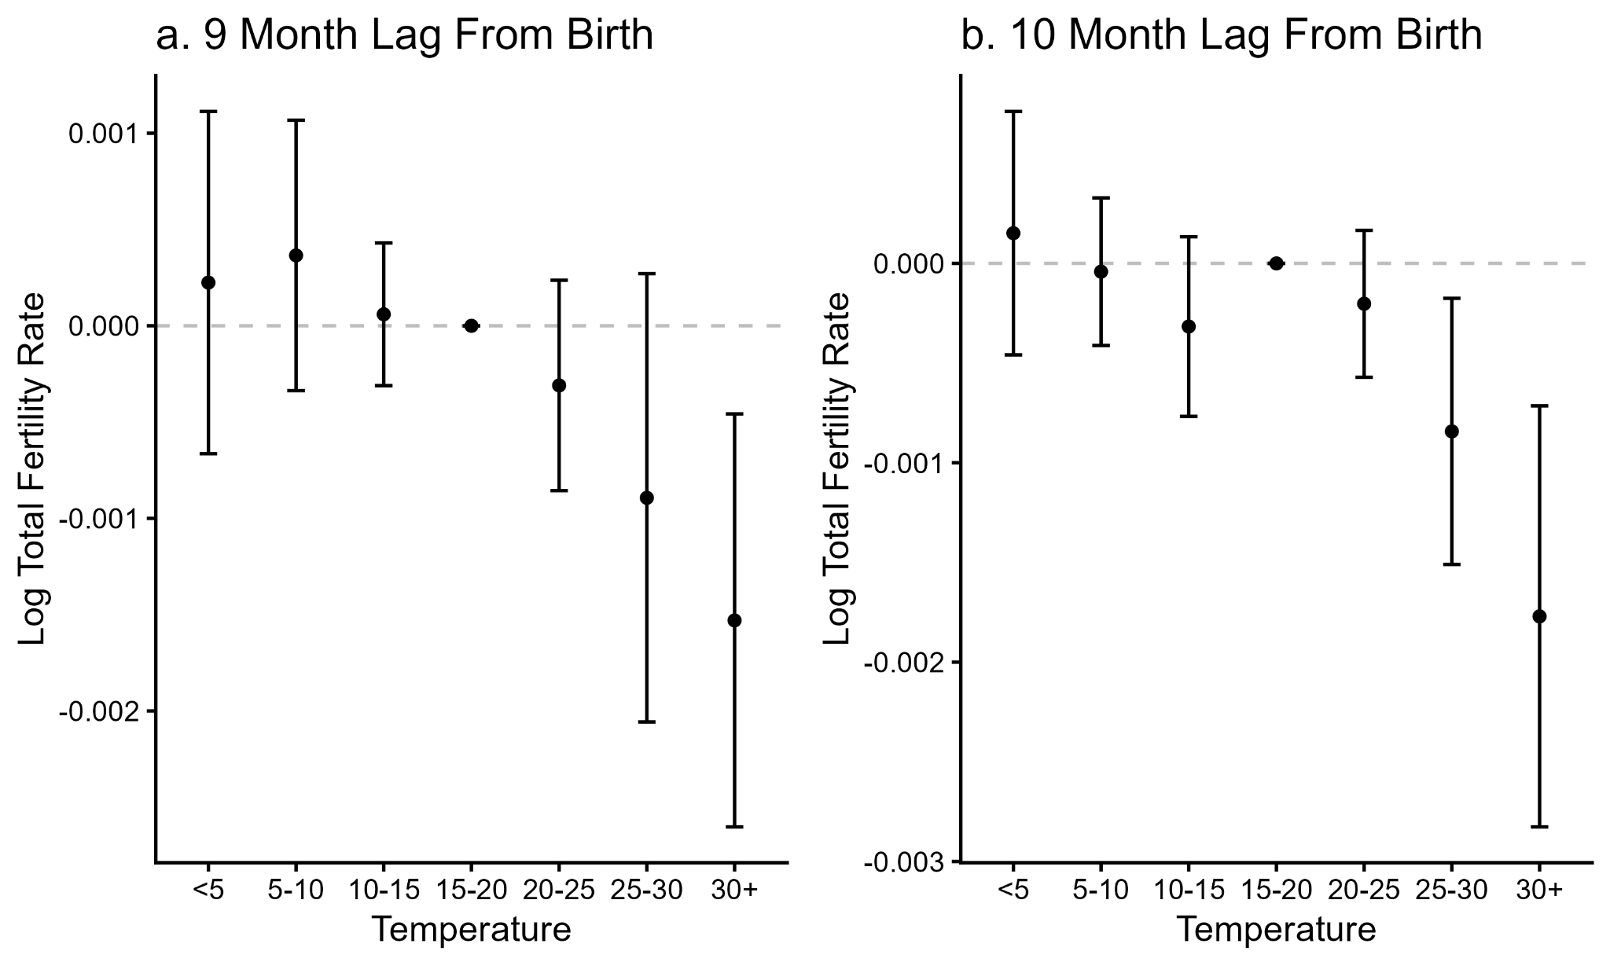
Figure S6. Estimated Effect of All Daily Temperature Bins (Maximum Temperature) Compared to a Day of Maximum Temperature 15- 20°C on 9- and 10-month lagged log TFR. Note: data derived from INSEE and Copernicus Climate Data Store (Cornes et al. 2018). Includes 22 French Regions in years 1975-2020.

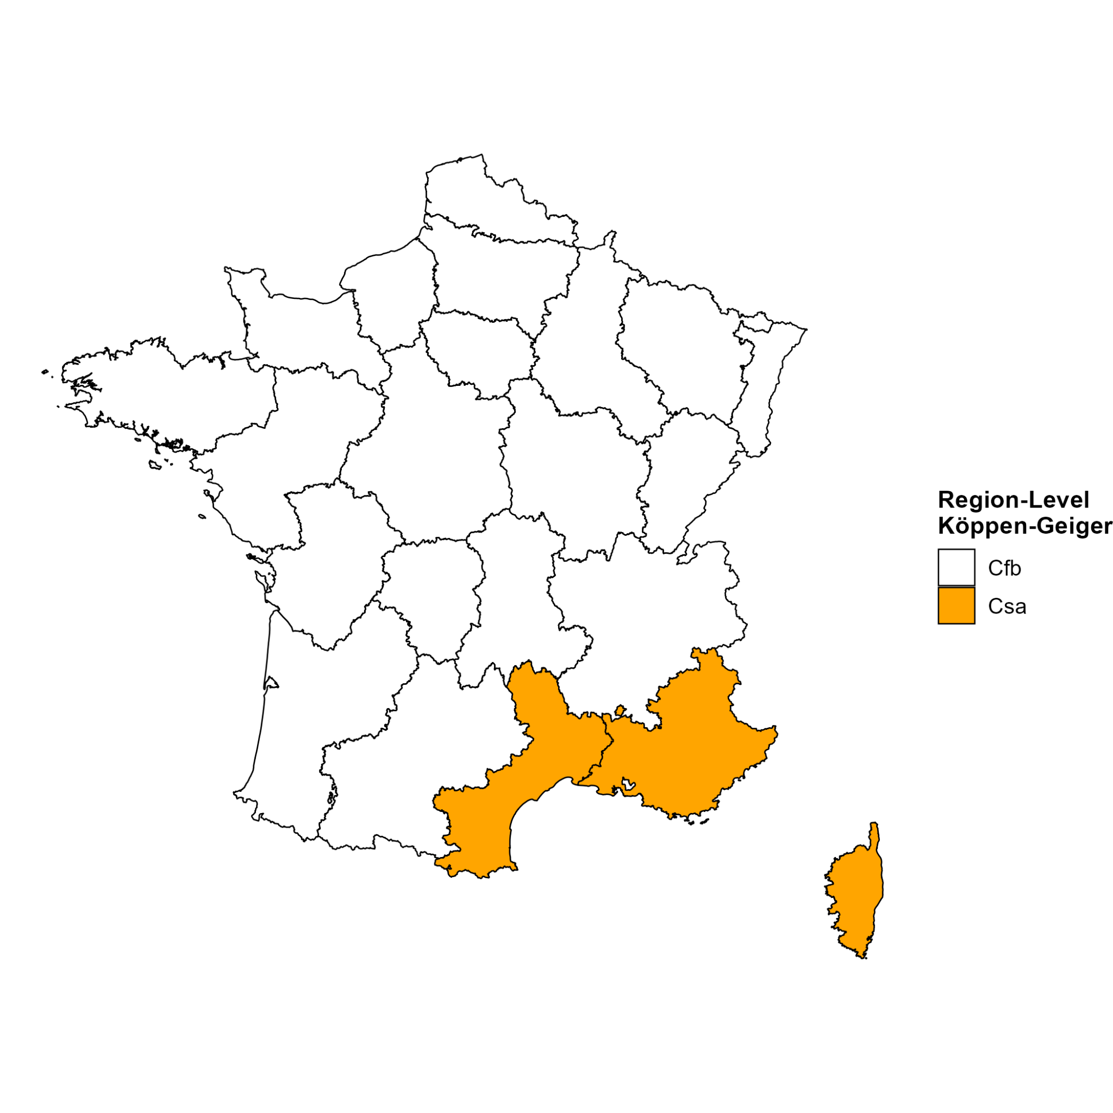
Figure S7. Region Level Koppen-Geiger classifications
Note: Based on Beck et al. (2018) and Strohmenger (2024). Climates of Provence-Alpes-Côte d'Azur and Rhône-Alpes are also influenced by Alp mountains (climates ET, Dfc, Dfb). Due to the regional granularity of the TFR measure, we prioritize the climate of major population centers in each region to reach a region-level classification.

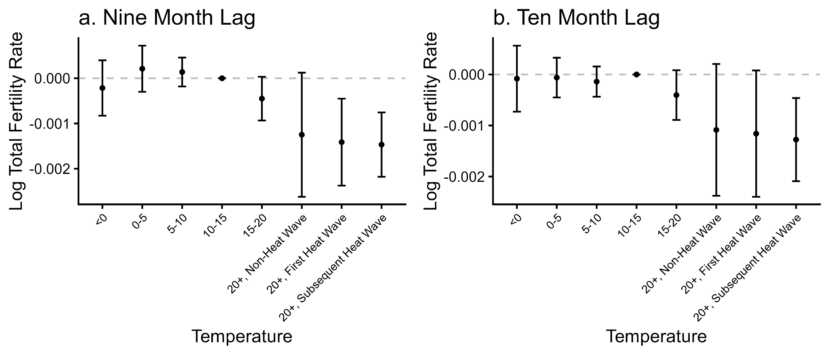
Figure S8. Estimated Effect of Heat Wave Versus Non Heat Wave Days on 9-month lagged log TFR. Includes 22 French Regions in years 1975-2020. Note: number of first heat wave days in sample: 3831. Number of subsequent heat wave days in sample: 14180

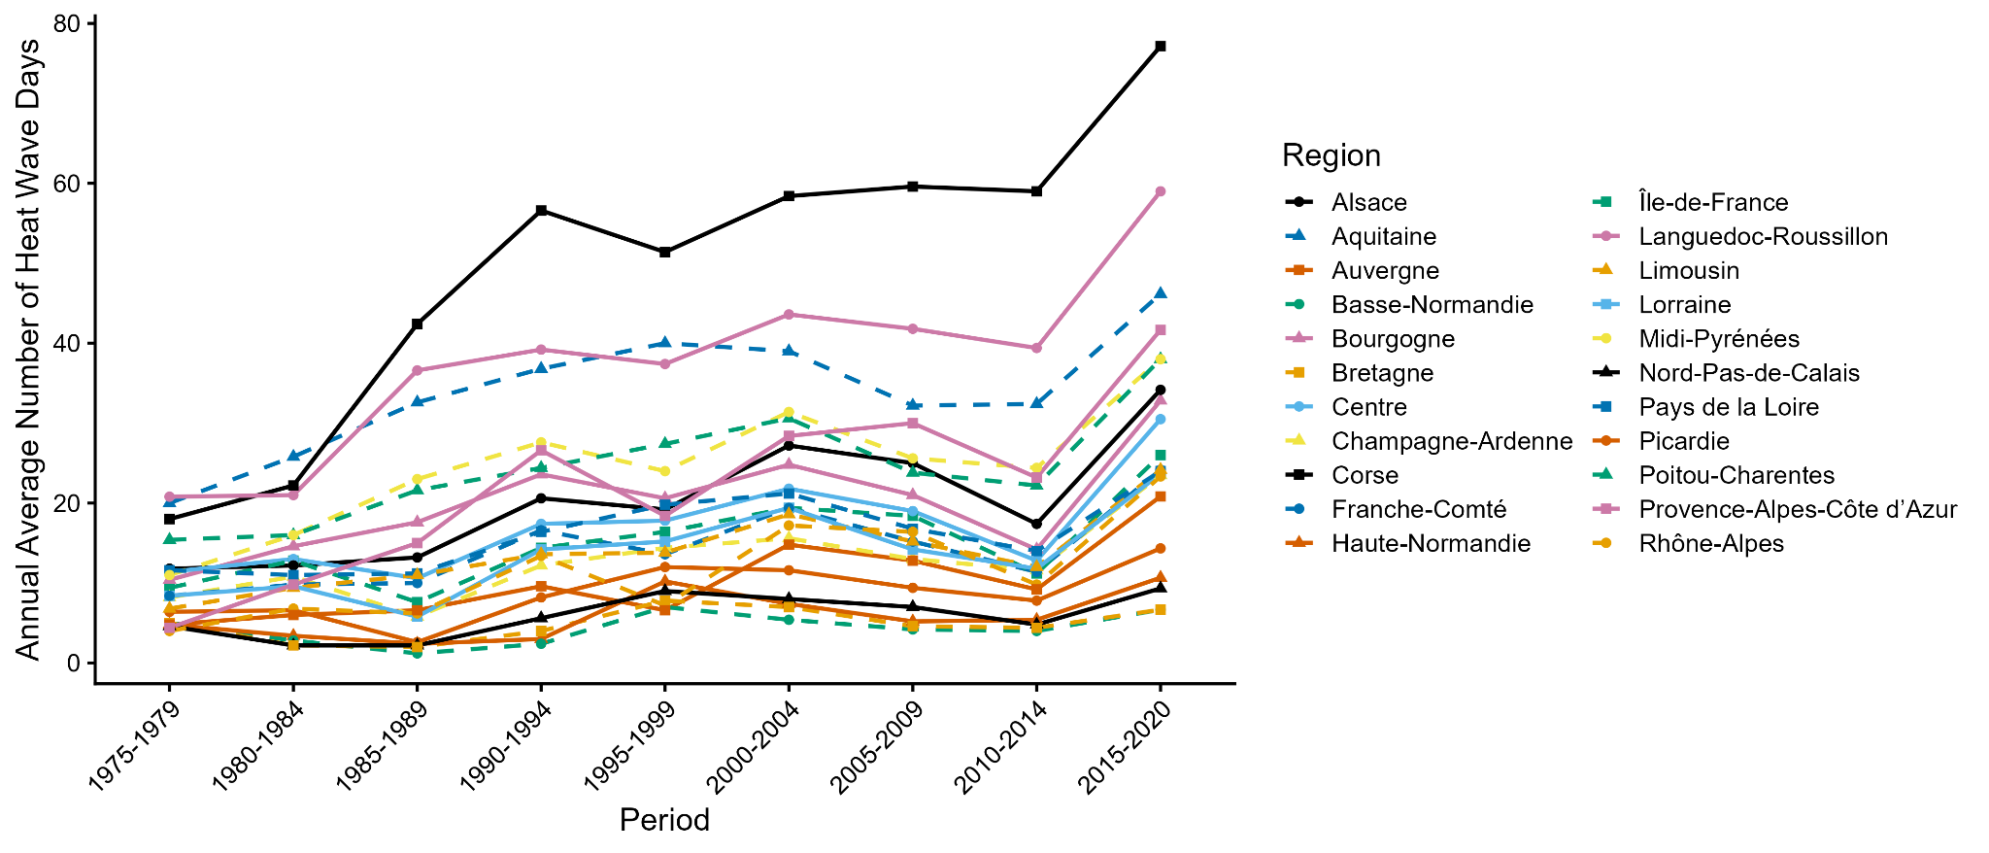
Figure S9: Days Above 20C With At Least Two Previous Days Also Above 20C (Heat Wave Days, as Defined Results of Figure 8) per Year by Five Year Average. Note: data is sourced from Copernicus Climate Data Store (Cornes et al. 2018).
Table S1. The Relationship of Heat and Fertility Over Time: Interaction Model Results
 | Interaction Coefficients
Day ≥ 25°C Month of Birth *Period 2  (Ref: Period 1) | -0.0007  (0.0015)
Day ≥ 25°C Month of Birth *Period 3  (Ref: Period 1) | 0.0011  (0.0021)
Day ≥ 25°C Lag 1 Month*Period 2  (Ref: Period 1) | 0.0030  (0.0029)
Day ≥ 25°C Lag 1 Month*Period 3  (Ref: Period 1) | 0.0022  (0.0024)
Day ≥ 25°C Lag 9 Months*Period 2  (Ref: Period 1) | -0.00003  (0.0016)
Day ≥ 25°C Lag 9 Months*Period 3  (Ref: Period 1) | -0.0003  (0.0014)
Day ≥ 25°C Lag 10 Months*Period 2  (Ref: Period 1) | 0.0014  (0.0026)
Day ≥ 25°C Lag 10 Months*Period 3  (Ref: Period 1) | -0.0002  (0.0010)
Day 20-25°C Month of Birth *Period 2  (Ref: Period 1) | -0.0004  (0.0004)
Day 20-25°C Month of Birth *Period 3  (Ref: Period 1) | -0.0003  (0.0005)
Day 20-25°C Lag 1 Month*Period 2  (Ref: Period 1) | -0.0008  (0.0005)
Day 20-25°C Lag 1 Month*Period 3  (Ref: Period 1) | -0.0001  (0.0004)
Day 20-25°C Lag 9 Months*Period 2  (Ref: Period 1) | 0.0003  (0.0004)
Day 20-25°C Lag 9 Months*Period 3  (Ref: Period 1) | 0.0005  (0.0006)
Day 20-25°C Lag 10 Months*Period 2  (Ref: Period 1) | -0.0002  (0.0005)
Day 20-25°C Lag 10 Months*Period 3  (Ref: Period 1) | 0.0012  (0.0007)

Note: Coefficients are displayed and standard errors in parentheses are displayed. Significance levels are displayed as *p<0.05, **p<0.01 and ***p<0.001.

Table S2. The Relationship of Heat and Fertility Over Space: Interaction Model Results
 | Interaction Coefficients
Day <0 °C Lag 9 Months *Mediterranean  (Ref: Non-Mediterranean) | -0.00108***  (0.00030)
Day 0-5°C Lag 9 Months *Mediterranean  (Ref: Non-Mediterranean) | -0.00062  (0.00052)
Day 5-10°C Lag 9 Months *Mediterranean  (Ref: Non-Mediterranean) | 0.00030  (0.00021)
Day 15-20°C Lag 9 Months *Mediterranean  (Ref: Non-Mediterranean) | 0.00010  (0.00039)
Day 20-25°C Lag 9 Months *Mediterranean  (Ref: Non-Mediterranean) | -0.00037  (0.00033)
Day ≥ 25°C Lag 9 Months *Mediterranean  (Ref: Non-Mediterranean) | 0.00069  (0.00069)
Day <0°C Lag 10 Months *Mediterranean  (Ref: Non-Mediterranean) | -0.00051  (0.00029)
Day 0-5°C Lag 10 Months *Mediterranean  (Ref: Non-Mediterranean) | -0.00022  (0.00031)
Day 5-10°C Lag 10 Months *Mediterranean  (Ref: Non-Mediterranean) | -0.00033*  (0.00017)
Day 15-20°C Lag 10 Months *Mediterranean  (Ref: Non-Mediterranean) | -0.00019  (0.00016)
Day 20-25°C Lag 10 Months *Mediterranean  (Ref: Non-Mediterranean) | -0.00064  (0.00043)
Day ≥ 25°C Lag 10 Months *Mediterranean  (Ref: Non-Mediterranean) | -0.00316***  (0.00094)

Note: Coefficients are displayed and standard errors in parentheses are displayed. Significance levels are displayed as *p<0.05, **p<0.01 and ***p<0.001.

