SUPPLEMENTAL MATERIAL
SI.1. Survey questions (n=16)

1. Have you experienced any of the following types of flooding? [SELECT ALL THAT APPLY]: Tidal flooding | Flooding from storm surge during severe weather events such as tropical storms, hurricanes, or nor’easters | Flooding from heavy rain | Don’t know | Refused
2. Which of the following have you experienced due to flooding in your community? [SELECT ALL THAT APPLY]: Difficulty commuting to work | Had to cancel doctors or other appointments | School delays or closures | Business delays or closures | Damage to personal vehicle | Damage to your home | Yard or tree damage | Damage to personal items in your home | Negative impact on your home’s value | Difficulty in getting homeowners insurance | Neighbors selling their homes and moving away | Neighbors renting their homes and moving away | More rundown and neglected properties in your area | Increased crime | Some other issue (please specify) | None of these | Don’t know | Refused
3. This is a list of concerns that might push you away from your community or prompt you to permanently relocate due to coastal flooding. On a scale from 1 to 5, with one being “least important” and five being “most important,” please rate each of the following concerns: Repetitive tidal flooding | Minor flooding of any type | Localized rainfall flooding | Occasional flooding from storm surges | Significant flooding from a combination of sources | Disastrous hurricane flooding | Damage to your home | Damage to your vehicle | Difficulty commuting to work | Difficulty accessing amenities and services | Having to cancel doctors and other appointments | Increased anxiety and stress | Frequent closures of local businesses | Frequent workplace closures | Frequent school closures and delays | Neighbors, friends, and family moving away | Increase in abandoned properties | Increase in crime | Higher insurance rates | Higher taxes | Higher costs of living | Declining property value | Decreased local revenues with impacts on services | Diminished investment in the community
4. Below is a list of concerns that might attract or pull you toward a new location if you decide to permanently relocate from your community due to coastal flooding. On a scale from 1 to 5, with one being “least important” and five being “most important,” please rate each of the following concerns: To be outside FEMA’s flood plain (Federal Emergency Management Agency) | To be on an elevated location | To be away from any waterways | To be in an area with physical flood protections such as levees, floodgates, or seawalls | To be in an area without any prior flooding | To be in an area without any previous disasters | To be closer to family | To be closer to friends | To be closer to better schools | To be closer to better healthcare services and facilities | be closer to amenities like libraries, restaurants, and retail stores | To be closer to places of sentimental value | To be closer to the same ethnic and racial groups | To be among the like-minded people | To be among people with the same political views | To be among people with the same religious beliefs | To have more social events | To have shorter commute or less traffic congestion | To have low crime rates or better public safety |
5. Would you consider permanently relocating from your home due to coastal flooding? [SELECT ONE]: Yes | No | Maybe in the future | Not sure | Refused
6. Below is a list of issues that might concern you if it becomes necessary for you to move away from your home somewhere else due to coastal flooding. On a scale from 1 to 5, with one being “least important” and five being “most important,” please rate each of the following issues: Availability of financial compensation for a home or property buyout | Ability to move together with your neighbors to a new location | Assistance in finding a new job in a new location | Free legal and technical advice on your options for moving | Offer of comparable housing in a similar community elsewhere | Offer of assistance with moving expenses | Knowing that your property would be permanently converted into an open green space | Knowing that your relocation would allow for the construction of physical measures that will protect others in the community | Knowing that you could participate in the relocation decision-making process and timing of relocation | Knowing that you could work with neighbors, local officials, and other community partners on discussing relocation options | Knowing that the application process for obtaining financial compensation or buyout of your property is straightforward and transparent | Knowing that available relocation assistance will match your personal needs and priorities
7. If you had to relocate, what type of area would you prefer. Would you say … [SELECT ONE]: Rural | Urban | Suburban | Not sure | Refused
8. If you had to relocate, would you prefer … [SELECT ONE]: Same neighborhood but different home | Same community, but a different neighborhood | Same County | Same region such as the Eastern Shore or Hampton Roads | Same state | A different state | A different country | Not sure | Refused
9. Assuming you had to relocate, there might be some considerations that would play a critical role in deciding where you would like to move. On a scale from 1 to 5, with one being “least important” and five being “most important,” please rate each of the following concerns: Finding a community of people with the same political affiliation | Finding a community with progressive local policies on crime, education, community programs, etc. | Finding a community with conservative local policies on crime, education, community programs, etc. | Finding a community with a diverse population | Finding a community of people with the same ethnic and racial background | Moving to an area with strong economic development and regional growth | Moving to an area committed to preserving its cultural and historical character | Moving to an area with investments in renewable energy and other sustainable initiatives | Moving to an area with effective local leadership | Moving to an area with limited local government
10. In what year were you born? List
11. What race or ethnicity do you consider yourself? White | Black | Hispanic/Latino | Multiracial | Asian | American Indian or Alaskan Native | Native Hawaiian or Other Pacific Islander | Middle Eastern | Indian from South Asia | Other race or ethnicity (Please specify) | Not sure | Refused
12. What is the highest level of education that you have completed? Less than high school | Some high school, but no degree | Completed high school or GED equivalent | Some college, but no degree | Completed associate degree (2-year program) | Completed bachelor’s degree (4-year program) | Graduate or professional degree | Not sure | Refused
13. Which of the following best describes your current employment status … [SELECT ONE]: Employed full-time | Employed part-time | Self-employed | Unemployed | Homemaker | Retired | Other | Not Sure | Refused
14. Do you own your residence, pay rent, or have some other arrangement? [SELECT ONE]: Own | Rent | Other arrangement | Refused
15. How many years have you been living in your current residence? List
16. I am going to read you a list of categories. Please stop me when I reach the category that best describes your annual household income from all sources before taxes. [SELECT ONE]: Less than $15,000; | $15,000 to under $30,000 | $30,000 to under $50,000 | $50,000 to under $75,000 | $75,000 to under $100,000 | $100,000 or more | Not Sure | Refused

SI.2. Survey catchment area
Flooded block groups at both 1.8ft flood height and 2ft and the results are quite close. In the shapefiles I have kept block groups which are at least 10% flooded in the projection. I am giving you an estimate below and some pictures along with the data.

Flooded Percentage | VA_80% | VA_50% | MD_80% | MD_50%
Block Group Count | 102 | 222 | 26 | 52
Count of Houses | 55,816 | 118,568 | 23,755 | 41,779
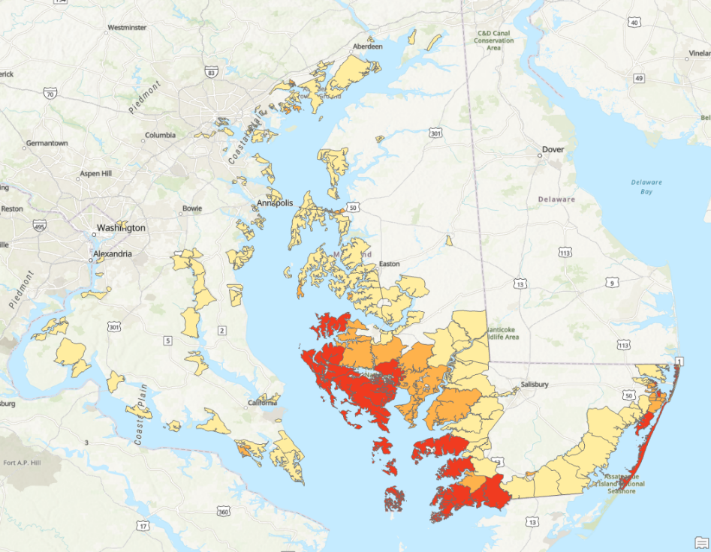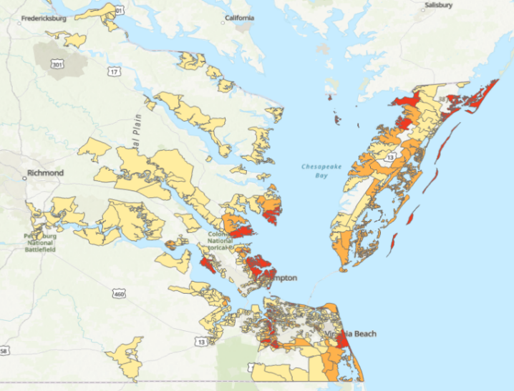
Figure A.1. Catchment area composed of census block groups located on the Eastern Shore in Maryland and Hampton Roads in Virginia. Areas marked have more than 80% of block groups in floodplain, in orange 50-80%, and yellow 10-50% (maps were prepared by XXX).

SI.3. Survey data collection strategy

TELEPHONE CALL LOG
Final Disposition Code Total Status
Completed survey 190 Number retired
Refused to participate 561 Number retired
Immediate hang‐up 154 Returned to queue
Scheduled callback 34 Returned to queue
No answer 1,546 Returned to queue
Busy signal 256 Returned to queue
Voicemail / Answering machine 16,093 Returned to queue
Unsafe location for call (cellphone user) 6 Returned to queue
Unable to participate due to health problem 36 Number retired
Respondent out of target area 209 Number retired
Respondent out of age range (cellphone) 17 Number retired
Business phone 419 Number retired
Total Telephone Numbers Purchased: 19,521
Cooperation Rate: 25.3% = Completes / (Completes + Refusals)
SI.4. Spearman correlations

Table 4.1. Spearman’s correlations between push factors and willingness to relocate.
PUSH FACTORS | Correlation coefficient & significance level (***p < 0.001, **p < 0.01)
Repetitive tidal flooding | 0.4338***
Minor flooding of any type | 0.2478***
Localized rainfall flooding | 0.1279
Occasional flooding from storm surges | 0.3184***
Significant flooding from a combination of sources | 0.4783***
Disastrous hurricane flooding | 0.3325***
Damage to your home | 0.3143***
Damage to your vehicle | 0.3201***
Difficulty commuting to work | 0.2859***
Difficulty accessing amenities and services | 0.3654***
Having to cancel doctors and other appointments | 0.3096***
Increased anxiety and stress | 0.3789***
Frequent closures of local businesses | 0.3687***
Frequent workplace closures | 0.3670***
Frequent school closures and delays | 0.3721***
Neighbors, friends, and family moving away | 0.3423***
Increase in abandoned properties | 0.3814***
Increase in crime | 0.2626***
Higher insurance rates | 0.2932***
Higher taxes | 0.2101**
Higher costs of living | 0.2957***
Declining property value | 0.2415***
Decreased local revenues with impacts on services | 0.2445***
Diminished investment in the community | 0.2918***

Table 4.2. Spearman’s correlations between pull factors and willingness to relocate.
PULL FACTORS | Correlation coefficient & significance level (***p < 0.001, **p < 0.01)
To be outside FEMA’s flood plain | 0.4594***
To be on an elevated location | 0.3605***
To be away from any waterways | 0.3228***
To be in an area with physical flood protections | 0.3367***
To be in an area without any prior flooding | 0.4105***
To be in an area without any previous disasters | 0.3158***
To be closer to family | 0.0062
To be closer to friends | 0.0524
To be closer to better schools | 0.2295***
To be closer to better healthcare services and facilities | 0.2633***
To be closer to amenities like libraries and restaurants | 0.3263***
To be closer to place of sentimental value | 0.2368***
To be closer to the same ethnic and racial groups | 0.1232
To be among the like-minded people | 0.1924**
To be among people with the same political views | 0.1240
To be among people with the same religious beliefs | 0.0876
To have more social events | 0.3541***
To have shorter commute or less traffic congestion | 0.2685***
To have low crime rates or better public safety | 0.2145**
Table 4.3. Spearman’s correlations between intervening factors and willingness to relocate.
INTERVENING FACTORS | Correlation coefficient & significance level  (***p < 0.001, **p < 0.01)
Availability of financial compensation for a home or property buyout | 0.3252***
Ability to move together with neighbors to a new location and at the same time | 0.1565
Assistance in finding a new job in a new location | 0.2781***
Free legal and technical advice on your options for moving | 0.3936***
Offer of comparable housing in a similar community elsewhere | 0.2491***
Offer of assistance with moving expenses | 0.1859**
Knowing that your property would be permanently converted into an open green space | 0.1325
Knowing that your relocation would allow for the construction of physical measures that will protect others in the community | 0.2848***
Knowing that you could participate in the relocation decision-making process and timing of relocation | 0.2750***
Knowing that you could work with neighbors, local officials, and other community partners on discussing relocation options | 0.2917***
Knowing that the application process for obtaining financial compensation or buyout of your property is straightforward and transparent | 0.2805***
Knowing that available relocation assistance will match your personal needs and priorities | 0.2356***

Table 4.5. Spearman’s correlations between reasons driving selection of relocation destinations and willingness to relocate.
REASONS FOR SELECTION OF RELOCATION DESTINATION | Correlation coefficient & significance level  (***p < 0.001, **p < 0.01)
Finding a community of people with the same political affiliation | 0.1115
Finding a community with progressive local policies on crime, education, community programs, etc. | 0.3056***
Finding a community with conservative local policies on crime, education, community programs, etc. | -0.0955
Finding a community with a diverse population | 0.1195
Finding a community of people with the same ethnic and racial background | 0.0562
Moving to an area with strong economic development and regional growth | 0.1322
Moving to an area committed to preserving its cultural and historical character | 0.0646
Moving to an area with investments in renewable energy and other sustainable initiatives | 0.3115***
Moving to an area with effective local leadership | 0.2829***
Moving to an area with limited local government | 0.0640

SI.5. Regression results in predicted probabilities
Table 5.1. Ordinal logistic regression model of willingness to relocate showing average marginal effects, expressed as changes in predicted probabilities.
Predictor | No | Unsure | Yes
Significant flooding from combined sources | −6.8 | +2.2 | +4.5
Neighbors, friends, and family moving away | −8.3 | +2.7 | +5.6
Frequent school closures and delays | −7.1 | +2.3 | +4.8
Frequent closures of local businesses | −6.5 | +2.1 | +4.3
Decreased local revenues affecting services | +6.4 | −2.1 | −4.3
To be outside the FEMA’s floodplain | −7.7 | +2.5 | +5.2
To be closer to friends | +10.7 | −3.5 | −7.2
Free legal & technical advice on moving options | −9.1 | +3.0 | +6.1
Finding community with conservative policies (Q09_03) | +7.1 | −2.3 | −4.8

