Supplementary Figure 1. Predicted probabilities of expecting a(nother) child by work characteristics, race/ethnicity. Women with no children.
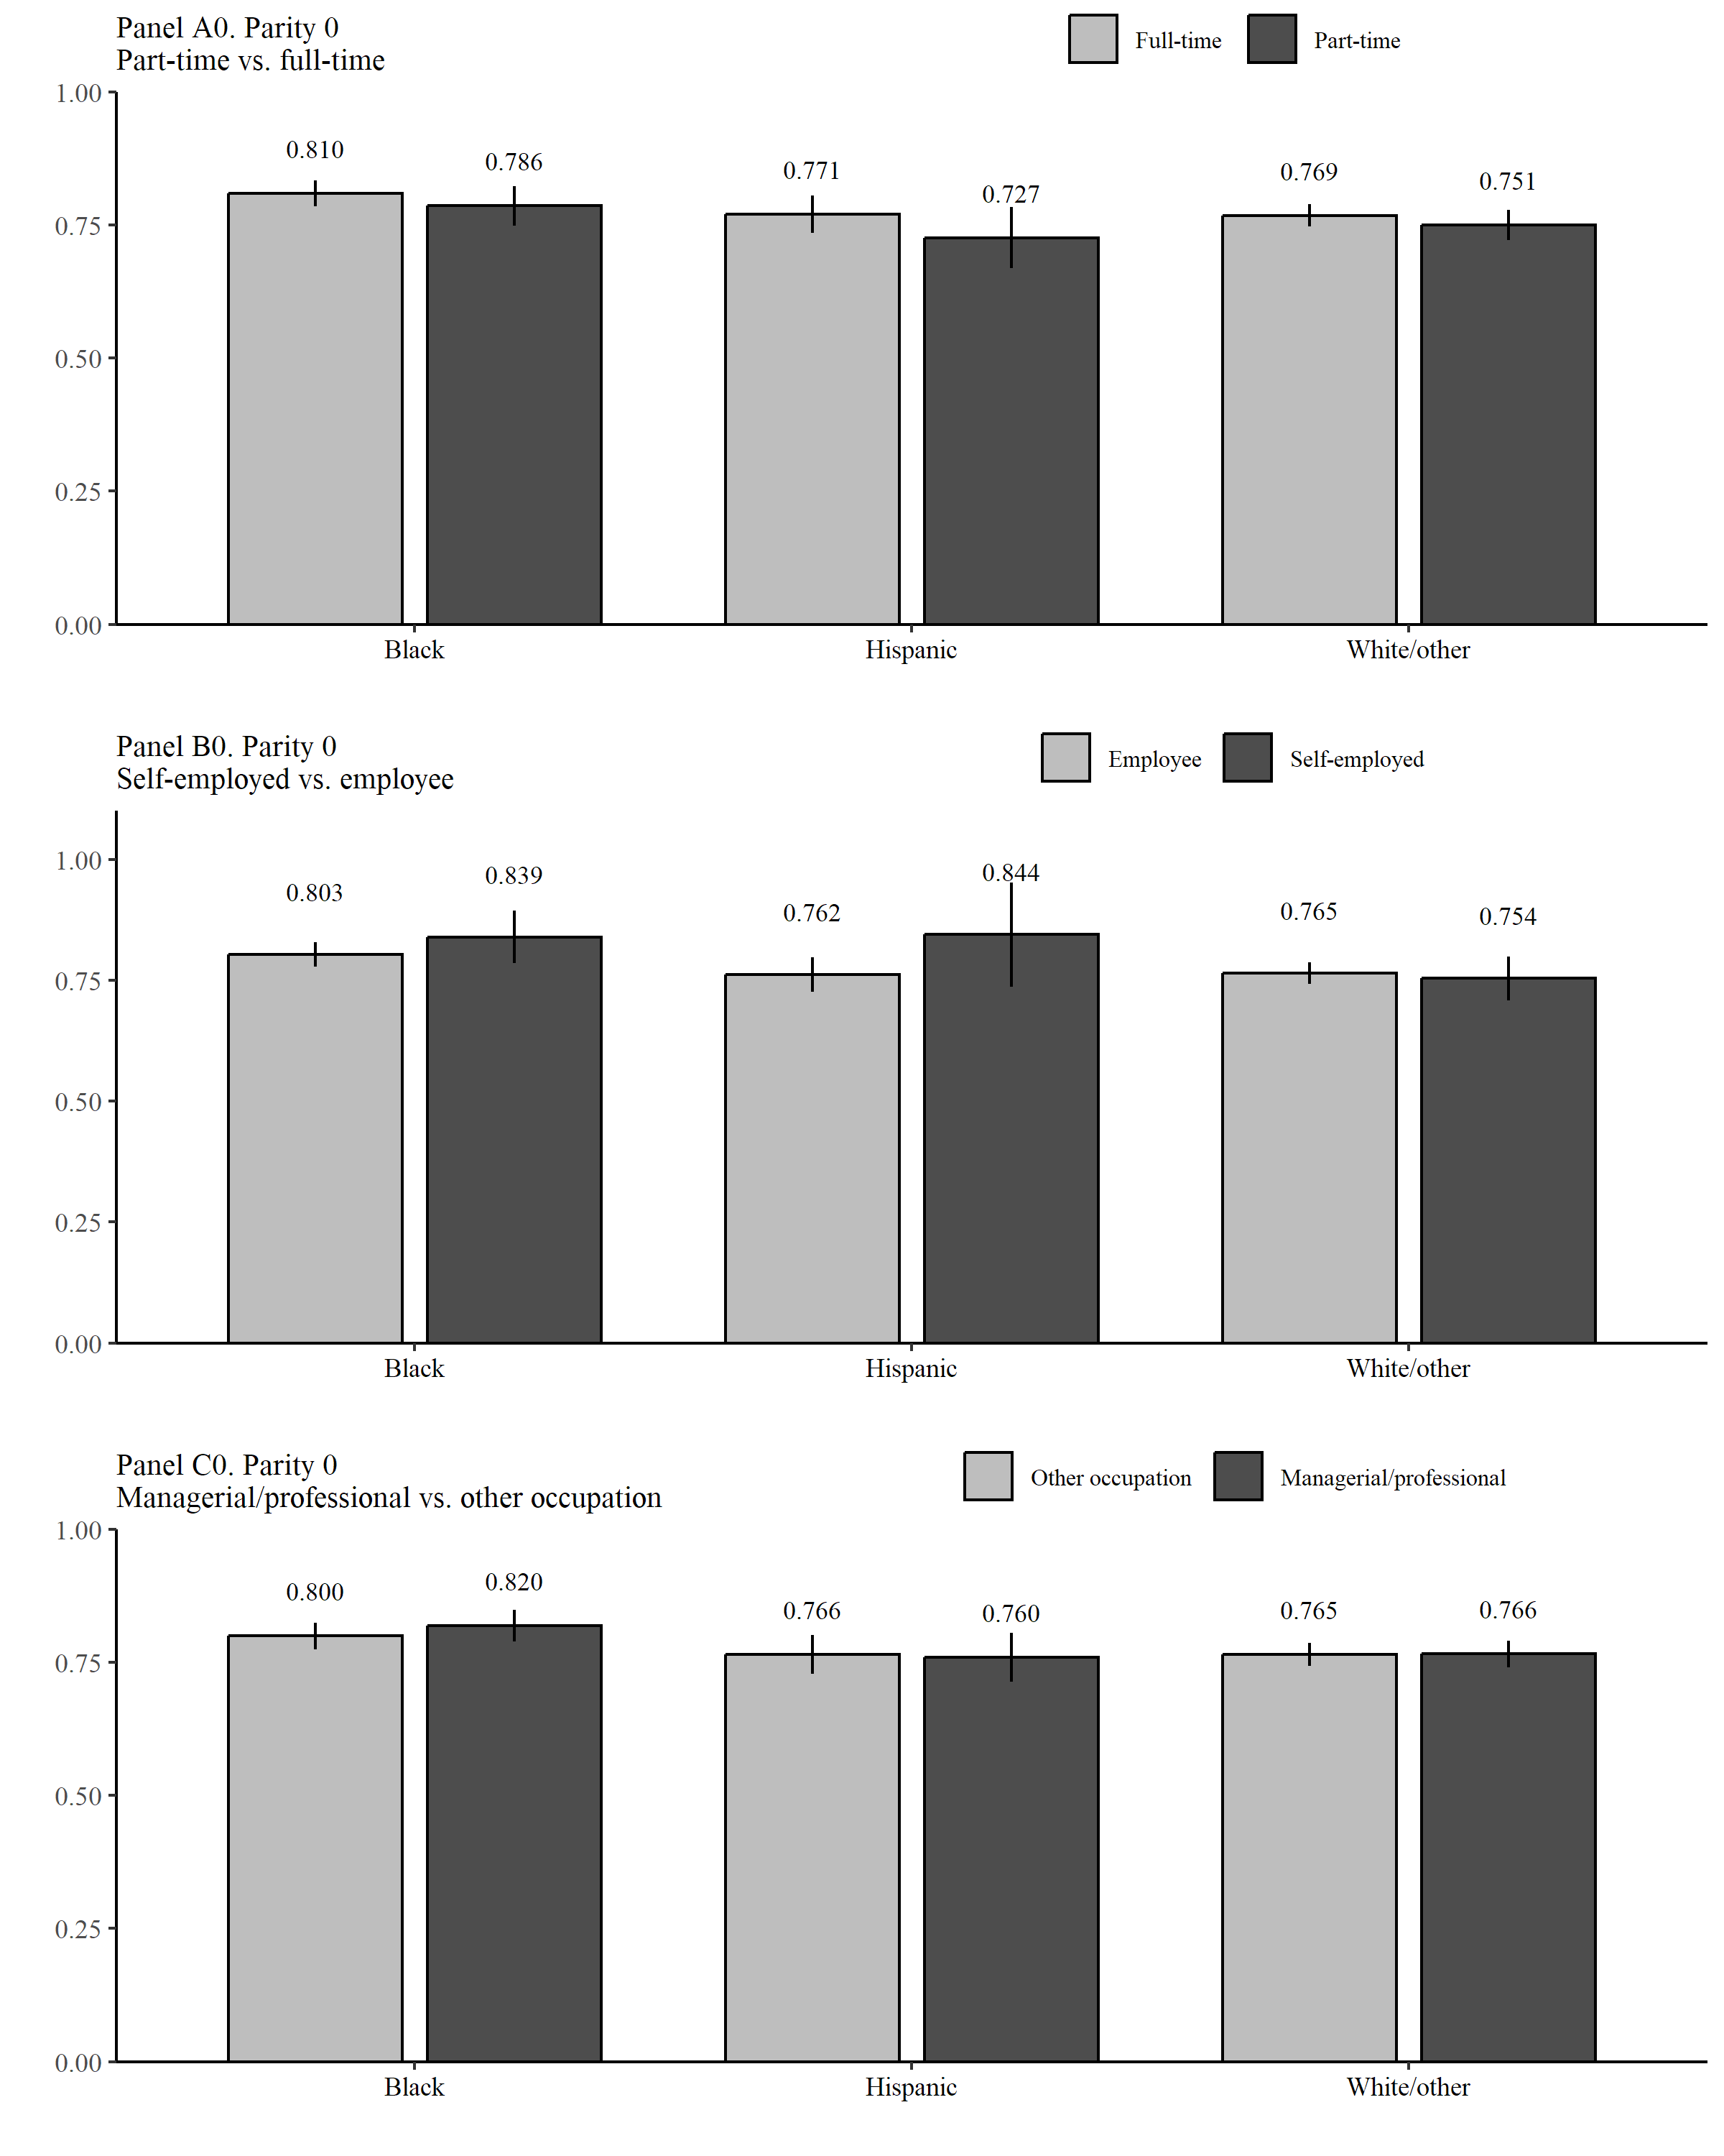
Hispanic vs White/other p<0.098
p<0.077
p<0.097

Supplementary Figure 1. Women with one child.
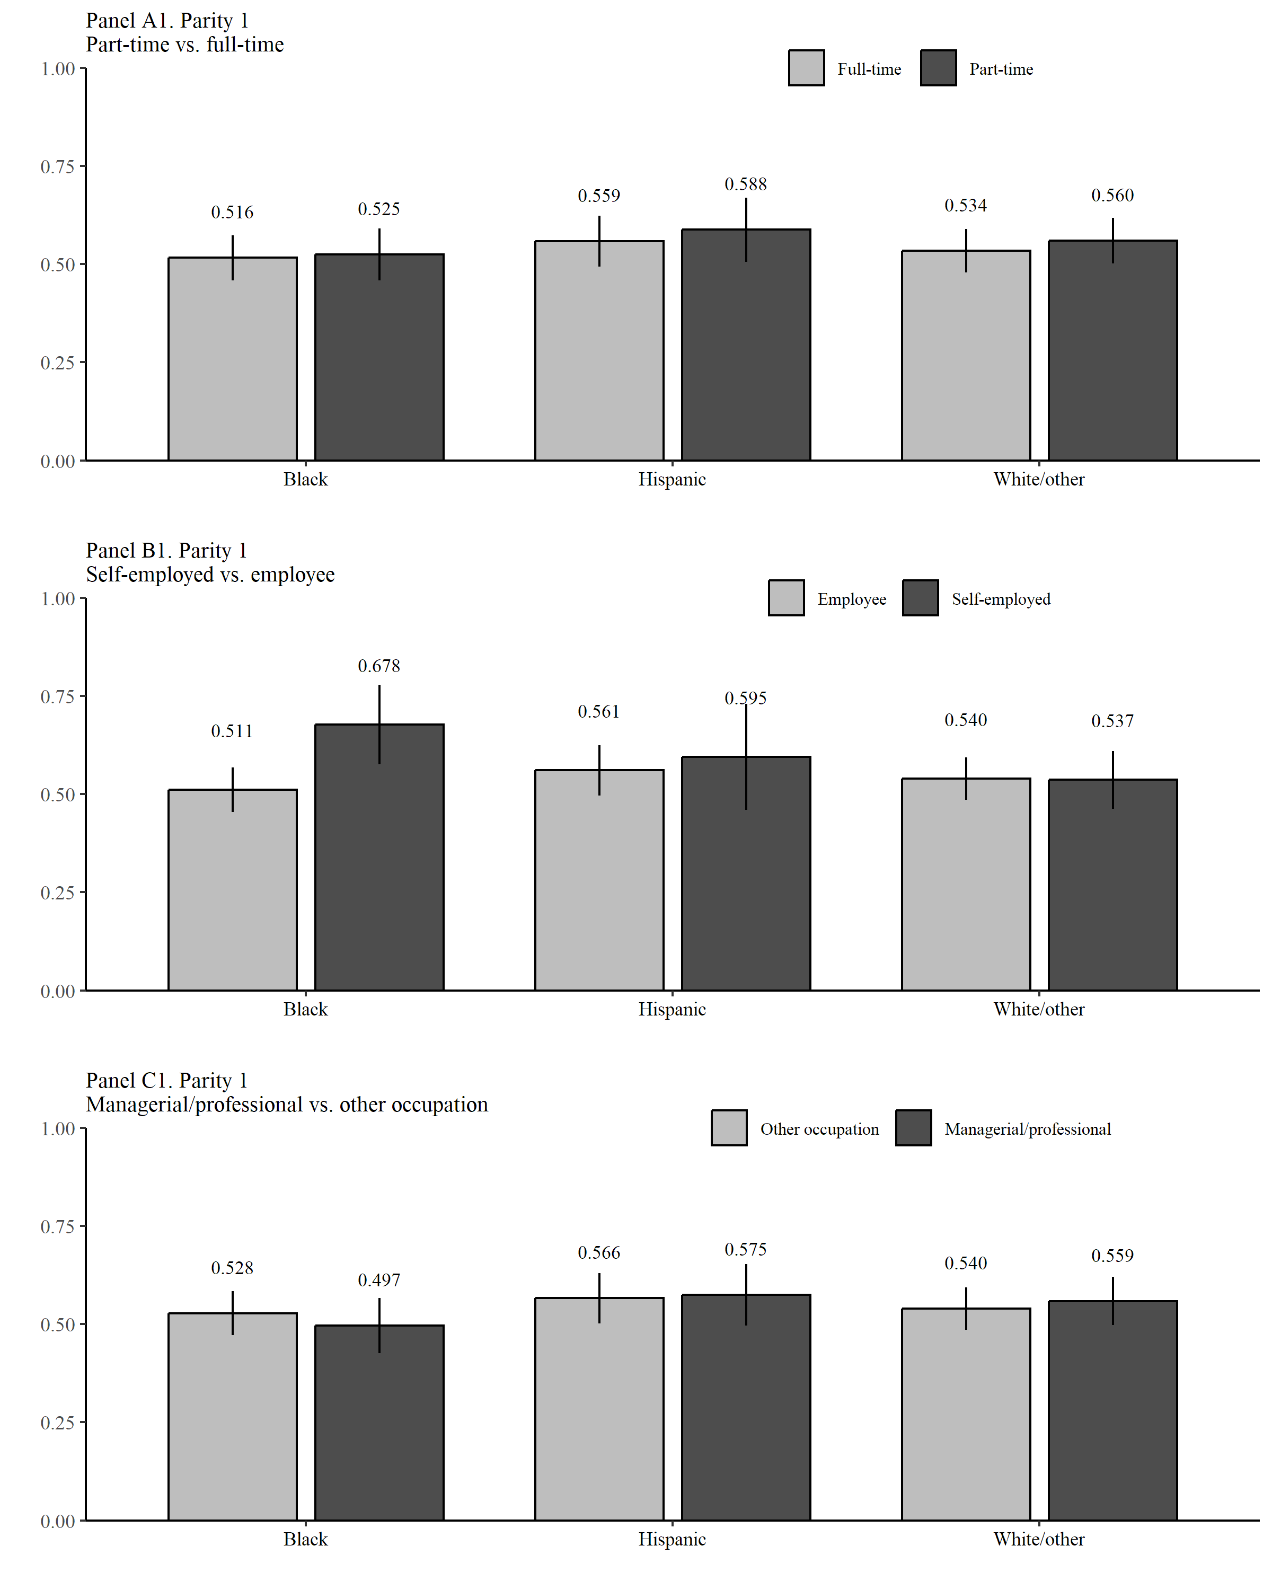
Black vs White/other p<0.079
Black vs White/other p<0.002
p<0.014

Supplementary Figure 1. Women with at least two children.
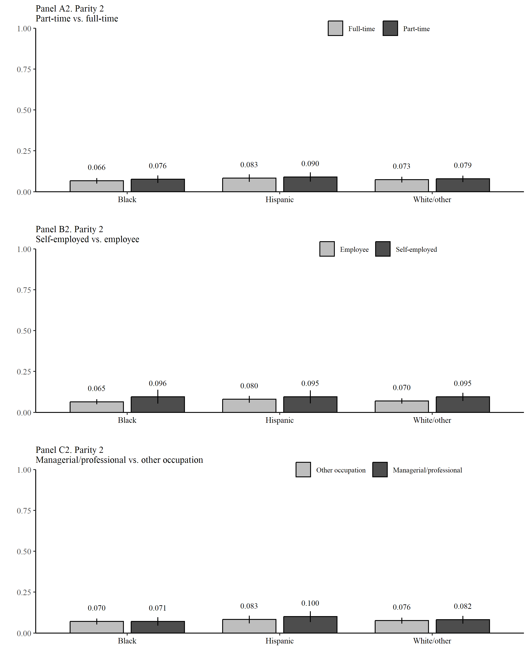 Note: Comparisons with p>.10 are not shown.
p<0.014

