ONLINE SUPPLEMENT

Self-Fulfillment and Fertility Intentions: The Interplay of Postmaterialism and Expected Welfare State Support

Table S1. Items of the Postmaterialism Scale
V1. People sometimes talk about what the aims of this country should be for the next ten years.
Listed below are some of the goals that different people might give top priority to.
Please indicate which one you consider the most important, and which one you consider the second most important.
1. | A high level of economic growth
2. | Making sure this country has strong defense forces
3. | Giving people more say in important decisions in business and in government
4. | Trying to make our cities and countryside more beautiful

V2. Now please tell me which of the following goals you consider most important.
Again, indicate your first and second choice.
1. | Maintaining order in the nation
2. | Giving people more say in important government decisions
3. | Fighting rising prices
4. | Protecting freedom of speech

V3. Now please tell me which of the following goals you consider most important.
As before, indicate your first and second choice.
1. | Maintaining economic stability
2. | Progress toward a less impersonal and more humane society
3. | Progress toward a society in which ideas are valued more than money
4. | Fighting crime

Note. The battery is taken from Inglehart & Abramson (1999) (see also WVS Wave 6 codebook). Inglehart, R., & Abramson, P. R. (1999). Measuring postmaterialism. American Political Science Review, 93(3), 665-677.

Table S2. Weighted Sample Characteristics by Country and Overall
 | Italy |  | Germany |  | France |  | Spain |  | Overall
 | N | % | N | % | N | % | N | % | N | %
Fertility intention (3 years)
Not intending to have a child (0) | 661 | 59.55 | 328 | 63.45 | 237 | 54.84 | 323 | 58.18 | 1550 | 59.25
Intending to have a child (1) | 449 | 40.45 | 189 | 36.55 | 196 | 45.16 | 232 | 41.82 | 1066 | 40.75
Childbearing motive (self-fulfillment)
No self-fulfillment (0) | 445 | 40.13 | 167 | 32.19 | 150 | 34.65 | 231 | 41.53 | 993 | 37.95
Self-fulfillment (1) | 665 | 59.87 | 351 | 67.81 | 283 | 65.35 | 325 | 58.47 | 1623 | 62.05
Expected welfare state support for childcare
Not expected (0) | 823 | 74.17 | 262 | 50.67 | 323 | 74.6 | 451 | 81.14 | 1859 | 71.07
Expected (1) | 287 | 25.83 | 255 | 49.33 | 110 | 25.4 | 105 | 18.86 | 757 | 28.93
Postmaterialism index (mean) | 7.02 |  | 7.2 |  | 7.25 |  | 6.73 |  | 7.03
Gender
Men (0) | 602 | 54.22 | 274 | 53.01 | 241 | 55.57 | 276 | 49.61 | 1224 | 46.78
Women (1) | 508 | 45.78 | 243 | 46.99 | 192 | 44.43 | 280 | 50.39 | 1392 | 53.22
Education
No tertiary degree (0) | 795 | 71.59 | 380 | 73.47 | 259 | 59.88 | 349 | 62.86 | 1783 | 68.17
Tertiary degree (1) | 315 | 28.41 | 137 | 26.53 | 174 | 40.12 | 206 | 37.14 | 833 | 31.83
Age class
25–29 | 579 | 52.18 | 261 | 50.49 | 229 | 52.78 | 287 | 51.74 | 1356 | 51.85
30–34 | 531 | 47.82 | 256 | 49.51 | 204 | 47.22 | 268 | 48.26 | 1260 | 48.15
Partnership
No stable partner (0) | 449 | 40.41 | 168 | 32.57 | 180 | 41.63 | 214 | 38.58 | 1012 | 38.67
Stable partner (1) | 661 | 59.59 | 349 | 67.43 | 253 | 58.37 | 341 | 61.42 | 1604 | 61.33
Employment condition
No studying, no working | 284 | 25.5 | 80 | 15.54 | 118 | 27.21 | 128 | 22.82 | 608 | 23.25
Studying | 183 | 16.43 | 82 | 15.94 | 55 | 12.71 | 99 | 17.82 | 418 | 16.01
Manager or professional | 68 | 6.15 | 24 | 4.67 | 28 | 6.53 | 27 | 4.87 | 147 | 5.65
Other self-employed | 32 | 2.92 | 23 | 4.54 | 5 | 1.14 | 24 | 4.25 | 84 | 3.23
Employee – permanent | 294 | 26.52 | 239 | 46 | 185 | 42.6 | 189 | 34 | 905 | 34.62
Employee – fixed-term | 178 | 16.1 | 55 | 10.59 | 39 | 9.15 | 65 | 11.8 | 338 | 12.95
Project-based & casual work | 71 | 6.38 | 14 | 2.71 | 3 | 0.66 | 25 | 4.44 | 116 | 4.3
Total | 1,110 | 100 | 517 | 100 | 433 | 100 | 556 | 100 | 2,616 | 100

Table S3. Logistic Regression Results for Considering Having at Least One Child a Prerequisite for a Self-Fulfilling Life by Postmaterialism and Expected Welfare State Support for Childcare Among Childless Individuals Aged 25–34, Adjusting for Control Variables
 | Coefficient | Robust SE | p
Gender (ref.: men)
Women | −0.360 | 0.097 | <.001
Education (ref.: no tertiary degree)
Tertiary degree | 0.094 | 0.102 | 0.356
Country (ref.: Italy)
Germany | 0.224 | 0.140 | 0.108
France | 0.377 | 0.138 | 0.006
Spain | −0.056 | 0.122 | 0.648
Age (ref.: 25–29 years)
30–34 years | −0.176 | 0.097 | 0.069
Partnership status (ref.: no stable partner)
Stable partner | 0.535 | 0.100 | <.001
Employment status (ref.: neither studying nor working)
Studying | 0.497 | 0.174 | 0.004
Manager or professional | 0.270 | 0.220 | 0.220
Other self-employed | 0.374 | 0.268 | 0.162
Employee: permanent contract | 0.313 | 0.137 | 0.022
Employee: fixed-term contract | 0.112 | 0.168 | 0.504
Project-based or casual work | 0.375 | 0.246 | 0.128
Postmaterialism | 0.381 | 0.167 | 0.023
Postmaterialism (quadratic term) | −0.032 | 0.012 | 0.007
Expected childcare support (ref.: not expected) | 0.999 | 1.267 | 0.430
Expected childcare support by postmaterialism | −0.248 | 0.357 | 0.488
Expected childcare support by postmaterialism (quadratic term) | 0.022 | 0.024 | 0.353
Constant | −1.101 | 0.592 | 0.063
Note. Coefficients are log-odds from a logistic regression model with robust standard errors. The outcome equals 1 when respondents report that having at least one child is necessary for a self-fulfilling life and 0 otherwise. Postmaterialism is entered linearly and quadratically. The model includes interactions between expected welfare-state childcare support and both the linear and quadratic postmaterialism terms.

Table S4. Logistic Regression Results for Intending to Have a Child Within the Next 3 Years Among Childless Individuals Aged 25–34 (N = 2,616)
 | Coefficient | Robust SE | p
Gender (ref.: men)
Women | 0.276 | 0.098 | 0.005
Education (ref.: no tertiary degree)
Tertiary degree | −0.063 | 0.103 | 0.538
Country (ref.: Italy)
Germany | −0.569 | 0.139 | <.001
France | 0.147 | 0.137 | 0.285
Spain | −0.029 | 0.128 | 0.819
Age (ref.: 25–29 years)
30–34 years | 0.129 | 0.098 | 0.187
Partnership status (ref.: no stable partner)
Stable partner | 0.986 | 0.104 | <.001
Employment status (ref.: neither studying nor working)
Studying | 0.049 | 0.185 | 0.789
Manager or professional | 0.734 | 0.225 | 0.001
Other self-employed | 0.774 | 0.278 | 0.005
Employee, permanent contract | 0.719 | 0.141 | <.001
Employee, fixed-term contract | 0.266 | 0.178 | 0.134
Project-based or casual work | 0.299 | 0.250 | 0.232
Postmaterialism | 0.288 | 0.167 | 0.085
Postmaterialism (quadratic term) | −0.023 | 0.012 | 0.053
Expected childcare support (ref.: not expected) | −1.776 | 1.318 | 0.178
Expected childcare support by postmaterialism | 0.651 | 0.365 | 0.074
Expected childcare support by postmaterialism (quadratic term) | −0.042 | 0.024 | 0.087
Constant | −2.465 | 0.604 | <.001
Note. Coefficients are log-odds from a logistic regression model with robust standard errors. The outcome equals 1 when respondents intend to have a child within the next 3 years and 0 otherwise. Postmaterialism is entered linearly and quadratically. The model includes interactions between expected welfare-state childcare support and both the linear and quadratic postmaterialism terms.

Table S5. Logistic Regression Results for Intending to Have a Child Within the Next 3 Years, Including Childbearing Relevance for Self-Fulfillment as a Predictor, Among Childless Individuals Aged 25–34 (N = 2,616)
 | Coefficient | Robust SE | p
Gender (ref.: men)
Women | 0.442 | 0.107 | <.001
Education (ref.: no tertiary degree)
Tertiary degree | −0.113 | 0.109 | 0.299
Country (ref.: Italy)
Germany | −0.720 | 0.149 | <.001
France | 0.040 | 0.146 | 0.784
Spain | −0.003 | 0.138 | 0.984
Age (ref.: 25–29 years)
30–34 years | 0.217 | 0.105 | 0.038
Partnership status (ref.: no stable partner)
Stable partner | 0.905 | 0.111 | <.001
Employment status (ref.: neither studying nor working)
Studying | −0.144 | 0.204 | 0.479
Manager or professional | 0.729 | 0.241 | 0.002
Other self-employed | 0.737 | 0.306 | 0.016
Employee, permanent contract | 0.683 | 0.151 | <.001
Employee, fixed-term contract | 0.274 | 0.185 | 0.138
Project-based or casual work | 0.174 | 0.263 | 0.508
Childbearing relevance for self-fulfillment | 1.665 | 0.118 | <.001
Postmaterialism | 0.121 | 0.167 | 0.468
Postmaterialism (quadratic term) | −0.009 | 0.012 | 0.438
Expected childcare support (ref.: not expected) | −2.498 | 1.368 | 0.068
Expected childcare support by postmaterialism | 0.864 | 0.383 | 0.024
Expected childcare support by postmaterialism (quadratic term) | −0.058 | 0.026 | 0.024
Constant | −3.040 | 0.601 | <.001
Note. Coefficients are log-odds from a logistic regression model with robust standard errors. The outcome equals 1 when respondents intend to have a child within the next 3 years and 0 otherwise. Childbearing relevance for self-fulfillment equals 1 when respondents report that having at least one child is necessary for a self-fulfilling life and 0 otherwise. Postmaterialism is entered linearly and quadratically. The model includes interactions between expected welfare-state childcare support and both the linear and quadratic postmaterialism terms.

Figure S1 – Panel A. Predicted Probability of Considering Childbearing Necessary for Self-Fulfillment by Postmaterialism, Expected Welfare State Support for Childcare, and Partnership Status
Panel A – In Stable Partnership
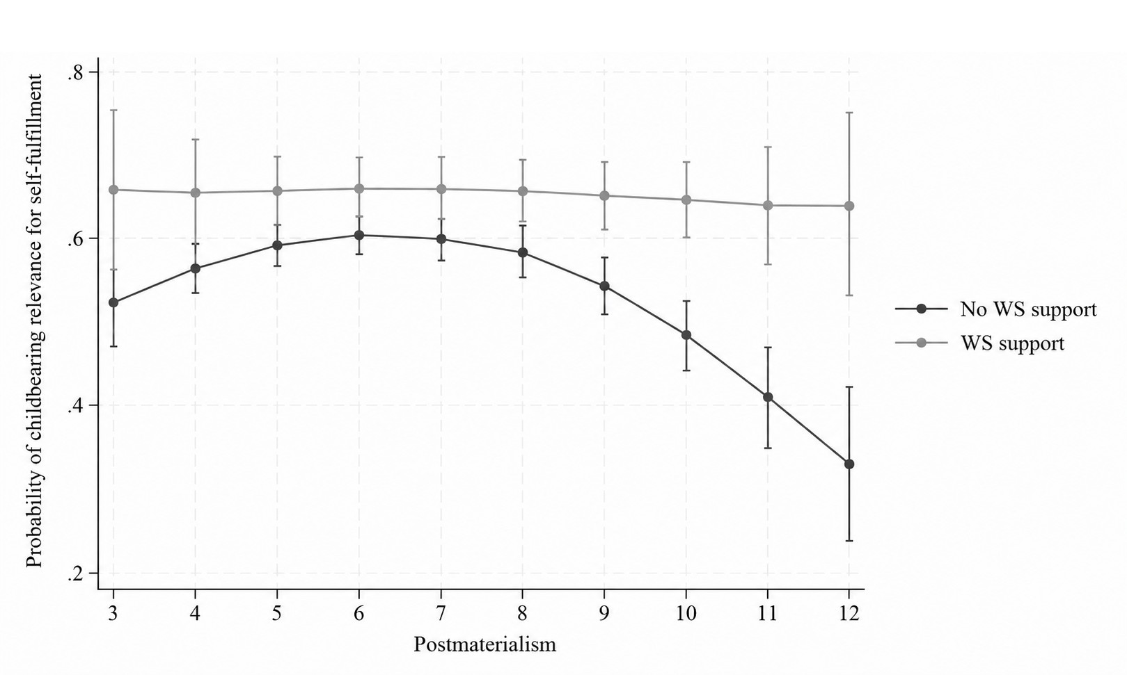
Panel B – Not in Stable Partnership
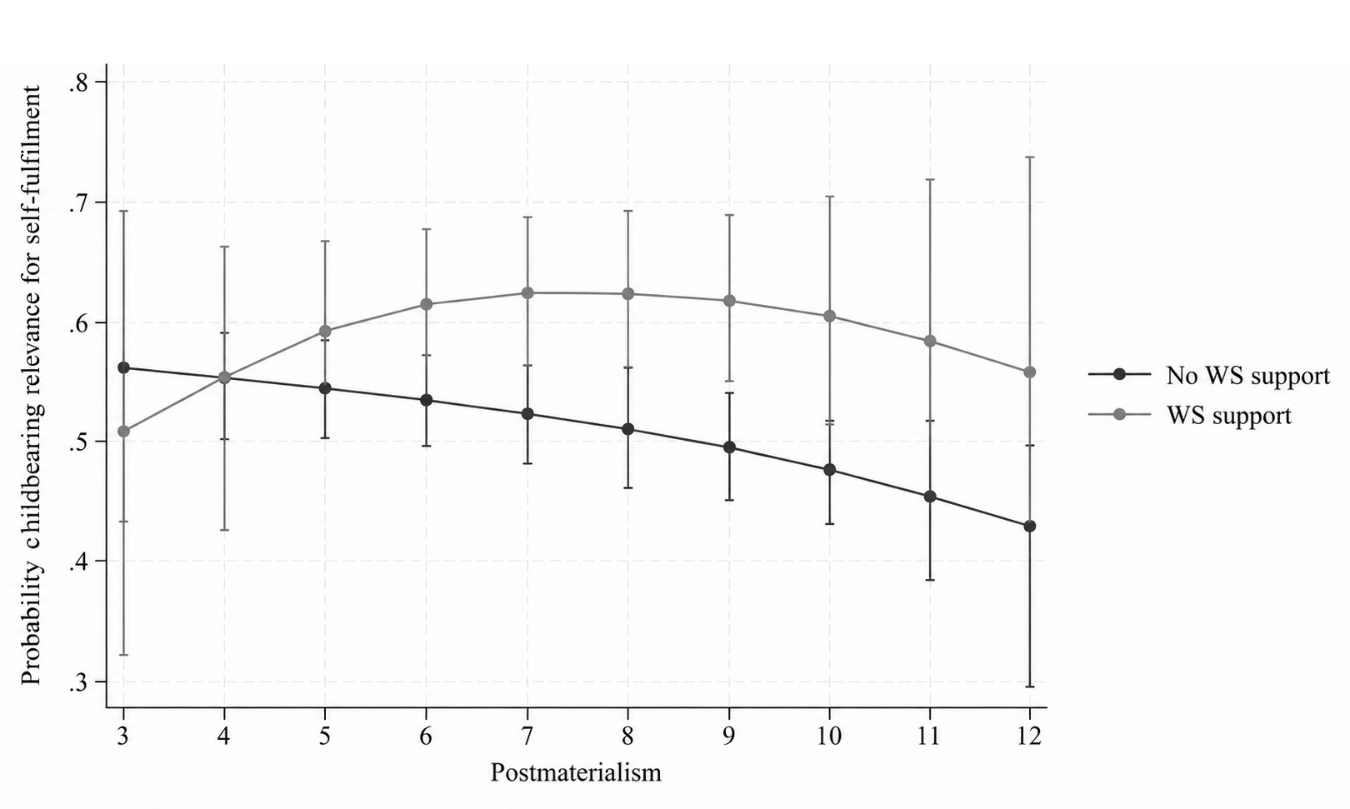
Note: Predicted probabilities are obtained from logistic regression models estimated separately by partnership status. The dependent variable equals 1 when respondents report that a fulfilled life requires at least one child, and 0 when they report that they could have a fulfilled life even without children. Models include expected welfare-state childcare support, postmaterialism entered linearly and quadratically, and their interactions. All models control for age, gender, education, employment status, and country of residence.
Table S6. Conditional Indirect Associations Between Postmaterialism and Fertility Intentions Through Childbearing Relevance for Self-Fulfillment by Expected Welfare State Support for Childcare Among Individuals in a Stable Partnership
Postmaterialism score | No WS support | 95% CI |  | WS support | 95% CI
3 | -0.805 | [-1.647, 0.038] |  | -0.160 | [-2.057, 1.737]
4 | -0.317 | [-0.844, 0.211] |  | -0.091 | [-1.299, 1.118]
5 | -0.005 | [-0.312, 0.302] |  | -0.041 | [-0.733, 0.651]
6 | 0.129 | [-0.036, 0.295] |  | -0.010 | [-0.345, 0.325]
7 | 0.087 | [0.029, 0.146] |  | 0.002 | [-0.097, 0.100]
8 | -0.132 | [-0.203, -0.060] |  | -0.006 | [-0.111, 0.099]
9 | -0.527 | [-0.792, -0.262] |  | -0.034 | [-0.416, 0.349]
10 | -1.100 | [-1.642, -0.558] |  | -0.080 | [-0.878, 0.718]
11 | -1.849 | [-2.758, -0.940] |  | -0.146 | [-1.521, 1.230]
12 | -2.775 | [-4.143, -1.406] |  | -0.231 | [-2.356, 1.894]
Note: Estimates refer to conditional indirect associations obtained from the moderated mediation model on the subsample of respondents in sable relationship. Values are reported separately for respondents who do not expect welfare-state childcare support and those who do, at each level of the postmaterialism index. Confidence intervals are based on bootstrapped standard errors. Bold values indicate estimates whose 95% confidence intervals do not include zero.

Figure S2. Bootstrapped Conditional Indirect Associations Between Postmaterialism and Fertility Intentions Through Childbearing Relevance for Self-Fulfillment by Expected Welfare State Support for Childcare Among Respondents in a Stable Partnership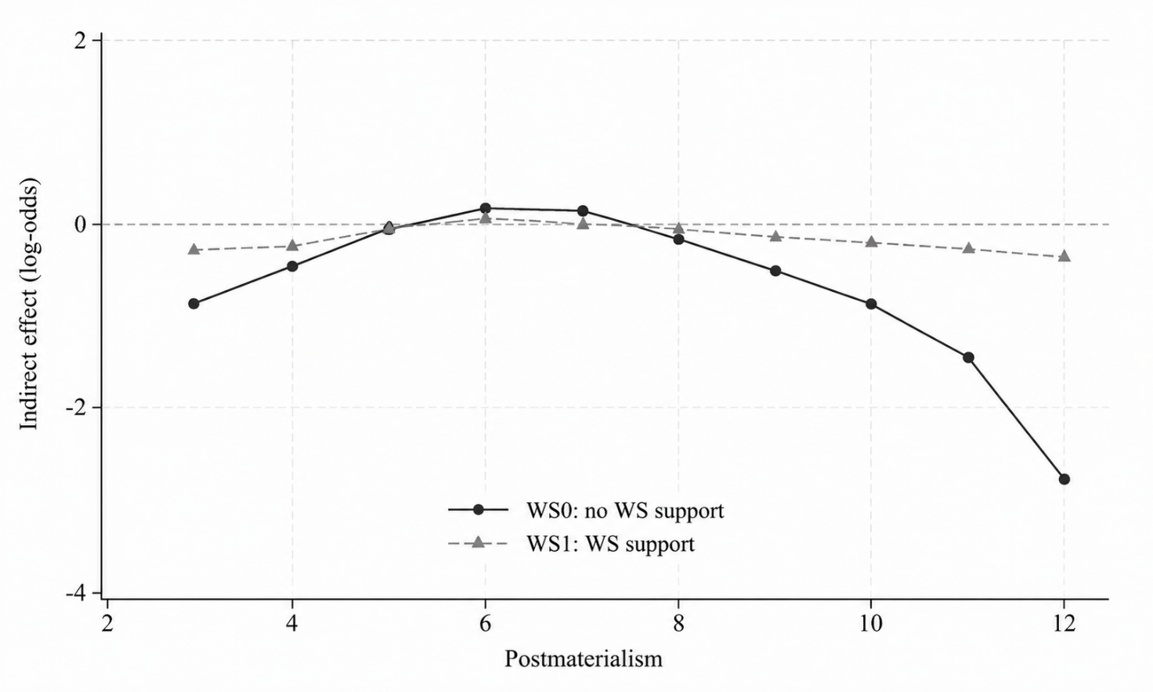
Note: Estimates are obtained from the moderated mediation model estimated among respondents with a stable partner. The figure shows conditional indirect associations at each level of the postmaterialism index, separately for respondents who do not expect welfare-state childcare support and those who do. Indirect associations are expressed in log-odds. The horizontal dashed line indicates zero.

