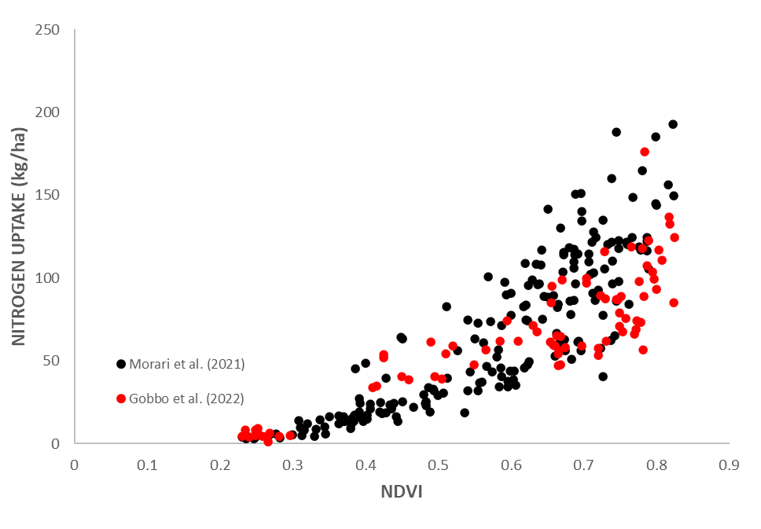
Figure S1. Comparison among NDVI to N uptake exponential relationships for winter wheat from Morari et al. (2021) and the current study.

Table S1. Calibrated genetic coefficients for the cv. Rebelde using the 2014-2016 dataset.

