Supplementary Material
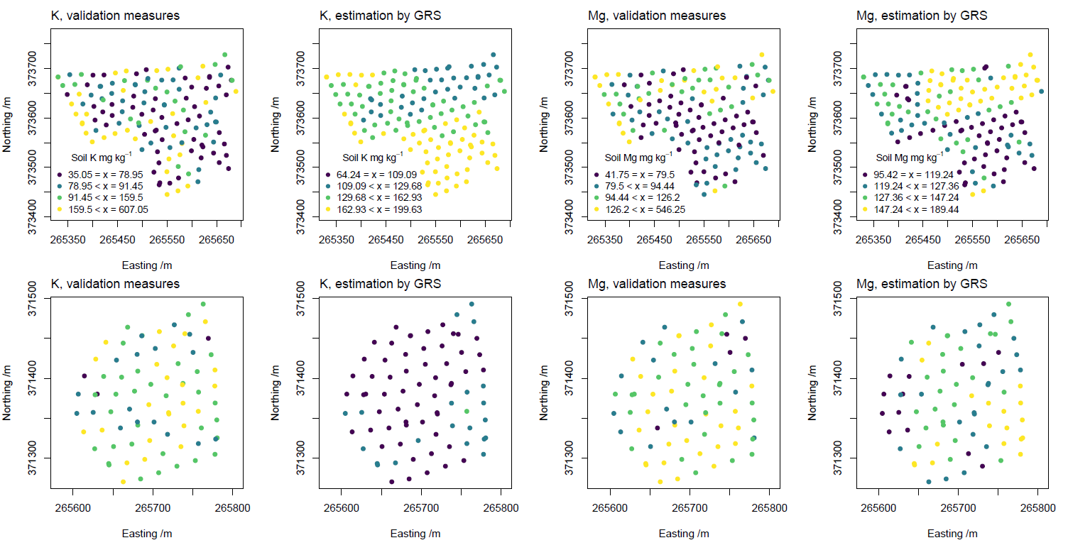
Fig. S1 Quantile classified post-maps of soil K and Mg for soil samples analysed ex situ in a centralised testing laboratory (validation measures) versus quantiles from estimated samples obtained from in situ -gamma-ray spectroscopy (GRS) across three fields (n = 95 for LL, n = 51 for ML and n = 79 for LUp, see Fig 1)
Table S1 Exploratory statistics of soil properties analysed ex situ in a centralised testing laboratory (validation data set) versus estimated soil properties obtained from in situ -gamma-ray spectroscopy across three fields (n = 95 for LL, n = 51 for ML and n = 79 for LUp, see Fig 1).
Properties | Field | Data set | Mean | SD | Max | Min | Medium
Nearest neighbour distance (m) | LL | NA | 1.42 | 0.46 | 2.51 | 0.09 | 1.46
Nearest neighbour distance (m) | ML | NA | 1.37 | 0.47 | 2.21 | 0.38 | 1.45
Nearest neighbour distance (m) | LUp | NA | 1.34 | 0.48 | 2.19 | 0.17 | 1.38
pH | LL | Validation | 6.02 | 0.39 | 7.54 | 4.95 | 6.04
pH | LL | Gamma Ray | 6.42 | 0.04 | 6.64 | 6.14 | 6.45
pH | ML | Validation | 6.42 | 0.47 | 7.62 | 5.38 | 6.38
pH | ML | Gamma Ray | 6.22 | 0.03 | 6.29 | 6.14 | 6.23
pH | LUp | Validation | 5.54 | 0.49 | 6.45 | 3.88 | 5.53
pH | LUp | Gamma Ray | 5.76 | 0.18 | 6.13 | 5.28 | 5.77
P | LL | Validation | 19.0 | 18.7 | 118 | 6.0 | 13.2
P | LL | Gamma Ray | 20.4 | 5.19 | 32.1 | 11.9 | 19.6
P | ML | Validation | 21.3 | 10.3 | 75,2 | 8.6 | 20.2
P | ML | Gamma Ray | 29.5 | 1.70 | 34.0 | 25.7 | 29.3
P | LUp | Validation | 12.5 | 6.59 | 44 | 6.2 | 10.6
P | LUp | Gamma Ray | 9.10 | 2.12 | 13.5 | 4.18 | 9.20
K | LL | Validation | 133 | 105 | 607 | 42.5 | 91.4
K | LL | Gamma Ray | 144 | 15.2 | 178 | 115 | 140
K | ML | Validation | 105 | 68 | 334 | 35 | 83
K | ML | Gamma Ray | 175 | 9.63 | 200 | 156 | 175
K | LUp | Validation | 151 | 67.1 | 369 | 72.1 | 130
K | LUp | Gamma Ray | 102 | 16.4 | 139 | 64.2 | 103
Mg | LL | Validation | 120 | 75.1 | 546 | 50 | 103
Mg | LL | Gamma Ray | 140 | 17.1 | 178 | 104 | 139
Mg | ML | Validation | 78.4 | 23.8 | 196 | 41.8 | 76.5
Mg | ML | Gamma Ray | 118 | 13.1 | 152 | 95.4 | 117
Mg | LUp | Validation | 126 | 42.2 | 372 | 69.4 | 117
Mg | LUp | Gamma Ray | 136 | 18.3 | 189 | 97.7 | 136
SOM | LL | Validation | 16.5 | 4.66 | 42.2 | 8.08 | 15.3
SOM | LL | Gamma Ray | 8.91 | 1.40 | 11.3 | 5.92 | 9.15
SOM | ML | Validation | 9.86 | 0.88 | 12.9 | 7.57 | 10.0
SOM | ML | Gamma Ray | 6.17 | 0.61 | 7.31 | 4.68 | 6.07
SOM | LUp | Validation | 22.3 | 3.56 | 34.8 | 12.3 | 21.6
SOM | LUp | Gamma Ray | 14.5 | 2.24 | 21.0 | 10.6 | 14.2

