Supplementary Materials

Suppl. table 1: Field operations conducted during the 2018 and 2020 season
Season | Days | Operations
2018 | 0 | Bioristor insertion
2018 | 0 | Soil probe placement
2018 | 6 | Actara 25 WG
2018 | 8 | Differential irrigation
2018 | 16 | Quantum R-OK
2018 | 16 | Dimetomorf plus copper
2018 | 62 | Harvest
2020 | 0 | Bioristor insertion
2020 | 1 | Tribase
2020 | 1 | Difloron 200 SL
2020 | 21 | Differential irrigation
2020 | 29 | Daramun
2020 | 29 | Actlect C
2020 | 36 | Actlect C
2020 | 36 | Shelter
2020 | 36 | Tribase
2020 | 36 | Steward
2020 | 36 | Borneo
2020 | 54 | Harvest

Suppl. Table 2: Sensor response (R) mean and standard deviation of 7 replicates of bioristor measured at different NaCl concentrations.
Molarity [NaCl] | R (mean, n=7) | R (standard deviation, n=7)
1,00E-04 | 0,063534 | ± 0,013368109
1,00E-03 | 0,140455 | ± 0,012427955
1,00E-02 | 0,223029 | ± 0,016164179

Suppl. Table 3: Analysis of variance (ANOVA) of the sensor response R in 2018 season (∗∗∗p ≤ 0.001, ∗∗p ≤ 0.01, and ∗p ≤ 0.05, NS, non significative). The significance of R differences between the thesis was evaluated in the days used to calculate the water savings hypothesized.
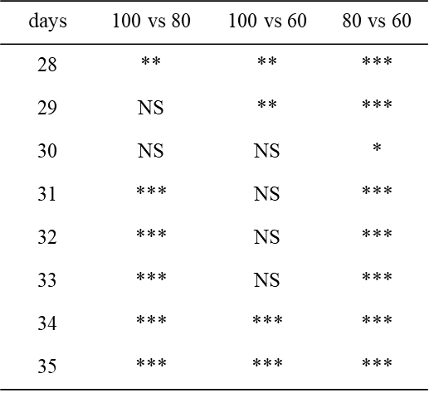

Suppl. Table 4. Analysis of variance (ANOVA) of the sensor response R in 2020 season (∗∗∗p ≤ 0.001, ∗∗p ≤ 0.01, and ∗p ≤ 0.05, NS, non significative). The significance of R differences between the thesis was evaluated in the days used to calculate the water savings hypothesized.
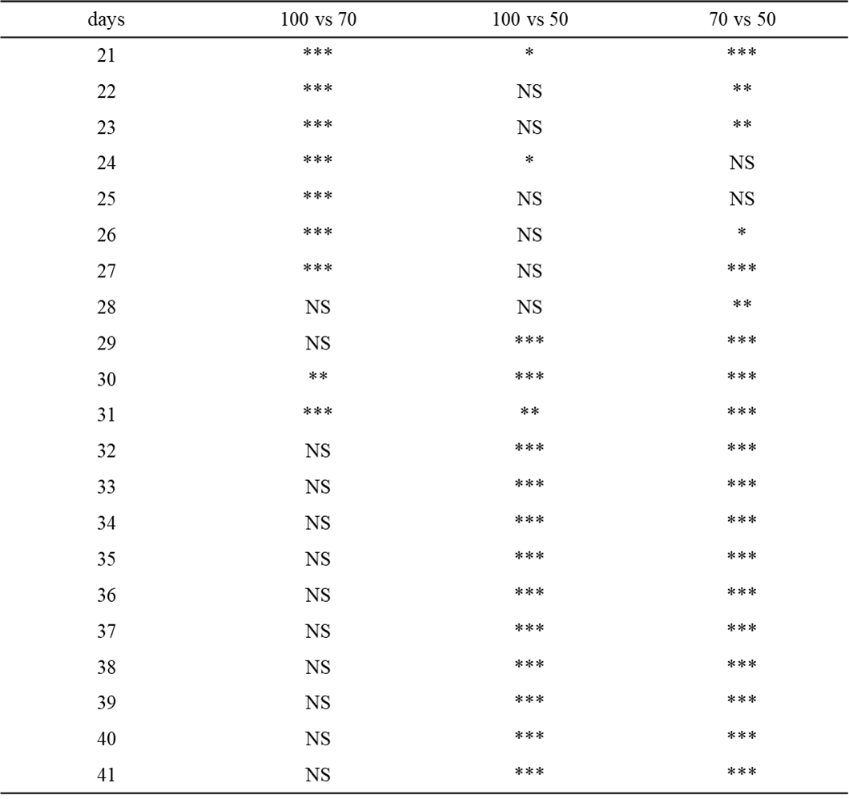

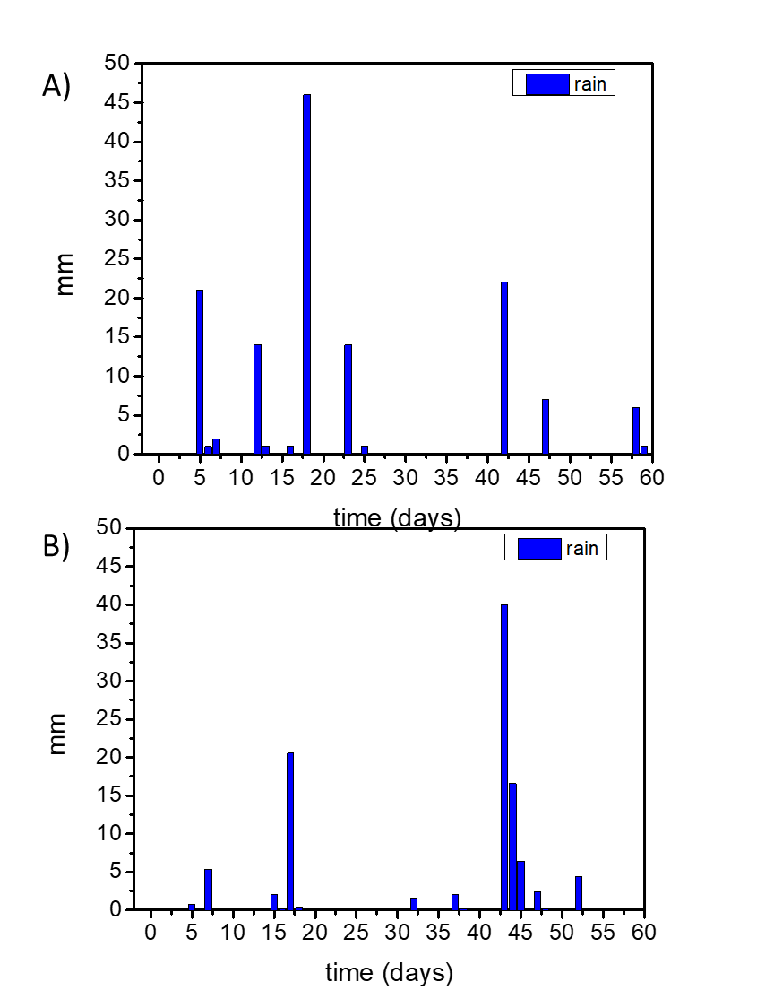
Suppl. Fig. 1: Cumulative daily rainfall measured during (A) 2018 season and (B)2020 season

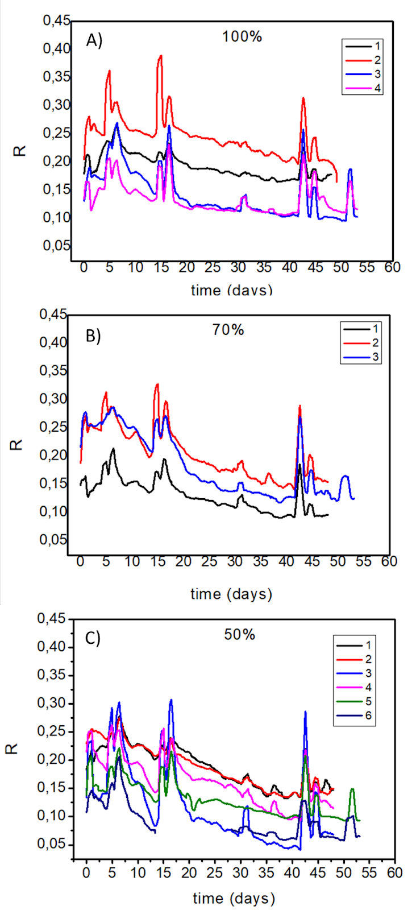
Suppl Fig. 2. Plot of the sensor response trend recorded for each plant in 2020 field trial. (A), 100% thesis, B) 70% thesis, and C) 50% thesis.

