Supplementary Material
Sweet corn yield prediction using machine learning models and field-level data
Daljeet S. Dhaliwal¹, Martin M. WilliamsⅡ^{2*}
¹Department of Crop Sciences, University of Illinois at Urbana Champaign, Urbana, IL, United States
²Global Change and Photosynthesis Research Unit, USDA-ARS, Urbana, IL, United States
*Author for correspondence: Martin M. Williams Ⅱ
Email: martin.williams@usda.gov
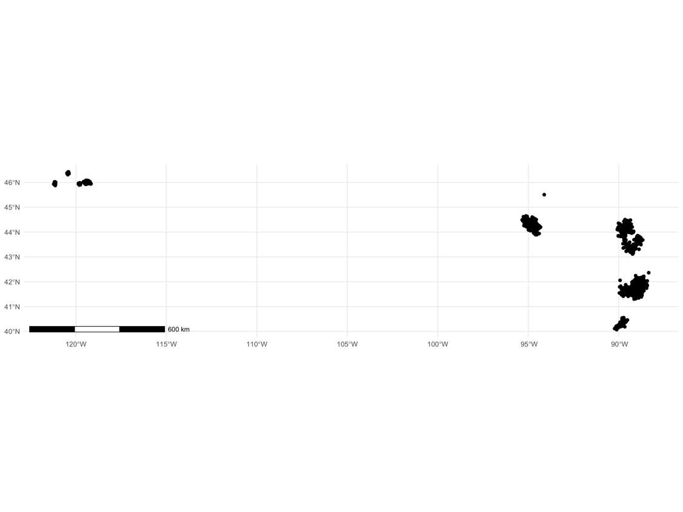
Fig S1 Location coordinates of commercial sweet corn fields used in the historic U.S. sweet corn dataset.

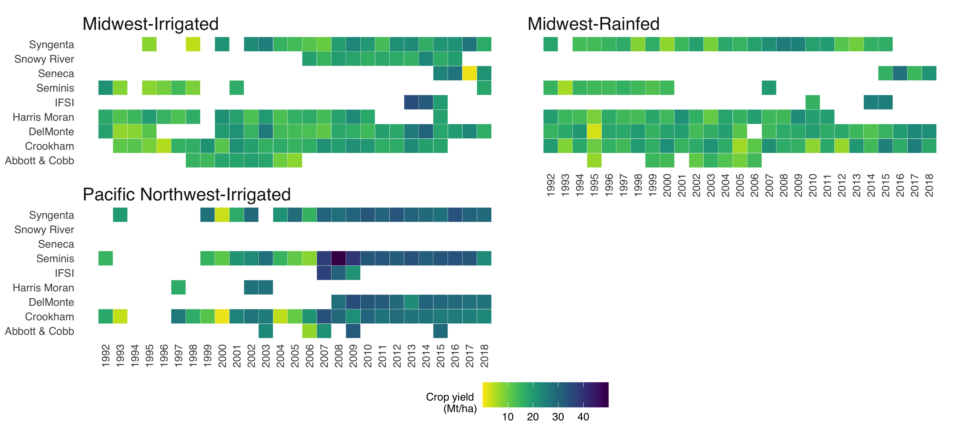

Fig S2 Sweet corn yield (Mt/ha) time-series by seed source for production-areas in the Midwest (i.e., Irrigated and Rainfed) and the Pacific Northwest regions from 1992–2018. Seed source is a proxy for genetic information
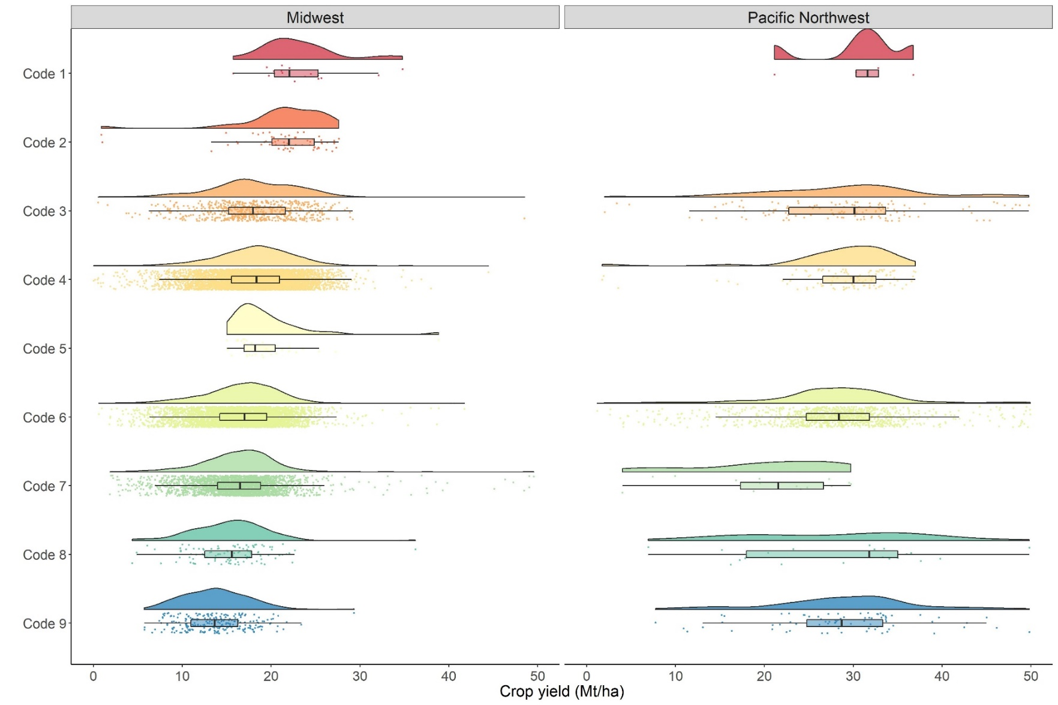
Fig S3 Sweet corn yield (Mt/ha) time-series by seed source for the Midwest and the Pacific Northwest regions from 1992–2018. Seed source (Code 1 to 9) is a proxy for genetic information

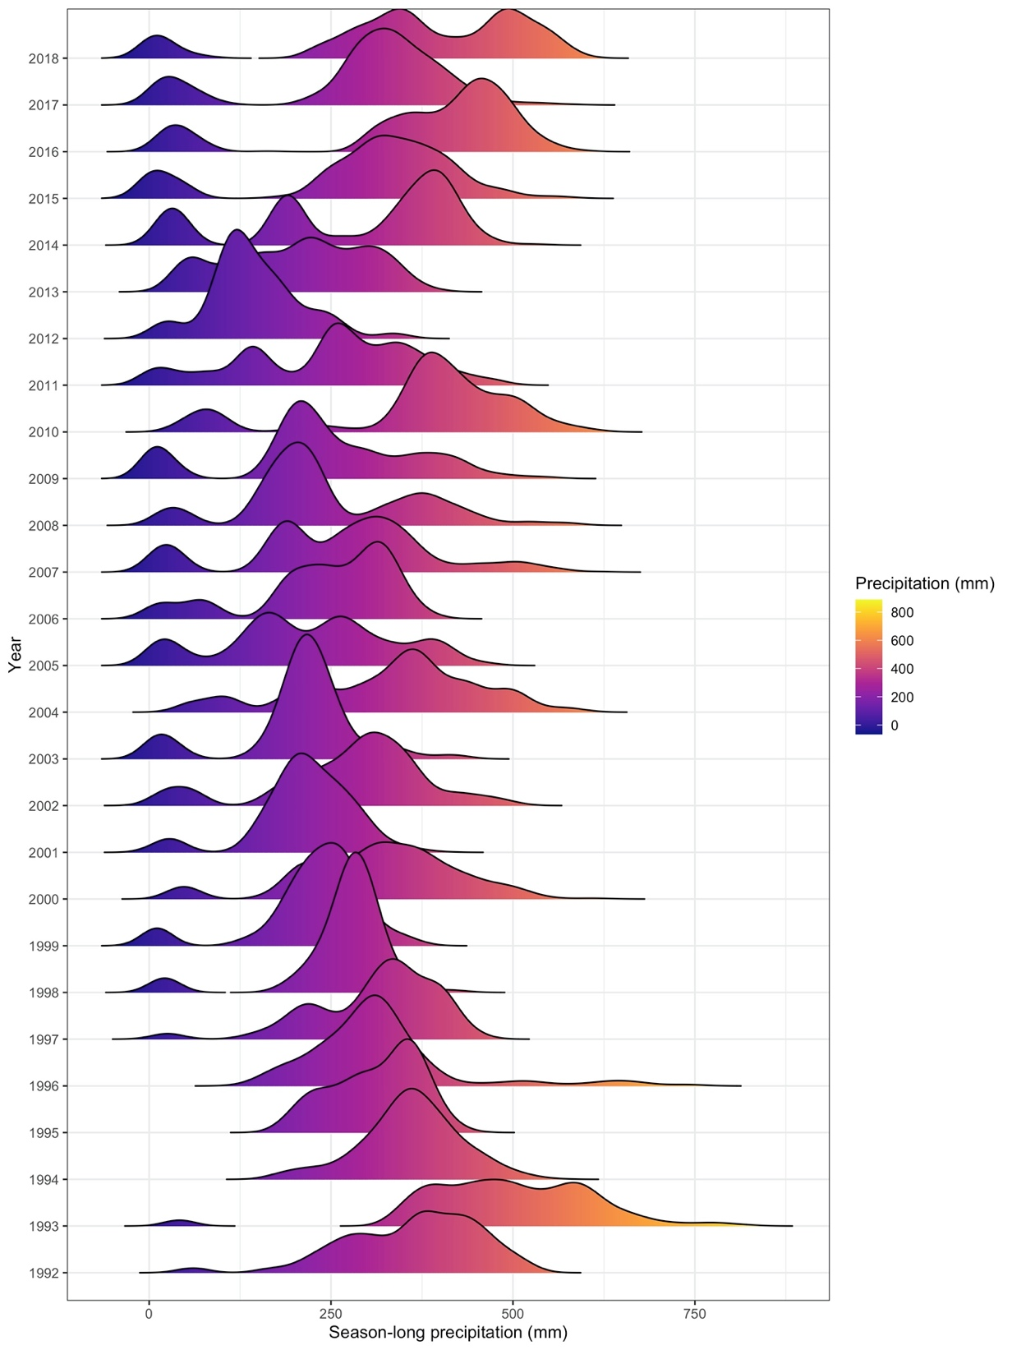

Fig S4 Season long precipitation (mm) distribution for the Midwest and the Pacific Northwest regions for years 1992–2018. Each year has two density plots; the smaller density plot denotes the Pacific Northwest data, and the larger density plot denotes the Midwest data for each of the years. Years 1994–1996 only show the Midwest precipitation data

