Article title: A new method for satellite-based remote sensing analysis of plant-specific biomass yield patterns for precision farming applications
Author: Ludwig Hagn (ludwig.hagn@tum.de)

Online Resource 1: Mean temperature and precipitation at site A*
Parameter |  | unit | Jan | Feb | Mar | Apr | May | Jun | Jul | Aug | Sep | Oct | Nov | Dec | Year
 | 1991 - 2020
Temperature x̄ |  | °C | -0.1 | 0.5 | 4.4 | 8.8 | 13.1 | 16.6 | 18.3 | 18.0 | 13.4 | 9.0 | 3.8 | 0.7 | 8.9
Precipitation ∑ |  | mm | 54.0 | 43.0 | 60.0 | 54.0 | 103.0 | 110.0 | 110.0 | 103.0 | 71.0 | 63.0 | 58.0 | 59.0 | 888.0
 | 2018
Temperature x̄ |  | °C | 3.9 | -2.9 | 2.8 | 12.9 | 15.4 | 17.3 | 19.3 | 20.2 | 15.0 | 10.0 | 3.9 | 2.8 | 10.6
Precipitation ∑ |  | mm | 99.7 | 44.5 | 27.3 | 12.7 | 92.8 | 128.7 | 101.1 | 82.5 | 88.9 | 39.0 | 23.8 | 80.3 | 821.3
 | 2019
Temperature x̄ |  | °C | -0.8 | 2.7 | 6.2 | 9.6 | 10.6 | 19.4 | 19.2 | 18.7 | 13.8 | 10.9 | 4.5 | 2.5 | 9.8
Precipitation ∑ |  | mm | 84.1 | 21.3 | 48.2 | 16.9 | 129.5 | 41.0 | 93.9 | 87.1 | 72.2 | 71.3 | 29.6 | 39.6 | 734.7
 | 2020
Temperature x̄ |  | °C | 2.1 | 5.2 | 4.9 | 11.0 | 11.9 | 15.8 | 18.6 | 18.9 | 14.7 | 9.2 | 4.8 | 1.1 | 9.9
Precipitation ∑ |  | mm | 20.7 | 118.0 | 52.8 | 25.8 | 45.1 | 253.4 | 61.3 | 130.4 | 47.6 | 82.5 | 13.4 | 39.1 | 890.1
 | 2021
Temperature x̄ |  | °C | -0.5 | 2.5 | 4.2 | 6.3 | 10.3 | 18.3 | 17.8 | 16.6 | 14.9 | 8.4 | 2.7 | 2.1 | 8.6
Precipitation ∑ |  | mm | 55.2 | 39.8 | 47.1 | 21.7 | 161.4 | 168.3 | 114.2 | 136.7 | 40.6 | 23.2 | 31.7 | 70.6 | 910.6
 | 2022
Temperature x̄ |  | °C | 1.3 | 3.8 | 4.5 | 7.4 | 14.8 | 18.5 | 19.6 | 19.2 | 12.9 | 12.6 | 5.6 | 1.6 | 10.2
Precipitation ∑ |  | mm | 23.4 | 30.2 | 13.6 | 42.3 | 85.9 | 97.4 | 71.2 | 60.7 | 81.3 | 78.8 | 53.7 | 53.4 | 691.9
*Weather station Maisach-Galgen (10 km west of the study fields)
Online Resource 2: Mean temperature and precipitation at site B*
Parameter | unit | Jan | Feb | Mar | Apr | May | Jun | Jul | Aug | Sep | Oct | Nov | Dec | Year
1991-2020
Temperature x̄ | °C | -0.7 | 0.6 | 4.3 | 9.0 | 13.3 | 16.9 | 18.1. | 17.8 | 13.3 | 8.9 | 3.7 | 0.5 | 8.8
Precipitation ∑ | mm | 50.4 | 39.2 | 51.6 | 49.0 | 91.5 | 100.1 | 102.1 | 94.5 | 66.3 | 61.9 | 53.5 | 53.2 | 813.1
2018
Temperature x̄ | °C | 3.6 | -2.5 | 2.9 | 13.1 | 16.3 | 17.8 | 19.2 | 19.8 | 14.7 | 10.0 | 4.2 | 2.7 | 10.2
Precipitation ∑ | mm | 88.1 | 29.2 | 30.2 | 8.8 | 93.4 | 123.0 | 69.3 | 66.7 | 65.8 | 55.3 | 27.2 | 97.4 | 745.4
2019
Temperature x̄ | °C | -0.6 | 2.2 | 6.3 | 10.2 | 10.6 | 19.6 | 19.0 | 18.7 | 13.8 | 10.2 | 4.5 | 2.2 | 9.7
Precipitation ∑ | mm | 86.3 | 38.3 | 48.5 | 12.3 | 118.0 | 79.3 | 54.3 | 98.9 | 48.4 | 50.2 | 35.9 | 54.9 | 725.3
2020
Temperature x̄ | °C | 1.3 | 4.7 | 5.0 | 10.6 | 11.8 | 16.1 | 18.4 | 18.8 | 14.3 | 9.0 | 4.2 | 1.2 | 9.6
Precipitation ∑ | mm | 25.9 | 96.0 | 37.5 | 23.4 | 31.8 | 154.1 | 68.0 | 104.3 | 37.7 | 90.0 | 16.4 | 45.7 | 766.8
2021
Temperature x̄ | °C | -0.7 | 2.3 | 4.1 | 6.3 | 10.5 | 18.8 | 17.9 | 16.4 | 14.5 | 8.0 | 2.8 | 2.0 | 8.6
Precipitation ∑ | mm | 53.7 | 40.2 | 36.6 | 29.0 | 161.0 | 131.0 | 114.8 | 166.7 | 35.9 | 17.7 | 36.9 | 90.9 | 914.4
2022
Temperature x̄ | °C | 1.2 | 3.8 | 4.6 | 7.4 | 14.8 | 18.8 | 19.6 | 19.4 | 12.7 | 11.9 | 5.2 | 1.3 | 10.1
Precipitation ∑ | mm | 48.5 | 36.7 | 13.8 | 57.4 | 70.1 | 99.4 | 57.0 | 85.4 | 75.3 | 60.6 | 55.9 | 56.6 | 719.7
*Weather station Freising (1 km north of the study fields)

Online Resource 3: Mean temperature and precipitation at site C*
Parameter | unit | Jan | Feb | Mar | Apr | May | Jun | Jul | Aug | Sep | Oct | Nov | Dec | Year
1991-2020
Temperature x̄ | °C | -0.8 | 0.4 | 4.4 | 9.2 | 13.6 | 16.9 | 18.5 | 18.2 | 13.6 | 8.9 | 3.6 | 0.1 | 8.9
Precipitation ∑ | mm | 48.4 | 40.5 | 61.6 | 49.6 | 93.6 | 100.4 | 106.5 | 102.4 | 77.7 | 60.6 | 53.7 | 53.9 | 848.8
2018
Temperature x̄ | °C | 3.0 | -2.4 | 2.6 | 13.7 | 16.6 | 18.3 | 19.6 | 20.5 | 15.3 | 11.0 | 4.6 | 2.0 | 10.4
Precipitation ∑ | mm | 88.0 | 27.3 | 41.7 | 13.5 | 68.5 | 63.2 | 79.0 | 86.4 | 55.7 | 47.1 | 32.2 | 92.7 | 695.3
2019
Temperature x̄ | °C | -0.9 | 1.9 | 6.6 | 10.6 | 11.0 | 20.8 | 19.6 | 19.3 | 14.3 | 10.3 | 4.2 | 2.4 | 10.0
Precipitation ∑ | mm | 65.6 | 36.5 | 57.4 | 15.3 | 162.5 | 44.9 | 65.7 | 53.7 | 52.8 | 44.8 | 37.9 | 32.5 | 669.6
2020
Temperature x̄ | °C | 0.9 | 4.4 | 5.2 | 11.4 | 12.3 | 16.7 | 18.6 | 19.2 | 14.9 | 8.9 | 4.0 | 1.0 | 9.8
Precipitation ∑ | mm | 23.9 | 91.5 | 39.0 | 33.7 | 57.1 | 186.0 | 96.8 | 125.3 | 81.2 | 71.2 | 20.7 | 37.1 | 863.5
2021
Temperature x̄ | °C | -1.1 | 2.3 | 4.4 | 6.7 | 11.0 | 19.8 | 18.7 | 16.9 | 15.5 | 8.2 | 3.2 | 1.5 | 8.9
Precipitation ∑ | mm | 66.4 | 32.7 | 19.4 | 28.2 | 127.5 | 107.4 | 164.1 | 193.1 | 35.3 | 34.5 | 46.1 | 78.2 | 933.0
2022
Temperature x̄ | °C | 1.1 | 3.9 | 5.4 | 7.7 | 15.2 | 19.0 | 19.9 | 20.1 | 13.0 | 12.3 | 5.3 | 0.9 | 10.3
Precipitation ∑ | mm | 34.1 | 31.3 | 19.0 | 44.7 | 53.7 | 103.5 | 34.4 | 54.1 | 71.3 | 58.9 | 69.9 | 66.7 | 641.7
*Weather station Frieding (15 km north of the study field)

Online Resource 4: Crop rotation at the study fields
Field | A1 | B1 | C1 | C2
Year | Crop rotation | Crop rotation | Crop rotation | Crop rotation
2018 | Winter wheat | Winter wheat | Winter wheat | Corn
2019 | Corn | Winter barley | Canola | Soybeans
2020 | Winter wheat | Canola | Winter barley | Corn
2021 | Winter barley | Winter wheat | Corn | Winter wheat
2022 | Spring barley | Winter barley | Winter wheat | Winter barley

Online Resource 5: Crop-specific growth stages
Growth stages | Description of growth stages | Winter wheat | Winter barley | Canola | Corn | Soybeans
GS 32 | Second node¹ detectable | X | X
GS 39 | Flag leaf fully unrolled, ligule just visible¹ | X | X |  | X
GS 50 | Flower buds present and enclosed by leaves ² |  |  | X
GS 60 | Start of flowering (first flowers open)² |  |  | X
GS 65 | Flowering halfway (50% of anthers mature¹ | X | X |  | X
GS 70 | 10 % of the pods have reached their final size² |  |  | X
V5 | Fifth Trifoliate (five nodes on the main steam with fully developed leaves)³ |  |  |  |  | X
R2 | Full bloom (there is an open flower at one of the two uppermost nodes³ |  |  |  |  | X
R5 | Beginning of seed filling (seed is 3 mm long in one of the pods of the four uppermost nodes at the main stem)³ |  |  |  |  | X
¹Description of the main system of growth stages of cereals according to Biologische Bundesanstalt, Bundessortenamt und CHemical Industry (BBCH) AHDB (2023a)
²Description of the development stages of canola according to the two main systems in use (BBCH and AAB scales AHDB (2023b)
³Decription of the development stages of soybeans (NDSU 2021)

Online resource 6: Methods description of plant data
Plant parameters
Variable | Unit | Data source |  |  | Method |  |  |  |  | Literature
- based on combine harvester
Grain yieldª | t ha⁻¹ | Combine harvester |  |  | Volume flow sensor |  |  |  |  | (Noack 2007)
- based on satellite data
Vegetation index | NDVI | Satellite data^{b} |  |  | Reflectance measurements |  |  |  |  | (DLR 2022)
Biomass potential | % | Satellite data^{b} |  |  | Multi-year NDVI raster/ mean multi-year NDVI field*100 |  |  |  |  | (Hagn et al. 2023)
- based on data from tractor-mounted sensor system
Vegetation index | REIP | Tractor-mounted sensor^{c} |  |  | Reflectance measurements |  |  |  |  | (tec5 2021)
Grain yield^{c} | t ha⁻¹ | Tractor-mounted sensor^{c} |  |  | Yield algorithm |  |  |  |  | (Maidl et al. 2019)
- based on biomass samples
Grain yieldª | t ha⁻¹ | Biomass samples |  |  | Threshing |  |  |  |  | (Wintersteiger 2023)
ª Grain yield (14 % moisture content)
^{b} Sentinel-2 MSI-Level 2A (MAJA Tiles)
^{c} Tractor-mounted reflectance measurements sensor (350-1140 nm)

Online resource 7: Methods description of soil data
Soil properties
Property | Unit | Data source | Method | Literature
Soil organic carbon content (0-30 cm) | % DM | Soil samples | C/N Analyzer | (DIN ISO 10694 1996)
Soil total nitrogen content (0-30 cm) | % DM | Soil samples | C/N Analyzer | (DIN ISO 10694 1996)
Plant available phosphorus content (0-30 cm) | mg (100 g)⁻¹ | Soil samples | CAL method | (VDLUFA 2012)
Plant available potassium content (0-30 cm) | mg (100 g)⁻¹ | Soil samples | CAL method | (VDLUFA 2012)
pH (0-30 cm) |  | Soil samples | CaCl₂ method | (VDLUFA 2016)
Soil texture (0-30cm) |  | Soil samples | Texture by feel method | (VDLUFA 1997)

Online Resource 8: Descriptive statistic of the plant parameters (field B1)
Variable | n | Unit | Mean | Median | Minimum | Maximum | Standard deviation | Skewness
rel. BMP GS 32 winter wheat (2018) | 511 | % | 100.0 | 101.8 | 81.9 | 117.5 | 8.5 | -0.33
rel. BMP GS 39 winter wheat (2018) | 511 | % | 100.0 | 102.4 | 72.8 | 122.5 | 13.1 | -0.22
rel. BMP GS 65 winter wheat (2018) | 511 | % | 100.0 | 100.9 | 88.5 | 108.4 | 5.0 | -0.46
rel. BMP GS 32 winter barley (2019) | 511 | % | 100.0 | 100.0 | 92.8 | 106.4 | 3.0 | -0.12
rel. BMP GS 39 winter barley (2019) | 511 | % | 100.0 | 100.0 | 91.7 | 106.2 | 3.0 | -0.06
rel. BMP GS 65 winter barley (2019) | 511 | % | 100.0 | 100.0 | 94.2 | 104.7 | 2.5 | 0.04
rel. BMP GS 50 canola (2020) | 511 | % | 100.0 | 100.2 | 62.4 | 136.3 | 15.9 | 0.16
rel. BMP GS 60 canola (2020) | 511 | % | 100.0 | 99.2 | 84.6 | 116.6 | 7.0 | 0.27
rel. BMP GS 70 canola (2020) | 511 | % | 100.0 | 100.3 | 95.1 | 105.6 | 1.6 | -0.92
Yield harvester (2018) | 4922 | t ha⁻¹ | 10.0 | 10.0 | 6.2 | 13.6 | 1.6 | 0.16
REIP (2018) | 2617 | nm | 730.5 | 730.7 | 727.1 | 733.3 | 1.5 | -0.29
Method description in Electronic Supplementary Material (Online Resource 6)

Online Resource 9: Descriptive statistic of the soil parameters (field B1)
Property | n | Unit | Mean | Median | Minimum | Maximum | Standard deviation | Skewness
SOC | 48 | % DM | 1.5 | 1.4 | 1.2 | 2.1 | 0.1 | 1.42
TN | 48 | % DM | 0.16 | 0.16 | 0.11 | 0.23 | 0.02 | 1.03
Sand | 48 | % | 24.3 | 23.3 | 16.9 | 35.2 | 4.6 | 0.46
Clay | 48 | % | 20.6 | 21.5 | 12.8 | 23.4 | 2.5 | -1.32
Silt | 48 | % | 55.0 | 56.6 | 45.2 | 57.7 | 3.3 | -1.38
AWC | 48 | Vol. % | 17.9 | 17.9 | 15.9 | 22.0 | 0.7 | 2.67
P_{CAL} | 48 | mg (100 g)⁻¹ | 5.7 | 5.4 | 3.4 | 12.4 | 1.5 | 1.09
K_{CAL} | 48 | mg (100 g)⁻¹ | 14.0 | 13.3 | 9.1 | 26.1 | 2.7 | 1.24
pH | 48 |  | 7.0 | 7.0 | 6.9 | 7.0 | 0.0 | -0.81
Elevation | 4922 | m | 480 | 480 | 471 | 487 | 3.6 | -0.06
Method description in Electronic Supplementary Material (Online Resource 7)

Online Resource 10: Descriptive statistic of the plant parameters (field C1)
Variable | n | Unit | Mean | Median | Minimum | Maximum | Standard deviation | Skewness
rel. BMP winter wheat (2018) | 781 | % | 100.0 | 100.3 | 91.8 | 106.9 | 3.5 | -0.35
rel. BMP canola (2019) | 781 | % | 100.0 | 100.9 | 92.7 | 105.5 | 2.9 | -0.79
rel. BMP winter barley (2020) | 781 | % | 100.0 | 100.1 | 94.1 | 105.2 | 2.1 | -0.43
rel. BMP corn (2021) | 781 | % | 100.0 | 100.4 | 92.7 | 105.2 | 2.9 | -0.43
rel. BMP winter wheat (2022) | 781 | % | 100.0 | 100.2 | 94.0 | 105.4 | 1.2 | -0.44
rel. BMP all crops (2018-2022) | 781 | % | 100.0 | 100.3 | 94.5 | 106.0 | 2.2 | -0.42
Yield¹ (2022) | 2114 | t ha⁻¹ | 9.4 | 9.5 | 8.9 | 10.0 | 0.24 | 0.00
Method description in Electronic Supplementary Material (Online Resource 6)
¹ Yield derived from REIP (tractor-mounted sensor system) + yield algorithm (Maidl et. al 2019)

Online Resource 11: Descriptive statistic of the soil parameters (field C1)
Property | n | Unit | Mean | Median | Minimum | Maximum | Standard deviation | Skewness
SOC (0-30 cm) | 60 | % DM | 1.4 | 1.3 | 1.1 | 2.1 | 0.2 | -0.33
TN (0- 30 cm) | 60 | % DM | 0.15 | 0.14 | 0.12 | 0.22 | 0.0 | -0.42
P_{CAL} (0-30 cm) | 60 | mg (100 g)⁻¹ | 7.6 | 5.8 | 3.1 | 31.7 | 5.5 | 2.64
K_{CAL} (0-30 cm) | 60 | mg (100 g)⁻¹ | 12.6 | 11.2 | 7.0 | 25.3 | 4.4 | 0.93
pH (0-30 cm) | 60 |  | 6.5 | 6.5 | 6.0 | 7.2 | 0.3 | -6.36
Method description in Electronic Supplementary Material (Online Resource 7)

Online Resource 12: Descriptive statistic of the plant parameters (field C2)
Variable | n | Unit | Mean | Median | Minimum | Maximum | Standard deviation | Skewness
rel. BMP corn (2018) | 713 | % | 99.9 | 99.9 | 96.1 | 103.0 | 1.5 | -0.28
rel. BMP soybeans (2019) | 713 | % | 99.8 | 99.7 | 95.7 | 103.5 | 1.8 | -0.23
rel. BMP winter wheat (2020) | 713 | % | 99.6 | 99.7 | 93.5 | 105.5 | 2.7 | -0.33
rel. BMP winter barley (2021) | 713 | % | 99.4 | 99.8 | 90.9 | 106.0 | 3.5 | -0.41
rel. BMP corn (2022) | 713 | % | 100.2 | 100.1 | 91.3 | 109.6 | 3.8 | 0.17
rel. BMP (2018 - 2022) | 713 | % | 99.8 | 99.8 | 94.5 | 104.2 | 1.9 | -0.19
Yield¹ (2020) | 1894 | t ha⁻¹ | 9.4 | 9.4 | 8.51 | 10.3 | 0.36 | -0.05
Method description in Electronic Supplementary Material (Online Resource 6)
¹ Yield derived from REIP (tractor-mounted sensor system) + yield algorithm (Maidl et. al 2019)

Online Resource 13: Descriptive statistic of the soil parameters (field C2)
Variable | n | Unit | Mean | Median | Minimum | Maximum | Standard deviation | Skewness
SOC | 60 | % DM | 1.5 | 1.5 | 1.4 | 1.8 | 0.1 | 0.18
TN | 60 | % DM | 0.15 | 0.15 | 0.13 | 0.19 | 0.0 | 0.29
P_{CAL} | 60 | mg (100 g)⁻¹ | 4.1 | 4.1 | 2.8 | 5.9 | 0.7 | 0.29
K_{CAL} | 60 | mg (100 g)⁻¹ | 7.5 | 7.5 | 3.2 | 14.1 | 1.5 | 0.41
pH | 60 |  | 6.5 | 6.5 | 6.0 | 6.9 | 0.1 | -0.18
Method description in Electronic Supplementary Material (Online Resource 7)

Online resource 14: Variograms of a) SOC content, b) TN content, c) Sand content, d) rel. BMP winter wheat 2018, e) rel. BMP winter wheat 2020, f) rel. BMP winter wheat 2018 &2020, g) yield combine harvester , h) yield biomass samples, i) spectral reflectance measurements (field A1)

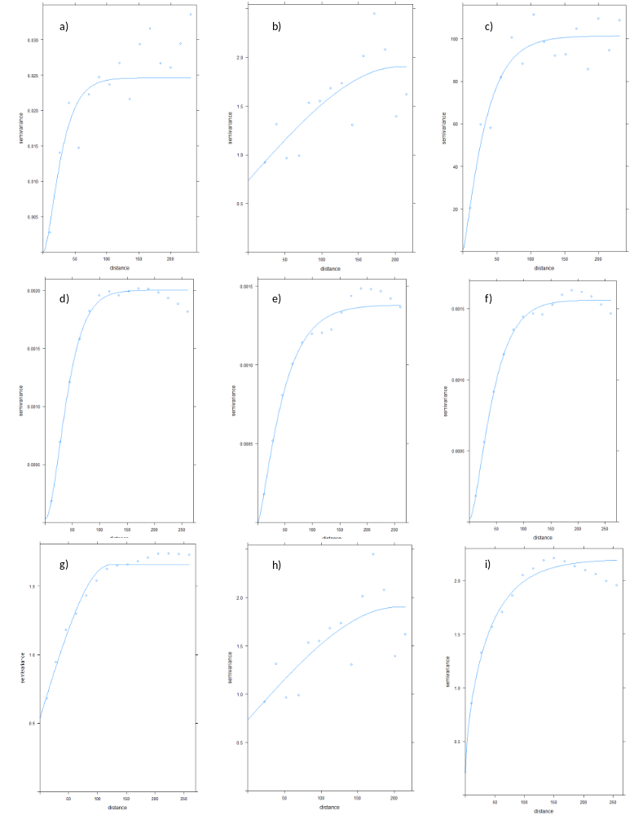

Online resource 15: Variograms of a) rel. BMP GS 32 winter wheat 2018, b) rel. BMP GS 39 winter wheat 2018 c) rel. BMP GS 65 winter wheat 2018, d) rel. BMP GS 32 winter barley 2019, e rel. BMP GS 39 winter barley 2019, f) rel. BMP GS 65 winter barley 2019, g) rel. BMP GS 50 canola 2020, h) rel. BMP GS 60 canola 2020, i) rel. BMP GS 70 canola 2020 (field B1)
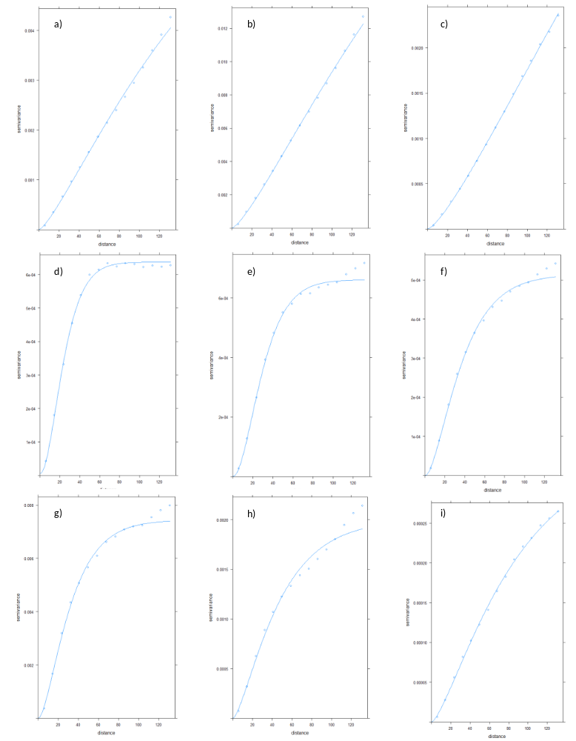

Online resource 16: Variograms of a) SOC content, b) TN content, c) pH, d) rel. BMP winter wheat 2018, e) rel. BMP canola 2019, f) rel. BMP winter barley 2020, g) rel. BMP corn 2021, h) rel. BMP winter wheat 2022, i) rel. BMP all crops 2018-2022 (field C1)

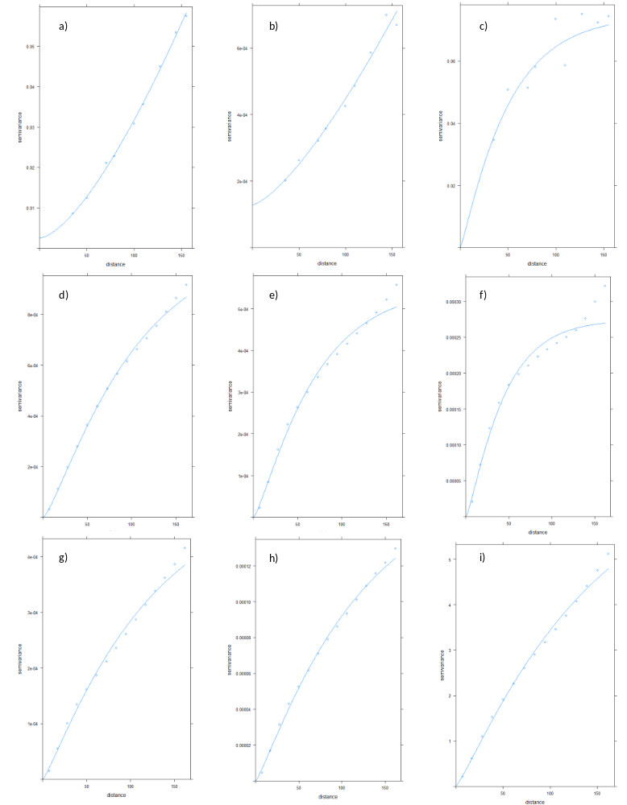

Online resource 17: Variograms of a) SOC content, b) TN content, c) pH, d) rel. BMP corn 2018, e) rel. BMP soybeans 2019, f) rel. BMP winter wheat 2020, g) rel. BMP winter barley 2021, h) rel. BMP corn 2022, i) rel. BMP all crops 2018-2022 (field C2)
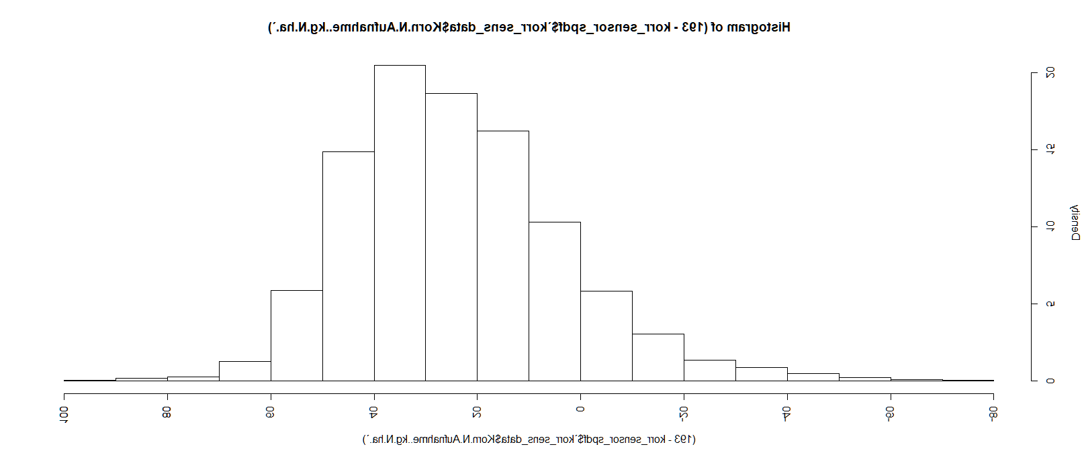
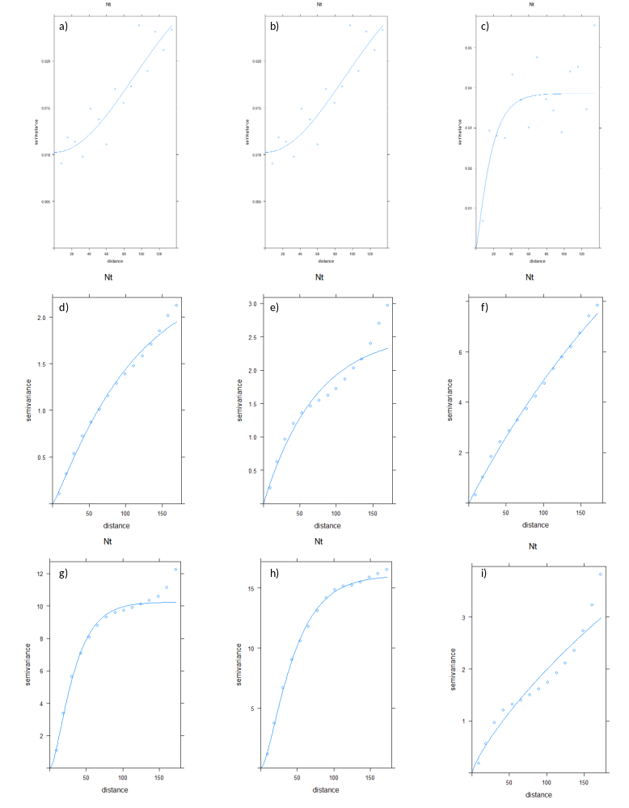
References
AHDB (2023a). The growth stages of cereals. https://ahdb.org.uk/knowledge-library/the-growth-stages-of-cereals. Accessed 20 November 2023.
AHDB (2023b). The growth stages of oilseed rape. https://ahdb.org.uk/knowledge-library/the-growth-stages-of-oilseed-rape. Accessed 20 November 2023.
DIN ISO 10694 (1996). Bestimmung von organischem Kohlenstoff und Gesamtkohlenstoff nach trockener Verbrennung (Elementaranalyse).
DLR (2022). CODE DE - Hauptseite. https://code-de.org/de/. Accessed 7 November 2022.
Hagn, L., Mittermayer, M., Schuster, J., Hu, Y., & Hülsbergen, K.-J. (2023). 113. Identifying key soil factors influencing spatial and temporal variability of cereal crops estimated using time-series of satellite-sensing data. In J. V. Stafford (Ed.), Precision agriculture ’23 (pp. 903–908). The Netherlands: Wageningen Academic Publishers.
Maidl, F.-X., Spicker, A. B., Weng, A., & Hülsbergen, K.-J. (2019). Ableitung des teilflächenspezifischen Kornertrags von Getreide aus Reflexionsdaten (Derivation of the site-specific grain yield from reflection data). In Meyer-Aurich (Ed.), Informatik in der Land-, Forst- und Ernährungswirtschaft. GI-Edition - Lecture notes in informatics Proceedings, Volume 287 (pp. 131–134). Bonn: Gesellschaft für Informatik e.V.
NDSU (2021). Soybean growth and management: NDSU Extension.
Noack, P. O. (2007). Ertragskartierung im Getreidebau. KTBL-Heft, vol. 70. Darmstadt: KTBL.
tec5 (2021). Optical Spectroscopy - modern process analytical technologies. https://tec5.com/en/technology/optical-spectroscopy/. Accessed 18 August 2023.
VDLUFA (1997). Methodenbuch I Verband Deutscher Landwirtschaftlicher Untersuchungs- und Forschungsanstalten (VDLUFA); Methode D 2.1 Bestimmung der Bodenart des Feinbodens mit der Fingerprobe: In: Handbuch der Landwirtschaftlichen Versuchs- und Untersuchungsmethodik: Bestimmung der Bodenart des Feinbodens mit der Fingerprobe. VDLUFA-Methodenbuch, Bd. I Die Untersuchung von Böden. VDLUFA-Schriftenreihe, vol. 1, 4th edn. Darmstadt: VDLUFA-Verl.
VDLUFA (2012). Methodenbuch I Verband deutscher landwirtschaftlicher Untersuchungs- und Forschungsanstalten (VDLUFA); Methode A 6.2.1.1 Bestimmung von Phosphor und Kalium im Calcium-Acetat-Lactat-Auszug.: In: Handbuch der Landwirtschaftlichen Versuchs- und Untersuchungsmethodik: Direkte Bestimmung von organischen Kohlenstoff durch Verbrennung von 550 °C und Gasanalyse. VDLUFA-Methodenbuch, Bd. I Die Untersuchung von Böden, 4th edn: VDLUFA-Verlag.
VDLUFA (2016). Methodenbuch I Verband deutscher landwirtschaftlicher Untersuchungs- und Forschungsanstalten (VDLUFA); Methode A 5.1.1 Bestimmung des pH-Wertes.: In: Handbuch der Landwirtschaftlichen Versuchs- und Untersuchungsmethodik (VDLUFA-Methodenbuch), Bd. I Die Untersuchung von Böden. 4. Aufl., 7. Teillieferung, VDLUFA-Verlag, Darmstadt: Bestimmung des pH-Wertes. VDLUFA-Methodenbuch, Bd. I Die Untersuchung von Böden. Darmstadt: VDLUFA-Verlag.
Wintersteiger (2020). Wintersteiger Delta Plot Combine. file:///C:/Users/LudwigHagn/Favorites/Downloads/Delta_EN.pdf. Accessed 18 August 2023.
Wintersteiger (2023). LD 350 Laboratory thresher. https://www.wintersteiger.com/us/Plant-Breeding-and-Research/Products/Product-range/Laboratory-preparation/69-LD-350. Accessed 17 November 2023.

