Exploring the Spatial Variability of Nitrogen Balance and Its Relationship with Soil Properties

Octavian P. Chiriac^{1*}, Samuele De Petris², Laura Zavattaro¹, Davide Cammarano³
¹ Department of Veterinary Sciences, University of Turin, Italy
² Department of Agricultural, Forest and Food Sciences, University of Turin, Italy
³ Department of Agroecology - Climate and Water, Aarhus University, Denmark

* Corresponding author: octavianpuiu.chiriac@unito.it

Supplementary Information

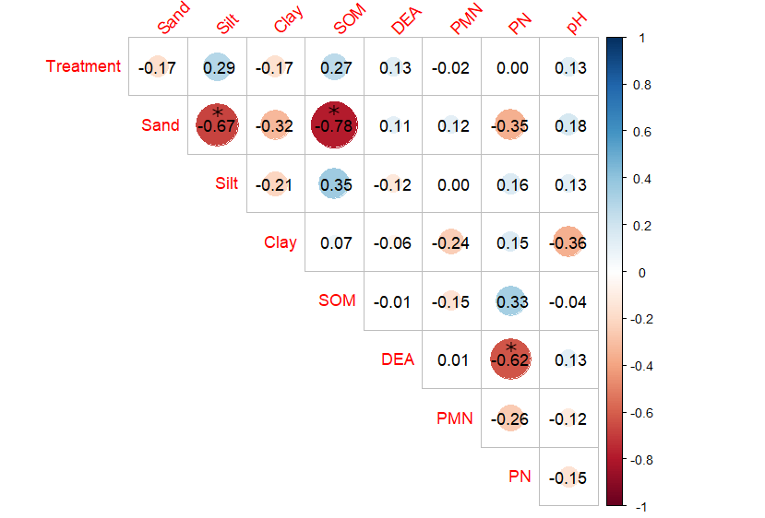
S.I. Fig. 1 Correlation matrix between soil properties using Spearman's correlation coefficient. Values with * have a p-value < 0.05.
SOM = soil organic matter, DEA = denitrifying enzymatic activity, PMN = potential mineralisation of nitrogen, PN = potential nitrification
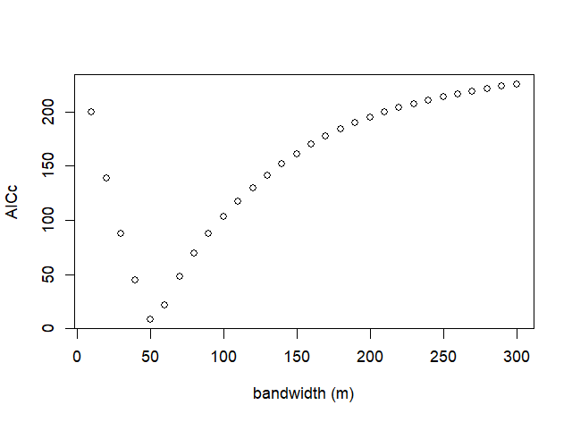
S.I. Fig. 2 Corrected Akaike Information Criterion in relation to the bandwidth used in the geographically weighted regression model.

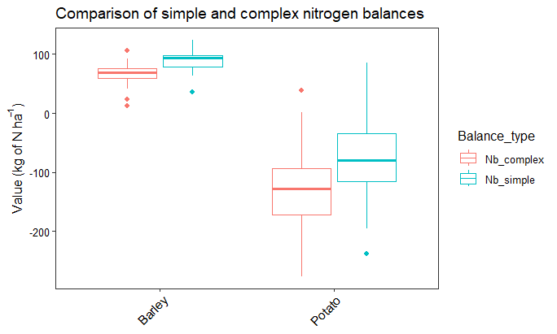
S.I. Fig. 3 Comparison of simple and complex nitrogen balances. For the simple balance, crop uptake, nitrogen fertilisation and the change in mineral nitrogen in the soil are considered, while for the complex balance, nitrogen losses such as leaching, nitrous oxide and atmospheric nitrogen deposition are added.

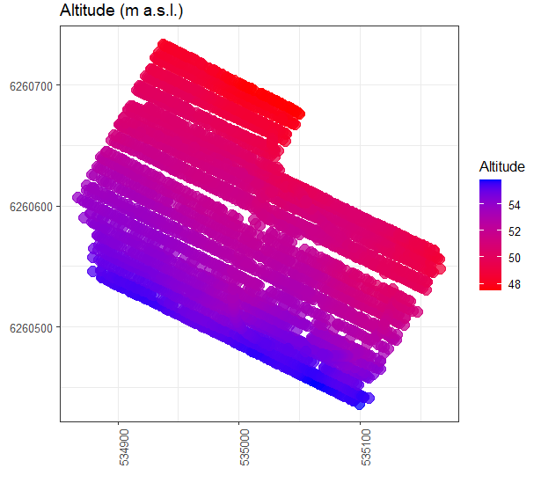
S.I. Fig. 4 Altitude map of the field expressed in metres above sea level.

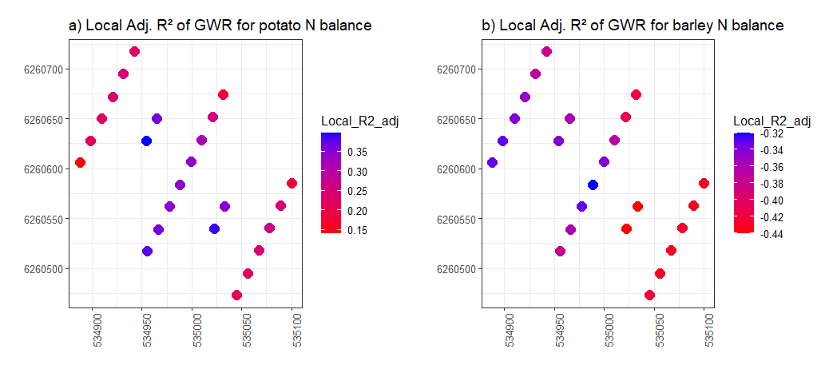
S.I. Fig. 5 Comparison of the local adjusted coefficients of determination of the geographically weighted regression model for: a) potato and b) barley.

