Supplementary material
Table S1 Overview of crop-specific N treatments, sowing dates, harvest dates, and pre-crops in the different trial years
Season | Crop | Sowing date | Harvest date | N fertilization  [kg N·ha⁻¹] | Pre-crop
2021/  22 | Silage maize | 2022-04-29 | 2022-10-08 | 0, 60, 120, 180, 240 | Winter wheat, winter oilseed rape
2021/  22 | Winter oilseed rape | 2021-08-27 | 2022-07-26 | 0, 70, 140, 210, 280 | Winter wheat, winter barley
2021/  22 | Winter wheat | 2021-10-08 | 2022-08-10 | 0, 80, 160, 240, 320 | Winter wheat, winter oilseed rape, faba bean
2021/  22 | Winter barley | 2021-09-20 | 2022-07-19 | 0, 70, 140, 210, 280 | Winter wheat
2022/  23 | Silage maize | 2023-05-08 | 2023-10-04 | 0, 60, 120, 180, 240 | Winter wheat, winter oilseed rape
2022/  23 | Winter oilseed rape | 2022-08-25 | 2023-08-05 | 0, 70, 140, 210, 280 | Winter wheat, winter barley
2022/  23 | Winter wheat | 2022-10-05 | 2023-08-11 | 0, 80, 160, 240, 320 | Winter wheat, winter oilseed rape, faba bean
2022/  23 | Winter barley | 2022-09-15 | 2023-07-11 | 0, 70, 140, 210, 280 | Winter wheat
2023/  24 | Silage maize | 2024-05-10 | 2024-10-02 | 0, 60, 120, 180, 240 | Winter wheat, winter oilseed rape
2023/  24 | Winter oilseed rape | 2023-08-24 | 2024-07-25 | 0, 70, 140, 210, 240 | Winter wheat, winter barley
2023/  24 | Winter wheat | 2023-09-27 | 2024-08-05 | 0, 80, 160, 240, 320 | Winter Wheat, winter oilseed rape, faba bean
2023/  24 | Winter barley | 2023-09-18 | 2024-07-11 | 0, 70, 140, 210, 280 | Winter wheat
Table S2 Calibration equations obtained by calibrating the MicaSense RedEdge-MX data (R) to the Parrot Sequoia (S) data using the three tested approaches and fitting the models crop-specifically and non-crop-specifically (=universal).
Approach | Crop | Calibration equation
Band-to-band | Universal | $${Green}_{s}=0.02+0.656378×{Green}_{R}+1.620600×{{Green}_{R}}^{2}$$
Band-to-band | Universal | $${Red}_{s}=0.009299+0.968642×{Red}_{R}-0.377232×{{Red}_{R}}^{2}$$
Band-to-band | Universal | $${RE}_{s}=0.07+1.55126×{RE}_{R}-2.15149×{{RE}_{R}}^{2}$$
Band-to-band | Universal | $${NIR}_{s}=-0.008749+1.066608×{NIR}_{R}-0.103940×{{NIR}_{R}}^{2}$$
Band-to-band | Silage maize | $${Green}_{s}=0.007497+0.705185×{Green}_{R}+1.756545×{{Green}_{R}}^{2}$$
Band-to-band | Silage maize | $${Red}_{s}=0.01244+0.57606×{Red}_{R}+1.70871×{{Red}_{R}}^{2}$$
Band-to-band | Silage maize | $${RE}_{s}=0.1917-0.3067×{RE}_{R}-1.9983×{{RE}_{R}}^{2}$$
Band-to-band | Silage maize | $${NIR}_{s}=-0.1212+1.6497×{NIR}_{R}-1.1732×{{NIR}_{R}}^{2}$$
Band-to-band | Winter oilseed rape | $${Green}_{s}=0.09663-0.72212×{Green}_{R}+8.19901×{{Green}_{R}}^{2}$$
Band-to-band | Winter oilseed rape | $${Red}_{s}=0.02501+0.71440×{Red}_{R}+0.77993×{{Red}_{R}}^{2}$$
Band-to-band | Winter oilseed rape | $${RE}_{s}=0.6474-3.0277×{RE}_{R}+7.2905×{{RE}_{R}}^{2}$$
Band-to-band | Winter oilseed rape | $${NIR}_{s}=-0.0893+1.4137×{NIR}_{R}-0.3147×{{NIR}_{R}}^{2}$$
Band-to-band | Winter wheat | $${Green}_{s}=0.00433+0.53525×{Green}_{R}+2.23234×{{Green}_{R}}^{2}$$
Band-to-band | Winter wheat | $${Red}_{s}=0.006766+1.018016×{Red}_{R}-0.512363×{{Red}_{R}}^{2}$$
Band-to-band | Winter wheat | $${RE}_{s}=0.2299-0.1758×{RE}_{R}+1.5439×{{RE}_{R}}^{2}$$
Band-to-band | Winter wheat | $${NIR}_{s}=0.1440+0.3343×{NIR}_{R}+0.7287×{{NIR}_{R}}^{2}$$
Band-to-band | Winter barley | $${Green}_{s}=0.004847+1.155396×{Green}_{R}-3.095304×{{Green}_{R}}^{2}$$
Band-to-band | Winter barley | $${Red}_{s}=0.007527+0.933717×{Red}_{R}-0.603444×{{Red}_{R}}^{2}$$
Band-to-band | Winter barley | $${RE}_{s}=0.115+1.383×{RE}_{R}+1.5439×{{RE}_{R}}^{2}$$
Band-to-band | Winter barley | $${NIR}_{s}=0.06051+0.53117×{NIR}_{R}+0.57927×{{NIR}_{R}}^{2}$$
Ratio-to-ratio | Universal | $${{NIR}/{Green}}_{S}=-0.96517+1.28776×{{NIR}/{Green}}_{R}-0.03005×{{{NIR}/{Green}}_{R}}^{2}$$
Ratio-to-ratio | Universal | $${{NIR}/{Red}}_{S}=-0.020441+0.930384×{{NIR}/{Red}}_{R}-0.006982×{{{NIR}/{Red}}_{R}}^{2}$$
Ratio-to-ratio | Universal | $${{NIR}/{RE}}_{S}=0.708232+0.340540×{{NIR}/{RE}}_{R}-0.008978×{{{NIR}/{RE}}_{R}}^{2}$$
Ratio-to-ratio | Universal | $${{Red}/{RE}}_{S}=-0.00346+0.65563×{{Red}/{RE}}_{R}+0.34106×{{{Red}/{RE}}_{R}}^{2}$$
Ratio-to-ratio | Universal | $${{Red}/{Green}}_{S}=0.21151+0.73426×{{Red}/{Green}}_{R}+0.00806×{{{Red}/{Green}}_{R}}^{2}$$
Ratio-to-ratio | Universal | $${{Green}/{RE}}_{S}=0.5319-2.2806×{{Green}/{RE}}_{R}+4.0415×{{{Green}/{RE}}_{R}}^{2}$$
Ratio-to-ratio | Silage maize | $${{NIR}/{Green}}_{S}=-0.035569+0.863602×{{NIR}/{Green}}_{R}+0.004789×{{{NIR}/{Green}}_{R}}^{2}$$
Ratio-to-ratio | Silage maize | $${{NIR}/{Red}}_{S}=0.492960+0.645012×{{NIR}/{Red}}_{R}+0.006445×{{{NIR}/{Red}}_{R}}^{2}$$
Ratio-to-ratio | Silage maize | $${{Red}/{RE}}_{S}=-0.1141+1.1975×{{Red}/{RE}}_{R}-0.1509×{{{Red}/{RE}}_{R}}^{2}$$
Ratio-to-ratio | Winter oilseed rape | $${{NIR}/{Red}}_{S}=0.7751754+0.7432333×{{NIR}/{Red}}_{R}-0.0007194×{{{NIR}/{Red}}_{R}}^{2}$$
Ratio-to-ratio | Winter oilseed rape | $${{NIR}/{RE}}_{S}=0.56588+0.49243×{{NIR}/{RE}}_{R}-0.05614×{{{NIR}/{RE}}_{R}}^{2}$$
Ratio-to-ratio | Winter oilseed rape | $${{Red}/{RE}}_{S}=0.03272+0.55200×{{Red}/{RE}}_{R}+0.33988×{{{Red}/{RE}}_{R}}^{2}$$
Ratio-to-ratio | Winter oilseed rape | $${{Red}/{Green}}_{S}=0.01223+1.28332×{{Red}/{Green}}_{R}-0.33703×{{{Red}/{Green}}_{R}}^{2}$$
Ratio-to-ratio | Winter oilseed rape | $${{Green}/{RE}}_{S}=0.4499-1.7072×{{Green}/{RE}}_{R}+3.3026×{{{Green}/{RE}}_{R}}^{2}$$
Ratio-to-ratio | Winter wheat | $${{NIR}/{Green}}_{S}=-1.32033+1.43093×{{NIR}/{Green}}_{R}-0.03736×{{{NIR}/{Green}}_{R}}^{2}$$
Ratio-to-ratio | Winter wheat | $${{NIR}/{RE}}_{S}=0.57970+0.45213×{{NIR}/{RE}}_{R}-0.02655×{{{NIR}/{RE}}_{R}}^{2}$$
Ratio-to-ratio | Winter wheat | $${{Red}/{RE}}_{S}=-0.03189+0.79862×{{Red}/{RE}}_{R}+0.17979×{{{Red}/{RE}}_{R}}^{2}$$
Ratio-to-ratio | Winter wheat | $${{Red}/{Green}}_{S}=0.06657+1.16133×{{Red}/{Green}}_{R}-0.27413×{{{Red}/{Green}}_{R}}^{2}$$
Ratio-to-ratio | Winter wheat | $${{Green}/{RE}}_{S}=0.5421-2.4504×{{Green}/{RE}}_{R}+4.3344×{{{Green}/{RE}}_{R}}^{2}$$
Ratio-to-ratio | Winter barley | $${{NIR}/{Green}}_{S}-0.13874+1.07176×{{NIR}/{Green}}_{R}-0.01862×{{{NIR}/{Green}}_{R}}^{2}$$
Ratio-to-ratio | Winter barley | $${{NIR}/{Red}}_{S}=0.190763+0.878767×{{NIR}/{Red}}_{R}-0.006224×{{{NIR}/{Red}}_{R}}^{2}$$
Ratio-to-ratio | Winter barley | $${{NIR}/{RE}}_{S}=0.782023+0.308010×{{NIR}/{RE}}_{R}-0.008097×{{{NIR}/{RE}}_{R}}^{2}$$
Ratio-to-GAI | Universal | $${GAI}_{S}=0.7830122+0.1533007×{{{NIR}/{RE}}_{R}}^{2}-0.1808370×{{{NIR}/{Green}}_{R}}^{2}+0.2555683×{{NIR}/{Red}}_{R}-0.0038622×{{Red}/{Green}}_{R}-1.2542573×{{{Red}/{Green}}_{R}}^{2}+2.0181756×{{{Red}/{RE}}_{R}}^{2}+0.0007689×{{{NIR}/{Blue}}_{R}}^{2}-0.3877050×{{Green}/{Blue}}_{R}-8.3469269×{{Blue}/{RE}}_{R}$$
Ratio-to-GAI | Silage maize | $${GAI}_{S}=2.1096+0.2674×{{NIR}/{Red}}_{R}-0.8146×{{Red}/{Green}}_{R}-0.7691×{{Green}/{Blue}}_{R}$$
Ratio-to-GAI | Winter oilseed rape | $${GAI}_{S}=0.31796+0.02580×{{{NIR}/{Green}}_{R}}^{2}+0.00411×{{{NIR}/{Red}}_{R}}^{2}+0.01336×{{{Red}/{Blue}}_{R}}^{2}$$
Ratio-to-GAI | Winter wheat | $${GAI}_{S}=0.31796+0.02580×{{NIR}/{Red}}_{R}+0.00411×{{{NIR}/{Red}}_{R}}^{2}-1.640333×{{{NIR}/{Green}}_{R}}^{2}+6.094771×{{Red}/{RE}}_{R}+1.134942×{{Red}/{Blue}}_{R}-5.286905×{{Green}/{Blue}}_{R}+0.824256×{{{Green}/{Blue}}_{R}}^{2}-16.076860×{{{Blue}/{RE}}_{R}}^{2}$$
Ratio-to-GAI | Winter barley | $${GAI}_{S}=0.7521-0.0114×{{NIR}/{RE}}_{R}+0.1992×{{{NIR}/{RE}}_{R}}^{2}+0.005157×{{{NIR}/{Green}}_{R}}^{2}+0.178×{{NIR}/{Red}}_{R}-0.002113×{{{NIR}/{Red}}_{R}}^{2}-0.00004801×{{{NIR}/{Blue}}_{R}}^{2}+0.0447×{{{Green}/{Blue}}_{R}}^{2}$$
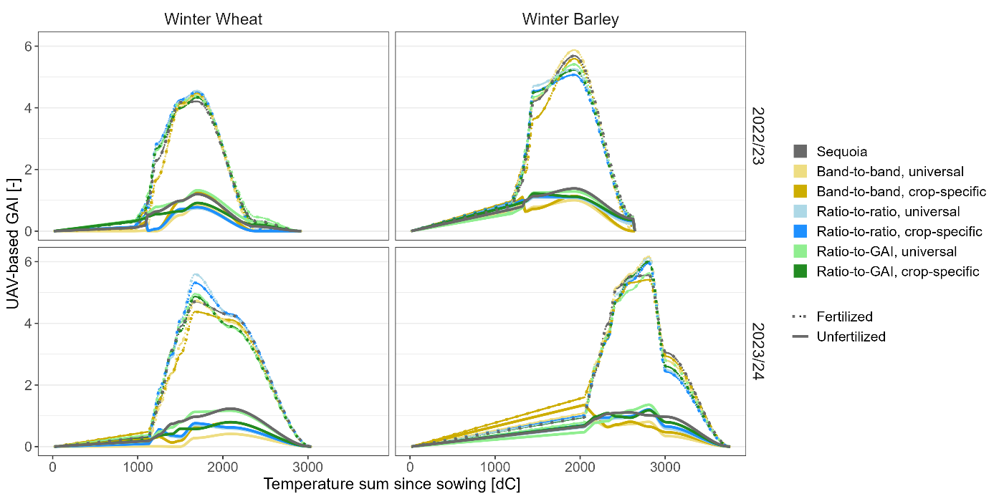
Fig. S1 Average UAV based generated GAI curves by cross-calibration approach, season, crop and N treatment (distinguishing between unfertilized and four fertilized treatments). Due to seasonal instabilities, the GAI of some cross-calibration approaches drops artifactually during growth phases.

