Supplemental 1a: Common intersection measurements for Nicotiana tabacum at 15-35 °C. Shown are means of n=5-7 ± SE.

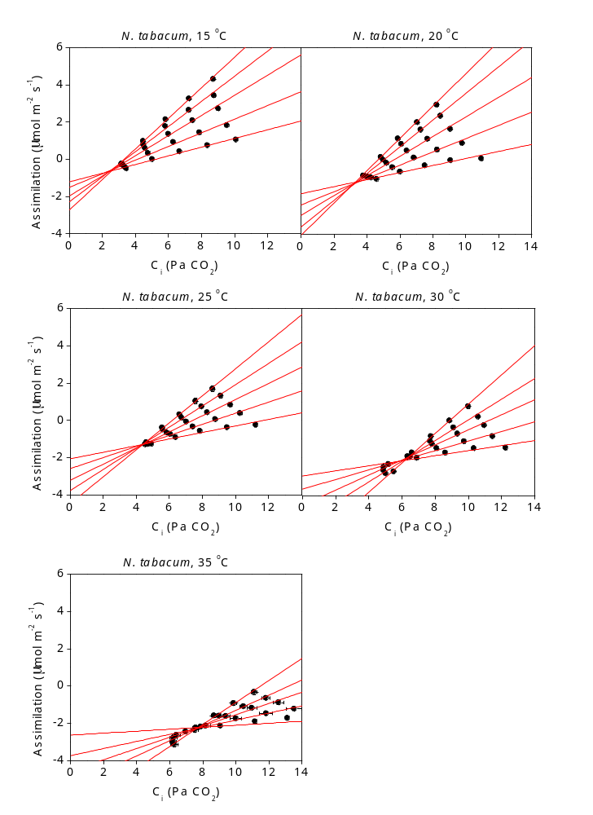

Supplemental 1b: Common intersection measurements for Glycine max at 15-35 °C. Shown are means of n=5-7 ± SE.

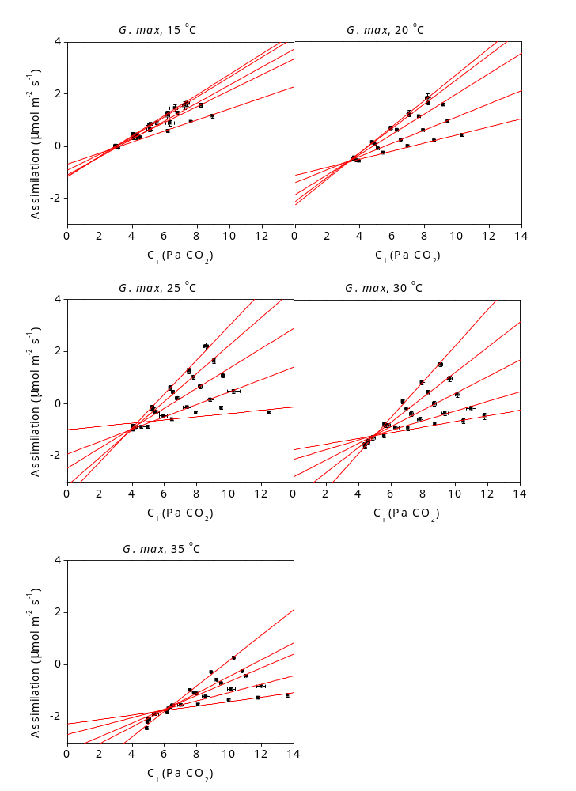

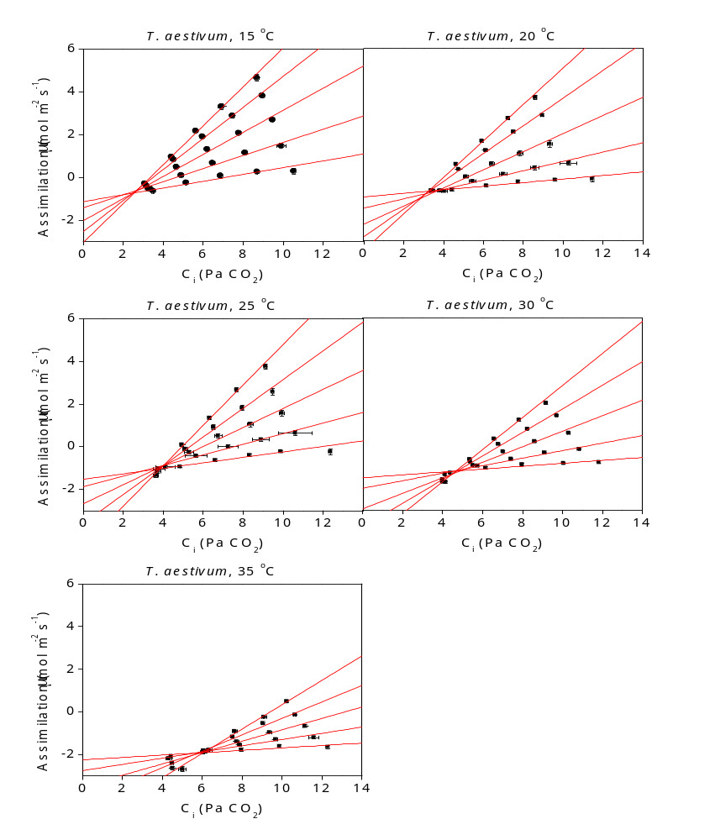

Supplemental 1c: Common intersection measurements for Triticum aestivum at 15-35 °C. Shown are means of n=5-7 ± SE.

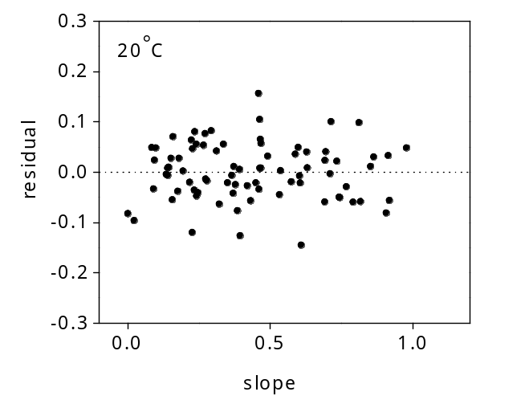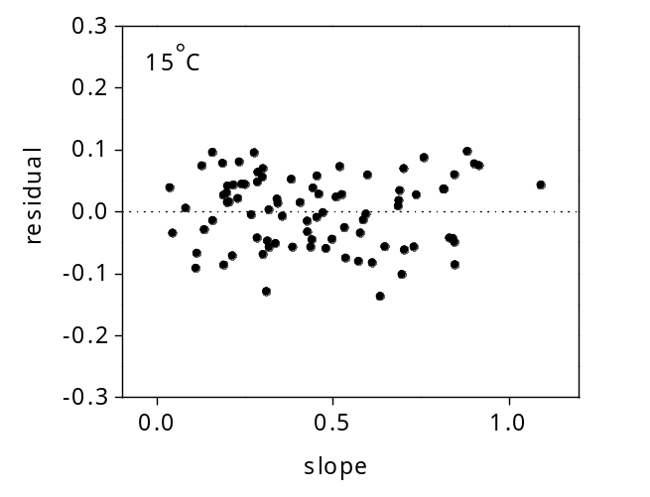Supplemental 2: Residual plot of slope-intercept regressions derived from common intersection measurements in Nicotiana tabacum. Shown are the differences between the measured slope-intercept coordinate and a linear regression used to determine C_{i*} and R_{d} values.
