Supporting Information for

Structural comparison of allophycocyanin variants reveals the molecular basis for their spectral differences
Christopher J. Gisriel^{1,†}, Eduard Elias^{2,†}, Gaozhong Shen³, Nathan T. Soulier^{3,‡}, Gary W. Brudvig^{1,4}, Roberta Croce^{2,}*, and Donald A. Bryant^{3,}*
¹Department of Chemistry, Yale University, New Haven, CT 06520, USA.
²Department of Physics and Astronomy and Institute for Lasers, Life and Biophotonics, Faculty of Sciences, VU University Amsterdam, 1081 HV Amsterdam, Netherlands
³Department of Biochemistry and Molecular Biology, The Pennsylvania State University, University Park, PA 16802, USA.
⁴Department of Molecular Biophysics and Biochemistry, Yale University, New Haven, CT 06520, USA.
*To whom correspondence should be addressed: r.croce@vu.nl and dab14@psu.edu
†These authors contributed equally.
‡Present address: Department of Biology, University of California San Diego, La Jolla, CA 92093, USA.

Supplementary Fig. 1 Schematic overview of the vectors involved in the calculation of the CD and OD signals.
Supplementary Fig. 2 Absorption spectra for allophycocyanin subunits in complexes and isolated subunits.
Supplementary Fig. 3 Sequence alignment of subunits from FRL-AP, AP, and AP-B.
Supplementary Fig. 4 Nomenclature of PBP helices.
Supplementary Fig. 5 Emission spectrum of FRL-AP dissociated by treatment with 3.0 M NaSCN.
.
Supplementary Fig. 1 Schematic overview of the vectors involved in the calculation of the CD and OD signals. The transition dipole moments are directed from the NA to the ND atom for both PCBs. The center-to-center vector is directed between the CHA atom of each PCB.

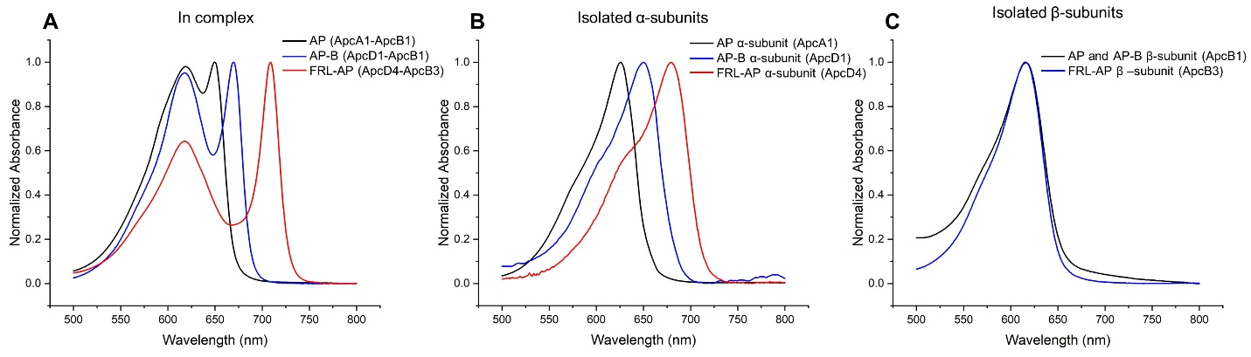

Supplementary Fig. 2 Absorption spectra for AP complexes and their isolated subunits. A Absorbance spectra of oligomeric AP, AP-B, and FRL-AP complexes. Trimeric AP (ApcA1-ApcB1) was produced from the genes of Leptolyngbya sp. JSC-1 expressed in E. coli. Trimeric AP-B (ApcD1-ApcB1) and helical FRL-AP (ApcD4-ApcB3) were produced from Synechococcus sp. A1463 genes. The proteins were produced in and isolated from E. coli and Synechococcus sp. PCC 7002, respectively. B Absorbance spectra of isolated α-subunits. The AP α-subunit (ApcA1) from Synechocystis sp. PCC 6803 was expressed and isolated from E. coli (Zhang et al. 2009). The AP-B and FRL-AP α-subunits (ApcD1 and ApcD4, respectively) from Synechococcus sp. A1463 were produced in and isolated from E. coli and Synechococcus sp. PCC 7002, respectively. C Absorbance spectra of isolated β-subunits. The AP β-subunit (ApcB1) of Leptolyngbya sp. JSC-1 was expressed and isolated from E. coli. The ApcB3 subunit of Synechococcus sp. A1463 was produced in and isolated from Synechococcus sp. PCC 7002 (see Soulier and Bryant (2021) for additional details).

A
FRL-AP MSIVAQVIAQSDAADRFLSSAEIAKLEDFFSKGQVRIRAAQKLAENEQKIVQEGSKRFWA 60
AP MSIVTKSIVNADAEARLYSPGELDRIKGFVTSGERRLRIAQVLTESRECIVKQAGDQLFQ 59
AP-B MSVVSQVILQADDQLRYPTSGELKGIQAFLTTGAQRIRIAETLAENEKKIVDQAQKQLFK 60
**:*:: * ::* * : .*: :: *.:.* *:* *: *:*..: **.:. .:::

FRL-AP KCPNTPSNKGNP---QKTALCQRDQGWYIRLVSYCILAGNDKPLEDIGLNGMREMYISLG 117
AP KRPDVVSPGGNAYGEEMTATCLRDMDYYLRLITYGVVAGDVTPIEEIGLVGVREMYNSLG 119
AP-B KHPEYRAPGGNAYGQRQYNQCLRDYGWYLRLVTYGVLAGNKEPIETTGLIGVKEMYNSLN 120
* *: : ** . * ** .:*:**::* ::**: *:* ** *::*** **.

FRL-AP VPLPNLRVAMSCLKEVAAGILSSEEMALAAPYFDRLIRAF- 157
AP TPIPAVAEAVRCMKSVASSLLSGENAAEAASYFDYVVGAMQ 160
AP-B VPVPGMVDAVTVLKDAALGLLSAEDANETAPYFDYIIQFMS 161
.*:* : *: :*..* .:**.*: :* *** :: :

B
FRL-AP MKDTITSLINPADEKGSYLDAAALEQLNRYFQSGNMRVKAAKTISSSASSIISKTVAKSL 60
AP MQDAITAVINSSDVQGKYLDGSAMEKLKAYFQTGKLRVRAATTISANAAEIVKDAVAKSL 60
AP-B MQDAITAVINSADVQGKYLDGAAMDKLKSYFASGELRVRAASVISANAATIVKEAVAKSL 60
*:*:**::** :* :*.***.:*:::*: ** :*::**:**..**:.*: *:..:*****

FRL-AP LYGDITLPGGNMYPTRRYAACLRDLTYFLRYATYAMLAADPSILDERVLQGLKETYITLG 120
AP LYSDITRPGGNMYTTRRYAACIRDLDYYLRYSTYAMLAGDPSILDERVLNGLKETYNSLG 120
AP-B LYSDVTRPGGNMYTTRRYAACIRDLDYYLRYATYAMLAGDASILDERVLNGLKETYNSLG 120
**.*:* ****** *******:*** *:***:******.* ********:****** :**

FRL-AP VPIDRVIQALNAMKEVLTESLDTEASQEMAVYLDHIIAGLS 161
AP VPVGATVQAIQAMKEVTATLVGADAGKEMGVYFDY------ 155
AP-B VPISSTVQAIQAIKEVTASLVGADAGKEMGVYLDYICSGLS 161
**:. .:**::*:*** : :.::*.:**.**:*:

Supplementary Fig. 3 Sequence alignment of subunits from FRL-AP, AP, and AP-B. A Alignment of α-subunits. B Alignment of β-subunits. Clustal Omega sequence conservation identifiers are shown below each position. The Cys residue providing the thioester linkage to the phycocyanobilin chromophore for each subunit is in bold font. The sequences for FRL-AP, AP, and AP-B are from species Synechococcus sp. A1463, Phormidium sp. A09DM, and Synechocystis sp. PCC 6803, respectively.

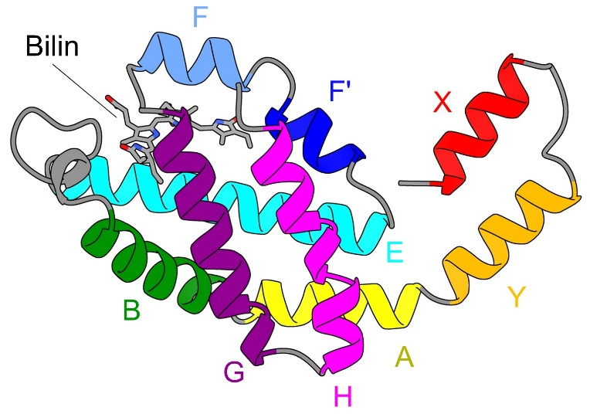

Supplementary Fig. 4 Nomenclature of PBP helices. The structure of the α-subunit from AP, ApcA1, is shown (Sonani et al. 2015). Helices are labeled as first described in Schirmer et al. (Schirmer et al. 1986). The phycocyanobilin (bilin) chromophore is additionally shown.

Supplementary Fig. 5 Emission spectrum of FRL-AP dissociated by treatment with 3.0 M NaSCN. The excitation wavelength was 580 nm.

