Supporting information
Chirality distribution in the fifth ligand coordination of chlorophylls-c in photosynthetic pigment–protein complexes

Toru Oba ^{a,}* and Hitoshi Tamiaki ^{b}

ª Department of Applied Chemistry, Faculty of Engineering, Utsunomiya University, 7-1-2 Yoto, Utsunomiya, Tochigi 321-8585, Japan
^{b} Graduate School of Life Sciences, Ritsumeikan University, Noji-higashi 1-1-1, Kusatsu, Shiga 525-8577, Japan

Contents

Table S1. α/β-ligation of (B)Chl molecules examined previously…………… S2
Table S2. Ligand coordination in LHCIIs…………………………………….. S3–S4
Fig. S1. Chl-c₁/c₂ molecules with axial ligands in 6A2W……………………...S5
Fig. S2. Chl-c₁/c₂ molecules with axial ligands in 9KQB……………………... S6–S12
Fig. S3. Chl-c₂ molecules with axial ligands in 9KZ9………………………… S13–S18
Fig. S4. Chl-c₂ molecules with axial ligands in 8WB4………………………... S19–S20
Fig. S5. Chl molecules at the a603 site………………………………………... S21–S22
References……………………………………………………………………... S23–S24

Table S1. The numbers of the ligand-coordinated macrocycle side of (B)Chl molecules examined in our previous studies based on 42 pigment-protein complexes (asymmetric units) [1–3].
Proteins | α-side | β-side | Ligand unidentified | Notes
Purple bacterial RC | 4/4 | 0/4 | 0/4 | Including RCs with BChl-a and BChl-b ^{a)}
Purple bacterial LH | 1/3 | 2/3 | 0/3 | Including LH1, LH2, and LH3 ^{b)}
FMO | 5/7 | 2/7 | 0/7 | The 6-coordinated ‘BChl-8’ is excluded.
Peridinin-Chl-protein | 1/1 | 0/1 | 0/1 | Including complexes of Chl-a, Chl-b, Chl-d, and BChl-a
PS1 RC | 6/6 | 0/6 | 0/6
core antenna | 74/90 | 14/90 | 2/90 | Based on 1JB0
PS2 RC | 6/6 | 0/6 | 0/6
PS2 core antenna | 20/29 | 9/29 | 0/29 | Based on 3ARC
LHCII | 11/14 | 3/14 | 0/14
Cyt b₆f | 1/1 | 0/1 | 0/1
WSCP | 0/1 | 1/1 | 0/1
Protochlorophyllide a reductase | 0/1 | 1/1 | 0/1
- RC with BChl-a (geranylgeranyl ester) has also been resolved later [4].
- LHs with BChl-a (geranylgeranyl ester) and BChl-b have also been resolved later [4,5].

Table S2a. Ligand coordination in normal LHCIIs (1RWT [10] and 8Y15 [11]).
1rwt |  |  | 8y15
pigment | macro-cycle side of ligand coordi-nation | ligand | pigment | macro-cycle side of ligand coordi-nation | ligand
CHL601 | β | α-C=O-Tyr24 | CHL601 | β | α-C=O-Tyr24
CLA602 | α | Glu65 | CLA602 | α | Glu65
CLA603 | β | His68 | CLA603 | β | His68
CLA604 | α | HOH7631 | CLA604 | α | HOH706
CHL605 | α | α-C=O-Val119 | CHL605 | α | α-C=O-Val119
CHL606 | α | HOH7632 | CHL606 | α | HOH703
CHL607 | α | HOH7630 | CHL607 | α | HOH713
CHL608 | α | HOH7624 | CHL608 | α | HOH728
CHL609 | α | Glu139 | CHL609 | α | Glu139
CLA610 | α | Glu180 | CLA610 | α | Glu180
CLA611 | α | PO₄-LHG2630 | CLA611 | α | PO₄-LHG1005
CLA612 | β | Asn183 | CLA612 | β | Asn183
CLA613 | α | Gln197 | CLA613 | α | Gln197
CLA614 | α | His212 | CLA614 | α | His212
CHL: Chl-b, CLA: Chl-a.

Table S2b. Ligand coordination in LHCII and its analog (8YEE: reconstituted LHCII [11], 9UC6: a LHCII-like complex containing Dvp from prasinophyte [12]).
8yee |  |  | 9uc6
pigment | macro-cycle side of ligand coordi-nation | ligand | pigment | macro-cycle side of ligand coordi-nation | ligand
CHL601 | β | α-C=O-Tyr24 | – ^{a)}
CLA602 | α | Glu65 | CLA301 | α | Glu61
CLA603 | β | His68 | CHL302 | α | His64
CLA604 | α | HOH704 | CLA303 | α | HOH442
CHL605 | α | α-C=O-Val119 | CHL304 ^{b)} | α | α-C=O-Leu112
CHL606 | α | HOH710 | CHL305 | α | HOH441
CHL607 | α | HOH717 | CHL306 | α | HOH406
CHL608 | α | HOH714 | CLA307 | α | HOH420
CHL609 | α | Glu139 | A1LOF308 ^{c)} | α | Glu137
CLA610 | α | Glu180 | CLA309 | α | Glu181
CLA611 | α | PO₄-LHG618 | CLA310 | α | Glu37
CLA612 | β | Asn183 | CLA311 | β | His184
CLA613 | α | Gln197 | CLA312 | α | Gln198
CLA614 | α | His212 | CHL313 | α | His213
 |  |  | CHL314 ^{b,d)} | α | α-C=O-Pro106
CHL: Chl-b, CLA: Chl-a.
- b601 in normal LHCII is absent.
- On the loop between A and C-helices.
- Dvp.
- Not exists in normal LHCII.

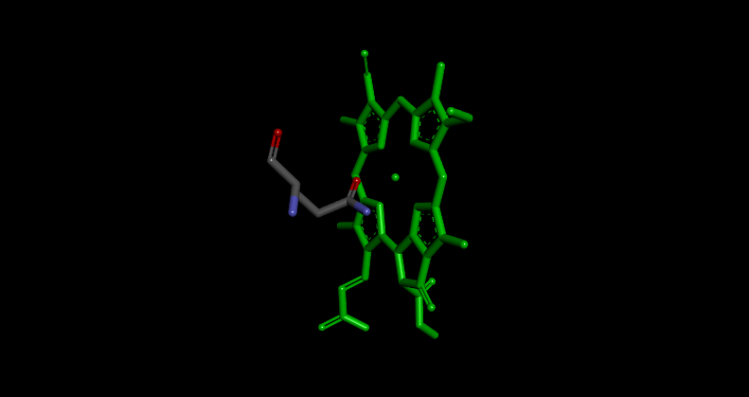
6a2w-A-KC1408: β-Chl-c₁ with Gln143

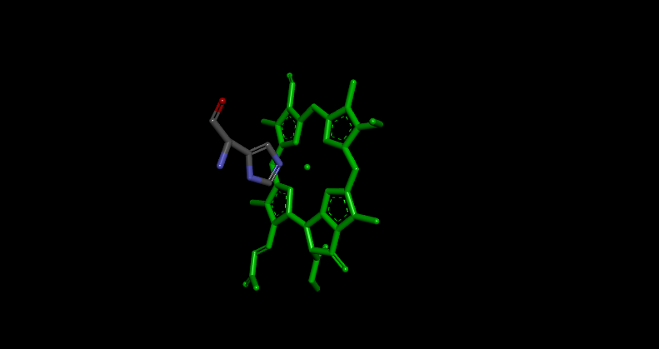
6a2w-A-KC2403: β-Chl-c₂ with His39

Fig. S1. Chl-c₁/c₂ molecules with axial ligands in FCP (PDB ID: 6A2W) [6].

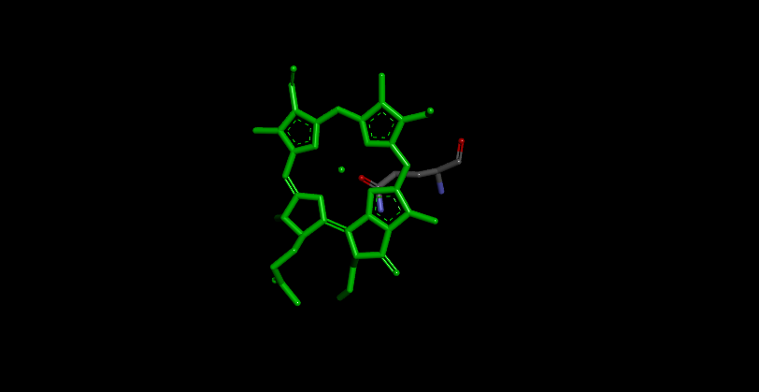
9kqb-1-315: α-Chl-c with Gln124

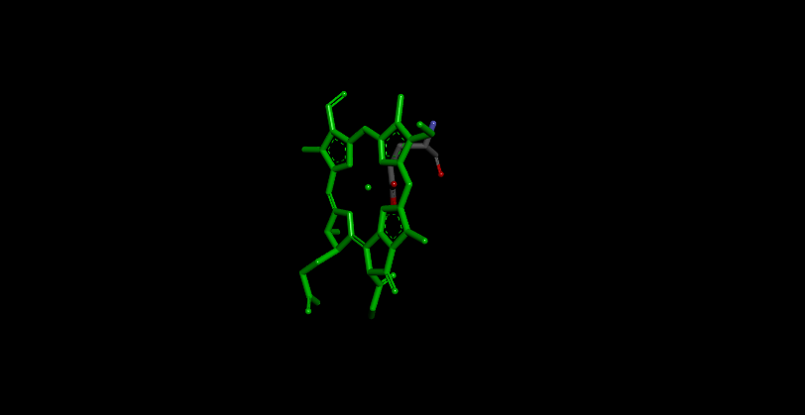
9kqb-1-316: α-Chl-c with Glu173

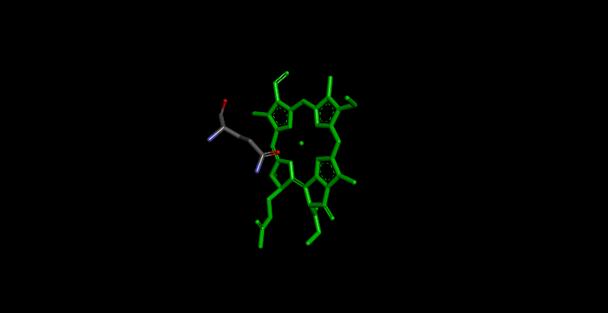
9kqb-2-313: β-Chl-c with Gln128

Fig. S2. Chl-c₁/c₂ molecules with(out) axial ligands in FCPII (PDB ID: 9KQB) [7].

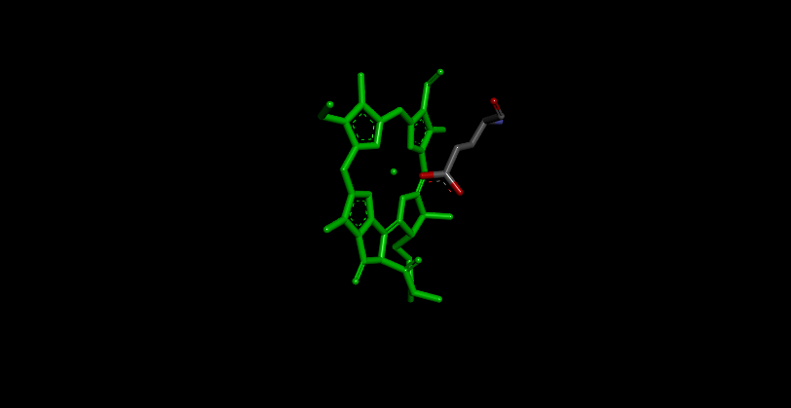
9kqb-2-314: α-Chl-c with Glu194

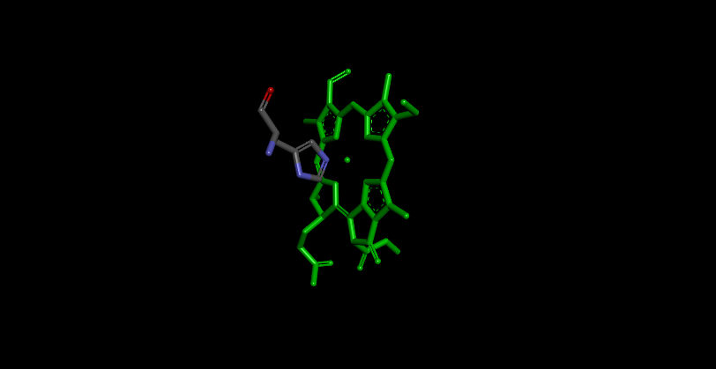
9kqb-2-315: β-Chl-c with His75

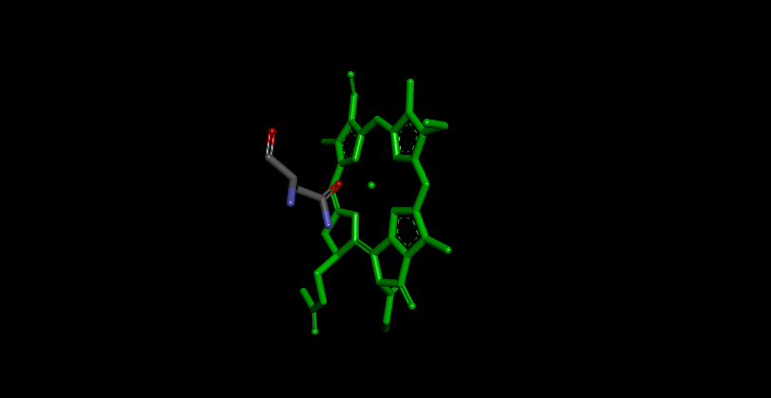
9kqb-2-316: β-Chl-c with Asn197

Fig. S2. (continued)

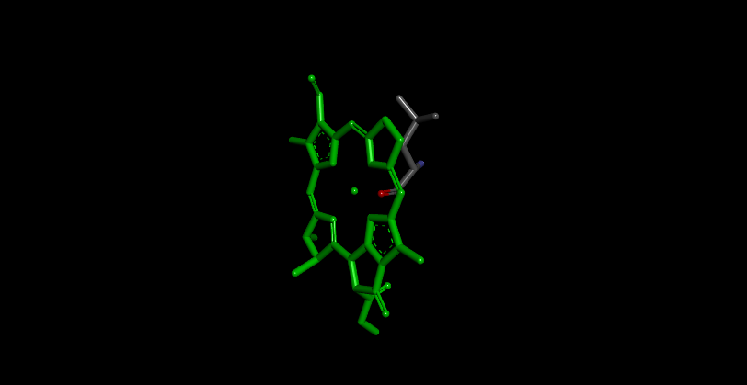
9kqb-4-306: α-Chl-c with Leu103

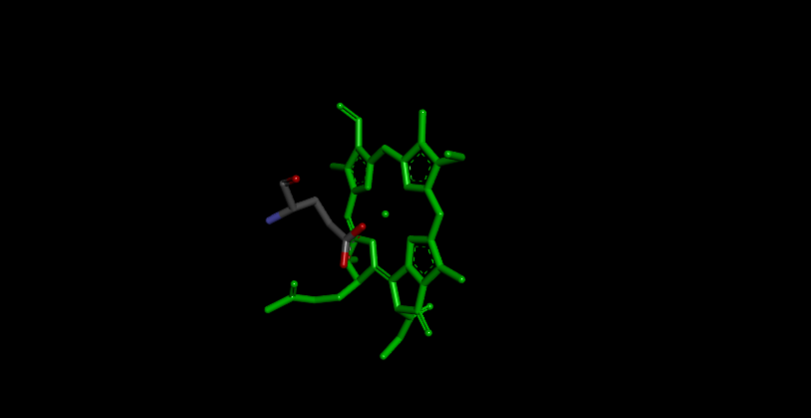
9kqb-4-307: β-Chl-c with Glu138

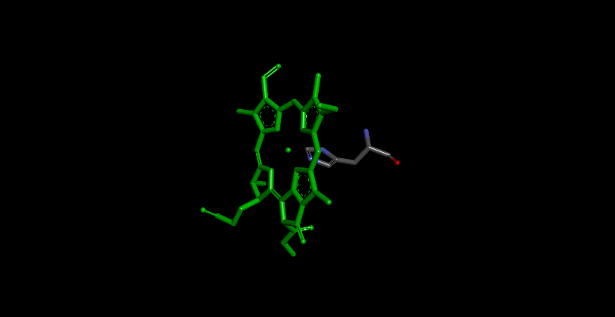
9kqb-4-308: α-Chl-c with His128

Fig. S2. (continued)
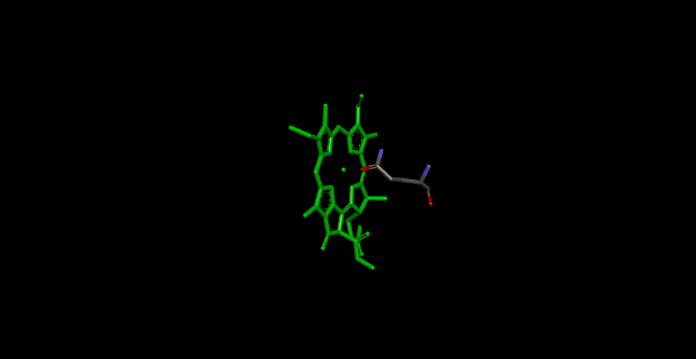
9kqb-4-309: α-Chl-c with Gln89

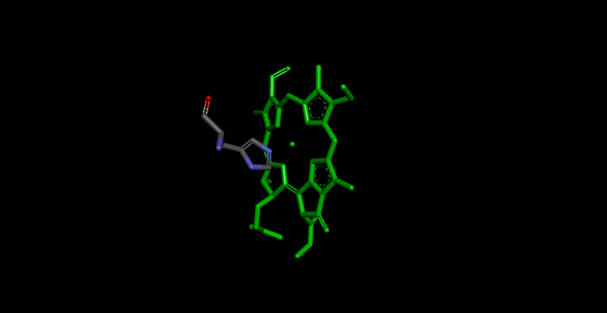
9kqb-5-313: β-Chl-c with His163

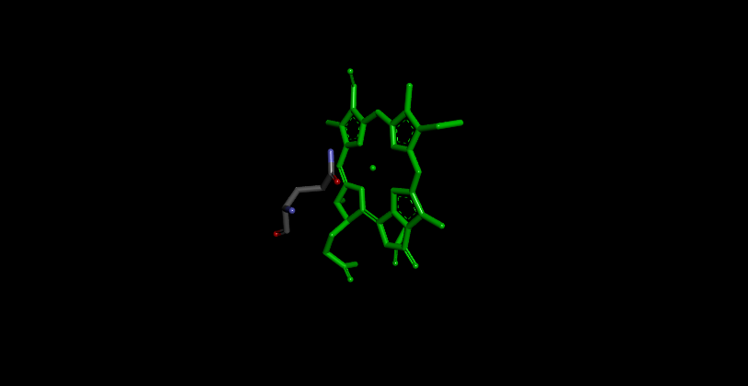
9kqb-5-314: β-Chl-c with Gln124

Fig. S2. (continued)

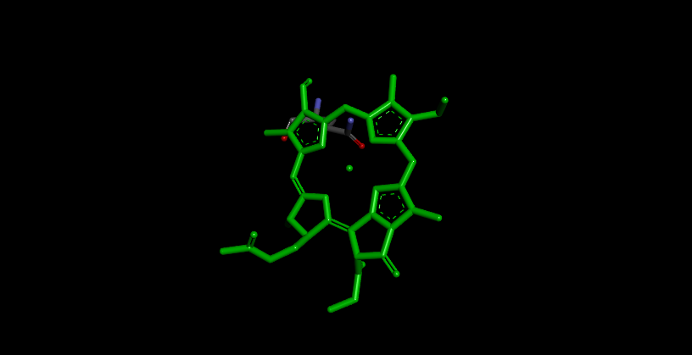
9kqb-5-315: Chl-c and Gln162 (α-side)

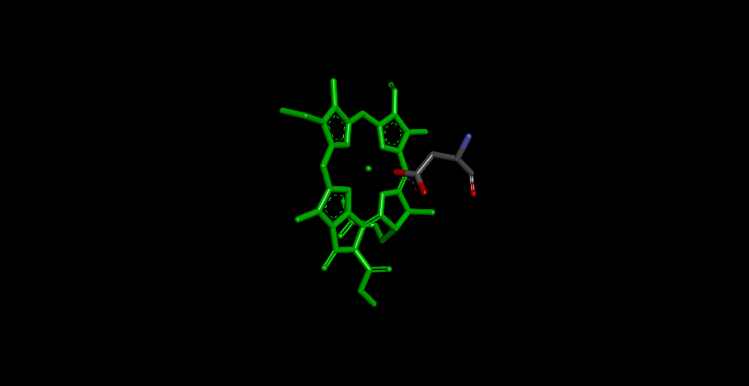
9kqb-6-311: α-Chl-c with Asp98

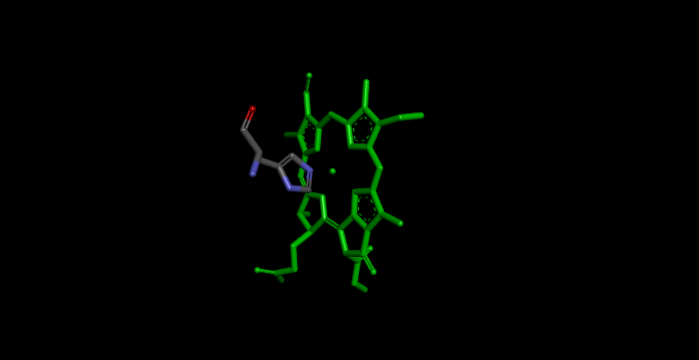
9kqb-6-312: β-Chl-c with His128

Fig. S2. (continued)
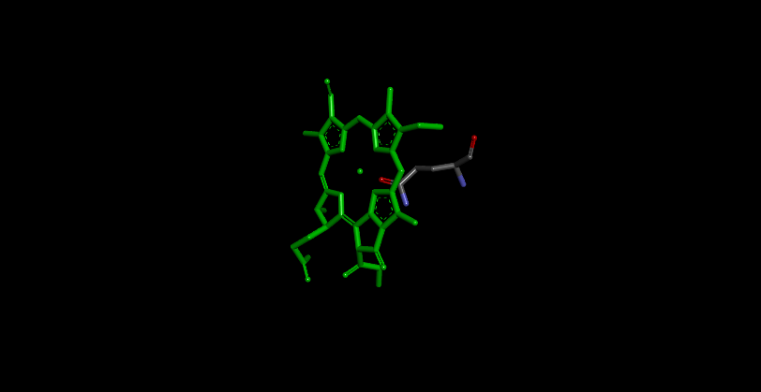
9kqb-6-313: α-Chl-c with Gln89

Fig. S2. (continued)

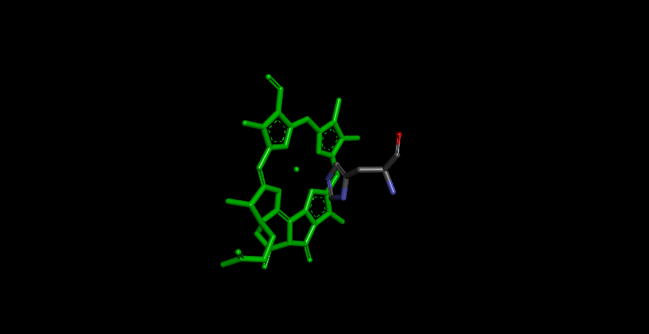
9kz9-c-310: β-Chl-c₂ with His183

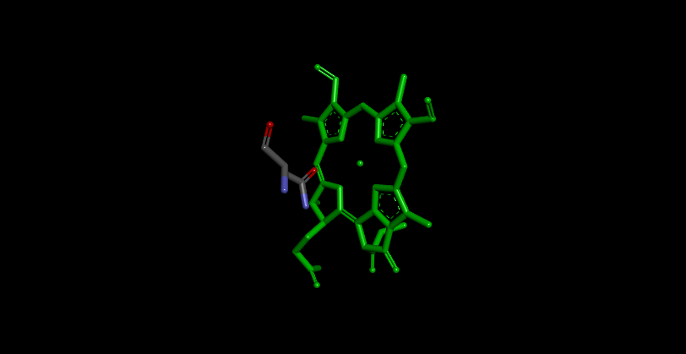
9kz9-d-311: β-Chl-c₂ with Asn184

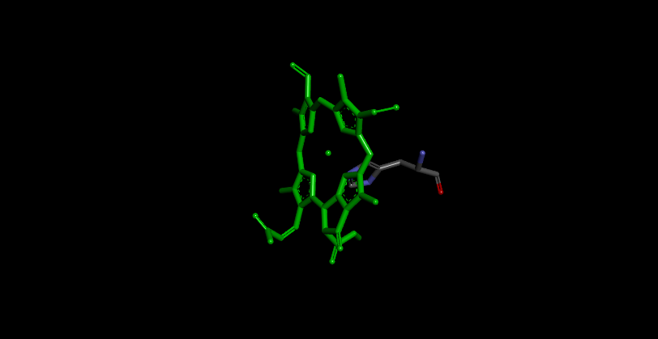
9kz9-d-312: α-Chl-c₂ with His198

Fig. S3. Chl-c₂ molecules with(out) axial ligands in ACPI (PDB ID: 9KZ9) [8].

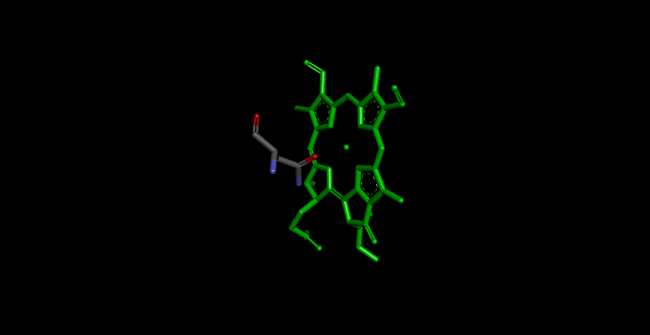
9kz9-e-309: β-Chl-c₂ with Asn170

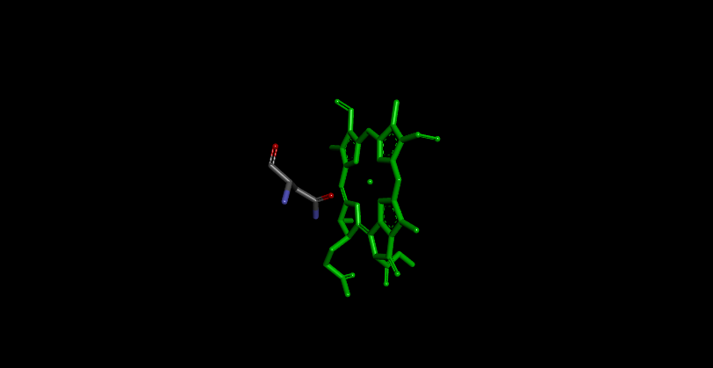
9kz9-f-611: β-Chl-c₂ with Asn181

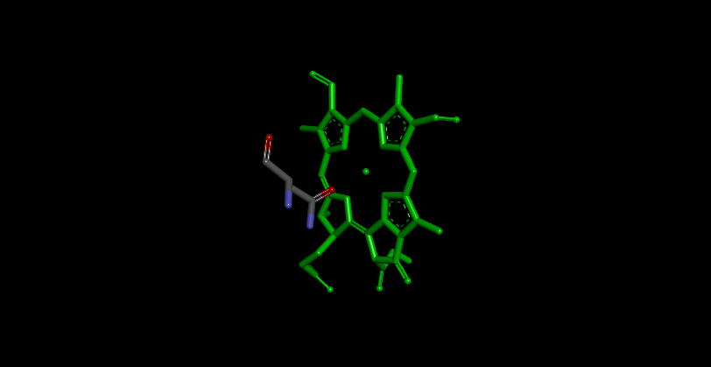
9kz9-g-313: β-Chl-c₂ with Asn194

Fig. S3. (continued)
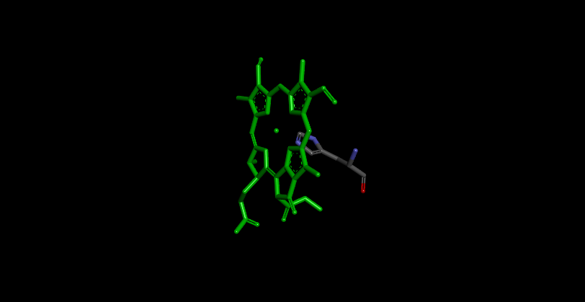
9kz9-g-314: α-Chl-c₂ with His208

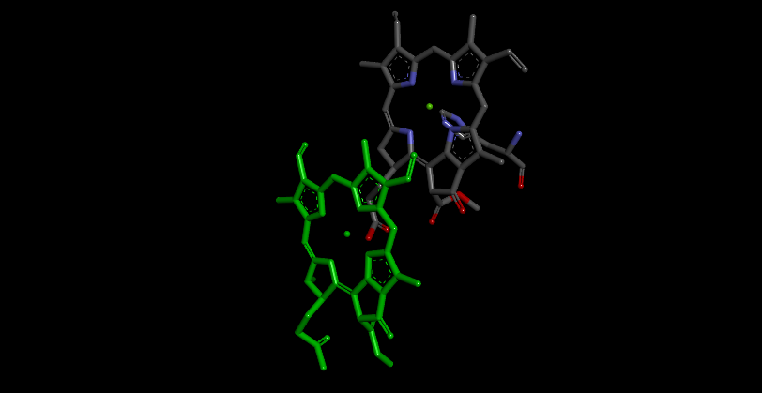
9kz9-g-315: α-Chl-c₂ with KC2314

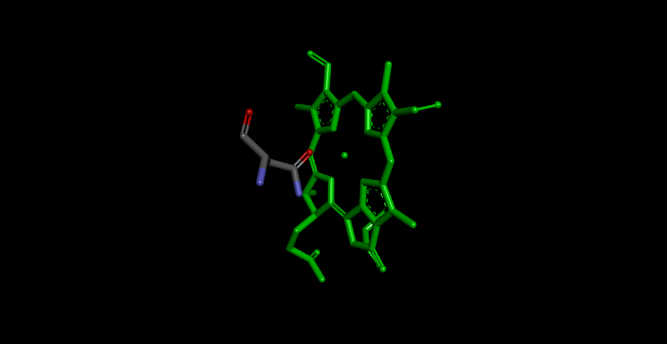
9kz9-i-310: β-Chl-c₂ with Asn183

Fig. S3. (continued)
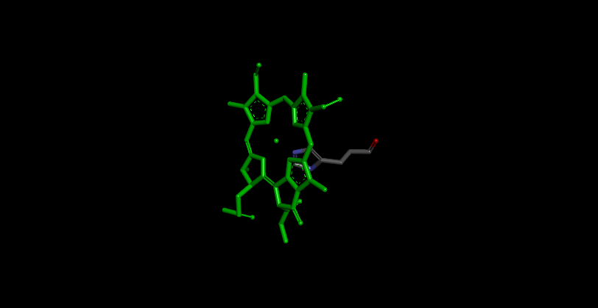
9kz9-i-318: α-Chl-c₂ with His137

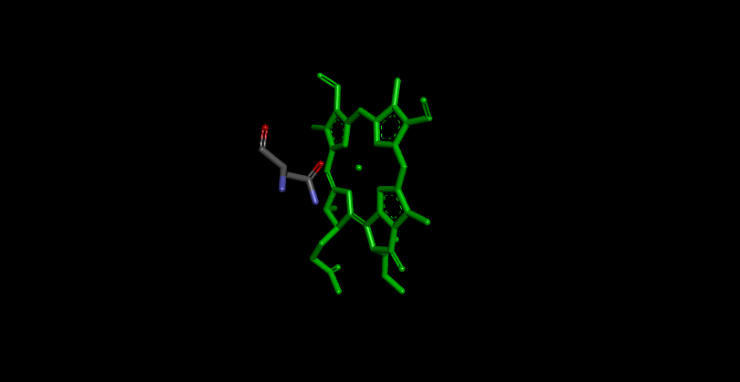
9kz9-j-312: β-Chl-c₂ with Asn181

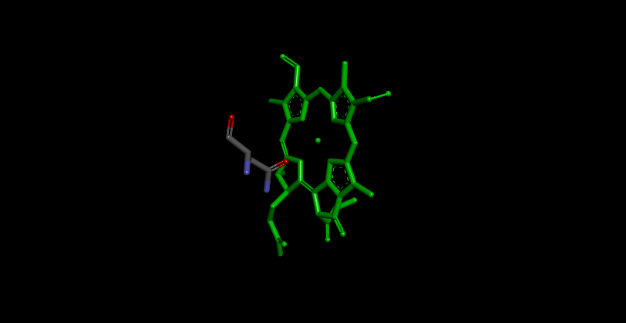
9kz9-k-611: β-Chl-c₂ with Asn196

Fig. S3. (continued)
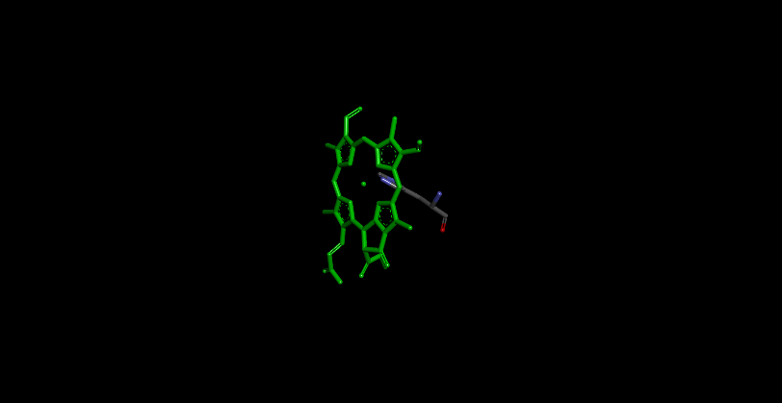
9kz9-k-612: α-Chl-c₂ with His210

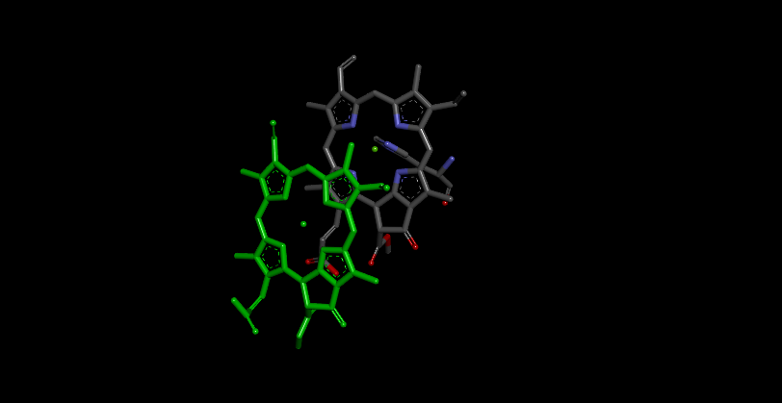
9kz9-k-613: Chl-c₂ and KC2612 (α-side)

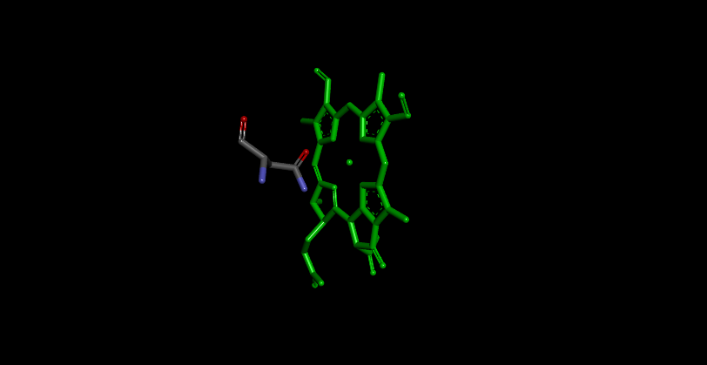
9kz9-l-311: β-Chl-c₂ with Asn178

Fig. S3. (continued)
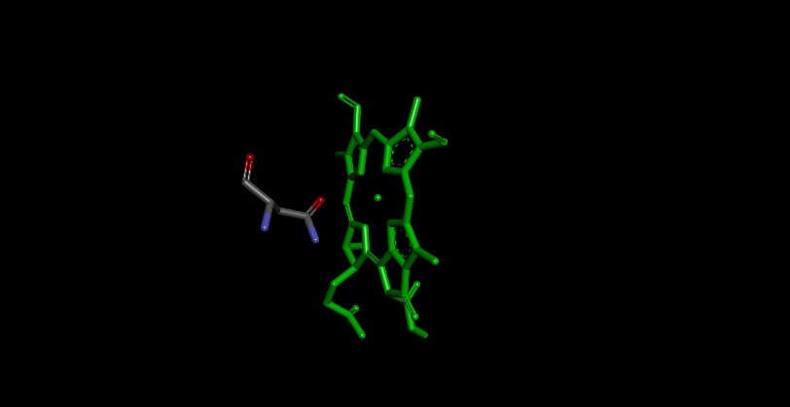
9kz9-m-611: β-Chl-c₂ with Asn181

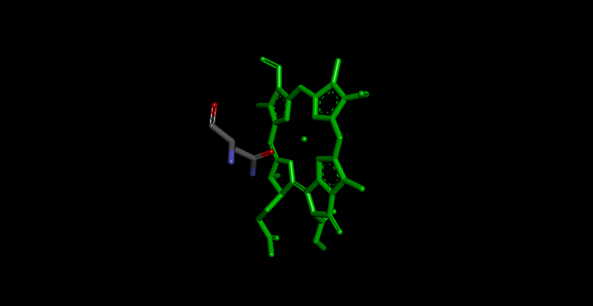
9kz9-n-611: β-Chl-c₂ with Asn195

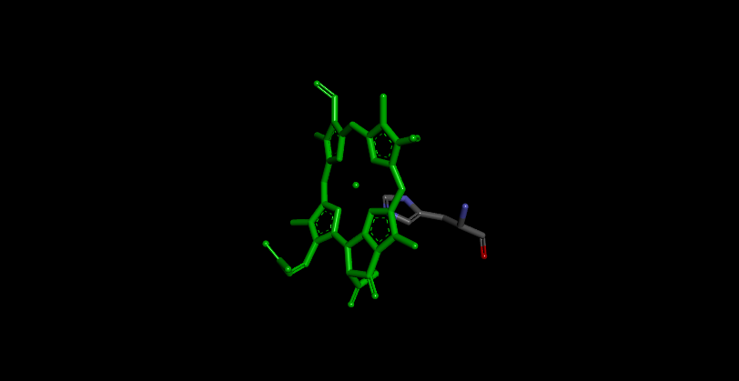
9kz9-n-612: α-Chl-c₂ with His209

Fig. S3. (continued)

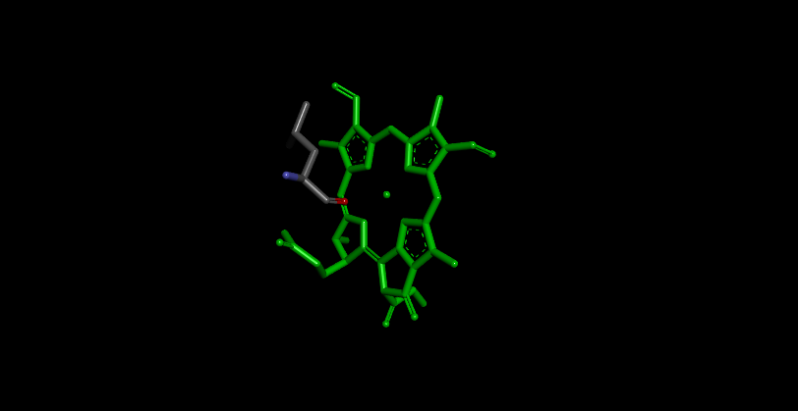
9kz9-s-401: β-Chl-c₂ with Leu128

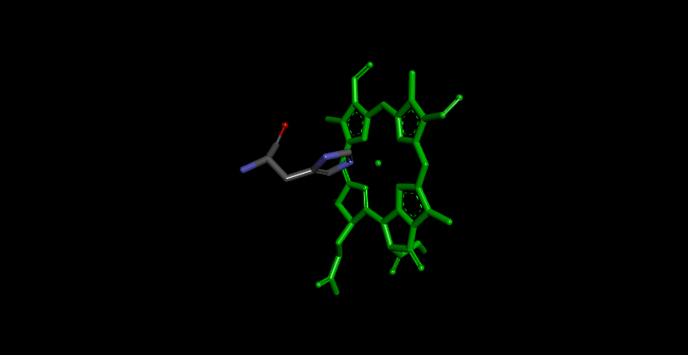
9kz9-s-404: β-Chl-c₂ with His146

Fig. S3. (continued)

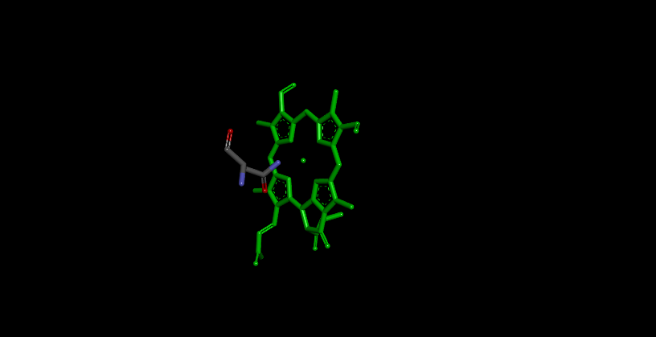
8wb4-1-610: β-Chl-c₂ with Asn196

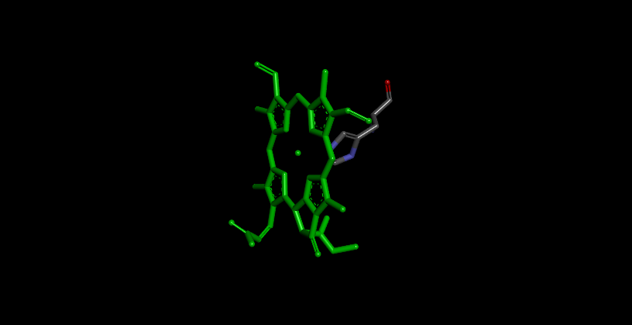
8wb4-2-610: α-Chl-c₂ with His184

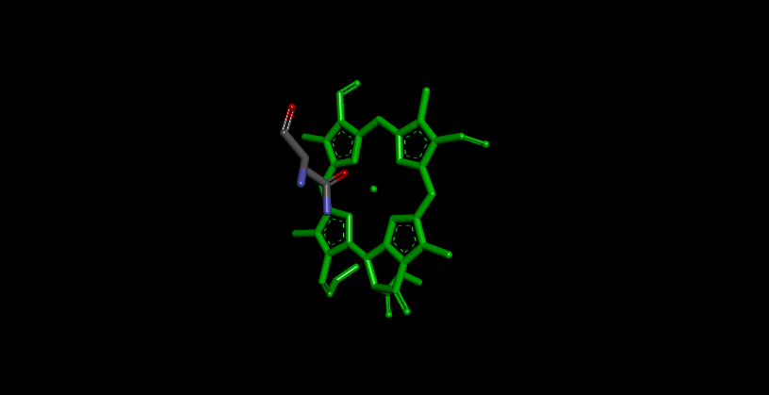
8wb4-4-610: β-Chl-c₂ with Asn195

Fig. S4. Chl-c₂ molecules with axial ligands in ACPII (PDB ID: 8WB4) [9].

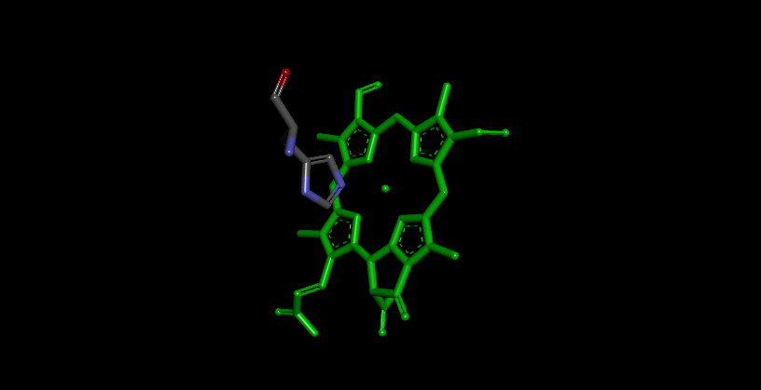
8wb4-5-311: β-Chl-c₂ with His177

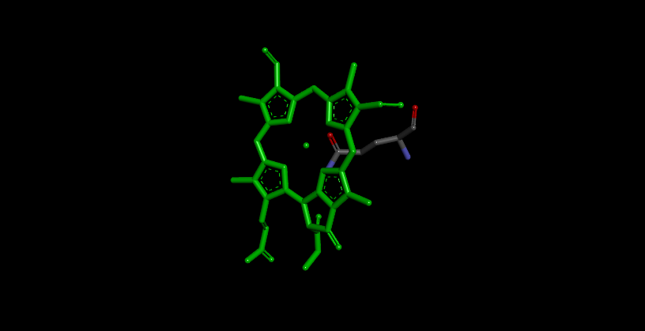
8wb4-6-605: α-Chl-c₂ with Gln131

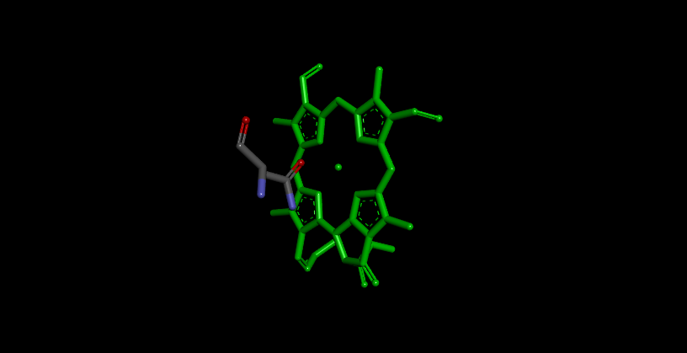
8wb4-6-609: β-Chl-c₂ with Gln187

Fig. S4. (continued)

a)
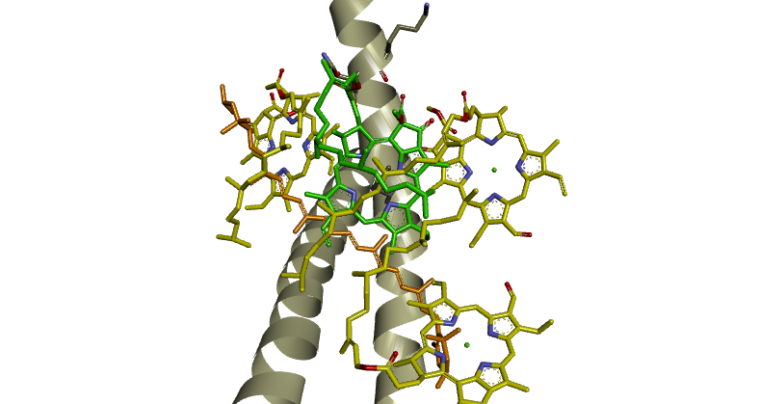

b)
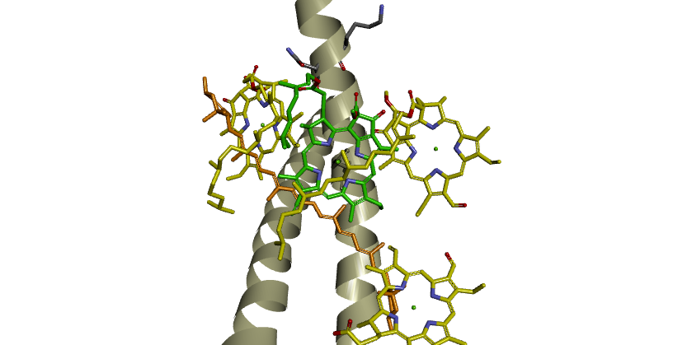
Fig. S5. Chl molecules at the a603 site (green). a) A normal LHCII (PDB ID: 1RWT) [10] and b) a normal LHCII (PDB ID: 8Y15) [11]. Neighboring Chls-a/b (a602, b607, and b609, yellow), lutein (orange), and peptidyl residues (gray) are also shown.
c)
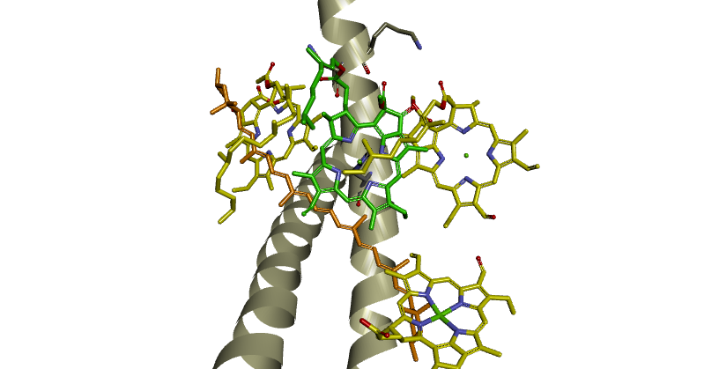

d)
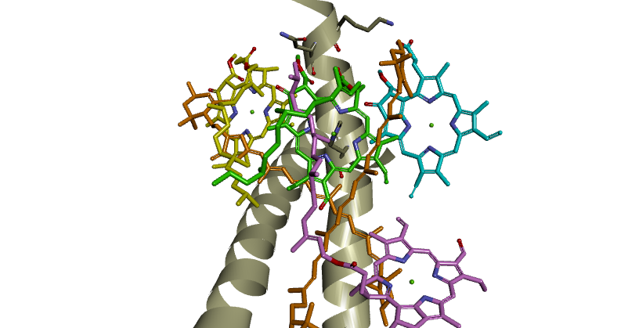
Fig. S5. (continued) Chl molecules at the a603 site (green). c) A reconstituted LHCII (PDB ID: 8YEE) [11]. Neighboring Chls-a/b (a602, b607, and b609, yellow), lutein or fucoxanthin (orange), and peptidyl residues (gray) are also shown. d) An LHCII-like complex containing Dvp (sky blue) from prasinophyte (PDB ID: 9UC6) [12]. Chl-b (CHL306 corresponding to a603, green; CHL307 corresponding to a607, pink), Chl-a (CLA302 corresponding to a602, yellow), lutein or fucoxanthin (orange), and peptidyl residues (gray) are also shown.
References
[1] T. Oba, H. Tamiaki, Effects of peripheral substituents on diastereoselectivity of the fifth ligand-binding to chlorophylls, and nomenclature of the asymmetric axial coordination sites, Bioorg. Med. Chem. 13 (2005) 5733–5739. https://doi.org/10.1016/j.bmc.2005.06.016
[2] T. Oba, H. Tamiaki, Which side of the π-macrocycle plane of (bacterio)chlorophylls is favored for binding of the fifth ligand?, Photosynth. Res. 74 (2022) 1–10. https://doi.org/10.1023/A:1020816128794
[3] T. Oba, H. Tamiaki, Asymmetry of chlorophylls in photosynthetic proteins: from the viewpoint of coordination chemistry, J. Porphyr. Phthalocyanines 18 (2014) 919–932. https://doi.org/10.1142/S1088424614500710
[4] K. Tani, R. Kanno, X.-C. Ji, M. Hall, L.-J. Yu, Y. Kimura, M.T. Madigan, A. Mizoguchi, B.M. Humbel, Z.-Y. Wang-Otomo, Cryo-EM structure of the photosynthetic LH1-RC complex from Rhodospirillum rubrum, Biochemistry 60 (2021) 2483–2491. https://doi.org/10.1021/acs.biochem.1c00360
[5] P. Qian, A. Siebert, P. Wang, D.P. Canniffe, N. Hunter, Cryo-EM structure of the Blastochloris viridis LH1–RC complex at 2.9 Å, Nature 556 (2018) 203–208. https://www.nature.com/articles/s41586-018-0014-5
[6] W. Wang, L.-J. Yu, C. Xu, T. Tomizaki, S. Zhao, Y. Umena, X. Chen, X. Qin, Y. Xin, M. Suga, G. Han, T. Kuang, J.-R. Shen, Structural basis for blue-green light harvesting and energy dissipation in diatoms, Science 363 (2022) eaav0365. https://doi.org/10.1126/science.aav0365
[7] R. La Rocca, K. Kato, P.-C. Tsai, Y. Nakajima, F. Akita, J.-R. Shen, Structure of a photosystem II-FCPII supercomplex from a haptophyte reveals a distinct antenna organization, Nat. Commun. 16 (2025) 4175. https://doi.org/10.1038/s41467-025-59512-9
[8] W. Zhang, N. Yonehara, M. Ishii, H. Jiang, R. La Rocca, P.-C. Tsai, H. Li, K. Kato, F. Akita, J.-R. Shen, Structural analysis of PSI-ACPI and PSII-ACPII supercomplexes from a cryptophyte alga Rhodomonas sp. NIES-2332, Front. Plant Sci. 16 (2025) 1716939. https://doi.org/10.3389/fpls.2025.1716939
[9] Z. Mao, X. Li, Z. Li, L. Shen, Y. Yang, W. Wang, T. Kuang, J.-R. Shen, G. Han, Structure and distinct supramolecular organization of a PSII-ACPII dimer from a cryptophyte alga Chroomonas placoidea, Nat. Commun. 15 (2024) 4535. https://doi.org/10.1038/s41467-024-48878-x
[10] Z. Liu, H. Yan, K. Wang, T. Kuang, J. Zhang, L. Gui, X. An, W. Chang, Crystal structure of spinach major light-harvesting complex at 2.72 Å resolution, Nature 428 (2004) 287–292. https://doi.org/10.1038/nature02373
[11] S. Seki, T. Miyata, N. Norioka, H. Tanaka, G. Kurisu, K. Namba, R. Fujii, Structure-based validation of recombinant light-harvesting complex II, PNAS Nexus 3 (2024) pgae405. https://doi.org/10.1093/pnasnexus/pgae405
[12] S. Seki, M. Kubota, N. Yamano, E. Kim, A. Ishii, T. Miyata, H. Tanaka, R.J. Cogdell, J.-P. Zhang, K. Namba, G. Kurisu, J. Minagawa, R. Fujii, Distinctive and functional pigment arrangements in Lhcp, a prasinophyte-specific photosynthetic light-harvesting complex, Commun. Biol. 8 (2025) 1586. https://doi.org/10.1038/s42003-025-08977-x

* Corresponding author. Tel.: +81-28-689-6147; fax: +81-28-689-6147; e-mail: tob_p206@cc.utsunomiya-u.ac.jp (T. Oba)

