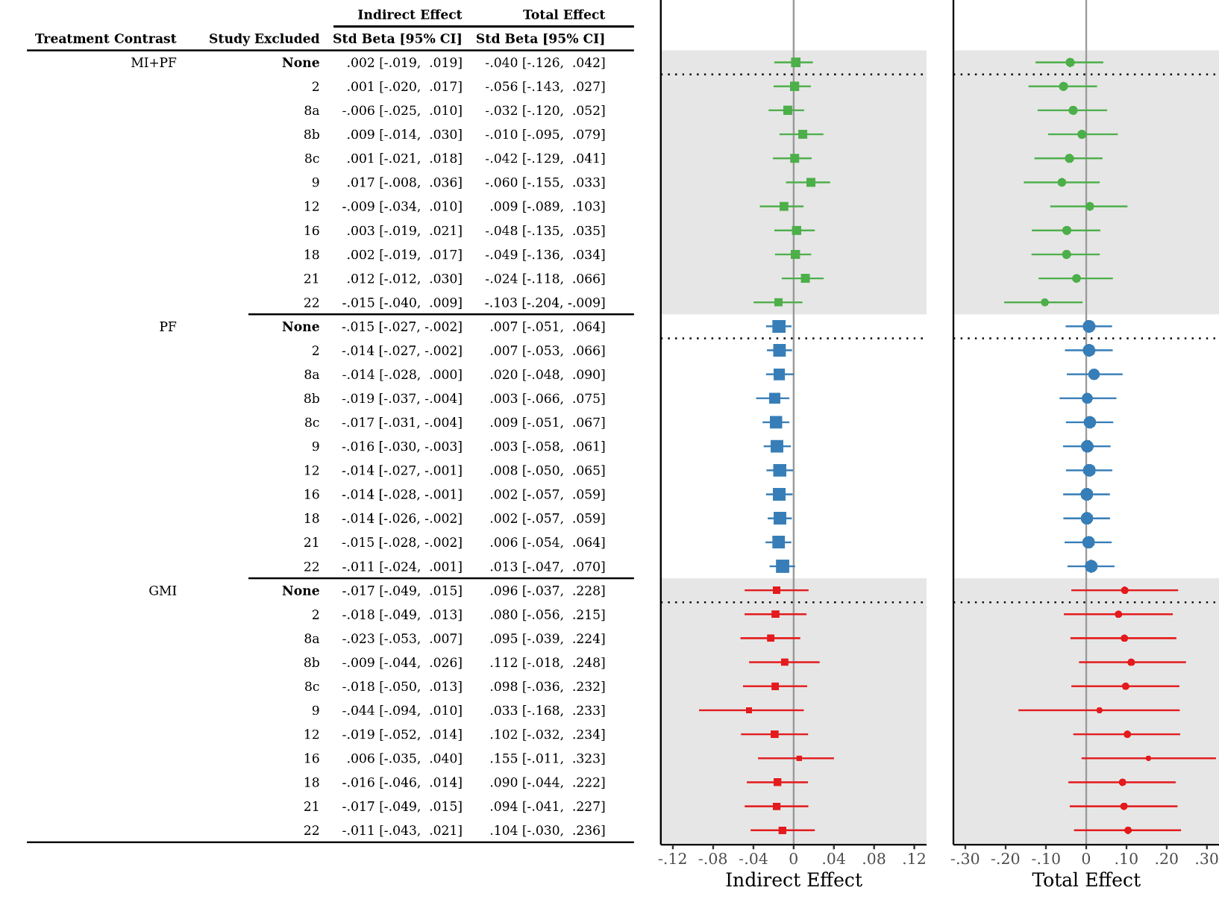
Supplemental Figure. Results of the leave-one-out cross-validation analysis. Std Beta = Standardized Beta, with respect to the outcome only; CI = Confidence Interval; MI+PF = Individually delivered Motivational Interviewing with Personalized Feedback (green-colored estimates); PF = Stand-alone Personalized Feedback (blue-colored estimates); GMI = Group Motivational Interviewing (red-colored estimates).

