Supplementary Materials 1

Association of Parent Contact with Parent Engagement

Outcome: Parent Use of handbook

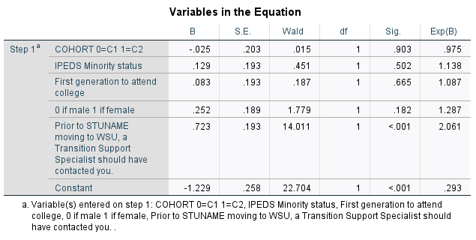

2. Association of Parent Engagement with Student Outcomes

ALCOHOL

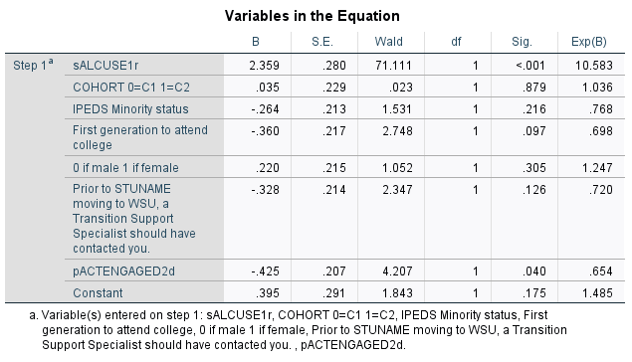

CANNABIS
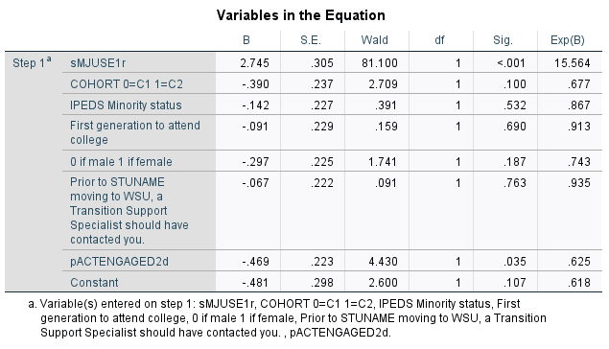

SIMULTANEOUS USE ALCOHOL and CANNABIS
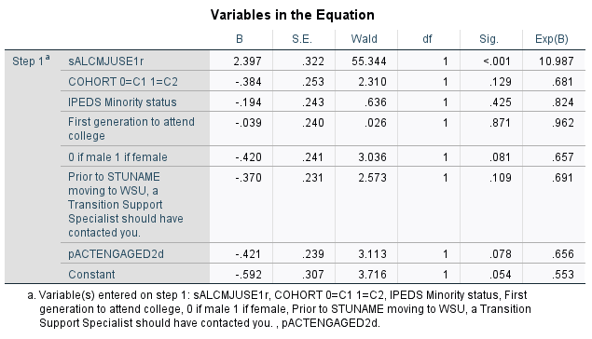

2 WK BINGE
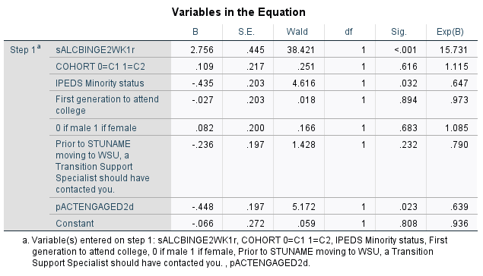

30 DAY HEAVY
