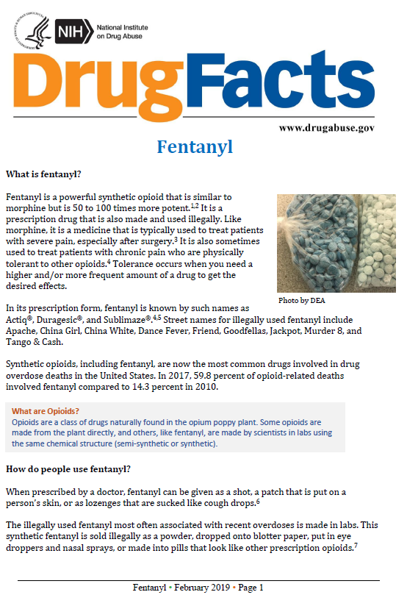
Supplemental Figure 2a. Opioid education workshop, general overview of opioids
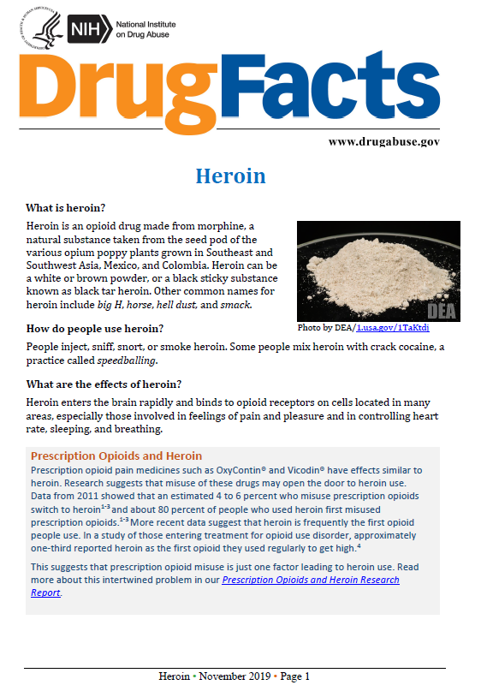

Originally published in D'Amico, E. J., Dickerson, D. L., Rodriguez, A., Brown, R. A., Kennedy, D. P., Palimaru, A. I., Johnson, C., Smart, R., Klein, D. J., Parker, J., McDonald, K., Woodward, M. J., & Gudgell, N. (2021). Integrating traditional practices and social network visualization to prevent substance use: study protocol for a randomized controlled trial among urban Native American emerging adults. Addict Sci Clin Pract, 16(1), 56.

Supplemental Figure 2b. How the opioid epidemic has affected AI/AN communities
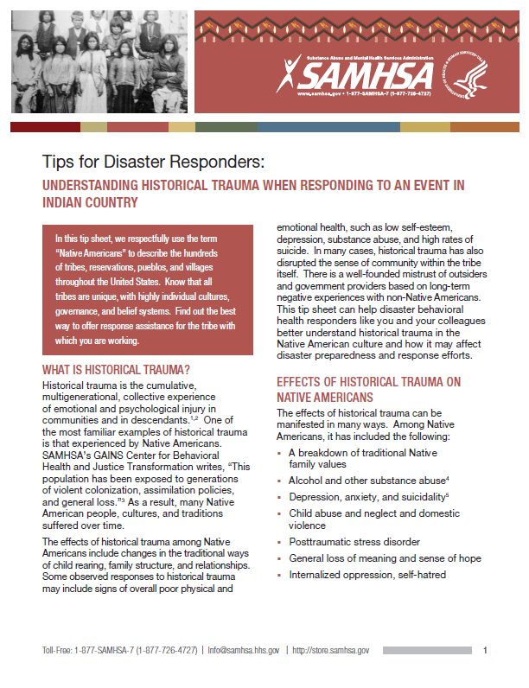
Originally published in D'Amico, E. J., Dickerson, D. L., Rodriguez, A., Brown, R. A., Kennedy, D. P., Palimaru, A. I., Johnson, C., Smart, R., Klein, D. J., Parker, J., McDonald, K., Woodward, M. J., & Gudgell, N. (2021). Integrating traditional practices and social network visualization to prevent substance use: study protocol for a randomized controlled trial among urban Native American emerging adults. Addict Sci Clin Pract, 16(1), 56.

