Supplemental Material

Table of Contents
Table S1: Example search strategy (CINAHL) 3
Table S2: Summary of findings table (quality of evidence ratings) 4
Figure S1- Risk of Bias of Randomised Studies 6
Figure S2- Risk of Bias of Non-Randomised Studies 7
Additional figures for subgroup and sensitivity analyses 8
Figure S3 - Sensitivity analysis for the prevention of e-cigarette use: Post-test timepoint only 8
Figure S4- Sensitivity analysis for the prevention of e-cigarette use: Omitting studies with follow-up <12-months (remaining studies ranged from 12- to 36-months) 8
Figure S5- Subgroup analysis for the prevention of e-cigarette use at longest follow up (6- to 36-months): Intervention type (student education/skills training alone versus broader interventions) 9
Figure S6 - Subgroup analysis for the prevention of e-cigarette use at longest follow up (6- to 36-months): Study design (RCT vs quasi-experimental) 9
Figure S7- Overall effect for past 30-Day tobacco use at longest follow-up 10
Figure S8 - Sensitivity analysis for past 30-Day tobacco use: Post-test timepoint only 10
Figure S9 - Subgroup analysis for past 30-Day tobacco use: Study design (RCT vs quasi-experimental) 11
Figure S10 - Subgroup analysis for past 30-Day tobacco use: Omitting studies with <12-month follow-up/high risk of bias 11
Figure S11- Overall effect for lifetime tobacco use at longest follow-up 12
Figure S12 - Sensitivity analysis for lifetime tobacco use: Post-test timepoint only 12
Figure S13 – Overall effect for knowledge about e-cigarettes at the first post-test timepoint 12
Figure S14 - Sensitivity analysis for knowledge about e-cigarettes: Longest follow-up timepoint only 12
Figure S15- Subgroup analysis for knowledge about e-cigarettes: Study design (RCT vs. quasi-experimental) 13
Figure S16- Sensitivity analysis for knowledge about e-cigarettes: Omitting studies with high risk of bias 13
Figure S17- Overall effect for intentions to use e-cigarettes at the first post-test timepoint 13
Figure S18- Sensitivity analysis for intentions to use e-cigarettes: Longest-follow-up timepoint only 14
Figure S19- Subgroup analysis for intentions to use e-cigarettes: Study design (RCT vs quasi-experimental) 14
Figure S20- Sensitivity analysis for intentions to use e-cigarettes: Omitting studies at high risk of bias 14
Figure S21- Overall effect for risky attitudes towards e-cigarettes at the first post-test timepoint 15
Figure S22- Overall effect for harm perceptions at the first post-test timepoint 15
Figure S23- Sensitivity analysis for harm perceptions: Longest-follow-up timepoint only 15

Table S1: Example search strategy (CINAHL)

S1 | (MH “Vaping”) | 688
S2 | TI ( vaping OR vape OR vapes OR "electronic nicotine delivery system*" OR ecig* OR "e-cig*" OR (electr* N2 cig*) OR juul OR juuls OR "nicotine vapo?r*" OR "heated tobacco product*" OR eliquid* OR "e-liquid" OR enicotine OR "e-nicotine" OR ejuice OR "e-juice" OR "cigarette liquid" OR "electronic vapo?r*" OR ehookah* OR "e-hookah*" OR eshisha* OR "e-shisha*" OR ewaterpipe* OR "e-waterpipe*" OR "electr* hookah*" ) OR AB ( vaping OR vape OR vapes OR "electronic nicotine delivery system*" OR ecig* OR "e-cig*" OR (electr* N2 cig*) OR juul OR juuls OR "nicotine vapo?r*" OR "heated tobacco product*" OR eliquid* OR "e-liquid" OR enicotine OR "e-nicotine" OR ejuice OR "e-juice" OR "cigarette liquid" OR "electronic vapo?r*" OR ehookah* OR "e-hookah*" OR eshisha* OR "e-shisha*" OR ewaterpipe* OR "e-waterpipe*" OR "electr* hookah*" ) | 7,103
S3 | S1 OR S2 | 7,196
S4 | (MH "Young Adult") OR (MH "Adolescence+") OR (MH "Child") OR (MH "Minors (Legal)") | 1,011,191
S5 | TI ( child OR children OR teen* OR adolescent* OR youth* OR juvenile* OR minor OR preadult* OR "pre adult*" OR (young N2 (adult* OR person* OR people* OR individual* OR man OR men OR wom?n)) OR (emerging N2 (adult* OR person* OR people)) ) OR AB ( child OR children OR teen* OR adolescent* OR youth* OR juvenile* OR minor OR preadult* OR "pre adult*" OR (young N2 (adult* OR person* OR people* OR individual* OR man OR men OR wom?n)) OR (emerging N2 (adult* OR person* OR people)) ) | 765,302
S6 | S4 OR S5 | 1,317,773
S7 | (MH "Schools") OR (MH "Schools, Elementary") OR (MH "Schools, Middle") OR (MH "Schools, Secondary") OR (MH "Students, High School") OR (MH "Students, Middle School") OR (MH "Students, Elementary") OR (MH "Students") | 61,940
S8 | TI ( school* N2 (middle OR high OR secondary OR based) ) OR AB ( school* N2 (middle OR high OR secondary OR based) ) | 44,693
S9 | S7 OR S8 | 88,025
S10 | S3 AND S6 AND S9 | 661

Table S2: Summary of findings table (quality of evidence ratings)

Certainty assessment |  |  |  |  |  |  | № of patients |  | Effect |  | Certainty | Importance
№ of studies | Study design | Risk of bias | Inconsistency | Indirectness | Imprecision | Other considerations | [intervention] | [comparison] | Relative  (95% CI) | Absolute  (95% CI) | Certainty | Importance
Lifetime e-cigarette use at longest f/u
5 | randomised trials | not serious | very seriousª | not serious | serious^{b} | none | 896/7096 (12.6%) | 930/4725 (19.7%) | OR 0.43  (0.16 to 1.12) | 101 fewer per 1,000  (from 159 fewer to 19 more) | ⨁◯◯◯  Very low
Past 30 day tobacco use at longest f/u
3 | randomised trials | serious | seriousª | not serious | not serious | none | 320/3340 (9.6%) | 363/1906 (19.0%) | OR 0.59  (0.39 to 0.89) | 69 fewer per 1,000  (from 106 fewer to 17 fewer) | ⨁⨁◯◯  Low
Lifetime tobacco use at longest f/u
2 | randomised trials | not serious | seriousª | not serious | not serious | none | 1626/3275 (49.6%) | 874/2142 (40.8%) | OR 1.01  (0.65 to 1.59) | 2 more per 1,000  (from 99 fewer to 115 more) | ⨁⨁⨁◯  Moderate
Knowledge at post-test
4 | randomised trials | serious | seriousª | not serious | not serious | none | 1313 | 1342 | - | SMD 0.38 SD lower  (0.68 lower to 0.08 lower) | ⨁⨁◯◯  Low
Outcome expectations/attitudes at post-test
3 | randomised trials | serious | not serious | not serious | not serious | none | 1171 | 1216 | - | SMD 0.14 SD lower  (0.22 lower to 0.06 lower) | ⨁⨁⨁◯  Moderate
Intentions at post-test
4 | randomised trials | serious | not serious | not serious | not serious | none | 1313 | 1342 | - | SMD 0.15 SD lower  (0.22 lower to 0.07 lower) | ⨁⨁⨁◯  Moderate
Harm perceptions at post-test
3 | randomised trials | serious | seriousª | not serious | not serious | none | 212 | 186 | - | SMD 0.29 SD lower  (0.73 lower to 0.15 higher) | ⨁⨁◯◯  Low
CI: confidence interval; OR: odds ratio; SMD: standardised mean difference
Explanations
a. High and significant heterogeneity
b. Wide confidence intervals, small sample size

Figure S1- Risk of Bias of Randomised Studies
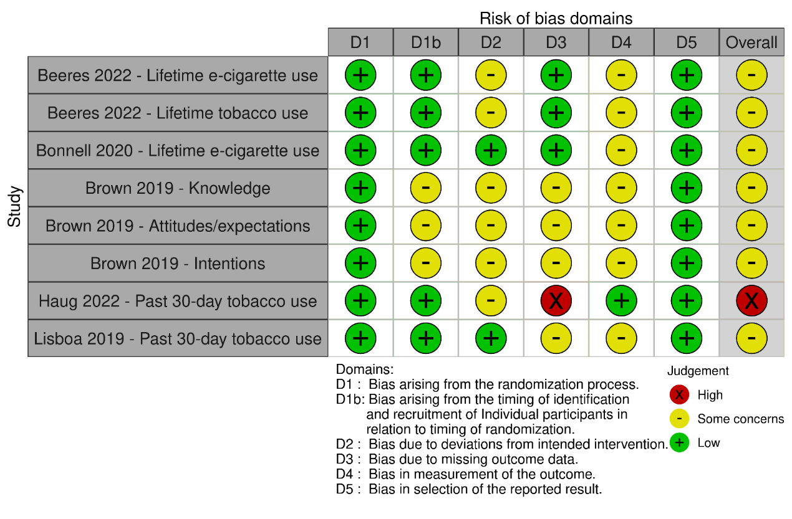

Figure S2- Risk of Bias of Non-Randomised Studies

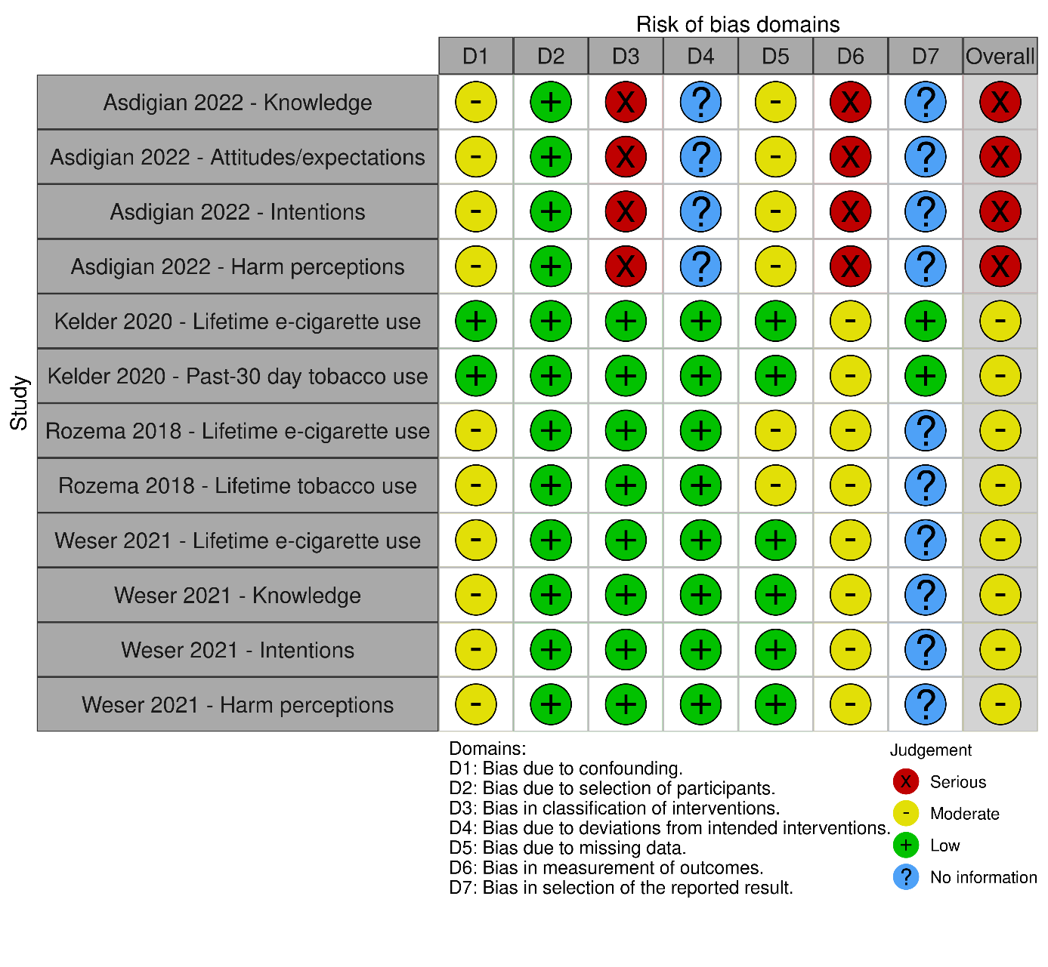

Additional figures for subgroup and sensitivity analyses

Figure S3 - Sensitivity analysis for the prevention of e-cigarette use: Post-test timepoint only

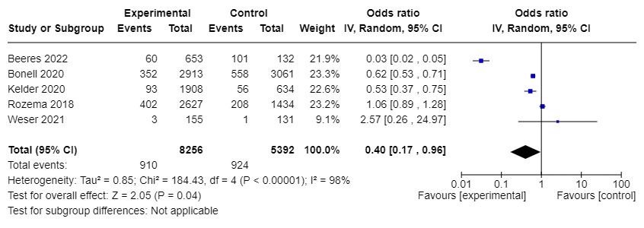

Figure S4- Sensitivity analysis for the prevention of e-cigarette use: Omitting studies with follow-up <12-months (remaining studies ranged from 12- to 36-months)
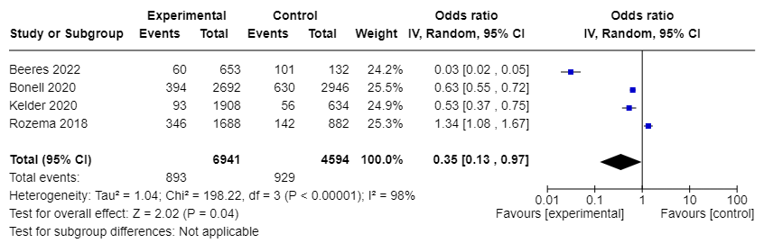

Figure S5- Subgroup analysis for the prevention of e-cigarette use at longest follow up (6- to 36-months): Intervention type (student education/skills training alone versus broader interventions)
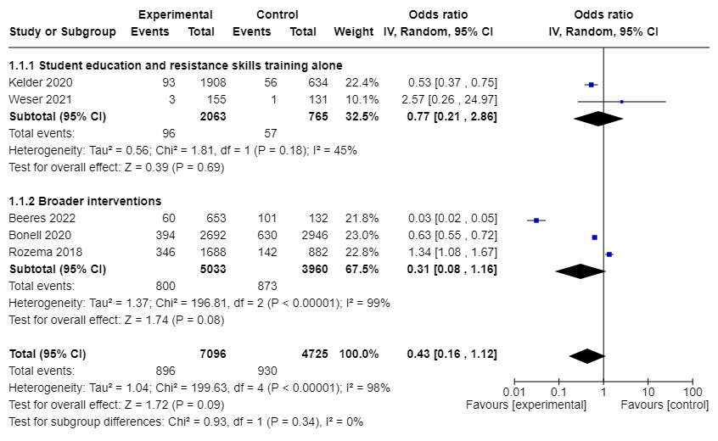

Figure S6 - Subgroup analysis for the prevention of e-cigarette use at longest follow up (6- to 36-months): Study design (RCT vs quasi-experimental)

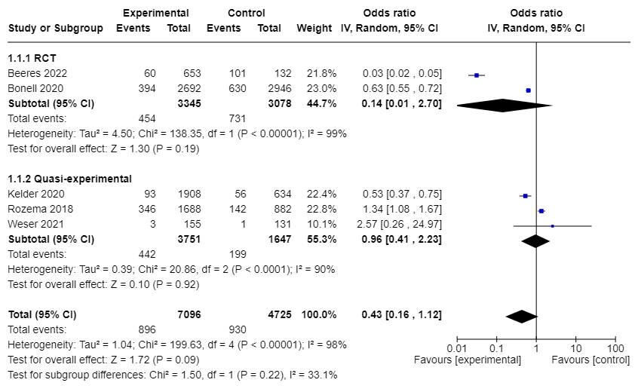

Figure S7- Overall effect for past 30-Day tobacco use at longest follow-up
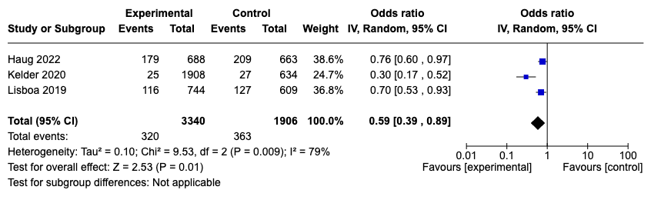

Figure S8 - Sensitivity analysis for past 30-Day tobacco use: Post-test timepoint only
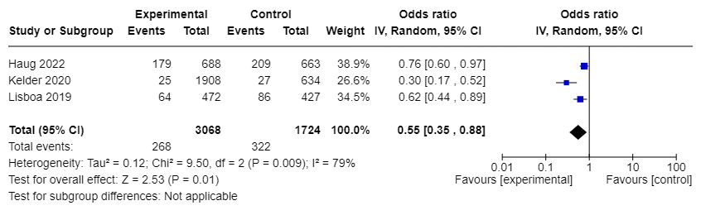

Figure S9 - Subgroup analysis for past 30-Day tobacco use: Study design (RCT vs quasi-experimental)
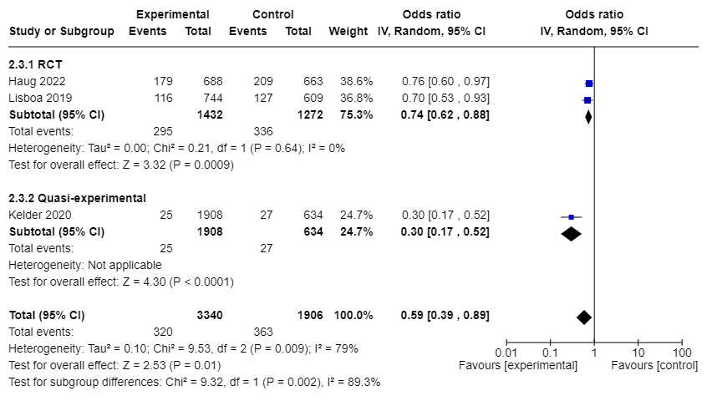

Figure S10 - Subgroup analysis for past 30-Day tobacco use: Omitting studies with <12-month follow-up/high risk of bias
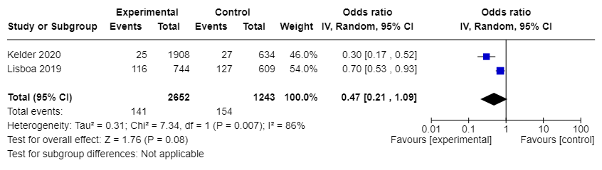
Note: This graph presents the effects of omitting one study (Haug 2022), as it met both criteria of collecting data at < 12 months post-intervention and having an overall rating of high risk of bias.

Figure S11- Overall effect for lifetime tobacco use at longest follow-up

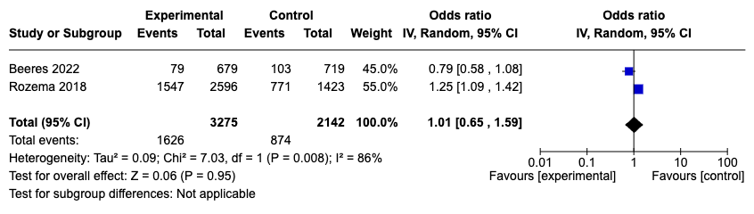

Figure S12 - Sensitivity analysis for lifetime tobacco use: Post-test timepoint only
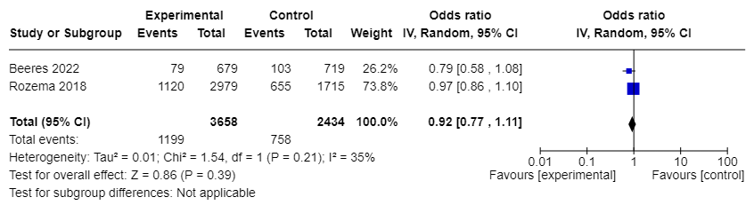

Figure S13 – Overall effect for knowledge about e-cigarettes at the first post-test timepoint

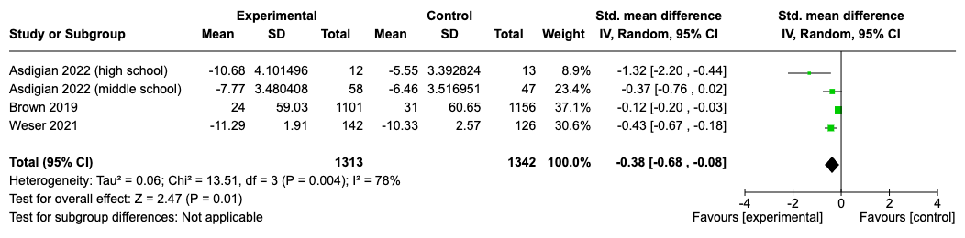

Figure S14 - Sensitivity analysis for knowledge about e-cigarettes: Longest follow-up timepoint only
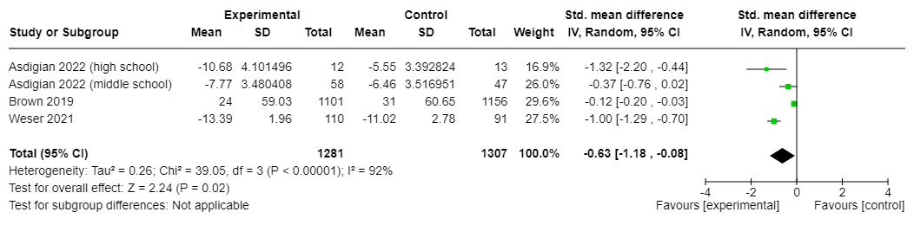

Figure S15- Subgroup analysis for knowledge about e-cigarettes: Study design (RCT vs. quasi-experimental)
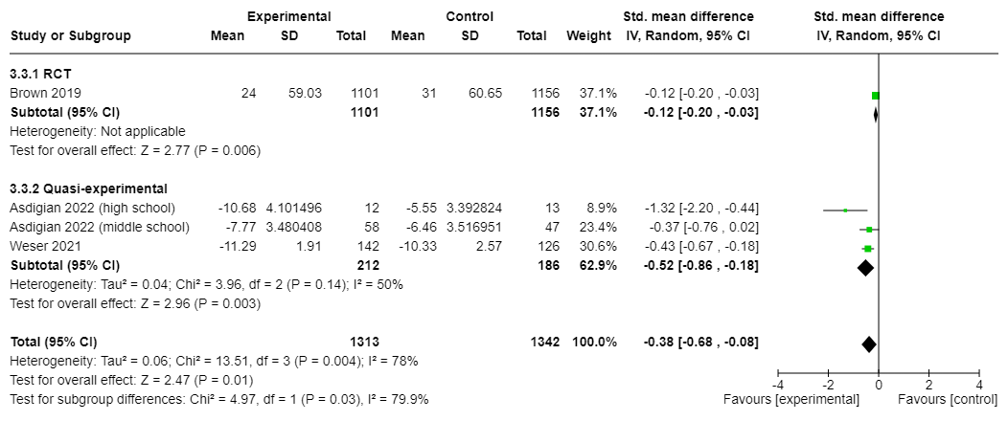

Figure S16- Sensitivity analysis for knowledge about e-cigarettes: Omitting studies with high risk of bias
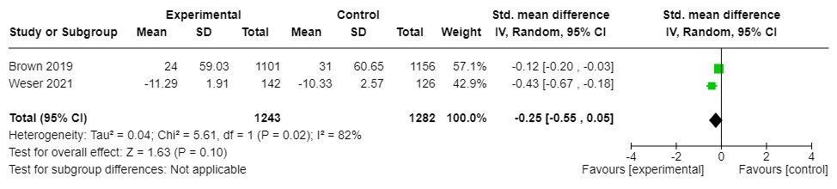

Figure S17- Overall effect for intentions to use e-cigarettes at the first post-test timepoint

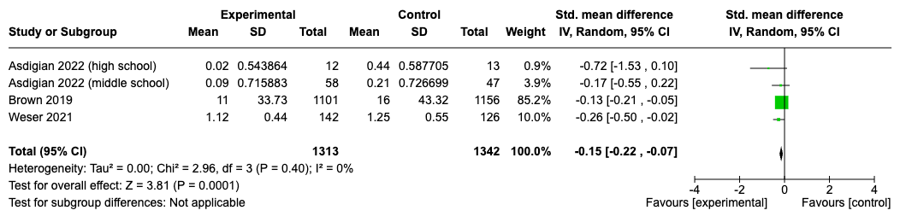

Figure S18- Sensitivity analysis for intentions to use e-cigarettes: Longest-follow-up timepoint only

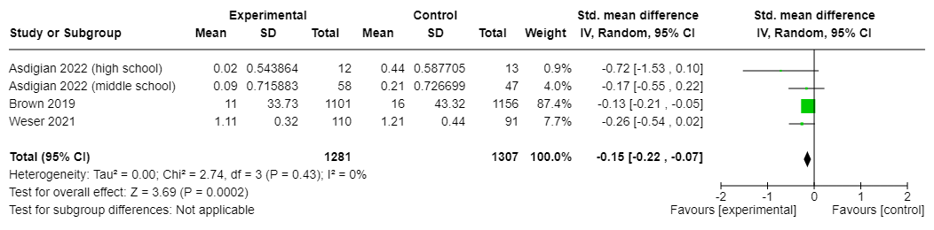

Figure S19- Subgroup analysis for intentions to use e-cigarettes: Study design (RCT vs quasi-experimental)
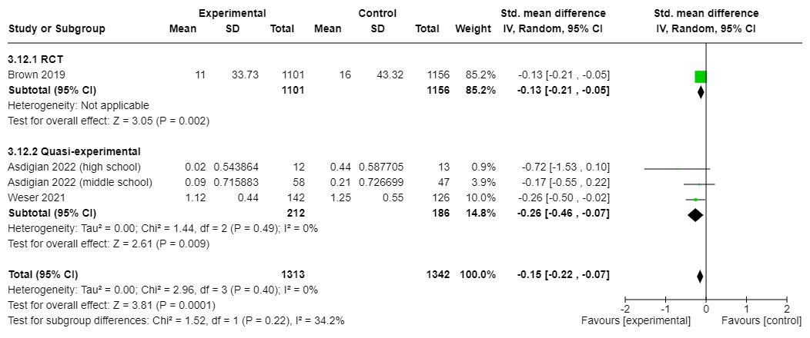

Figure S20- Sensitivity analysis for intentions to use e-cigarettes: Omitting studies at high risk of bias
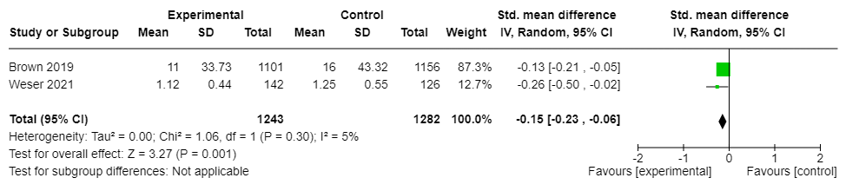

Figure S21- Overall effect for risky attitudes towards e-cigarettes at the first post-test timepoint

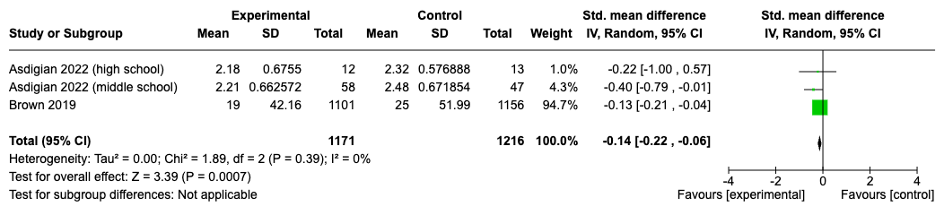

Figure S22- Overall effect for harm perceptions at the first post-test timepoint

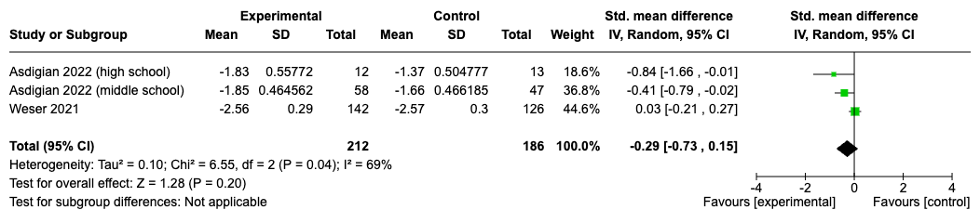

Figure S23- Sensitivity analysis for harm perceptions: Longest-follow-up timepoint only

