Supplementary Tables and Figures

Table S1

MNLFA Parameters for Burnout
Item | Factor Loading | Threshold (τ; 0 to 1) | Threshold  (1 to 2) | Threshold  (2 to 3) | Tx λ  DIF | Time 1 λ  DIF | Time 2 λ  DIF | Time 3 λ  DIF | Time 4 λ  DIF | Time 5 λ  DIF | Time 6 λ  DIF | Tx τ  DIF | Time 1 τ  DIF | Time 2 τ  DIF | Time 3 τ  DIF | Time 4 τ  DIF | Time 5 τ  DIF | Time 6 τ  DIF
1. Burned out | 5.08 | -7.37 | -0.88 | 5.08 |  |  |  |  |  |  |  |  |  |  |  | 0.86 | 2.21 | 2.62
2. End of Rope | 2.46 | -1.22 | 2.78 | 5.67 |  |  |  | -.09 | .09 |  |  |  |  |  | 0.67 | 0.64 | 2.51 | 2.61
3. Emotionally Drained | 4.32 | -7.23 | -2.03 | 3.06 |  |  |  |  |  |  |  |  |  | .07
4. Used Up | 2.39 | -4.84 | -2.13 | 1.10 |  |  | -0.40
Note. Tx = Treatment condition (i.e., GBG+MTP or control), DIF = Differential Item Functioning.

Table S2

LCPMM Fit Statistics for Burnout
Baseline to COVID Year 1
 | BIC | SSA-BIC | Adj. LMR p-value | Class 1 Size | Class 2 Size | Cass 3 size
1 Class | 2653.99 | 2571.64 | -- | 184 (100%)
2 Class | 2519.48 | 2367.46 | <.001 | 123 (67%) | 61 (33%)
3 Class | 2583.88 | 2362.18 | .27 | 34 (18%) | 60 (33%) | 90 (49%)
Baseline to COVID Year 2
 | BIC | SSA-BIC | Adj. LMR p-value | Class 1 Size | Class 2 Size | Cass 3 size
1 Class | 3083.47 | 2994.79 | -- | 184 (100%)
2 Class | 2909.06 | 2747.53 | <.001 | 131 (71%) | 53 (29%)
3 Class | 2935.65 | 2701.28 | <.001 | 55 (30%) | 51 (28%) | 78 (42%)
Note. BIC = Bayesian Information Criteria, SSA-BIC = Sample Size Adjusted Bayesian Information Criteria, Adj. LMR = Adjusted Lo-Mendell Rubin Likelihood Ratio Test.

Table S3

LCPMM Fit Statistics for Self-Efficacy
Baseline to COVID Year 1
 | BIC | SSA-BIC | Adj. LMR p-value | Class 1 Size | Class 2 Size | Cass 3 size
1 Class | 2530.71 | 2454.70 | -- | 184 (100%)
2 Class | 2447.08 | 2307.72 | <.001 | 118 (64%) | 66 (36%)
3 Class | 2934.65 | 2738.28 | <.001 | 96 (52%) | 45 (25%) | 43 (23%)
Baseline to COVID Year 2
 | BIC | SSA-BIC | Adj. LMR p-value | Class 1 Size | Class 2 Size | Cass 3 size
1 Class | 2960.50 | 2878.15 | -- | 184 (100%)
2 Class | 2830.85 | 2681.97 | <.001 | 95 (52%) | 89 (48%)
3 Class | 3300.07 | 3091.03 | <.001 | 75 (41%) | 55 (30%) | 54 (29%)
Note. BIC = Bayesian Information Criteria, SSA-BIC = Sample Size Adjusted Bayesian Information Criteria, Adj. LMR = Adjusted Lo-Mendell Rubin Likelihood Ratio Test.

Table S4

Probability of Participating at Each Timepoint for the 2-Class Models: Burnout and Self-Efficacy
 | Burnout |  |  |  | Self-Efficacy
 | Baseline to CY1 |  | Baseline to CY2 |  | Baseline to CY1 |  | Baseline to CY2
 | Class 1: “Low Attrition” | Class 2: “High Attrition” | Class 1: “Low Attrition” | Class 2: “High Attrition” | Class 1: “Low Attrition” | Class 2: “High Attrition” | Class 1: “Low Attrition” | Class 2: “High Attrition”
Time 1 | 98% | 100% | 98% | 100% | 98% | 99% | 97% | 99%
Time 2 | 98% | 60% | 97% | 57% | 100% | 59% | 96% | 74%
Time 3 | 99% | 3% | 92% | 5% | 95% | 13% | 89% | 41%
Time 4 | 91% | 6% | 88% | 0% | 83% | 12% | 76% | 38%
Time 5 | 71% | 12% | 72% | 0% | 71% | 15% | 98% | 0%
Time 6 | -- | -- | 55% | 0% | -- | -- | 75% | 0%
Note. CY1 = COVID Year 1/Time 5, CY2 = COVID Year 2/Time 6.

Figure S1. Original Trial and Follow-Up Study Timeline

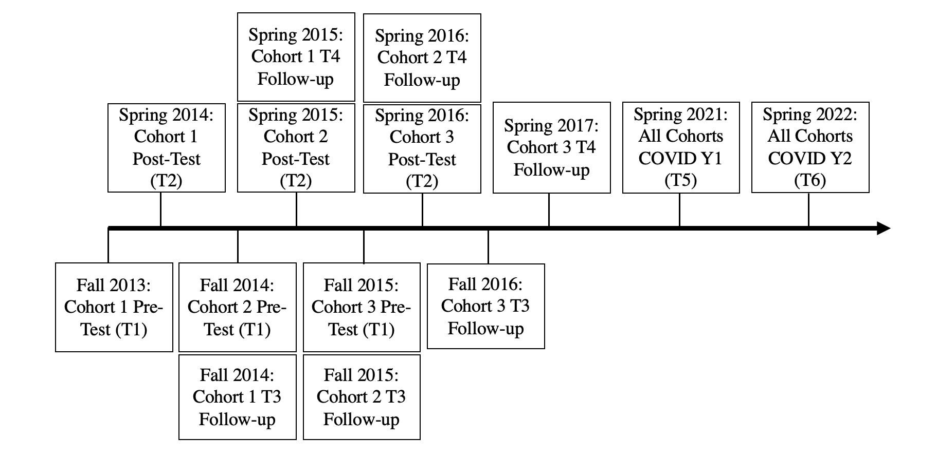
Note. T = Time, Y = Year.

