Supplementary Material
Why are we still using the PHQ-9? A historical review and psychometric evaluation of measurement invariance

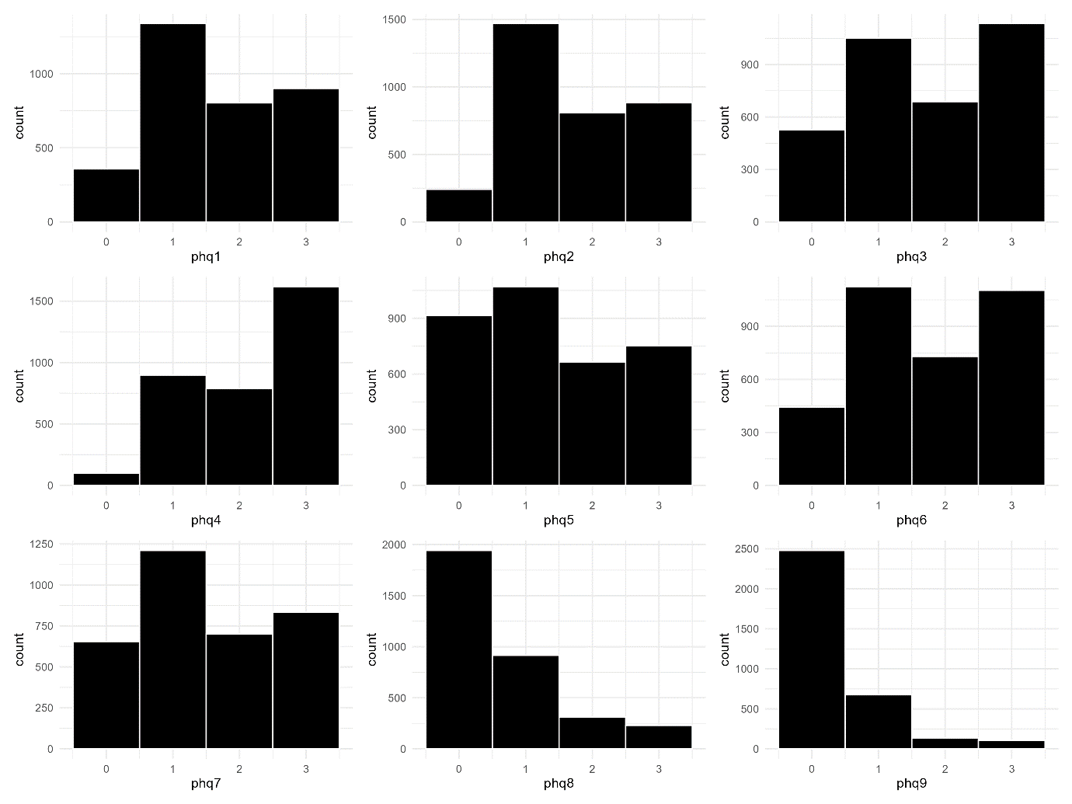

Figure S1. Histograms for each item on the PHQ-9 displaying the response distribution at pre-treatment screening.

Table S1. Significant modification indices for the PHQ-9 items at pre-treatment screening.
Left hand side variable | Operator | Right hand side variable | Modification index (MI)
Item 1 | ~~ | Item 2 | 349.24
Item 7 | ~~ | Item 8 | 118.40
Item 6 | ~~ | Item 9 | 92.93
Item 3 | ~~ | Item 4 | 73.74
Item 2 | ~~ | Item 7 | 59.31
Item 2 | ~~ | Item 5 | 58.61
Item 2 | ~~ | Item 8 | 52.35
Item 1 | ~~ | Item 8 | 52.29
Item 1 | ~~ | Item 5 | 41.50
Item 1 | ~~ | Item 7 | 39.40
Item 4 | ~~ | Item 9 | 31.64
Item 1 | ~~ | Item 6 | 31.24
Item 1 | ~~ | Item 9 | 31.08
Item 3 | ~~ | Item 5 | 29.01
Item 3 | ~~ | Item 6 | 23.79
Item 2 | ~~ | Item 3 | 23.73
Item 1 | ~~ | Item 3 | 22.55
Item 5 | ~~ | Item 8 | 21.51
Item 4 | ~~ | Item 6 | 11.78
Item 4 | ~~ | Item 5 | 11.13
Item 5 | ~~ | Item 7 | 10.60
Item 2 | ~~ | Item 4 | 10.40
Item 4 | ~~ | Item 8 | 9.57
Item 3 | ~~ | Item 9 | 8.26
Item 3 | ~~ | Item 7 | 6.50
Item 6 | ~~ | Item 7 | 6.34
Item 2 | ~~ | Item 9 | 4.67
Item 1 | ~~ | Item 4 | 4.16
Item 6 | ~~ | Item 8 | 4.12

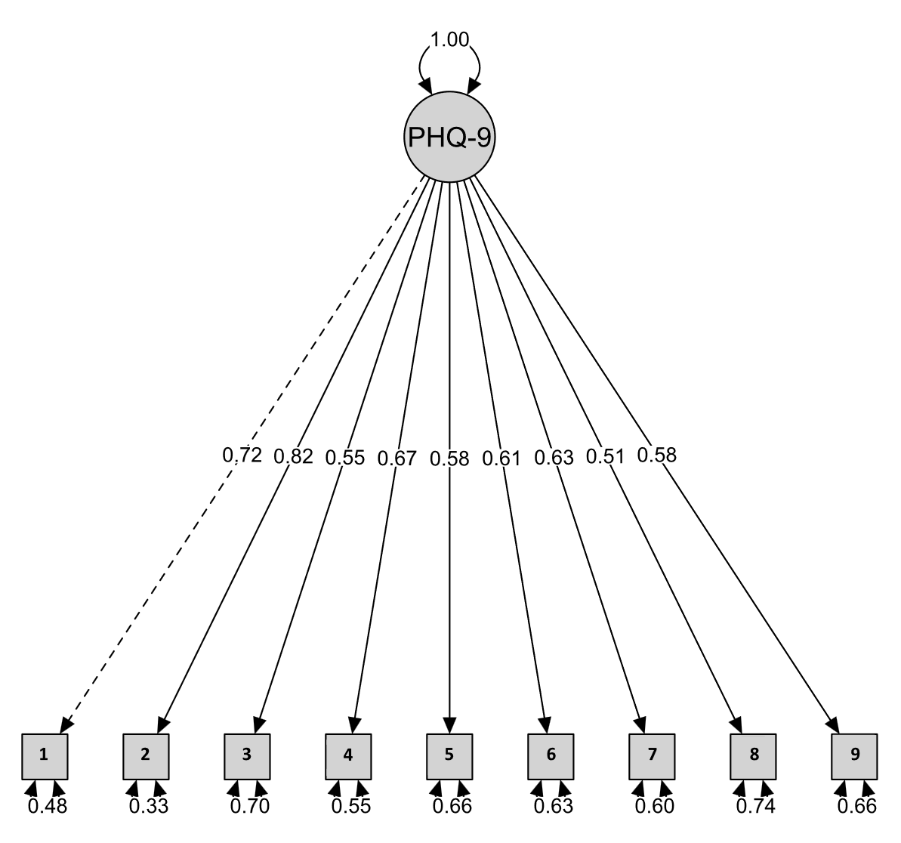
Figure S2. Structural equation model path diagram with standardized factor loadings for the PHQ-9.

Table S2. Descriptive statistics for all items on the PHQ-9, grouped by treatment weeks.
PHQ-9 items | M | SD | Min-Max | Skewness | Kurtosis
Week one
Item 1 | 1.33 | 0.85 | 0-3 | 0.49 | -0.32
Item 2 | 1.30 | 0.83 | 0-3 | 0.57 | -0.15
Item 3 | 1.45 | 1.03 | 0-3 | 0.21 | -1.10
Item 4 | 1.86 | 0.93 | 0-3 | -0.05 | -1.26
Item 5 | 1.12 | 1.01 | 0-3 | 0.54 | -0.81
Item 6 | 1.29 | 0.97 | 0-3 | 0.39 | -0.80
Item 7 | 1.16 | 0.97 | 0-3 | 0.49 | -0.71
Item 8 | 0.36 | 0.65 | 0-3 | 1.85 | 3.09
Item 9 | 0.21 | 0.51 | 0-3 | 2.80 | 8.85
Week two
Item 1 | 1.22 | 0.83 | 0-3 | 0.59 | -0.06
Item 2 | 1.22 | 0.83 | 0-3 | 0.64 | 0.01
Item 3 | 1.35 | 1.00 | 0-3 | 0.33 | -0.95
Item 4 | 1.77 | 0.93 | 0-3 | 0.03 | -1.16
Item 5 | 1.02 | 1.00 | 0-3 | 0.67 | -0.62
Item 6 | 1.20 | 0.95 | 0-3 | 0.53 | -0.57
Item 7 | 1.09 | 0.95 | 0-3 | 0.59 | -0.53
Item 8 | 0.32 | 0.63 | 0-3 | 2.16 | 4.60
Item 9 | 0.21 | 0.52 | 0-3 | 2.85 | 8.89
Week three
Item 1 | 1.13 | 0.81 | 0-3 | 0.68 | 0.22
Item 2 | 1.18 | 0.84 | 0-3 | 0.66 | 0.04
Item 3 | 1.31 | 1.02 | 0-3 | 0.37 | -0.96
Item 4 | 1.67 | 0.94 | 0-3 | 0.17 | -1.13
Item 5 | 0.95 | 1.00 | 0-3 | 0.81 | -0.41
Item 6 | 1.14 | 0.95 | 0-3 | 0.54 | -0.57
Item 7 | 1.03 | 0.95 | 0-3 | 0.69 | -0.42
Item 8 | 0.28 | 0.60 | 0-3 | 2.41 | 6.17
Item 9 | 0.19 | 0.51 | 0-3 | 3.11 | 10.75
Week four
Item 1 | 1.09 | 0.81 | 0-3 | 0.66 | 0.19
Item 2 | 1.16 | 0.83 | 0-3 | 0.63 | 0.07
Item 3 | 1.27 | 1.0 | 0-3 | 0.41 | -0.89
Item 4 | 1.62 | 0.96 | 0-3 | 0.17 | -1.10
Item 5 | 0.92 | 0.96 | 0-3 | 0.82 | -0.29
Item 6 | 1.04 | 0.90 | 0-3 | 0.69 | -0.22
Item 7 | 0.96 | 0.92 | 0-3 | 0.78 | -0.18
Item 8 | 0.26 | 0.57 | 0-3 | 2.36 | 5.68
Item 9 | 0.19 | 0.50 | 0-3 | 3.03 | 10.41
Note. M and SD denote the arithmetic mean and standard deviation. Week one marks the first week following pre-treatment screening. Missing data rates were 25.2% in week one, 34.3% in week two, 41.5% in week three, and 45.3% in week four.

Measurement invariance across treatment groups
In total, measurement invariance was explored across 13 groups; 12 treatment and waitlist groups and one group of excluded participants. All 8-week groups had 207 observations, all 16-week groups had 206 observations, and 907 observations were in the excluded group. In a preliminary analysis, we observed that the highest response category for the PHQ-9 item was unpopulated in the 8-week waitlist without access to a clinician-moderated forum group (i.e., frequency = 0), which impedes the estimation of thresholds and polychoric correlations using the DWLS estimator [1]. Given that ordinal SEM models require that all response categories be adequately represented to yield reliable parameter estimates, we collapsed the empty category (score = 3) with the adjacent category (score = 2). This recoding maintained the ordinal nature of the data and ensured sufficient cell frequencies across groups, thereby enhancing the robustness and validity of our measurement model.

The configural model, which allowed factor loadings and intercepts to vary freely across treatment groups while constraining only the overall factor structure, exhibited a suboptimal fit to the data: χ²(351) = 982.694, p < .001, CFI = .980, SRMR = .081, RMSEA = .083 [90% CI: .077, .089]. Although the CFI and SRMR fell within an acceptable range, the RMSEA exceeded the conventional cutoff acceptable model fit (cf. [1] Hu & Bentler, 1999), suggesting misfit at the configural level. This is further supported by comparing these model fit indices to the DFI cutoffs obtained for this sample. Given that configural invariance is a prerequisite for higher-order invariance tests, these results already raise concerns about the stability of the PHQ-9 across different treatment groups. However, the model fit for the configural model is isomorphic with the baseline pre-treatment screening data model and thus, despite the suboptimal fit at the configural level, we proceeded with metric invariance testing in an effort to garner a greater understanding of the stability of the PHQ-9 across treatment groups.

The metric invariance model constrained factor loadings to be equal across treatment groups while allowing intercepts to vary. Model fit remained suboptimal at the metric level, χ²(447) = 2231.307, p < .001, CFI = .945, SRMR = .114, RMSEA = .124 [90% CI: .119, .129], a significant model fit deterioration from the configural model. Metric invariance across treatment groups was not supported by difference tests that evaluated configural and metric model similarity: Δχ²(96) = 1255.4, p < .001; ΔCFI = -.036; ΔSRMR = .033; ΔRMSEA = .041. Given the statistically significant Δχ² test, ΔCFI > .01, ΔSRMR > .015, and ΔRMSEA > .015, metric invariance across treatment groups was unsupported by all the criteria that had to have been met for further invariance testing. Taken together, tentative support for the configural model was detected, albeit with a suboptimal model fit which raises questions about whether participants in different treatment groups have a similar enough understanding of the items on the PHQ-9 to make comparisons across groups meaningful.

References
1. Flora DB, Curran PJ. An Empirical Evaluation of Alternative Methods of Estimation for Confirmatory Factor Analysis With Ordinal Data. Psychol Methods. 2004;9:466–91.
2. Hu L, Bentler PM. Cutoff criteria for fit indexes in covariance structure analysis: Conventional criteria versus new alternatives. Struct Equ Model Multidiscip J. 1999;6:1–55.

