Appendix 1. Alternative forcing variable
We run the main analyses with two alternative forcing variables.
Margin2 calculates the majority margin as the percentage of votes that the incumbent would need to lose in favour of the second most voted party so that the former loses its absolute majority. This variable is making the alternative plausible assumption that votes go to the main opposition party, instead of to abstention (which is the assu,ption we made for the forcing variable in the manuscript).
Seat margin computes the forcing variables using seats, instead of vote shares. It captures the number of seats by which the incumbent party is above the minimum needed to form a single-party majority government. We compute this variable in the following way: Seat margin=Incumbent Seats-int(Total Seats/2), where incumbent seats is the number of seats obtained by the winning party, and int(total seats/2) is the smallest integer number that is larger or equal than half of the seat count. The seat margin would, for example, take value zero if the major party obtains the minimum number of seats needed to form a single-party majority government, and it would take value -1 if the winning party needs one more seat to form a single-party majority government. The probability of a municipality being a single-party majority is then a discontinuous function of the seat margin, with the discontinuity occurring exactly at zero. The advantage of this variable is that it requires no assumptions regarding the transfer of votes. However, it is less continuous (seats are only integers) and has some problems related to size heterogeneity across municipalities. These problems can be addressed in parametric specifications that include controls for size and fixed effects, which allow us to have treatment and control groups balanced across the threshold.
It can be observed that the results with these alternative specifications of the forcing variables remain the same.

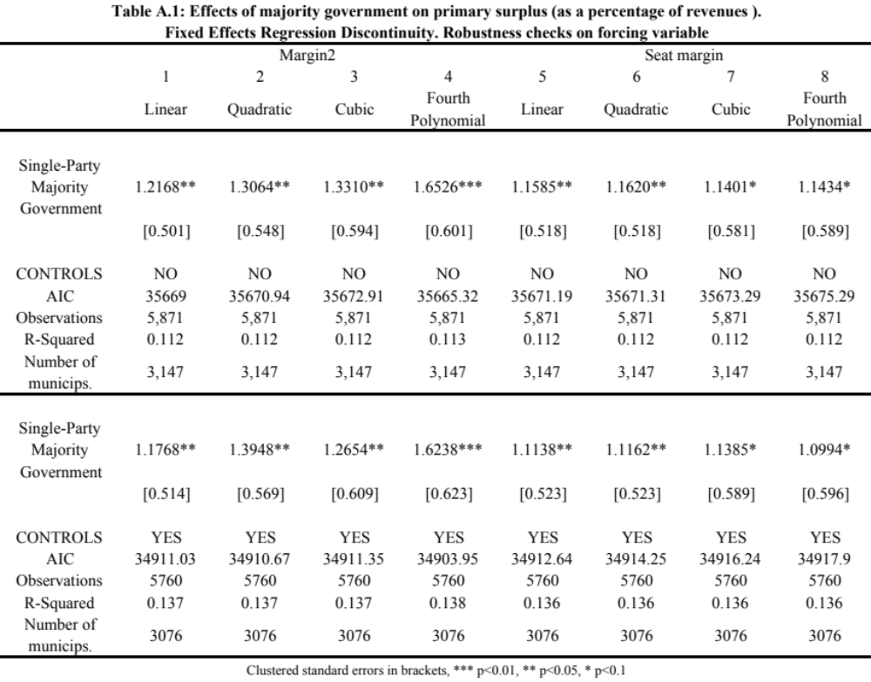

Appendix 2. Primary surplus per capita as dependent variable
In this analysis, we show that changing the dependent variable and using primary surplus per capita does not change the results. Fifteen out of sixteen estimations reach conventional levels of significance.
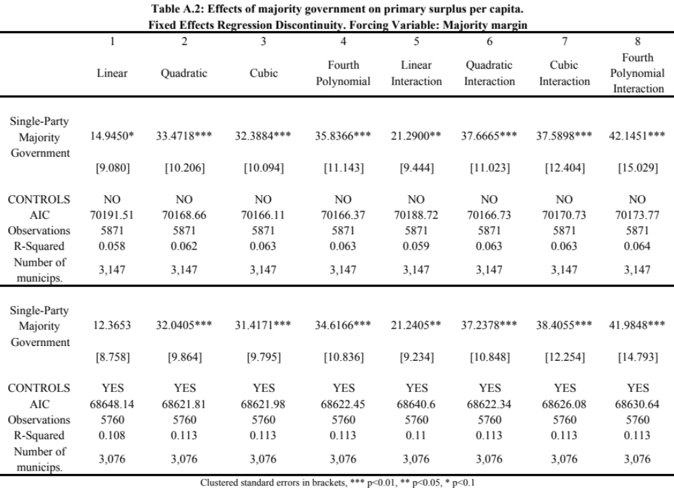

Appendix 3. Robustness to additional covariates
The analysis is robust to the inclusion of further economic covariates that account for the dynamics of budget surpluses. Here we show the two main robustness checks.

3.1. Lagged expenditures and lagged revenues as covariates
In Table A.3 we include the lagged level of revenues and expenditures, which should have a strong influence over the posterior budget deficits. The effect of single-party majority governments remains very robust and of a similar magnitude.
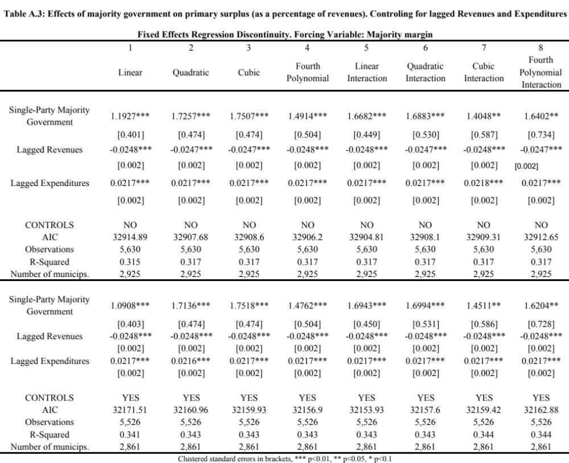

  - Debt payments as covariate
In Table A.4 we include the debt payments that each municipality incurs in every year, as those municipalities with larger debt burdens will be more likely to incur in further budget deficits. We find again that the results are robust to this inclusion.

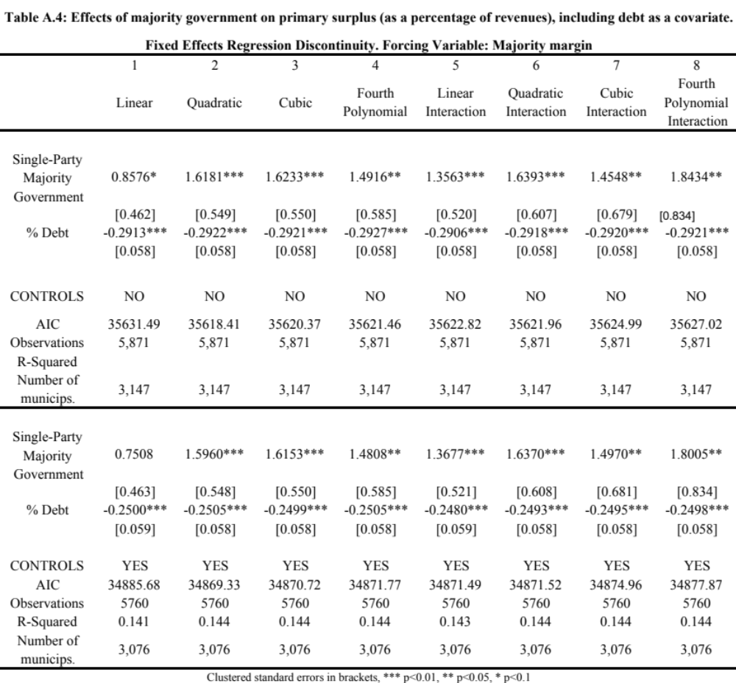

Appendix 4. Analyses with three electoral terms
All analyses in the manuscript have been run using two electoral terms, coded as 2003 to 2006 and 2007 to 2010. As we do not have financial data split by months, we believe this is the best codification, given that local elections took place in May 2003 and May 2007. This means, in any case, that we are attributing the first four months that do not belong to the electoral term to our budget deficit calculation. We are also not able to include the last four months of the electoral term that belong to the next term according to this operationalization).
In table A.5, we compute the electoral terms as 2004-2007, and 2008 -2011, so that we can include the last months in office (but not the first ones). As we have data since 2001, this means we can also add a third term (although we calculate the deficit for that term as an average of three years –missing 2000-, and not four years). Including this third electoral period and increasing observations does not change the results. The average treatment effect is always between a 1% and 1.4% surplus and it is very robust as all fifteen out of sixteen specifications yield significant coefficients.

