Supplementary Material A: Evaluation of the Exclusion Criteria on synthetic control method and “too few observations”
Supplementary Material for “Were COVID-19 Lockdowns worth it? A Meta-Analysis”
Jonas Herby†, Lars Jonung, and Steve H. Hanke
October 10, 2024

Background
In our protocol (Herby et al. 2021) we exclude synthetic control studies because of inherent empirical problems as discussed by Bjørnskov (2021). We also exclude studies with very few observations, e.g. Conyon et al. (2020), which “exploit policy variation between Denmark and Norway on the one hand and Sweden on the other” and, thus, only have one observation in one group.
Our reasons to exclude these studies are twofold.
First, there are methodological problems related to the synthetic control method (SCM) in a COVID-19 setting. Abadie (2021) writes that “[t]he credibility of a synthetic control estimator depends in great part on its ability to steadily track the trajectory of the outcome variable for the affected unit before the intervention” and “when designing a synthetic control study, it is of crucial importance to collect information on the affected unit and the donor pool for a large pre-intervention window.” As discussed by Bjørnskov (2021), this lack of a large pre-intervention window is an inherent problem in the evaluation of the effect of lockdown on COVID-19 mortality.
Second, we worried that these studies could be biased because they would tend to focus on a few special places such as Italy and Sweden, who – possibly because they were hit early and were surprised by the pandemic – experienced very high death tolls.

The October 28, 2020 update of our protocol
On October 28, 2020, we published an updated protocol where synthetic control studies and studies with very few observations were excluded.
The decision to exclude these studies were made on a Zoom meeting August 20, 2020, after Jonas Herby had lengthy talks with Professor Christian Bjørnskov after reading his blogpost about the inherent problems with the synthetic control method (SCM) in the evaluation of the effect of lockdown on COVID-19 mortality (Bjørnskov 2021).
At the time of the decision, we had been through Conyon and Thomsen (2021) and Ghosh et al. (2020) which were marked as “done” in our spreadsheet, meaning that we knew that the studies used a difference in difference method, focused at mortality, and that their results probably could be converted to a standardized measure. We had also briefly looked at Born et al. (2021), Reinbold (2021), Friedson et al. (2021), Neidhöfer and Neidhöfer (2020), and Cerqueti et al. (2021). According to our spreadsheet at the time, we had registered main results (usually from the abstract) but were unsure whether they were synthetic control studies. We also had registered Cho (2020) and Mader and Rüttenauer (2021) but had not registered any data on them. We did not yet know of Dave et al. (2020b).
The decision to exclude studies with too few observations was made earlier, but we are uncertain about the exact date; it is mentioned in a draft for the new protocol dated August 16, 2020. We were surprised to find several studies based on very few observations often with just Sweden in the control group.

The purpose of this supplementary material
Following the publication of our working paper, scholars such as Professor David Paton have questioned this decision. One argument is that few observations is not a problem because the difference-in-difference method does not require a certain number of observations to be valid (if there are sufficient degrees of freedom). Hence, studies based on few jurisdictions can be assumed to produce useful knowledge regarding the effects of lockdown measures but are likely to have less precision than studies based on more cases. The key point is that if there is sufficient variation in the jurisdictions covered, the full set of estimates from studies with few observations are still unbiased.
In general, it is best to avoid changing the research protocol after the results of the study have been obtained, as this can introduce bias and compromise the validity of the initial research plan. However, it is still valuable to assess whether our exclusion criteria are problematic in that they have excluded useful information or biased our results.
In this supplementary section, we explore whether:
- the excluded studies are focusing solely on a few special places with many deaths during the first wave, such as Italy and Sweden, effectively preventing “sufficient variation;”
- we find evidence that the SCM is as problematic in a COVID-19 setting as Bjørnskov (2021) proposes.

The Synthetic Control Method (SCM) criteria
We exclude the following 10 SCM studies:
- Born et al. (2021)
- Cerqueti et al. (2021)
- Cho (2020)
- Conyon and Thomsen (2021)
- Dave et al. (2020b)
- Friedson et al. (2021)
- Ghosh et al. (2020)
- Mader and Rüttenauer (2021)
- Neidhöfer and Neidhöfer (2020)
- Reinbold (2021)

Geographical coverage of the 10 studies
Nine of the 10 above-mentioned studies cover 13 jurisdictions in total; whereas, Mader and Rüttenauer (2021) use the Generalized Synthetic Control Method (GSCM) and cover 169 Countries.
Seven of the 13 jurisdictions examined in the nine studies are special areas with many COVID-19 deaths during the first wave such as Sweden (three studies), Italy (three studies), and New York (one study). Two cover Delhi and South Korea and are not relevant given our protocol limiting our research to studies including “at least one EU-country, the United States or one US state or Latin America, and where at least one country/state is not an island.” The last four jurisdictions covered by the above-mentioned studies are Argentina, Illinois, California, and Wisconsin.
It is clear that the variation in these studies is limited. Hence, the full set of estimates are possibly biased, if, for example, Sweden, Italy, and New York are special cases with unobserved confounders. And as we will discuss below, this is likely the case.
Figure 1 shows the total number of COVID-19 deaths per million during the 1st wave (Y-axis) and the date each jurisdiction reached 20 COVID-19 deaths per million. The vertical lines mark three weeks after school closures (“all levels,” cf. Hale et al. (2020)) which was typically the first NPI implemented by governments. Since, on average, it takes approximately three to four weeks from infection to death, and since virtually all jurisdictions closed schools at the same time, Figure 1 illustrates that some jurisdictions that were initially hit early and hard by the pandemic, encountered much higher death tolls than in those locations in which populations had fair warning of an impending pandemic.
Since the counterfactuals in the SCM studies are typically estimated based on case numbers in a short period before lockdowns, there is a potential risk that the seven estimates based on Italy, Sweden, and New York do not illustrate the effect of lockdowns but simply the effect of being among the first jurisdictions to be hit by the pandemic.
Figure 1 Many SCM studies cover European countries and U.S. states that were hit early and hard by the pandemic
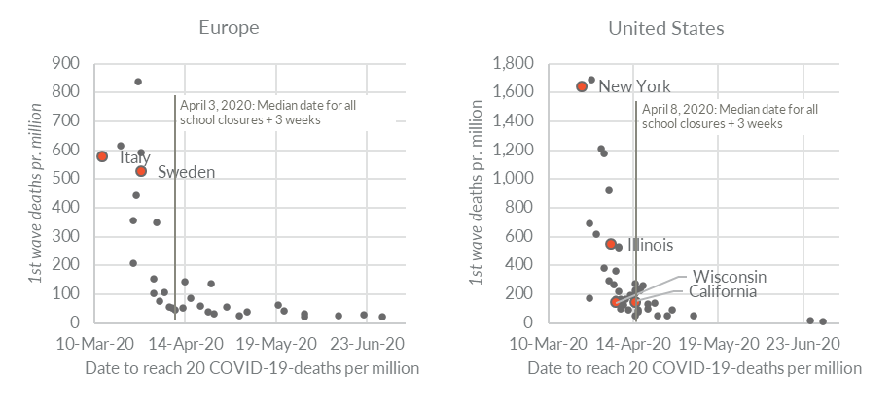
Note: The figure illustrates the relationship between early pandemic strength and total 1st wave of COVID-19 mortality. On the X-axis is “Days to reach 20 COVID-19-deaths per million (measured from February 15, 2020).” The Y-axis shows mortality (deaths per million) by June 30, 2020. Countries and states covered by the excluded SCM studies are marked with red.
Source: Reported COVID-19 deaths and OxCGRT stringency for European countries and US states with more than one million citizens. Data from Our World in Data (2022).
Based on the above, it should be clear that the seven studies do not reflect “sufficient variation.” Rather, they are examinations of special cases in which the very short pre-intervention window is an important limitation of the SCM.
Next, we examine the remaining four studies and the GSCM-study by Mader and Rüttenauer (2021).
The four SCM-studies not examining jurisdictions that were initially hit early and hard
In this section, we take a closer look at the four SCM-studies that do not examine Sweden, Italy, and New York, which were surprised by the pandemic and therefore experienced many deaths during the first wave.
The four studies are
- Friedson et al. (2021) who examine SIPO in California.
- Neidhöfer and Neidhöfer (2020) who examine school closures in Illinois.
- Reinbold (2021) who examines school closures and other pre-lockdown covid-19 mitigation strategies in Argentina.
- Dave et al. (2020b) who exploit a natural experiment to examine the repeal of SIPO in Wisconsin

Friedson et al. (2021) – SIPO in California
Friedson et al. (2021) examine the effect of SIPO in California. They find a large but insignificant effect of California’s SIPO on mortality of 35% to 56% fewer COVID-19 deaths.
Their reason for choosing California reveals a potential source for bias: “With California being the first state in the nation to issue a statewide SIPO at a time when the COVID epidemic was still new, cases in the early periods, by definition, were low.”
They also write that “matching on these relatively small values of pre-treatment COVID-19 cases may not fully leverage the construction of a valid counterfactual and end up minimizing meaningful differences prior to policy adoption relative to post-treatment differences.” Indeed, their matching is based on a total of just 793 COVID-19 cases in California prior to SIPO, corresponding to 20 cases per million.
While this does not in itself reveal any biases of concern, Friedson et al. (2021) is a perfect case to illustrate the inherent problems related to using SCM to evaluate the effect of lockdowns on COVID-19.
Figure 2 below illustrates basic information about Friedson et al. (2021). First, it illustrates that the Synthetic California is based on a very short pre-intervention window, March 11 to March 18, 2022, before California imposed its SIPO.
Second, it illustrates that the short pre-intervention window may affect the results. After 7 (14) days, Synthetic California in Figure 2 has 23% (49%) fewer deaths compared to California. Given the lag between infection and death it is very unlikely that one should see such large effects after just 7 and 14 days respectively even if the SIPO was highly effective (see the appendix to this supplementary material). The 49% almost corresponds to the estimated effect of the SIPO (54%, cf. footnote 8). Hence, there is a high risk that a flaw in matching the synthetic control – caused by a very short pre-intervention window – drives the results, not the SIPO.
Interestingly, South Carolina (shown with dashed line in Figure 2), which matches California almost 1:1 during the first three weeks after California’s SIPO, and did not impose a SIPO until April 7th, 2020, had almost the exact same cumulative COVID-19 mortality rate by June 30, 2020.
Figure 2 COVID-19 mortality in California, Synthetic California, and donor states
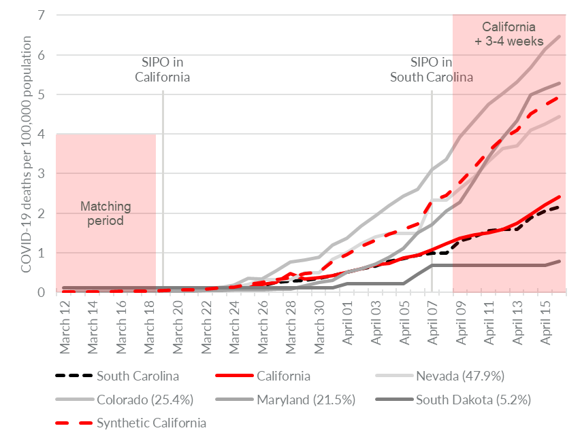
Source: Own calculations based on data from Our World in Data (2022) and Friedson et al. (2021).
Note: The figure is based on the weights from model 1 (see Table A1, Panel II(1)) in Friedson et al. (2021).

Neidhöfer and Neidhöfer (2020) – School closures in Argentina
Neidhöfer and Neidhöfer (2020) examine the effectiveness of proactive school closures and other early social distancing interventions in three countries that reacted relatively early during the pandemic. In the following, we focus on Argentina, as Italy is a special case (see above) and South Korea is excluded given the criteria in our protocol.
The authors create synthetic controls based on COVID-19 cases and deaths in the 14-day period before school closures. They estimate that the “effect of the interventions ranges from a 63% to a 90% reduction in daily average deaths in Argentina.”
The very short pre-intervention window mirrors the same problems as does Friedson et al. (2021) (illustrated in Figure 2). Indeed, they find an enormous and immediate effect of nationwide school closures which is incompatible with the fact that there is a lag between infection and death, cf. Figure 3 below, which is a replica of the authors’ Figure 1 (also see the appendix to this supplementary material).
Figure 3 COVID-19 mortality in Argentina and Synthetic Argentina
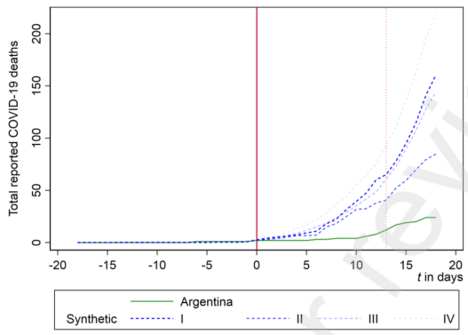.
Source: Figure 1 in Neidhöfer and Neidhöfer (2020)

Reinbold (2021) – School closures in Illinois
Reinbold (2021) examines the effect of school closures in Illinois in August 2020 and thus does not suffer from the same “surprise” problems as Friedson et al. (2021) and Neidhöfer and Neidhöfer (2020).
Reinbold (2021) does not explain the reason for using data from Illinois. In the period examined (August 24, 2020 to September 13, 2020), the number of COVID-19 deaths were relatively stable in Illinois and the U.S. as a whole, and reveal no potential source for bias regarding the geographical coverage.
Reinbold (2021) finds “no significant differences in […] deaths between any of the 3 county groups” (majority hybrid, majority online-only, and majority in-person counties).
One possible concern is that the period studied is only three weeks, so any effect on deaths from the school closures is likely to be small because of the lag between infection and death, which is particularly long when the reproduction rate is close to 1 (see the appendix to this supplementary material). This may explain why Reinbold (2021) finds no significant effect on mortality.

Dave et al. (2020b) – Wisconsin
Dave et al. (2020b) examine the effect of Wisconsin’s SIPO, exploiting a natural experiment arising when the Wisconsin Supreme Court abolished the state’s “Safer at Home” order [SIPO] on May 13, 2020 and thus do not suffer from the same “surprise” problems as Friedson et al. (2021) and Neidhöfer and Neidhöfer (2020). Since Dave et al. (2020b) rely on a natural experiment, there is no reason to believe that the selection of Wisconsin as a case was biased.
In their first version, Dave et al. (2020a), the authors only examine a two week period following the Supreme Court decision, but in the authors’ updated version, Dave et al. (2020b), they examine one full month. They conclude that “we find no evidence that the Wisconsin Supreme Court decision impacted COVID-19 growth up to a month following the repeal.” Although insignificant, their Figure 7(a) shows that the total effect of the SIPO on COVID-19 mortality after one month is approximately 8% fewer deaths, cf. Figure 4 below.
Figure 4 Replication of Figure 7(a) in Dave et al. (2020b)
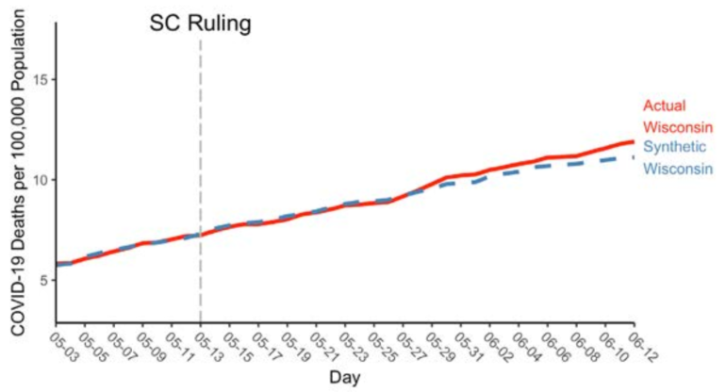
Source: Figure 7(a) in Dave et al. (2020b).
Note: Synthetic WI is comprised of ME (.539), HI (.209) CA (.08) & PA (.048).

The Generalized Synthetic Control Method (GSCM)

Mader and Rüttenauer (2021)
Mader and Rüttenauer (2021) analyze data on daily confirmed COVID-19-related deaths per capita from Our World in Data, and on 10 different NPIs from the Oxford COVID-19 Government Response Tracker for 169 countries from July 1st, 2020 to May 31st, 2021.
They use GSCM thereby effectively avoiding any potential selection bias.
Mader and Rüttenauer (2021) “do not find substantial and consistent mitigating effects of any NPI under investigation on COVID-19-related deaths per capita. We see a tentative change in the trend of COVID-19-related deaths around 30 days after workplace closing, public transport closing, and stay at home rules have been implemented, but none of them exerts a statistically significant effect.” Their results are summarized in Figure 5 below.
Figure 5 Effect on COVID-19 deaths of various NPIs in Mader and Rüttenauer (2021)
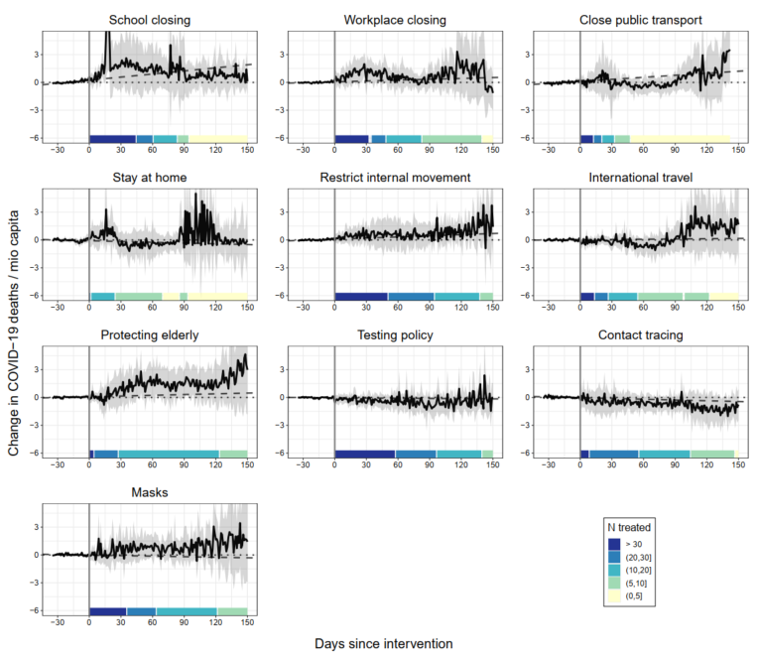
Source: Figure 1 in Mader and Rüttenauer (2021)
Conclusion on the SCM criteria
Born et al. (2021), Cerqueti et al. (2021), Cho (2020), Conyon and Thomsen (2021), and Ghosh et al. (2020) study special cases, i.e. jurisdictions which were hit early and surprised by the pandemic and would have experienced very high COVID-19 mortality even if they managed to reduce the reproduction number, R_{t}, to the same level at the same time as other places.
Friedson et al. (2021) and Neidhöfer and Neidhöfer (2020) find very large and very early effects which indicate that their synthetic control is flawed. The explanation may lie in the very short data period available for estimating the synthetic control which is exactly the problem discussed by Bjørnskov (2021) and initially pointed out by Abadie (2021).
Reinbold (2021) does not find any effect on mortality but only looks at a three-week period after treatment, hiding any potential effect on mortality of school closures due to the delay between infection and death.
Dave et al. (2020b) exploit a natural experiment to examine the repeal of SIPO in Wisconsin and find a small (approximately -8%) and insignificant effect of (repealing) SIPOs.

Conclusion on SCM-studies
We conclude that the exclusion criteria in our protocol was well founded. The SCM studies in general do not show “sufficient variation” but rather examination of special cases where the very short pre-intervention window is an important limitation of the SCM. Only two studies, Mader and Rüttenauer (2021) and to some degree Dave et al. (2020b), do not suffer from the biases we expected when preparing our protocol. But, if these two studies would have been included in our meta-study, our meta-results would not have been significantly altered.
Since it is prudent not to deviate from one’s research protocol ex-post-facto, we have adhered to our protocol with regard to the SCM studies.
In the next section we look at the studies excluded based on our “too few observations” criteria.

The “too few observations” criteria
We exclude the following 10 studies based on the “too few observations” criteria:
- Bongaerts et al. (2021)
- Gordon et al. (2020)
- Berardi et al. (2020)
- Alemán et al. (2020)
- Conyon et al. (2020)
- Juranek and Zoutman (2021)
- Kapoor and Ravi (2020)
- Ciminelli and Garcia-Mandicó (2021)
- Porto et al. (2022)
- Borri et al. (2020)

Geographical coverage of the 10 studies
Six of the 10 studies examine variation within one country (five – Bongaerts et al. (2021), Berardi et al. (2020), Ciminelli and Garcia-Mandicó (2021), Porto et al. (2022), and Borri et al. (2020) – examine Italy and one – Alemán et al. (2020) – examines Spain).
The remaining four studies – Gordon et al. (2020), Conyon et al. (2020), Juranek and Zoutman (2021), and Kapoor and Ravi (2020) – compare Sweden (control group) to other countries (primarily Scandinavian countries).
Given the data contained in Figure 6, these selections do not seem to be random. Indeed, the studies seem to focus on jurisdictions which were surprised by the pandemic and would have experienced very high COVID-19 mortality even if they managed to reduce the reproduction number, R_{t}, to the same level at the same time as other places.
Figure 6 All “too few observations” studies cover European countries that were hit early and hard by the pandemic
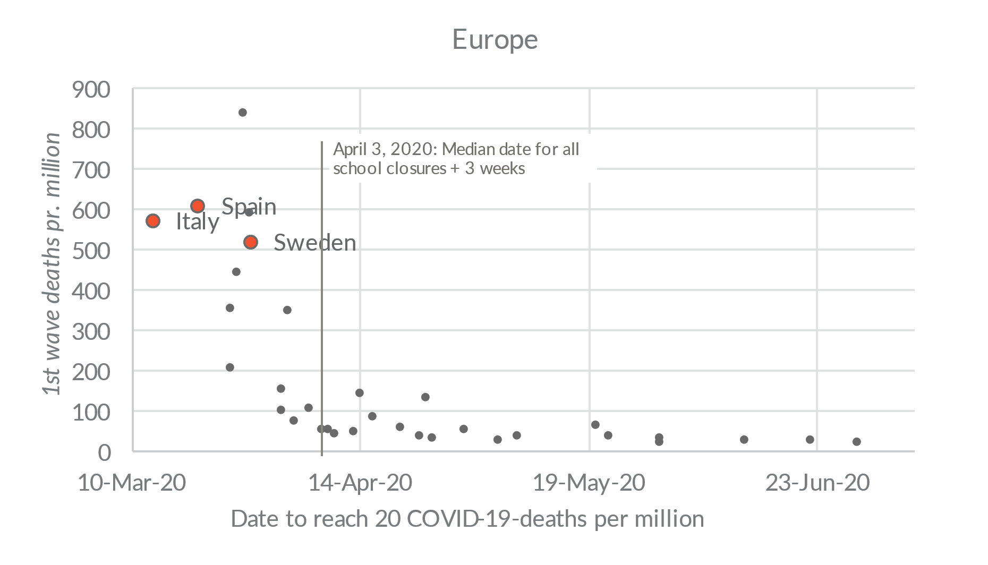
Note: The figure shows the relationship between early pandemic strength and total 1st wave of COVID-19 mortality. On the X-axis is “Days to reach 20 COVID-19-deaths per million (measured from February 15, 2020).” The Y-axis shows mortality (deaths per million) by June 30, 2020.
Source: Reported COVID-19 deaths and OxCGRT stringency for European countries and US states with more than one million citizens. Data from Our World in Data (2022).

Conclusion on the “too few observations”-criteria
We conclude that the exclusion criteria in our protocol in most cases was well founded. The “too few observations” studies in general do not show “sufficient variation” but rather focus on special cases.
Since it is prudent not to deviate from one’s research protocol ex-post-facto, we have adhered to our protocol with regard to the “too few observations”-studies.

Conclusion
In general, it is best to avoid changing the research protocol after the results of the study have been obtained, as this can introduce bias and compromise the validity and credibility of the research reported on the basis of the protocol.
The above evaluation of the exclusion criteria in our protocol shows that:
- the excluded studies tend to focus on a few special cases such as Italy and Sweden, which were hit early and surprised by the pandemic. As a result, they would have experienced very high COVID-19 mortality even if they managed to reduce the reproduction number, R_{t}, to the same level at the same time as other places. These studies examine special cases and do not – even when combined – reflect “sufficient variation” in the data.
- many SCM studies suffer from a very short pre-intervention window which tends to render their synthetic control approach ineffective.
There are only two excluded studies where conclusion 1) and/or 2) do not apply (Mader and Rüttenauer (2021) and to some degree Dave et al. (2020b)). These studies yield results similar to our meta-results and, thus, would not significantly alter our meta-results if included.

Appendix – the time from infection to death
There is considerable variability in the time from infection with COVID-19 to death. Virtually no-one dies within the first week of infection, but thereafter the probabilities climb quite steeply, cf. Figure 7 from Wood (2022). On average, it takes 26 days from infection to death, and 29% die within the third week after infection (day 15 to 21) while 26% die within the fourth week after infection (day 22 to 28).
Figure 7 Fatal disease duration distribution from infection to death
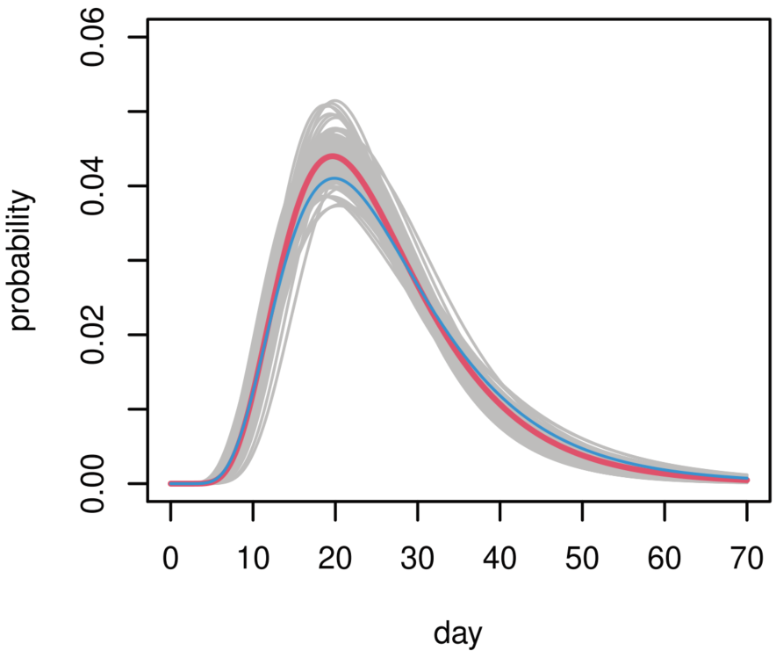
Source: Wood (2022) Figure 1 (right).
Because the duration between infection and death is probabilistic rather than deterministic, there will be a delay before the possible effect of a lockdown is visible in mortality data.
To illustrate this point, Figure 8 below shows the development of COVID-19-deaths from a simple SEIR-model which is deterministic and assumes that 0.5% of all infected individuals die every day compared to the same model where the risk of death is probabilistic. Figure 8 illustrates that in this case, where the reproduction rate is 2.584 before the lockdown and 0.704 after, the effect of the lockdown is hardly visible in the cumulative number of deaths before day 14-16 after the (effective) lockdown.
Figure 8 Fatal disease duration distribution from infection to death
Panel A: Deterministic deaths  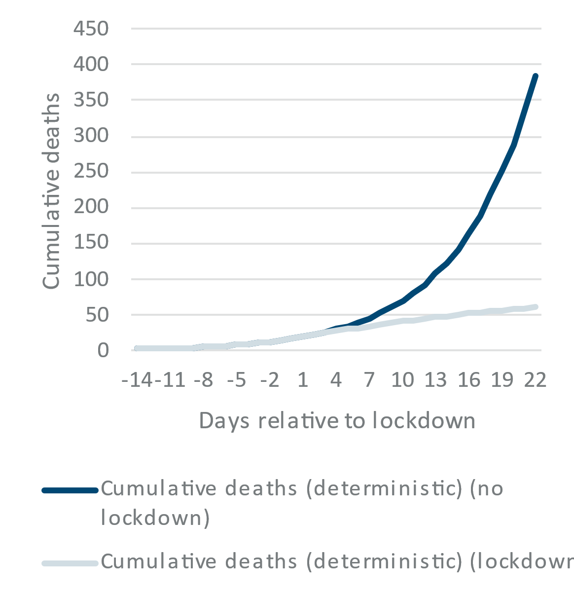 | Panel B: Probabilistic deaths  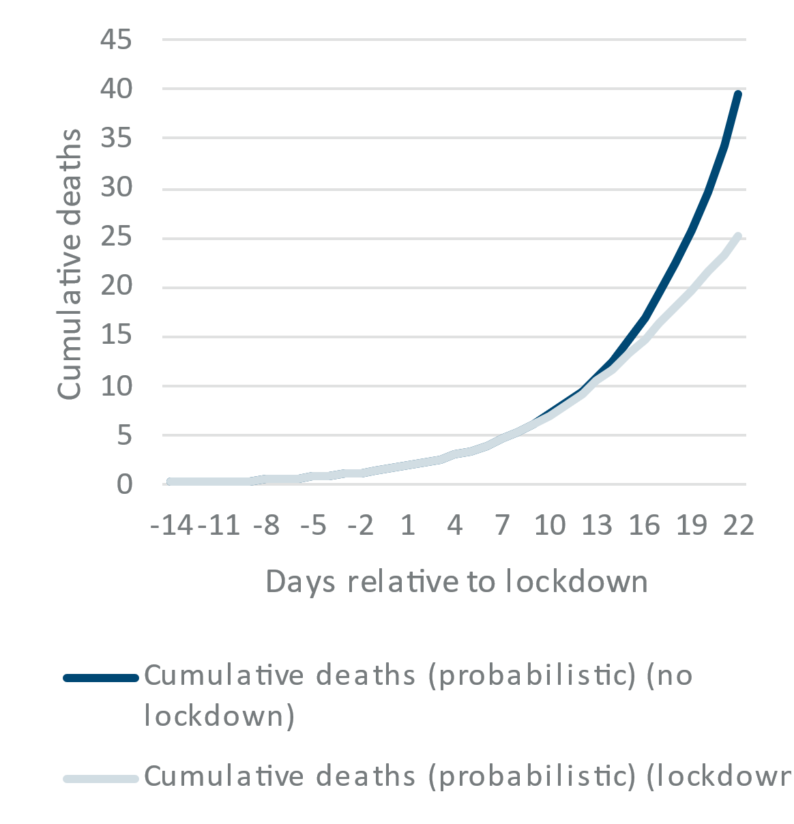
Note: The model shows the development in deaths in Sweden if a lockdown had reduced the reproduction rate, R_{t}, from 2.584 to 0.704 at the day where 800 people were infected and 1-2 persons had died. The values of R_{t} corresponds to the values for Sweden derived from “Extended Data Fig. 1” in Flaxman et al. (2020) (Flaxman et al. estimate R_{t} to 2.584 before public events were banned and 0.704 after the ban).

As Wood (2022) illustrates, R_{t} changed gradually as governments informed the public and advised people to self-isolate and work from home. Figure 9 below illustrates the importance of this insight for when the effect of a lockdown is visible in cumulative COVID-19 deaths. The figure shows the relative difference (deaths with lockdown relative to deaths without lockdown) for different values of R_{t} before lockdown brings R_{t} down to 0.704. The figure shows that if R_{t} = 1.5 before a lockdown, the difference in cumulative deaths with and without an effective lockdown is only approximately 8% after 21 days. If R_{t} = 2.0 the difference after 21 days is 15%, and if R_{t} = 2.584 the difference is 32%.
In all cases there is virtually no difference after 12 days, and after 15 days the difference is less than 10% in all three cases.
Figure 9 Difference in cumulative deaths given different values of R_{t} prior to lockdown
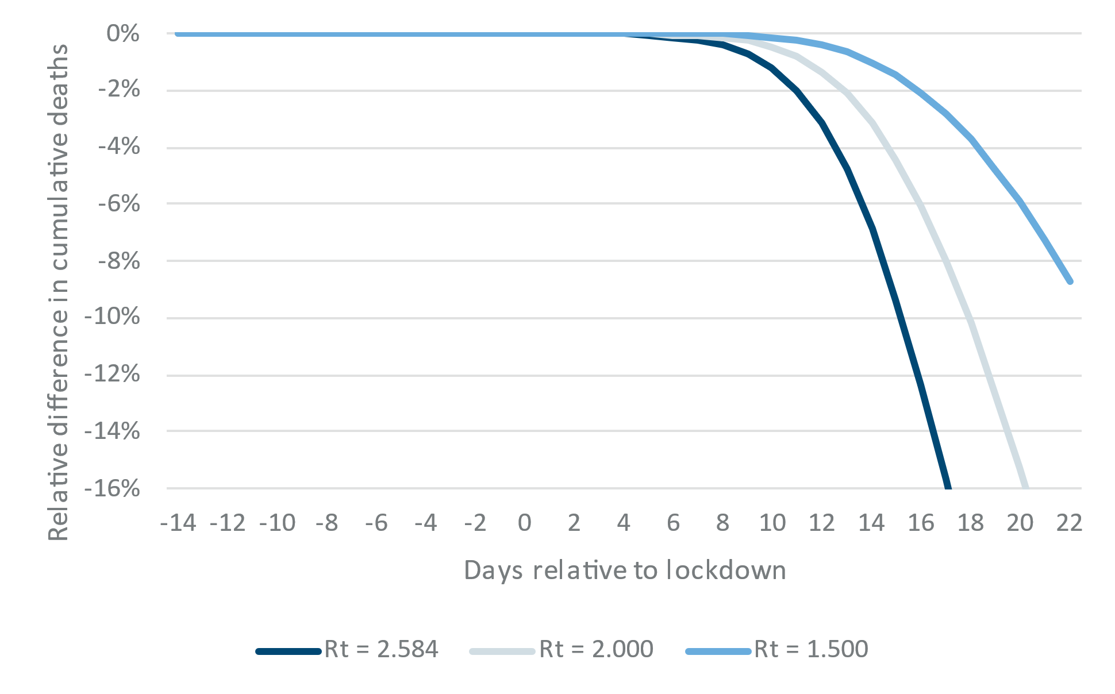
Note: In all cases R_{t} = 0.704 after lockdown.

References
Abadie, A. (2021). Using Synthetic Controls: Feasibility, Data Requirements, and Methodological Aspects. Journal of Economic Literature, 59(2), 391–425. https://doi.org/10.1257/jel.20191450
Alemán, C., Busch, C., Ludwig, A., & Santàeulalia-Llopis, R. (2020). Evaluating the Effectiveness of Policies Against a Pandemic (p. 36).
Auger, K. A., Shah, S. S., Richardson, T., Hartley, D., Hall, M., Warniment, A., et al. (2020). Association Between Statewide School Closure and COVID-19 Incidence and Mortality in the US. JAMA, 324(9), 1–13. https://doi.org/10.1001/jama.2020.14348
Berardi, C., Antonini, M., Genie, M. G., Cotugno, G., Lanteri, A., Melia, A., & Paolucci, F. (2020). The COVID-19 pandemic in Italy: Policy and technology impact on health and non-health outcomes. Health Policy and Technology, 9(4), 454–487. https://doi.org/10.1016/j.hlpt.2020.08.019
Bjørnskov, C. (2021, June 14). Born et al. om epidemien i Sverige – hvad er der galt og hvordan ser det ud nu? Punditokraterne. http://punditokraterne.dk/2021/06/14/born-et-al-om-epidemien-i-sverige-hvad-er-der-galt-og-hvordan-ser-det-ud-nu/. Accessed 23 August 2021
Bongaerts, D., Mazzola, F., & Wagner, W. (2021). Closed for business: The mortality impact of business closures during the Covid-19 pandemic. PLOS ONE, 16(5), e0251373. https://doi.org/10.1371/journal.pone.0251373
Born, B., Dietrich, A. M., & Müller, G. J. (2021). The lockdown effect: A counterfactual for Sweden. PLOS ONE, 16(4), e0249732. https://doi.org/10.1371/journal.pone.0249732
Borri, N., Drago, F., Santantonio, C., & Sobbrio, F. (2020). The “Great Lockdown”: Inactive Workers and Mortality by Covid-19 (preprint). Health Economics. https://doi.org/10.1101/2020.09.17.20190595
Cerqueti, R., Coppier, R., Girardi, A., & Ventura, M. (2021). The sooner the better: lives saved by the lockdown during the COVID-19 outbreak. The case of Italy. arXiv:2101.11901 [econ]. http://arxiv.org/abs/2101.11901. Accessed 17 August 2021
Cho, S.-W. (Stanley). (2020). Quantifying the impact of nonpharmaceutical interventions during the COVID-19 outbreak: The case of Sweden. The Econometrics Journal, 23(3), 323–344. https://doi.org/10.1093/ectj/utaa025
Ciminelli, G., & Garcia-Mandicó, S. (2021). When and how do business shutdowns work? Evidence from Italy’s first COVID-19 wave, 1664. https://doi.org/10.1787/095b5d62-en
Conyon, M. J., He, L., & Thomsen, S. (2020). Lockdowns and COVID-19 Deaths in Scandinavia. SSRN Electronic Journal. https://doi.org/10.2139/ssrn.3616969
Conyon, M. J., & Thomsen, S. (2021, March 5). COVID-19 in Scandinavia. https://doi.org/10.2139/ssrn.3793888
Dave, D., Friedson, A. I., Matsuzawa, K., McNichols, D., & Sabia, J. J. (2020a). Are the Effects of Adoption and Termination of Shelter-in-Place Orders Symmetric? Evidence from a Natural Experiment. https://doi.org/10.3386/w27322
Dave, D., Friedson, A. I., Matsuzawa, K., McNichols, D., & Sabia, J. J. (2020b). Did the Wisconsin Supreme Court Restart a Covid-19 Epidemic? Evidence from a Natural Experiment. SSRN Electronic Journal. https://doi.org/10.2139/ssrn.3620628
Flaxman, S., Mishra, S., Gandy, A., Unwin, H. J. T., Mellan, T. A., Coupland, H., et al. (2020). Estimating the effects of non-pharmaceutical interventions on COVID-19 in Europe. Nature, 584(7820), 257–261. https://doi.org/10.1038/s41586-020-2405-7
Friedson, A. I., McNichols, D., Sabia, J. J., & Dave, D. (2021). Shelter-in-Place Orders and Public Health: Evidence from California During the Covid-19 Pandemic. Journal of Policy Analysis and Management, 40(1), 258–283. https://doi.org/10.1002/pam.22267
García-García, D., Vigo, M. I., Fonfría, E. S., Herrador, Z., Navarro, M., & Bordehore, C. (2021). Retrospective methodology to estimate daily infections from deaths (REMEDID) in COVID-19: the Spain case study. Scientific Reports, 11(1), 11274. https://doi.org/10.1038/s41598-021-90051-7
Ghosh, S. K., Ghosh, S., & Narumanchi, S. S. (2020). A Study on the Effectiveness of Lock-down Measures to Control the Spread of COVID-19. arXiv:2008.05876 [physics]. http://arxiv.org/abs/2008.05876. Accessed 17 August 2021
Gordon, D. V., Grafton, R. Q., & Steinshamn, S. I. (2020). Statistical Analyses of the Public Health and Economic Performance of Nordic Countries in Response to the COVID-19 Pandemic, 2020.11.23.20236711. https://doi.org/10.1101/2020.11.23.20236711
Hale, T., Angrist, N., Boby, T., Cameron-Blake, E., Hallas, L., Kira, B., et al. (2020). Variation in government responses to COVID-19 (Version 10.0). BSG Working Paper Series. https://www.bsg.ox.ac.uk/sites/default/files/2020-12/BSG-WP-2020-032-v10.pdf. Accessed 17 December 2022
Herby, J., Jonung, L., & Hanke, S. H. (2021). Protocol for “What Does the First XX Studies Tell Us about the Effects of Lockdowns on Mortality? A Systematic Review and Meta-Analysis of COVID-19 Lockdowns.” SSRN Electronic Journal. https://dx.doi.org/10.2139/ssrn.3872977
Juranek, S., & Zoutman, F. T. (2021). The effect of non-pharmaceutical interventions on the demand for health care and on mortality: evidence from COVID-19 in Scandinavia. Journal of Population Economics, 34(4), 1299–1320. https://doi.org/10.1007/s00148-021-00868-9
Kapoor, M., & Ravi, S. (2020). Impact of national lockdown on COVID-19 deaths in select European countries and the US using a Changes-in-Changes model. arXiv:2006.12251 [physics, q-bio, q-fin]. http://arxiv.org/abs/2006.12251. Accessed 24 August 2021
Leffler, C. T., Ing, E., Lykins, J. D., Hogan, M. C., McKeown, C. A., & Grzybowski, A. (2020). Association of Country-wide Coronavirus Mortality with Demographics, Testing, Lockdowns, and Public Wearing of Masks. The American Journal of Tropical Medicine and Hygiene, 103(6), 2400–2411. https://doi.org/10.4269/ajtmh.20-1015
Mader, S., & Rüttenauer, T. (2021, June 11). The effects of non-pharmaceutical interventions on COVID-19-related mortality: A generalized synthetic control approach across 169 countries. SocArXiv. https://doi.org/10.31235/osf.io/v2ef8
Neidhöfer, G., & Neidhöfer, C. (2020). The Effectiveness of School Closures and Other Pre-Lockdown COVID-19 Mitigation Strategies in Argentina, Italy, and South Korea. SSRN Electronic Journal. https://doi.org/10.2139/ssrn.3649953
Our World in Data. (2022). COVID-19 Data Explorer. Our World in Data. https://ourworldindata.org/coronavirus-data-explorer. Accessed 7 April 2022
Porto, E. D., Naticchioni, P., & Scrutinio, V. (2022). Lockdown, essential sectors, and Covid-19: Lessons from Italy. Journal of Health Economics, 81, 102572. https://doi.org/10.1016/j.jhealeco.2021.102572
Reinbold, G. W. (2021). Effect of Fall 2020 K-12 instruction types on COVID-19 cases, hospital admissions, and deaths in Illinois counties. American Journal of Infection Control, 0(0). https://doi.org/10.1016/j.ajic.2021.05.011
Stokes, J., Turner, A. J., Anselmi, L., Morciano, M., & Hone, T. (2020). The relative effects of non-pharmaceutical interventions on early Covid-19 mortality: natural experiment in 130 countries, 2020.10.05.20206888. https://doi.org/10.1101/2020.10.05.20206888
Wood, S. N. (2022). Inferring UK COVID-19 fatal infection trajectories from daily mortality data: Were infections already in decline before the UK lockdowns? Biometrics, 78(3), 1127–1140. https://doi.org/10.1111/biom.13462

† Corresponding author: jherby@gmail.dk // +45 2728 2748
In the update we also excluded “studies lacking focus on mortality”. This addition had no real effect.
See https://www.sciencemediacentre.org/expert-reaction-to-a-preprint-looking-at-the-impact-of-lockdowns-as-posted-on-the-john-hopkins-krieger-school-of-arts-and-sciences-website/
Ghosh et al. (2020) cover Delhi and Neidhöfer and Neidhöfer (2020) cover South Korea.
The data all schools in the jurisdiction was closed, cf.
Leffler et al. (2020) write “On average, the time from infection with the coronavirus to onset of symptoms is 5.1 days, and the time from symptom onset to death is on average 17.8 days. Therefore, the time from infection to death is expected to be 23 days.” Meanwhile, Stokes et al. (2020) state that “evidence suggests a mean lag between virus transmission and symptom onset of 6 days, and a further mean lag of 18 days between onset of symptoms and death.” Also see the appendix to this supplementary material.
All 50 U.S. states closed schools between March 13, 2020, and March 23, 2020, and 44 states closed schools in just four school days (March 15, 2020 (Sunday) to March 19, 2020 (Friday)), see Table 1 in Auger et al. (2020).
Friedson et al. (2021) write: “While our estimated mortality decline is substantial in magnitude, permutation-based p-values are insufficiently small to conclude definitively that there was a decline in COVID-19 deaths due to California’s SIPO.”
Friedson et al. (2021) estimate that “the adoption of a SIPO is associated with 636 to 1,556 fewer deaths across these specifications, with a median estimate of around 1,436 lives saved.” By the end of their study-period (April 20, 2020), there were 1,201 COVID-19 deaths in California, so the effect of the SIPO is estimated at -35% to -56%, with a median estimate of -54%.
See https://governor.sc.gov/news/2020-04/governor-mcmaster-issues-home-or-work-order
García-García et al. (2021) find a somewhat different distribution, where approximately 20% die within 14 days (Wood (2022): 11%), 42% die on day 15 to 21 (29%), and 25% on day 22 to 28 (26%). However, the overall conclusion that the effect of lockdowns are not visible in mortality data the first 14 days remains.
The SEIR-model was downloaded from https://www.wku.edu/da/covid-19-research/excel_sir_model.php (direct link: https://www.wku.edu/da/covid-19-research/sir_model.xlsx) and used the following values: Gamme = 0.2, Delta = 0.005, Lambda = 0.333 and Beta = 0,5168 (before lockdown) and 0,1408 (after lockdown). The values of Beta corresponds to the values of the reproduction rate, R_{t}, for Sweden derived from “Extended Data Fig. 1” in Flaxman et al. (2020) (they estimate R_{t} to 2.584 before public events were banned and 0.704 after the ban).
For example, see Wood (2022) figure 3.

