Electronic Supplementary Material

Online Appendix

- Distribution of research activity by region

Figure A1 presents the distribution of research activity by region.

- Further tests of the parallel trends assumption

In Table A1, we provide further tests of the parallel trends assumption based on placebo difference-in-differences (DiD) analyses (see Gertler et al., 2016, for a description of these types of tests, and Shai, 2022, for a recent application). Specifically, we first conduct a DiD analysis based on a fake treatment time (columns 1 and 2). Next, we conduct another DiD analysis based on a fake treatment group (column 3).
In specifications 1 (for the war regions) and 2 (for Crimea), we assume that the fake treatment happened in 2010 and do not include post-2014 data in the sample. We thus estimate the following amended version of Equation (1) in the paper:
$${NumberofPapersPublished}_{it}=α+δ{(Treatment ×AfterFake)}_{it}+λ_{i}+θ_{t}+ε_{it}$$ | (A1)
Treatment_{it} is a dummy equal to one at time t if author i is affiliated with institutions in Russia-occupied territories that include parts of the Donetsk and Luhansk regions and the entire Crimea region, and zero otherwise. The control group comprises researchers affiliated with institutions located in the entire unoccupied Ukraine. AfterFake_{t} is a dummy variable equal to one over the period 2010-2014, and zero otherwise. δ is our main difference-in-differences coefficient measuring the treatment effect of the fake 2010 event on the number of papers published by Ukrainian scientists. As in Equation (1) in the paper, $λ_{i} represents$ author-level fixed effects; $θ_{t}$, year fixed effects; and $ε_{it}$ is an idiosyncratic error term. As expected, columns 1 and 2 of Table A1 show that the DiD coefficient is insignificant.
In specification 3, we estimate the following amended version of Equation (1) in the paper in which we keep the post-2014 data in the sample, but assume the bordering regions (i.e., Kharkiv, Kherson, Zaporizhzhia, and Dnipro) to be a fake treatment group, while excluding the actual treatment regions (i.e., the war regions and Crimea):

${NumberofPapersPublished}_{it}=α+δ{(TreatmentFake ×After)}_{it}+λ_{i}+θ_{t}+ +ε_{it}$ (A2)
TreatmentFake_{it} is a dummy equal to one if author i is affiliated with institutions in the bordering regions (i.e., Kharkiv, Kherson, Zaporizhzhia, and Dnipro) at time t, and zero otherwise. Researchers affiliated with institutions located in the rest of Ukraine make up the control group. The After_{t} dummy is equal to 1 over the period 2014-2023, and 0 otherwise. The results show that, once again, the estimated DID coefficient is insignificant, supporting the parallel trends assumption.
Based on the outcome of these placebo tests and on the estimates of Equation (2) in the paper, we can be confident that, overall, the assumption of parallel trends is satisfied. In other words, we can conclude that the downward (upward) trend in the number of papers published by scientists based in the war regions (Crimea) following 2014 was not part of a pre-war trend.

- Further robustness tests

Table A2 presents a number of further robustness tests. In all cases, the treatment group is made up of researchers affiliated with institutions located in the war regions/Crimea, whilst the control group consists of researchers affiliated with institutions located in the unoccupied Ukrainian regions.

Including additional control variables in our model. We first verify that our results are robust to including region-specific time-effects, which pick region-specific business cycles, as well as additional control variables. Specifically, in column 1 (column 5) of Table A2, we provide estimates of Equation (1) in the paper augmented with region-specific time dummies in the case in which the war regions (Crimea) make up the treatment group. In all cases, the dependent variable is the number of papers published by a given Ukrainian scientist.
Second, in column 2 (column 6) of the same Table, we provide estimates of Equation (1) in the paper augmented with the following control variables, once again in the case in which the war regions (Crimea) make up the treatment group:

1. Number of new co-authors for a given author in a given year;
2. Number of co-authors for a given author in a given year;
3. Dummy variable equal to 1 if a given author had at least one Russian co-author in a given year, 0 otherwise;
4. Number of Russian co-authors for a given author in a given year.

In both cases, the results suggest that the productivity of researchers in the war-affected regions declined after 2014. At the same time, the output of the researchers in the annexed region (Crimea) remained unchanged or increased. Hence, we can conclude that our baseline results are robust to adding region-specific business cycle effects and the above-mentioned control variables to our main specification.
It is interesting to note that in both the war regions and Crimea, the coefficient associated with the number of new co-authors is positive and statistically significant. This is not surprising, as having a new co-author is intrinsically associated with the publication of at least one additional paper. Yet, the coefficient associated with the total number of co-authors is negative and significant in all regions, suggesting that having more co-authors goes hand-in-hand with lower productivity. This can be explained by reduced marginal efforts and, consequently, quality of work in projects with multiple co-authors. By contrast, having Russian co-authors and the number of Russian co-authors both show positive and significant coefficients in all regions. This suggests that participating in Russian networks can be beneficial, likely due to Russian co-authors bringing funding.

Including a lagged dependent variable. In columns 3 and 7 of Table A2, we show that our baseline results are robust to adding a lagged dependent variable in the model. The coefficient associated with the lagged dependent variable is positive and statistically significant, indicating that there is some persistence in the research output.

Using an unbalanced panel. Finally, we verify whether our results are robust to using an unbalanced panel, in which we remove all observations for a given author before his/her first publication. The results, which are reported in columns 4 and 8 of Table A2 are consistent with our baseline results. Given that the results based on the balanced and unbalanced panel are consistent, we prefer to report the former in the paper as the latter leads to a drop in sample size of around 25 percent.

- Accounting for authors’ heterogeneity

In Table A3, we report estimates of an augmented version of Equation (1) in the paper whereby the DiD term is differentiated across a range of different groups: researchers who had/did not have Russian co-authors before 2014; researchers who had/did not have Russian funding before 2014; junior, mid-career, senior, and emeriti researchers; and researchers with small, medium-sized, large, and very large networks. It is noteworthy that we did not include these researchers’ characteristics as control variables as they are largely time-invariant, and hence subsumed in the researcher-specific component of the error term. The results, which are also presented graphically in Figure 10 in the paper, are summarized hereafter:

- Columns 1a (for the war zones) and 1b (for Crimea): Authors who did not (Group 1) and did have (Group 2) Russian co-authors before 2014.

All researchers in the war zone were hurt by the war and hence experienced a lower number of publications after 2014. Yet, those with Russian co-authors were hurt the most (Group 2). A potential explanation is that after they evacuated to the Ukraine-controlled part of the country, they cut the ties with their Russian co-authors, which may, in turn, have led to lower productivity. As for Crimea, only Ukrainian scientists co-authoring with Russians before 2014 showed an increase in their productivity thereafter, likely due to increased Russian funding after the Annexation. The performance of authors without Russian co-authors remained unchanged.

- Columns 2a (for the war zones) and 2b (for Crimea): Authors with (Group 1) and without (Group 2) Russian funding prior to 2014.

In the war regions, those researchers who received Russian funding prior to 2014 suffered the most as they likely relied on it and then lost it when the war started. In Crimea, those who had a history of receiving Russian grants saw a 2.5 times higher increase in productivity than those who had never received Russian funding before 2014.

- Columns 3a (for the war zones) and 3b (for Crimea): Junior (Group 1), mid-career (Group 2), senior (Group 3), and emeriti authors (Group 4). The groups are defined as follows: within 3 years after publishing the first paper (Group 1), within 4 to 8 years (Group 2), within 9 to 20 years (Group 3), and within 20+ years (Group 4).

In the war regions, all authors were adversely affected regardless of seniority. Yet, the most senior researchers were affected the most, probably because it was harder for the older generations to adapt to a new life characterized by war. In Crimea, on the other hand, only the mid-career and young researchers were able to increase their productivity. This can be explained bearing in mind that it may have been easier for younger generations to adapt to the new life after the Annexation.

- Columns 4a (for the war zones) and 4b (for Crimea): Groups 1, 2, 3, and 4: quartiles of co-author network size, with 1 corresponding to the smallest and 4 to the largest network.

In column 4a, the coefficients associated with the DiD term interacted with all four network-size groups are very similar in magnitude. This suggests that, in Donetsk and Luhansk, the war negatively affected all the researchers, regardless of the size of their network. As for Crimea, only the researchers with the largest network of co-authors (top 25%) were able to increase their productivity. The other 75% remained as productive as they were before the Annexation. This can be explained bearing in mind that better-networked researchers were able to attract the increased funding available from Russia after the Annexation.

In summary, the results of our heterogeneity tests indicate that the productivity of authors located in war zones was generally negatively affected by the war, with researchers who had Russian co-authors and/or Russian funding prior to 2014, and more senior researchers being affected most. By contrast, in Crimea, those authors who benefited in terms of productivity after the Annexation were those with Russian co-authors and/or funding prior to 2014, those with larger network sizes, and those at the junior or mid-career level.

References not included in the paper

Gertler, P. J., Martinez, S., Premand, P., Rawlings, L. B., Vermeersch, C. M. J. (2016). Impact Evaluation in Practice, Chapter 7. Second Edition. Washington, DC: Inter-American Development Bank and World Bank.
Shai, O. (2022). Does armed conflict increase individuals’ religiosity as a means of coping with adverse psychological effects of wars? Social Science and Medicine, 296, 114769.

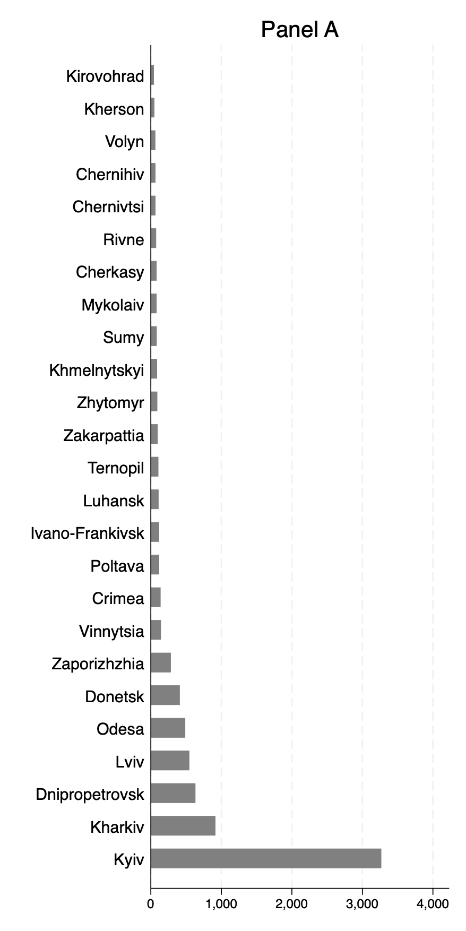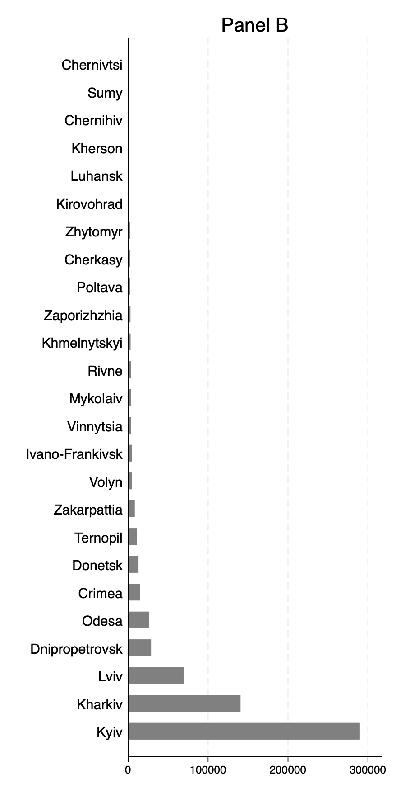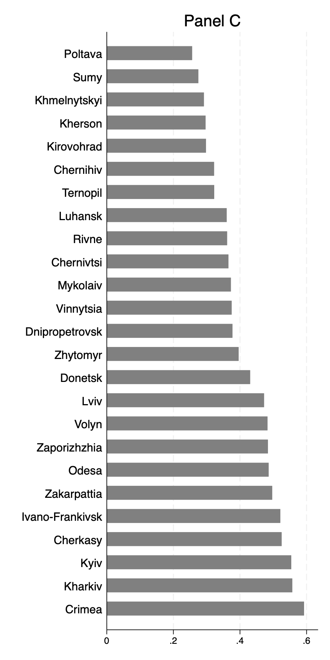

Fig. A1 Research activity by region

Note: Panel A shows the number of publications by authors affiliated with universities/institutions based within each Ukrainian region over the period 2004-2023. Panel B presents the number of unique research institutions with authors who published at least one paper over the period 2004-2023, by region. Panel C shows the average SJR score of the publications of authors affiliated with institutions/universities based within each region.
Source: Scopus (2023), Scimago (2023).

Table A1 Placebo tests

 | (1) | (2) | (3)
 | Time Placebo (Fake Treatment Time) |  | Group Placebo  (Fake Treatment Group)
Treatment Groups | War regions (Donetsk and Luhansk) | Annexed region (Crimea) | Bordering Regions
Treatment Time | 2010 |  | 2014
Sample | Excludes Post 2014 |  | Excludes War and Annexed Regions
Fake DiD | 0.007 | -0.027 | 0.001
 | (0.025) | (0.036) | (0.018)
R-Square | 0.040 | 0.040 | 0.031
Sample size | 211,150 | 204,850 | 364,860

This Table presents fixed-effects estimates of the fake DiD coefficients in Equations (A1) (columns 1 and 2) and (A2) (column 3). In columns 1 and 2, a fake treatment time is used, whilst in column 3, a fake treatment group is used. In column 1 (for the war regions) and 2 (for Crimea), we assume that the fake treatment happened in 2010 and do not include post-2014 data in the sample. In both columns, the control group is the entire unoccupied Ukraine. In column 3, we keep the post-2014 data in the sample, but assume the bordering regions (i.e., Kharkiv, Kherson, Zaporizhzhia, and Dnipro) to be a fake treatment group, while the control group includes the rest of Ukraine, and the war regions and Crimea are excluded from the sample. In all specifications the dependent variable is the number of papers published by Ukrainian scientists. All regressions include author and year fixed effects. Robust standard errors are presented in parentheses.

Table A2 Further robustness tests

 | (1) | (2) | (3) | (4) | (5) | (6) | (7) | (8)
Treatment group | War regions (Donetsk and Luhansk) |  |  |  | Annexed region (Crimea)
Specifications | Region- specific time effects | Additional controls | Dynamic Panel | Unbalanced  panel | Region- specific time effects | Additional controls | Dynamic panel | Unbalanced  Panel
DiD coefficient | -0.121*** | -0.215*** | -0.152*** | -0.229*** | -0.018 | 0.203** | 0.130*** | 0.230***
 | (0.035) | (0.063) | (0.022) | (0.049) | (0.059) | (0.101) | (0.048) | (0.089)
Lagged dependent variable |  |  | 0.313*** |  |  |  | 0.316***
 |  |  | (0.005) |  |  |  | (0.005)
Number of new co-authors |  | 0.066*** |  |  |  | 0.065***
 |  | (0.005) |  |  |  | (0.004)
Russian co-author |  | 0.613*** |  |  |  | 0.621***
 |  | (0.028) |  |  |  | (0.028)
Total number of co-authors |  | -0.066*** |  |  |  | -0.065***
 |  | (0.006) |  |  |  | (0.006)
Number of Russian co-authors |  | 0.026*** |  |  |  | 0.025***
 |  | (0.004) |  |  |  | (0.004)
R-Square | 0.035 | 0.156 | 0.118 | 0.009 | 0.035 | 0.157 | 0.120 | 0.009
Sample size | 380,070 | 125,563 | 358,955 | 275,714 | 368,730 | 123,005 | 348,245 | 267,895

This Table presents fixed-effects estimates of the DiD coefficient (Treatment*After) in a modified version of Equation (1) in the paper, whereby the dependent variable is the number of papers published by Ukrainian scientists. Columns 1 and 5 also include region-specific time effects. Columns 2 and 6 include additional control variables. Columns 3 and 7 present estimates of a dynamic version of Equation (1). Columns 4 and 8 present estimates based on an unbalanced panel in which we remove all observations for a given author before his/her first publication. The control group in all specifications comprises all unoccupied regions of Ukraine. All regressions include author and year fixed effects. Robust standard errors are presented in parentheses.

Table A3 Effects of the war on different types of researchers

 | 1a | 1b | 2a | 2b |  | 3a | 3b | 4a |  | 4b
Treatment Groups | War regions (Donetsk and Luhansk) | Annexed region (Crimea) | War regions (Donetsk and Luhansk) | Annexed region (Crimea) |  | War regions (Donetsk and Luhansk) | Annexed region (Crimea) | War regions (Donetsk and Luhansk) |  | Annexed region (Crimea)
Specifications | Groups 1 & 2: Authors w/o & with a Russian co-author before 2014 |  | Groups 1 & 2: Authors w/o Russian funding prior to 2014 |  | Groups 1, 2, 3, & 4: Junior, mid-career,  senior, and emeriti researchers |  |  |  | Groups 1, 2, 3, & 4: The four quartiles of co-author network size, with 1 corresponding to the smallest, and 4 - to the largest network
DiD coefficient for Group 1 | -0.192*** | 0.068 | -0.205*** | 0.160** |  | -0.133*** | 0.265** | -0.219*** |  | -0.076
 | (0.029) | (0.068) | (0.030) | (0.066) |  | (0.034) | (0.117) | (0.033) |  | (0.083)
DiD coefficient for Group 2 | -0.381*** | 0.499*** | -0.454*** | 0.477* |  | -0.207*** | 0.475*** | -0.236*** |  | 0.042
 | (0.104) | (0.149) | (0.145) | (0.269) |  | (0.069) | (0.153) | (0.054) |  | (0.092)
DiD coefficient for Group 3 |  |  |  |  |  | -0.155** | 0.223* | -0.192*** |  | 0.192
 |  |  |  |  |  | (0.076) | (0.132) | (0.065) |  | (0.156)
DiD coefficient for Group 4 |  |  |  |  |  | -0.395*** | -0.010 | -0.243** |  | 0.733***
 |  |  |  |  |  | (0.085) | (0.185) | (0.101) |  | (0.181)
Constant | 0.514*** | 0.514*** | 0.514*** | 0.514*** |  | 0.594*** | 0.594*** | 0.514*** |  | 0.514***
 | (0.007) | (0.007) | (0.007) | (0.007) |  | (0.008) | (0.008) | (0.007) |  | (0.007)
R-Square | 0.031 | 0.032 | 0.031 | 0.031 |  | 0.029 | 0.029 | 0.031 |  | 0.032
Sample size | 379,602 | 368,262 | 379,602 | 368,262 |  | 328,572 | 319,122 | 379,602 |  | 368,262

This Table presents the fixed-effects estimates of the DiD coefficient (Treatment*After) in a modified version of Equation (1) in the paper whereby the dependent variable is the number of papers published by Ukrainian scientists differentiated by categories. In all specifications, the control group comprises all unoccupied regions of Ukraine. All regressions include author and year fixed effects. Robust standard errors are presented in parentheses.

All results were robust to only including researchers affiliated with institutions located in the bordering regions of Kharkiv, Kherson, Zaporizhzhia, and Dnipro in the control group.
These observations are currently set to 0. In fact, as we discuss in the paper, if an author had no publication in a specific year, the number of papers for him/her was set to zero in that year.
In all columns, the control group includes all unoccupied parts of Ukraine, but the results were robust to only including the bordering regions of Kharkiv, Kherson, Zaporizhzhia, and Dnipro in the control group.

