Electronic Supplementary Material
Political Power and Wealth Distribution: How Anti-Corruption Reforms Reshape Inequality

Denis Ivanov

This Electronic Supplementary Material contains additional empirical results referenced in the main paper. Section S1 presents the baseline two-way fixed effects (TWFE) panel regressions for the top and bottom wealth shares using both the Control of Corruption (WGI) indicator and the Public Sector Corruption (V-Dem) index. Section S2 presents the full donor-country weight tables underlying the synthetic control analysis of Georgia. Section S3 presents auxiliary figures on Georgia’s wealth shares.

S1 Baseline TWFE Panel Regressions
The baseline models in this section regress wealth shares on standardized corruption indicators without additional time-varying controls. They replicate for completeness the descriptive relationships that motivated the difference-in-differences analysis in the main paper. All models include country and year fixed effects with country-clustered robust standard errors. These estimates are correlational, not causal.

S1.1 Control of Corruption (WGI)

1

Table S1: Base models: Control of Corruption (WGI) and top wealth shares
2
 | (1) | (2) | (3) | (4) | (5) | (6) | (7) | (8)
VARIABLES | Top 1% (Base) | Top 1% (Levels) | Top 1% (Lagged  Corruption) | Top 1% (Lagged Corr.  + Concen.) | Top 10% (Base) | Top 10% (Levels) | Top 10% (Lagged  Corruption) | Top 10% (Lagged Corr.  + Concen.)

Top 1 Wealth (t−1) |  | 0.734*** |  | 0.700***
 |  | (0.130) |  | (0.130)
Top 1 Wealth (t−2) |  | 0.128 |  | 0.145
 |  | (0.118) |  | (0.118)
Control of Corruption | −0.005 | −0.001 |  |  | −0.008 | −0.002
 | (0.008) | (0.002) |  |  | (0.007) | (0.002)
Control of Corruption (t−1) |  |  | −0.006 | −0.002 |  |  | −0.009 | −0.003
 |  |  | (0.008) | (0.002) |  |  | (0.007) | (0.002)
Top 10 Wealth (t−1) |  |  |  |  |  | 0.758*** |  | 0.716***
 |  |  |  |  |  | (0.142) |  | (0.141)
Top 10 Wealth (t−2) |  |  |  |  |  | 0.109 |  | 0.136
 |  |  |  |  |  | (0.130) |  | (0.128)
Constant | 0.307*** | 0.040*** | 0.306*** | 0.047*** | 0.639*** | 0.084*** | 0.638*** | 0.095***
 | (0.003) | (0.006) | (0.003) | (0.007) | (0.003) | (0.013) | (0.003) | (0.014)
Country FE | YES | YES | YES | YES | YES | YES | YES | YES
Year dummies | YES | YES | YES | YES | YES | YES | YES | YES
Observations | 2,785 | 2,636 | 2,784 | 2,636 | 2,785 | 2,636 | 2,784 | 2,636
R-squared | 0.009 | 0.724 | 0.011 | 0.723 | 0.012 | 0.749 | 0.015 | 0.749
No. of countries | 147 | 147 | 147 | 147 | 147 | 147 | 147 | 147
Robust standard errors in parentheses. *** p < 0.01, ** p < 0.05, * p < 0.1

Table S2: Base models: Control of Corruption (WGI) and bottom wealth shares
3
 | (1) | (2) | (3) | (4) | (5) | (6) | (7) | (8)
VARIABLES | Bottom 50% (Base) | Bottom 50% (Levels) | Bottom 50% (Lagged  Corruption) | Bottom 50% (Lagged Corr.  + Concen.) | Bottom 20% (Base) | Bottom 20% (Levels) | Bottom 20% (Lagged  Corruption) | Bottom 20% (Lagged Corr.  + Concen.)

Control of Corruption | 0.005** | 0.001 |  |  | 0.003** | 0.000*
 | (0.003) | (0.001) |  |  | (0.001) | (0.000)
Control of Corruption (t−1) |  |  | 0.006** | 0.001 |  |  | 0.003** | 0.000
 |  |  | (0.003) | (0.001) |  |  | (0.001) | (0.000)
Bottom 50 Wealth (t−1) |  | 0.805*** |  | 0.776***
 |  | (0.127) |  | (0.121)
Bottom 50 Wealth (t−2) |  | 0.051 |  | 0.063
 |  | (0.117) |  | (0.109)
Bottom 20 Wealth (t−1) |  |  |  |  |  | 1.051*** |  | 1.029***
 |  |  |  |  |  | (0.132) |  | (0.134)
Bottom 20 Wealth (t−2) |  |  |  |  |  | −0.199 |  | −0.184
 |  |  |  |  |  | (0.151) |  | (0.151)
Constant | 0.036*** | 0.005*** | 0.036*** | 0.006*** | −0.013*** | −0.002*** | −0.013*** | −0.002***
 | (0.001) | (0.001) | (0.001) | (0.001) | (0.000) | (0.000) | (0.000) | (0.001)
Country FE | YES | YES | YES | YES | YES | YES | YES | YES
Year dummies | YES | YES | YES | YES | YES | YES | YES | YES
Observations | 2,785 | 2,636 | 2,784 | 2,636 | 2,785 | 2,636 | 2,784 | 2,636
R-squared | 0.019 | 0.756 | 0.021 | 0.750 | 0.023 | 0.797 | 0.023 | 0.794
No. of countries | 147 | 147 | 147 | 147 | 147 | 147 | 147 | 147
Robust standard errors in parentheses. *** p < 0.01, ** p < 0.05, * p < 0.1

S1.2 Public Sector Corruption (V-Dem)

4

Table S3: Base models: Public Corruption Index (V-Dem) and top wealth shares
5
 | (1) | (2) | (3) | (4) | (5) | (6) | (7) | (8)
VARIABLES | Top 1% (Base) | Top 1% (Levels) | Top 1% (Lagged  Corruption) | Top 1% (Lagged Corr.  + Concen.) | Top 10% (Base) | Top 10% (Levels) | Top 10% (Lagged  Corruption) | Top 10% (Lagged Corr.  + Concen.)

Public Corruption Index (V-Dem) | −0.007 | −0.002 |  |  | −0.008 | −0.002
 | (0.006) | (0.001) |  |  | (0.005) | (0.001)
Top 1 Wealth (t−1) |  | 0.735*** |  | 0.736***
 |  | (0.129) |  | (0.129)
Top 1 Wealth (t−2) |  | 0.128 |  | 0.128
 |  | (0.118) |  | (0.118)
Public Corruption (t−1) |  |  | −0.005 | −0.001 |  |  | −0.006 | −0.001
 |  |  | (0.006) | (0.001) |  |  | (0.006) | (0.001)
Top 10 Wealth (t−1) |  |  |  |  |  | 0.759*** |  | 0.759***
 |  |  |  |  |  | (0.142) |  | (0.142)
Top 10 Wealth (t−2) |  |  |  |  |  | 0.111 |  | 0.111
 |  |  |  |  |  | (0.130) |  | (0.130)
Constant | 0.285*** | 0.040*** | 0.306*** | 0.040*** | 0.655*** | 0.082*** | 0.638*** | 0.082***
 | (0.030) | (0.006) | (0.003) | (0.006) | (0.015) | (0.013) | (0.003) | (0.013)
Country FE | YES | YES | YES | YES | YES | YES | YES | YES
Year dummies | YES | YES | YES | YES | YES | YES | YES | YES
Observations | 3,243 | 2,783 | 2,931 | 2,783 | 3,243 | 2,783 | 2,931 | 2,783
R-squared | 0.025 | 0.742 | 0.010 | 0.742 | 0.017 | 0.766 | 0.012 | 0.766
No. of countries | 147 | 147 | 147 | 147 | 147 | 147 | 147 | 147
Robust standard errors in parentheses. *** p < 0.01, ** p < 0.05, * p < 0.1

Table S4: Base models: Public Corruption Index (V-Dem) and bottom wealth shares
6
 | (1) | (2) | (3) | (4) | (5) | (6) | (7) | (8)
VARIABLES | Bottom 50% (Base) | Bottom 50% (Levels) | Bottom 50% (Lagged  Corruption) | Bottom 50% (Lagged Corr.  + Concen.) | Bottom 20% (Base) | Bottom 20% (Levels) | Bottom 20% (Lagged  Corruption) | Bottom 20% (Lagged Corr.  + Concen.)

Public Corruption Index (V-Dem) | 0.003* | 0.001* |  |  | 0.001* | 0.001
 | (0.002) | (0.000) |  |  | (0.001) | (0.000)
Public Corruption (t−1) |  |  | 0.002 | 0.000 |  |  | 0.001 | 0.000
 |  |  | (0.002) | (0.000) |  |  | (0.001) | (0.000)
Bottom 50 Wealth (t−1) |  | 0.810*** |  | 0.811*** |  | 0.373***
 |  | (0.119) |  | (0.119) |  | (0.092)
Bottom 50 Wealth (t−2) |  | 0.049 |  | 0.049 |  | −0.018
 |  | (0.108) |  | (0.109) |  | (0.061)
Bottom 20 Wealth (t−1) |  |  |  |  |  |  |  | 1.050***
 |  |  |  |  |  |  |  | (0.131)
Bottom 20 Wealth (t−2) |  |  |  |  |  |  |  | −0.190
 |  |  |  |  |  |  |  | (0.148)
Constant | 0.036*** | 0.005*** | 0.036*** | 0.005*** | −0.017*** | −0.026*** | −0.013*** | −0.002***
 | (0.005) | (0.001) | (0.001) | (0.001) | (0.006) | (0.002) | (0.000) | (0.000)
Country FE | YES | YES | YES | YES | YES | YES | YES | YES
Year dummies | YES | YES | YES | YES | YES | YES | YES | YES
Observations | 3,243 | 2,783 | 2,931 | 2,783 | 3,243 | 2,783 | 2,931 | 2,783
R-squared | 0.013 | 0.770 | 0.010 | 0.770 | 0.055 | 0.544 | 0.010 | 0.807
No. of countries | 147 | 147 | 147 | 147 | 147 | 147 | 147 | 147
Robust standard errors in parentheses. *** p < 0.01, ** p < 0.05, * p < 0.1

S2 Synthetic Control Unit Weights for Georgia
The following two tables report the full set of donor-country weights generated by the synthetic control algorithm for each of the four outcome variables, separately for the reform period (treatment: 2004) and the reversal period (treatment: 2014). These correspond to the synthetic control analyses presented in Section 4.2 of the main paper.

7

Table S5: Synthetic control unit weights: Georgia reform period (2000–2011, treatment: 2004)
8

Country | Top 1% | Top 10% | Bottom 50% | Bottom 20%
Albania | 0.036 | 0.038 | 0.032 | 0.031
Armenia | 0.036 | 0.038 | 0.033 | 0.029
Austria | 0.040 | 0.035 | 0.020 | 0.024
Belgium | 0.043 | 0.045 | 0.069 | 0.031
Croatia | 0.033 | 0.037 | 0.040 | 0.028
Czech Republic | 0.036 | 0.039 | 0.033 | 0.029
Denmark | 0.026 | 0.035 | 0.023 | 0.033
Finland | 0.062 | 0.038 | 0.026 | 0.017
Germany | 0.031 | 0.033 | 0.045 | 0.014
Greece | 0.034 | 0.071 | 0.182 | 0.024
Italy | 0.062 | 0.035 | 0.029 | 0.020
Kazakhstan | 0.032 | 0.035 | 0.031 | 0.032
Latvia | 0.034 | 0.031 | 0.025 | 0.028
Lithuania | 0.035 | 0.038 | 0.045 | 0.030
Netherlands | 0.078 | 0.038 | 0.062 | 0.050
Norway | 0.033 | 0.063 | 0.026 | 0.022
Poland | 0.036 | 0.034 | 0.019 | 0.015
Portugal | 0.031 | 0.034 | 0.049 | 0.028
Romania | 0.044 | 0.037 | 0.027 | 0.030
Russia | 0.034 | 0.052 | 0.051 | 0.083
Spain | 0.075 | 0.047 | 0.022 | 0.033
Sweden | 0.038 | 0.035 | 0.032 | 0.290
Switzerland | 0.029 | 0.036 | 0.024 | 0.030
Ukraine | 0.036 | 0.038 | 0.033 | 0.029
United Kingdom | 0.026 | 0.035 | 0.021 | 0.020
Notes: Weights sum to 1 for each outcome variable. Weights are optimized to minimize pre-treatment RMSPE.

Table S6: Synthetic control unit weights: Georgia reversal period (2011–2020, treatment: 2014)
9

Country | Top 1% | Top 10% | Bottom 50% | Bottom 20%
Albania | 0.000 | 0.000 | 0.016 | 0.022
Armenia | 0.000 | 0.000 | 0.016 | 0.022
Austria | 0.989 | 0.000 | 0.009 | 0.008
Belgium | 0.000 | 0.000 | 0.101 | 0.023
Croatia | 0.000 | 0.000 | 0.015 | 0.023
Czech Republic | 0.000 | 0.000 | 0.015 | 0.021
Denmark | 0.000 | 0.000 | 0.009 | 0.198
Finland | 0.000 | 0.000 | 0.010 | 0.009
Germany | 0.000 | 0.000 | 0.011 | 0.018
Greece | 0.000 | 0.369 | 0.024 | 0.011
Italy | 0.000 | 0.504 | 0.284 | 0.011
Kazakhstan | 0.000 | 0.000 | 0.013 | 0.023
Latvia | 0.000 | 0.000 | 0.010 | 0.019
Lithuania | 0.000 | 0.000 | 0.016 | 0.023
Netherlands | 0.000 | 0.000 | 0.003 | 0.000
Norway | 0.000 | 0.000 | 0.007 | 0.076
Poland | 0.000 | 0.000 | 0.005 | 0.007
Portugal | 0.000 | 0.000 | 0.000 | 0.012
Romania | 0.000 | 0.000 | 0.016 | 0.023
Russia | 0.011 | 0.126 | 0.011 | 0.022
Spain | 0.000 | 0.000 | 0.355 | 0.034
Sweden | 0.000 | 0.000 | 0.014 | 0.022
Switzerland | 0.000 | 0.000 | 0.013 | 0.036
Ukraine | 0.000 | 0.000 | 0.014 | 0.024
United Kingdom | 0.000 | 0.000 | 0.011 | 0.311
Notes: Weights sum to 1 for each outcome variable. Sparse weights for top wealth shares in the reversal period indicate fewer comparable units, explaining the poorer pre-treatment fit for these outcomes.

S3 Auxiliary Figure on Georgia

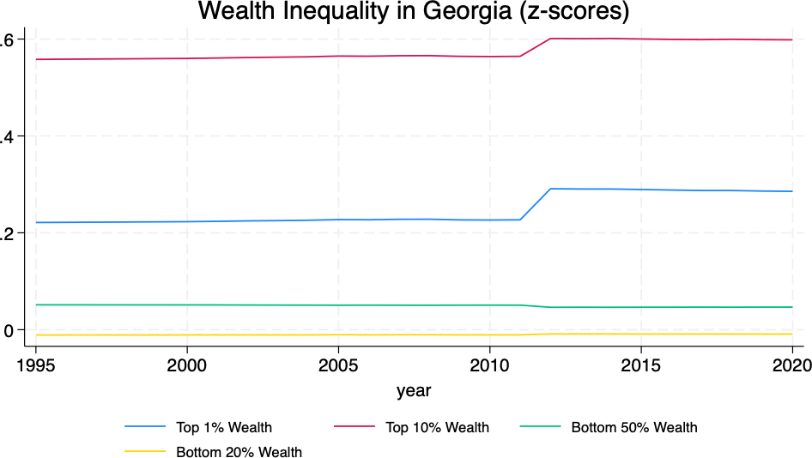

Figure S1: Wealth indicators in Georgia

10

