The Nutritional and Health Benefits of Kiwiberry (Actinidia arguta) – A Review
Plant Foods for Human Nutrition
Piotr Latocha
Department of Environmental Protection, Faculty of Horticulture, Biotechnology and Landscape
Architecture, Warsaw University of Life Sciences – SGGW,
Nowoursynowska 159, 02-776 Warsaw, Poland. E-mail: piotr_latocha@sggw.pl

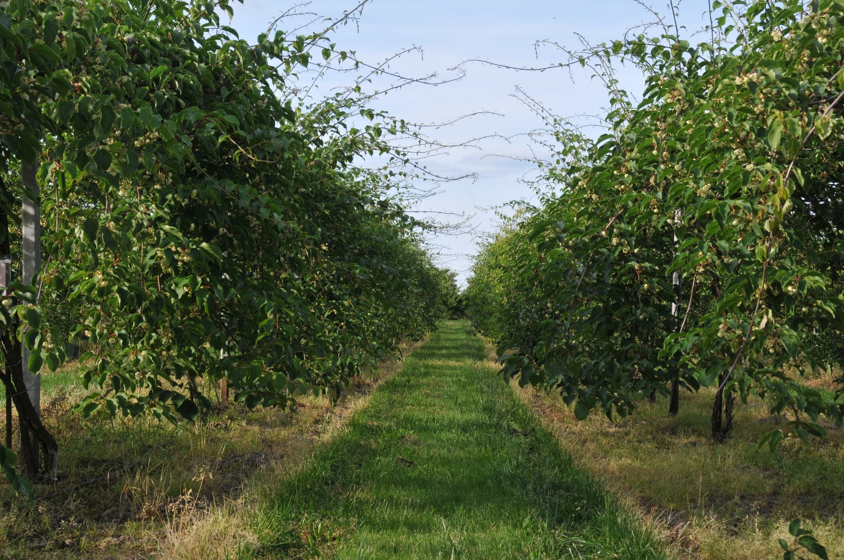
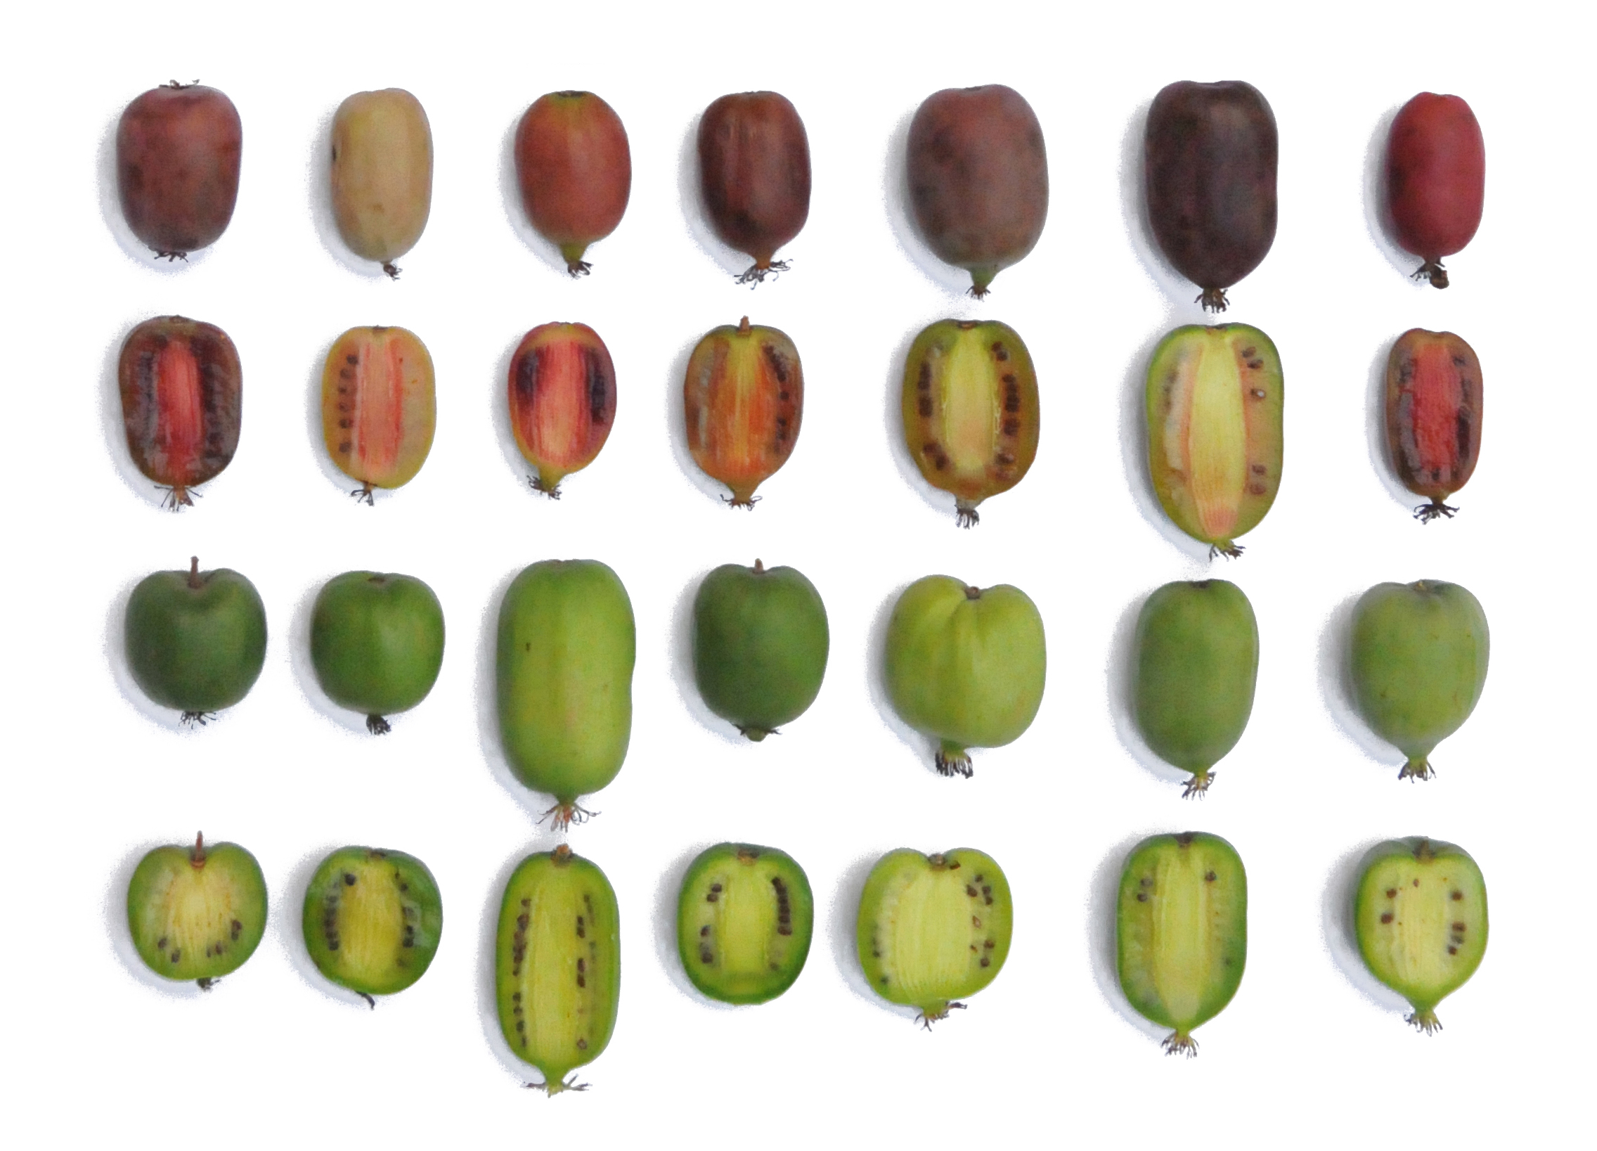
Figure 1. The kiwiberry (Actinidia arguta) on commercial plantation and the diversity of its fruit

