SUPPLEMENTARY MATERIAL
Materials and Methods
Plant materials and Treatment
Saffron plants were cultivated in the fields of Huzhou City, Zhejiang Province, China, using a two-stage cultivation method [1]. Saffron plants at orange stigma stage and those at the vegetative growth stage were subjected to intense light treatment of 20,000 Lux, with a light cycle of 16 hours of light and 8 hours of darkness for two weeks and one week, respectively. Subsequently, they were returned to natural conditions for further cultivation. Columbia (Col-0) and Arabidopsis transgenic lines carrying pro35S::CsCCD2L-GUS-GFP plasmid were grown at 22 °C under a light cycle of 16 hours of light and 8 hours of darkness with 60% humidity. 3-week-old Arabidopsis plants were exposed to intense light treatment of 20,000 Lux for one week.
Phylogenetic analysis of the CCD gene family
To explore the phylogenetic relationships within the CCD gene family and assess the conservation of their functions, we retrieved the amino acid sequences of the CCD gene family in monocotyledons from NCBI (https://www.ncbi.nlm.nih.gov/). Multiple sequence alignments were generated with the ClustalW2 tool (http://www.ebi.ac.uk/Tools/msa/clustalw2/) and an evolutionary tree was constructed using MEGA-X11 software. Rooted phylogenetic trees were generated employing the neighbor-joining method with a bootstrap analysis of 1000 replicates, and the resulting evolutionary tree was beautified using the online tool iTOL (https://itol.embl.de/).
Cis-element analysis and GO analysis
For the analysis of cis-acting regulatory elements in the promoter regions, the 2000 bp upstream of the start codon (ATG) of CsCCD1 and CsCCD2L genes were retrieved from the published genome database [2]. These sequences were then input into the PlantCARE database (http://bioinformatics.psb.ugent.be/webtools/plantcare/html/) for the identification of cis-acting elements and their functional categorization [3]. Default parameters were employed, and the results from the PlantCARE analysis were streamlined. Visualization was performed using TBtools software [4]. To better understand the biological pathways that CCD family genes were involved in, Gene Ontology (GO) enrichment analysis and visualization were performed using Gene Ontology Enrichment Analysis software (https://www.omicshare.com/tools/Home/Soft/gogseasenior).
RNA isolation and cDNA synthesis
Total RNA was isolated from saffron apical buds, petals, leaves, stamens, stigmas and Arabidopsis seedlings using the RNeasy® Plant Mini Kit (Qiagen, Germany). cDNA was prepared using the PrimeScript™ RT reagent Kit with gDNA Eraser (Takara, Japan) following the manufacturer’s instructions. The Real-time PCR reactions were performed on a QuantStudio Q5 system (Life Technologies, USA) with 2×SYBR® Premix Ex Taq™ II (Takara, Japan). The PCR were performed using a program at 95 ℃ for 30 s, 40 cycles of 95 ℃ for 5 s and 60 ℃ for 34 s. Tubulin and EF1α were used as reference genes for saffron and Arabidopsis, respectively. The primer sequences used for Real-time PCR were detailed in Table 1.
The generation of transgenic plants
To construct the proCsCCD2L::GUS plasmid, the promoter region from - 1608 to - 1 bp was amplified from genomic DNA using primers pCsCCD2L-1303 F and pCsCCD2L-1303 R. The purified PCR product was cloned into pCAMBIA1303 digested with NcoI and BamHI by Gibson assembly. To construct the pro35S::CsCCD2L-GUS-GFP plasmid, the coding sequence of CsCCD2L was amplified from cDNA using primers CsCCD2L-1303 F and CsCCD2L-1303 R. The purified PCR product was cloned into pCAMBIA1303 digested with NcoI by Gibson assembly. The proCsCCD2L::GUS and pro35S::CsCCD2L-GUS-GFP recombinant plasmids were then introduced into Agrobacterium tumefaciens strain GV3101 using electroporation. The Agrobacterial culture was pelleted at 5000 g for 10 min, followed by resuspension in 5% sucrose supplemented with 0.02% Silwet L-77. Transgenic plants were generated using the floral dipping method [5] and subsequently screened on MS medium supplemented with 25 mg/L hygromycin B. All required primer sequences can be referred to in Table 1.
Histochemical staining of GUS
GUS expression in the transgenic plants was assessed using the GUS Stain Kit (Solarbio®) following the manufacturer's guidelines. Transgenic Arabidopsis plants carrying the proCCD2L::GUS fusion construct were selected on 1/2 MS medium supplemented with 25 mg/L hygromycin B. Plant tissues were immersed in the GUS staining solution and subjected to a 5-minute vacuum treatment. Subsequently, they were incubated overnight at 37 ℃. After the incubation, chlorophyll was removed from the tissues by sequential washes (10 minutes each) in 50%, 70%, 80%, 90%, and 100% ethanol.
Cytological observation
The flower buds at different growth and development stages were visually examined and photographed using a digital single-lens reflex camera (DSLR, Canon, model DS126321). Arabidopsis thaliana seedlings, inflorescences, and leaves stained with GUS were observed under a stereomicroscope (SOPTOP SZN).
Subcellular localization of CsCCD2L
The CsCCD2L fragment was cloned into pCAMBIA1303 binary vector digested with NcoI by Gibson assembly. The resulting recombinant plasmids containing pro35S::CsCCD2L-GUS-GFP and the empty vector pro35S::GUS-GFP were transformed into Agrobacterium tumefaciens strain GV3101. The A. tumefaciens cells were cultured, resuspended in infiltration buffer (10 mM MgCl₂, 10 mM MES, and 100 μM acetosyringone, pH 5.7) to a final OD₆₀₀ of 0.4 - 0.6, and subsequently infiltrated into the leaf epidermal cells of 4-week-old Nicotiana benthamiana plants. The subcellular localization of the fusion proteins was observed using a confocal laser scanning microscope (Carl Zeiss Microscopy GmbH; Carl-Zeiss-Promenade 1007745 Jena, Germany) after 48 hours of infiltration, with excitation at 488 nm and emission at 507 nm. All required primer sequences can be referred to in Table 1.
Detection of natural products
Zeaxanthin, antheraxanthin and violaxanthin belong to the group of carotenoids, and the content of carotenoids was detected by UPLC-MS/MS. The frozen samples were ground into powder in liquid nitrogen. Fifty milligrams of the homogenized sample was extracted with a 0.5 mL n-hexane/acetone/ethanol mixture (1:1:1, v/v/v) containing 0.01% butylated hydroxytoluene (BHT). The extract was vortexed for 20 minutes and centrifuged at 12000 rpm for 5 minutes at 4 ℃. To the supernatants, 0.5 mL of saturated sodium chloride solution was added, mixed gently, and the upper layer was collected; this step was repeated two times. The supernatant was evaporated to dryness and dissolved in 0.5 mL methyl tert-butyl ether (MTBE), followed by the addition of 0.5 mL 10% KOH-methanol solution for saponification in the dark. After saponification, 1 mL saturated NaCl aqueous solution and 0.5 mL MTBE were added, mixed well, and the upper liquid layer was transferred to a new tube. This liquid was washed twice with 1 mL saturated NaCl aqueous solution, and the supernatant was evaporated to dryness and reconstituted in 150 μL dichloromethane. The solution was filtered through a 0.22 μm membrane filter for further UPLC-MS/MS analysis. The sample extracts were analyzed using an UPLC-APCI-MS/MS system (UPLC, ExionLC™ AD; MS, Applied Biosystems 6500 Triple Quadrupole) fitted with a YMC C30 column (3 μm, 100 mm×2.0 mm i.d). The solution A of acetonitrile (1:3, v/v) with 0.01% BHT and 0.1% formic acid, and solution B of MTBE with 0.01% BHT were used as mobile phase A and B, respectively, at a flow rate of 0.8 mL/min. The gradient elution program was as follows: started at 0% B (0-3 min), increased to 70% B (3-5 min), then increased to 95% B (5-9 min), finally ramped back to 0% B (10-11 min). The column temperature was 28 °C, and the injection volume was 2 μL.
The content of crocin was also detected by UPLC-MS/MS. The frozen stigmas were ground into powder in liquid nitrogen. Fifty milligrams of powder was weighed and extracted with 20 mL of 70% ethanol. The mixture was sonicated at 50 Hz for 30 minutes and then adjusted to a final volume of 25 mL. The extracts were filtered through a 0.22 μm membrane filter for subsequent UPLC-MS/MS analysis. The sample extracts were analyzed using an UPLC-ESI-MS/MS system (UPLC, Jasper™ SCIEX; MS, AB SCIEX Triple Quad™ 4500MD) fitted with a phenomenex PFP (pentafluorophenyl) column (2.6 μm, 100 mm×3.0 mm i.d.). 0.5 mM ammonium acetate and methanol were used as mobile phase A and B, respectively, at a flow rate of 0.5 mL/min. The gradient elution program was as follows: started at 20% B (0-1.3 min), increased to 98% B (1.3-4 min), then maintained at 98% B (4-5.7 min), ramped back to 20% B (5.7-5.8 min), and finally maintained at 20% B (5.8-6.8 min). The column temperature was 40 °C, and the injection volume was 5 μL.
The content of chlorophyll was measured by spectrophotometry. The frozen leaves were ground into powder in liquid nitrogen. About 40 mg of powder was weighed and extracted with 0.8 mL extraction buffer of ethanol : acetone : water in a ratio of 4.5 : 4.5 : 1 (v/v/v). The mixture was incubated at 4 °C in the dark for 12 h. The absorbance of the extract was measured using a UV spectrophotometer (SmartSpec™ Plus, BIO-RAD) at wavelengths of 645 nm and 663 nm, with the acetone/ethanol/water mixture serving as the blank. Chlorophyll a, b, and total chlorophyll concentrations were calculated from spectral measurements using the following formulas: Chlorophyll a = (12.72A₆₆₃ - 2.59A₆₄₅) × V/(1000 × W), Chlorophyll b = (22.88A₆₄₅ - 4.67A₆₆₃) × V/(1000 × W), and total chlorophyll = (20.29A₆₄₅ + 8.05A₆₆₃) × V/(1000 × W).

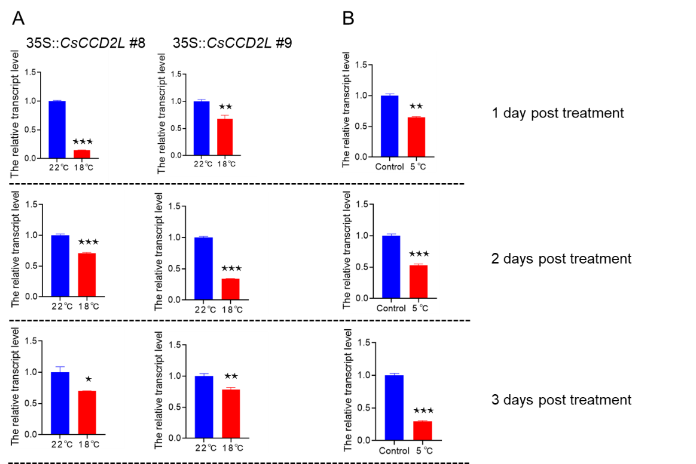
Fig.S1 Effect of temperature on the expression levels of CsCCD2L. (A) Transgenic lines 35S::CsCCD2L #8 and 35S::CsCCD2L #9 were grown at 18 °C for 1, 2, and 3 days, and the expression levels of CsCCD2L were assessed via qPCR assay, with plants grown at 22 °C used as the control. (B) Saffron plants at the vegetative growth stage were cultured at 5 °C for 1, 2, and 3 days. Variations in CsCCD2L expression levels were assessed using qPCR assay, with saffron plants cultured at 5 °C serving as the control.

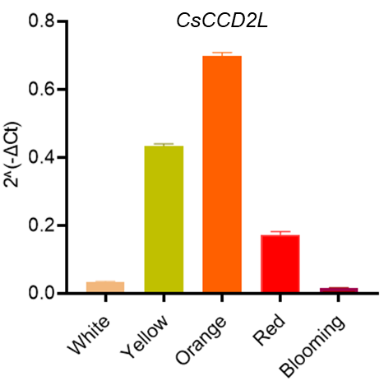

Fig.S2 Expression levels of CsCCD2L at different developmental stages of the stigma. White, Yellow, Orange, Red and Blooming represent the white stigma stage, yellow stigma stage, orange stigma stage, red stigma stage and on the day of anthesis, respectively.

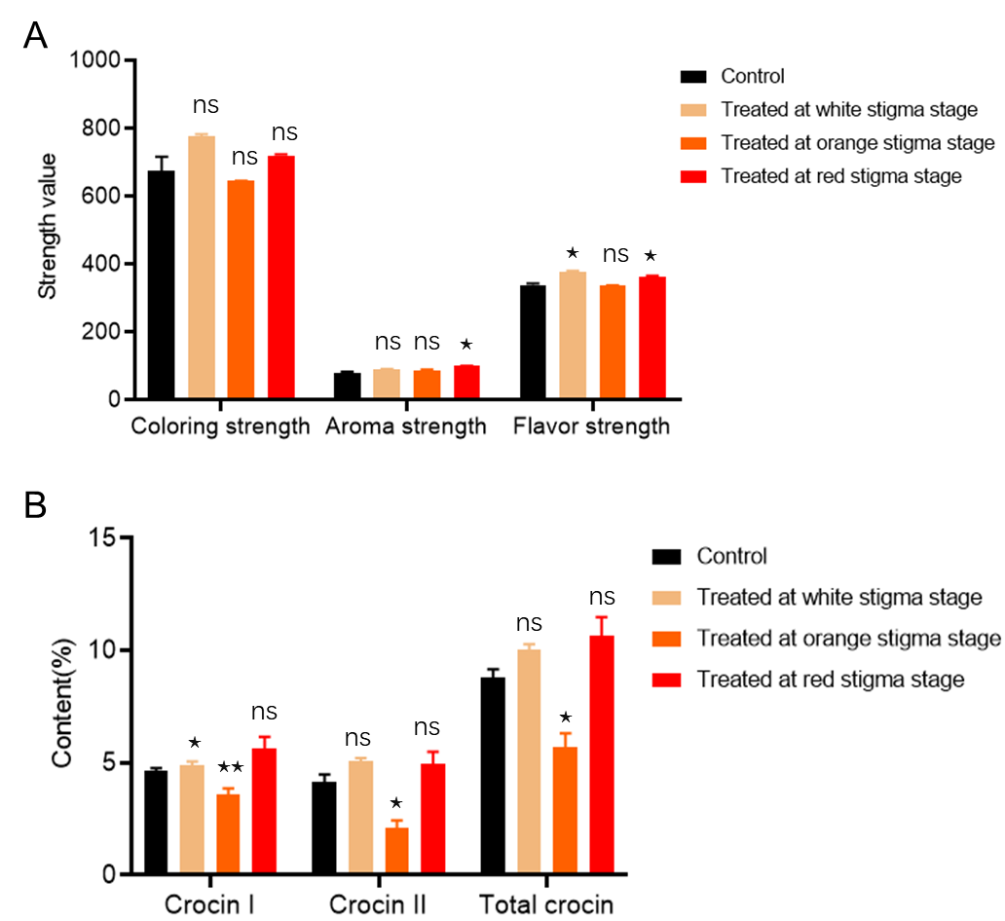

Fig.S3 Quality evaluation of stigmas exposed to high-intensity light at white, orange and red stages (A) and the contents of crocin in stigmas exposed to high-intensity light at white, orange and red stages.

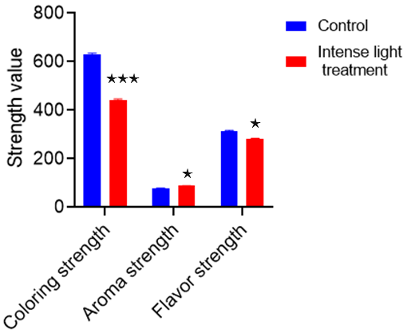

Fig.S4 Effect of strong light on saffron quality. The saffron plants were treated with strong light (20,000 Lux) for 2 weeks at orange stigma stage.

Table 1 Primers used in this study
Name | Primer (5’-3’) | Application
mGFP 172 R | CAGGTAGTTTTCCAGTAGTGCAAATA | Genotyping
pCsCCD2L-1303 F  ALM23547.1 | tcgagctcggtacccgggGTGCTCTGATATTCTTTGGTCTGC | GUS staining
pCsCCD2L-1303 R | CGTAAACTAGTCAGATCTACCATGTCAAGAATAATAGTGAGGAGT | GUS staining
CsCCD2L-1303 F | ACACGGGGGACTCTTGACATGGAATCTCCTGCTACTAA | Subcellular localization
CsCCD2L-1303 R | CGTAAACTAGTCAGATCTACCATTGTCTCTGCTTGGTGCT | Subcellular localization
CsCCD2L Q-F | CGGTGTGCTTCCACGATATG | qPCR
CsCCD2L Q-R | CCGCAGGTCCACTAAGCATG | qPCR
Tubulin Q-F  Csativus38860.1 | CGTGCGTTTGTTCACTGGTA | qPCR
Tubulin Q-R | CCCACCTCTTCGTAATCCTTC | qPCR
EF1α Q-F  NM_125432.4 | AAATACTCCAAGGCTAGGTACG | qPCR
EF1α Q-R | AAATGGGATTTTGTCAGGGTTG | qPCR
AtVDE Q-F  NM_127755.3 | CGTTTTGGTATGAGCCCGTG | qPCR
AtVDE Q-R | TCCTTCTCTGCCGGGTAAGA | qPCR
AtZEP1 Q-F  NM_180954.3 | TGTTTGGCCGTAGTGAAGCT | qPCR
AtZEP1 Q-R | TCCTCAGTCGCATGCAACAA | qPCR
AtPsbS Q-F  NM_001333231.1 | CTTTGGAACGTCTGGTGGGA | qPCR
AtPsbS Q-R | AGGAATGACGGCTTTCTCGA | qPCR
AtPORC Q-F  NM_100243.4 | ACGAGGAAACAGGAGTCACG | qPCR
AtPORC Q-R | TTTGCCTTCTCCGCATCACT | qPCR
AtCHLG Q-F  NM_115041.4 | GTTTGGGGAGTCGTCTGTGG | qPCR
AtCHLG Q-R | GCCCTGCCCACACATCTAAT | qPCR
AtCAO Q-F  NM_103548.5 | CCGCCGTGTTTAGTCCTTCT | qPCR
AtCAO Q-R | CGAGCACGCCAATCCAAGTA | qPCR

References
- Xi X, Li J, Song J, Qian X, Xu X, Feng M et al (2024) CsERECTA alternative splicing regulates the flowering numbers depending on temperature in Crocus sativus L. Ind Crop Prod 218: 118971. https://doi.org/10.1016/j.indcrop.2024.118971
- Xu Z, Chen S, Wang Y, Tian Y, Wang X, Xin T et al (2024) Crocus genome reveals the evolutionary origin of crocin biosynthesis. Acta Pharm Sin B. 14(4):1878-1891. https://doi.org/10.1016/j.apsb.2023.12.013
- Lescot M, Déhais P, Thijs G, Marchal K, Moreau Y, van de Peer Y et al (2002) PlantCARE, a database of plant cis-acting regulatory elements and a portal to tools for in silico analysis of promoter sequences. Nucleic Acids Res 30: 325–327. https://doi.org/10.1093/nar/30.1.325
- Chen C, Chen H, Zhang Y, Thomas HR, Frank MH, He Y et al (2020) TBtools: an integrative toolkit developed for interactive analyses of big biological data. Mol Plant 13: 1194–1202. https://doi.org/10.1016/j.molp.2020.06.009
- Clough SJ, Bent AF (1998) Floral dip: a simplified method for Agrobacterium-mediated transformation of Arabidopsis thaliana. Plant J 16: 735–743. https://doi.org/10.1046/j.1365-313x.1998.00343.x

