Supplementary Material

2. Materials and Methods
2.1 Chemical Reactants
Folin–Ciocalteu reagent, 2,4,6-tris(2-pyridyl)-s-triazine (TPTZ), gallic acid standard, 2, 2’-Azino-bis (3-ethylbenzothiazoline-6-sulfonic acid) (ABTS), 2,2-diphenyl-1-picrylhydrazyl (DPPH), and 6-hydroxy-2,5,7,8-tetramethylchroman-2-carboxylic acid (Trolox) were purchased from Sigma-Aldrich (St. Louis, MO, USA).
2.2 Raw materials and sample preparation
Mangosteen (Garcinia mangostana L.) leaves and fruits were collected from a commercial plantation (Ecuaforestar, Quinindé, Esmeraldas, Ecuador) in May 2025. Fruits were harvested at commercial ripeness.
In the laboratory, fruits were previously washed and manually separated into pericarp, pulp, and seeds (Figure S1). Three independent batches were obtained for each mangosteen fraction (biological replicates). Each fraction, together with the leaves, was freeze-dried using a lyophilizer (Alpha 1-4 LDplus, CHRIST, Germany). The freeze-drying process was carried out in three stages: freezing (-20 ºC during 24 h), primary drying (-54 °C y 0.03 mbar, 20 h) and secondary drying (-54 °C y 0.03 mbar, 52 h). Later, samples were ground into a fine powder using a cyclone mill (Twister, Retsch, Germany).
The obtained powders were stored under controlled conditions until further analysis. Each analytical determination was performed in triplicate within each batch (technical replicates).
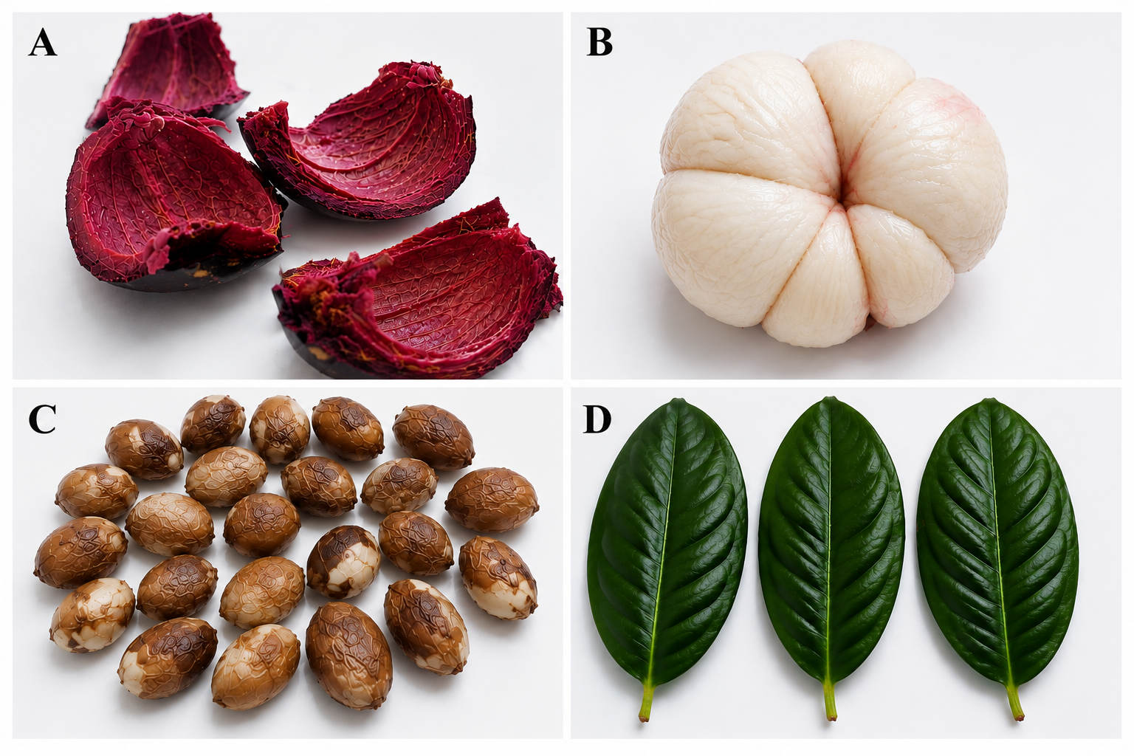
Figure S1. Plant materials of Garcinia mangostana L. were investigated in this study. A peel (Husk); B pulp; C seed; D leaf.

2.3 Proximate composition
The proximate composition of mangosteen fractions was determined according to standard analytical methods, and results were expressed on a dry matter basis (g/100 g dm). Moisture content was determined according to AOAC 925.10 [1], fat content by AOAC 2003.06 [2], and ash content according to AOAC 923.03 [3]. Crude fiber was measured using AOAC 962.09 [2]. Protein content was determined using the Dumas combustion method, and available carbohydrate content was calculated by difference.

2.4 Fiber analysis and elemental analysis
Fiber fractions, including neutral detergent fiber (NDF), acid detergent fiber (ADF), and acid detergent lignin (ADL), as well as cellulose and hemicellulose, were determined according to the Van Soest method [4].
Elemental composition (C, H, N, and S) was determined using a Dumas combustion analyzer (Vario Macro Cube, Elementar, Germany). Approximately 20 mg of sample were analyzed using sulfanilamide as calibration standard.

2.5 Mineral composition
Mineral content (Ca, K, Mg, Cu, Fe, Mn, and Zn) was determined by atomic absorption spectroscopy (AAS) (AA500, PG Instruments) as described in Briceño et al. [5]. Samples were digested using nitric acid and hydrogen peroxide in a microwave digestion system (Anton Paar, Austria). All analyses were performed in triplicate, and certified reference material (Accu Trace™) was used for quality control.

2.6 Extraction of phytochemicals
Phytochemicals were extracted following the methodology reported by Quinteros et. al. [6] with slight modifications. Briefly, 500 mg of sample were mixed with 5 mL of extraction of a methanol-water solution (70:30, v/v) and subjected to sonicated for 20 min in an ultrasonic bath (Elmasonic P 300 H, Germany). The samples were subsequently centrifuged at 6000 rpm for 15 min, and the resulting supernatants were collected. The extraction procedure was repeated five times, after which the pooled extracts were brought to a final volume of 25 mL with the extraction solvent using an amber volumetric flask. The extracts were stored at 5 °C until analysis. These extracts were also used to evaluate antioxidant activity.

2.7 Antioxidant activity
2.7.1 ABTS assay
The antioxidant activity was determined following the method described by Vilcacundo et. al. [7]. The ABTS radical cation (ABTS•⁺) was generated by mixing 7.4 mM ABTS with 2.4 mM potassium persulfate (1:1, v/v) and incubating the solution for 16 h in the dark. The working solution was diluted with phosphate buffer (pH 7.0) to an absorbance of 1.12 ± 0.02. A volume of 100 µL of sample extract was mixed with 1900 µL of ABTS solution and incubated for 45 min in the dark. Absorbance was measured at 734 nm with a spectrophotometer (Thermo Fisher Scientific 5225, NanoDrop One, EE. UU.). Results were expressed as µmol Trolox equivalents per gram of dry matter (µmol TE/g dm).

2.7.2 DPPH assay
A 0.06 mM DPPH solution was prepared in methanol. A volume of 50 µL of extract was added to 1950 µL of DPPH solution, vortexed, and incubated for 30 min in the dark at 25 ± 2 °C. Absorbance was measured at 515 nm with a spectrophotometer (Thermo Fisher Scientific 5225, NanoDrop One, EE. UU.). Results were expressed as µmol TE/g dm, following the method reported by Brand- Williams et al. [8].

2.7.3 FRAP assay
The FRAP reagent was prepared by mixing acetate buffer (300 mM, pH 3.6), TPTZ (10 mM), and FeCl₃·6H₂O (20 mM) in a ratio of 10:1:1. For the assay, 1800 µL of FRAP reagent, 180 µL of distilled water, and 60 µL of extract were mixed and incubated at 37 °C for 30 min. Absorbance was measured at 593 nm, and results were expressed as µmol TE/g dm, following the method reported by Benzie and Strain [9] with slight modifications.

2.8 Total phenolic content (TPC)
TPC was determined using the Folin-Ciocalteu method with slight modifications as in Quinteros et al. [6]. A 100 µL aliquot of extract was mixed with 100 µL of Folin-Ciocalteu reagent, 2 mL of 7.5% Na₂CO₃, and 2.8 mL of distilled water. The mixture was incubated at room temperature for 60 min in the dark, and absorbance was measured at 750 nm using a UV-Vis spectrophotometer (Thermo Fisher Scientific, NanoDrop One). Results were expressed as mg gallic acid equivalents per gram of dry matter (mg GAE/g dm) using a calibration curve (50-600 ppm; R² = 0.998).

2.9 Total flavonoid content (TFC)
TFC was assessed following the procedure reported by Ramos-Escudero et. al [10]. 1 mL of extract was mixed with 1 mL of 40% AlCl₃ solution and incubated at 25 °C for 40 min in the dark. Absorbance was measured at 415 nm. Results were expressed as mg quercetin equivalents per gram of dry matter (mg QE/g dm), using a calibration curve (2.5-35 ppm; R² = 0.9982).

2.10 Total flavonol content (TFLC)
The TFLC was determined according to the methodology reported by Ramos-Escudero et al. [10]. Samples (250 µL) were mixed with 1500 µL of sodium acetate solution (50%) and 250 µL of AlCl₃ (20%). After incubation in the dark for 2 h, absorbance was measured at 440 nm. Results were expressed as mg quercetin equivalents per gram of dry matter (mg QE/g dm), using a calibration curve (7.5-35 ppm; R² = 0.996).

2.11 Total anthocyanin content (TAC)
The TAC was determined according to the method described by Saldaña et al. [11]. Extracts were diluted in buffer solutions at pH 1.0 and 4.5, and absorbance was measured at 510 and 700 nm with a spectrophotometer UV-Vis (Thermo Fisher Scientific 5225, NanoDrop One, EE. UU.). Results were expressed as mg cyanidin-3-glucoside equivalents per gram of dry matter (mg C3GE/g dm).

2.12 Color analysis
The procedure was performed according to Wilcaso et al. [12]. Color measurements were carried out using a portable tristimulus colorimeter (Minolta CR-200, Osaka, Japan) under D65 illumination and a 2° observer angle. CIELab parameters (L*, a*, b*) were recorded, and chroma (C*) and hue angle (h°) were calculated. Measurements were performed in triplicate.

2.13 Statistical analysis
All analyses were performed in the triplicate. Results were expressed as mean ± standard deviation. Statistical differences among samples were evaluated by one-way analysis of variance (ANOVA), followed by Tukey’s test at a significance level of p < 0.05 using Statgraphics Centurion XIX software (Statgraphics Technologies, Inc., The Plains, VA, USA).

REFERENCES
1. AOAC (2012) Official Method AOAC 55 925.10:2012. Solids (Total) and Moisture in Flour-Air Oven Method. In: AOAC Interntional (ed) Official Methods of Analysis of AOAC International, 19th ed. Gaithersburg, MD.
2. AOAC (2012) Official Method 2003.06. 2012. Crude Fat in Feeds, Cereal Grains and Forages. In: Official Methods of Analysis of AOAC International, 19th ed. AOAC Inc, Washington (UK).
3. AOAC (2012) Official Methods of Analysis, 19th ed. Gaithersburg, MD.
4. Van Soest PJ, Robertson JB, Lewis BA (1991) Methods for Dietary Fiber, Neutral Detergent Fiber, and Nonstarch Polysaccharides in Relation to Animal Nutrition. J Dairy Sci 74:3583–3597. https://doi.org/10.3168/jds.S0022-0302(91)78551-2
5. Briceño J, Tonato E, Silva M, et al (2020) Metal content evaluation in soils and edible tissues of allium fistulosum l. On crops near the tungurahua volcano. Granja 32:112–123. https://doi.org/10.17163/lgr.n32.2020.09
6. Quinteros MF, Martínez J, Barrionuevo A, et al (2022) Functional, Antioxidant, and Anti-Inflammatory Properties of Cricket Protein Concentrate (Gryllus assimilis). Biology (Basel) 11:776. https://doi.org/10.3390/biology11050776
7. Vilcacundo E, Montalvo V, Sanaguano H, et al (2022) Identification of Phytochemical Compounds, Functional Properties and Antioxidant Activity of Germinated Purple Corn Protein Concentrate and Its Gastrointestinal Hydrolysates. Agronomy 12:2217. https://doi.org/10.3390/agronomy12092217
8. Brand-Williams W, Cuvelier ME, Berset C (1995) Use of a Free Radical Method to Evaluate Antioxidant Activity. LWT-Food science 28:25–30
9. Benzie IFF, Strain JJ (1999) Ferric Reducing/Antioxidant Power Assay: Direct Measure of Total Antioxidant Activity of Biological Fluids and Modified Version for Simultaneous Measurement of Total Antioxidant Power and Ascorbic Acid Concentration. In: Lester Parker (ed) Methods in Enzymology. Academic Press, pp 15–27
10. Ramos-Escudero F, Muñoz AM, Alvarado-Ortíz C, et al (2012) Purple corn (Zea mays L.) phenolic compounds profile and its assessment as an agent against oxidative stress in isolated mouse organs. J Med Food 15:206–215. https://doi.org/10.1089/jmf.2010.0342
11. Saldaña MDA, Martinez ER, Sekhon JK, Vo H (2021) The effect of different pressurized fluids on the extraction of anthocyanins and total phenolics from cranberry pomace. Journal of Supercritical Fluids 175:105279. https://doi.org/10.1016/j.supflu.2021.105279
12. Wilcaso P, Landázuri AC, Castelló ML, Ortolá MD (2025) Comprehensive characterization of nutritional, phytochemical, optical, and electrical properties of Moringa oleifera Lam. parts from Ecuador. LWT 228:118108. https://doi.org/10.1016/j.lwt.2025.118108

