Online Supplementary Material (OSM) 1


Figure OSM1 Screenshot of the M1 question on trust in the parliament


Figure OSM2 Screenshot of the M2 question on trust in the parliament

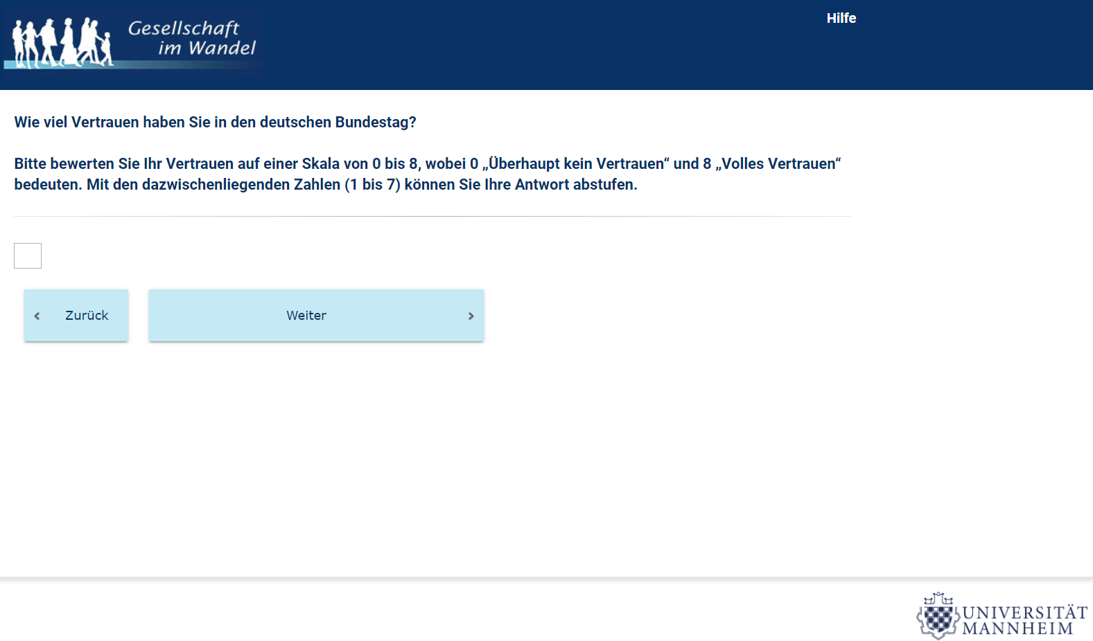
Figure OSM3 Screenshot of the M3 question on trust in the parliament

Online Supplementary Material (OSM) 2

Step-by-step corrections that were introduced in the model and corresponding chi² values.

The testing mainly relied on the JRule results. However, since JRule provides information for each parameter of the model – seen the size of our model and the number of groups – it is not possible to report all JRule information. Instead, we report the chi² values, as a broad indication of the overall model fit.

Table OSM1 Corrections of the model and corresponding chi² values
Corrections of the model | Chi²
Free te 4 4 gp4 = gp5 | 1,497
Free te 4 4 gp10 = gp11 | 1,313
Free te 4 4 gp7 = gp8 | 1,290
Free ph 4 4 gp4 = gp5 = gp6 | 1,285
Free ph 4 4 gp10 = gp11 = gp12 | 1,231
Free te 7 7 gp11 | 1,222
Free te 8 8 gp11 | 1,208
Free te 2 2 gp10 = gp12 | 1,195
Free ph 2 1 gp4 = gp5 =gp6 | 1,155
Free ph 2 1 gp10 = gp11 = gp12 | 1,114
Free ph 2 1 gp7 = gp8 = gp9 | 1,103
Free ga 5 5 gp4 | 1,061
Free ga 8 6 gp5 | 1,043
Free ga 2 4 gp7 | 1,027
Free ph 6 6 gp8 | 1,015
Free ph 6 6 gp11 | 1,006
Free ga 4 1 gp4 = gp5 = gp6 | 994
Free ga 7 1 gp3 | 974
Fr ga 7 1 gp7 = gp8=gp9=gp10=gp11=gp12 | 959
Fr ga 7 1 gp4=gp5=gp6 | 958
Free ga 2 4 gp 6 | 937
Free ga 1 4 gp 6 | 919
Free ga 7 6 gp 6 | 912
Free te 7 7 gp9 | 898
Free ga 8 6 gp2 | 893
Free te 1 1 gp10 = gp12 | 861
Free ga 1 1 gp4 + ga 1 1 gp5 = gp1 | 832
Fr ph 4 4 gp7 | 824
Note. In the Base Model (before any correction): chi² = 1,629 and df = 228.

Online Supplementary Material (OSM) 3

Syntax of the LISREL input for the final Model.

!Group 1 (MTMM-R-C)

Data ng=12 ni=9 no=645 ma=cm
km file=G1-R-C.corr
mean file=G1-R-C.mean
sd file=G1-R-C.sd
model ny=9 ne=9 nk=6 ly=fu,fi te=sy,fi ps=sy,fi be=fu,fi ga=fu,fi ph=sy,fi
va 1 ly 1 1 ly 2 2 ly 3 3 ly 4 4 ly 5 5 ly 6 6
fr te 1 1 te 2 2 te 3 3 te 4 4 te 5 5 te 6 6
va 1 te 7 7 te 8 8 te 9 9
va 0 ly 7 7 ly 8 8 ly 9 9
fr ga 1 1 ga 2 2 ga 3 3
fr ga 4 1 ga 5 2 ga 6 3
fr ga 7 1 ga 8 2 ga 9 3
va 1 ga 1 4 ga 2 4 ga 3 4
va 1 ga 4 5 ga 5 5 ga 6 5
va 1 ga 7 6 ga 8 6 ga 9 6
fr ph 2 1 ph 3 1 ph 3 2
va 1 ph 1 1 ph 2 2 ph 3 3
fr ph 4 4 ph 5 5 ph 6 6
pd
out mi iter= 300 adm=off sc

Group 2 (MTMM2-R-C)
Data ni=9 no=735 ma=cm
km file=G2-R-C.corr
mean file=G2-R-C.mean
sd file=G2-R-C.sd
model ny=9 ne=9 nk=6 ly=fu,fi te=sy,fi ps=in be=in ga=in ph=in
fr te 4 4 te 5 5 te 6 6 te 7 7 te 8 8 te 9 9
va 1 ly 4 4 ly 5 5 ly 6 6 ly 7 7 ly 8 8 ly 9 9
eq te 1 4 4 te 4 4
eq te 1 5 5 te 5 5
eq te 1 6 6 te 6 6
va 1 te 1 1 te 2 2 te 3 3
va 0 ly 1 1 ly 2 2 ly 3 3
fr ga 8 6
out iter= 300 adm=off sc

Group 3 (MTMM3-R-C)
Data ni=9 no=346 ma=cm
km file=G3-R-C.corr
mean file=G3-R-C.mean
sd file=G3-R-C.sd
model ny=9 ne=9 nk=6 ly=fu,fi te=sy,fi ps=in be=in ga=in ph=in
fr te 1 1 te 2 2 te 3 3 te 7 7 te 8 8 te 9 9
va 1 ly 1 1 ly 2 2 ly 3 3 ly 7 7 ly 8 8 ly 9 9
eq te 1 1 1 te 1 1
eq te 1 2 2 te 2 2
eq te 1 3 3 te 3 3
eq te 2 7 7 te 7 7
eq te 2 8 8 te 8 8
eq te 2 9 9 te 9 9
va 1 te 4 4 te 5 5 te 6 6
va 0 ly 4 4 ly 5 5 ly 6 6
fr ga 7 1
out mi iter= 300 adm=off sc

Group 4 (MTMM1-R-NC)
Analysis of group 4 R-NC
Data ni=9 no=378 ma=cm
km file=G1-R-NC.corr
mean file=G1-R-NC.mean
sd file=G1-R-NC.sd
model ny=9 ne=9 nk=6 ly=fu,fi te=sy,fi ps=in be=in ga=in ph=in
va 1 ly 1 1 ly 2 2 ly 3 3 ly 4 4 ly 5 5 ly 6 6
fr te 1 1 te 2 2 te 3 3 te 4 4 te 5 5 te 6 6
va 1 te 7 7 te 8 8 te 9 9
va 0 ly 7 7 ly 8 8 ly 9 9
eq te 1 1 1 te 1 1
eq te 1 2 2 te 2 2
eq te 1 3 3 te 3 3
!eq te 1 4 4 te 4 4
eq te 1 5 5 te 5 5
eq te 1 6 6 te 6 6
fr ph 4 4 ph 2 1 ga 5 5 ga 1 1 ga 4 1 ga 7 1 te 4 4
out iter= 200 adm=off sc ec mi

Group 5 (MTMM2-R-NC)
Data ni=9 no=237 ma=cm
km file=G2-R-NC.corr
mean file=G2-R-NC.mean
sd file=G2-R-NC.sd
model ny=9 ne=9 nk=6 ly=fu,fi te=sy,fi ps=in be=in ga=in ph=in
fr te 4 4 te 5 5 te 6 6 te 7 7 te 8 8 te 9 9
va 1 ly 4 4 ly 5 5 ly 6 6 ly 7 7 ly 8 8 ly 9 9
eq te 4 4 4 te 4 4
eq te 1 5 5 te 5 5
eq te 1 6 6 te 6 6
eq te 2 7 7 te 7 7
eq te 2 8 8 te 8 8
eq te 2 9 9 te 9 9
va 1 te 1 1 te 2 2 te 3 3
va 0 ly 1 1 ly 2 2 ly 3 3
eq ph 4 4 4 ph 4 4
eq ph 4 2 1 ph 2 1
fr ga 8 6
eq ga 4 4 1 ga 4 1
eq ga 4 7 1 ga 7 1
eq ga 1 1 1 ga 1 1
out iter= 300 adm=off sc ec mi

Group 6 (MTMM3-R-NC)
Data ni=9 no=484 ma=cm
km file=G3-R-NC.corr
mean file=G3-R-NC.mean
sd file=G3-R-NC.sd
model ny=9 ne=9 nk=6 ly=fu,fi te=sy,fi ps=in be=in ga=in ph=in
fr te 1 1 te 2 2 te 3 3 te 7 7 te 8 8 te 9 9
va 1 ly 1 1 ly 2 2 ly 3 3 ly 7 7 ly 8 8 ly 9 9
eq te 1 1 1 te 1 1
eq te 1 2 2 te 2 2
eq te 1 3 3 te 3 3
eq te 2 7 7 te 7 7
eq te 2 8 8 te 8 8
eq te 2 9 9 te 9 9
va 1 te 4 4 te 5 5 te 6 6
va 0 ly 4 4 ly 5 5 ly 6 6
eq ph 4 4 4 ph 4 4
eq ph 4 2 1 ph 2 1
eq ga 4 4 1 ga 4 1
eq ga 4 7 1 ga 7 1
fr ga1 4 ga 2 4 ga 7 6
out mi iter= 300 adm=off sc

Group 7 (MTMM1-NR-C)
Data ni=9 no=143 ma=cm
km file=G1-NR-C.corr
mean file=G1-NR-C.mean
sd file=G1-NR-C.sd
model ny=9 ne=9 nk=6 ly=fu,fi te=sy,fi ps=in be=in ga=in ph=in
va 1 ly 1 1 ly 2 2 ly 3 3 ly 4 4 ly 5 5 ly 6 6
fr te 1 1 te 2 2 te 3 3 te 4 4 te 5 5 te 6 6
va 1 te 7 7 te 8 8 te 9 9
va 0 ly 7 7 ly 8 8 ly 9 9
eq te 1 1 1 te 1 1
eq te 1 2 2 te 2 2
eq te 1 3 3 te 3 3
eq te 1 5 5 te 5 5
eq te 1 6 6 te 6 6
fr ph 4 4 ph 2 1 ga 2 4 ga 7 1 te 4 4
out iter= 200 adm=off sc ec mi

Group 8 (MTMM2-NR-C)
Data ni=9 no=207 ma=cm
km file=G2-NR-C.corr
mean file=G2-NR-C.mean
sd file=G2-NR-C.sd
model ny=9 ne=9 nk=6 ly=fu,fi te=sy,fi ps=in be=in ga=in ph=in
fr te 4 4 te 5 5 te 6 6 te 7 7 te 8 8 te 9 9
va 1 ly 4 4 ly 5 5 ly 6 6 ly 7 7 ly 8 8 ly 9 9
eq te 7 4 4 te 4 4
eq te 1 5 5 te 5 5
eq te 1 6 6 te 6 6
eq te 2 7 7 te 7 7
eq te 2 8 8 te 8 8
eq te 2 9 9 te 9 9
va 1 te 1 1 te 2 2 te 3 3
va 0 ly 1 1 ly 2 2 ly 3 3
eq ph 7 2 1 ph 2 1
eq ga 7 7 1 ga 7 1
fr ph 6 6
out iter= 300 adm=off sc ec mi

Group 9 (MTMM3-NR-C)
Data ni=9 no=179 ma=cm
km file=G3-NR-C.corr
mean file=G3-NR-C.mean
sd file=G3-NR-C.sd
model ny=9 ne=9 nk=6 ly=fu,fi te=sy,fi ps=in be=in ga=in ph=in
fr te 1 1 te 2 2 te 3 3 te 7 7 te 8 8 te 9 9
va 1 ly 1 1 ly 2 2 ly 3 3 ly 7 7 ly 8 8 ly 9 9
eq te 1 1 1 te 1 1
eq te 1 2 2 te 2 2
eq te 1 3 3 te 3 3
eq te 2 8 8 te 8 8
eq te 2 9 9 te 9 9
va 1 te 4 4 te 5 5 te 6 6
va 0 ly 4 4 ly 5 5 ly 6 6
eq ph 7 2 1 ph 2 1
eq ga 7 7 1 ga 7 1
out mi iter= 300 adm=off sc

Group 10 (MTMM1-NR-NC)
Data ni=9 no=156 ma=cm
km file=G1-NR-NC.corr
mean file=G1-NR-NC.mean
sd file=G1-NR-NC.sd
model ny=9 ne=9 nk=6 ly=fu,fi te=sy,fi ps=in be=in ga=in ph=in
va 1 ly 1 1 ly 2 2 ly 3 3 ly 4 4 ly 5 5 ly 6 6
fr te 1 1 te 2 2 te 3 3 te 4 4 te 5 5 te 6 6
va 1 te 7 7 te 8 8 te 9 9
va 0 ly 7 7 ly 8 8 ly 9 9
eq te 1 3 3 te 3 3
eq te 1 5 5 te 5 5
eq te 1 6 6 te 6 6
fr ph 4 4 ph 2 1 te 4 4
eq ga 7 7 1 ga 7 1
out iter= 200 adm=off sc ec mi

Group 11 (MTMM2-NR-NC)
Data ni=9 no=141 ma=cm
km file=G2-NR-NC.corr
mean file=G2-NR-NC.mean
sd file=G2-NR-NC.sd
model ny=9 ne=9 nk=6 ly=fu,fi te=sy,fi ps=in be=in ga=in ph=in
fr te 4 4 te 5 5 te 6 6 te 7 7 te 8 8 te 9 9
va 1 ly 4 4 ly 5 5 ly 6 6 ly 7 7 ly 8 8 ly 9 9
eq te 10 4 4 te 4 4
eq te 1 5 5 te 5 5
eq te 1 6 6 te 6 6
eq te 2 9 9 te 9 9
va 1 te 1 1 te 2 2 te 3 3
va 0 ly 1 1 ly 2 2 ly 3 3
eq ph 10 4 4 ph 4 4
eq ph 10 2 1 ph 2 1
eq ga 7 7 1 ga 7 1
fr ph 6 6
out iter= 300 adm=off sc ec mi

Group 12 (MTMM3-NR-NC)
Data ni=9 no=294 ma=cm
km file=G3-NR-NC.corr
mean file=G3-NR-NC.mean
sd file=G3-NR-NC.sd
model ny=9 ne=9 nk=6 ly=fu,fi te=sy,fi ps=in be=in ga=in ph=in
fr te 1 1 te 2 2 te 3 3 te 7 7 te 8 8 te 9 9
va 1 ly 1 1 ly 2 2 ly 3 3 ly 7 7 ly 8 8 ly 9 9
eq te 10 1 1 te 1 1
eq te 10 2 2 te 2 2
eq te 1 3 3 te 3 3
eq te 2 7 7 te 7 7
eq te 2 8 8 te 8 8
eq te 2 9 9 te 9 9
va 1 te 4 4 te 5 5 te 6 6
va 0 ly 4 4 ly 5 5 ly 6 6
eq ph 10 4 4 ph 4 4
eq ph 10 2 1 ph 2 1
eq ga 7 7 1 ga 7 1
out mi iter= 300 adm=off sc

