APPENDICES

Appendix 1: Necessity Analysis

Since tree-based models utilize "logical and" instead of "logical or," XGBoost selects variables and generates their intersections rather than their unions. As a result, the recommended variables are not intended to guide QCA necessity tests. Figure A.1 demonstrates that the top 10 conditions suggested by XGBoost do not produce high necessity consistency or coverage. Additionally, a correlation analysis indicates that the SHAP value is not significantly correlated with either parameter among the 70 candidate conditions, with a p-value of 0.391 and 0.626 respectively.

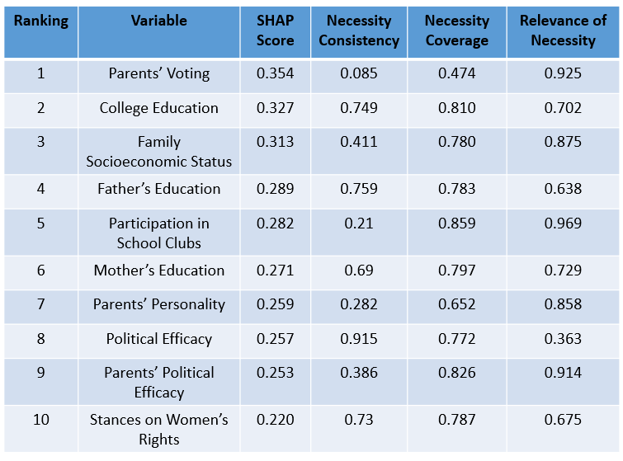
Figure A.1

Appendix 2: XGBoost Winning Model

XGBoost models were developed without splitting the cases into training and test sets due to the small sample size. Instead, a five-fold cross-validation process was used, involving training and evaluating subsamples to determine the models' prediction accuracy. The following parameters were tuned: subsample ratio of the training sample (0.75, 0.85, or 1), maximum tree depth (3, 4, or 5), sample ratio of columns when constructing a tree (0.6, 0.8, or 1), and the number of trees (50, 100, or 150). Figure A.2 presents the prediction accuracy of all XGBoost models. The winning model, which had the lowest log loss, is detailed in Table A.1 and provides the ranking list of conditions and their respective cut-offs.
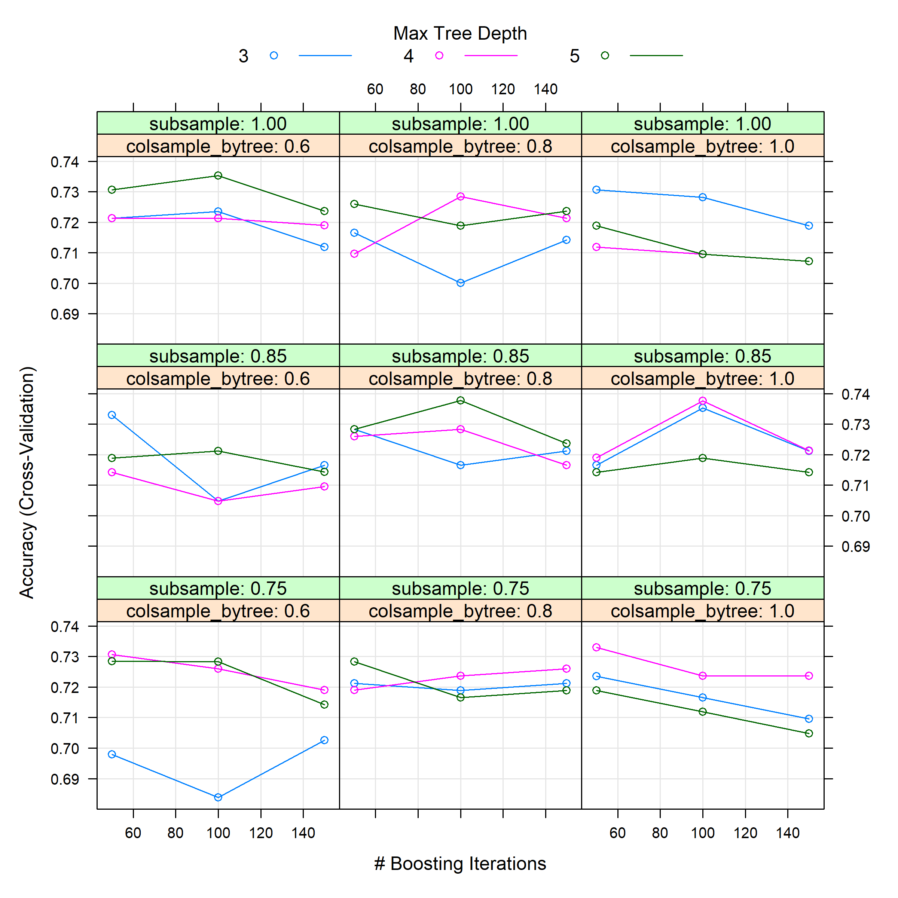
Figure A.2

Model | Subsample Ratio | Max Depth | Ratio of Columns | Number of Trees | Accuracy
#68 | 0.85 | 5 | 0.8 | 100 | 0.74

Table A.1

Appendix 3: Top Five Models by Radical MlQCA

Table A.2 presents three additional top QCA models generated by mlQCA. The top 1 and 5 models have been presented in the main body. These three models include three conditions related to parents' influences and only one condition related to youths' features. Therefore, they are not suitable models to examine the interplay of the theories that we are interested in.

Model | Pathways | Consistency | Coverage
Top 2 | Voted-Parents * College-Education + Voted-Parents * High-Socioeconomic-Status * Father’s-Education | 0.833 | 0.815
Top 3 | Voted-Parents * High-Socioeconomic-Status * Political Efficacy + Voted-Parents * Political Efficacy * Parents-on-Women-Rights | 0.835 | 0.793
Top 4 | Voted-Parents * Mother’s-Education * Political Efficacy + Voted-Parents * Parents-Personality * Political Efficacy | 0.847 | 0.761

Table A.2

Appendix 4: The Analysis of the Negation of the Outcome

An iteration of QCA sufficiency tests was conducted to explain non-voting behavior in three steps, similar to the process outlined in Section 3 of the main body. The results, presented in Table A.3, indicate that the top 30 conditions recommended by XGBoost hold sufficient empirical importance to form QCA solutions explaining non-voting behavior. In contrast, the bottom 40 conditions do not yield a single truth-table row that meets the consistency threshold of 0.8. Therefore, forming any QCA models with these empirically insignificant conditions is not feasible.

Model Development | Average Consistency | Average Coverage
Selecting from Top 10 | 0.8 | 0.074
Selecting from Top 11-20 | 0.823 | 0.080
Selecting from Top 21-30 | 0.85 | 0.079
Selecting from Top 31-40 | None | None
Selecting from Top 41-50 | None | None
Selecting from Top 51-60 | None | None
Selecting from Top 61-70 | None | None

Table A.3

Appendix 5: The Analysis of Variable Concurrence
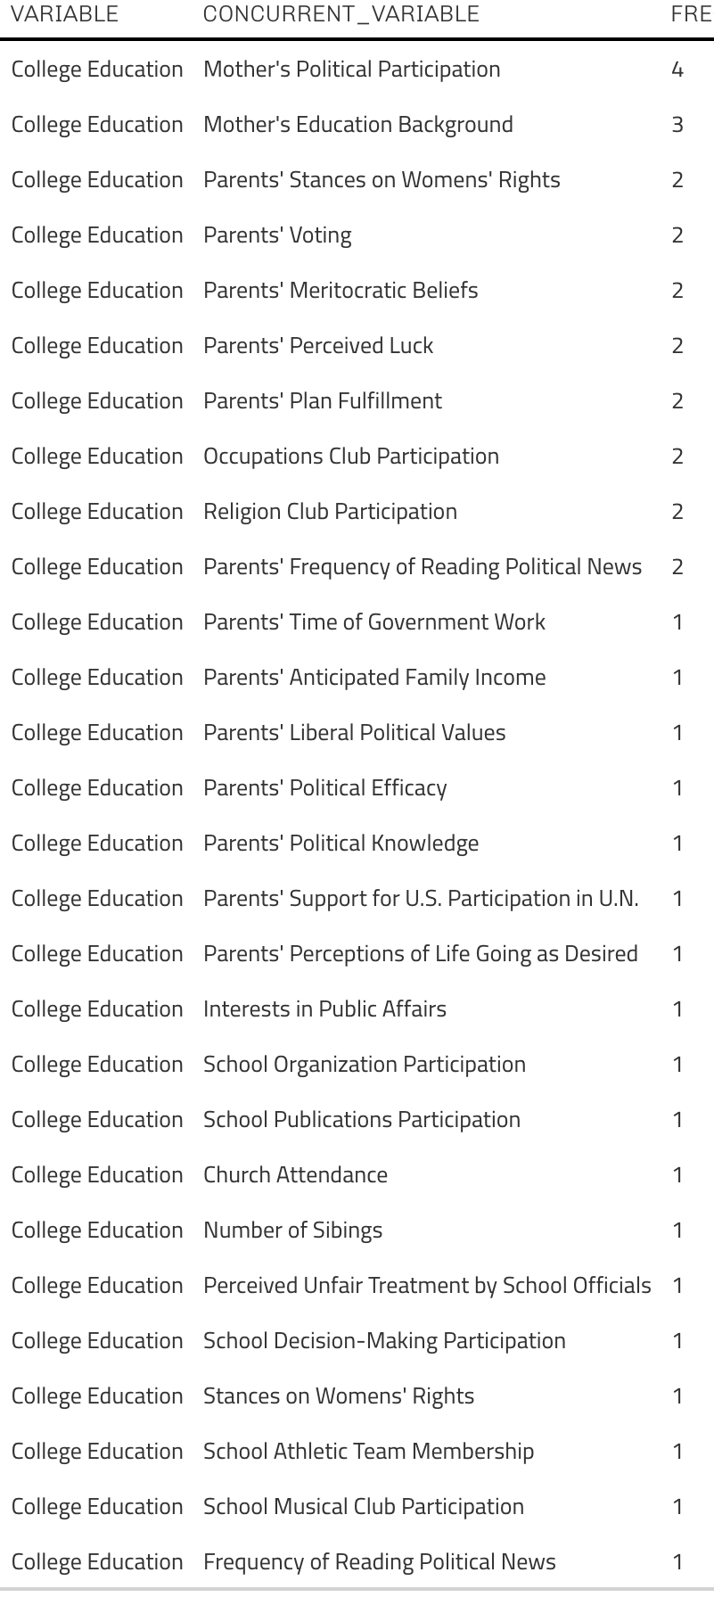
Figure A.3

To demonstrate how college education should be combined with other variables in QCA analysis, a list of co-occurring variables was derived from the tree-based model. In total, more than 20 variables appeared at least once with college education in the same decision trees used to collectively predict political participation. These concurrent variables varied in frequency, with mother's political participation being the most prevalent, co-occurring with college education in four decision trees. This concurrence analysis can also be conducted for other variables. Additionally, similar analyses can examine the concurrence of one or more variables with combinations of two or more variables.

