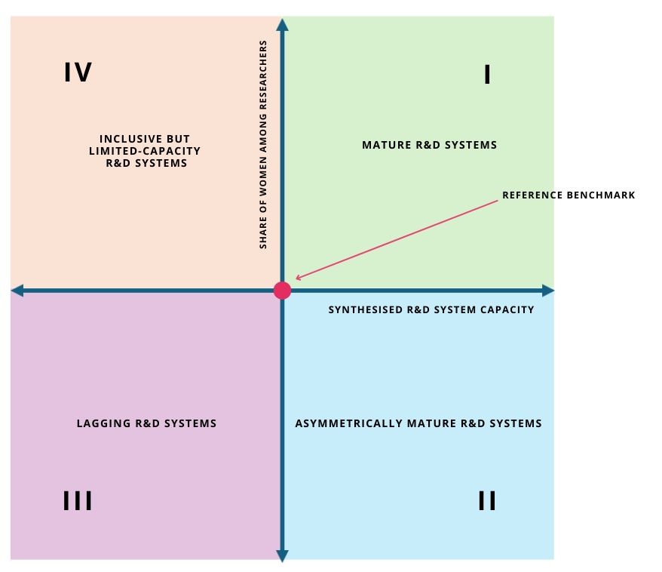
Figure 1. Coordinate-based analytical space of the multidimensional quadrant-based framework.

