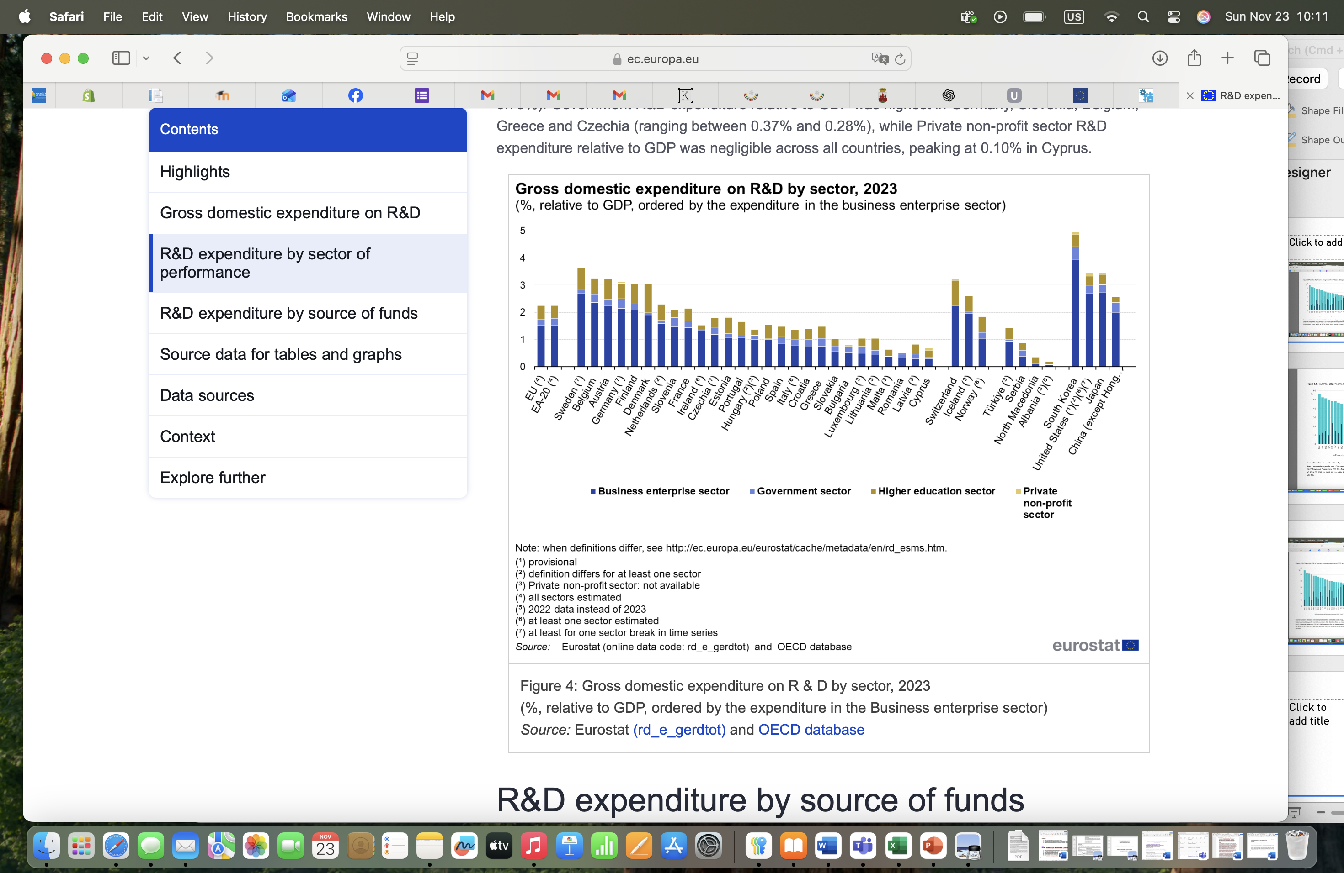
Figure 2. Linear ranking of national R&D systems by total R&D expenditure (% of GDP), 2023.

