Supplementary Figure 2. The ratio between the average relative validity (RV) and relative required sample size using CAT measurement compared to using the QLQ-C30 cognitive functioning sum scale based on the simulated data.
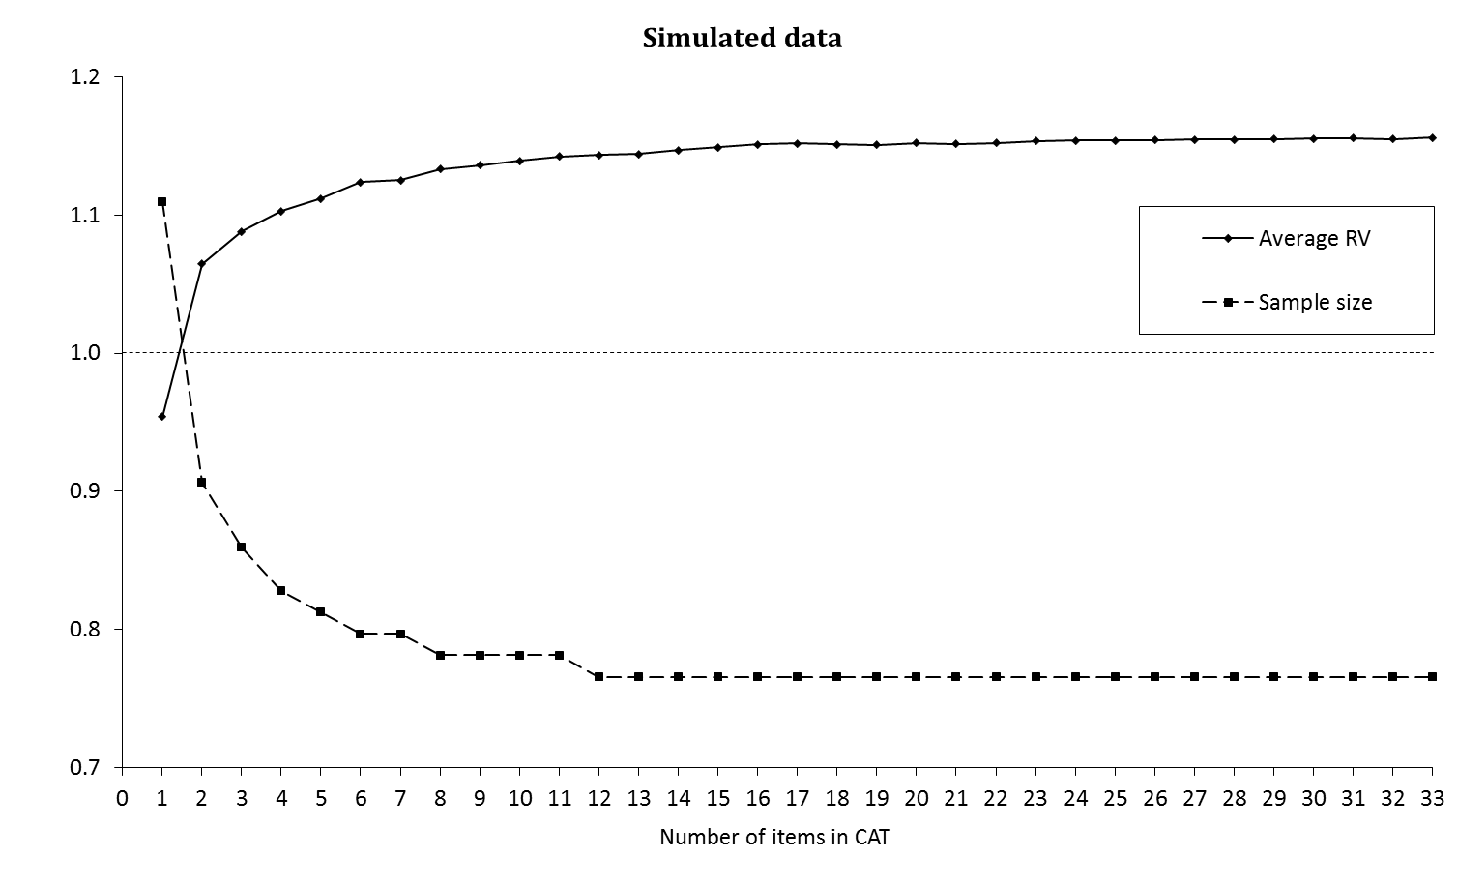
Average RV/required sample compared to QLQ-C30 CF scale

