Gibbons and Skevington (2017). Adjusting for cross-cultural differences in international item banks for quality of life. Appendix 1 – Detailed differential item functioning results
Differential item functioning plots and post-doc Tukey test results for Item F1.4
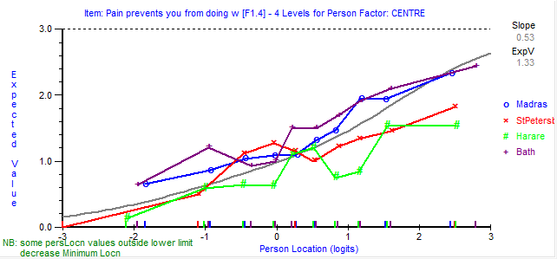
This figure shows the expected response to the item (y-axis) at each level across the continuum of quality of life (x-axis). Each country is plotted separately.
Country 1 | Country 2 | Mean 1 | Mean 2 | Absolute Difference | Dmin criterion
Bath | Harare | 0.31 | -0.51 | 0.82 | 0.27
Bath | StPete | 0.31 | -0.26 | 0.57 | 0.27
Bath | Madras | 0.31 | 0.24 | 0.07 | 0.25
StPete | Madras | -0.26 | 0.24 | 0.5 | 0.26
Harare | Madras | -0.51 | 0.24 | 0.75 | 0.25
Harare | StPete | -0.51 | -0.26 | 0.25 | 0.28
DIF is evident when the absolute difference is greater than the Dmin criterion.
Differential item functioning plots and post-doc Tukey test results for Item F2.1
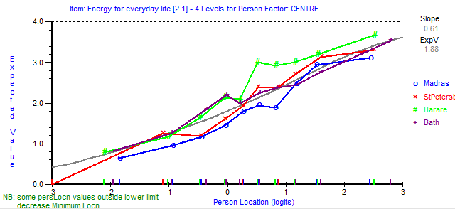

This figure shows the expected response to the item (y-axis) at each level across the continuum of quality of life (x-axis). Each country is plotted separately.
Country 1 | Country 2 | Mean 1 | Mean 2 | Absolute Difference | Dmin criterion
Bath | Harare | 0.07 | 0.32 | 0.25 | 0.23
Bath | StPete | 0.07 | 0.05 | 0.02 | 0.23
Bath | Madras | 0.07 | -0.31 | 0.38 | 0.21
StPete | Madras | 0.05 | -0.31 | 0.36 | 0.22
Harare | Madras | 0.32 | -0.31 | 0.63 | 0.22
Harare | StPete | 0.32 | 0.05 | 0.27 | 0.24
DIF is evident when the absolute difference is greater than the Dmin criterion.

Differential item functioning plots and post-doc Tukey test results for Item F2.3
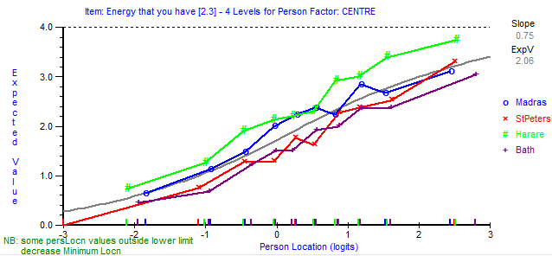
This figure shows the expected response to the item (y-axis) at each level across the continuum of quality of life (x-axis). Each country is plotted separately.

Country 1 | Country 2 | Mean 1 | Mean 2 | Absolute Difference | Dmin criterion
Bath | Harare | -0.4 | 0.47 | 0.87 | 0.25
Bath | StPete | -0.4 | -0.21 | 0.19 | 0.25
Bath | Madras | -0.4 | 0.13 | 0.53 | 0.23
StPete | Madras | -0.21 | 0.13 | 0.34 | 0.24
Harare | Madras | 0.47 | 0.13 | 0.34 | 0.23
Harare | StPete | 0.47 | -0.21 | 0.68 | 0.26
DIF is evident when the absolute difference is greater than the Dmin criterion.

Differential item functioning plots and post-doc Tukey test results for Item F10.1
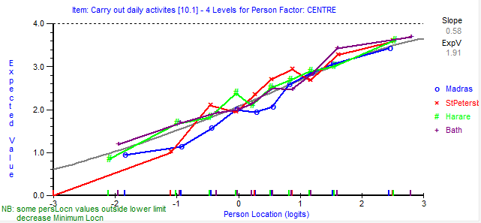
This figure shows the expected response to the item (y-axis) at each level across the continuum of quality of life (x-axis). Each country is plotted separately.
Country 1 | Country 2 | Mean 1 | Mean 2 | Absolute Difference | Dmin criterion
Bath | Harare | 0.16 | 0.01 | 0.15 | 0.23
Bath | StPetes | 0.16 | 0.17 | 0.01 | 0.24
Bath | Madras | 0.16 | -0.22 | 0.38 | 0.22
StPetes | Madras | 0.17 | -0.22 | 0.39 | 0.23
Harare | Madras | 0.01 | -0.22 | 0.23 | 0.22
Harare | StPetes | 0.01 | 0.17 | 0.16 | 0.24
DIF is evident when the absolute difference is greater than the Dmin criterion.

Differential item functioning plots and post-doc Tukey test results for Item F10.2

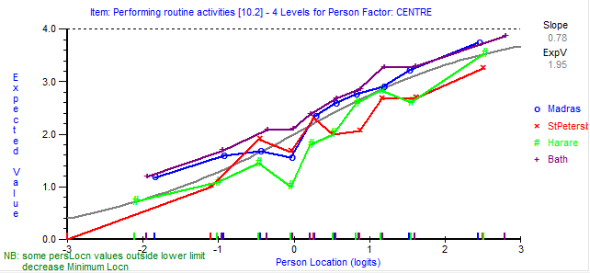
This figure shows the expected response to the item (y-axis) at each level across the continuum of quality of life (x-axis). Each country is plotted separately.

Country 1 | Country 2 | Mean 1 | Mean 2 | Absolute Difference | Dmin criterion
Bath | Harare | 0.39 | -0.23 | 0.62 | 0.28
Bath | StPetes | 0.39 | -0.33 | 0.72 | 0.28
Bath | Madras | 0.39 | 0.14 | 0.25 | 0.26
StPetes | Madras | -0.33 | 0.14 | 0.47 | 0.27
Harare | Madras | -0.23 | 0.14 | 0.37 | 0.26
Harare | StPetes | -0.23 | -0.33 | 0.1 | 0.29
DIF is evident when the absolute difference is greater than the Dmin criterion.
Differential item functioning plots and post-doc Tukey test results for Item F10.4
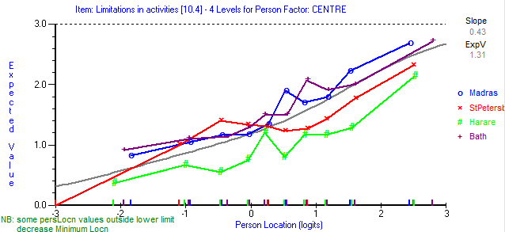
This figure shows the expected response to the item (y-axis) at each level across the continuum of quality of life (x-axis). Each country is plotted separately.

Country 1 | Country 2 | Mean 1 | Mean 2 | Absolute Difference | Dmin criterion
Bath | Harare | 0.27 | -0.56 | 0.83 | 0.28
Bath | StPetes | 0.27 | -0.12 | 0.39 | 0.28
Bath | Madras | 0.27 | 0.24 | 0.03 | 0.26
StPetes | Madras | -0.12 | 0.24 | 0.36 | 0.27
Harare | Madras | -0.56 | 0.24 | 0.8 | 0.26
Harare | StPetes | -0.56 | -0.12 | 0.44 | 0.29
DIF is evident when the absolute difference is greater than the Dmin criterion.
Differential item functioning plots and post-doc Tukey test results for Item F12.2
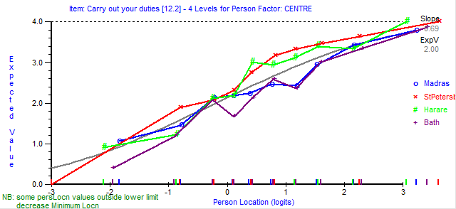
This figure shows the expected response to the item (y-axis) at each level across the continuum of quality of life (x-axis). Each country is plotted separately.

Country 1 | Country 2 | Mean 1 | Mean 2 | Absolute Difference | Dmin criterion
Bath | Harare | -0.25 | 0.15 | 0.4 | 0.26
Bath | StPetes | -0.25 | 0.38 | 0.63 | 0.26
Bath | Madras | -0.25 | -0.12 | 0.13 | 0.24
StPetes | Madras | 0.38 | -0.12 | 0.5 | 0.25
Harare | Madras | 0.15 | -0.12 | 0.27 | 0.24
Harare | StPetes | 0.15 | 0.38 | 0.23 | 0.27
DIF is evident when the absolute difference is greater than the Dmin criterion.

Differential item functioning plots and post-doc Tukey test results for Item F12.4

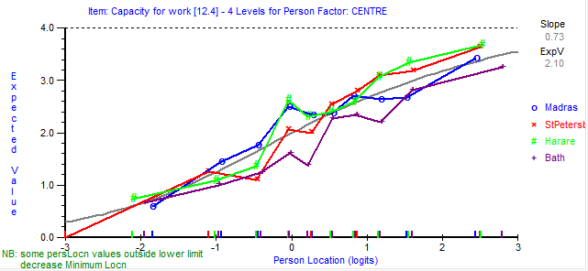
This figure shows the expected response to the item (y-axis) at each level across the continuum of quality of life (x-axis). Each country is plotted separately.
Country 1 | Country 2 | Mean 1 | Mean 2 | Absolute Difference | Dmin criterion
Bath | Harare | -0.37 | 0.19 | 0.56 | 0.28
Bath | StPetes | -0.37 | 0.19 | 0.56 | 0.29
Bath | Madras | -0.37 | 0.08 | 0.45 | 0.26
StPetes | Madras | 0.19 | 0.08 | 0.11 | 0.27
Harare | Madras | 0.19 | 0.08 | 0.11 | 0.26
Harare | StPetes | 0.19 | 0.19 | 0 | 0.29
DIF is evident when the absolute difference is greater than the Dmin criterion.

Differential item functioning plots and post-doc Tukey test results for Item F4.1
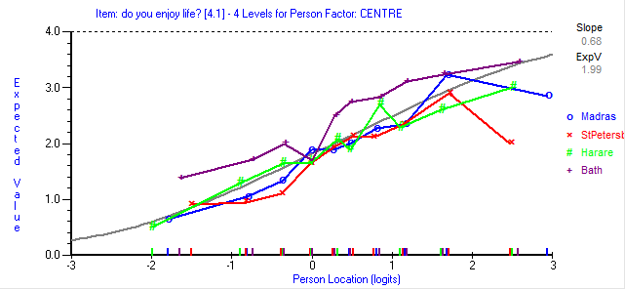
This figure shows the expected response to the item (y-axis) at each level across the continuum of quality of life (x-axis). Each country is plotted separately.

Country 1 | Country 2 | Mean 1 | Mean 2 | Absolute Difference | Dmin criterion
Bath | Harare | 0.47 | -0.14 | 0.61 | 0.24
Bath | StPete | 0.47 | -0.22 | 0.69 | 0.25
Bath | Madras | 0.47 | -0.14 | 0.61 | 0.23
StPete | Madras | -0.22 | -0.14 | 0.08 | 0.25
Harare | Madras | -0.14 | -0.14 | 0 | 0.24
Harare | StPete | -0.14 | -0.22 | 0.08 | 0.27
DIF is evident when the absolute difference is greater than the Dmin criterion.
Differential item functioning plots and post-doc Tukey test results for Item F4.3
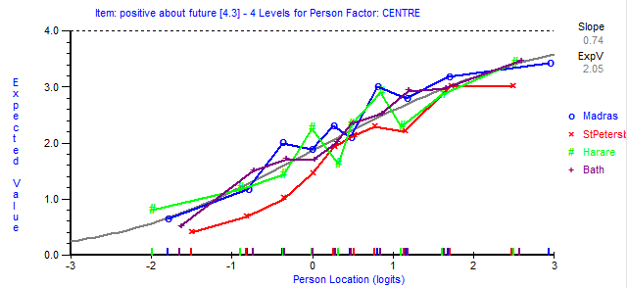
This figure shows the expected response to the item (y-axis) at each level across the continuum of quality of life (x-axis). Each country is plotted separately.
Country 1 | Country 2 | Mean 1 | Mean 2 | Absolute Difference | Dmin criterion
Bath | Harare | 0.05 | 0.06 | 0.01 | 0.26
Bath | StPete | 0.05 | -0.38 | 0.43 | 0.27
Bath | Madras | 0.05 | 0.18 | 0.13 | 0.24
StPete | Madras | -0.38 | 0.18 | 0.56 | 0.25
Harare | Madras | 0.06 | 0.18 | 0.12 | 0.25
Harare | StPete | 0.06 | -0.38 | 0.44 | 0.27
DIF is evident when the absolute difference is greater than the Dmin criterion.

Differential item functioning plots and post-doc Tukey test results for Item F5.3
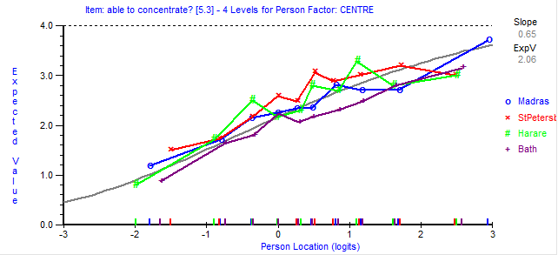
This figure shows the expected response to the item (y-axis) at each level across the continuum of quality of life (x-axis). Each country is plotted separately.
Country 1 | Country 2 | Mean 1 | Mean 2 | Absolute Difference | Dmin criterion
Bath | Harare | -0.36 | 0.03 | 0.39 | 0.29
Bath | StPetes | -0.36 | 0.33 | 0.69 | 0.30
Bath | Madras | -0.36 | 0.03 | 0.39 | 0.27
StPetes | Madras | 0.33 | 0.03 | 0.3 | 0.28
Harare | Madras | 0.03 | 0.03 | 0 | 0.27
Harare | StPetes | 0.03 | 0.33 | 0.3 | 0.30
DIF is evident when the absolute difference is greater than the Dmin criterion.

Differential item functioning plots and post-doc Tukey test results for Item F6.1
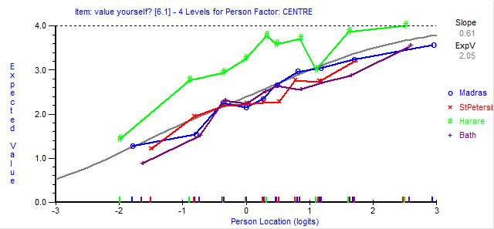
This figure shows the expected response to the item (y-axis) at each level across the continuum of quality of life (x-axis). Each country is plotted separately.
Country 1 | Country 2 | Mean 1 | Mean 2 | Absolute Difference | Dmin criterion
Bath | Harare | -0.39 | 0.83 | 1.22 | 0.26
Bath | StPetes | -0.39 | -0.25 | 0.14 | 0.26
Bath | Madras | -0.39 | -0.14 | 0.25 | 0.24
StPetes | Madras | -0.25 | -0.14 | 0.11 | 0.25
Harare | Madras | 0.83 | -0.14 | 0.97 | 0.24
Harare | StPetes | 0.83 | -0.25 | 1.08 | 0.27
DIF is evident when the absolute difference is greater than the Dmin criterion.

Differential item functioning plots and post-doc Tukey test results for Item F6.2
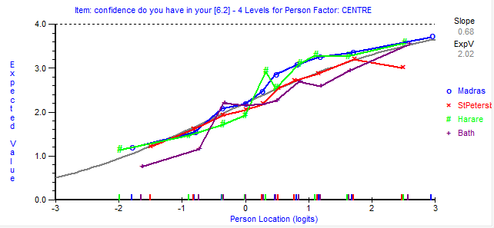
This figure shows the expected response to the item (y-axis) at each level across the continuum of quality of life (x-axis). Each country is plotted separately.
Country 1 | Country 2 | Mean 1 | Mean 2 | Absolute Difference | Dmin criterion
Bath | Harare | -0.25 | 0.13 | 0.38 | 0.26
Bath | StPetes | -0.25 | -0.09 | 0.16 | 0.27
Bath | Madras | -0.25 | 0.2 | 0.45 | 0.25
StPetes | Madras | -0.09 | 0.2 | 0.29 | 0.26
Harare | Madras | 0.13 | 0.2 | 0.07 | 0.25
Harare | StPetes | 0.13 | -0.09 | 0.22 | 0.27
DIF is evident when the absolute difference is greater than the Dmin criterion.

Differential item functioning plots and post-doc Tukey test results for Item F8.1
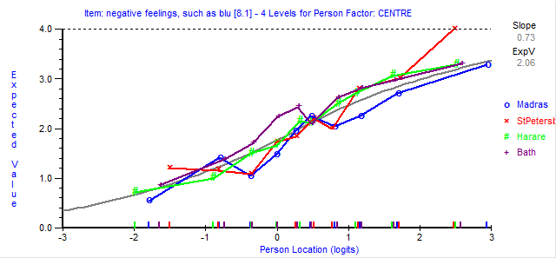
This figure shows the expected response to the item (y-axis) at each level across the continuum of quality of life (x-axis). Each country is plotted separately.
Country 1 | Country 2 | Mean 1 | Mean 2 | Absolute Difference | Dmin criterion
Bath | Harare | 0.26 | 0.05 | 0.21 | 0.27
Bath | StPetes | 0.26 | -0.03 | 0.29 | 0.27
Bath | Madras | 0.26 | -0.2 | 0.46 | 0.25
StPetes | Madras | -0.03 | -0.2 | 0.17 | 0.26
Harare | Madras | 0.05 | -0.2 | 0.25 | 0.25
Harare | StPetes | 0.05 | -0.03 | 0.08 | 0.28
DIF is evident when the absolute difference is greater than the Dmin criterion.
Differential item functioning plots and post-doc Tukey test results for Item F8.2
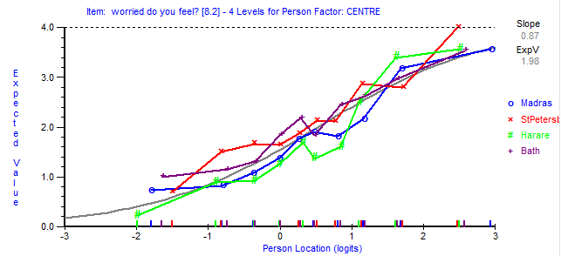
This figure shows the expected response to the item (y-axis) at each level across the continuum of quality of life (x-axis). Each country is plotted separately.

Country 1 | Country 2 | Mean 1 | Mean 2 | Absolute Difference | Dmin criterion
Bath | Harare | 0.17 | -0.22 | 0.39 | 0.26
Bath | StPetes | 0.17 | 0.21 | 0.04 | 0.27
Bath | Madras | 0.17 | -0.13 | 0.3 | 0.25
StPetes | Madras | 0.21 | -0.13 | 0.34 | 0.26
Harare | Madras | -0.22 | -0.13 | 0.09 | 0.25
Harare | StPetes | -0.22 | 0.21 | 0.43 | 0.28
DIF is evident when the absolute difference is greater than the Dmin criterion.
Differential item functioning plots and post-doc Tukey test results for Item F8.3
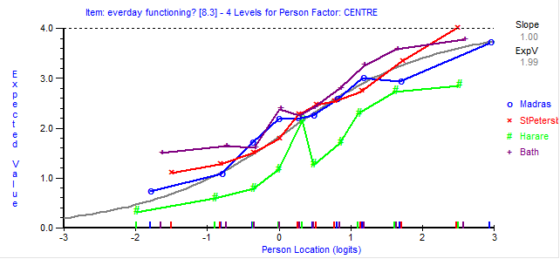
This figure shows the expected response to the item (y-axis) at each level across the continuum of quality of life (x-axis). Each country is plotted separately.
Country 1 | Country 2 | Mean 1 | Mean 2 | Absolute Difference | Dmin criterion
Bath | Harare | 0.37 | -0.58 | 0.95 | 0.27
Bath | StPetes | 0.37 | 0.09 | 0.28 | 0.25
Bath | Madras | 0.37 | 0.08 | 0.29 | 0.25
StPetes | Madras | 0.09 | 0.08 | 0.01 | 0.26
Harare | Madras | -0.58 | 0.08 | 0.66 | 0.25
Harare | StPetes | -0.58 | 0.09 | 0.67 | 0.28
DIF is evident when the absolute difference is greater than the Dmin criterion.

Differential item functioning plots and post-doc Tukey test results for Item F13.1
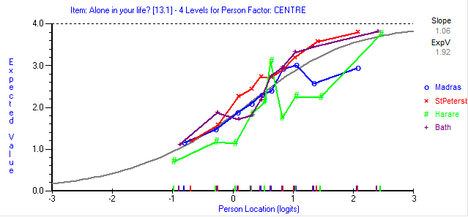
This figure shows the expected response to the item (y-axis) at each level across the continuum of quality of life (x-axis). Each country is plotted separately.
Country 1 | Country 2 | Mean 1 | Mean 2 | Absolute Difference | Dmin criterion
Bath | Harare | 0.2 | -0.25 | 0.45 | 0.26
Bath | StPetes | 0.2 | 0.27 | 0.07 | 0.26
Bath | Madras | 0.2 | -0.11 | 0.31 | 0.24
StPetes | Madras | 0.27 | -0.11 | 0.38 | 0.25
Harare | Madras | -0.25 | -0.11 | 0.14 | 0.24
Harare | StPetes | -0.25 | 0.27 | 0.52 | 0.27
DIF is evident when the absolute difference is greater than the Dmin criterion.

Differential item functioning plots and post-doc Tukey test results for Item F13.2
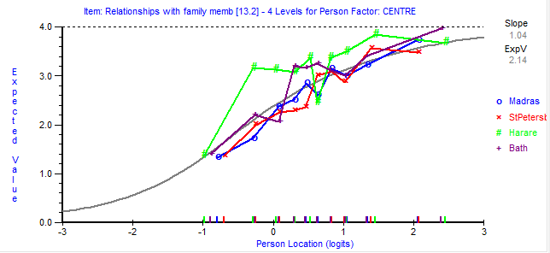
This figure shows the expected response to the item (y-axis) at each level across the continuum of quality of life (x-axis). Each country is plotted separately.
Country 1 | Country 2 | Mean 1 | Mean 2 | Absolute Difference | Dmin criterion
Bath | Harare | 0.19 | 0.29 | 0.1 | 0.26
Bath | StPetes | 0.19 | -0.13 | 0.32 | 0.27
Bath | Madras | 0.19 | -0.11 | 0.3 | 0.24
StPetes | Madras | -0.13 | -0.11 | 0.02 | 0.25
Harare | Madras | 0.29 | -0.11 | 0.4 | 0.25
Harare | StPetes | 0.29 | -0.13 | 0.42 | 0.27
DIF is evident when the absolute difference is greater than the Dmin criterion.
Differential item functioning plots and post-doc Tukey test results for Item F13.4
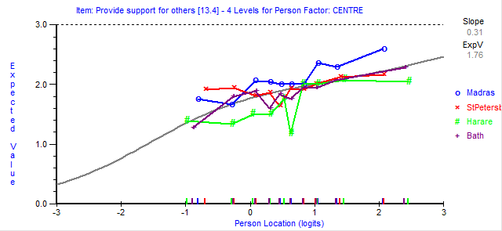
This figure shows the expected response to the item (y-axis) at each level across the continuum of quality of life (x-axis). Each country is plotted separately.
Country 1 | Country 2 | Mean 1 | Mean 2 | Absolute Difference | Dmin criterion
Bath | Harare | -0.05 | -0.43 | 0.38 | 0.31
Bath | StPetes | -0.05 | 0.03 | 0.08 | 0.32
Bath | Madras | -0.05 | 0.36 | 0.41 | 0.29
StPetes | Madras | 0.03 | 0.36 | 0.33 | 0.30
Harare | Madras | -0.43 | 0.36 | 0.79 | 0.29
Harare | StPetes | -0.43 | 0.03 | 0.46 | 0.32
DIF is evident when the absolute difference is greater than the Dmin criterion.

Differential item functioning plots and post-doc Tukey test results for Item F14.1
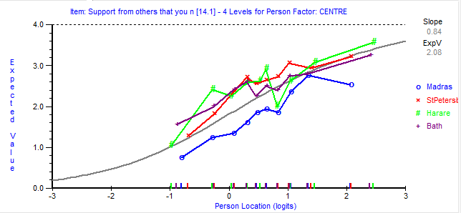
This figure shows the expected response to the item (y-axis) at each level across the continuum of quality of life (x-axis). Each country is plotted separately.
Country 1 | Country 2 | Mean 1 | Mean 2 | Absolute Difference | Dmin criterion
Bath | Harare | 0.13 | 0.29 | 0.16 | 0.27
Bath | StPetes | 0.13 | 0.31 | 0.18 | 0.28
Bath | Madras | 0.13 | -0.47 | 0.6 | 0.25
StPetes | Madras | 0.31 | -0.47 | 0.78 | 0.28
Harare | Madras | 0.29 | -0.47 | 0.76 | 0.27
Harare | StPetes | 0.29 | 0.31 | 0.02 | 0.29
DIF is evident when the absolute difference is greater than the Dmin criterion.

Differential item functioning plots and post-doc Tukey test results for Item F14.4
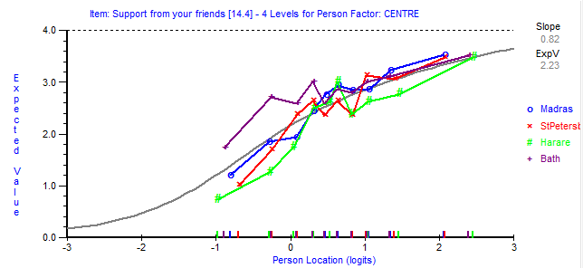
This figure shows the expected response to the item (y-axis) at each level across the continuum of quality of life (x-axis). Each country is plotted separately.
Country 1 | Country 2 | Mean 1 | Mean 2 | Absolute Difference | Dmin criterion
Bath | Harare | 0.25 | -0.18 | 0.43 | 0.27
Bath | StPetes | 0.25 | -0.01 | 0.26 | 0.27
Bath | Madras | 0.25 | 0.05 | 0.2 | 0.25
StPetes | Madras | -0.01 | 0.05 | 0.06 | 0.27
Harare | Madras | -0.18 | 0.05 | 0.23 | 0.27
Harare | StPetes | -0.18 | -0.01 | 0.17 | 0.29
DIF is evident when the absolute difference is greater than the Dmin criterion.

Differential item functioning plots and post-doc Tukey test results for Item F15.3
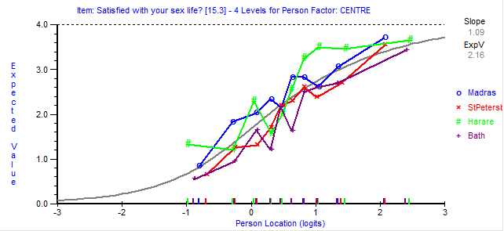
This figure shows the expected response to the item (y-axis) at each level across the continuum of quality of life (x-axis). Each country is plotted separately.
Country 1 | Country 2 | Mean 1 | Mean 2 | Absolute Difference | Dmin criterion
Bath | Harare | -0.24 | 0.33 | 0.57 | 0.32
Bath | StPetes | -0.24 | -0.19 | 0.05 | 0.31
Bath | Madras | -0.24 | 0.22 | 0.46 | 0.29
StPetes | Madras | -0.19 | 0.22 | 0.41 | 0.30
Harare | Madras | 0.33 | 0.22 | 0.11 | 0.31
Harare | StPetes | 0.33 | -0.19 | 0.52 | 0.33
DIF is evident when the absolute difference is greater than the Dmin criterion.

Differential item functioning plots and post-doc Tukey test results for Item F15.4
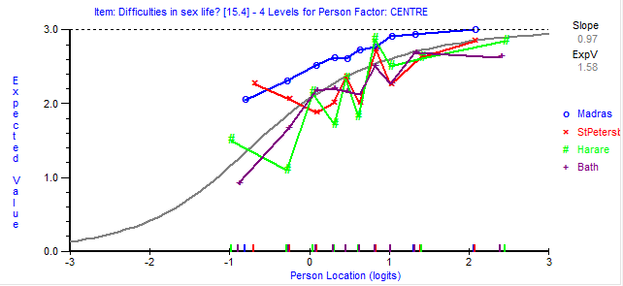
This figure shows the expected response to the item (y-axis) at each level across the continuum of quality of life (x-axis). Each country is plotted separately.

Country 1 | Country 2 | Mean 1 | Mean 2 | Absolute Difference | Dmin criterion
Bath | Harare | -0.32 | -0.14 | 0.18 | 0.24
Bath | StPetes | -0.32 | -0.1 | 0.22 | 0.25
Bath | Madras | -0.32 | 0.47 | 0.79 | 0.23
StPetes | Madras | -0.1 | 0.47 | 0.57 | 0.25
Harare | Madras | -0.14 | 0.47 | 0.61 | 0.24
Harare | StPetes | -0.14 | -0.1 | 0.04 | 0.27
DIF is evident when the absolute difference is greater than the Dmin criterion.
Differential item functioning plots and post-doc Tukey test results for Item F16.1
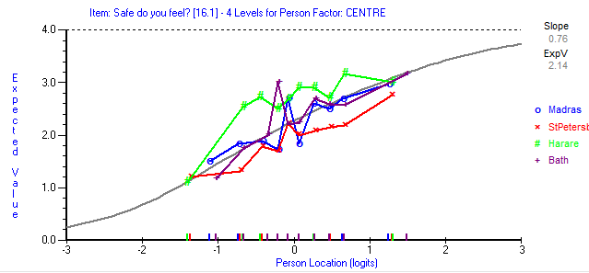
This figure shows the expected response to the item (y-axis) at each level across the continuum of quality of life (x-axis). Each country is plotted separately.
Country 1 | Country 2 | Mean 1 | Mean 2 | Absolute Difference | Dmin criterion
Bath | Harare | 0 | 0.38 | 0.38 | 0.27
Bath | StPetes | 0 | -0.35 | 0.35 | 0.27
Bath | Madras | 0 | -0.01 | 0.01 | 0.25
StPetes | Madras | -0.35 | -0.01 | 0.34 | 0.26
Harare | Madras | 0.38 | -0.01 | 0.39 | 0.25
Harare | StPetes | 0.38 | -0.35 | 0.73 | 0.28
DIF is evident when the absolute difference is greater than the Dmin criterion.

Differential item functioning plots and post-doc Tukey test results for Item F16.4
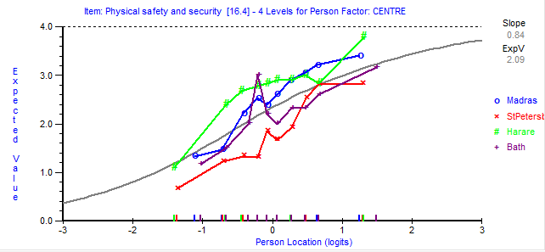
This figure shows the expected response to the item (y-axis) at each level across the continuum of quality of life (x-axis). Each country is plotted separately.

Country 1 | Country 2 | Mean 1 | Mean 2 | Absolute Difference | Dmin criterion
Bath | Harare | -0.18 | 0.42 | 0.6 | 0.23
Bath | StPetes | -0.18 | -0.56 | 0.38 | 0.23
Bath | Madras | -0.18 | 0.29 | 0.47 | 0.21
StPetes | Madras | -0.56 | 0.29 | 0.85 | 0.22
Harare | Madras | 0.42 | 0.29 | 0.13 | 0.22
Harare | StPetes | 0.42 | -0.56 | 0.98 | 0.24
DIF is evident when the absolute difference is greater than the Dmin criterion.
Differential item functioning plots and post-doc Tukey test results for Item F17.3
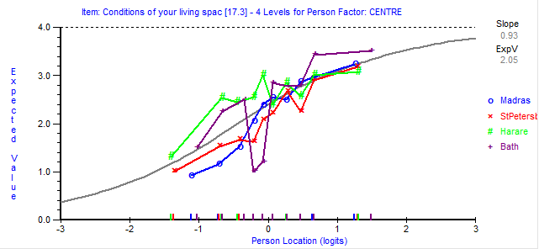
This figure shows the expected response to the item (y-axis) at each level across the continuum of quality of life (x-axis). Each country is plotted separately.
Country 1 | Country 2 | Mean 1 | Mean 2 | Absolute Difference | Dmin criterion
Bath | Harare | 0.27 | 0.25 | 0.02 | 0.24
Bath | StPetes | 0.27 | -0.27 | 0.54 | 0.25
Bath | Madras | 0.27 | -0.14 | 0.41 | 0.23
StPetes | Madras | -0.27 | -0.14 | 0.13 | 0.24
Harare | Madras | 0.25 | -0.14 | 0.39 | 0.23
Harare | StPetes | 0.25 | -0.27 | 0.52 | 0.25
DIF is evident when the absolute difference is greater than the Dmin criterion.

Differential item functioning plots and post-doc Tukey test results for Item F18.3
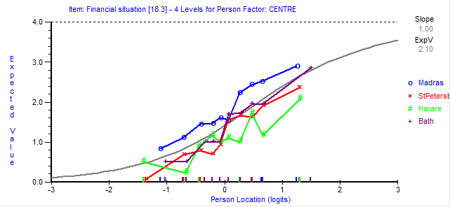
This figure shows the expected response to the item (y-axis) at each level across the continuum of quality of life (x-axis). Each country is plotted separately.
Country 1 | Country 2 | Mean 1 | Mean 2 | Absolute Difference | Dmin criterion
Bath | Harare | 0.06 | -0.32 | 0.38 | 0.25
Bath | StPetes | 0.06 | -0.3 | 0.36 | 0.26
Bath | Madras | 0.06 | 0.39 | 0.33 | 0.23
StPetes | Madras | -0.3 | 0.39 | 0.69 | 0.25
Harare | Madras | -0.32 | 0.39 | 0.71 | 0.24
Harare | StPetes | -0.32 | -0.3 | 0.02 | 0.26
DIF is evident when the absolute difference is greater than the Dmin criterion.

Differential item functioning plots and post-doc Tukey test results for Item F20.2
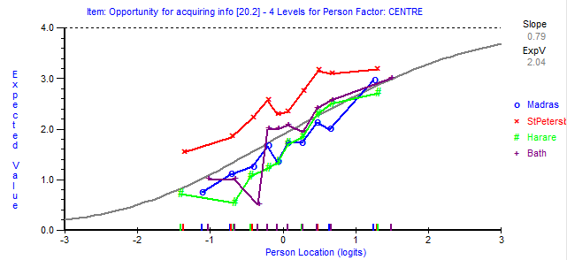
This figure shows the expected response to the item (y-axis) at each level across the continuum of quality of life (x-axis). Each country is plotted separately.
Country 1 | Country 2 | Mean 1 | Mean 2 | Absolute Difference | Dmin criterion
Bath | Harare | 0.04 | -0.35 | 0.39 | 0.24
Bath | StPetes | 0.04 | 0.7 | 0.66 | 0.25
Bath | Madras | 0.04 | -0.25 | 0.29 | 0.22
StPetes | Madras | 0.7 | -0.25 | 0.95 | 0.23
Harare | Madras | -0.35 | -0.25 | 0.1 | 0.23
Harare | StPetes | -0.35 | 0.7 | 1.05 | 0.25
DIF is evident when the absolute difference is greater than the Dmin criterion.

Differential item functioning plots and post-doc Tukey test results for Item F20.4
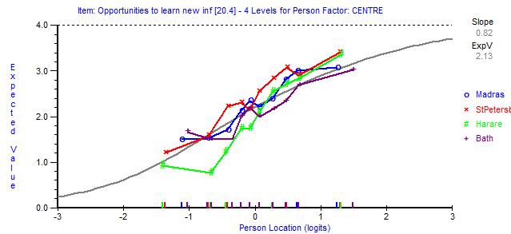
This figure shows the expected response to the item (y-axis) at each level across the continuum of quality of life (x-axis). Each country is plotted separately.
Country 1 | Country 2 | Mean 1 | Mean 2 | Absolute Difference | Dmin criterion
Bath | Harare | -0.14 | -0.2 | 0.06 | 0.26
Bath | StPetes | -0.14 | 0.29 | 0.43 | 0.27
Bath | Madras | -0.14 | 0.08 | 0.22 | 0.24
StPetes | Madras | 0.29 | 0.08 | 0.21 | 0.25
Harare | Madras | -0.2 | 0.08 | 0.28 | 0.25
Harare | StPetes | -0.2 | 0.29 | 0.49 | 0.27
DIF is evident when the absolute difference is greater than the Dmin criterion.

Differential item functioning plots and post-doc Tukey test results for Item F21.2
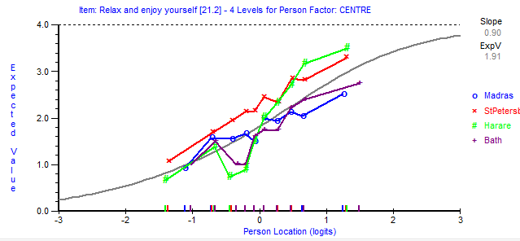
This figure shows the expected response to the item (y-axis) at each level across the continuum of quality of life (x-axis). Each country is plotted separately.
Country 1 | Country 2 | Mean 1 | Mean 2 | Absolute Difference | Dmin criterion
Bath | Harare | -0.26 | -0.12 | 0.14 | 0.27
Bath | StPetes | -0.26 | 0.47 | 0.73 | 0.28
Bath | Madras | -0.26 | -0.09 | 0.17 | 0.26
StPetes | Madras | 0.47 | -0.09 | 0.56 | 0.27
Harare | Madras | -0.12 | -0.09 | 0.03 | 0.26
Harare | StPetes | -0.12 | 0.47 | 0.59 | 0.29
DIF is evident when the absolute difference is greater than the Dmin criterion.

