Electronic Supplementary Material

JOURNAL: Quality of Life Research

TITLE: Direct and indirect effects of socioeconomic, relational and health factors on the mental well-being of the general population

AUTHORS: Natalia Soldevila-Domenech^{1,2,3}†, Carlos G. Forero⁴†, Itxaso Alayo^{1,5}, Jordina Capella⁶, Joan Colom⁶, Davide Malmusi⁷, Anna Mompart⁸, Philippe Mortier^{1,5}, Beatriz Puértolas^{1,5}, Néstor Sánchez⁴, Anna Schiaffino^{8,9}, Gemma Vilagut^{1,5*,} Jordi Alonso^{1,3,5*}.
¹Health Services Research Group, Epidemiology and Public Health Program, Hospital del Mar Medical Research Institute (IMIM), Carrer del Doctor Aiguader, 88, PRBB building, 08003 Barcelona, Spain.
²Integrative Pharmacology and Systems Neurosciences Research Group, Neurosciences Research Program, Hospital del Mar Medical Research Institute (IMIM), Carrer del Doctor Aiguader, 88, PRBB building, 08003 Barcelona, Spain.
³Department of Experimental and Health Sciences, Pompeu Fabra University (UPF), Carrer del Doctor Aiguader, 88, PRBB building, 08003 Barcelona, Spain.
⁴ School of Medicine, Universitat Internacional de Catalunya (UIC), Barcelona, Spain.
⁵CIBER en Epidemiología y Salud Pública (CIBERESP), Av. Monforte de Lemos, 3-5, 28029 Madrid, Spain.
⁶Sub-direcció General de Drogodependències, Agència de Salut Pública de Catalunya, Carrer Roc Boronat, 81-95, 08005 Barcelona, Spain
⁷Ajuntament de Barcelona, Barcelona, Spain.
⁸Direcció General de Planificació en Salut, Departament de Salut, Generalitat de Catalunya, Travessera de les Corts, 131-159, 08028 Barcelona, Spain.
⁹Institut Català d’Oncologia, Gran Via de l’Hospitalet 199-203, 08908 l’Hospitalet de Llobregat, Spain

†Contributed equally. Natalia Soldevila-Domenech and Carlos G. Forero should be consider joint first authors.
*Corresponding authors: Gemma Vilagut and Jordi Alonso should be consider joint senior author.
Gemma Vilagut. Health Services Research Group, Epidemiology and Public Health Program, Hospital del Mar Medical Research Institute (IMIM), Carrer del Doctor Aiguader, 88, PRBB building, 08003 Barcelona, Spain. Phone: +34 933 160 745. Email: gvilagut@imim.es. ORCID-iD: https://orcid.org/0000-0002-3714-226X
Jordi Alonso. Health Services Research Group, Epidemiology and Public Health Program, Hospital del Mar Medical Research Institute (IMIM), Carrer del Doctor Aiguader, 88, PRBB building, 08003 Barcelona, Spain. Phone: +34 933 160 754. Email: jalonso@imim.es ORCID iD: https://orcid.org/0000-0001-8627-9636

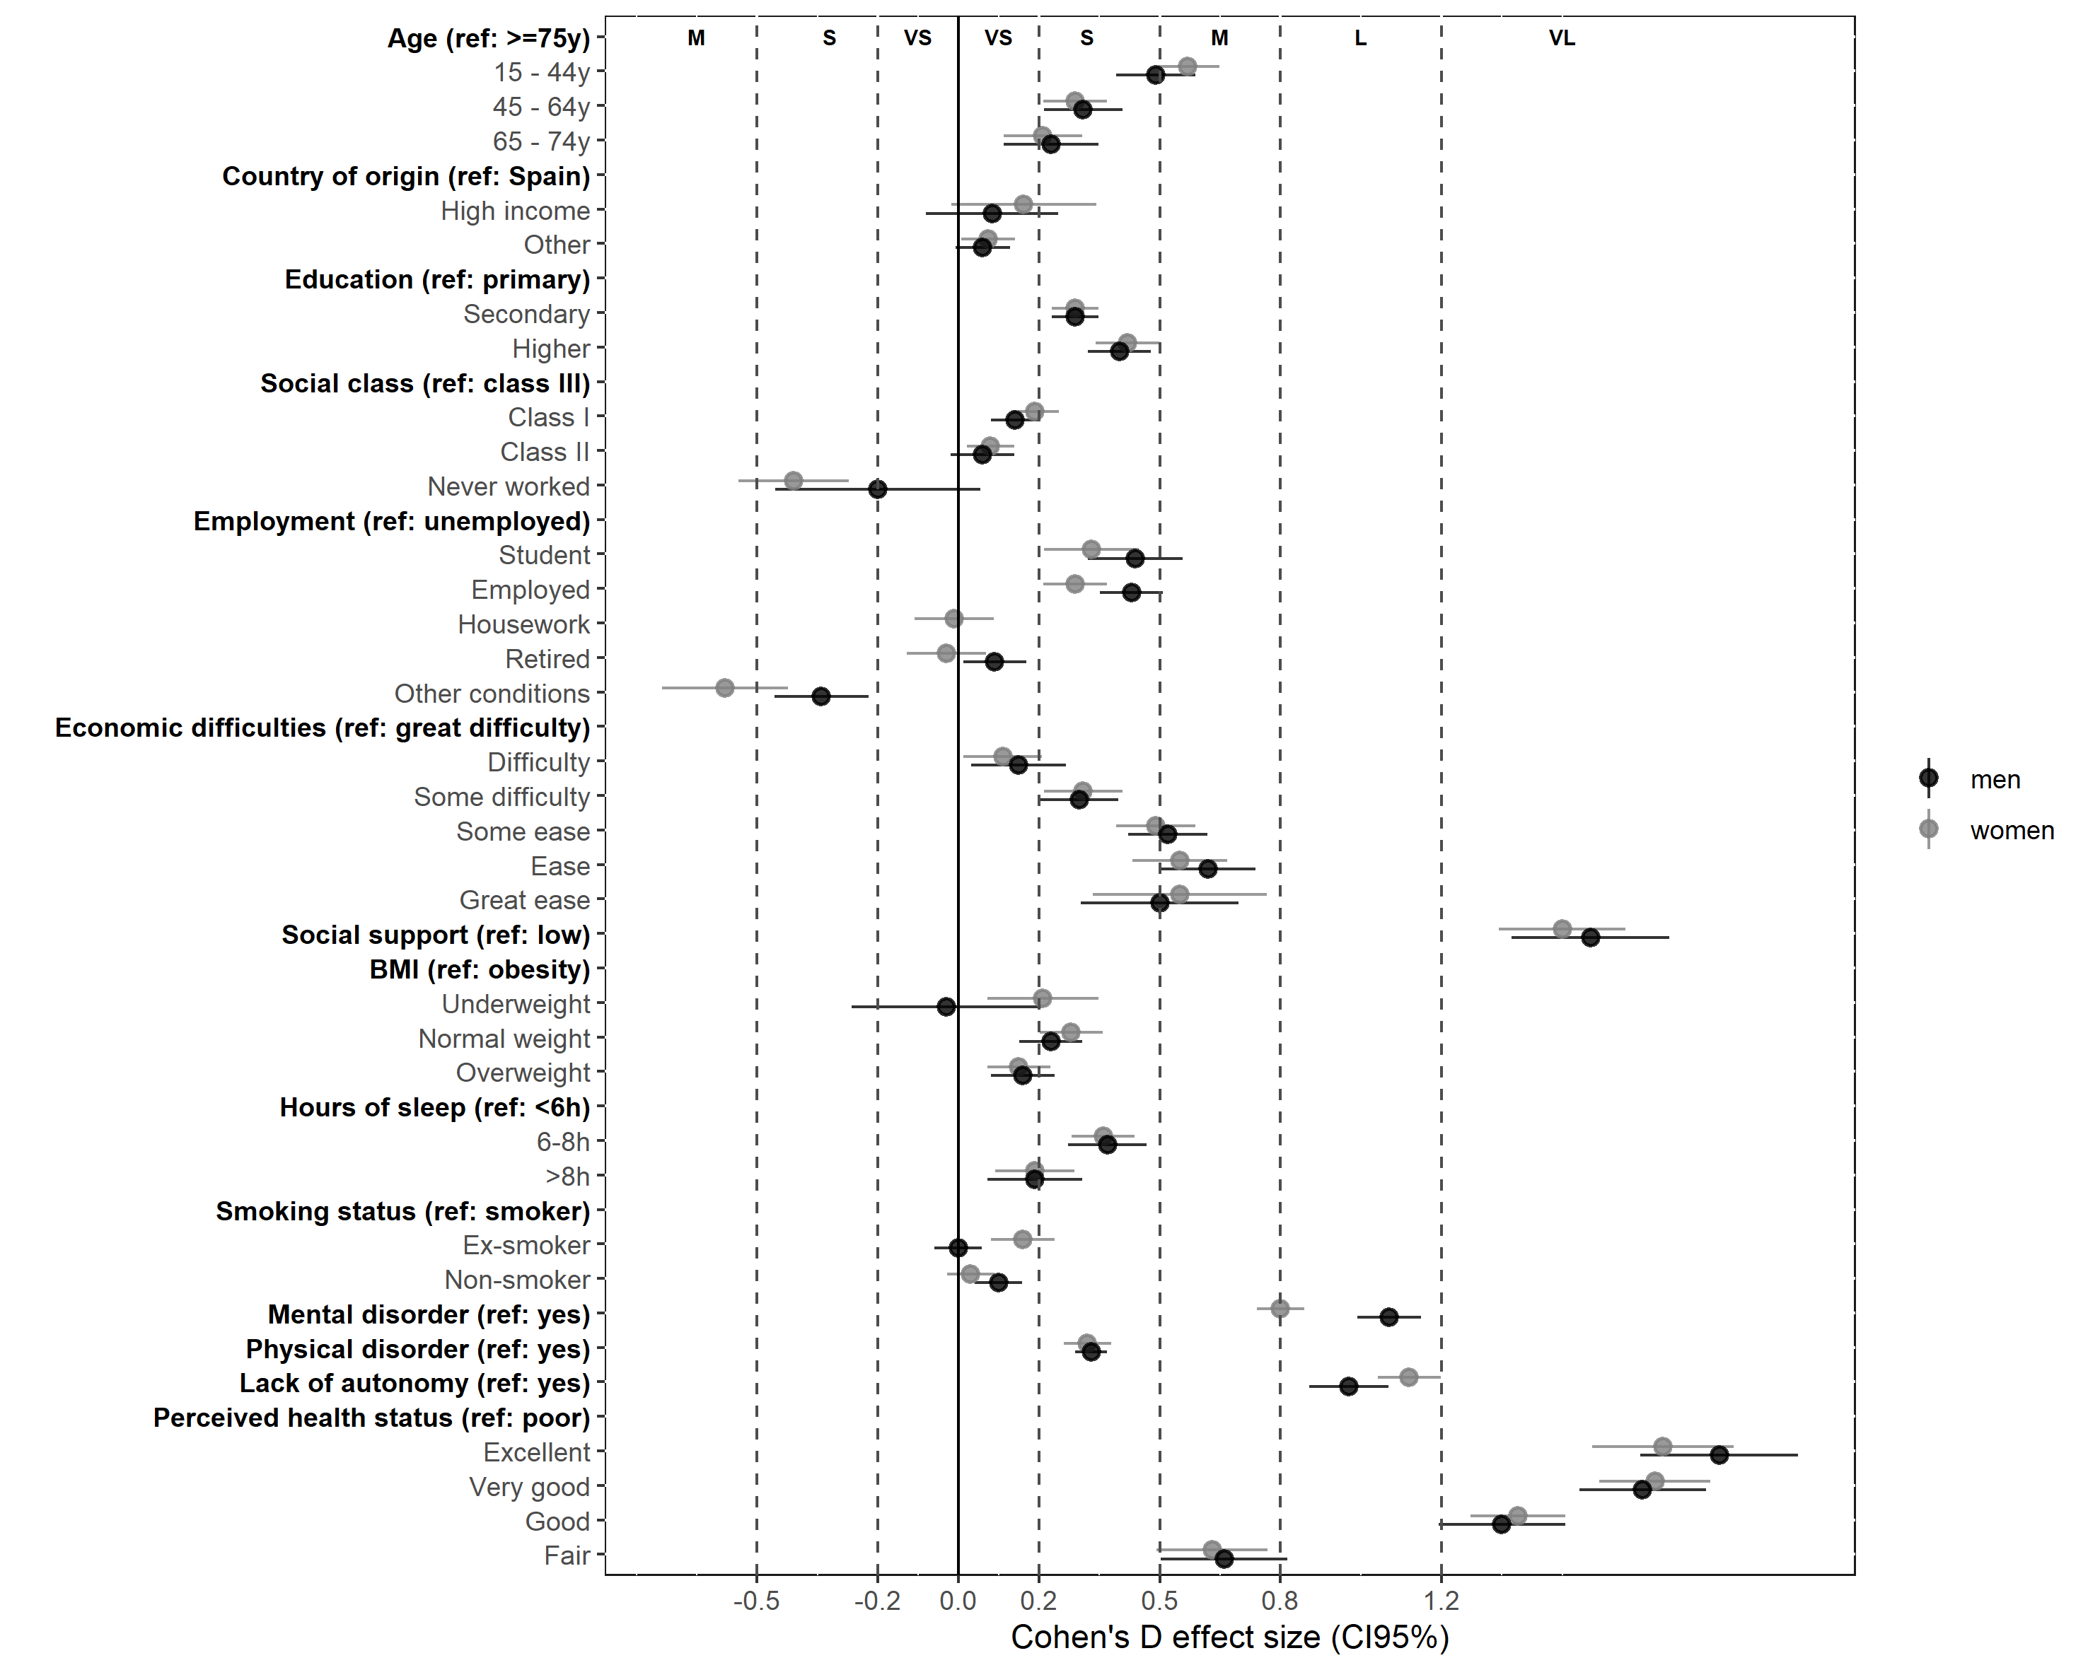
Supplementary Figure 1. Cohen’s D effect of the unadjusted relationship between studied variables and mental well-being

Supplementary Figure 2. Minimally sufficient adjustment set (MSAS) of each predictor variable of mental well-being, identified with the directed acyclic graph (DAG-1, Figure 1) to analyse both total and direct effects.

Supplementary Figure 3. Secondary directed acyclic graph (DAG-2) without health factors and perceived health. Variable names are abbreviated: origin, country of origin; education, educational level; work, employment status; income, family economic difficulties; BMI, body mass index; smoke, smoking status; sleep, hours of sleep; dependency, lack of autonomy. Node colours represent the group to which each variable belongs: demographic factors (in blue), socioeconomic factors (in green) and relational factors (in purple).
Supplementary Figure 4. Minimally sufficient adjustment set (MSAS) of each predictor variable of mental well-being, identified with the directed acyclic graph (DAG-2, Supplementary Figure 3) to analyse both total and direct effects excluding health factors and perceived health.

Supplementary Table 1. Comparison of direct and total of each variable on WEMWBS score adjusted by the minimal sufficient adjustment sets identified with DAG-1 that includes health factors and DAG-2 that excludes health factors.

Variable | Category | DAG-1  (including health factors) |  |  |  |  |  |  | DAG-2  (excluding health factors) |  |  |  |  |  | Difference in direct effects | Indirect effects explained by health factors*
Variable | Category | Total effects |  |  | Direct effects |  |  | Indirect effects | Total effects |  |  | Direct effects |  |  | Difference in direct effects | Indirect effects explained by health factors*
Variable | Category | β | SE | P | β | SE | P | Indirect effects | β | SE | P | β | SE | P | Difference in direct effects | Indirect effects explained by health factors*
Sex  (Ref: Women) | Men | 1.32 | 0.15 | <0.001 | -0.05 | 0.14 | 0.741 | NS | 1.32 | 0.15 | <0.001 | 0.95 | 0.15 | <0.001 | NA | NA
Age (years)  (Ref: ≥75) | 15 - 44 | 5.21 | 0.26 | <0.001 | 1.33 | 0.36 | <0.001 | 3.89 | 5.21 | 0.26 | <0.001 | 3.83 | 0.38 | <0.001 | 2.51 | 64.51%
Age (years)  (Ref: ≥75) | 45 - 64 | 3.35 | 0.27 | <0.001 | 1.24 | 0.33 | <0.001 | 2.10 | 3.35 | 0.27 | <0.001 | 2.89 | 0.36 | <0.001 | 1.64 | 78.14%
Age (years)  (Ref: ≥75) | 65 - 74 | 2.67 | 0.32 | <0.001 | 1.47 | 0.29 | <0.001 | 1.19 | 2.67 | 0.32 | <0.001 | 2.46 | 0.31 | <0.001 | 0.99 | 82.82%
Country of origin (Ref: Spain) | High income | 1.36 | 0.54 | 0.012 | 0.68 | 0.50 | 0.173 | 0.68 | 1.36 | 0.54 | 0.012 | 0.68 | 0.50 | 0.173 | NA | NA
Country of origin (Ref: Spain) | Other | 0.90 | 0.21 | <0.001 | 1.01 | 0.21 | <0.001 | -0.11 | 0.90 | 0.21 | <0.001 | 1.01 | 0.21 | <0.001 | 0.00 | 0.00%
Educational level (Ref: Primary) | Secondary | 1.99 | 0.20 | <0.001 | 0.84 | 0.19 | <0.001 | 1.15 | 1.99 | 0.20 | <0.001 | 0.91 | 0.20 | <0.001 | 0.07 | 5.87%
Educational level (Ref: Primary) | Higher | 3.05 | 0.24 | <0.001 | 0.71 | 0.26 | 0.006 | 2.33 | 3.05 | 0.24 | <0.001 | 0.89 | 0.27 | 0.001 | 0.18 | 7.59%
Social class  (Ref: III) | I | 0.68 | 0.22 | 0.002 | -0.42 | 0.20 | 0.037 | 1.10 | 0.68 | 0.22 | 0.002 | -0.45 | 0.21 | 0.032 | -0.03 | -2.68%
Social class  (Ref: III) | II | 0.16 | 0.21 | 0.444 | -0.46 | 0.18 | 0.013 | 0.62 | 0.16 | 0.21 | 0.444 | -0.45 | 0.19 | 0.021 | 0.01 | 1.90%
Social class  (Ref: III) | Never worked | -3.75 | 0.52 | <0.001 | -2.58 | 0.50 | <0.001 | -1.17 | -3.75 | 0.52 | <0.001 | -2.30 | 0.53 | <0.001 | 0.28 | -23.76%
Employment status  (Ref: Unemployed) | Student | 3.35 | 0.34 | <0.001 | 1.67 | 0.32 | <0.001 | 1.69 | 3.35 | 0.34 | <0.001 | 2.08 | 0.34 | <0.001 | 0.42 | 24.79%
Employment status  (Ref: Unemployed) | Employed | 3.16 | 0.24 | <0.001 | 1.81 | 0.23 | <0.001 | 1.35 | 3.16 | 0.24 | <0.001 | 2.08 | 0.24 | <0.001 | 0.27 | 20.07%
Employment status  (Ref: Unemployed) | Housework | 2.34 | 0.36 | <0.001 | 1.50 | 0.33 | <0.001 | 0.85 | 2.34 | 0.36 | <0.001 | 1.39 | 0.35 | <0.001 | -0.11 | -12.72%
Employment status  (Ref: Unemployed) | Retired | 2.65 | 0.39 | <0.001 | 1.90 | 0.37 | <0.001 | 0.74 | 2.65 | 0.39 | <0.001 | 1.72 | 0.38 | <0.001 | -0.18 | -24.93%
Employment status  (Ref: Unemployed) | Other | -4.11 | 0.41 | <0.001 | -1.81 | 0.38 | <0.001 | -2.30 | -4.11 | 0.41 | <0.001 | -3.88 | 0.40 | <0.001 | -2.07 | 90.10%
Family economic difficulties to make monthly ends meet  (Ref: Great difficulty) | Difficulty | 1.59 | 0.33 | <0.001 | 0.60 | 0.31 | 0.050 | 0.99 | 1.59 | 0.33 | <0.001 | 0.90 | 0.32 | 0.005 | 0.30 | 30.47%
 | Some difficulty | 3.14 | 0.30 | <0.001 | 1.52 | 0.29 | <0.001 | 1.63 | 3.14 | 0.30 | <0.001 | 2.15 | 0.30 | <0.001 | 0.64 | 39.17%
 | Some ease | 4.36 | 0.30 | <0.001 | 2.24 | 0.29 | <0.001 | 2.11 | 4.36 | 0.30 | <0.001 | 3.24 | 0.30 | <0.001 | 0.99 | 47.06%
 | Ease | 5.64 | 0.33 | <0.001 | 3.70 | 0.32 | <0.001 | 1.95 | 5.64 | 0.33 | <0.001 | 4.65 | 0.34 | <0.001 | 0.95 | 48.93%
 | Great ease | 6.02 | 0.55 | <0.001 | 3.98 | 0.52 | <0.001 | 2.05 | 6.02 | 0.55 | <0.001 | 4.91 | 0.55 | <0.001 | 0.93 | 45.42%
Social support  (Ref: Low) | Adequate | 12.80 | 0.48 | <0.001 | 9.97 | 0.45 | <0.001 | 2.84 | 12.80 | 0.48 | <0.001 | 12.80 | 0.48 | <0.001 | 2.84 | 100.00%
BMI  (Ref: Obesity) | Underweight | -0.38 | 0.50 | 0.446 | -0.80 | 0.46 | 0.086 | NS | -0.38 | 0.50 | 0.446 | -0.38 | 0.50 | 0.446 | NA | NA
BMI  (Ref: Obesity) | Normal weight | 0.78 | 0.22 | <0.001 | 0.34 | 0.20 | 0.097 | NS | 0.78 | 0.22 | <0.001 | 0.78 | 0.22 | <0.001 | NA | NA
BMI  (Ref: Obesity) | Overweight | 0.72 | 0.22 | <0.001 | 0.37 | 0.20 | 0.068 | NS | 0.72 | 0.22 | <0.001 | 0.72 | 0.22 | <0.001 | NA | NA
Hours of sleep  (Ref: <6h) | 6-8h | 1.37 | 0.24 | <0.001 | 1.37 | 0.24 | <0.001 | 0.00 | 2.24 | 0.26 | <0.001 | 2.24 | 0.26 | <0.001 | NA | NA
Hours of sleep  (Ref: <6h) | >8h | 1.51 | 0.32 | <0.001 | 1.51 | 0.32 | <0.001 | 0.00 | 2.18 | 0.34 | <0.001 | 2.18 | 0.34 | <0.001 | NA | NA
Smoking status  (Ref: smoker) | Ex-smoker | 0.96 | 0.22 | <0.001 | 0.70 | 0.20 | <0.001 | 0.27 | 0.96 | 0.22 | <0.001 | 0.96 | 0.22 | <0.001 | 0.27 | 100.00%
Smoking status  (Ref: smoker) | Non-smoker | 0.65 | 0.18 | <0.001 | 0.31 | 0.16 | 0.058 | NS | 0.65 | 0.18 | <0.001 | 0.65 | 0.18 | <0.001 | NA | NA
*It is calculated with the difference in direct effects divided by indirect effects from DAG-1(%).
Each variable has been adjusted by its minimal sufficient adjustment sets identified with the DAG-1 (see Figure 1 and Supplementary Figure 2) or DAG-2 (see supplementary figures 3 and 4), as well as, by the year of survey.
Ref, reference category; β, regression coefficient; SE, standard error; BMI, body mass index. P, p-value. NS, non-significant effect. NA, no apply due to the absence of indirect effects or due to the absence of statistically significant direct effects.

