Supplementary Table 1. Calculation of the multidimensional prognostic index in the English Longitudinal Study on Ageing
Domain | 0 (low risk) | 0.5 (medium risk) | 1 (high risk)
Number of difficulties in ADL | 0 | 1-2-3 | 4-5
Number of difficulties in IADL | 0 | 1-2-3 | 4-5
CESD | 0 | 1 | >2
Number of medical conditions | 0-1-2 | 3-4 | >5
Body mass index | 18.5-25 | 25-35 | <18.5; >35
Physical activity level | High/moderate | Low | Sedentary
Social | With family | - | Alone

Supplementary Table 2. Life Expectancy (LE) and Good Quality of Life Expectancy (GQoLE, years and % of the total life expectancy) by sex, age and MPI risk group for the ELSA study
 | LE  (years)* | GQoLE  (years and % of LE) | GQoLE  (years and % of LE)  by MPI risk group
 | LE  (years)* | GQoLE  (years and % of LE) | Low risk | Moderate risk | Severe risk
Women
60-64 years | 23.6 | 11.8 (50%) | 14.9 (63%) | 10.2 (43%) | 5.7 (24%)
65-69 years | 19.4 | 9.2 (48%) | 11.9 (62%) | 8.5 (44%) | 4.4 (23%)
70-74 years | 15.4 | 6.8 (44%) | 9.1 (59%) | 6.7 (44%) | 3.6 (24%)
75-79 years | 11.7 | 4.8 (41%) | 6.6 (56%) | 5.1 (43%) | 2.6 (23%)
80-84 years | 8.6 | 3.0 (35%) | 4.4 (51%) | 3.6 (42%) | 1.4 (17%)
85 years | 5.9 | 1.9 (32%) | 2.8 (47%) | 2.4 (40%) | 1 (17%)
Men
60-64 years | 20.7 | 10.4 (50%) | 12.1 (58%) | 8.4 (41%) | 2.8 (13%)
65-69 years | 16.8 | 8.3 (50%) | 9.8 (58%) | 7.0 (42%) | 2.1 (13%)
70-74 years | 13.3 | 6.2 (47%) | 7.3 (55%) | 5.4 (41%) | 1.9 (15%)
75-79 years | 10.1 | 4.4 (44%) | 5.2 (52%) | 4.3 (43%) | 1.3 (12%)
80-84 years | 7.5 | 2.9 (39%) | 3.8 (51%) | 3.0 (51%) | 0.8 (11%)
85 years | 5.4 | 1.9 (35%) | 2.4 (44%) | 2.5 (46%) | 0.3 (5%)
*: according to abridged life tables for United Kingdom of Great Britain and Northern Ireland, year 2005 (available at https://www.who.int/data/gho/data/indicators/indicator-details/GHO/gho-ghe-life-tables-by-country)

Figure 1. Survival curves in the ELSA Study according to MPI categories (weighted data)
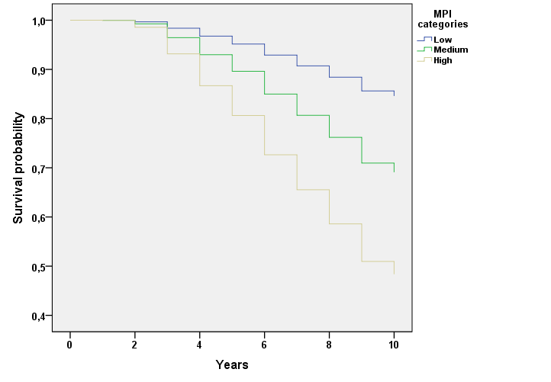

Supplementary Table 3. SAS programs
proc freq data=database;
tables death mpi_categ ragender edu_dic smo_dic adl_mpi iadl_mpi cesd_mpi pa_mpi
bmi_mpi cirs_mpi social_mpi items_mpi
casp2_mio casp_dic
death*(mpi_categ ragender edu_dic smo_dic adl_mpi iadl_mpi cesd_mpi pa_mpi
bmi_mpi cirs_mpi social_mpi items_mpi
casp_dic)/chisq;
weight r2lwtresp;
run;

proc means data=database mean stddev median q1 q3 n;
var mpi r2agey casp2_mio;
class death;
weight r2lwtresp;
run;
proc univariate data=database normal;
var mpi r2agey casp2_mio;
*weight r2lwtresp;
run;
proc univariate data=database;
var casp2;
output pctlpre=P_ pctlpts= 33.3, 66.6 to 100 by 33.3;
weight r2lwtresp;
run;
proc glm data= database;
class death;
model mpi r2agey=death;
means death/hovtest=levene welch;
lsmeans death/tdiff stderr;
weight r2lwtresp;
run; quit;
proc npar1way data=database wilcoxon;
var casp2_mio;
class death;
run;

/*******/
ods output lsmeans=x1;
proc mixed data=database;
class tte ragender r2agey;
model mpi= tte ragender r2agey
tte*ragender tte*r2agey/outp=p;
random intercept;
weight r2lwtresp;
run; quit;
ODS OUTPUT CLOSE;

data p;
set p;
format pred best4.;
if 0<=pred <0.25 then mpi_categ_m=1;
else if 0.25<=pred <=0.43 then mpi_categ_m=2;
else if pred>0.43 then mpi_categ_m=3;
run;

proc phreg data=p;
class ragender (param=ref ref='2')
edu_dic (param=ref ref='0')
mar_dic (param=ref ref='0')
smo_dic (param=ref ref='0');
model tte*death(0)= pred ragender r2agey edu_dic mar_dic smo_dic predt ragendert r2ageyt edu_dict mar_dict smo_dict /rl ties=efron;
predt=pred*(tte);
ragendert=ragender*(tte);
r2ageyt=r2agey*(tte);
edu_dict=edu_dic*(tte);
mar_dict=mar_dic*(tte);
smo_dict=smo_dic*(tte);
test_proportionality: test predt;
test_proportionality: test ragendert;
test_proportionality: test r2ageyt;
test_proportionality: test edu_dict;
test_proportionality: test mar_dict;
test_proportionality: test smo_dict;
weight r2lwtresp;
run; quit;

ods graphics on;
proc phreg data=p;
class ragender (param=ref ref='2')
edu_dic (param=ref ref='0')
mar_dic (param=ref ref='0')
smo_dic (param=ref ref='0');
model tte*death(0)= pred ragender r2agey edu_dic mar_dic smo_dic /rl ties=efron;
hazardratio '0.10 unit change in MPI' pred/units=0.1000;
hazardratio '5 unit change in age' r2agey/units=5;
weight r2lwtresp;
run; quit;

ods graphics on; /*SAS STUDIO*/
proc phreg data=p concordance=harrell(SE)
plots=auc plots(overlay=individual)=roc
rocoptions(at=3 to 9 by 3);
model years*death(0)=pred ragender r2agey
edu_dic mar_dic smo_dic /rl ties=efron ;
run;

/*******/
proc freq data=p;
tables ragender*age_table*mpi_categ*casp_dic;
weight r2lwtresp;
run;

proc freq data=database;
tables ragender*age_table*casp_dic;
weight r2lwtresp;
run;

