Supplemental Item: Winsteps Table 23.99 – standardized residual correlations

Study 1 (ASCS). ASCOT-SCT4
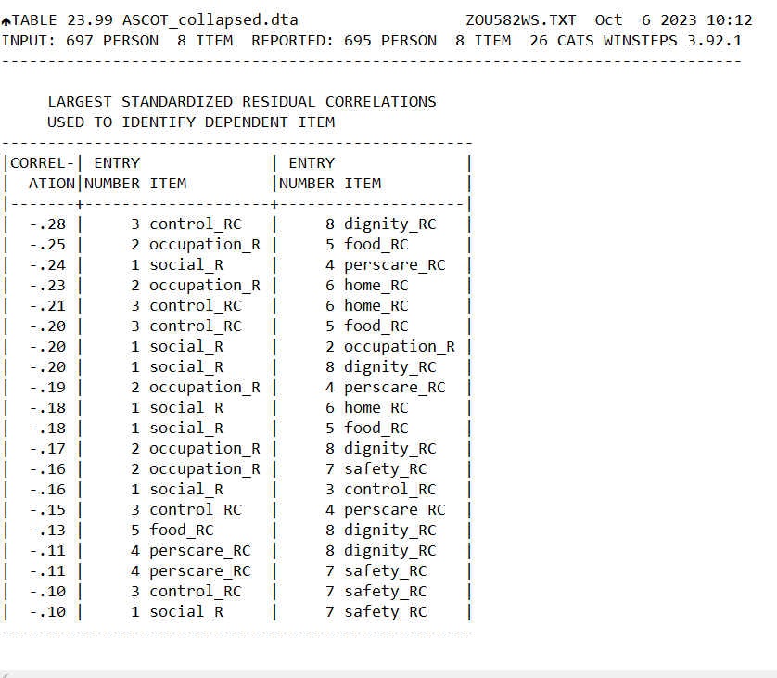
Key to Item labels:
1 Social_R ASCOT-SCT4 Social participation
2 Occupation_R ASCOT-SCT4 Occupation
3 Control_RC ASCOT-SCT4 Control over daily life (collapsed categories)
4 perscare_RC ASCOT-SCT4 Personal comfort and cleanliness (collapsed categories)
5 food_RC ASCOT-SCT4 Food and drink (collapsed categories)
6 home_RC ASCOT-SCT4 Accommodation comfort and cleanliness (collapsed categories)
7 safety_RC ASCOT-SCT4 Personal safety (collapsed categories)
8 dignity_RC ASCOT-SCT4 Dignity (collapsed categories)

Study 2 (DACHA). ASCOT-Proxy-Resident
TABLE 23.99 ASCOT proxy resident.dta ZOU046WS.TXT Jan 11 2024 10:47
INPUT: 462 PERSON 8 ITEM REPORTED: 462 PERSON 8 ITEM 30 CATS WINSTEPS 5.5.0.0
---------------------------------------------------------------------------------

LARGEST STANDARDIZED RESIDUAL CORRELATIONS
USED TO IDENTIFY DEPENDENT ITEM
-----------------------------------------------
|CORREL-| ENTRY | ENTRY |
| ATION|NUMBER ITEM |NUMBER ITEM |
|-------+------------------+------------------|
| .28 | 2 ascot_q2pR | 3 ascot_q3p |
|-------+------------------+------------------|
| -.34 | 1 ascot_q1p | 5 ascot_q5p |
| -.31 | 2 ascot_q2pR | 6 ascot_q6p |
| -.29 | 1 ascot_q1p | 6 ascot_q6p |
| -.26 | 2 ascot_q2pR | 5 ascot_q5p |
| -.26 | 4 ascot_q4p | 8 ascot_q8p |
| -.26 | 3 ascot_q3p | 6 ascot_q6p |
| -.21 | 3 ascot_q3p | 4 ascot_q4p |
| -.21 | 3 ascot_q3p | 5 ascot_q5p |
| -.21 | 5 ascot_q5p | 8 ascot_q8p |
| -.20 | 6 ascot_q6p | 8 ascot_q8p |
| -.20 | 4 ascot_q4p | 6 ascot_q6p |
| -.18 | 1 ascot_q1p | 4 ascot_q4p |
| -.17 | 5 ascot_q5p | 7 ascot_q7pR |
| -.16 | 2 ascot_q2pR | 8 ascot_q8p |
| -.13 | 1 ascot_q1p | 8 ascot_q8p |
| -.13 | 4 ascot_q4p | 7 ascot_q7pR |
| -.12 | 3 ascot_q3p | 7 ascot_q7pR |
| -.11 | 7 ascot_q7pR | 8 ascot_q8p |
| -.09 | 6 ascot_q6p | 7 ascot_q7pR |
-----------------------------------------------

Key to Item labels:
1 ascot_q1p ASCOT-Proxy-Resident Food and drink
2 ascot_q2pR ASCOT-Proxy-Resident Accommodation comfort and cleanliness (collapsed categories)
3 ascot_q3p ASCOT-Proxy-Resident Personal comfort and cleanliness
4 ascot_q4p ASCOT-Proxy-Resident Social participation
5 ascot_q5p ASCOT-Proxy-Resident Occupation
6 ascot_q6p ASCOT-Proxy-Resident Control over daily life
7 ascot_q7pR ASCOT-Proxy-Resident Personal safety (collapsed categories)
8 ascot_q8p ASCOT-Proxy-Resident Dignity

