Supplementary Materials: Rohde et al. 2024

Supplementary table 1. Health state classification system of the QLU-C10D

Dimension | Level | Stem | Descriptor | QLQ-C30 item scores
Physical functioning | 1 | You have… | No trouble taking a long walk outside the house | Item 2 (long walk) = 1
 | 2 |  | No trouble taking a short walk outside the house, but at least a little trouble taking a long walk | Item 3 (short walk) = 1 AND Item 2 ≥ 2
 | 3 |  | At least a little trouble taking a short walk outside the house, and at least a little trouble taking a long walk | Item 3 = 2 AND Item 2 ≥ 2
 | 4 |  | Quite a bit or very much trouble taking a short walk outside the house | Item 3 ≥ 3 AND Item 2 ≥ 2
Role functioning | 1 | You are limited in pursuing your work or other daily activities… | Not at all | Item 6 = 1
 | 2 |  | A little | Item 6 = 2
 | 3 |  | Quite a bit | Item 6 = 3
 | 4 |  | Very much | Item 6 = 4
Social functioning | 1 | Your physical condition or medical treatment interferes with your social or family life… | Not at all | Items 26 AND 27 = 1
 | 2 |  | A little | Items 26 OR 27 = 2
 | 3 |  | Quite a bit | Items 26 OR 27 = 3
 | 4 |  | Very much | Items 26 OR 27 = 4
Emotional functioning | 1 | You feel depressed… | Not at all | Item 24 = 1
 | 2 |  | A little | Item 24 = 2
 | 3 |  | Quite a bit | Item 24 = 3
 | 4 |  | Very much | Item 24 = 4
Pain | 1 | You have pain… | Not at all | Item 9 = 1
 | 2 |  | A little | Item 9 = 2
 | 3 |  | Quite a bit | Item 9 = 3
 | 4 |  | Very much | Item 9 = 4
Fatigue | 1 | You feel tired… | Not at all | Item 18 = 1
 | 2 |  | A little | Item 18 = 2
 | 3 |  | Quite a bit | Item 18 = 3
 | 4 |  | Very much | Item 18 = 4
Sleep | 1 | You have trouble sleeping… | Not at all | Item 11 = 1
 | 2 |  | A little | Item 11 = 2
 | 3 |  | Quite a bit | Item 11 = 3
 | 4 |  | Very much | Item 11 = 4
Appetite | 1 | You lack appetite… | Not at all | Item 13 = 1
 | 2 |  | A little | Item 13 = 2
 | 3 |  | Quite a bit | Item 13 = 3
 | 4 |  | Very much | Item 13 = 4
Nausea | 1 | You feel nauseated… | Not at all | Item 14 = 1
 | 2 |  | A little | Item 14 = 2
 | 3 |  | Quite a bit | Item 14 = 3
 | 4 |  | Very much | Item 14 = 4
Bowel problems | 1 | You… | Do not have constipation or diarrhoea at all | Items 16 AND 17 = 1
 | 2 |  | Have a little constipation or diarrhoea | Items 16 OR 17 = 2
 | 3 |  | Have constipation or diarrhoea quite a bit | Items 16 OR 17 = 3
 | 4 |  | Have constipation or diarrhoea very much | Items 16 OR 17 = 4
Duration | 1 | You will live in this health state for… | 1 year, and then die | Not applicable
 | 2 |  | 2 years, and then die | Not applicable
 | 3 |  | 5 years, and then die | Not applicable
 | 4 |  | 10 years, and then die | Not applicable

Supplementary table 2: Feedback information on the DCE

Variable |  | Norway (n=1019) | Sweden (n=1048)
Clarity of DCE | Clear/very clear | 59.0% | 64.0%
 | Unclear/very unclear | 17.5% | 11.7%
Difficulty of DCE | Easy/very easy | 37.4% | 25.0%
 | Difficult/very difficult | 37.3% | 46.9%
Strategy used | Considered all aspects | 24.3% | 13.0%
 | Considered most aspects | 25.0% | 30.4%
 | Highlighted aspects | 25.5% | 25.3%
 | Only a few aspects | 14.4% | 19.3%
 | Other strategy/ no strategy | 10.7% | 12.1%

Supplementary Figure 1: English language example screenshot from the DCE survey.

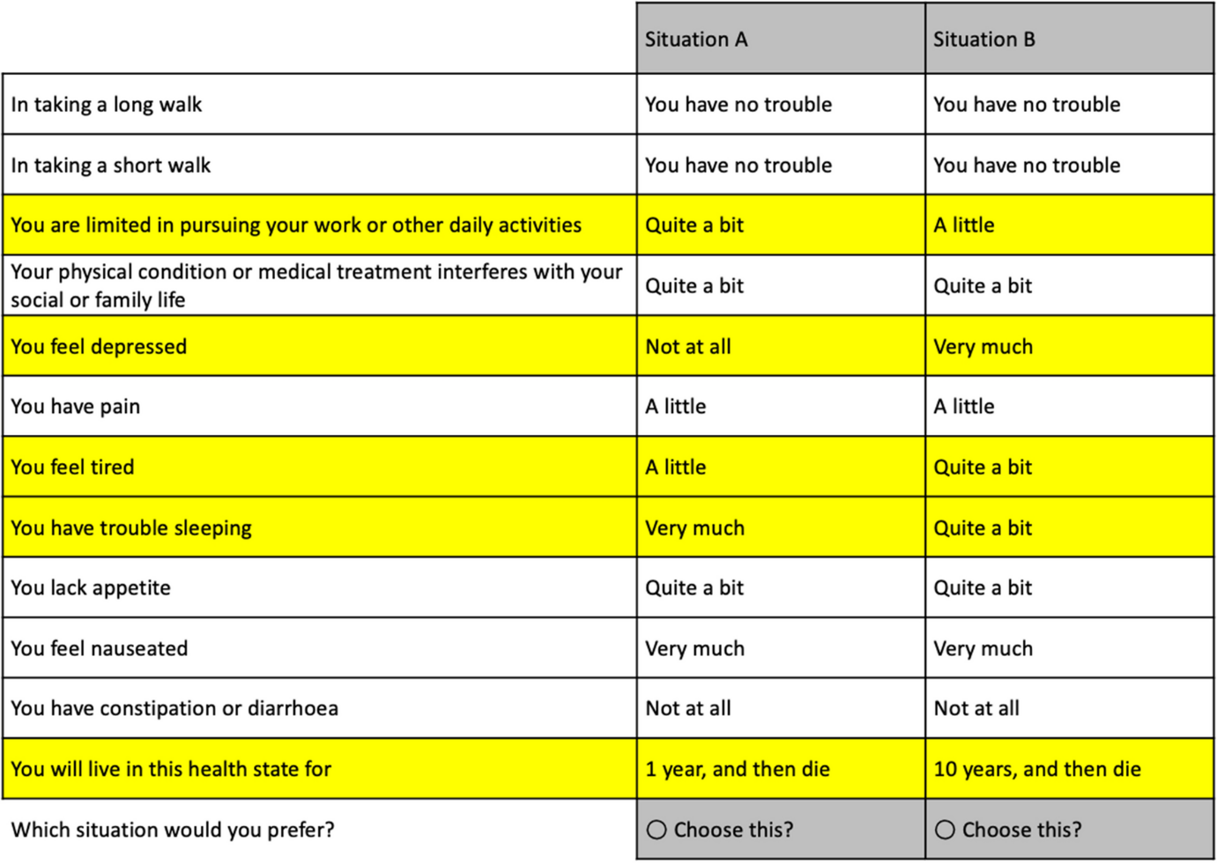
The task required participants to choose between two QLU-C10D health states, labeled as 'Situation A' and 'Situation B', each with a specified duration. In the QLU-C10D valuation methods experiment, choice sets were formatted according to participant preference, with differences between the situations highlighted in yellow. Due to the complexity of the descriptors for levels 2 and 3 of the Physical Functioning dimension, the survey separated the items 'long walk' and 'short walk' to enhance understanding. For DCE design and data analysis, the Physical Functioning dimension was treated as a single four-level dimension.
With over a million possible health states in the QLU-C10D classification system, a designed experiment selected 960 choice sets to maximize statistical efficiency for estimating utility model parameters. The survey's DCE component incorporated two levels of randomization: each respondent was randomly allocated 16 out of the 960 choice sets, and within each set, the assignment of Situation A or B was randomized to avoid ordering bias. Previous research demonstrated that presenting the dimensions in a consistent order does not systematically bias utility weights for the QLU-C10D [1, 2]

1. King MT, Viney R, Simon Pickard A, Rowen D, Aaronson NK, Brazier JE, Cella D, Costa DSJ, Fayers PM, Kemmler G, et al: Australian Utility Weights for the EORTC QLU-C10D, a Multi-Attribute Utility Instrument Derived from the Cancer-Specific Quality of Life Questionnaire, EORTC QLQ-C30. Pharmacoeconomics 2018, 36:225-238. https://doi.org/10.1007/s40273-017-0582-5
2. Norman R, Kemmler G, Viney R, Pickard AS, Gamper E, Holzner B, Nerich V, King M: Order of Presentation of Dimensions Does Not Systematically Bias Utility Weights from a Discrete Choice Experiment. Value Health 2016, 19:1033-1038. https://doi.org/10.1016/j.jval.2016.07.003

