Quality of Life Research
Supplementary Materials for:

Psychometric evaluation of the Functional Assessment of Chronic Illness Therapy–Fatigue (FACIT-Fatigue) in adults with moderately to severely active Crohn’s disease
Miguel Regueiro,¹ Sylvia Su,² Aisha Vadhariya,² Xian Zhou,³ Frederick Durand,² Larissa Stassek,⁴ Ariane K. Kawata,⁴ Claudine Clucas,⁴ Vipul Jairath⁵
¹Department of Gastroenterology, Hepatology and Nutrition, Cleveland Clinic, Cleveland, OH, USA
²Eli Lilly and Company, Indianapolis, IN, USA
³Syneos Health, Morrisville, NC, USA
⁴Evidera, Wilmington, NC, USA
⁵Evidera, London, UK
⁶Division of Gastroenterology, Department of Medicine, Western University, London, ON, Canada

Correspondence: Sylvia Su (su_sylvia@lilly.com)

Table S1 Known-groups validity of the FACIT-Fatigue by PGRS at Week 12
PGRS | 1=None | 2=Very mild | 3=Mild | 4=Moderate | 5=Severe | 6=Very severe
FACIT-Fatigue score
N | N=107 | N=211 | N=272 | N=282 | N=108 | N=25
Mean (SD) | 42.2 (8.2) | 40.1 (9.2) | 39.1 (9.0) | 34.7 (10.3) | 29.8 (11.3) | 28.8 (12.3)
Median (range) | 45.0 (16.0–52.0) | 43.0 (9.0–52.0) | 40.0 (7.0–52.0) | 37.0 (7.0–52.0) | 29.5 (0.0–49.0) | 31.0 (5.0–52.0)
LSM (SE) | 42.2 (0.9) | 40.1 (0.7) | 39.1 (0.6) | 34.7 (0.6) | 29.8 (0.9) | 28.8 (1.9)
LSMD (CI)
vs. 1=None |  | −2.2 (−6.0, 1.7) | −3.2 (−6.8, 0.5) | −7.5 (−11.2, −3.9)**** | −12.4 (−16.8, −8.0)**** | −13.4 (−20.6, −6.3)****
vs. 2=Very mild |  |  | −1.0 (−4.0, 2.0) | −5.4 (−8.3, −2.4)**** | −10.2 (−14.0, −6.4)**** | −11.3 (−18.1, −4.4)****
vs. 3=Mild |  |  |  | −4.4 (−7.1, −1.6)**** | −9.2 (−12.9, −5.6)**** | −10.3 (−17.0, −3.5)***
vs. 4=Moderate |  |  |  |  | −4.9 (−8.5, −1.2)** | −5.9 (−12.6, 0.8)
vs. 5=Severe |  |  |  |  |  | −1.0 (−8.2, 6.1)
CI confidence interval; FACIT-Fatigue Functional Assessment of Chronic Illness Therapy–Fatigue; LSM least square mean; LSMD least square mean difference; PGRS Patient Global Rating of Severity; SD standard deviation; SE standard error.
**p <0.01, ***p <0.001, ****p <0.0001. The pairwise LSMD (CI) and p-values were adjusted using Scheffé’s correction.

Table S2 Known-groups validity of the FACIT-Fatigue by PGRS at Week 52
PGRS | 1=None | 2=Very mild | 3=Mild | 4=Moderate | 5=Severe | 6=Very severe
FACIT-Fatigue score
N | N=218 | N=230 | N=216 | N=128 | N=39 | N=2
Mean (SD) | 43.8 (7.7) | 40.8 (8.3) | 38.7 (9.1) | 36.0 (9.5) | 34.6 (10.0) | 32.5 (6.4)
Median (range) | 46.0 (10.0–52.0) | 43.0 (13.0–52.0) | 40.0 (6.0–52.0) | 37.0 (9.0–52.0) | 36.0 (8.0–50.0) | 32.5 (28.0–37.0)
LSM (SE) | 43.8 (0.6) | 40.8 (0.6) | 38.7 (0.6) | 36.0 (0.8) | 34.6 (1.4) | 32.5 (6.1)
LSMD (CI)
vs. 1=None |  | −3.0 (−5.8, −0.3)* | −5.1 (−7.9, −2.3)**** | −7.8 (−11.0, −4.6)**** | −9.2 (−14.2, −4.2)**** | −11.3 (−31.8, 9.1)
vs. 2=Very mild |  |  | −2.1 (−4.8, 0.7) | −4.7 (−7.9, −1.6)** | −6.1 (−11.1, −1.2)** | −8.3 (−28.7, 12.2)
vs. 3=Mild |  |  |  | −2.7 (−5.9, 0.5) | −4.1 (−9.1, 0.9) | −6.2 (−26.7, 14.2)
vs. 4=Moderate |  |  |  |  | −1.4 (−6.7, 3.9) | −3.5 (−24.1, 17.0)
vs. 5=Severe |  |  |  |  |  | −2.1 (−23.0, 18.7)
CI confidence interval; FACIT-Fatigue Functional Assessment of Chronic Illness Therapy–Fatigue; LSM least square mean; LSMD least square mean difference; PGRS Patient Global Rating of Severity; SD standard deviation; SE standard error.
*p <0.05, **p <0.01, ****p <0.0001. The pairwise LSMD (CI) and p-values were adjusted using Scheffé’s correction.

Table S3 Known-groups validity of the FACIT-Fatigue by IBDQ total score at Baseline, Week 12, and Week 52
 | IBDQ total score ≤ median | IBDQ total score > median
FACIT-Fatigue score
Baseline | N=531 | N=530
Mean (SD) | 24.4 (10.3) | 38.6 (7.9)
Median (range) | 24.0 (2.0–49.0) | 40.0 (14.0–52.0)
LSM (SE) | 24.4 (0.4) | 38.6 (0.4)
LSMD (CI) |  | 14.2 (13.1, 15.3)****
Week 12 | N=510 | N=500
Mean (SD) | 31.1 (10.2) | 43.3 (6.2)
Median (range) | 32.0 (0.0–52.0) | 45.0 (12.0–52.0)
LSM (SE) | 31.1 (0.4) | 43.3 (0.4)
LSMD (CI) |  | 12.2 (11.1, 13.2)****
Week 52 | N=436 | N=418
Mean (SD) | 34.6 (9.0) | 45.6 (4.9)
Median (range) | 36.0 (6.0–51.0) | 47.0 (26.0–52.0)
LSM (SE) | 34.6 (0.3) | 45.6 (0.4)
LSMD (CI) |  | 11.0 (10.0, 12.0)****
CI confidence interval; FACIT-Fatigue Functional Assessment of Chronic Illness Therapy–Fatigue; IBDQ Inflammatory Bowel Disease Questionnaire; LSM least square mean; LSMD least square mean difference; SD standard deviation; SE standard error.
****All comparisons between both IBDQ total score groups reached a significance level of p <0.0001.

Table S4 Known-groups validity of the FACIT-Fatigue by IBDQ item 2 at Baseline, Week 12, and Week 52
 | IBDQ item 2ª score ≤ median | IBDQ item 2ª score > median
FACIT-Fatigue score
Baseline | N=590 | N=471
Mean (SD) | 24.7 (10.0) | 40.0 (7.0)
Median (range) | 24.0 (2.0–49.0) | 41.0 (16.0–52.0)
LSM (SE) | 24.7 (0.4) | 40.0 (0.4)
LSMD (CI) |  | 15.3 (14.2, 16.4)****
Week 12 | N=745 | N=265
Mean (SD) | 34.0 (10.1) | 45.9 (4.5)
Median (range) | 36.0 (0.0–52.0) | 47.0 (23.0–52.0)
LSM (SE) | 34.0 (0.3) | 45.9 (0.6)
LSMD (CI) |  | 11.9 (10.6, 13.1)****
Week 52 | N=497 | N=357
Mean (SD) | 35.5 (9.0) | 46.2 (4.4)
Median (range) | 37.0 (6.0–52.0) | 47.0 (22.0–52.0)
LSM (SE) | 35.5 (0.3) | 46.2 (0.4)
LSMD (CI) |  | 10.7 (9.7, 11.7)****
CI confidence interval; FACIT-Fatigue Functional Assessment of Chronic Illness Therapy–Fatigue; IBDQ Inflammatory Bowel Disease Questionnaire; LSM least square mean; LSMD least square mean difference; SD standard deviation; SE standard error.
****All comparisons reached a significance level of p <0.0001.
ªFrequency of feeling fatigued or being tired/worn out.

Table S5 Score change correlations of the FACIT-Fatigue with the anchor measures
 | Baseline to Week 12 |  | Baseline to Week 52
 | N | Spearman r (95% CI) | N | Spearman r (95% CI)
PGRS average change | 999 | −0.32 (−0.37, −0.26)**** | 830 | −0.29 (−0.35, −0.23)****
PGIC | 1006 | −0.32 (−0.37, −0.26)**** | 851 | −0.27 (−0.33, −0.20)****
IBDQ item 2ª score change | 1006 | 0.59 (0.54, 0.62)**** | 852 | 0.64 (0.59, 0.67)****
IBDQ total score change | 1006 | 0.61 (0.57, 0.65)**** | 852 | 0.64 (0.60, 0.68)****
SF-36 Vitality Domain score change | 1006 | 0.60 (0.56, 0.64)**** | 852 | 0.64 (0.59, 0.67)****
CDAI score change | 975 | −0.36 (−0.42, −0.31)**** | 821 | −0.36 (−0.42, −0.30)****
CDAI Crohn’s Disease Activity Index; CI confidence interval; FACIT-Fatigue Functional Assessment of Chronic Illness Therapy–Fatigue; IBDQ Inflammatory Bowel Disease Questionnaire; PGRS Patient Global Rating of Severity; SF-36 Medical Outcomes Study 36-Item Short Form Health Survey.
****All comparisons reached a significance level of p <0.0001.
ªFrequency of feeling fatigued or being tired/worn out.

Table S6 Responsiveness of the FACIT-Fatigue by PGIC category at Weeks 12 and 52
PGIC category | 1=Very much better | 2=Much better | 3=A little better | 4=No change | 5=A little worse | 6=Much worse | 7=Very much worse
FACIT-Fatigue score change from Baseline to Week 12 | N=153 | N=324 | N=306 | N=160 | N=33 | N=22 | N=8
LSM (SE) | 10.4 (0.6) | 7.6 (0.4) | 4.0 (0.4) | 2.3 (0.6) | −0.5 (1.4) | −2.3 (1.7) | −14.5 (2.8)
LSMD (CI)
vs. very much better |  | 2.8 (0.0, 5.6)* | 6.4 (3.6, 9.2)**** | 8.1 (4.9, 11.3)**** | 10.9 (5.5, 16.3)**** | 12.7 (6.3, 19.2)**** | 25.0 (14.7, 35.2)****
vs. much better |  |  | 3.6 (1.4, 5.9)**** | 5.3 (2.6, 8.1)**** | 8.1 (2.9, 13.3)**** | 10.0 (3.7, 16.2)**** | 22.2 (12.1, 32.3)****
vs. a little better |  |  |  | 1.7 (−1.1, 4.5) | 4.5 (−0.7, 9.6) | 6.3 (0.1, 12.5)* | 18.5 (8.4, 28.6)****
vs. no change |  |  |  |  | 2.8 (−2.6, 8.2) | 4.6 (−1.8, 11.0) | 16.8 (6.6, 27.0)****
vs. a little worse |  |  |  |  |  | 1.8 (−5.9, 9.6) | 14.1 (2.9, 25.2)**
vs. much worse |  |  |  |  |  |  | 12.2 (0.6, 23.9)*
FACIT-Fatigue score change from Baseline to Week 52 | N=291 | N=350 | N=149 | N=41 | N=13 | N=3 | N=4
LSM (SE) | 12.0 (0.4) | 8.0 (0.4) | 5.4 (0.6) | 1.8 (1.2) | −1.5 (2.1) | −14.9 (4.3) | 0.7 (3.8)
LSMD (CI)
vs. very much better |  | 4.0 (1.9, 6.1)**** | 6.6 (3.9, 9.3)**** | 10.2 (5.8, 14.7)**** | 13.5 (5.9, 21.1)**** | 26.8 (11.3, 42.4)**** | 11.3 (−2.2, 24.8)
vs. much better |  |  | 2.6 (−0.0, 5.2) | 6.2 (1.8, 10.7)*** | 9.5 (2.0, 17.1)** | 22.9 (7.4, 38.4)*** | 7.3 (−6.1, 20.8)
vs. a little better |  |  |  | 3.6 (−1.1, 8.4) | 6.9 (−0.8, 14.7) | 20.3 (4.6, 35.9)** | 4.7 (−8.8, 18.3)
vs. no change |  |  |  |  | 3.3 (−5.2, 11.8) | 16.6 (0.6, 32.6)* | 1.1 (−12.9, 15.1)
vs. a little worse |  |  |  |  |  | 13.3 (−3.8, 30.5) | −2.2 (−17.5, 13.1)
vs. much worse |  |  |  |  |  |  | −15.5 (−36.0, 4.9)
CI confidence interval; FACIT-Fatigue Functional Assessment of Chronic Illness Therapy–Fatigue; LSM least square mean; LSMD least square mean difference; PGIC Patient Global Impression of Change; SE standard error.
*p <0.05, **p <0.01, ***p <0.001, ****p <0.0001. The pairwise LSMD (CI) and p-values were adjusted using Scheffé’s correction.

Table S7 Responsiveness of the FACIT-Fatigue by supplemental anchors from baseline to Weeks 12 and 52
 | FACIT-Fatigue score change  from Baseline to Week 12 |  |  | FACIT-Fatigue score change  from Baseline to Week 52
Supplemental anchors | N | LSM (SE) | LSMD (CI) | N | LSM (SE) | LSMD (CI)
IBDQ item 2ª change score
≥1-point increase | 647 | 8.3 (0.3) | 8.0 (7.0, 9.1)**** | 631 | 10.4 (0.3) | 8.0 (6.9, 9.2)****
<1-point increase | 359 | 0.3 (0.4) |  | 221 | 2.4 (0.5)
IBDQ response
Yes: ≥16-point increase | 705 | 7.9 (0.3) | 8.2 (7.1, 9.3)**** | 711 | 9.6 (0.3) | 7.8 (6.4, 9.2)****
No: <16-point increase | 301 | −0.3 (0.5) |  | 141 | 1.8 (0.7)
IBDQ remission
Yes: ≥170 | 493 | 10.3 (0.3) | 9.5 (8.6, 10.5)**** | 570 | 12.0 (0.3) | 11.1 (10.1, 12.1)****
No: <170 | 513 | 0.8 (0.3) |  | 282 | 0.9 (0.4)
SF-36 Vitality Domain response
≥9.3-point increase | 565 | 9.0 (0.3) | 8.2 (7.2, 9.1)**** | 583 | 11.0 (0.3) | 8.4 (7.3, 9.5)****
<9.3-point increase | 441 | 0.9 (0.4) |  | 269 | 2.6 (0.5)
Clinical response by CDAI
Yes: ≥100-point reduction | 602 | 7.7 (0.3) | 5.5 (4.4, 6.5)**** | 695 | 9.2 (0.3) | 5.4 (3.9, 6.9)****
No: <100-point reduction | 373 | 2.2 (0.4) |  | 126 | 3.8 (0.7)
Clinical remission by CDAI
Yes: <150 | 375 | 8.6 (0.4) | 5.0 (4.0, 6.1)**** | 524 | 10.2 (0.3) | 5.2 (4.1, 6.3)****
No: ≥150 | 621 | 3.6 (0.3) |  | 307 | 5.0 (0.5)
CDAI Crohn’s Disease Activity Index; CI confidence interval; FACIT-Fatigue Functional Assessment of Chronic Illness Therapy–Fatigue; IBDQ Inflammatory Bowel Disease Questionnaire; LSM least square mean; LSMD least square mean difference; PGIC Patient Global Impression of Change; SE standard error; SF-36 Medical Outcomes Study 36-Item Short Form Health Survey.
****All comparisons reached a significance level of p <0.0001 (overall F-test).
ªFrequency of feeling fatigued or being tired/worn out.

Table S8 Anchor-based estimates for change in FACIT-Fatigue from Baseline to Week 52
Anchors | N | Mean (SD) | 10th percentile | 25th percentile  (Q1) | 50th percentile  (Q2) | 75th percentile  (Q3) | 90th percentile
PGRS change from Baseline
≥3-point decrease | 308 | 12.0 (11.5) | −1.0 | 3.5 | 10.0 | 20.0 | 27.0
2-point decrease | 209 | 8.2 (10.8) | −5.0 | 1.0 | 6.0 | 14.0 | 24.0
1-point decrease | 202 | 4.3 (10.1) | −5.0 | −2.0 | 3.5 | 9.0 | 17.0
No change | 98 | 5.2 (9.7) | −5.0 | −1.0 | 3.5 | 10.0 | 17.0
≥1-point increase | 13 | 3.6 (12.4) | −5.0 | 1.0 | 1.0 | 13.0 | 18.0
PGIC
1=Very much better | 291 | 11.8 (11.7) | −1.0 | 3.0 | 10.0 | 20.0 | 27.0
2=Much better | 350 | 8.2 (10.6) | −3.0 | 1.0 | 6.0 | 14.0 | 22.0
3=A little better | 149 | 5.0 (9.2) | −5.0 | −1.0 | 3.0 | 10.0 | 16.0
4=No change | 41 | 3.0 (12.1) | −10.0 | −4.0 | 3.0 | 9.0 | 15.0
5=A little worse | 13 | −4.2 (10.2) | −17.0 | −11.0 | −4.0 | 1.0 | 2.0
6=Much worse | 3 | −11.3 (12.9) | −26.0 | −26.0 | −6.0 | −2.0 | −2.0
7=Very much worse | 4 | 2.3 (7.9) | −6.0 | −4.0 | 1.5 | 8.5 | 12.0
IBDQ response
≥16-point increase | 711 | 10.3 (10.8) | −2.0 | 3.0 | 8.0 | 17.0 | 25.0
<16-point increase | 141 | −1.8 (7.6) | −11.0 | −4.0 | −1.0 | 3.0 | 6.0
CDAI response
≥100-point increase | 705 | 9.0 (11.2) | −3.0 | 1.0 | 7.0 | 16.0 | 25.0
<100-point increase | 126 | 3.8 (10.3) | −6.0 | −2.0 | 2.5 | 10.0 | 17.0
IBDQ item 2ª change from Baseline
≥4-point increase | 108 | 22.4 (11.4) | 6.0 | 14.5 | 24.0 | 31.0 | 38.0
3-point increase | 134 | 14.2 (10.6) | 0.0 | 7.0 | 14.0 | 22.0 | 27.0
2-point increase | 207 | 9.7 (7.6) | 1.0 | 4.0 | 10.0 | 15.0 | 20.0
1-point increase | 182 | 4.9 (7.1) | −3.0 | 1.0 | 5.0 | 8.0 | 14.0
No change | 148 | 0.8 (6.4) | −5.0 | −3.0 | 1.0 | 4.0 | 8.0
≥1-point decrease | 73 | −3.4 (9.2) | −16.0 | −8.0 | −2.0 | 3.0 | 8.0
SF-36 Vitality Domain response
≥9.3-point increase | 583 | 12.0 (10.6) | 0.0 | 4.0 | 10.0 | 19.0 | 27.0
<9.3-point increase | 269 | 0.3 (8.2) | −9.0 | −4.0 | 1.0 | 5.0 | 9.0
CDAI Crohn’s Disease Activity Index; FACIT-Fatigue Functional Assessment of Chronic Illness Therapy–Fatigue; IBDQ Inflammatory Bowel Disease Questionnaire; PGIC Patient Global Impression of Change; PGRS Patient Global Rating of Severity; Q quartile; SD standard deviation; SF-36 Medical Outcomes Study 36-Item Short Form Health Survey.
ªFrequency of feeling fatigued or being tired/worn out.

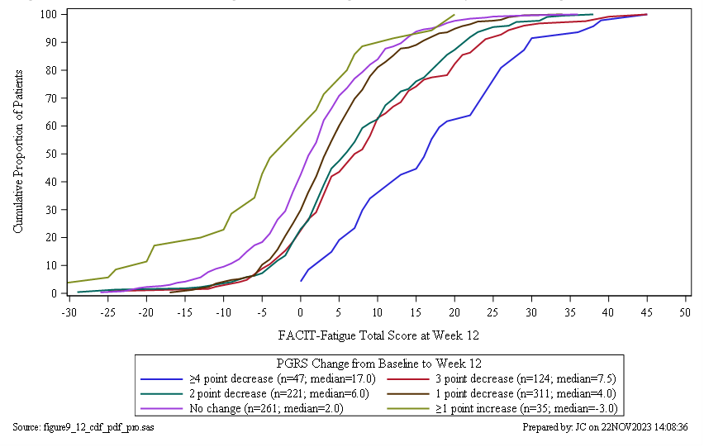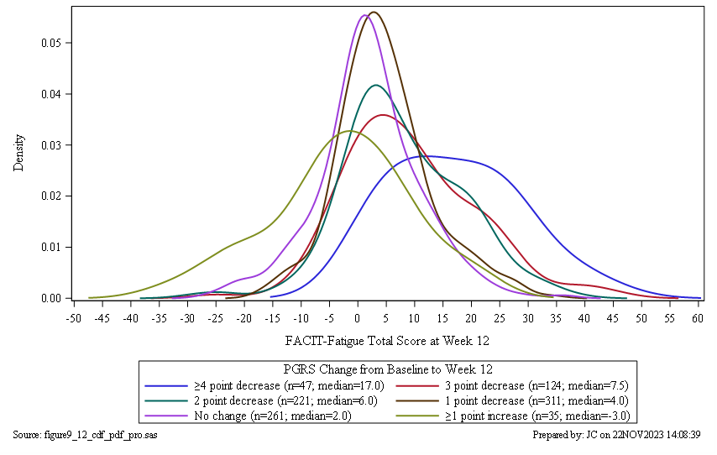

Figure S1 CDF (top) and PDF (bottom) of change in FACIT-Fatigue score by PGRS at Week 12
CDF Cumulative Distribution Function; FACIT-Fatigue Functional Assessment of Chronic Illness Therapy–Fatigue; PDF Probability Density Function; PGRS Patient Global Rating of Severity.

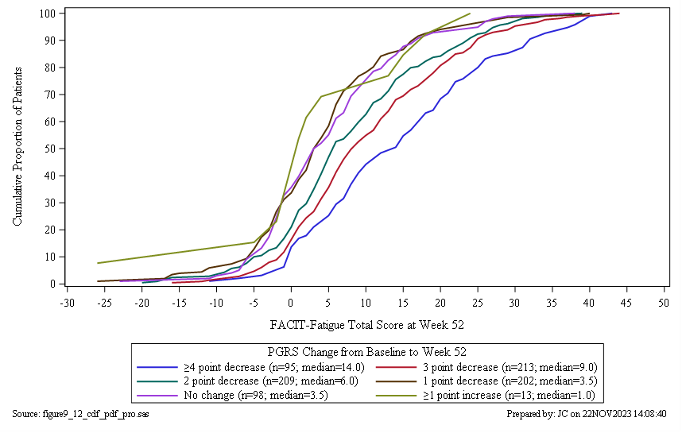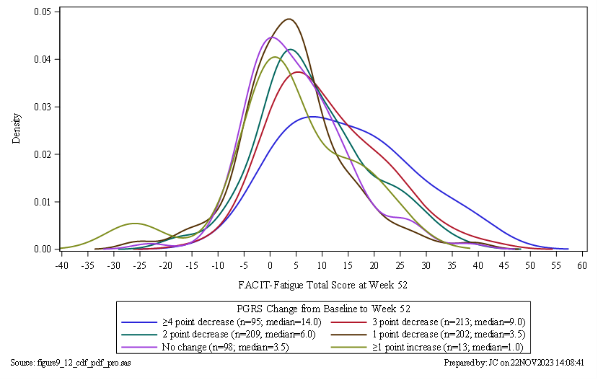

Figure S2 CDF (top) and PDF (bottom) of change in FACIT-Fatigue score by PGRS at Week 52
CDF Cumulative Distribution Function; FACIT-Fatigue Functional Assessment of Chronic Illness Therapy–Fatigue; PDF Probability Density Function; PGRS Patient Global Rating of Severity.

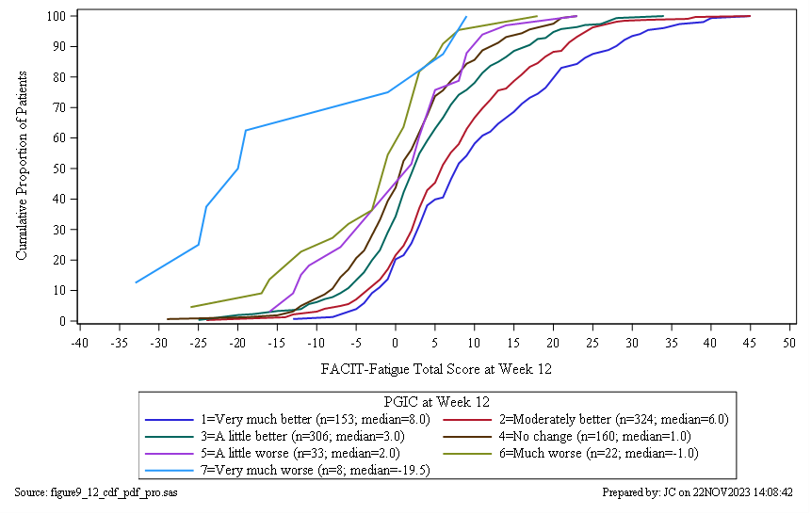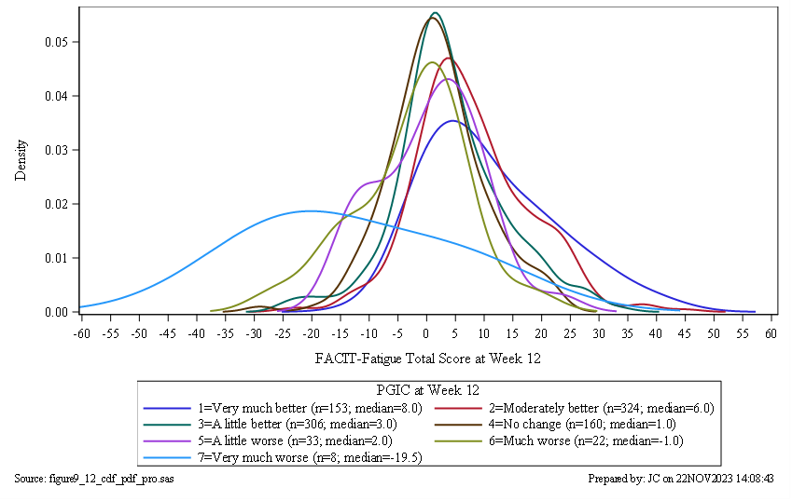

Figure S3 CDF (top) and PDF (bottom) of change in FACIT-Fatigue score by PGIC at Week 12
CDF Cumulative Distribution Function; FACIT-Fatigue Functional Assessment of Chronic Illness Therapy–Fatigue; PDF Probability Density Function; PGIC Patient Global Impression of Change.

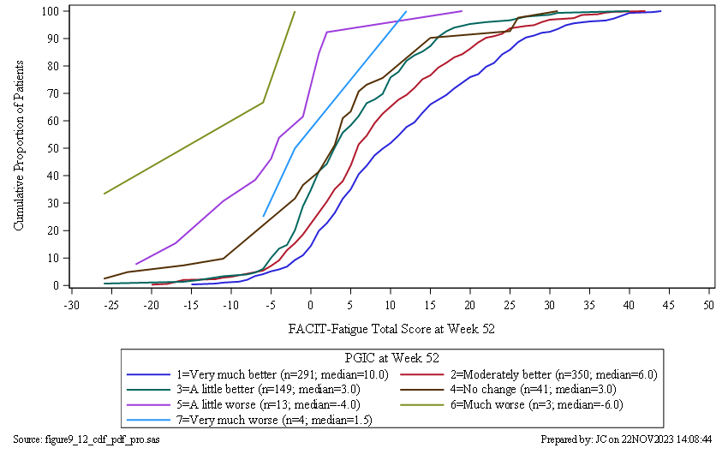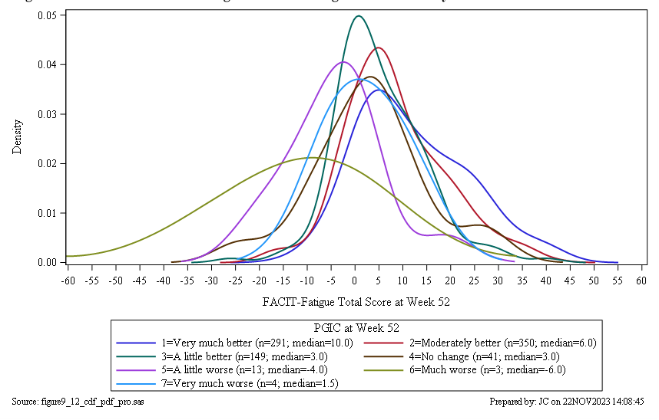

Figure S4 CDF (top) and PDF (bottom) of change in FACIT-Fatigue score by PGIC at Week 52
CDF Cumulative Distribution Function; FACIT-Fatigue Functional Assessment of Chronic Illness Therapy–Fatigue; PDF Probability Density Function; PGIC Patient Global Impression of Change.

