Supplementary Figure 1
Sensitivity plots where the solid line represents the mean index value for simulated populations derived around each EQ VAS score (0-100), standard error range by shaded areas and 95% confidence interval by dotted lines. Norway (NO), crosswalk (UKXW), Denmark (DK), Sweden (SE), and United States (US)
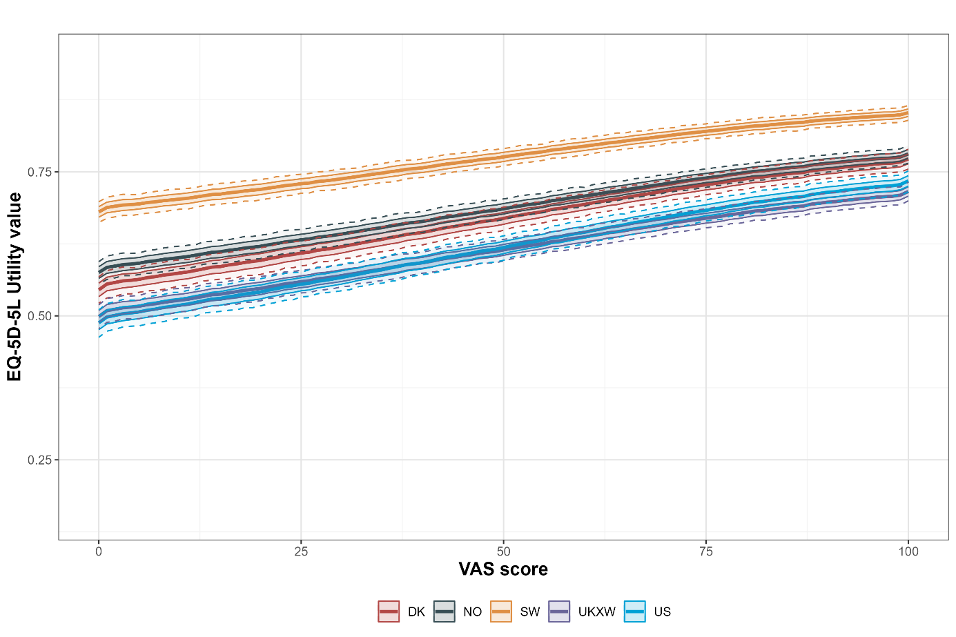

Article title: EQ-5D-5L value set for Norway: a hybrid model using cTTO and DCE data
Journal: Quality of Life Research
Authors: Andrew Garratt, Knut Stavem, James W Shaw, Kim Rand.
Corresponding author email: andrew.garratt@fhi.no

