Online Supplement

Supplement Figure 1. Study sample enrollment flowchart.
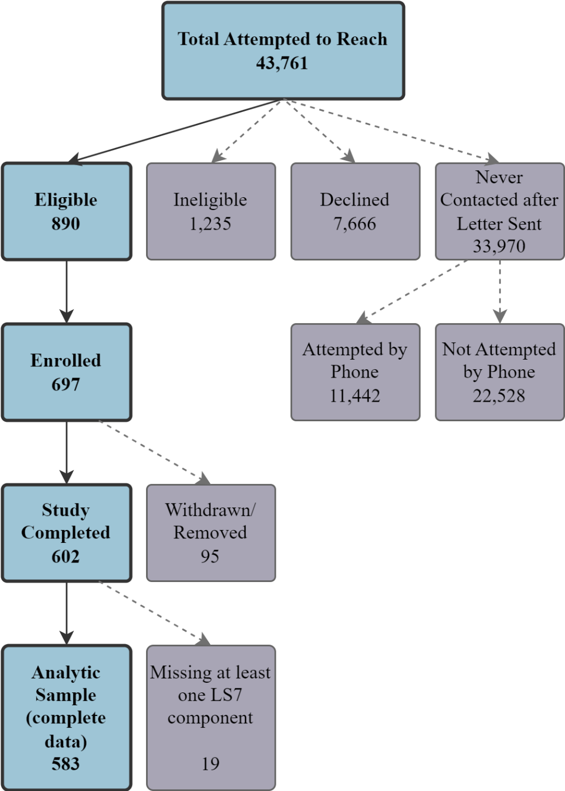

Supplemental Figure 2. Number of ideal LS7 components in the 583 participants with complete LS7 data.

Supplemental Table 1. Full model summary of multivariable linear regression analysis examining the association of CVH categories with total PQoL and PQoL domains (β (95% CI)).
Variable | PQoL Score | PQoL-Physical | PQoL-Cognitive | PQoL-Social
CVH category  Intermediate CVH  Ideal CVH | 0.22 (0.09, 0.35)  0.22 (0.08, 0.36) | 0.42 (0.26, 0.58)  0.57 (0.40, 0.74) | 0.08 (-0.09, 0.26)  -0.03 (-0.21, 0.16) | 0.13 (-0.01, 0.28)  0.06 (-0.09, 0.22)
Age (per 5-year change) | 0.06 (0.04, 0.09) | 0.08 (0.05, 0.12) | 0.04 (0.001, 0.07) | 0.06 (0.03, 0.09)
Hispanic/Latino ethnicity | 0.16 (0.03, 0.28) | 0.10 (-0.05, 0.26) | 0.05 (-0.12, 0.22) | 0.23 (0.09, 0.37)
Female | 0.16 (0.05, 0.28) | 0.01 (-0.13, 0.15) | 0.04 (-0.11, 0.19) | 0.31 (0.18, 0.43)
Income  ≤$30,000  $30,001-≤$55,000 | -0.14 (-0.29, 0.004)  -0.20 (-0.34, -0.05) | -0.07 (-0.25, 0.11)  -0.19 (-0.37, -0.02) | -0.07 (-0.26, 0.12)  -0.06 (-0.25, 0.14) | -0.21 (-0.37, -0.05)  -0.24 (-0.40, -0.08)
Education  High school grad or less  Some college or vocational school | 0.04 (-0.14, 0.23)  -0.03 (-0.16, 0.11) | 0.16 (-0.07, 0.38)  0.03 (-0.13, 0.20) | 0.01 (-0.24, 0.25)  0.03 (-0.14, 0.21) | -0.02 (-0.22, 0.19)  -0.09 (-0.24, 0.06)
Current history of depression | -0.62 (-0.74, -0.49) | -0.68 (-0.83, -0.53) | -0.59 (-0.76, -0.43) | -0.58 (-0.72, -0.45)
Reference groups: Poor CVH; income >$55,000; college graduate or graduate school

Perceived quality of life questionnaire

I. QUALITY OF LIFE
Please answer the questions by indicating how happy you are with the following.
- How happy are you with… | Extremely unhappy | Somewhat unhappy | Neutral | Somewhat happy | Extremely happy
- your physical health (the health of your body) | ₁ | ₂ | ₃ | ₄ | ₅
- how well you care for yourself, for example preparing meals, bathing, or shopping | ₁ | ₂ | ₃ | ₄ | ₅
- how well you think and remember | ₁ | ₂ | ₃ | ₄ | ₅
- the amount of walking you do | ₁ | ₂ | ₃ | ₄ | ₅
- how often you get outside | ₁ | ₂ | ₃ | ₄ | ₅
- how well you carry on a conversation, for example speaking clearly, hearing others, or being understood | ₁ | ₂ | ₃ | ₄ | ₅
- how often you see or talk to your family and friends | ₁ | ₂ | ₃ | ₄ | ₅
- the help you give to your family and friends | ₁ | ₂ | ₃ | ₄ | ₅
- your contribution to your community | ₁ | ₂ | ₃ | ₄ | ₅
- the kind and amount of recreation or leisure you have | ₁ | ₂ | ₃ | ₄ | ₅
- how respected you are by others | ₁ | ₂ | ₃ | ₄ | ₅
- the meaning and purpose of your life | ₁ | ₂ | ₃ | ₄ | ₅
 | Extremely unhappy | Somewhat unhappy | Neutral | Somewhat happy | Extremely happy

